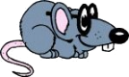
RAT (Radar Tools)
Tutorial “Working with RAT” V1.0

This tutorial tries to give an overview over the basic concepts of RAT. Specific image processing routines are not described here, instead it is explained how to use the basic functionality of RAT.
Import / Reading SAR data
- Reading a file in RAT format File->Open RAT file
  - RAT needs a while to read the data and to calculate the preview. You should see something like this:
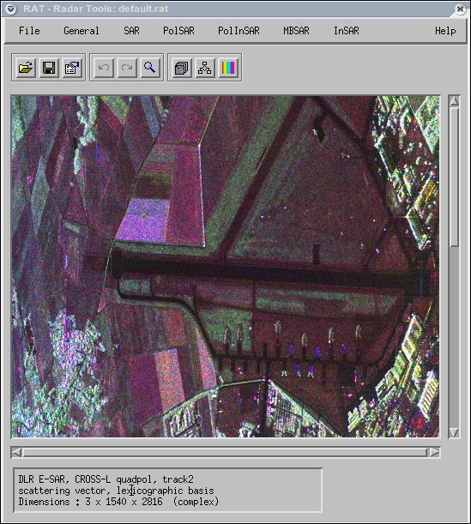
In the so-called info-box at the bottom of the RAT window you get some information about the currently loaded data. In the above example you have loaded 3 complex channels with 1540x2816 pixel. The data type is a polarimetric scattering vector (see section “file types”).
- Construct RAT data File->Construct-> *
This function allows you to construct multi-channel RAT files from several single-channel RAT files. For example, if you have 3 channels of polarimetric data in single files, you can generate a polarimetric vector out of them.
- Import SAR data. File->Open external-> *
Currently, RAT supports 5 airborne SAR sensors (E-SAR, EMISAR, Convair, RAMSES and PISAR) and 3 spaceborne sensors (ENVISAT, RADARSAT-2 and ALOS). It was tried to support most possible imaging modes, although there are some limitations: Due to a lack of data, not all cases could be checked in practice. Additionally, RAT doesn't support some modes, like for example all partial (compact) polarimetry modes. In this case, RAT might load the images, but further processing is not possible.
The individual import modules are written by different persons, so their usage is slightly different. Depending on the sensor, the function might ask whether you want to read a single data set or polarimetric data in vector or matrix format. A file selector allows you to select one or several files. Then RAT is recoding the data into its own format. Once the data are loaded and displayed you should save them using File->Save RAT file .
RAT also support import from the ENVI and POLSARPRO software packages. In both cases, not all data types can be imported, but it's worth a try. Sometimes this way helps importing data from sensors which are not natively supported by RAT. After import, probably you'll have to set the correct data type (see chapter “file types”)
- Open internal formats File->Open internal-> *
These functions are for importing some of your own (internal) data formats. You'll have to program an own import routine in IDL (see RAT website for a short tutorial). For others, this is not relevant.
- Open pixmap File->Open pixmal->*
These functions are for importing standard graphic formats (jpg, png, tiff). This makes not much sense in case of SAR data, since they are complex or have a too large dynamic range for pixmap formats. Nevertheless, if you want to play a bit with RAT to discover its functionality, you might want to try.
Saving / exporting SAR data
- Saving a file in RAT format File->Save RAT file
The data are stored in RAT's native format, which saves data and some auxiliary information in two files, the *.rat file (binary, containing the data) and the *.rit file (ASCII, containing processing history and palette information); the *.rit file is optional, i.e. *.rat files can be opened without having the *.rit file.
RAT uses a quite simple format, which is described in detail on its website. It should be easy to read with any programming language or software providing generic binary import. Note 1: *.rat files always use the platform independent IEEE network format, so take care to use the correct byte swap when importing. Note 2: For multi-channel data, the binary part is stored in pixel-interleaved format (BIP).
- Saving in external formats File->Save external->*
  - ENVI format: It is tried to save in a format compatible to the ENVI package. Since ENVI seems to be a bit strange with handling complex data your mileage might vary.
  - Generic binary: The data are saved directly in a file without any header. You should write down image size and variable type (complex, integer) to read this file.
- Save in standard graphic formats File->Save pixmap->* The currently visible representation of the data is saved into a standard graphic format, with the only difference that the data are exported in full-resolution and not in the preview size. The actual channel and palette settings are preserved for the output. Note: This function requires to load the entire image into memory. Take care to sufficiently reduce image size or to have enough memory in your computer...

File types and header
RAT internally uses a certain value denoted here as file type. The file type describes what kind of SAR data is actually loaded, for example a single-channel complex SLC image, a polarimetric covariance matrix, etc. RAT needs this value for two reasons. On the one hand it will stop you (sometimes, hopefully) from doing things which are impossible with this type of data, while on the other hand the file type is used to calculate the preview image in an optimised way. The file type is a content of *.rat files, i.e. it is stored together with the data. If you open a *.rat file, the file type setting changes according to what is found in the file. The actual file type is always visible in the “info box” below the image:
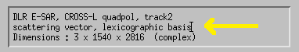
If this value is wrong or unknown (“unknown type”) probably the display is black or looking strange. In this case, select File->Edit file header or click on the icon . The following dialogue appears:
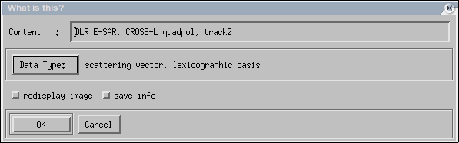
By clicking on “Data type” a new (correct) data type can be set. Of course you should know what you do, because with wrong types you can easily confuse and crash RAT. Select “redisplay image” if you want to recalculate the preview with the new file type setting. Select “save info” if you want to explicitly save the new file type the currently loaded RAT file. Otherwise, next time you open this file, the old type will appear again.
Additionally, in the top line you can add some ASCII text describing your data. As the file type it can be stored in the *.rat file and is displayed in the info box below the image.

Watching the data
For each data set (and each channel), RAT calculates an optimised preview image, which is displayed in the main window. How this is generated depends on the type of data and cannot be influenced by the user. However, all image processing routines work on the real data set. When the processing is finished, a new preview image is calculated.
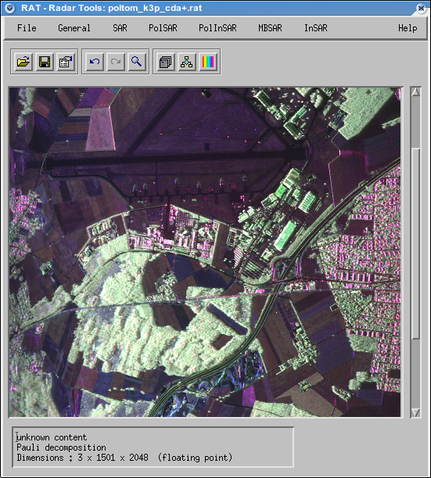
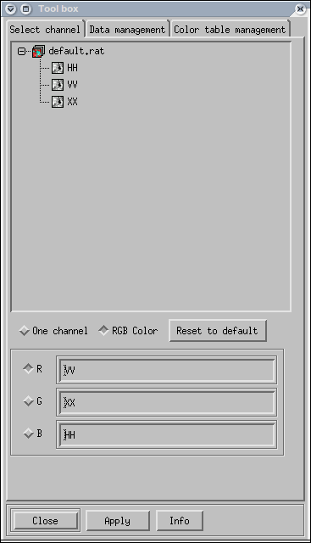
- Channel selection: By default, RAT displays a RGB composite of the three channels, or a b/w version if only one channel is available. If you have more than one channel, you might want to watch an individual channels. To do so, press the icon in the icon bar under the pull-down menus to open the channel selection dialogue.
  - To display only one channel, click first on “One channel” and then in the channel list above on the channel you want to display. The content of the main window changes immediately after you clicked on a channel.
  - To switch back to RGB display, click on “RGB colour” and select three channels for red, green, blue. Press “Apply” to display the data with the new channel selection.
  - To go back to the channel selection, which RAT believes to be optimal, click on “Reset to defaults”.
- Colour table: When displaying only a single channel, RAT can switch between different colour palettes. To activate this function, click the icon to open the palette tool box.
  - There are two types of palettes: Linear ones for displaying images, parameters , etc. and palettes for classification results, which contain only few colours. Click on one of the palettes in the list and then on “Apply” to change the display. Again: Palettes functionality is not available in the RGB display mode.
  - The first palette “RAT's suggestion” is variable and represents the default. All others are fix. By clicking on “New” you can define own custom made palettes.
  - The colour palettes is saved together with a *.rat file in the *.rit file, i.e. when opening a RAT file, the last colour palette is restored. If there is not *.rit file, the default palette will be used.
  - When exporting to pixmap, the current colour palettes (and the current channel selection) is used.
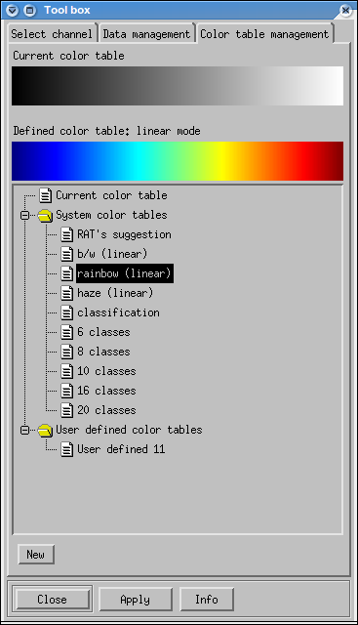

- Zoom function: If you want to magnify a region of interest, click the icon to activate the zoom function. With the mouse, drag a box in the main window to select the area to magnify. After a short moment, a window with a zoomed ROI will appear:
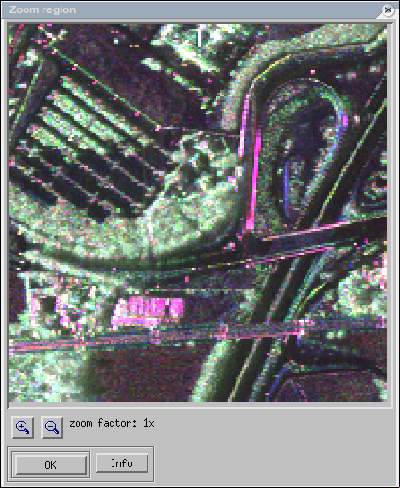
The zoom function zooms into the full-resolution image, not into the preview, i.e. it allows to display small features possibly not visible in the main window. When displaying individual channels, only this channel is zoomed and the actual colour palettes is used. The image scaling in the zoom window is optimised for the selected area, i.e. the zoom might look darker or brighter than the main preview.

Crop data
Start this module with General->Cut out region
The mouse pointer switches to a cross. With pressed left mouse button drag around to select a region of interest in the preview image; a white box shows your actual selection. When you release the mouse button, the following window appears:
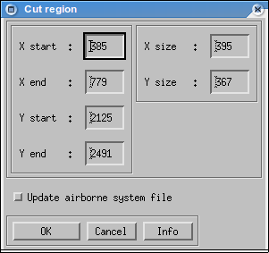
The left values show you the pixel coordinates of the four corners, the right ones the corresponding new image size in x and y. You can change everything by entering new values. When you press <ENTER> the white box in the preview window is updated to show you the extend of the new region. Click on <OK> to start cropping.

Undo / Redo
RAT has the possibility to undo the last processing step. To do so, select General->Undo or click on the icon . The last data set, or the result before the last processing step is loaded and displayed. At this point, you can also switch back forward to your actual result by selecting General->Redo or clicking on the icon .
Note: These two functions can be very useful to compare “before” and “after” by quickly flipping forward and backward using the two icons.

Presumming
Start this module with General->Presumming
This function can be used to shrink your data by summing up adjacent lines and rows. The following window appears:
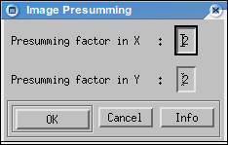
Here you can set presumming factors in x and y. Use this function if your data have very different resolution in range and azimuth (choose appropriate factors then) or if your data are very large and you want to speed up calculations. Also use this function to generated jpg/png/tiff output with a reasonable image size.
Note: This function can be very useful but doesn't make sense on all types of data. For example, when presumming complex SAR images, only the image resolution is degraded, while speckle noise stays constant. In contrast to that, when summing up amplitude images or polarimetric covariance matrices, the speckle noise is reduced, the effective number of looks and image quality increases accordingly and image. When presumming classification results, nearest neighbour sub-sampling is used to avoid mixing of classes.

Extract channels
Start this module with General->Extract channel
This function is used to extract a single channel from a multi-channel data set. Depending on the data type, a window similar to this one will pop up:
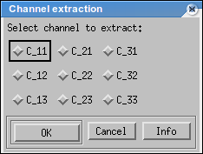
If RAT knows the channel names, they will be displayed properly. If not (see above the example of a 3x3 polarimetric covariance matrix), some templates are used. Click on one channel which you want to extract. Press <OK> to start the extraction. It is not possible to extract more than one channel in one step. In this case, wait until extraction has finished, save the result and select General->Undo to go back to the original image. Now you can extract another channel by repeating the above procedure.

Measure value / location
Start this module with General->Measure value/location
This function displays the content of individual pixels in the actually loaded data set. First the left window will pop up:
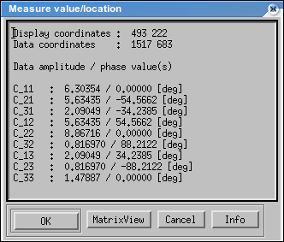
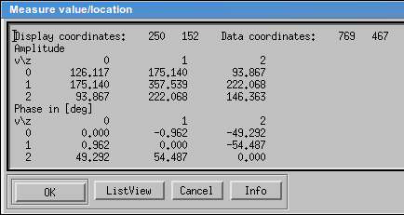
With the button <MatrixView> resp. <ListView> you can switch between left and right display version. On the main window you can now move around with the mouse pointer. While doing so, the current pixel coordinates and the corresponding content of all channels will be displayed. Press <OK> to leave this function.
Note: Possibly not all data corrdinates can be selected due to the reduced resolution of the display.

Preferences
Start this module with File->Preferences
The RAT preferences dialogue will appear:
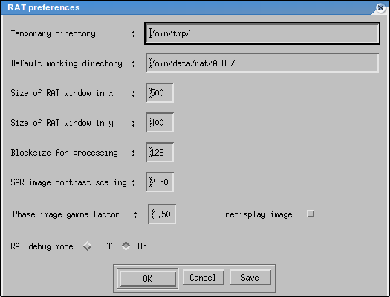
- Temporary directory: This is a directory where RAT puts all its temporary files. They are removed when leaving RAT. If RAT crashes (well, that happens...), some directories (“TMPRAT_*”) might remain in here, which you could and should delete. Note: RAT saves memory by using the hard disk. For good performance it is therefore recommended to put the temporary directory on a fast local disk.
- Working directory: This is the default working directory of RAT. When you open a file, this is the default location. Note: You can save a file “default.rat” in the working directory. This file is opened automatically when starting RAT.
- RAT window size: The main window size of RAT cannot be changed while using RAT, but here you can. The new window size takes effect after restarting RAT. Note: A smaller horizontal window size speeds up the preview calculation.
- Block size for processing: This defines the vertical size of the image blocks used during block processing. A larger window might increase performance, but uses more memory. Recommendation: 128
- SAR image contrast scaling: With this parameter you can lighten or darken the display of SAR images. Recommendation: 2.5
- Phase image gamma factor: Well, probably not used any more...
- Redisplay image: Select if you want to recalculate the preview after changing the contrast scaling
- RAT debug mode: When set to “off”, RAT tries to catch its internal bugs. In this case, instead of crashing, a popup window with an error message will appear. Then RAT tries to resume, which might work or which might not work. Good luck! When set to “on”, RAT will behave like any good piece of software when crashing, i.e. it crashes, which gives you the possibility of proper debugging. Recommendation: If you develop own RAT modules, set to “on”, in all other cases leave this to “off”.

Known issues at time of writing
- Well, several, to lazy now to mention them [...]
General Notes
- Author: Andreas Reigber
- This tutorial refers to RAT V0.18. In other versions the procedure might be different.
- If you encounter any errors or crashes, please report them in the RAT forum.

