# Motivation

In the real world, it is possible to obtain the distance between a loudspeaker and a microphone by playing a reference signal out of the loudspeaker and measuring the time delay of arrival at the microphone. Given such information from a cluster of multiple microphones with known geometry, the loudspeaker position with respect to the microphone cluster can be accurately determined by “triangulation”.

# Setup

There are six microphone clusters distributed randomly within an 8 m × 8 m space as shown in Figure 1, where four microphones within each cluster are placed at the corners of a 0.5 m square.

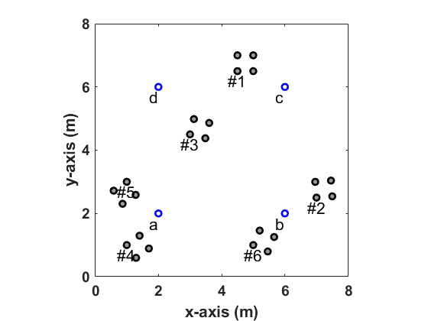

Figure . Positions of six microphone clusters and four loudspeakers.

There are also four loudspeakers, labeled ‘a’, ‘b’, ‘c’, and ‘d’, in the same space that are placed at the corners of a 4 m square as shown in the figure above.

Distance between each microphone-loudspeaker pair in the above configuration is provided in the appendix of this document.

# Question #1

For example, the position of loudspeaker ‘c’ with respect to the four microphones in cluster #1 is show in Figure 2.



Figure . Relative positions of microphone cluster #1 and loudspeaker ‘c’.

The problem is to generate all 24 plots like the one in Figure 2. More specifically, if the microphone 1 in each cluster is placed at the origin of a Cartesian coordinate system, and the sides of cluster are aligned with the x-y axes, what is the exact position of each loudspeaker in terms of the coordinate (x, y)?

# Question #2

Given that the loudspeakers are located at coordinates (2 m, 2 m), (6 m, 2 m), (6 m, 6 m), and (2 m, 6 m) as shown in Figure 1, determine all the microphone positions by using the provided distances.

## Suggested Steps

1. Choose a frame of reference that simplifies parametrization (hint: see Figure 2).
2. Compute the position of a loudspeaker with respect to the microphone cluster (as done for Question #1).
3. Change the reference frame from that of microphone to that of loudspeaker by applying proper rotation to the results from Step 2.
4. Rotate and shift the microphone cluster to be in the loudspeaker reference frame by using the provided distance information and the results from Step 3.

# Question #3

Can the positions and the orientations of microphone clusters be still determined if the exact positions of loudspeakers are unknown? Describe in words how the problem of computing the relative locations of randomly distributed loudspeakers and microphones can be solved when only the distance between them are known (e.g., how many loudspeakers and microphone clusters are needed to obtain a unique solution?).

# Appendix

Distances for all loudspeaker-microphone pairs are provided below in terms of meter.

|  |  |  |  |  |
| --- | --- | --- | --- | --- |
| Cluster #1 | a | b | c | d |
| 1 | 5.15 | 4.74 | 1.58 | 2.55 |
| 2 | 5.41 | 4.61 | 1.12 | 3.04 |
| 3 | 5.83 | 5.10 | 1.41 | 3.16 |
| 4 | 5.59 | 5.22 | 1.80 | 2.69 |
|  |  |  |  |  |
| Cluster #2 | a | b | c | d |
| 1 | 5.02 | 1.12 | 3.64 | 6.10 |
| 2 | 5.52 | 1.59 | 3.77 | 6.50 |
| 3 | 5.56 | 1.79 | 3.30 | 6.21 |
| 4 | 5.06 | 1.38 | 3.15 | 5.80 |
|  |  |  |  |  |
| Cluster #3 | a | b | c | d |
| 1 | 2.69 | 3.91 | 3.35 | 1.80 |
| 2 | 2.80 | 3.46 | 2.99 | 2.20 |
| 3 | 3.28 | 3.73 | 2.65 | 1.97 |
| 4 | 3.19 | 4.15 | 3.05 | 1.51 |
|  |  |  |  |  |
| Cluster #4 | a | b | c | d |
| 1 | 1.41 | 5.10 | 7.07 | 5.10 |
| 2 | 1.57 | 4.91 | 7.17 | 5.45 |
| 3 | 1.15 | 4.44 | 6.68 | 5.12 |
| 4 | 0.92 | 4.65 | 6.58 | 4.74 |
|  |  |  |  |  |
| Cluster #5 | a | b | c | d |
| 1 | 1.41 | 5.10 | 5.83 | 3.16 |
| 2 | 1.59 | 5.46 | 6.33 | 3.57 |
| 3 | 1.17 | 5.14 | 6.32 | 3.86 |
| 4 | 0.93 | 4.76 | 5.82 | 3.49 |
|  |  |  |  |  |
| Cluster #6 | a | b | c | d |
| 1 | 3.16 | 1.41 | 5.10 | 5.83 |
| 2 | 3.66 | 1.32 | 5.23 | 6.25 |
| 3 | 3.73 | 0.82 | 4.76 | 5.99 |
| 4 | 3.25 | 0.96 | 4.61 | 5.56 |