1. Below is a table shows the first step in a use case description for the main flow of the Withdraw Money use case for an ATM system. Use your experience with ATM machines to help you fill out the rest of the table. The goal of the Withdraw Money use case is, of course, to withdraw money from your account, and in the Main Flow of this use case, the goal is achieved as expected.

# WITHDRAW_MONEY Use Case Description: Main Flow

|  |  |
| --- | --- |
| **User Action** | **System Response** |
| 1. User types in PIN into main screen | 1. System checks validity of PIN and presents options to user on another screen |
| 2. User will Select Withdraw Money operation from the Options Screen | 2. System displays the withdrawable  amounts /custom amount. |
| 3. User Selects Amount to withdraw /  Enters custom amount to withdraw. | 3. System process Transaction and sends Confirmation. |

1. Create a Use Case Diagram for the ATM system (refer to the slides for the three use cases that you will use). There should be two actors in your diagram.

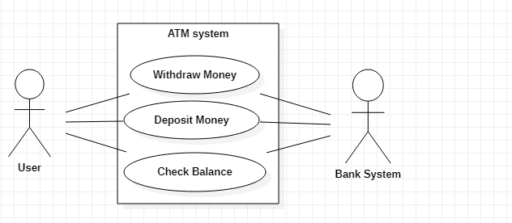

1. **The Project Management Tracking System**. The following is a problem statement for building a simple project management tool. The tool would be used by a Project Manager (who would be an Actor in relation to this system), and we can assume that the final system will have a user interface which would be used by the Project Manager. Use the techniques discussed in class to create a static model – identify the classes for this system and determine the attributes that belong to each class. We will develop this example further in Lab 2. For this lab, you do not need to specify associations or operations.

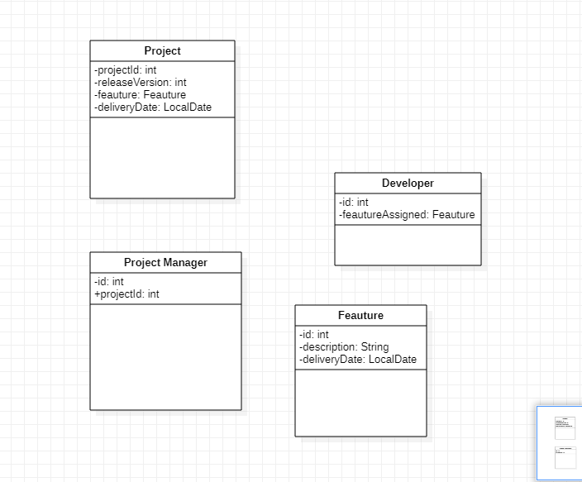

4. **Properties Management System.** The following is a problem statement for a simple properties management system, which would be used by a manager of multiple properties. Use the techniques discussed in class to create a static model – identify the classes for this system and determine the attributes that belong to each class. We will develop this example further later on – for this lab, you do not need to specify associations or operations.

