| col |
| --- |
| **Week 34 Epidemiological Bulletin 19th - 25th, August, 2024** |

| col |
| --- |
| **Summary** |

Executive Summary

• Fill in the summary manually

## Immediately Notifiable Diseases and Events

• Afp: 6 suspected cases — Harari(3), Amhara(2), SNNP(1)
• Anthrax: 8 suspected cases — Harari(7), SNNP(1)
• Cholera: 4 suspected cases — Dire Dawa(4)
• Measles: 28 suspected cases — Somali(14), Amhara(7), Afar(3), Oromia(2), SNNP(1), Sidama(1)

## Other Diseases and Events

• Non-bloody Diarrhoea: 35175 suspected cases — Amhara(5419), Harari(5142), Tigray(4568), SNNP(4163), Dire Dawa(3856), Sidama(3828), Oromia(2495), Somali(2289), Afar(1950), Benishangul Gumz(1465)
• Malaria: 144640 suspected cases — Amhara(25239), Dire Dawa(23810), Sidama(23453), Afar(22041), Somali(14352), Tigray(10517), SNNP(10414), Benishangul Gumz(7282), Oromia(4643), Harari(2889)
• Typhoid Fever: 33 suspected cases — Oromia(18), Somali(9), Dire Dawa(4), Tigray(2)
• Monkeypox: no suspected cases reported.
• Plague: no suspected cases reported.

| col |
| --- |
| **Summary Report Priority Diseases, Conditions and Events** |

|  | **Week 34** | | | **Week 1 to 34, Cumulative Total** | | |
| --- | --- | --- | --- | --- | --- | --- |
| **Disease/Event/Condition** | **suspected.x** | **tested.x** | **confirmed.x** | **suspected.y** | **tested.y** | **confirmed.y** |
| **AFP** | 6 | 4 | 1 | 318 | 259 | 1 |
| **Anthrax** | 8 | 2 | 1 | 283 | 36 | 5 |
| **Cholera** | 4 | 0 | 0 | 16,684 | 4,410 | 2,034 |
| **Non-bloody Diarrhoea** | 35,175 | 2,435 | 2,171 | 813,029 | 46,953 | 50,502 |
| **Malaria** | 144,640 | 138,717 | 40,329 | 8,011,914 | 7,570,205 | 3,693,242 |
| **Measles** | 28 | 21 | 3 | 4,360 | 1,343 | 655 |
| **Monkeypox** | 0 | 0 | 0 | 8 | 4 | 0 |
| **Plague** | 0 | 0 | 0 | 13 | 1 | 0 |
| **Typhoid Fever** | 33 | 20 | 4 | 822 | 499 | 45 |

| col |
| --- |
| **Summary of VPD Surveillance Indicators** |

| col |
| --- |
| **Measles Laboratory Test Results by Region** |

• The country has recorded a total of 4360 suspected measles cases in 2024.
• From the 553 measles specimen that have been tested, 192 have been confirmed positive (PR 34.7 %).

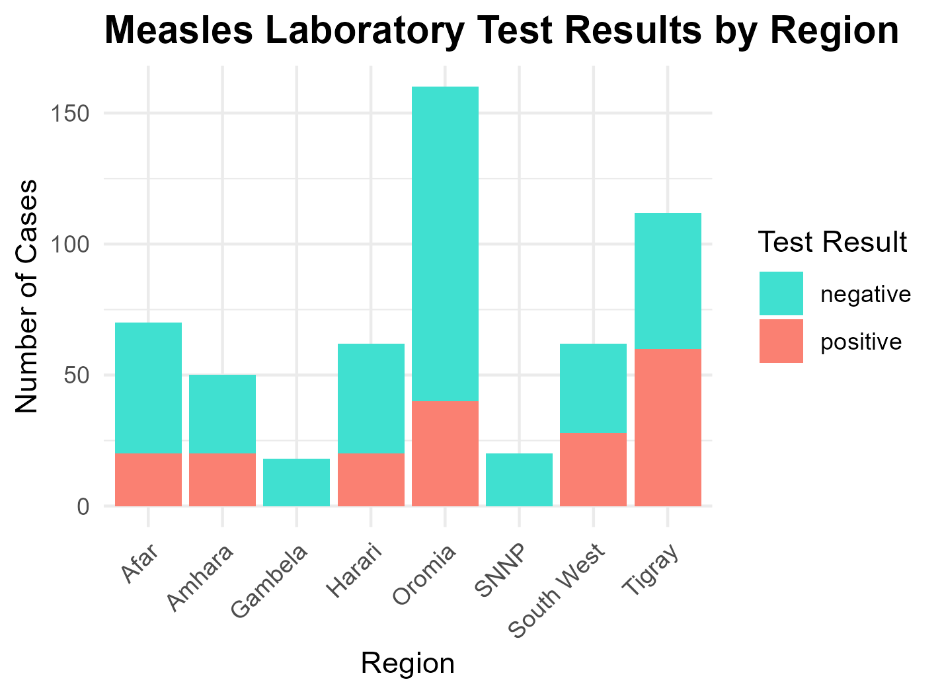

| col |
| --- |
| **Maternal Deaths** |

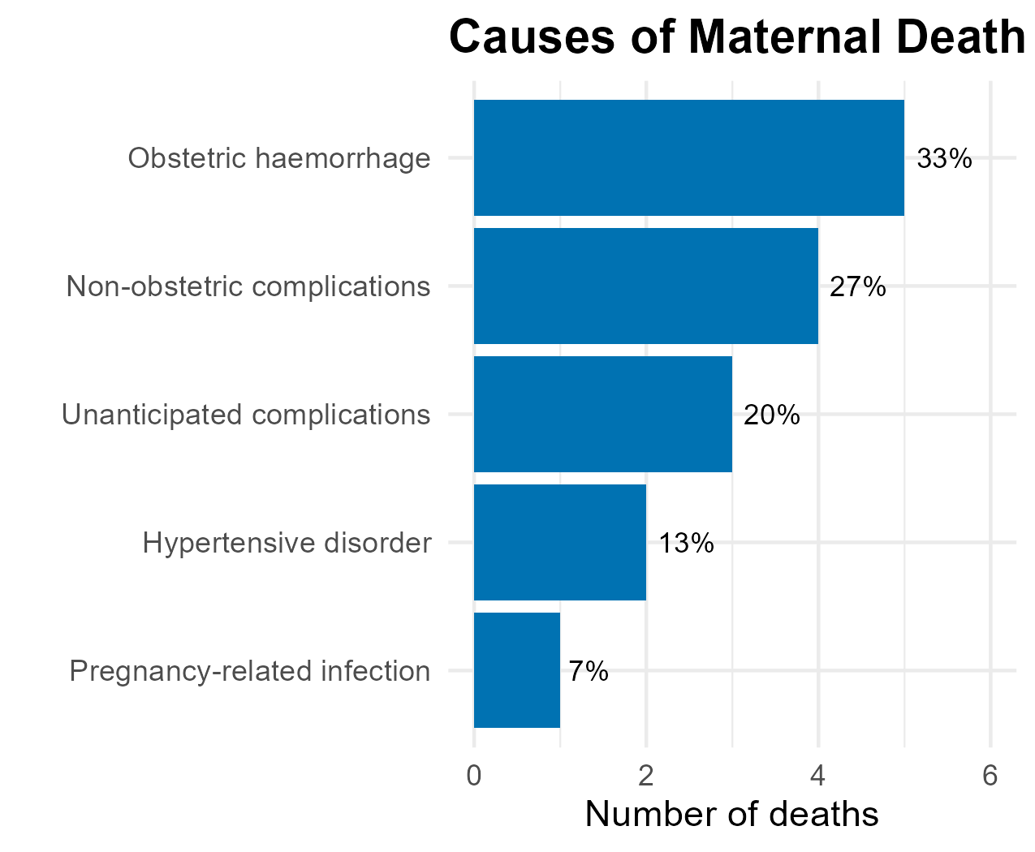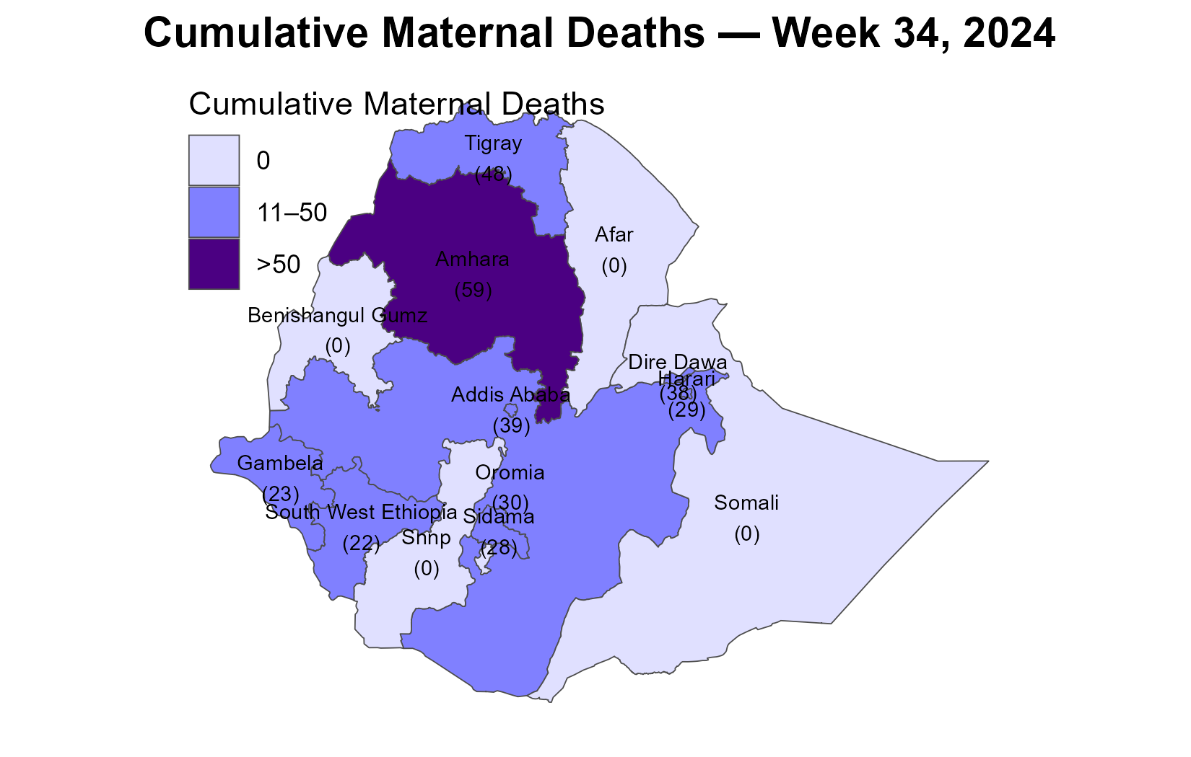

• The bar chart on the left summarizes the causes of deaths of 15 maternal deaths recorded in week 34.

• Hypertensive disorder, Non-obstetric complications, and Obstetric haemorrhage continue to be the leading causes of maternal deaths this year.

• Cumulatively, in 2024, 410 maternal deaths have been recorded across the country, as depicted on the map.

• Regions with darker shades (Amhara, Tigray, Addis Ababa) indicate those with a higher number of reported maternal deaths.

— End of Bulletin —