Dimensional weight reconsidered
- [ ] If your neighbor does not get along, help him/her without being asked explicitly!
- [ ] Checklist before you start coding:
  - Go to a working directory where you are allowed to save files
  - If you are in AppData/Roaming, change to your home directory
  - Open a terminal and navigate to your working directory
- [ ] Create an Org-mode file "dweight.org"
- [ ] Add one named C code block (use <s [TAB] to do this)
- [ ] Name the code block dweight
- [ ] Start with the code that we created last week, or take the code from dweight.c in GitHub (in cc100/3_basics/src).
- [ ] Check: your code block should now look like this:
Listing 1:
#include <stdio.h>

int main(void)
{
const int INCHES_PER_POUND = 166;
int height, length, width, volume, weight;

height = 8;
length = 12;
width = 10;
volume = height * length * width;
weight = (volume + INCHES_PER_POUND-1) / INCHES_PER_POUND;

printf("Dimensions: %dx%dx%d\n", length, width, height);
printf("Volume (cubic inches): %d\n", volume);
printf("Dimensional weight (pounds): %d\n", weight);

return 0;
}
- [ ] You do not need any code block header arguments except C and :results output.
- [ ] Note that the number 166 is now defined as const.
- [ ] Run the code block in Emacs with C-c C-c to make sure it is correct. You should get this output:
#+RESULTS: dweight
: Dimensions: 12x10x8
: Volume (cubic inches): 960
: Dimensional weight (pounds): 6
- [ ] Copy the code block into a second code block, and name it dweight1.
- [ ] Alter the code so that the three variables height, length, and width have to be given as input:
  - Add three printf statements asking for these variables
  - After each of these, add a scanf statement to take the input
  - You must delete the assignments to these variables
  - Make sure that you use the correct format identifier %d
- [ ] Your code block should now look like this (without the comments):
Listing 2:
#include <stdio.h>

int main(void)
{
// declare variables and constants
const int INCHES_PER_POUND = 166;
int height, length, width, volume, weight;

// Enter input
printf("Enter the box height: ");
scanf("%d", &height);
printf("Enter the box length: ");
scanf("%d", &length);
printf("Enter the box width: ");
scanf("%d", &width);

// compute volume and dimensional weight
volume = height * length * width;
weight = (volume + INCHES_PER_POUND-1) / INCHES_PER_POUND;

printf("Dimensions: %dx%dx%d\n", length, width, height);
printf("Volume (cubic inches): %d\n", volume);
printf("Dimensional weight (pounds): %d\n", weight);

return 0;
}
- [ ] Add the necessary tangle information to the code block header:
:tangle dweight1.c
- [ ] Tangle the code block with the key sequence C-c C-v t to get the C source code file dweight1.c
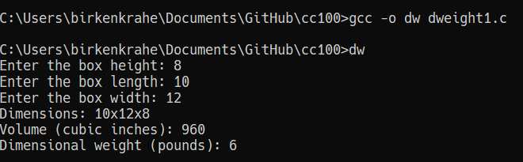
- [ ] Compile and run it on the Windows command line, and you're done!

