COURSE OVERVIEW

CSC 100 - Introduction to programming - Spring 2024

Marcus Birkenkrahe

Practice: first "literate" C program! (30 min)
(You can find a PDF of this exercise on GitHub.)
Let's set emacs up, write and run a first "literate" c program! it is very important that you enter everything exactly as shown. if you get something wrong just go back one step. Contact me if you need me after checking with your neighbor if he or she can help.
- open the command line terminal with cmd in the search field
- At the prompt, type gcc --version
- Open https://github.com/birkenkrahe/org/ in a browser
- Navigate to the repository emacs in GitHub
- Click on the file name .emacs to open it
- Open the Raw version of this file (there's a button)
- Right click to Save as and save file as emacs.txt in /Downloads
- Open a terminal by entering CMD in the Windows search bar
- Pin the terminal to your taskbar to open it quickly next time!
- At the prompt, enter DIR emacs.txt - you should see the file
- At the prompt, enter emacs --version
- Enter emacs -nw -l emacs.txt
- Inside Emacs, enter CTRL + x CTRL + f to enter a new file.
- At the prompt at the bottom of the screen, enter first.org
- Enter the following text (replace yourname with your own name):
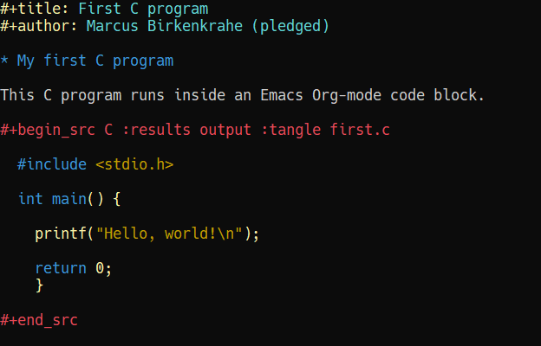
- 'Run' the program by putting the cursor anywhere on the code block and typing CTRL-c CTRL-c. You should see the result on the screen.
- Save the file with CTRL + x CTRL + s
- 'Tangle' the code with CTRL + c CTRL + v t (or M-x org-babel-tangle): Emacs reports "Tangled 1 code block from first.org".
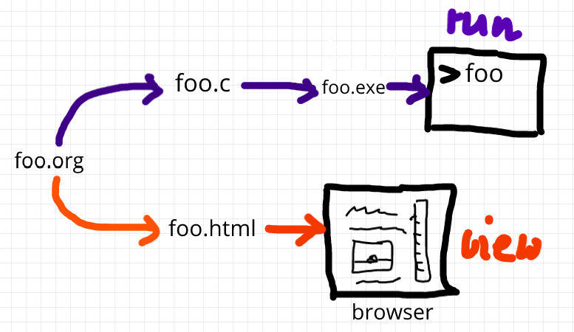 Figure 1: What happens when you tangle or weave a literate program
- Open a shell inside Emacs by entering ALT-x eshell
- At the $ prompt, enter ls -l first* - you should see first.c listed
- Display first.c by entering cat first.c
- Enter gcc first.c -o hello to compile the C program into an executable
- Enter hello to run the executable. You should see the output.
- Exit and close Emacs with CTRL-x CTRL-c
- Exit and close the shell by entering exit after the prompt
- Save your file to a directory on your GDrive (you can do this with File Explorer, or directly in Emacs with the following commands (you don't have to worry about spaces etc. because you can auto-complete using the <TAB> key):
C-x C-w ;; write file
w:/My Drive/ ;; target directory
C-x d w:/My Drive/ ;; open target directory
s ;; sort to see recent files at top
You can also do it in the Emacs eshell that you used earlier to compile and run the file on the shell (auto-complete with <TAB>):
cp first.org w:/My\ Drive/ # copy file to target directory
cat w:/My\ Drive/first.org # view copy of file at target location
- Upload first.org as your first in-class assignment:
  - Open a browser to GDrive and upload the file
  - Open the assignment in Canvas at lyon.instructure.com
  - Upload the file from GDrive (click on "More")
  - When you see it attached, click on Submit Assignment.

