Marcus Birkenkrahe

Popquiz 1
Without any other resources, complete the following tasks in R for Solar Eclipse data from NASA/kaggle.com for a total of 5,000 years.
- Store URL: Create an R object url for the web address http://tinyurl.com/solar-csv and check that the object is there:
url <- 'http://tinyurl.com/solar-csv'
url # or ls()
ls()
- Data import: The CSV data do have a header row. Import the CSV file from the web into a dataframe solar and display its data structure.
solar <- read.csv(url,header=TRUE)
str(solar)
- Index extraction: Write a command to extract the number of the column named Calendar.Date from the solar dataframe.
which(names(solar)=='Calendar.Date')
which(names(solar)=='Eclipse.Type')
which(names(solar)=='Latitude')
which(names(solar)=='Longitude')
which(names(solar)=='Central.Duration')
[1] 2
[1] 7
[1] 10
[1] 11
[1] 15
- Transformation: Write the following steps in a code block:
  - Store the indices of some columns (given in a table below) in a vector cols.
  - Copy these columns from the dataframe solar to a new dataframe sol.
  - Change the names of the columns from the old to the new name shown in the table.
  - Display the structure of sol.
Column | Old name | New name
2 | Calendar.Date | date
7 | Eclipse.Type | type
10 | Latitude | lat
11 | Longitude | lon
15 | Central.Duration | tot
cols <- c(2,7,10,11,15)
sol <- solar[cols]
names(sol) <- c('date','type','lat','lon','tot')
str(sol)
- Display the contingency table of the solar eclipse types (in type) and store it in an R object called tbl. Then print the table.
tbl <- table(sol$type)
tbl
- How many types of solar eclipses are there? Write a command that returns the number of types.
length(tbl)
- The table tbl has names and frequencies. Make a barplot of the table names. Label the x- and y-axis appropriately.
Listing 1:
barplot(tbl,
xlab="Solar eclipse types",
ylab="Number of solar eclipses")
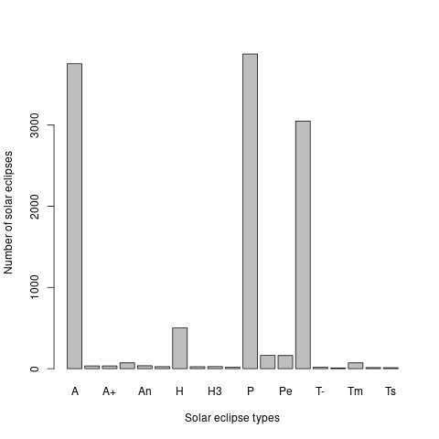
- Convert the table tbl to a dataframe types and name the first column Type, then print the dataframe.
types <- as.data.frame(tbl)
names(types)[1] <- "Type"
types
- Make a histogram of the frequencies in types in decreasing order, and name the x-axis appropriately. Tip: to sort a vector x in decreasing order, run sort(x, decreasing=TRUE).
Listing 2:
x <- sort(types$Freq,decreasing=TRUE)
hist(x,
xlab="Frequency of solar eclipse types")
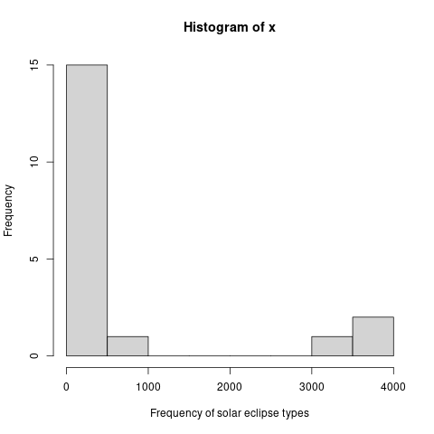
- Place both the barplot and histogram you just made in one panel on top of one another (barplot on top, histogram below).
par(mfrow=c(2,1))
barplot(tbl,
xlab="Solar eclipse types",
ylab="Number of solar eclipses")
x <- sort(types$Freq,decreasing=TRUE)
hist(x,
xlab="Frequency of solar eclipse types")
par()
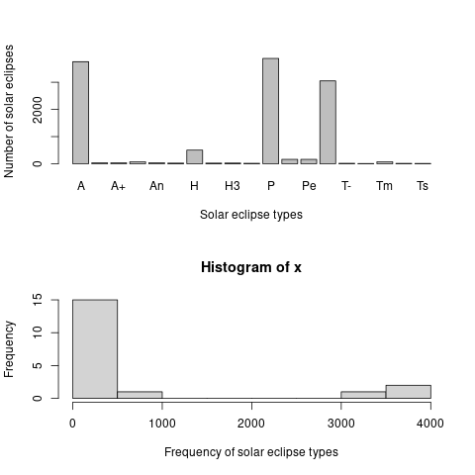
- When you're finished, tell me your confidence that your code is error-free.
- Create an Emacs Org-mode file and enter your code.
- Enter all code blocks first, then start at the top and run them.
- Grade yourself based on the percentage of your code that worked.
- Hand in your graded pop quiz if you like, for bonus points.
- Fix your code based on the solutions file.

