Reviewing Python and R basics

Intro to Advanced Data Science - DSC 205 - Lyon College Spring'24

Marcus Birkenkrahe (pledged)

Time-stamp: <2024-02-09 Fri 07:23>

Table of Contents
1. Bonus: Math plots with R

Bonus: Math plots with R
- This section is prompted by a Calculus II exercise that I came across. Especially when dealing with trigonometric functions, it can be useful to plot them and get a visual on the problem.
- Plot a complicated function, e.g. $f(x) = sin^2(x) sin(2x)$:
  - Base R (package:base) has trigonometric functions pre-loaded. Check ?sin on the command line to see documentation and function names.
  - To plot, all you need is the plot function.
  - In Emacs, you can change the code block header arguments. The following metadata will store the result in a file graph.png and it will also link to the file in the #+RESULTS output. If you don't do this, the plot will appear in a separate window.
#+begin_src R :results output graphics file :file graph.png
- Here's the code that opens the graph in a separate window:
## function definition
f <- function(x) {
return (sin(x)**2 * sin(2*x))
}
## arguments (independent variable)
x = seq(from = 0,to = 10,by = 0.01)

## plot as line plot
plot(x,f(x), type="l")
- Here's the code with the altered header line and with some customization:
## function definition
f <- function(x) {
return (sin(x)**2 * sin(2*x))
}
## arguments (independent variable)
x = seq(from = 0,to = 10,by = 0.01)

## plot as line plot
plot(x,f(x), type="l")
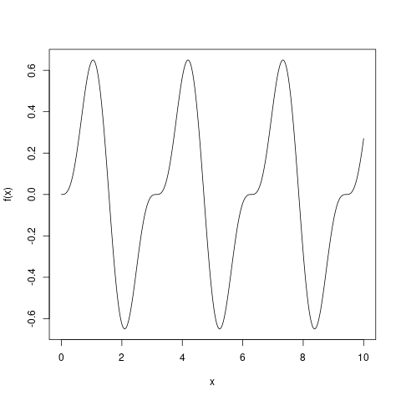
- Here is the minimal code without function, in one line:
plot(x=seq(from = 0,to = 10,by = 0.01),
sin(x)**2 * sin(2*x),
type="l")
