Birkenkrahe@LCJVYZ1B3

Table of Contents
1. GNU Emacs
1.1. Overview
1.2. Open Emacs
1.3. Open the Emacs tutorial
1.4. Read a file into Emacs

GNU Emacs

Overview
This short tutorial to guide you to your first steps with the GNU Emacs editor. You should also take time to complete the onboard tutorial. I will make a video of this tutorial, too.
All PATH values assume that you work on a PC in Lyon 104.
The sequence of lessons follows losely the GNU Emacs Reference Card (PDF)

Open Emacs
- If there's a Desktop shortcut, double-click on it to open Emacs
- If there is no Destktop shortcut, open a terminal:
Windows Search bar: CMD
- In the terminal, enter this:
C:\Program Files\GNU Emacs 27\x86_64\bin\emacs &
Troubleshoot: check the location of the file emacs.exe using the File explorer, and correct the PATH accordingly.
You should now see the Emacs startup screen:
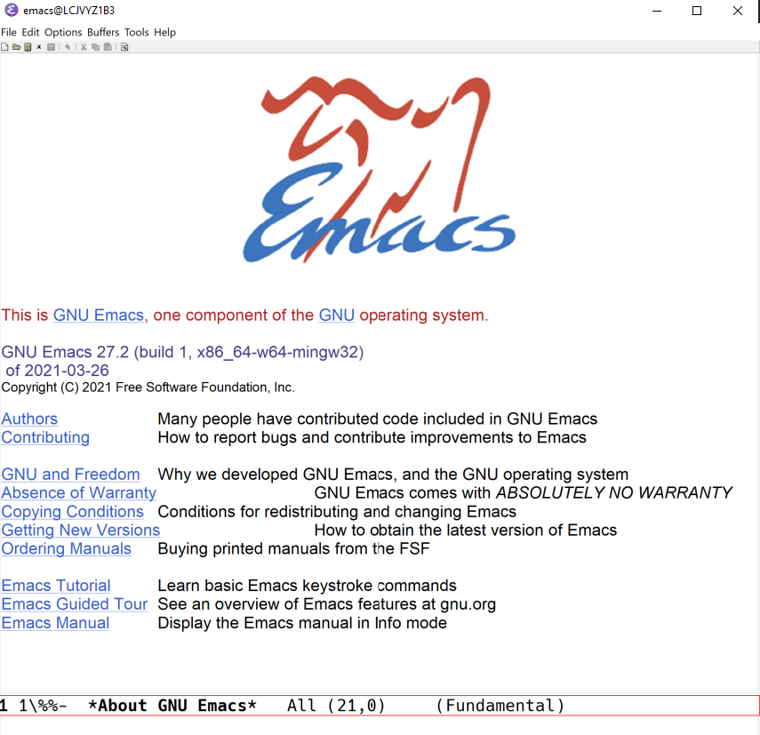 Figure 1.2.1: GNU Emacs startup screen
You can always get back to this screen by typing CTRL+h CTRL+a (two commands, hold down the CTRL key and press the letter).
Note: you can also start Emacs in the terminal alone (no graphics window). To do this, add a -nw (for "no window"):
C:\Program Files\GNU Emacs 27\x86_64\bin\emacs -nw &

Open the Emacs tutorial
Emacs has an onboard tutorial. To open it, type
CTRL-h t
This command consists of two parts:
- press CTRL, hold it and press x (you see C-x at the bottom of the screen)
- press h
The tutorial should appear in the Emacs buffer. It takes about 1 hour to work through. This is well worth it if you want to use Emacs.

Read a file into Emacs
This lesson consists of several steps:
- download a text file from GitHub
- open an empty file inside Emacs
- copy ("yank") or insert the file into Emacs
- save the file in Emacs
- Open a browser and go to https://github.com/birkenkrahe/org/blob/master/emacs/emacs.txt.
- Copy the raw contents in your clipboard by clicking on the copy icon at the top of the file.
- Go to the Emacs window ("frame"), or open GNU Emacs, and type C-x C-f (on the keyboard, this looks like CTRL+x followed by CTRL-f - from now on, I will use the shorthand notation).
- Delete the path all the way, and replace it by ~/ (your home directory).
- Enter emacs.txt after the / and press ENTER (~RET).
Find file: ~/emacs.txt
- In the buffer (you know that you're there because of the cursor that should be blinking at you at the top of the empty page), press C-y.
- The text that you copied to the clipboard earlier, should now show up in the buffer.
- The file is unsaved - indicated by the two stars left of the buffer name at the bottom of the page in the "modeline" ("\**"). Save it by typing C-x C-s.
- You should get a confirmation at the bottom of the buffer (in the "echo area"), and the stars are replaced by dashes ("–")
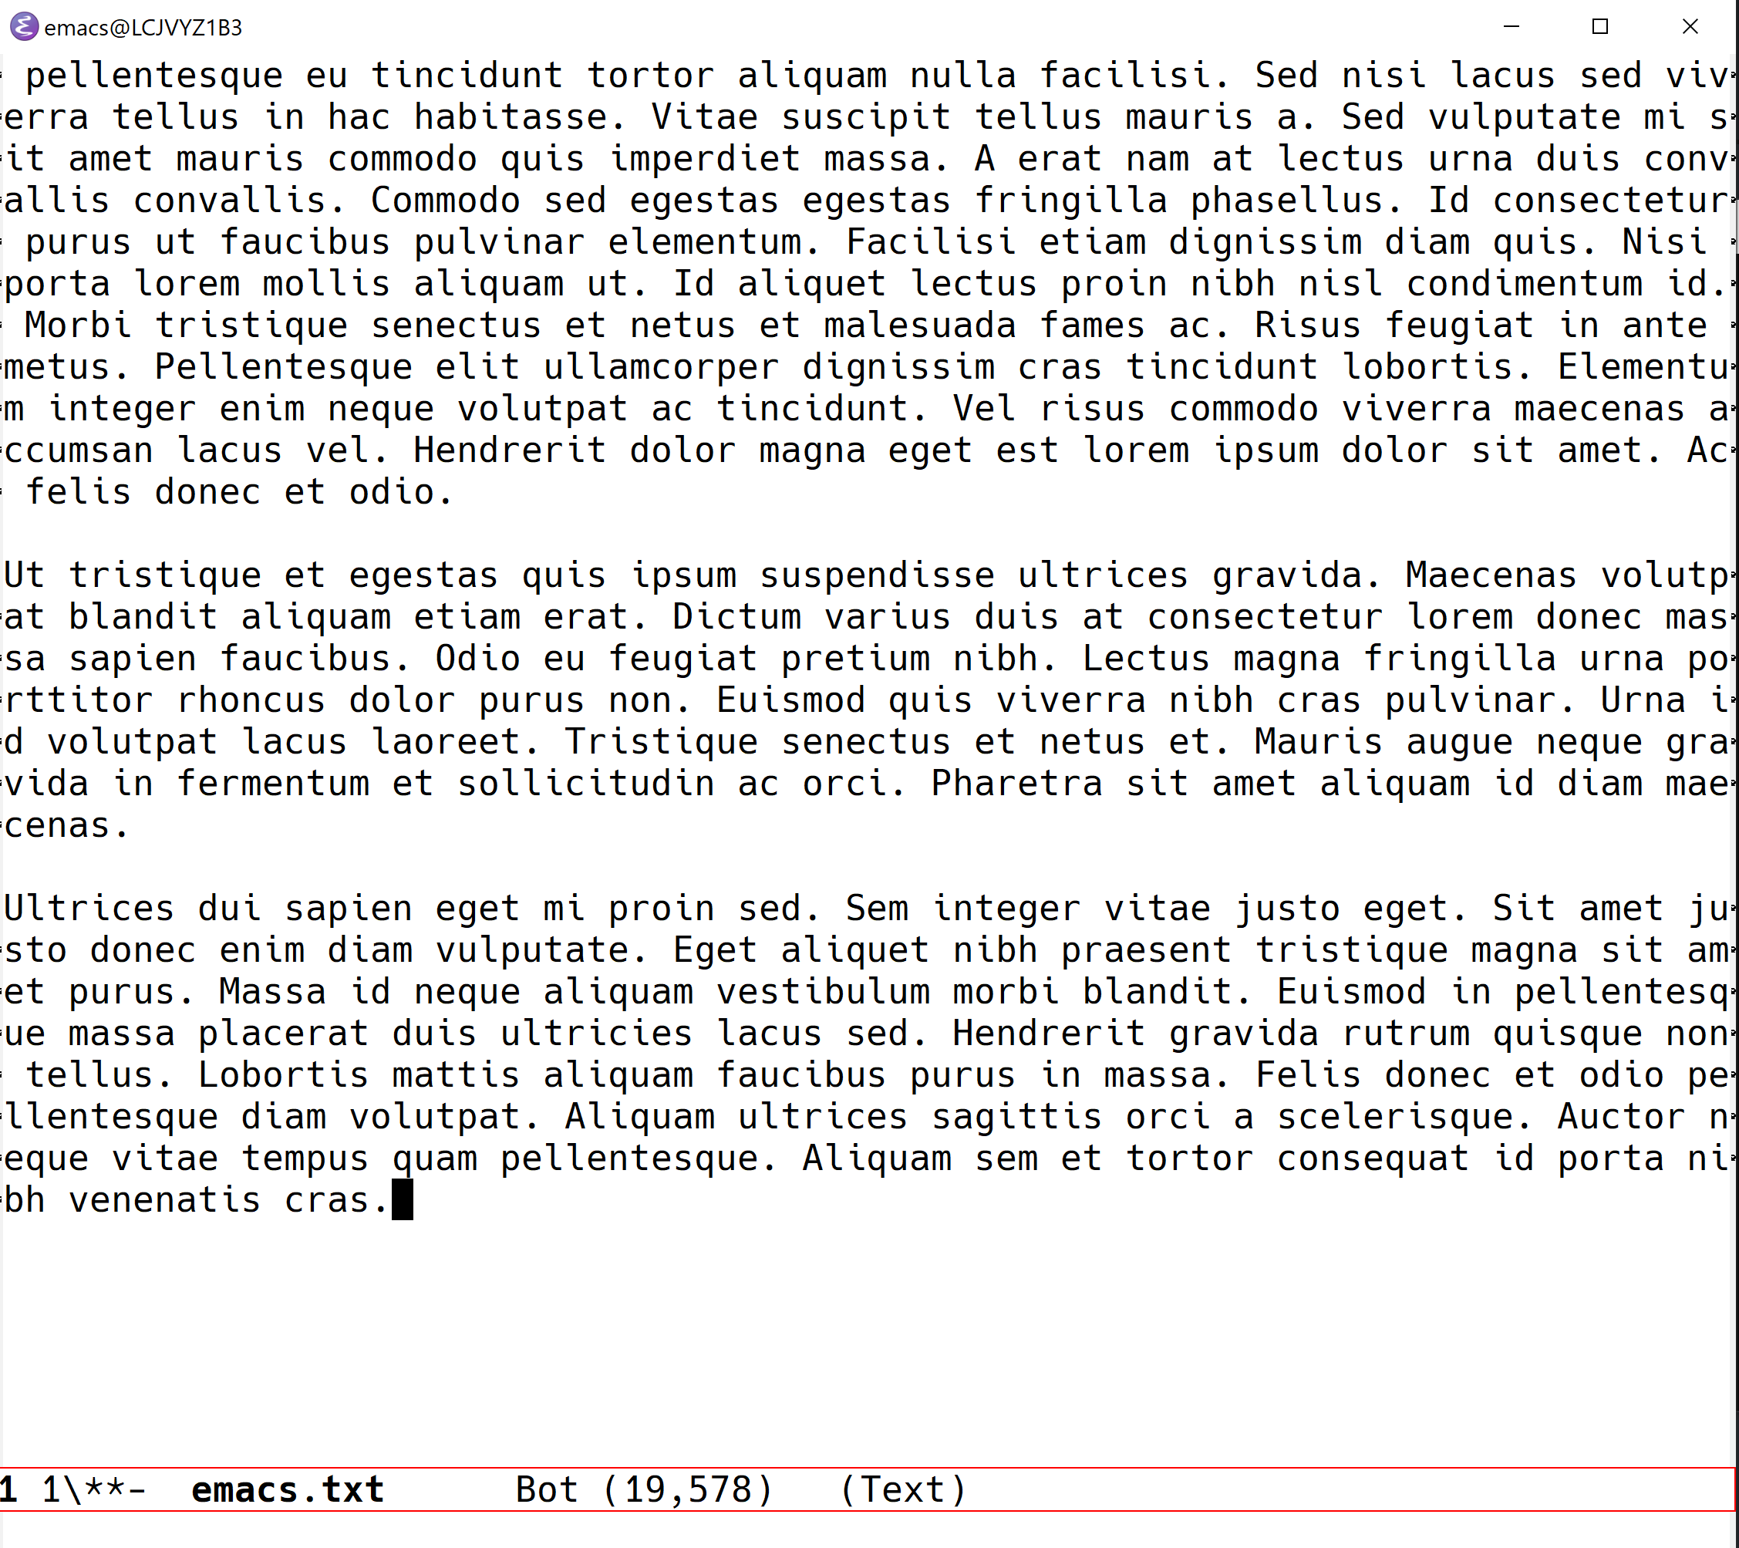 Figure 1.4.1: emacs.txt buffer (unsaved)
Troubleshoot: if the copying with the copy button in GitHub does not work, click on "Raw". The text will then be shown in a new tab and you can copy it with CTRL+a CTRL+c.

The PATH variable is the search path that the computer uses to find a file. You can set it yourself on a computer where you have administrative capabilities (such as your personal computer but not in the lab).
This screen differs from the one you see when I work with Emacs in class, because I have disabled the menu bar, the tool bar, and the tool tips. You can do this in your .emacs file later on, or you can do it right away by typing, in Emacs, the commands: M-x menu-bar-mode M-x tool-bar-mode M-x tooltip-mode

