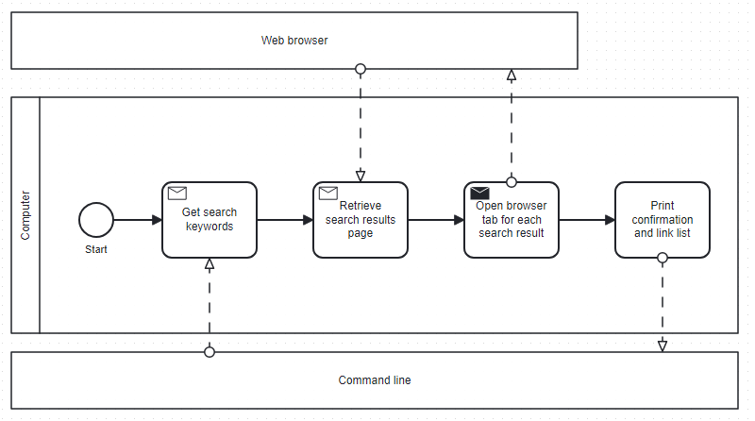
WEBSCRAPING WITH PYTHON: SYS, REQUESTS, BEAUTIFUL SOUP, WEBBROWSER
