Where the EPI cascade breaks:
separating entry-point from follow-up failure across 38 sub-Saharan African countries

Abstract
Placeholder, ~250 words. Key claims:
- Background. Standard vaccination coverage statistics treat each antigen as independent, masking whether unvaccinated children were never reached or started but did not complete the schedule. The two failures require different policy responses.
- Methods. 163 DHS surveys from 38 sub-Saharan African countries (1989–2024, n=263,385 children aged 12–23 months). Cascades from BCG through MCV1; conditional dose-completion probabilities; decomposition into entry-point failure (zero-dose) and follow-up failure (started but did not complete DPT3). We then formalized the cascade as a five-state Markov chain, fitted country-specific transition probabilities via random-effects meta-analysis on the logit scale with empirical Bayes shrinkage, and predicted terminal-state occupation per country.
- Findings. Continental cascade declines gradually rather than at a single break point: BCG 88.1%, DPT/Penta 1 85.9%, DPT/Penta 2 81.0%, DPT/Penta 3 74.2%, MCV1 74.7%. Largest mid-cascade leak is DPT2→DPT3 (−6.8 pp). Countries split into four policy quadrants: 21 functioning (both low), 6 entry-point dominant (incl. Nigeria), 4 follow-up dominant (incl. South Africa), 7 requiring comprehensive rebuild. The Markov decomposition added a new finding: between-country variance falls ~10-fold along the cascade (τ² 0.96 at Start→BCG → 0.11 at Dose3→MCV1) — countries differ much more in EPI entry than in completion. Predicted terminal states: 14% zero-dose, 27% partial, 59% completed through MCV1.
- Interpretation. The DPT3→MCV1 dropoff commonly cited as a bottleneck is small at continental scale. The cascade leaks fastest mid-sequence and varies dramatically by country in how it fails. Intervention design should match failure type: outreach campaigns where entry-point dominates, reminder systems where follow-up dominates. The cascade-level heterogeneity decomposition reorients the policy question: entry-point access is the largest source of cross-country variance and therefore the largest scope for between-country improvement.

1. Introduction
- Childhood immunization in sub-Saharan Africa follows a sequential schedule of ~6 antigens delivered across the first year of life.
- Standard coverage reports (WUENIC, DHS final reports) treat each antigen independently and present a single "% coverage" number per vaccine.
- This obscures the conditional structure of the cascade. A 70% DPT3 number can arise from different system failures:
  - 30% of children never started → an access problem (entry-point failure)
  - 30% started but dropped out → a follow-up/retention problem
  - 15% in each → a combined system weakness
- The interventions are mutually distinct:
  - Entry-point failure ← outreach campaigns, mobile vaccination, geographical access, zero-dose mapping (Gavi IRMMA/ZIPS)
  - Follow-up failure ← SMS/digital reminders, defaulter tracing, integration with other child-health visits
- Aim. Quantify the cascade structure across all available African DHS rounds, classify countries by dominant failure mode, and decompose between-country heterogeneity along the cascade to identify where interventions have the largest scope for impact.

2. Methods

2.1 Data source
- DHS Individual Recode (IR) hierarchical CSPro files, 1989–2024. 210 surveys extracted; 163 retained (≥30 dated dose-3 records per survey).

2.2 Study population
- Children aged 12–23 months at interview, born to women aged 15–49. N = 263,385 children across 163 surveys × 38 countries.

2.3 Vaccine receipt
- Per child: BCG, OPV0, DPT1/2/3 OR Penta1/2/3, OPV1/2/3, PCV1/2/3, Rotavirus 1/2, MCV1.
- Unified DPT/Penta series: DHS migrated from DPT (H3/H5/H7) to Penta (H51/H52/H53) ~2010. For each child, use whichever is recorded.
- Dose counted as received if DHS status code is 1 (card date), 2 (mother recall), or 3 (card marked). Codes 0/8/9 excluded.

2.4 Cascade metrics (weighted)
- Marginal coverage: at each step (BCG, dose 1/2/3, MCV1).
- Conditional dose-completion probability: P(dose k+1 | dose k = received).
- Zero-dose rate: % with NEITHER BCG NOR dose 1.
- Sample weights: DHS V005 / 1,000,000.

2.5 Failure-type classification
- Entry-point failure rate = zero-dose rate.
- Follow-up failure rate = 100% − P(dose 3 | dose 1).
- Thresholds: entry ≥ 10% = "high"; follow-up ≥ 20% = "high". Four quadrants: Both low (maintain); Entry-point dominant (access); Follow-up dominant (reminders); Both high (rebuild).

2.6 Multistate Markov model
We formalize the cascade as a five-state Markov chain with state space:
s₀ = zero-dose, s₁ = BCG only, s₂ = +Dose 1, s₃ = +Dose 2, s₄ = +Dose 3, s₅ = +MCV1 (completed)
For each of the five transitions q_j = P(next state | current state), per country c:
- Compute V005-weighted Bernoulli proportions p̂_{c,j} with Kish-effective sample size.
- Random-effects meta-analysis on the logit scale (DerSimonian-Laird): logit(p) ~ N(μ_j, τ_j²).
- Empirical Bayes posterior means with shrinkage weight B = s² / (s² + τ̂²).
- Marginalize the chain to predict terminal-state probabilities per country.
- Heterogeneity decomposition: τ_j² and I_j² at each transition.

2.7 Software
- Python 3.10 with pandas, numpy, matplotlib, scipy. ~1,200 lines across cascade and multistate scripts.

2.8 Validation
- Ethiopia 2016 coverage estimates reproduce published EDHS-7 within 1.6 pp (BCG), 0.9 pp (DPT3), 0.1 pp (MCV1).
- Multistate Bayes-shrunk transitions match descriptive cascade probabilities to within 0.2 pp on average.

3. Results

3.1 Continental cascade structure
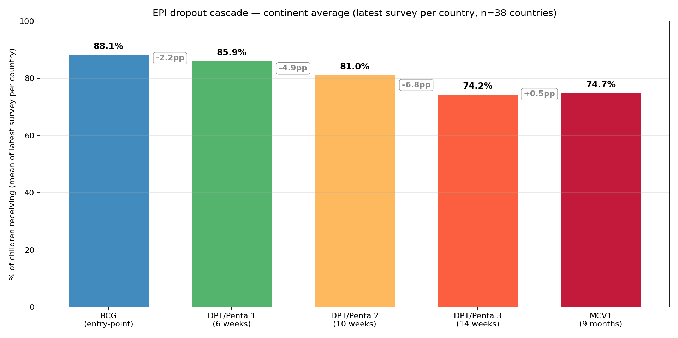
Figure 1. Continental cascade across the 38 latest DHS surveys per country. Largest leak: DPT2→DPT3 (−6.8 pp).
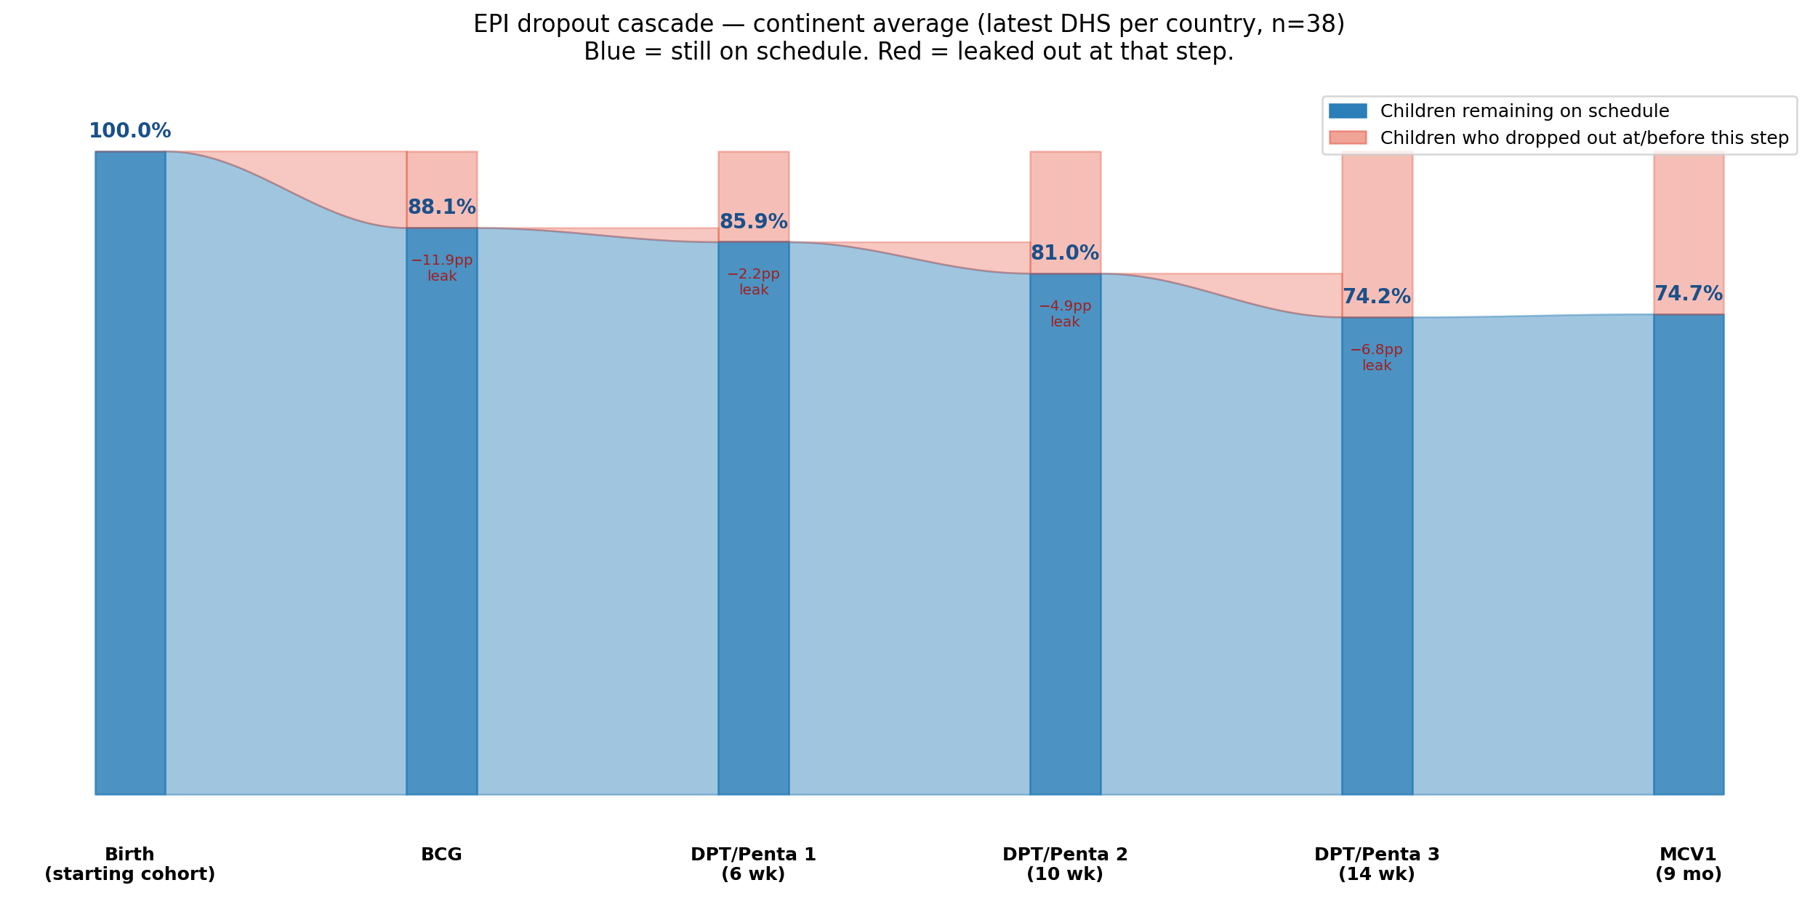
Figure 2. Sankey-style flow showing children remaining on schedule (blue) vs leaked at or before each step (red).
- BCG 88.1% — ~12% of children never enter the EPI system.
- Dose 1 85.9%; Dose 2 81.0%; Dose 3 74.2%; MCV1 74.7%.
- MCV1 ≈ Dose 3; the "DPT3→MCV1 dropoff" is NOT a continent-level phenomenon.

3.2 Conditional dose-completion probabilities
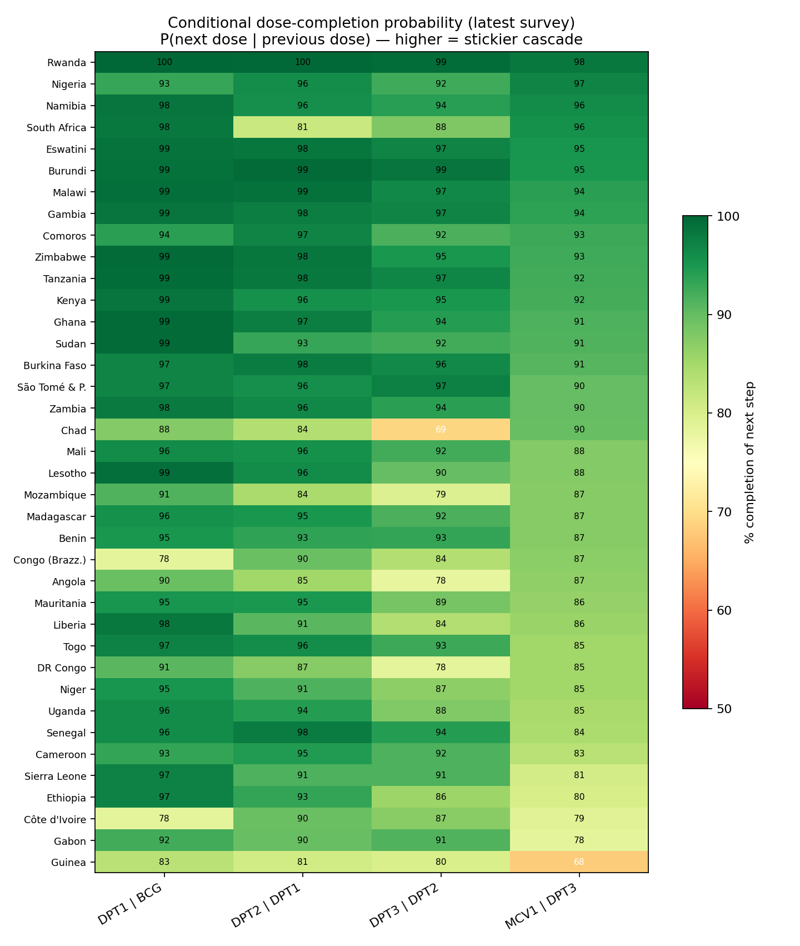
Figure 3. Country-level conditional probabilities P(next | previous). Greener = stickier cascade.
- Mean P(D1|BCG) = 95.0%; P(D2|D1) = 93.5%; P(D3|D2) = 90.3%; P(MCV1|D3) = 88.3%.
- Each transition loses 5–10% of the prior cohort. Losses compound multiplicatively.

3.3 Country classification
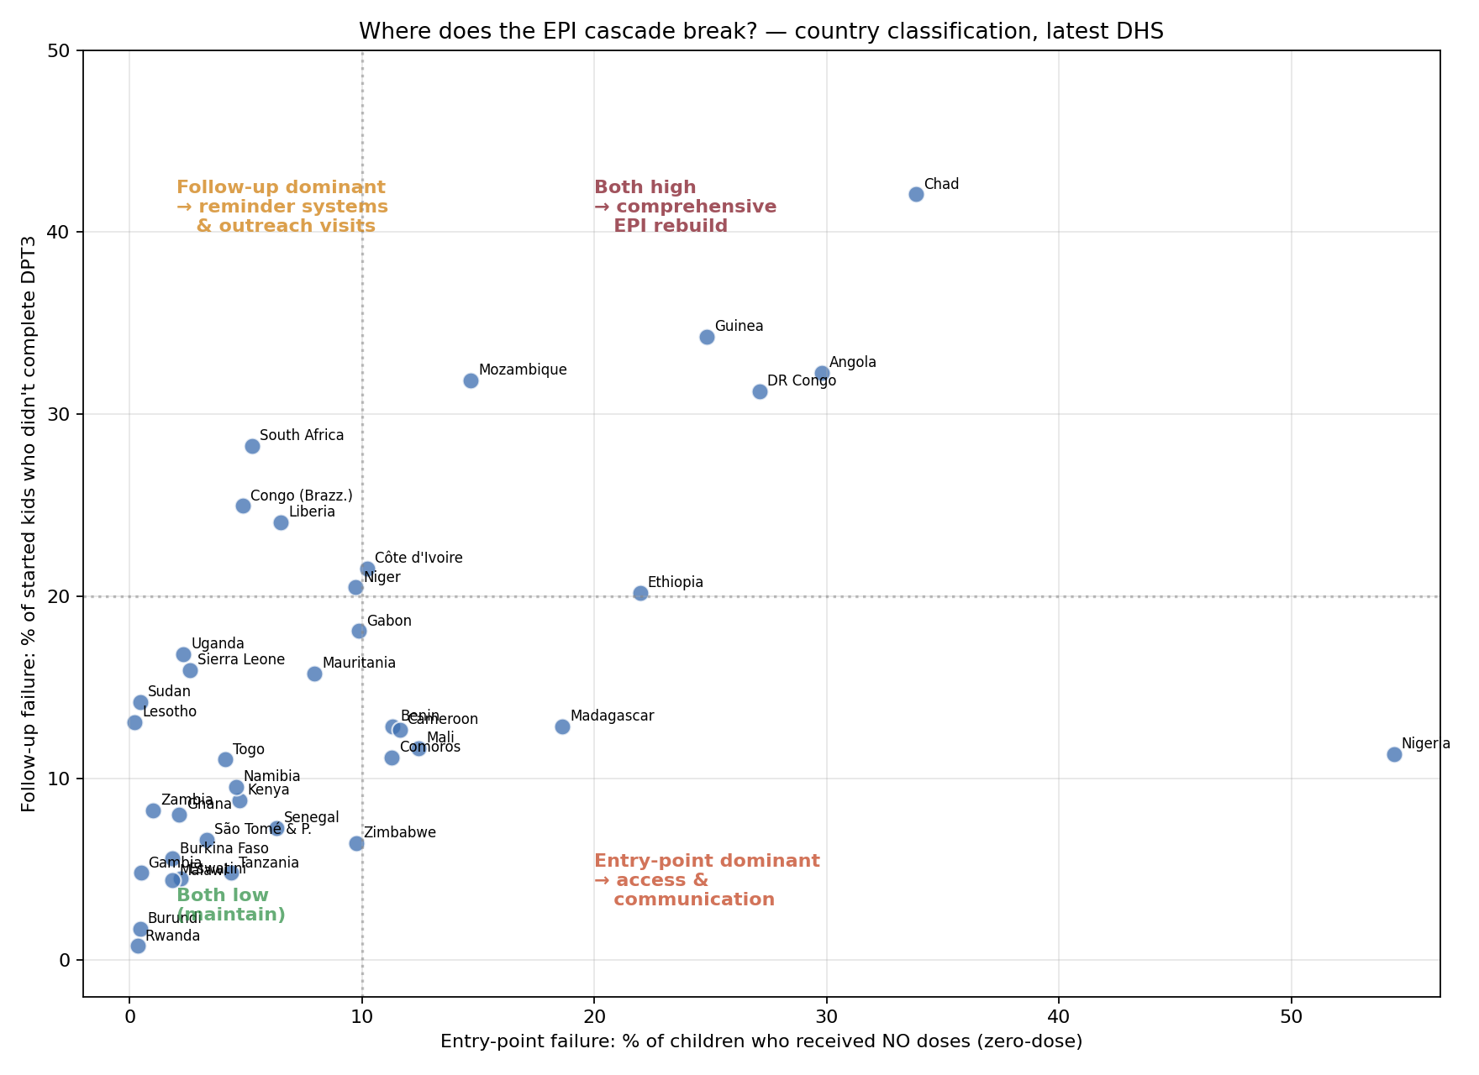
Figure 4. Each country plotted by entry-point failure (x) and follow-up failure (y). Four-quadrant classification.
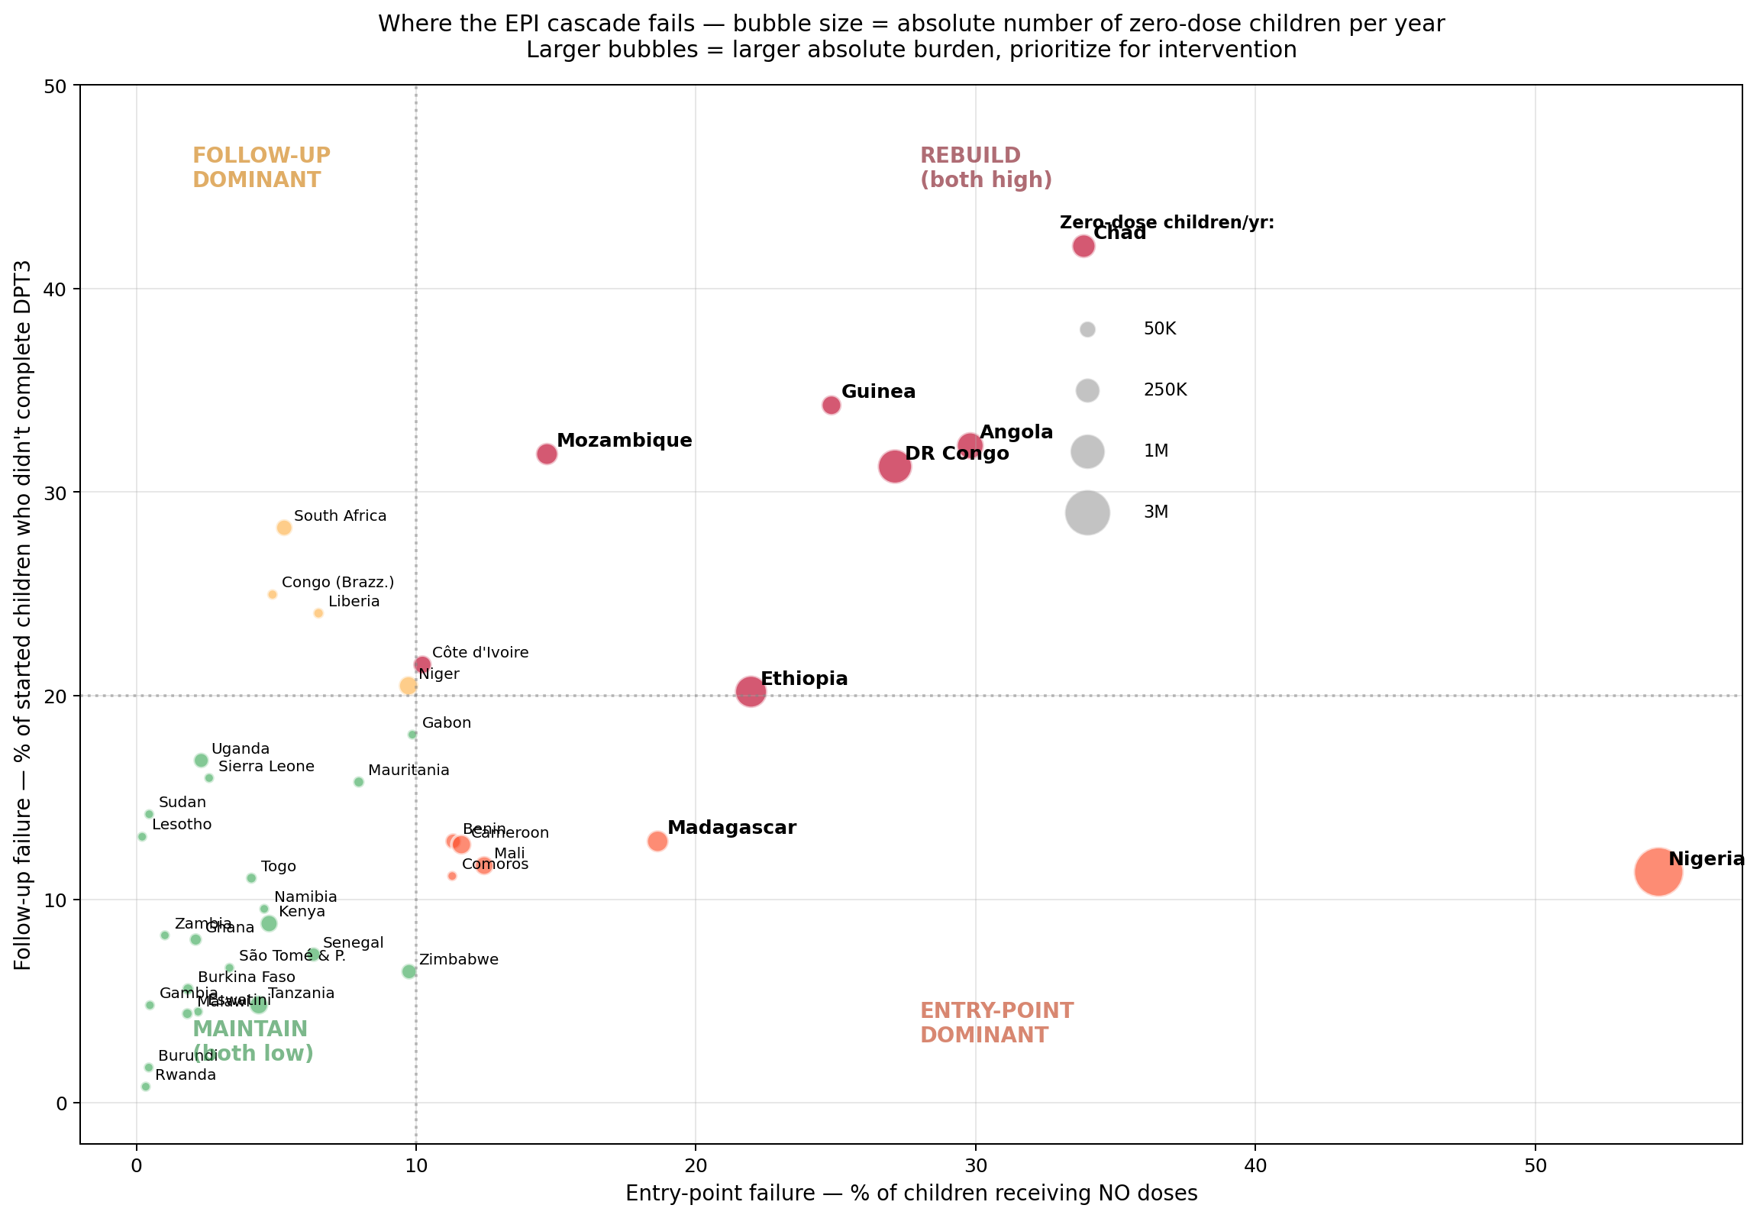
Figure 5. Same axes as Fig 4 with bubble size proportional to absolute number of zero-dose children per year.
- 21 countries — Both low (maintain): Burkina Faso, Burundi, Eswatini, Gabon, Gambia, Ghana, Kenya, Lesotho, Malawi, Mauritania, Namibia, Rwanda, Senegal, Sierra Leone, Sudan, São Tomé & P., Tanzania, Togo, Uganda, Zambia, Zimbabwe.
- 6 countries — Entry-point dominant: Benin, Cameroon, Comoros, Madagascar, Mali, Nigeria.
- 4 countries — Follow-up dominant: Congo (Brazzaville), Liberia, Niger, South Africa.
- 7 countries — Both high (rebuild): Angola, Chad, Côte d'Ivoire, DR Congo, Ethiopia, Guinea, Mozambique.

3.4 Regional patterns
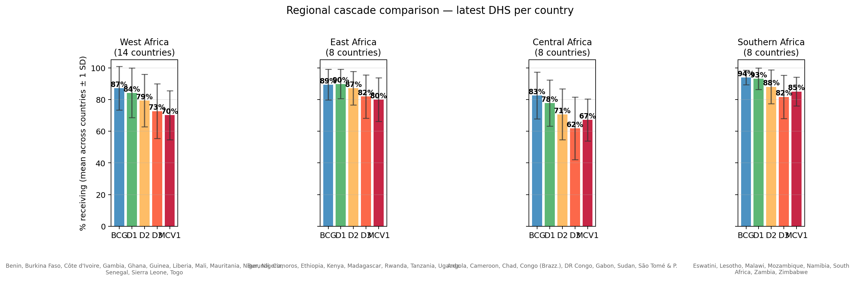
Figure 6. Cascade by region (mean ± 1 SD). East/Southern flatter; West/Central steeper and more variable.

3.5 Country-level cascades
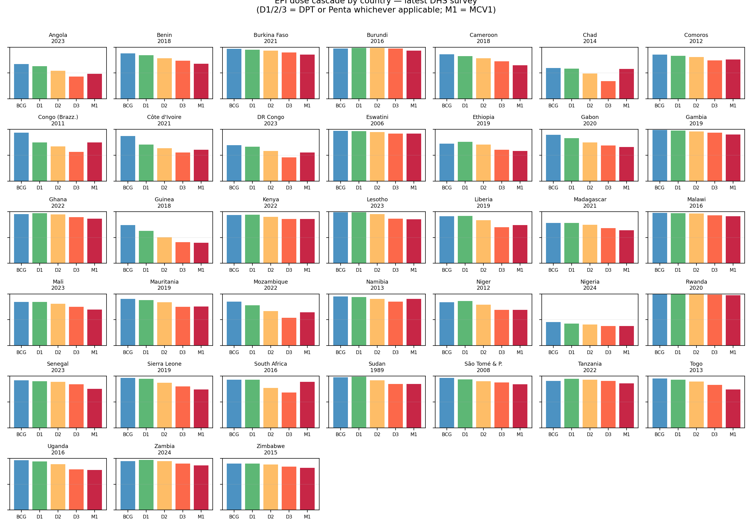
Figure 7. All 38 countries' cascades side by side (latest DHS).
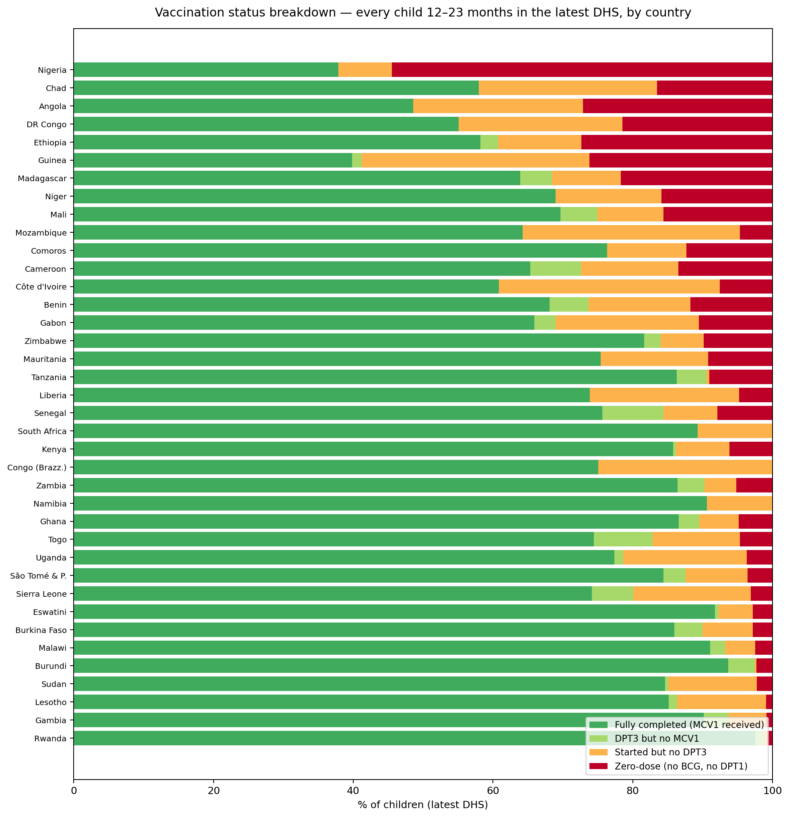
Figure 8. Each country's 12–23-month population decomposed into 4 categories. Stacked to 100%.

3.6 Change over time
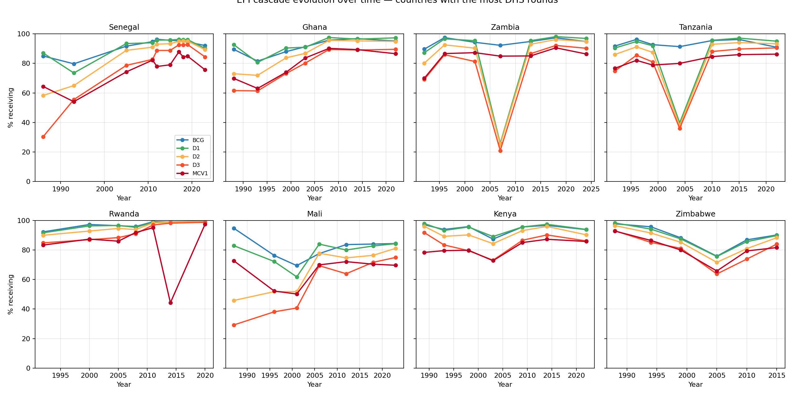
Figure 9. Cascade evolution for the 8 countries with the most DHS rounds.
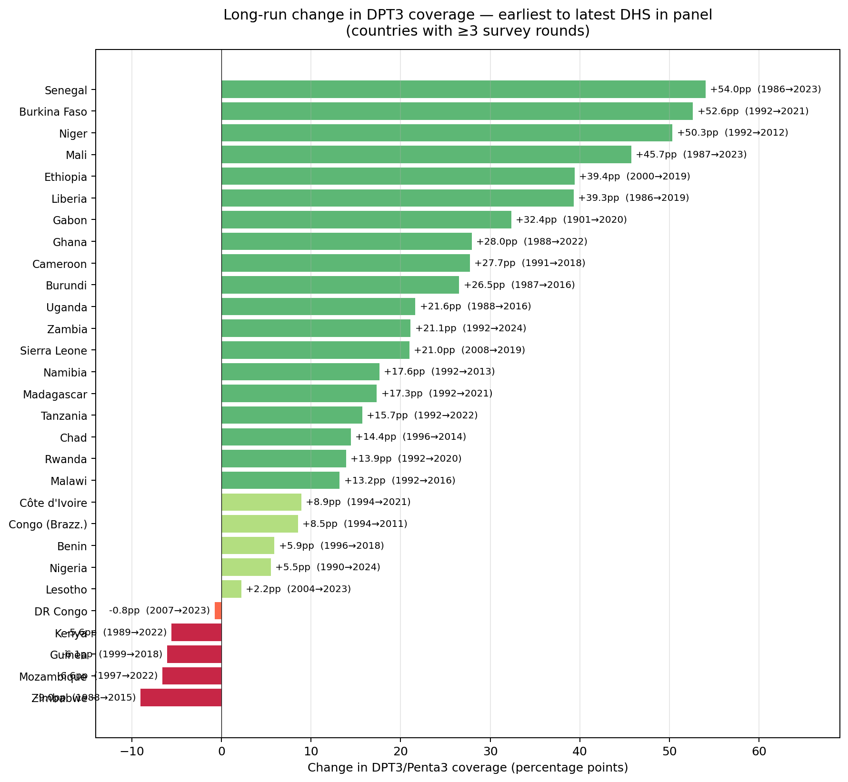
Figure 10. Percentage-point change in DPT3 coverage, earliest to latest survey, for countries with ≥3 rounds.

3.7 Formal multistate Markov decomposition
The descriptive cascade (§ 3.1–3.6) is informative but unprincipled in two ways: (i) it computes raw conditional probabilities with no statistical pooling across surveys; and (ii) it doesn't formalize the cascade as a probabilistic process. The multistate Markov model addresses both.
3.7.1 Continent-level transition probabilities (Bayes-shrunk)
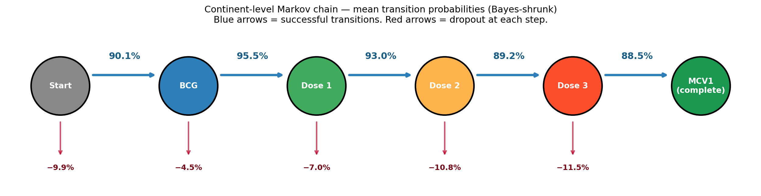
Figure 11. Five-state Markov chain with Bayes-shrunk continent-mean transition probabilities (blue, success) and per-step dropout (red). Cascade leaks gradually.
- Start→BCG 90.1%, BCG→D1 95.5%, D1→D2 93.0%, D2→D3 89.2%, D3→MCV1 88.5%.
- Smallest conditional probability (largest mid-cascade leak) is D2→D3 — confirms descriptive analysis.
3.7.2 Country-specific transitions and shrinkage
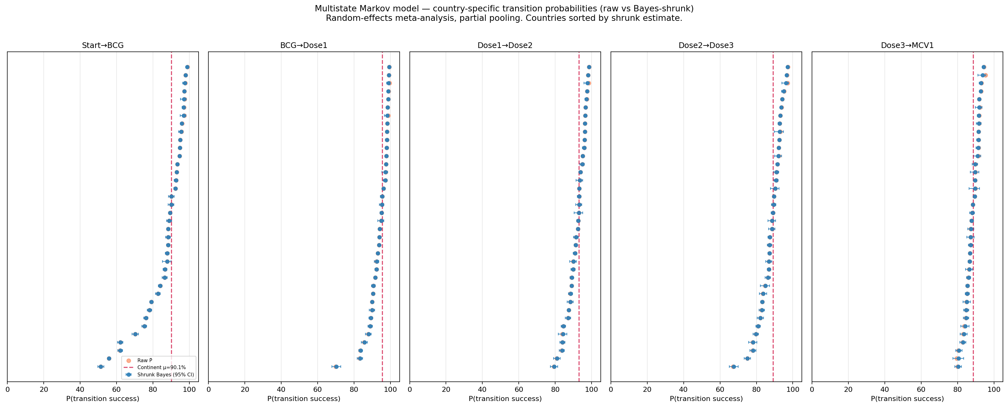
Figure 12. Per-country forest plot: orange = raw, blue with 95% CI = Bayes-shrunk posterior. Red dashed = continent posterior mean. Sorted by shrunk estimate.
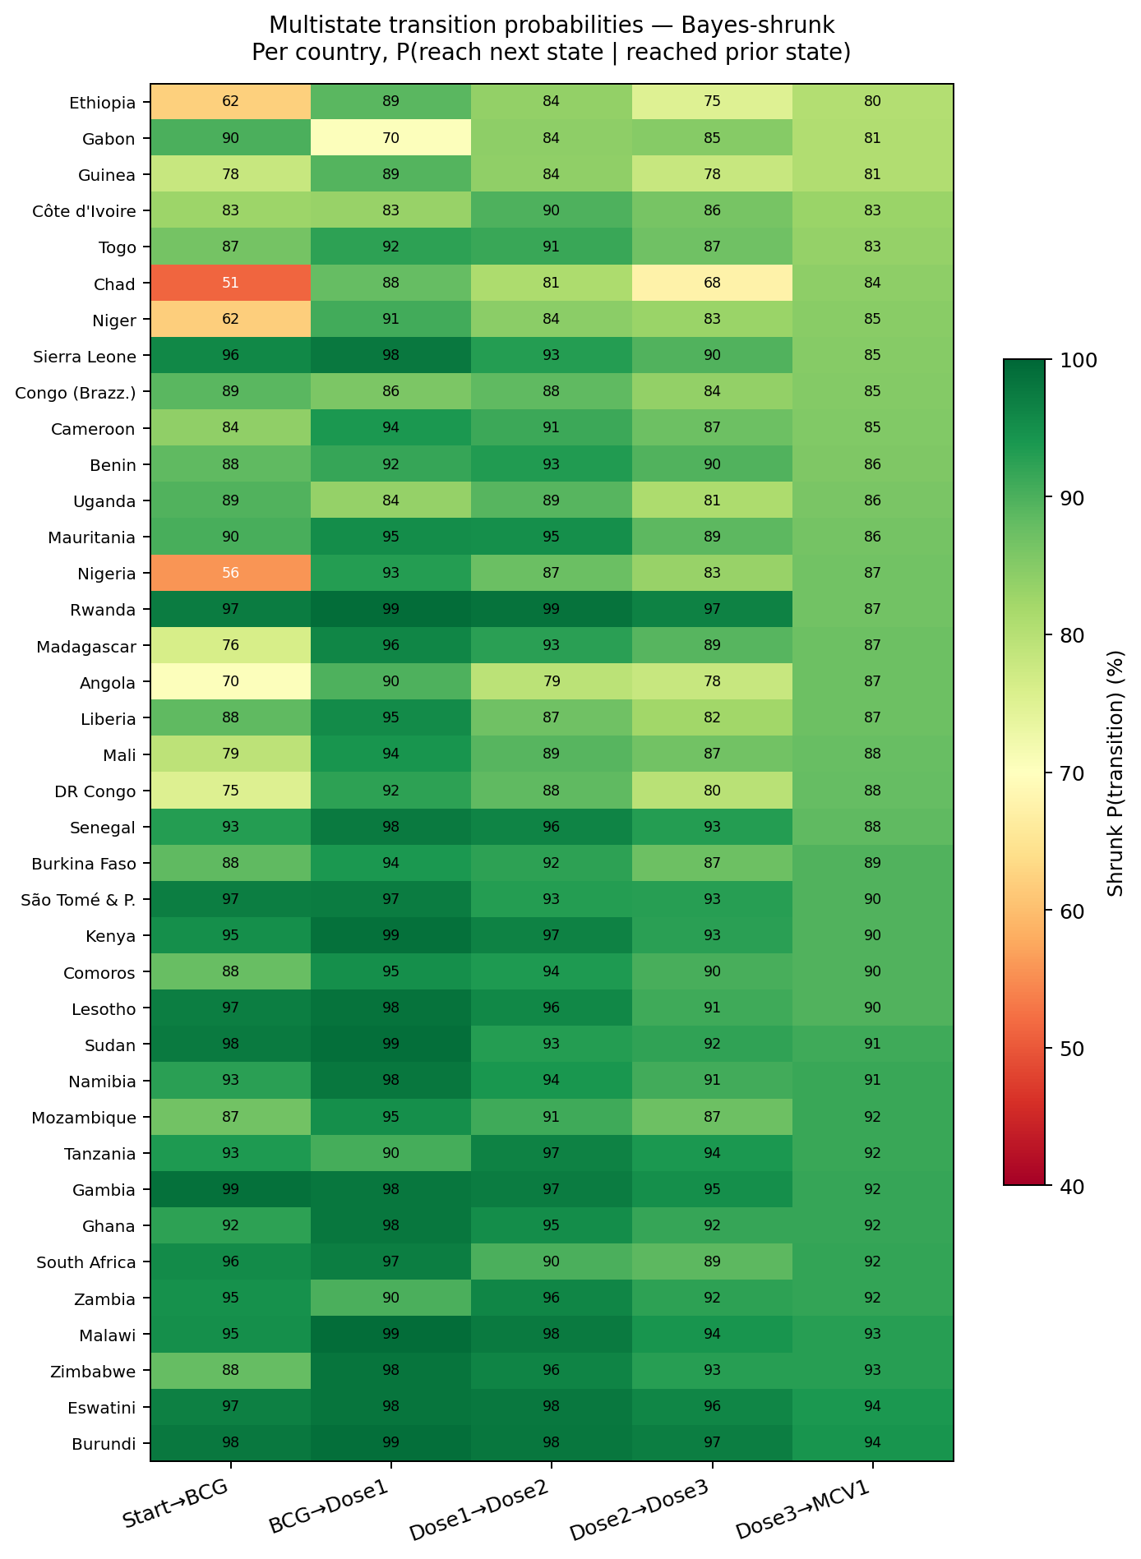
Figure 13. Heatmap of Bayes-shrunk transition probabilities. Countries sorted by D3→MCV1.
- Shrinkage is uniformly small (<0.2 pp on average) — country samples are large enough that raw estimates dominate the prior. Reassuring for the descriptive analysis.
3.7.3 Heterogeneity decomposition — a new finding
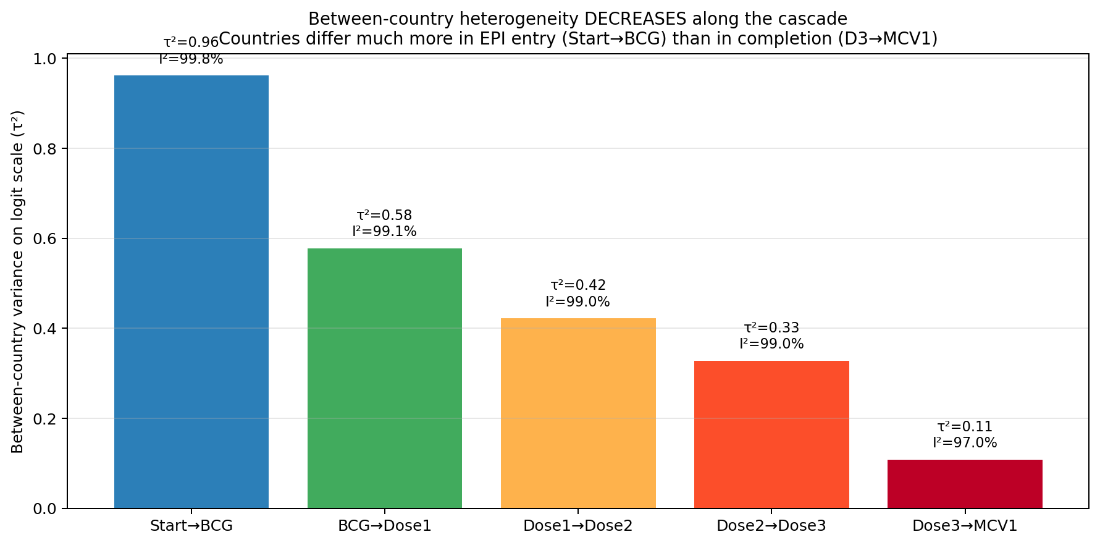
Figure 14. Between-country variance τ² (logit scale) at each Markov transition. Variance falls roughly 10-fold from Start→BCG (τ² = 0.96) to D3→MCV1 (τ² = 0.11). I² > 97% at all transitions.
This is the multistate model's distinctive contribution:
- τ² is highest at the entry point and falls monotonically through the cascade.
- All five transitions have I² > 97% — between-country variance overwhelms within-country sampling error.
- Implication: countries differ much more in EPI entry than in completion. Entry-point access addresses the largest source of cross-country variance and therefore has the largest scope for between-country improvement.
3.7.4 Predicted terminal-state occupation
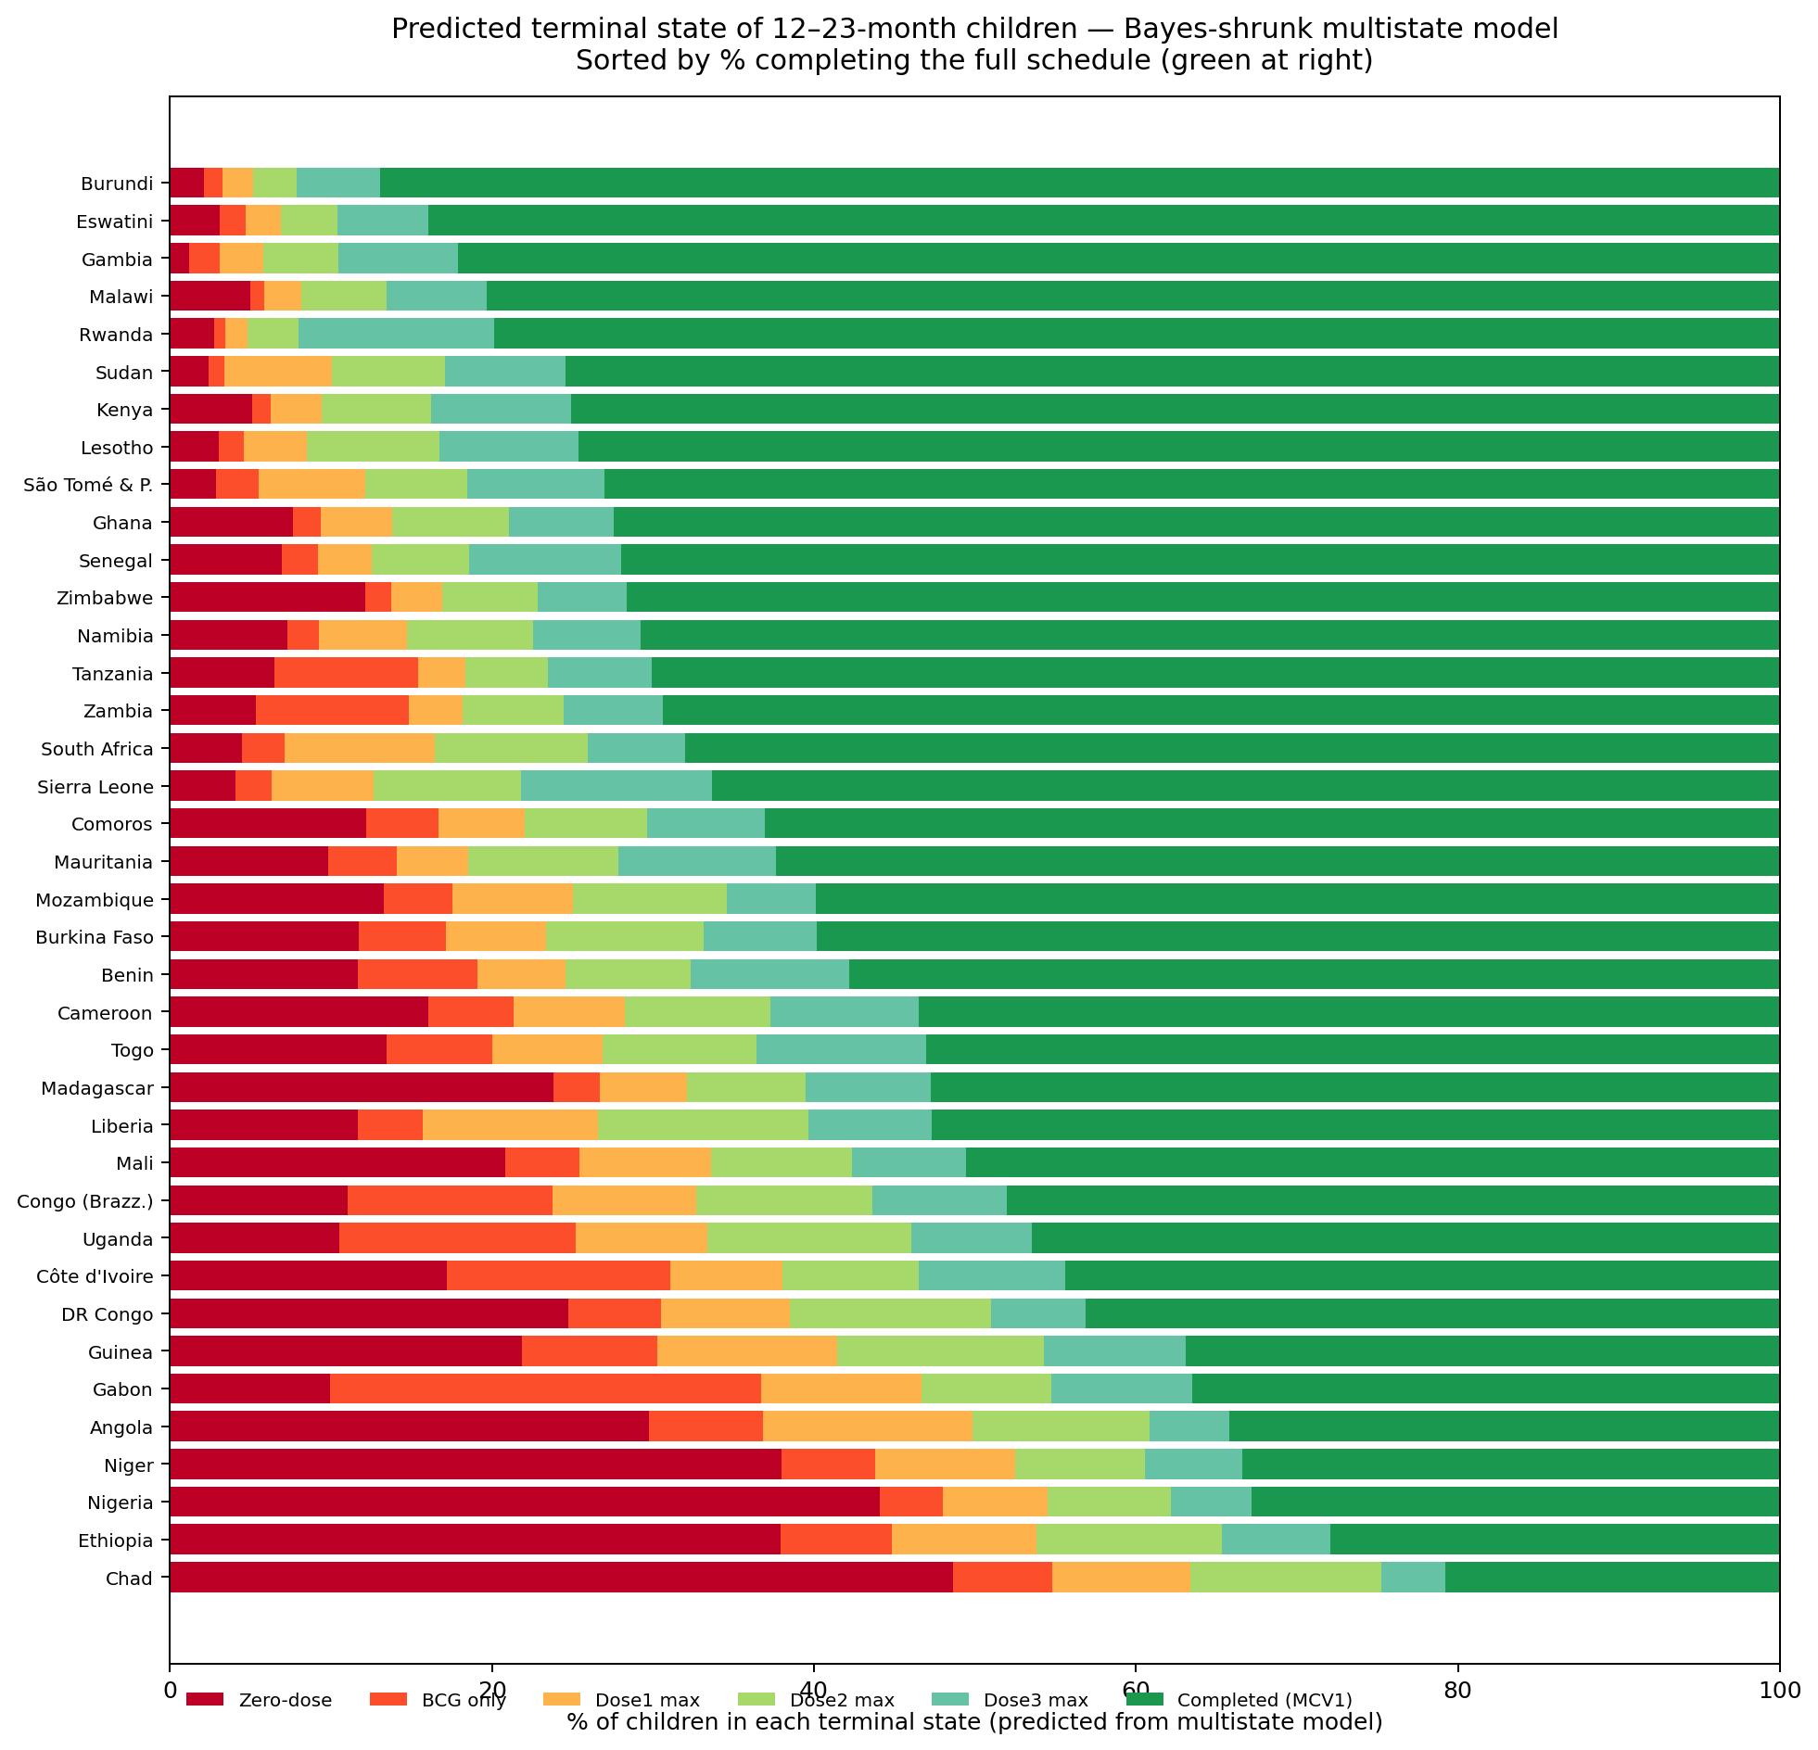
Figure 15. Predicted % of children in each terminal state (zero-dose / BCG only / D1 max / D2 max / D3 max / completed), per country.
Terminal state | Predicted % of children
Zero-dose | 13.7%
BCG only | 5.4%
Dose 1 max | 6.2%
Dose 2 max | 8.2%
Dose 3 max | 7.5%
Completed (MCV1) | 59.0%

- ~3 in 5 children complete the schedule; 14% never reach EPI; 27% start but don't complete.
- Zero-dose is the largest single unprotected category.

4. Discussion

4.1 Main findings recapped
- The cascade leaks gradually, not at a single break point. Each transition loses 5–10% of the prior cohort.
- Largest single mid-cascade leak is DPT2→DPT3 (−6.8 pp).
- DPT3 and MCV1 sit at essentially the same coverage level (~74%); the 'measles outreach' gap is not where the cascade breaks at continental scale.
- Country heterogeneity is patterned into four meaningfully distinct policy regimes.
- The multistate Markov decomposition reveals that between-country variance falls ~10-fold along the cascade — countries differ much more in EPI entry (τ² = 0.96) than in completion (τ² = 0.11).
- Predicted terminal-state distribution: 59% complete the schedule, 14% are zero-dose, 27% partial.

4.2 Policy implications by quadrant
- Both-low countries (n=21): focus on the final 10%.
- Entry-point dominant (n=6, incl. Nigeria): reaching unvaccinated children is the dominant lever — community health worker networks, zero-dose mapping. SMS reminders are not the primary tool.
- Follow-up dominant (n=4, incl. South Africa): completion is the dominant lever — defaulter tracing, reminders, missed-opportunity reduction.
- Both high (n=7): require integrated rebuilds; single-lever interventions will underperform.

4.3 The variance-based interpretation refines the policy framing
The multistate τ² decomposition adds a quantitative dimension to the quadrant classification:
- Entry-point access varies 10× more across countries than completion. The variance is structurally located at the cascade's beginning.
- Interventions targeting entry (outreach, mobile vaccination, zero-dose communities) have therefore the largest scope for between-country improvement — closing the gap between worst and best entry-point performers (τ² 0.96 → ~0.1) would harmonize EPI more than closing completion gaps (already at τ² 0.11).
- This does not mean completion is unimportant — it means completion is a more uniform problem across countries. Universal interventions (SMS reminders, defaulter systems) may be cost-effective there because each country has similar levels to address.

4.4 Why the DPT2→DPT3 leak matters more than DPT3→MCV1
- Children due for MCV1 at 9 months have already passed three prior visits. The MCV1 cohort is pre-selected by the DPT cascade.
- Improvements upstream propagate downstream more efficiently than additional MCV1 outreach.
- Sequencing recommendation: strengthen 10-week→14-week interval delivery first, then MCV1 outreach.

4.5 Comparison with prior estimates
- Our DPT3 estimates align closely with WUENIC for overlapping country-years.
- Novel contributions: cascade structure, quadrant classification, and Markov-based heterogeneity decomposition.
- Our zero-dose definition (no BCG AND no DPT1) is stricter than WUENIC's no-DPT1.

4.6 Limitations
- Card vs recall doses pooled. Recall bias may inflate coverage by 5–10 pp. Card-only sensitivity recommended.
- Age cohort 12–23 months. Older children may have received doses subsequently.
- EPI schedules vary. WHO-standard windows used. Some countries shift MCV1 to 12 months.
- Sub-national variation hidden. National panels mask within-country inequities.
- Empirical Bayes (not full Bayes). Plugs in point estimates for μ̂ and τ̂². Full Bayesian implementation in Stan/PyMC would propagate uncertainty in τ̂² to country-level intervals.
- Markov assumption. Conditional on having received the previous dose, the next dose probability is treated as independent of age-at-previous-dose. A duration-based semi-Markov extension would relax this.

4.7 Future work
- Sub-national (region/cluster-level) multistate replication using cluster GPS.
- Linkage with sub-national conflict, urbanicity, and wealth data to model determinants.
- Card-confirmed-only sensitivity analysis at full panel scale.
- Continuous-time multistate model using card-dated doses — transition intensity matrix Q, transition rates per unit time.
- Covariate-adjusted multistate model (logistic regression with country random effects).

5. Funding & ethics
- No external funding.
- Secondary analysis of de-identified public-use DHS data.

6. Data availability
- DHS files publicly available at https://dhsprogram.com/ under registration.
- All analysis code and derived CSVs accompany this manuscript.

7. Acknowledgements
- DHS Program and participating Ministries of Health.

Figure list (in manuscript order)
# | Filename | Purpose
1 | fig1_continent_dropout_funnel.png | Continental cascade with step-level losses
2 | fig_a1_sankey_cascade.png | Sankey-style cumulative cohort attrition
3 | fig2_conditional_prob_heatmap.png | Country × transition conditional probabilities
4 | fig3_entry_vs_followup_quadrant.png | Classification scatter
5 | fig_a3_bubble_burden.png | Burden-weighted bubble chart
6 | fig_a2_regional_bars.png | Regional comparison
7 | fig4_country_small_multiples.png | All-countries small multiples
8 | fig_a5_status_decomposition.png | Status decomposition stack
9 | fig5_cascade_over_time.png | Selected-country trajectories
10 | fig_a4_change_over_time.png | Long-run DPT3 change
11 | ms_fig5_markov_diagram.png | Continent-level Markov chain with shrunk transitions
12 | ms_fig1_forest_raw_vs_shrunk.png | Per-country forest: raw vs Bayes-shrunk transitions
13 | ms_fig4_transition_heatmap.png | Per-country shrunk transition heatmap
14 | ms_fig2_heterogeneity_decreases.png | Between-country variance τ² along cascade — new finding
15 | ms_fig3_state_occupation_stack.png | Predicted terminal-state probabilities per country

Supplementary CSV files
Filename | Content
dropout_cascade_panel.csv | 163-row panel: every survey × cascade percentages + conditional probabilities
country_classification.csv | 38 rows, latest survey per country, with failure_type label
multistate_markov/country_transition_shrunk.csv | Bayes-shrunk Markov transition probabilities with 95% CIs
multistate_markov/meta_summary.csv | Per-transition meta-analysis statistics (τ², I², Q)
multistate_markov/state_occupation_shrunk.csv | Predicted terminal-state probabilities per country

