OpenSceneGraph

Alexander Birkner

Programming of Graphics Shaders

Prof. Dr.-Ing. C. Schiedermeier

Technische Hochschule Nürnberg Georg Simon Ohm

Fakultät Informatik

WS 20/21

11.01.2021

# Table of Contents

Table of Contents 2

List of Figures 3

1 Introduction 4

2 OpenSceneGraph 4

2.1 Scene Graphs 4

2.2 Retained Rendering 5

3 Use of OpenSceneGraph 5

3.1 „Hello World“ 6

3.2 Libraries 6

3.3 Classes to Represent Nodes 7

3.4 Traversing the Scene Graph 8

3.5 Smart Pointer 8

3.6 State Sets 9

4 Playground Project 10

4.1 Architecture 10

4.2 Implementation 11

4.2.1 Add of Group Nodes 11

4.2.2 Adjust Polygon Mode 12

5 Features and Advantages of OpenSceneGraph 13

6 Conclusion 14

References 15

Appendix I: Image of all OpenSceneGraph Libraries 18

Appendix II: Screenshot of the “Hello World” Project 19

Appendix III: Screenshots of the Playground Project 20

# List of Figures

Figure 1: Comparison of immediate and retained mode rendering(based on figures of [6]) 5

Figure 2: Simplified class diagram of the osg::Geode class including some derived classes 7

Figure 3: Simplified class diagram of the osg::StateSet class including related classes 9

Figure 4: Simplified class diagram of the architecture of the playground project 10

Figure 5: List of al libraries provided by OpenSceneGraph (Version 3.6.5) 18

Figure 6: Screenshot of the "Hello World" Project 19

Figure 7: Closed editor 20

Figure 8: Opened editor 20

Figure 9: Opened tree view 21

Figure 10: Group node selected 21

Figure 11: Geode node selected 22

Figure 12: Sphere added 22

Figure 13: "Add Node from File" option opened 23

Figure 14: Nodes from cessna.osg file added to the scene graph 23

Figure 15: Switch node with nodes from cessna.osg and censsafire.osg as child nodes 24

Figure 16: Switch node with nodes from cessna.osg and censsafire.osg as child nodes, while cessna.osg group is toggled to off 24

Figure 17: LOD node with nodes of two cessna.osg files as child nodes 25

Figure 18: LOD node with nodes of two cessna.osg files as child nodes 25

Figure 19: Group node from added cessna.osg file selected and "Adjust State" option opened 26

Figure 20: Added toon shader from [31] with uniforms displayed in the editor 26

# Introduction

OpenSceneGraph is established as the world´s leading scene graph technology [1]. Its history began as Don Burns developed a scene graph component of a hang-gliding simulator for Silicon Graphics International (SGI) in 1998. He wrote a scene graph application programmableiInterface (API), runnable on Linux systems. This API was later used as the prototype of OpenSceneGraph. In 1999 Robert Ostfield started to collaborate on the project. Together they took the developed scene graph API, made a standalone open source project out of it and ported it to Windows. After that Robert Ostfield gave the project the name OpenSceneGraph [2].

In the following years, the project received growing interest. In response to that, Robert Osfield set up OpenSceneGraph Professional Services and provided both commercial and free OpenSceneGraph services. Like Robert Osfield, Dan Burns also formed his own company, namely Andes Computer Engineering. He pursued to support the further development of the OpenSceneGraph project. After many libraries and packages, like osgText for text rendering or osgFX for special effects, were added to the project, OpenSceneGraph 1.0 was announced in 2005. Two years later OpenSceneGraph 2.0 was released [2].

Till the release of OpenSceneGraph 3.0 which came with the support of OpenGL ES and OpenGL 3.0 in 2010, many further packages like osgWidget for the integration of user interface (UI) components, osgVolume to enable the rendering of volumes or osgAnimation to animate objects of the scene graph were included in the project [2]. In 2019 the most recent version, OSG 3.6.5, was released and the team behind OpenSceneGraph also started further projects like VulkanSceneGraph, an attempt combining Vulkan and C++ 17 to create a next-gen scene graph [1].

This report is intended to provide an introduction and an overview of OpenSceneGraph and its use. For this purpose, OpenSceneGraph is described in more detail in the second chapter. Afterwards, chapter three describes the use and the most important components of OpenSceneGraph. To demonstrate the effect of different nodes and settings within a scene graph, an interactive editor was developed. It is described in chapter four. Subsequently, the features and advantages of using OpenSceneGraph are listed in chapter 5. The report concludes with the personal experiences that were made while using OpenSceneGraph and tries to clarify the question of when it makes sense to use OpenSceneGraph for the development of rendering ap­plications.

# OpenSceneGraph

This chapter provides a first description of OpenSceneGraph. It is an open-source high-performance 3D graphics toolkit, that is used in fields such as visual simulation, games and scientific visualization [1]. As rendering middleware, it raises the level of abstraction of the usage of the low-level graphics API OpenGL [3]. It has been developed using Standard C ++ [1]. Actually, OpenSceneGraph supports OpenGL 1.0 up to OpenGL 4.2 as well as OpenGL ES. This makes it possible to develop applications that can run on both rather older and also newer hardware [4].

As the name suggests, OpenSceneGraph is based on the idea of scene graphs [1]. So an short explanation of scene graphs itself should be given in the following section 2.1. Since OpenSceneGraph is a retained rendering system [3], the term should also be described in more detail in section 2.2.

## Scene Graphs

A scene graph is a general data structure that is used to define the spatial and logical relationships within a graphical scene to efficiently manage and render the scene. Often it is represented as a hierarchical graph that contains a collection of different types of graphical nodes including a top-level root node, several group nodes that can have any number of child nodes and also a set of leaf nodes that have zero child nodes. The grouping of child nodes under a parent node makes it possible to share the information of the parent node among all children. In addition it allows to treat them as one unit [5].

## Retained Rendering

In general, graphic APIs can be distinguished in retained mode APIs and intermediate mode APIs [6]. Figure 1 displays a side-by-side comparison of both forms.

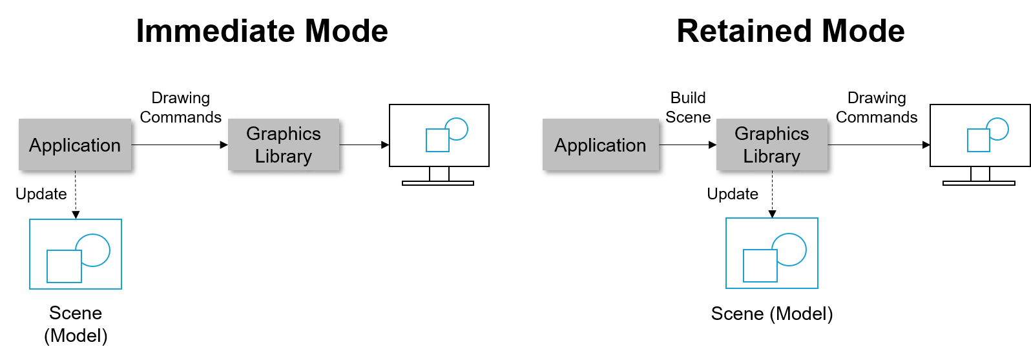

Figure 1: Comparison of immediate and retained mode rendering(based on figures of [6])

When using immediate mode rendering APIs (shown on the left in Figure 1) the application must store and keep track of their scene model itself. Each time a new frame should be drawn on the screen, the application directly issues the drawing commands of the graphics library in a procedural way [6]. The graphics library than uses the hardware to draw the scene on the screen.

In contrary to immediate mode rendering APIs, retained mode APIs (shown on the right in Figure 1) are declarative. Here the graphics library stores a model of the scene in memory that is constructed by the application out of graphics primitives. To draw a new frame on the screen, the graphics library trans­forms it into a set of drawing commands. In order to change the rendered frames (e.g. adding a new shape), the application issues commands of the graphics library to update the scene rather than do drawing commands itself. The library then updates the drawing commands depending on the changes in the scene [6].

On the one hand, retained rendering APIs simplify use, as the API does more work such as initialization, status management and cleanup. On the other hand, they often offer less flexibility than immediate mode rendering APIs because the API imposes its own scene model [6].

When using the OpenSceneGraph, it stores the scene that is build up by an application in a scene graph rep­resentation and records rendering commands and data in a buffer. This enables the OpenSceneGraph toolkit to perform various optimization before the actual rendering. For the actual rendering the OpenGL API is used by the toolkit [3]. The application does not issue OpenGL drawing commands itself.

# Use of OpenSceneGraph

After the overview given in Chapter 2, this section explains the use of OpenSceneGraph. First, the code of a simple example of an OpenSceneGraph application is shown. Afterwards, the most important of the libraries provided by OpenSceneGraph are listed and described. Then the classes for represent­ing graphic nodes, how scene graphs are traversed, and the concept of smart pointers are explained in more detail. The last section of this chapter deals with the StateSet class, which is used to encapsulate the OpenGL state machine [7].

## „Hello World“

Listing 1 shows the source code of the probably simplest possible OpenSceneGraph appli­cation.



Listing 1: A minimalistic OpenSceneGraph sample (strongly inspired by [8])

In line 5, a model, that is built with a scene graph, is loaded from a file and the reference to the root node of the loaded model is stored in an instance of the osg::ref_ptr<> class template. This is a smart pointer provided by OpenSceneGraph for additional features in terms of efficient memory management (further explanation in section 3.5). The stored reference is of the osg::node type. It represents basic nodes of a scene graph (further explanation in section 3.3). In line 7 an osgViewer::Viewer object, which provides a simulation loop for the application [8] and allows the rendering of a scene graph on the screen, is generated. With the call of the method setSceneData( ) it is possible to inform the viewer about which node is the root of the scene graph to be rendered. By calling the run( ) method of the viewer in line 10, a window will be created and the rendering of the scene graph is started beginning with the specified root node. A screenshot of the result of the rendering can be found in Figure 6 in Appendix II: Screenshot of the “Hello World” Project.

## Libraries

The OpenSceneGraph functionalities are provided via several libraries. These are divided into the stand­ard core libraries and a set of additional modular libraries, the so-called node kits [9]. The libraries ei­ther can be built from source (available at [10]) using CMake and a C++ Compiler or the pre-build bina­ries (only available for Windows) from [11] are used [12].

The core libraries are [9]:

* **osg library:** It contains basic methods and elements to build a scene graph including nodes, geometries and rendering states, as well as its own set of math classes to implement vector and matrix operations [9].
* **osgDB library**: This library provides support for reading and writing a wide variety of image types (e.g. .jpg, .png and .bmp [4]) and 3D database formats (e.g. COLLADA, LightWave and Alias Wavefront [4]) via a dynamic plugin mechanism [9].
* **OpenThreads library:** The intention of the OpenThreads library is to give programmers a minimal and object-oriented thread interface [9].
* **osgUtil library:** It is designed to be used to implement OpenSceneGraph rendering backends, that traverse the scene graph, perform culling operations and convert the information in the scene into a series of OpenGL calls. Additionally, functionalities for polygon modification algo­rithms and user interaction are included [9].

By providing node kits, OpenSceneGraph offers a wide range of rendering functionality that can be com­piled within the application or be loaded at runtime [9]. In order to not go beyond the scope of this report, only two of the currently available node kits are exemplarily described here:

* **osgManipulator library:** This library is enables developers, to add interactive controls to the scene [9].
* **osgViewer library**: It offers a viewer class that can render a scene and provides a simulation loop for applications (it was already used in the sample in section 3.1). The library also contains further viewer-related classes to integrate OpenSceneGraph scenes in a wide variety of window­ing systems [9].

Most of the applications that are based on OpenSceneGraph use the osg, osgDB, osgUtil and osgViewer libraries [9]. Additional libraries are used de­pending on the requirements of the respective application. Figure 5 in appendix I shows all libraries provided by OpenSceneGraph, including all node kits available within the current distribution (Version 3.6.5).

## Classes to Represent Nodes

The osg::Node class, that is also used in the example from section 3.1, represents a basic element in a scene graph [8]. In order to provide different functionality through different types of nodes, OpenSce­neGraph provides many classes that inherit from the osg::Node class.

The osg::Group is used to group nodes within a scene graph. Instances of this class can have any number of child nodes. Since the osg::Group class represents a node, it is derived from osg::Node class [13]. Since osg::Group nodes do nothing special except for traversing down their to all of their children, OpenSceneGraph offers different derivatives of the osg::Group class to be able to pass specific properties and functionalities to child nodes. Figure 2 displays the osg::Geode class and a subset of classes that derive from it. For the sake of clarity, only a subset of the classes that inherit from the osg::Group class is shown. A full list of all classes that are derived from the osg::Group class can be found in [14].

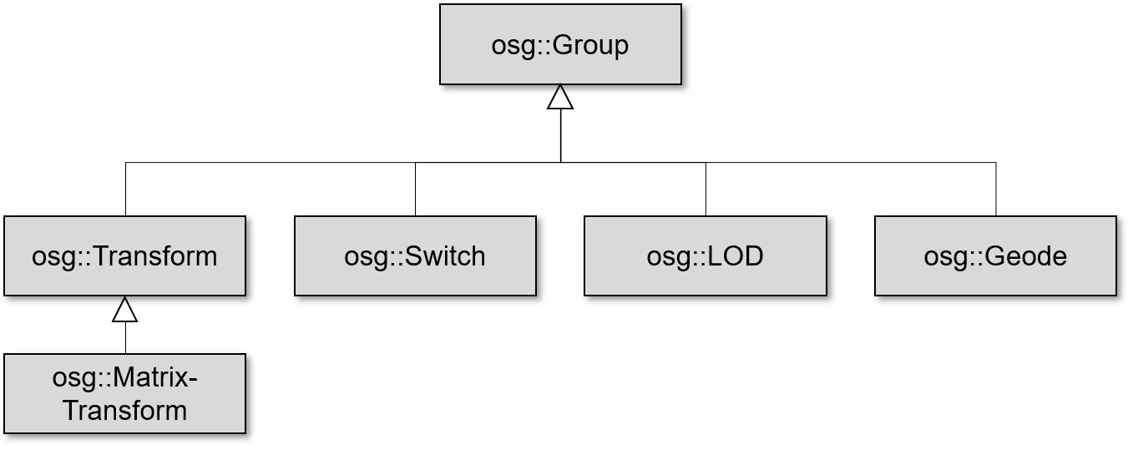

Figure 2: Simplified class diagram of the osg::Geode class including some derived classes

The derived classes that are displayed in fFigure 2 are described in more detail below:

* **osg::Transform class:** This class is used to apply traversal-concatenated transformations to ge­ometries of child nodes. When a scene graph is traversed down, osg::Transform nodes add their own transformation to the currently used transformation matrix (the OpenGL model-view ma­trix). It is not possible to instantiate an osg::Transform node directly. Instead, OpenSceneGraph provides a variety of subclasses of the osg::Transform, class, like the osg::MatrixTransform class, to realize different transformations [15].
* **osg::MatrixTransform class:** As shown in Figure 2, this class is derived from osg::Transform class. It is used to apply 4x4 double type matrix transformation and uses an osg::Matrix variable internally to do so. The osg::Matrix class offers methods to create matrices for different types of transformations.
* **osg::Switch:** This type of node can be used to render or skip specific children depending on a given condition. To achieve this, it attaches a Boolean value, that indicates if the child node (and nodes that are below it) should be rendered or not [17].
* **osg::LOD:** Nodes of this class can be used to represent the same object with different levels of detail, in order to render the object with the appropriate detail level according to the distance of the viewer. All child nodes of osg::LOD nodes should be the same object at varying levels of detail, while they are ordered from the highest to the lowest level. For each level (and therefore also for each child) a minimum and maximum visible range needs to be specified. This allows the renderer to au­tomatically decide which child nodes need be rendered depending on the viewers current distance to the osg::LOD node [18].
* **osg::Geode:** The osg::Geode nodes represent leaf nodes of a scene graph. Nodes of this class have no children but they contain and manage geometry information for the actual rendering [19].

Geometry data that should be drawn on the screen are stored in osg::Drawable objects. Those can be attached to osg::Geode nodes. The osg::Drawable class is a pure virtual class and therefore it cannot be instantiated. It has a variety of subclasses to render models, images and texts to the OpenGL pipeline [19]. For example, to render basic geometry shapes, the osg::ShapeDrawable class can be instantiated and attached to an osg:.Geode node [20].

## Traversing the Scene Graph

In scene graphs, various update and rendering operations are carried out on nodes during a traversal. It is one of the key functions of a scene graph. The traversal of a scene graph typi­cally consists of repeating steps. Starting from a certain node (at the root node if the whole graph should be traversed) the graph is traversed recursively down until a leaf node is reached. The graph is then traced back to the first node that has not yet been fully explored. The steps are repeated till all nodes have been explored. This type of traversal is also known as a depth-first search [21].

In OpenSceneGraph, four different types of traversals should be performed per frame one after another. First, all mouse and keyboard inputs as well as other user events should be processed in an event tra­versal. In the next traversal, the update traversal (or application traversal), the application can modify the scene graph (e.g. setting node and geometry properties). Then within the cull traversal checks are made to determine which nodes of the scene graph are within the viewport and are therefore worth rendering. During the last traversal, the draw traversal (or rendering traversal), the low‑level OpenGL API is called to actually render the scene. For systems with multiple processors and graphic cards, OpenSceneGraph supports processing of the different traversals in parallel to improve rendering effi­ciency. To implement further rendering traversals, the visitor pattern can be used [21].

## Smart Pointer

Typically, when programming scene graphs, a pointer is created to the root node and this node directly or indirectly manages all further child nodes of the scene graph. If a node is no longer needed for ren­dering, the application needs to traverse the scene graph and delete its internal data carefully. This can quickly lead to errors or memory leaks, as it can be difficult for developers to evaluate if and how many other objects are still holding a pointer to the object that should be deleted. Some of the modern pro­gramming languages, like for example C# or Java, use a garbage collector to free any memory blocks that cannot be reached from any variables of a program. In standard C++ this behavior can be mimicked utilizing smart pointers [22].

OpenSceneGraph comes with its own native smart pointer, the class template osg::ref_ptr<>, to enable automatic garbage collection and deallocation. For this to work, OpenSceneGraph provides the osg::Referenced class to manage the reference-counted memory blocks. The osg::Referenced class is used as the base class of all classes that can be used as template arguments [23]. The classes for representing nodes and geometries mentioned in section 3.3 are also indirectly derived from osg::Referenced.

An integer counter is kept within the osg::Reference class to handle the number of allocated memory blocks. This reference count is initialized with 0 when the constructor is called. If the object is referenced by an osg::ref_ptr<>, the count is increased by 1. If it is removed from a smart pointer, the count is re­duced by 1. If the object is no longer referenced by a smart pointer, i.e. the count falls back to 0, the object will be automatically destroyed. To save resources, to simplify debugging and to avoid bugs, OpenSceneGraph always recommends using smart pointers to manage a scene [23].

## State Sets

To keep track of states that are related to the rendering, like attributes such as scene lights, materials, textures and modes that can be turned on or off using the OpenGL functions glEnable( ) or glDisable( ), OpenGL typically uses a state machine. This may not be suitable for direct use in a scene graph structure. Therefore OpenSceneGraph uses the osg::StateSet class to encapsulate the OpenGL state machine. This enables developers to create realistic rendering effects [7].

To record rendering state attributes, OpenSceneGraph defines the virtual class osg::StateAttribute. It is inherited by different classes to implement various rendering attributes like lights, materials or blend functions [24]. Figure 3 shows the relationship between the osg::Node, the osg::StateSet, the osg::StateAttribute and derived classes of the osg::StateAttribute like osg::BlendFunc.

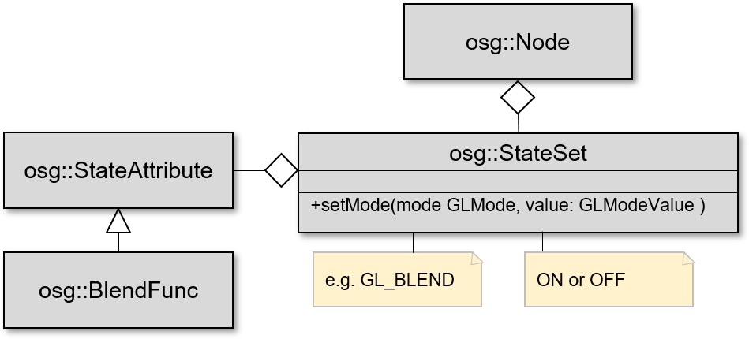

Figure 3: Simplified class diagram of the osg::StateSet class including related classes

An osg::StateSet object can be applied to an osg::Node[7]. Instances of classes that are derived from the osg::StateAttribute class can be added to an osg::StateSet object to adjust the rendering behavior of objects to which the state set is applied to. It is also possible to turn on or off different rendering modes off an osg::StateSet by calling the method setMode( ). The OpenGL type to be set (managed by a GLMode enum) and a corre­sponding value (managed by the type definition GLModeValue, on or off are the possible values) are expected as parameters. Sometimes a specific rendering mode is associated with an attribute [24]. For example, the mode GL_BLEND determines if specific blend functions, that can be set in a osg::StateSet via instances of the osg::BlendFunc class (it is derived from osg::StateAttribute), are used or not.

The state of a node not only affects itself but also its children. However, it is possible for child nodes to overwrite the state set of their parent. To change the inheritance of state sets, the three flags osg::StateAttribute::OVERRIDE, osg::StateAttribute::PROTECTED and osg::StateAttribute::INHERITAT can be used while setting or adding the values of state sets [25]. State sets also offer the possibility of adding vertex, fragment and geometry shaders [26], as well as uniforms that should be used within the shaders [27], to a node. How this is achieved can be found in the source code of the Playground application (within the AddShaderOption class), which is described in the next chapter.

# Playground Project

In order to show the effects of different nodes, attributes and rendering modes, an application was de­veloped that enables the user to dynamically add or remove nodes to a scene graph via a UI that is cre­ated with Dear ImGui. All of the node classes mentioned in section 3.3 are addable within the application. It also supports the functionality to add nodes from .osg files.

In addition, the application provides the functionality to adapt the state set of each node. This enables the user to select lighting settings and the polygon rasterization mode that should be used for the ren­dering. The creation of transparent rendering effects using blend functions and the addition of various shaders and associated uniforms is also possible.

To make the structure of the current scene graph recognizable for the user, the current scene graph is always displayed in a tree view in the UI (see screenshot Figure 9 in the Appendix III: Screenshots of the Playground Project). The user can select a node via this tree view (see Figure 10 in the Appendix III: Screenshots of the Playground Project). Depending on which type of node is selected, options to add or delete nodes and to adjust the state set, that are allowed on this type of node (e.g. it is not allowed to add further group nodes to nodes of the type osg::Geode), are displayed.

The following sections of this chapter give an overview of the architecture of the application and de­scribe exemplary how some of the available functionalities were implemented.

## Architecture

When the architecture of the developed application was created, an attempt was made to ensure that actions that can be carried out on nodes are designed as modularly as possible, so that they can be dis­played or not depending on the type of node selected. Figure 4 shows a reduced class diagram of the architecture of the application.

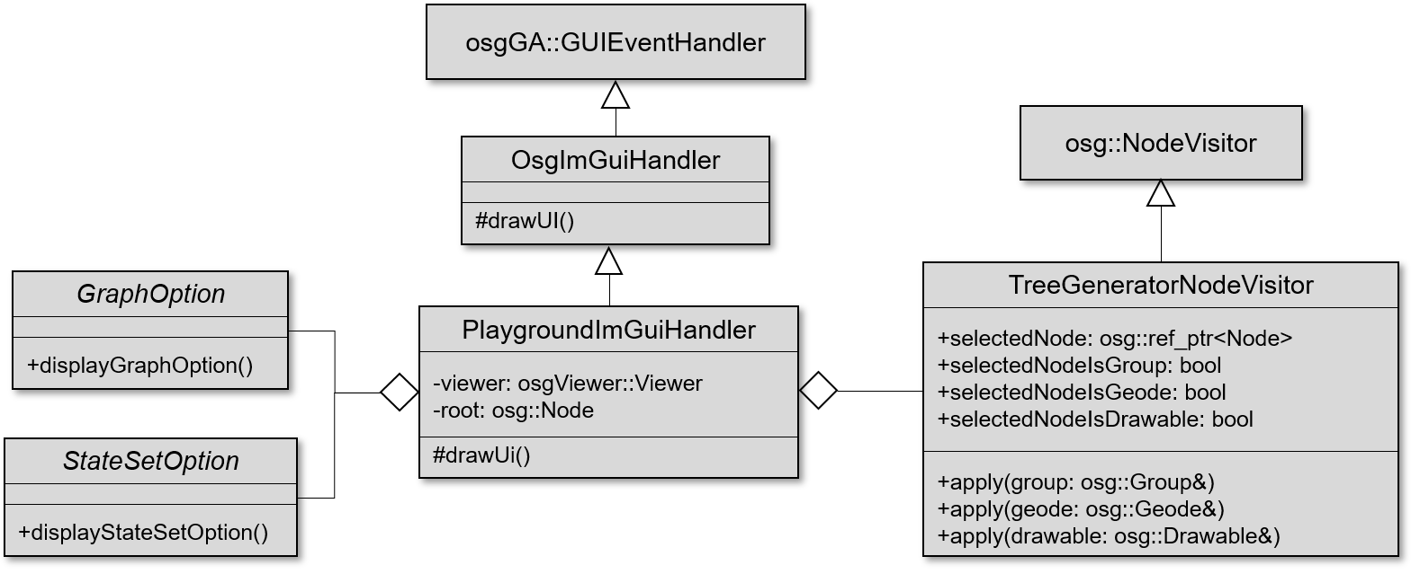

Figure 4: Simplified class diagram of the architecture of the playground project

The start point of the application is the main( ) method as usual. First, an osg::Viewer object and an osg::Group node is created. It is used as the root node of the scene graph of the application. Then the axes.osg file (it is delivered with OpenSceneGraph and contains a scene graph representing the coordinate axes) is read out using the osgDB library. When reading out, a group node is created that contains the coordinate axes as children. The axes should serve as an orientation for the user. The group that contains the axes is afterwards added to the root node.

Drawing the Dear ImGui UI is within the responsibility of the PlaygroundImGuiHandler class. An instance of this class is created in the main( ) method. Instances of the viewer and the root node of the main( ) method are passed to the constructor. To be able to use Dear ImGui in with OpenSceneGraph, the PlaygroundImGuIHandler extends the OsgImGuiHandler class. The OsgImGuiHandler class is derived from the osgGA::GUIEventHandler class. This allows it to pass inputs and events to the Dear Dear ImGui elements. This class was not created as part of this work. It is imported from [28]. The PlaygroundImGuiHandler uses it as base class and overwrites the drawUI( ) method. The osgGA::GUIEventHandler and the OsgImGuiHandler classes ensure that the drawUI( ) method of the PlaygroundImGuiHandler is called in every frame to draw the GUI and that mouse and keyboard inputs are forwarded to the ImGui controls correctly.

The TreeGeneratorNodeVisitor class is used to create the tree view, which shows the current state of the scene graph. Derived classes of the osg::NodeVisitor class can traverse scene graphs and carry out self-defined operations for each node. To define these operations, the apply( ) method must be imple­mented. It can be overloaded with several different types of nodes. Depending on which node type is currently available during the traversal, the corresponding method is called within the traversal [29]. If the apply( ) method is not overwritten for a specific node class, then the method with next base class in the class hierarchy is called instead. Within the apply( ) methods of the TreeGeneratorNodeVisitor an entry in a tree view, to represent the current node, is created. Additionally, the currently selected node is set ac­cording to the selected tree view element. To display the possible options on this node, the type of the selected node is also stored. The TreeGeneratorNodeVisitior overloads the apply( ) method to accept the three types osg::Group, osg::Geode and osg::Drawable, since different operations should be possible for these three types of nodes (and their derivatives). Besides, leaf nodes should be displayed differently in the tree view (see Figure 9 in Appendix III: Screenshots of the Playground Project).

The various options are implemented using derivatives of the two abstract classes GraphOption and StateSetOption. All these derivations overwrite either the displayGraphOption or the displayStateSetOption method, depending on the base class. For each option, a fold-out label is created in the overwritten method (implemented via a tree). The derivatives of the GraphOptions class include classes for adding or removing nodes. The derivatives of the StateSetOption class contain classes to adapt the state sets of the nodes (e.g. adding shaders).

In the DrawUI( ) method of the PlaygroundImGuiHandler, the UI is drawn in each frame. First, the tree view is created using the TreeGeneratorNodeVisitor as described above. Then, depending on the selected type of node, the permitted options are displayed using the derivatives of the GraphOption and the StateSetOption class. Also, UI elements are created for adjusting the background color and for updating the camera control. The implementation of these functionali­ties is located directly in the PlaygroundImGuiHandler, as they only refer indirectly to the scene graph.

To enable the PlaygroundImGuiHandler to draw the UI and to receive user input within the osg::Viewer, an instance of it is added to the viewer in the main( ) method. Then the osg::Viewer is started by calling the run( ) method. This creates a window and the rendering loop is executed until the user exits the program. In this loop the various traverses (see section 3.4), are run through.

## Implementation

This section exemplifies the implementation of a GraphOption and a StateSetOption to show how the implementation of the options, which contain the essential code for adapting the scene graph, was car­ried out.

### Add of Group Nodes

The AddGroupOption class is a derivative of the GraphOption class. Listing 2 shows the implementation of the displayOption( ) method of the AddGroupOption class.



Listing 2: Implementation of the method displayGraphOption( ) of the AddGroupOption class

The reference of the TreeGeneratorVisitor, that stores the selected node, transferred as a parameter within a smart pointer. With the condition of the if statement in line 3, an expandable tree node (within Dear ImGui, these nodes have nothing to do with the nodes in the scene graph) with the label "Add Group" is drawn in the UI. If this tree node is expanded, the condition of the if statement is considered valid. A button is then added to the UI via the if statement in line 4. If this is clicked, the code block of the if statement will be executed. First, a new group node is created, and its reference is assigned to a smart pointer. The currently se­lected node is then cast into a group node because adding nodes using a reference to an osg::Node object is not permitted. Since this option is only displayed if the selected node is a group node, it is ensured, that the node stored in the TreeGeneratorVisition, is a group node. The newly created group node is then added as a child to the selected node.

### Adjust Polygon Mode

In order to exemplarily show how the options to adjust the state sets of nodes are implemented, the displayStateSetOption( ) method of the AdjustPolygonModeOption class is shown in **Fehler! Verweisquelle konnte nicht gefunden werden.**. The class inherits from the StateSetOption class. It offers the user the possibility to change the polygon rasterization mode of an object.



Code Snippet 3: Listing 3: Major part of the implementation of the displayStateSetOption( ) method of the AdjustPolygonMode class

A smart pointer (described in section 3.5) to the StateSet object (described in 3.6) of the selected node is transferred as parameter. In the lines 6 and 7 combo boxes are display, that allow the user to decide on which face which polygon mode should be applied. The selection of the faces corresponds to the OpenGL enumerations GL_FRONT, GL_BACK and GL_FRONT_AND_BACK. The selection of the polygon mode to be applied corresponds to GL_POINT, GL_LINE and GL_FILL. To manage this values within, OpenSceneGraph, it provides the enumerations osg::PolygonMode::Face and osg::PolygonMode::Mode. The selection within the combo box is mapped to values of these enumeration within the maps selctionIdToPolygonModeFace and selectionIdToPolygonModeMode. In line 8 a addition combo box is displayed, to allow the user to define the flag of the polygon mode to be used. With the flag he can control the inheritance of this mode. The flags are described in section 3.6. To use them in OpenSceneGraph provides a further enumeration. It is osg::StateAttribute::Values. To be able to transfer the selection to values of this enumeration, the map selctionIdToStateAttributeFlag is used.

Below the combo boxes to specifiy the values that define the polygon mode, a button is displayed in line 10 to add the polygon mode to the state set. If the button is pressed, the code block between lines 11 to 14 will be executed. To apply the polygon mode to a state set, the osg::PolygonMode class needs to be used. It is derived from the osg::StateAttribute class, which is described in section 3.6. A instance of it is created in line 11. By calling the setMode() method in line 12, the mode selected in the combo boxes by the user, will be applied to the osg::PolygonMode state attribute. The mode that is set here, is not the mode that is described in section 3.6. It only affects the attribute of the state set. After the configuration of the osg::PolygonMode instance, it is added to the state set of the selected node in line 13 with the call of the setAttribute( ) method of the StateSet object. The flags are used as second parameter.

The explanation of the displayStateSetOption( ) methods of further classes would exceed the scope of this report. The calls within the respective classes of the source code of the Playground project shows how StateAttribute objects can be read out as well as how various rendering modes can be adapted.

# Features and Advantages of OpenSceneGraph

OpenSceneGraph as the most popular 3D graphics toolkit based on scene graphs comes with several features and advantages. These are explained in this chapter.

The basic functionality that the toolkit offers is the API, which allows the definition and rendering of a scene graph. One advantage that results from this is, that the productivity of developers can be increased compared to the pure use of a low-level API such as OpenGL. The developers no longer have to worry about low level coding but can instead focus on developing the content of the application. The performance that is achieved by the sup­port of view-frustum culling, occlusion culling, small feature culling, Level Of Detail (LOD) nodes, OpenGL state sorting, vertex arrays, vertex buffer objects, the OpenGL Shader Language and display lists is another advantage that OpenSceneGraph can offer [4].

Via the osgDB library, which was already mentioned in section 3.2, OpenSceneGraph also offers support for reading and writing many 3D databases and 2D image file formats. In addition, OpenSceneGraph provides a large number of different NodeKits, which offer numerous additional functionalities such as the rendering of texts, volumes or particles. Since OpenSceneGraph only requires Standard C ++ and OpenGL and is designed in such a way that the dependencies on the various platforms are minimal, it can be executed on various platforms such as Windows, Android, MacOs and iOS. Further features are the support of additional programming languages like Java or Python through community projects and the support of multiple graphic contexts. This allows the execution of OpenSceneGraph based applica­tions on multi-threaded and multi-GPU systems [4].

# Conclusion

This report started with a brief introduction to the 3D graphics toolkit OpenSceneGraph and its history. Afterwards, the toolkit itself, retained rendering systems and scene graphs were briefly described. In the third chapter, the use of OpenSceneGraph was explained using a minimal example, followed by a description of some of the central elements for usage such as smart pointers and classes for representing nodes. Then the playground project, which offers an interactive editor for a scene graph, was presented in chapter 4. In the fifth chapter, the features and advantages of OpenSceneGraph were listed. In addition to the features, the object-oriented concept, the use of smart pointers, the easy access to additional functionality via node kits and the flat learning curve, were positive points that were experienced during the development with OpenSceneGraph.

Especially due to the positive experience and the many features that OpenSceneGraph offers, the ques­tion of why it is not widely used in large projects arises. There are of course projects, like the flight simulator Flight Gear [30], that uses it. But during the research for this report no large and popular project, like for a example AAA game (classification that is used for games that are produced and dis­tributed by mid-sized or major publisher [31]) was found, that is based on OpenSceneGraph. One pos­sible reason for this is, that in large applications, it is often necessary to map different types of relationships (e.g. spatial and semantic relationships, but also something like the rendering or­der) of objects. It seems quite difficult to map all these relationships using a single scene graph. It may only be achieved with additional properties or regulations (for example using rendering hints, men­tioned in section **Fehler! Verweisquelle konnte nicht gefunden werden.**). Additionally, in projects with very large and complex scenes the mapping of the scene using a single scene graph, will likely result in either a root node with a very large number of single child nodes or into a graph with an unmanageable number of branches [32].

In conclusion, the decision about whether OpenSceneGraph should be used in a software system prob­ably depends on the type of application that should be developed. In applications that cover a limited field that can be controlled by a scene graph, such as the Playground project, the use of OpenSceneGraph has certainly great advantages. In applications that require multiple complex scenes, the use of OpenSceneGraph may be more of an obstacle for devel­opers than it brings advantages.

References

[1] OpenSceneGraph, *The OpenSceneGraph Project Website.* [Online]. Available: http://​www.openscenegraph.org​/​ (accessed: Dec. 22 2020).

[2] R. Wang and X. Qian, *Openscenegraph 3.0 Beginner's Guide, Chapter 1, Section: The Birth and development of OSG*. Birmingham, Mumbai: Gardners Books, 2010. [Online]. Available: http://​search.ebscohost.com​/​login.aspx​?​direct=​true&​scope=​site&​db=​nlebk&​db=​nlabk&​AN=​350535

[3] R. Wang and X. Qian, *Openscenegraph 3.0 Beginner's Guide, Chapter 1, Section: A quick overview of rendering middleware*. Birmingham, Mumbai: Gardners Books, 2010. [Online]. Available: http://​search.ebscohost.com​/​login.aspx​?​direct=​true&​scope=​site&​db=​nlebk&​db=​nlabk&​AN=​350535

[4] OpenSceneGraph, *Features.* [Online]. Available: http://​www.openscenegraph.org​/​index.php/​about/​features (accessed: Dec. 22 2020).

[5] R. Wang and X. Qian, *Openscenegraph 3.0 Beginner's Guide, Chapter 1, Section: Scene graphs*. Birmingham, Mumbai: Gardners Books, 2010. [Online]. Available: http://​search.ebscohost.com​/​login.aspx​?​direct=​true&​scope=​site&​db=​nlebk&​db=​nlabk&​AN=​350535

[6] Quinn Radich and Michael Satran, *Retained Mode Versus Immediate Mode.* [Online]. Available: https://​docs.microsoft.com​/​en-​us/​windows/​win32/​learnwin32/​retained-​mode-​versus-​immediate-​mode

[7] R. Wang and X. Qian, *Openscenegraph 3.0 Beginner's Guide, Chapter 6, Section: Encapsulationg the OpenGL state machine*. Birmingham, Mumbai: Gardners Books, 2010. [Online]. Available: http://​search.ebscohost.com​/​login.aspx​?​direct=​true&​scope=​site&​db=​nlebk&​db=​nlabk&​AN=​350535

[8] R. Wang and X. Qian, *Openscenegraph 3.0 Beginner's Guide, Chapter 1, Section: Have a quick taste*. Birmingham, Mumbai: Gardners Books, 2010. [Online]. Available: http://​search.ebscohost.com​/​login.aspx​?​direct=​true&​scope=​site&​db=​nlebk&​db=​nlabk&​AN=​350535

[9] R. Wang and X. Qian, *Openscenegraph 3.0 Beginner's Guide, Chapter 1, Section: Components*. Birmingham, Mumbai: Gardners Books, 2010. [Online]. Available: http://​search.ebscohost.com​/​login.aspx​?​direct=​true&​scope=​site&​db=​nlebk&​db=​nlabk&​AN=​350535

[10] OpenSceneGraph, *Github Repository: OpenSceneGraph.* [Online]. Available: https://​github.com​/​openscenegraph/​OpenSceneGraph/​ (accessed: Dec. 23 2020).

[11] OBJEXX Engineering, *OpenSceneGraph.* [Online]. Available: https://​objexx.com​/​OpenSceneGraph.html

[12] OpenSceneGraph, *Stable Releases.* [Online]. Available: http://​www.openscenegraph.org​/​index.php/​download-​section/​stable-​releases

[13] R. Wang and X. Qian, *Openscenegraph 3.0 Beginner's Guide, Chapter 5, Section: The Group interface*. Birmingham, Mumbai: Gardners Books, 2010. [Online]. Available: http://​search.ebscohost.com​/​login.aspx​?​direct=​true&​scope=​site&​db=​nlebk&​db=​nlabk&​AN=​350535

[14] OpenSceneGraph, *Reference Guide - osg::Group Class Reference.* [Online]. Available: https://​codedocs.xyz​/​openscenegraph/​OpenSceneGraph/​a02438.html (accessed: Dec. 23 2020).

[15] R. Wang and X. Qian, *Openscenegraph 3.0 Beginner's Guide, Chapter 5, Section: Transformation nodes*. Birmingham, Mumbai: Gardners Books, 2010. [Online]. Available: http://​search.ebscohost.com​/​login.aspx​?​direct=​true&​scope=​site&​db=​nlebk&​db=​nlabk&​AN=​350535

[16] R. Wang and X. Qian, *Openscenegraph 3.0 Beginner's Guide, Chapter 5, Section: The MatrixTransform class*. Birmingham, Mumbai: Gardners Books, 2010. [Online]. Available: http://​search.ebscohost.com​/​login.aspx​?​direct=​true&​scope=​site&​db=​nlebk&​db=​nlabk&​AN=​350535

[17] R. Wang and X. Qian, *Openscenegraph 3.0 Beginner's Guide, Chapter 5, Section: Switch nodes*. Birmingham, Mumbai: Gardners Books, 2010. [Online]. Available: http://​search.ebscohost.com​/​login.aspx​?​direct=​true&​scope=​site&​db=​nlebk&​db=​nlabk&​AN=​350535

[18] R. Wang and X. Qian, *Openscenegraph 3.0 Beginner's Guide, Chapter 5, Section: Level-of-detail-nodes*. Birmingham, Mumbai: Gardners Books, 2010. [Online]. Available: http://​search.ebscohost.com​/​login.aspx​?​direct=​true&​scope=​site&​db=​nlebk&​db=​nlabk&​AN=​350535

[19] R. Wang and X. Qian, *Openscenegraph 3.0 Beginner's Guide, Chapter 4, Section: Geode and Drawable classes*. Birmingham, Mumbai: Gardners Books, 2010. [Online]. Available: http://​search.ebscohost.com​/​login.aspx​?​direct=​true&​scope=​site&​db=​nlebk&​db=​nlabk&​AN=​350535

[20] R. Wang and X. Qian, *Openscenegraph 3.0 Beginner's Guide, Chapter 4, Section: Rendering basic shapes*. Birmingham, Mumbai: Gardners Books, 2010. [Online]. Available: http://​search.ebscohost.com​/​login.aspx​?​direct=​true&​scope=​site&​db=​nlebk&​db=​nlabk&​AN=​350535

[21] R. Wang and X. Qian, *Openscenegraph 3.0 Beginner's Guide, Chapter 5, Section: Traversing the scene graph*. Birmingham, Mumbai: Gardners Books, 2010. [Online]. Available: http://​search.ebscohost.com​/​login.aspx​?​direct=​true&​scope=​site&​db=​nlebk&​db=​nlabk&​AN=​350535

[22] R. Wang and X. Qian, *Openscenegraph 3.0 Beginner's Guide, Chapter 3, Section: Understanding memory management*. Birmingham, Mumbai: Gardners Books, 2010. [Online]. Available: http://​search.ebscohost.com​/​login.aspx​?​direct=​true&​scope=​site&​db=​nlebk&​db=​nlabk&​AN=​350535

[23] R. Wang and X. Qian, *Openscenegraph 3.0 Beginner's Guide, Chapter 3, Section: ref_ptr<> and Referenced classes*. Birmingham, Mumbai: Gardners Books, 2010. [Online]. Available: http://​search.ebscohost.com​/​login.aspx​?​direct=​true&​scope=​site&​db=​nlebk&​db=​nlabk&​AN=​350535

[24] R. Wang and X. Qian, *Openscenegraph 3.0 Beginner's Guide, Chapter 6, Section: Attributes and modes*. Birmingham, Mumbai: Gardners Books, 2010. [Online]. Available: http://​search.ebscohost.com​/​login.aspx​?​direct=​true&​scope=​site&​db=​nlebk&​db=​nlabk&​AN=​350535

[25] R. Wang and X. Qian, *Openscenegraph 3.0 Beginner's Guide, Chapter 6, Section: Inheriting render states*. Birmingham, Mumbai: Gardners Books, 2010. [Online]. Available: http://​search.ebscohost.com​/​login.aspx​?​direct=​true&​scope=​site&​db=​nlebk&​db=​nlabk&​AN=​350535

[26] R. Wang and X. Qian, *Openscenegraph 3.0 Beginner's Guide, Chapter 6, Section: Understanding graphics shaders*. Birmingham, Mumbai: Gardners Books, 2010. [Online]. Available: http://​search.ebscohost.com​/​login.aspx​?​direct=​true&​scope=​site&​db=​nlebk&​db=​nlabk&​AN=​350535

[27] R. Wang and X. Qian, *Openscenegraph 3.0 Beginner's Guide, Chapter 6, Section: Using uniforms*. Birmingham, Mumbai: Gardners Books, 2010. [Online]. Available: http://​search.ebscohost.com​/​login.aspx​?​direct=​true&​scope=​site&​db=​nlebk&​db=​nlabk&​AN=​350535

[28] Alexey Galitsyn, *Github Repository: imgui-osg.* [Online]. Available: https://​github.com​/​Tordan/​imgui-​osg (accessed: Dec. 23 2020).

[29] R. Wang and X. Qian, *Openscenegraph 3.0 Beginner's Guide, Chapter 5, Section: Visiting scene graph structures*. Birmingham, Mumbai: Gardners Books, 2010. [Online]. Available: http://​search.ebscohost.com​/​login.aspx​?​direct=​true&​scope=​site&​db=​nlebk&​db=​nlabk&​AN=​350535

[30] OpenSceneGraph, *Use Cases - FlightGear.* [Online]. Available: http://​www.openscenegraph.org​/​index.php/​gallery/​use-​cases/​81-​flightgear

[31] Wikipedia - The Free Encyclopedia, *AAA (video game industry)*.

[32] Tom Forsyth, *Scene Graphs - just say no.* [Online]. Available: http://​tomforsyth1000.github.io​/​blog.wiki.html​#%5B%5BScene%20Graphs%20-%20just%20say%20no%5D%5D (accessed: Dec. 22 2020).

[33] R. Wang and X. Qian, *Openscenegraph 3.0 Beginner's Guide, Chapter 6, Section: Time for action - implementing a cartoon cow*. Birmingham, Mumbai: Gardners Books, 2010. [Online]. Available: http://​search.ebscohost.com​/​login.aspx​?​direct=​true&​scope=​site&​db=​nlebk&​db=​nlabk&​AN=​350535

# Appendix I: Image of all OpenSceneGraph Libraries

Ein Bild, das Text enthält.

Figure 5: List of al libraries provided by OpenSceneGraph (Version 3.6.5)

# Appendix II: Screenshot of the “Hello World” Project

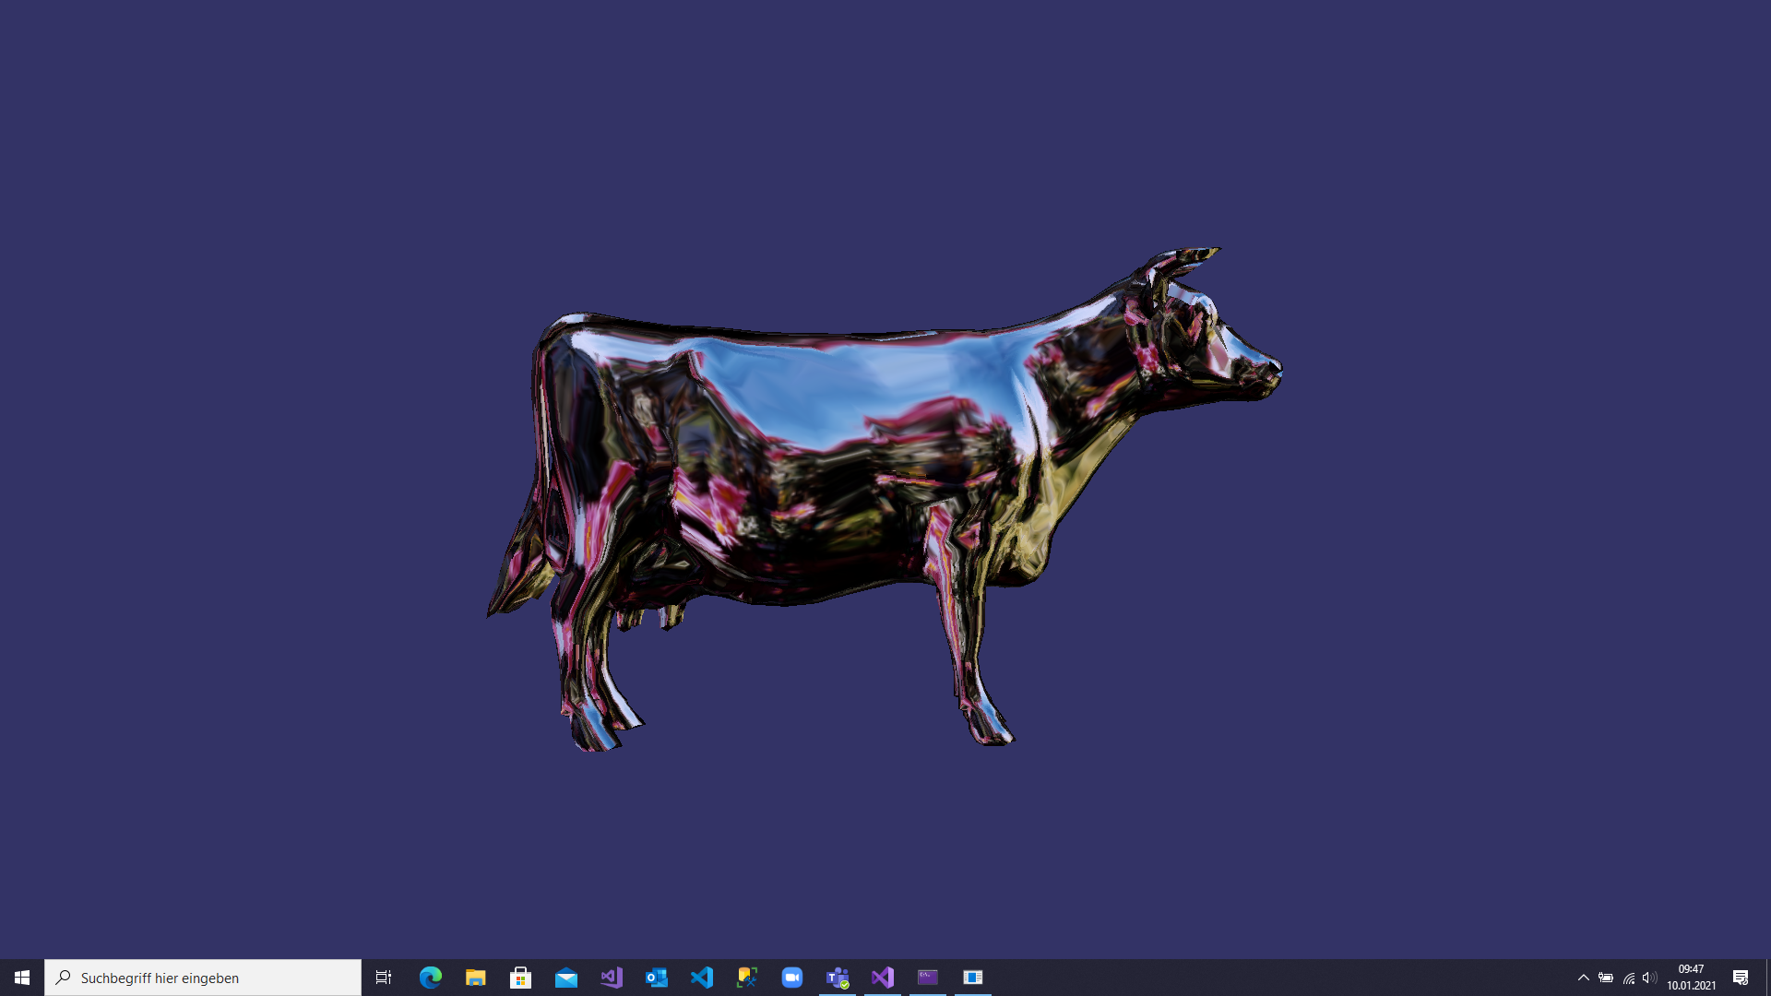

Figure 6: Screenshot of the "Hello World" Project

# Appendix III: Screenshots of the Playground Project

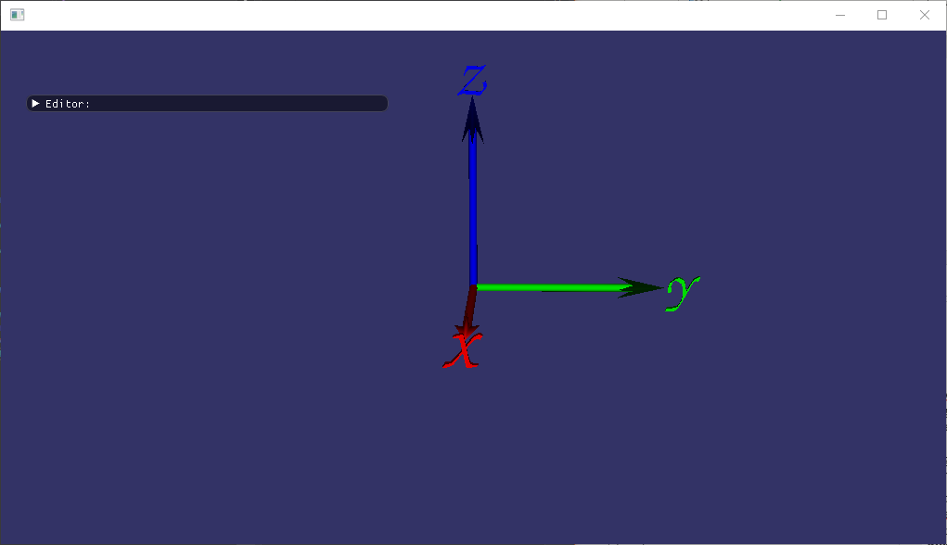

Figure 7: Closed editor

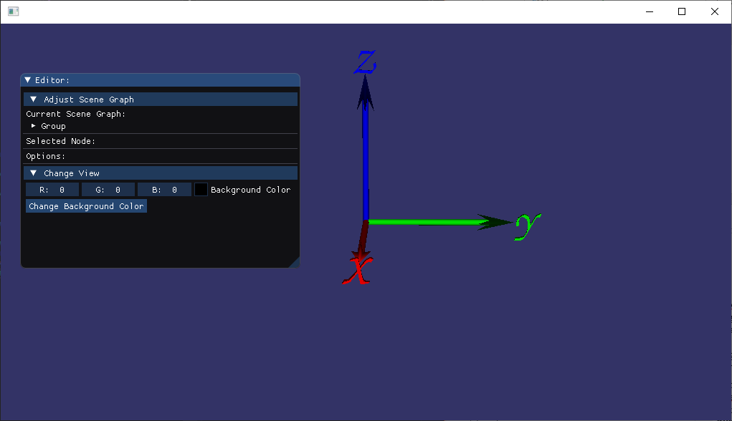

Figure 8: Opened editor

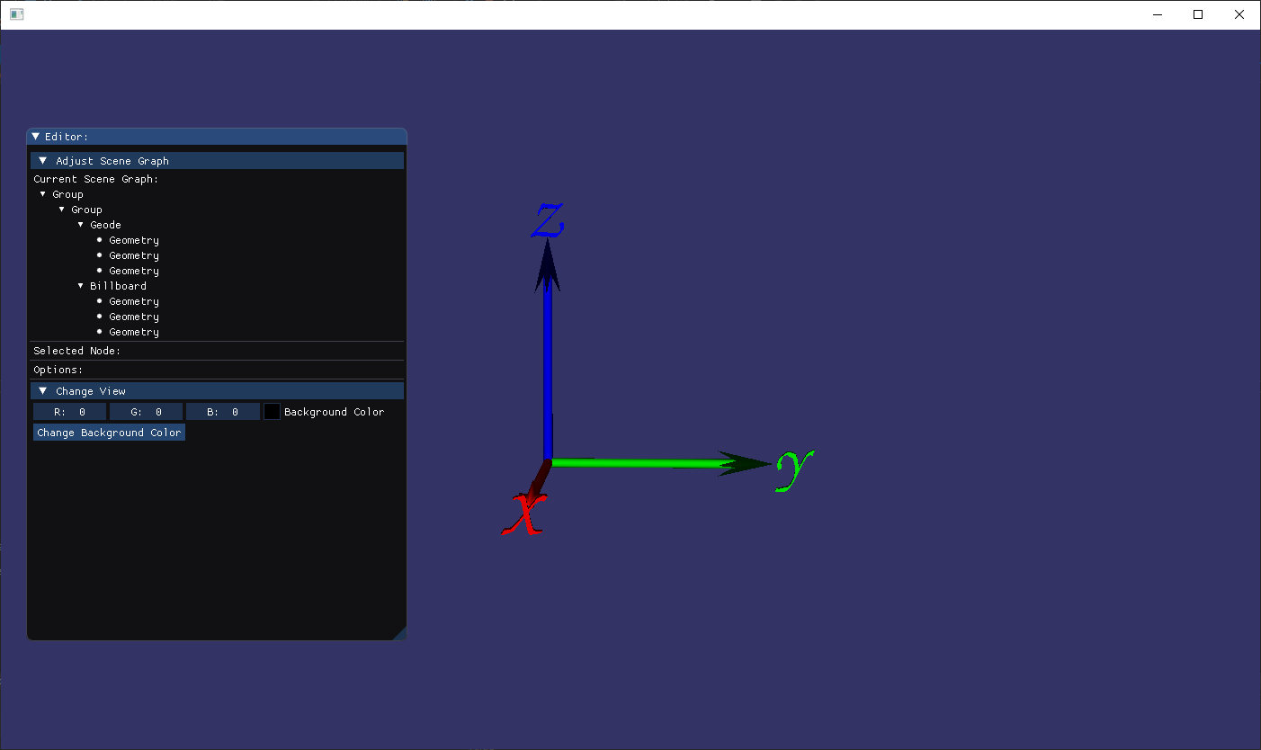

Figure 9: Opened tree view

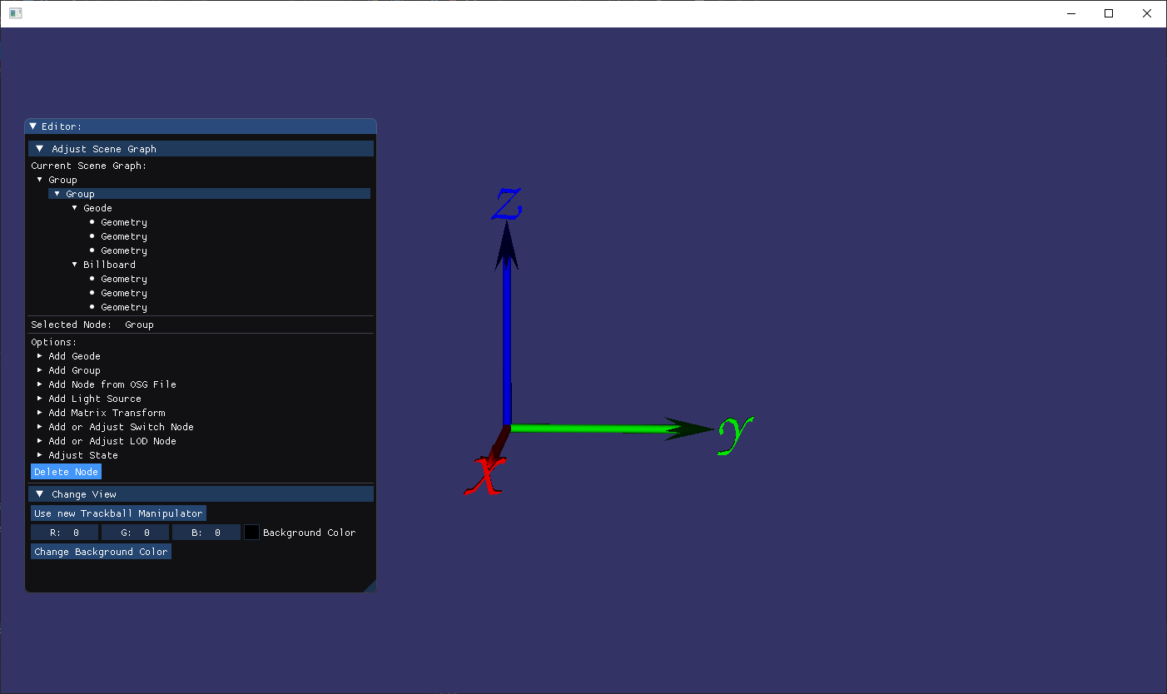

Figure 10: Group node selected

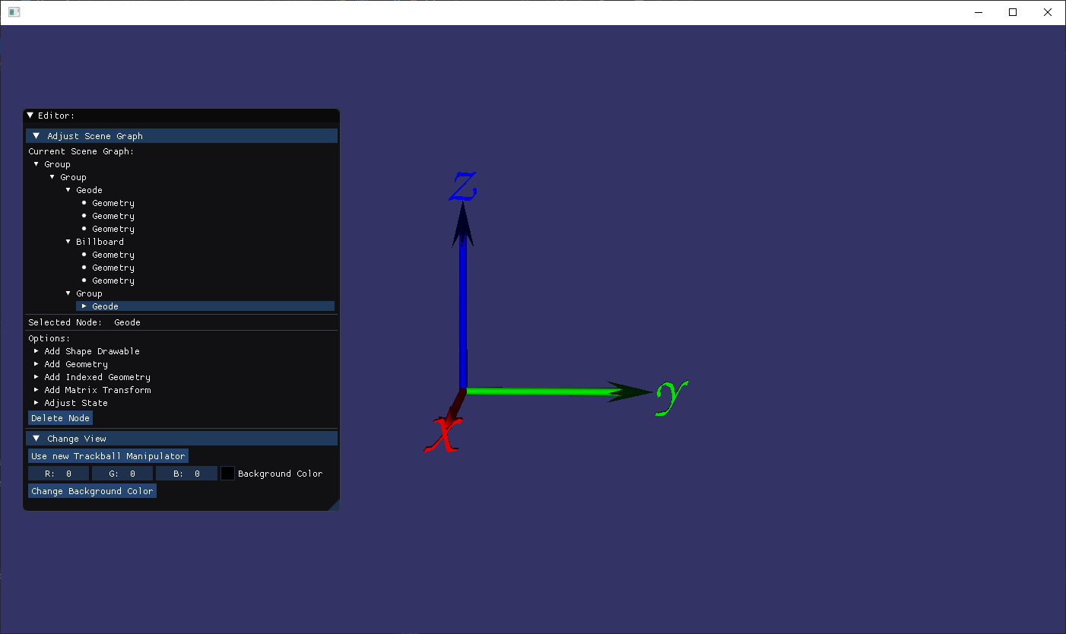

Figure 11: Geode node selected

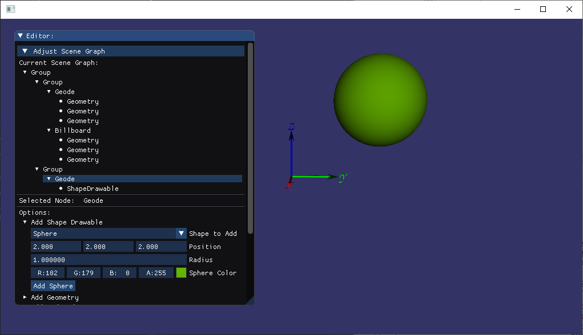

Figure 12: Sphere added

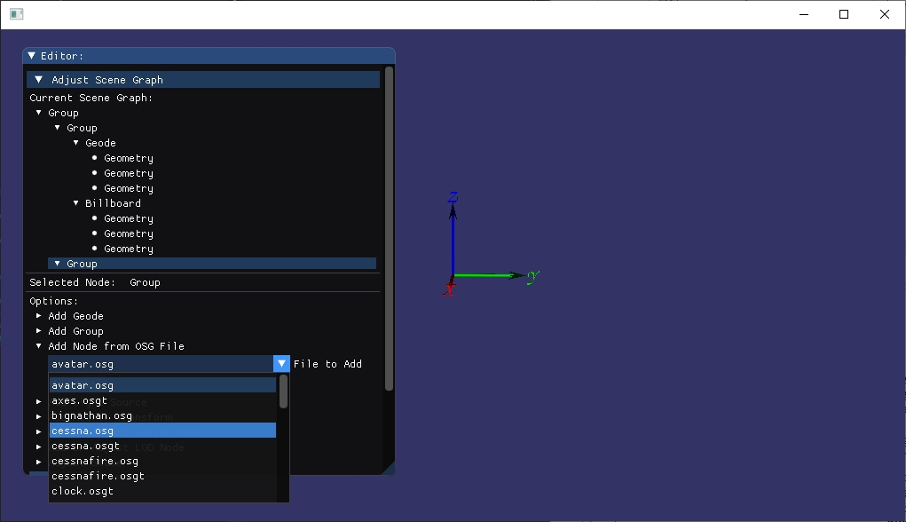

Figure 13: "Add Node from File" option opened

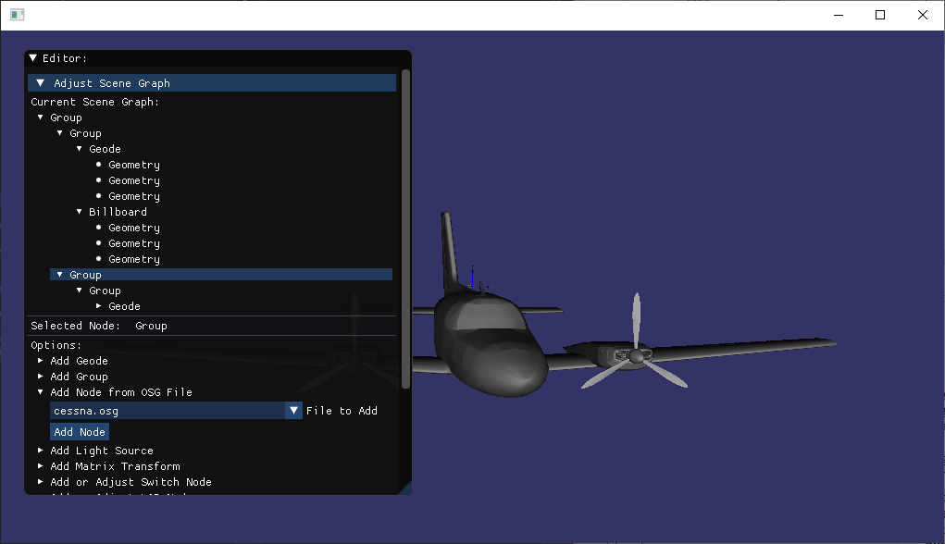

Figure 14: Nodes from cessna.osg file added to the scene graph

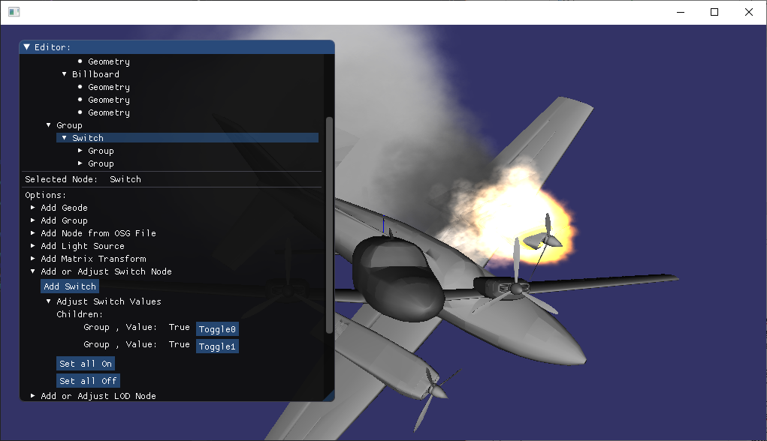

Figure 15: Switch node with nodes from cessna.osg and censsafire.osg as child nodes

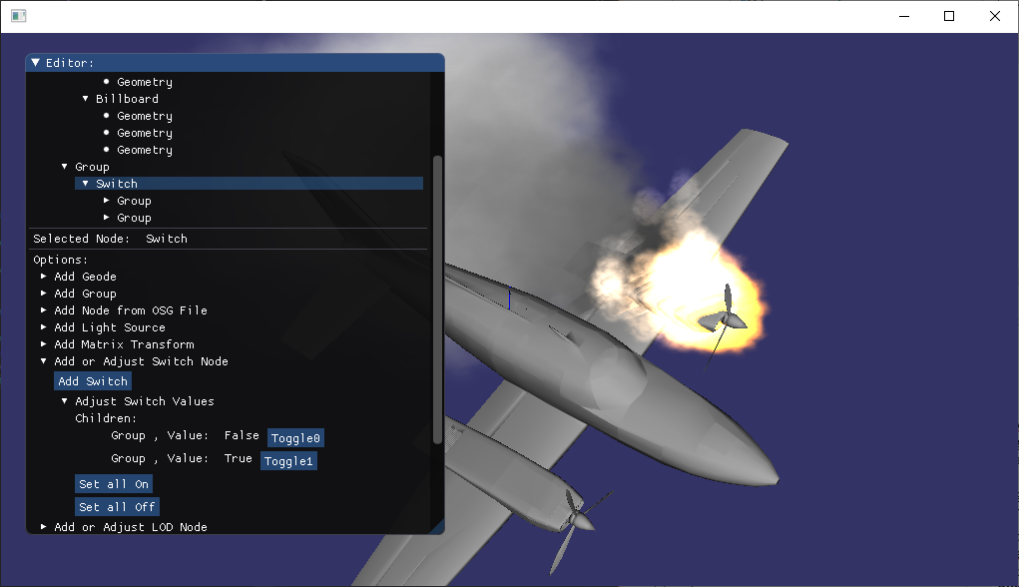

Figure 16: Switch node with nodes from cessna.osg and censsafire.osg as child nodes, while cessna.osg group is toggled to off

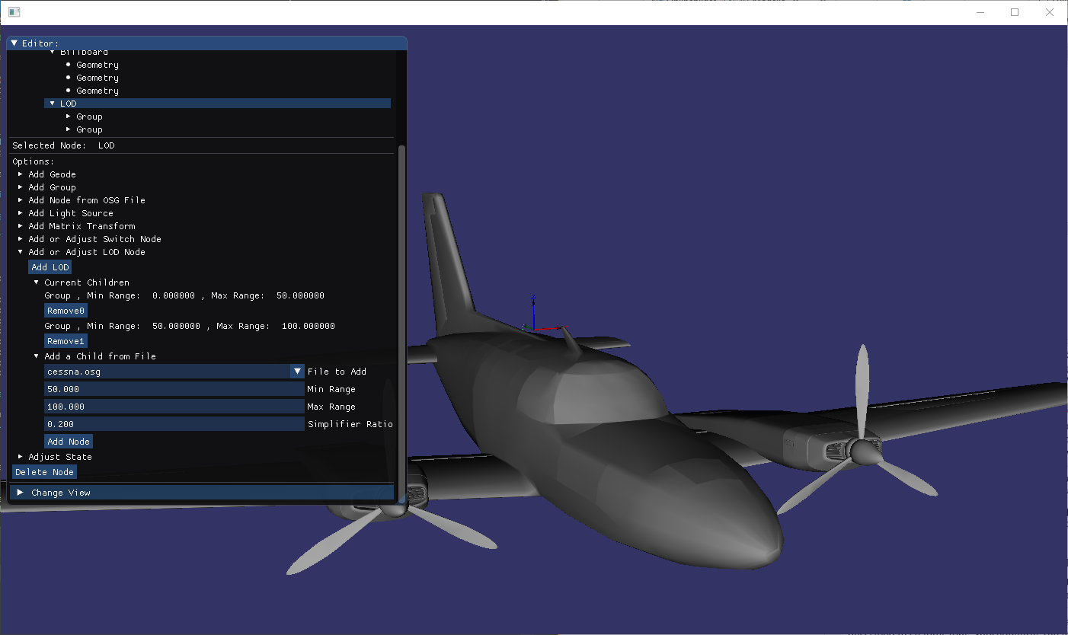

Figure 17: LOD node with nodes of two cessna.osg files as child nodes (first for range 0 to 50 and simplifier set to 1.0; second for range 50 to 100 with simplifier set to 0.2) - current distance to node between 0 and 50

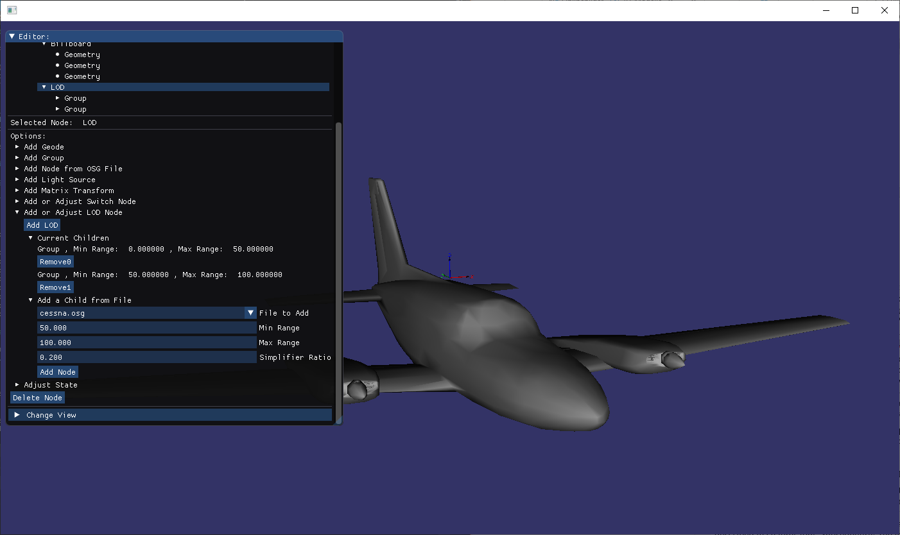

Figure 18: LOD node with nodes of two cessna.osg files as child nodes (first for range 0 to 50 and simplifier set to 1.0; second for range 50 to 100 with simplifier set to 0.2) - current distance to node between 0 and 50

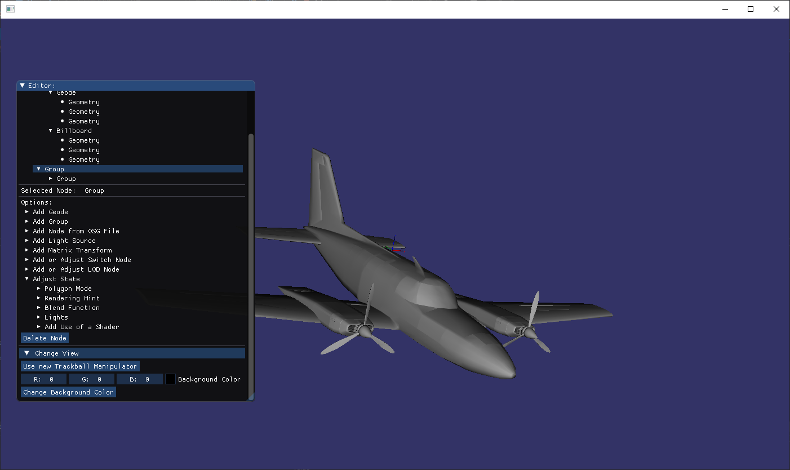

Figure 19: Group node from added cessna.osg file selected and "Adjust State" option opened

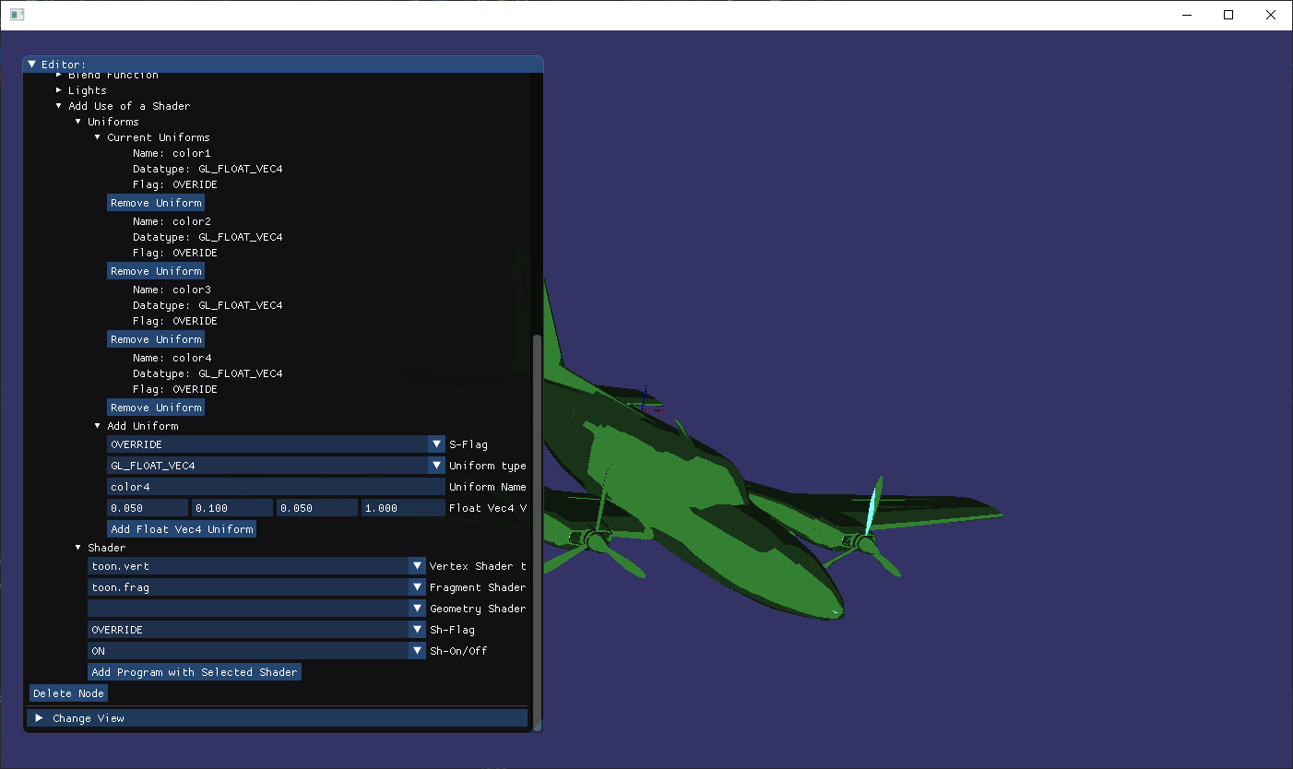

Figure 20: Added toon shader from [33] with uniforms displayed in the editor