**SOUND MANUAL**

**1.1 SOFTWARE REQUIREMENTS:**

* Ableton Live 10
* Max MSP 8 ( not required, but if you have it then you can also save changes)
* BlackHole ( preferred over Soundflower, if it is not possible than use Soundflower)

**1.2 PLUGINS/EXTERNALS AND LIBRARIES**

* Valhalla Shimmer VST
* Waves Ultrapitch 6 Voices
* Envelope Bundle
* Fiddle, Bonk, Shell Max MSP Objects (these objects are stored in a folder named externals inside the SFProject folder , see Fig. 3)

On MAX MSP you also have to choose the path, in this way, the software knows were to search for files. This process can be set once and for all. If by any chance, you change the location of the project folder, than the path also need to be reset in here.

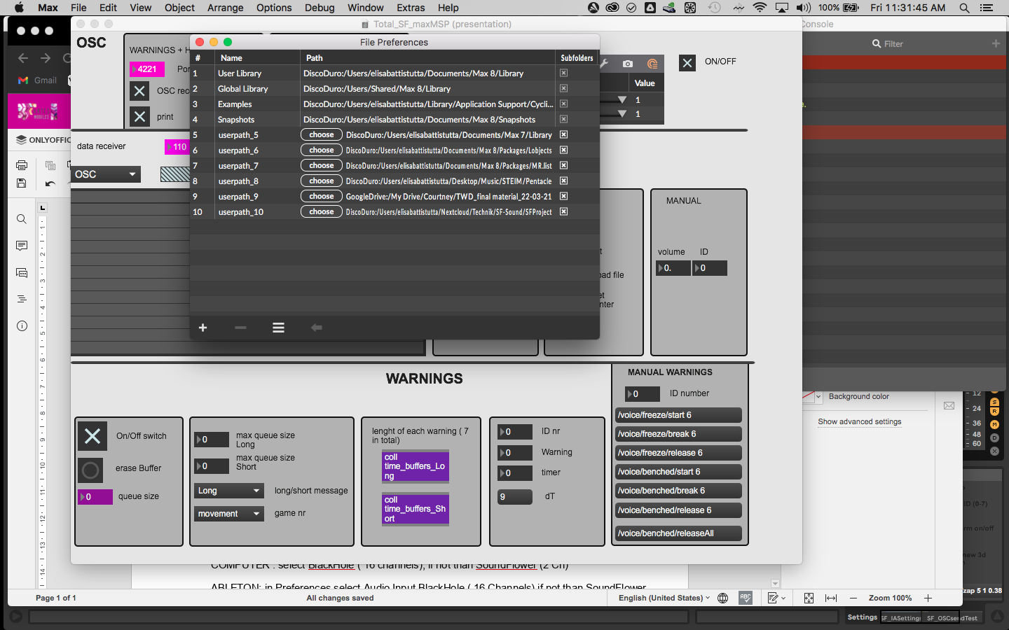

Figure 1

Go to Options -> File Preferences and on the bottom left of the window there is a plus. Toggle it and add you folder

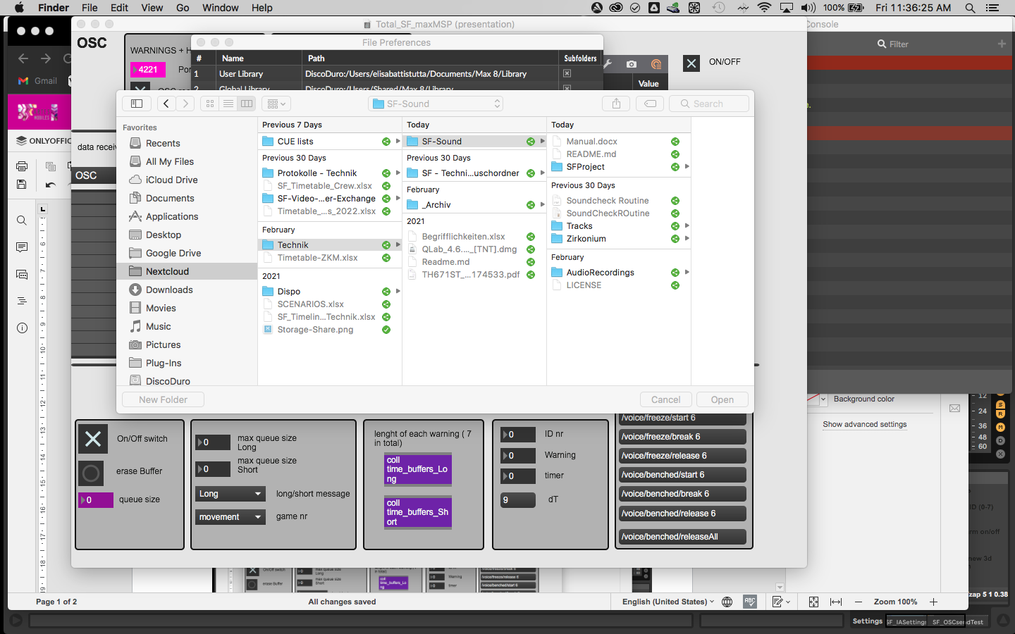

Figure 2

**1.3 AUDIO ROUTING**

MAX MSP: open top menu Options -> Audio Status and select for Output the soundcard

COMPUTER : select BlackHole ( 16 channels), if not than SoundFlower (2 Ch)

ABLETON: in Preferences select Audio Input BlackHole ( 16 Channels) if not than SoundFlower (2 Ch) Output the soundcard

FILES

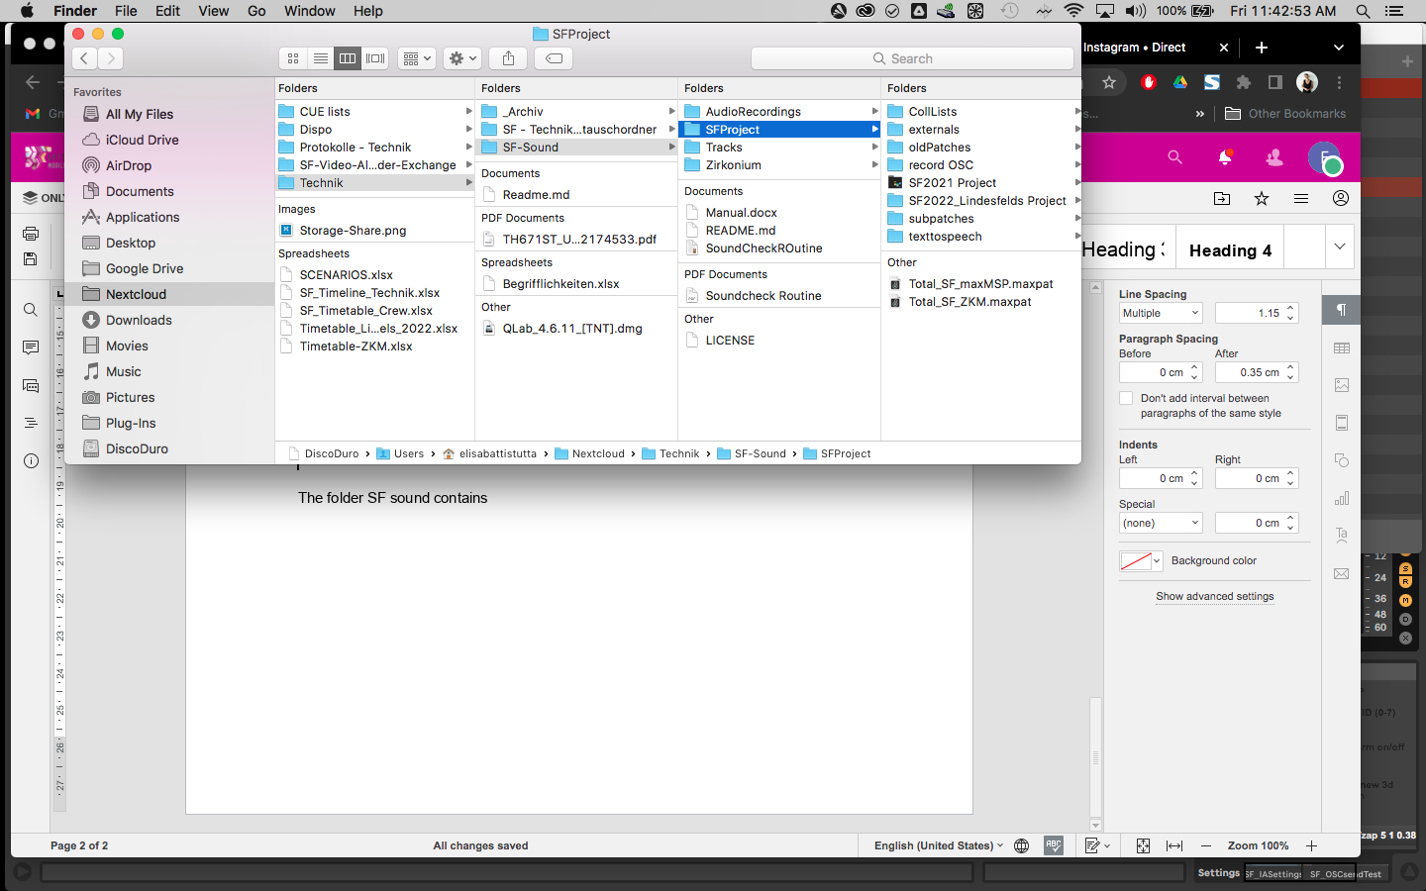

Figure 3

The folder SF sound contains SFProject. In there you find the two files you have to open which are

Total_SF_maxMSP.maxpat

And inside the Ableton folder SF2021, select the file

SF2022.als

**1.4 OSC CONNECTIONS**

Sound computer should be 192.168.0.9

Switch off the wifi connections

**1.4.1 PORTS:**

Check in Ableton that the correct ports are selected ( see pink objects )

You can find this window if you select the track named settings

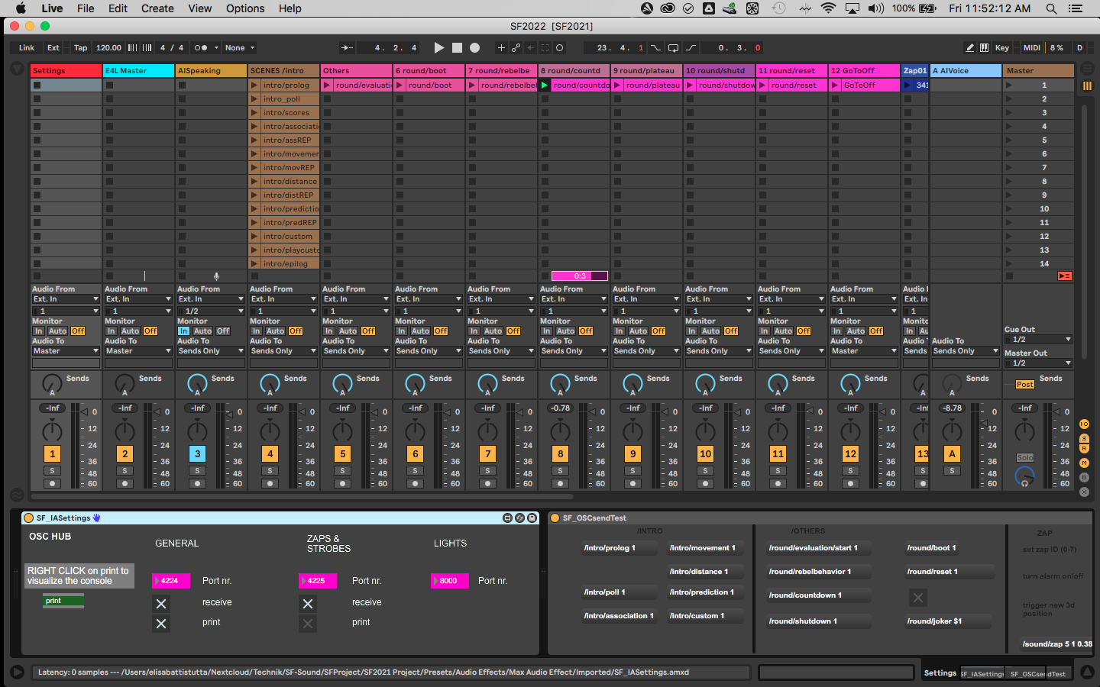

Figure 4

In MAX MSP the ports are also displayed in pink:

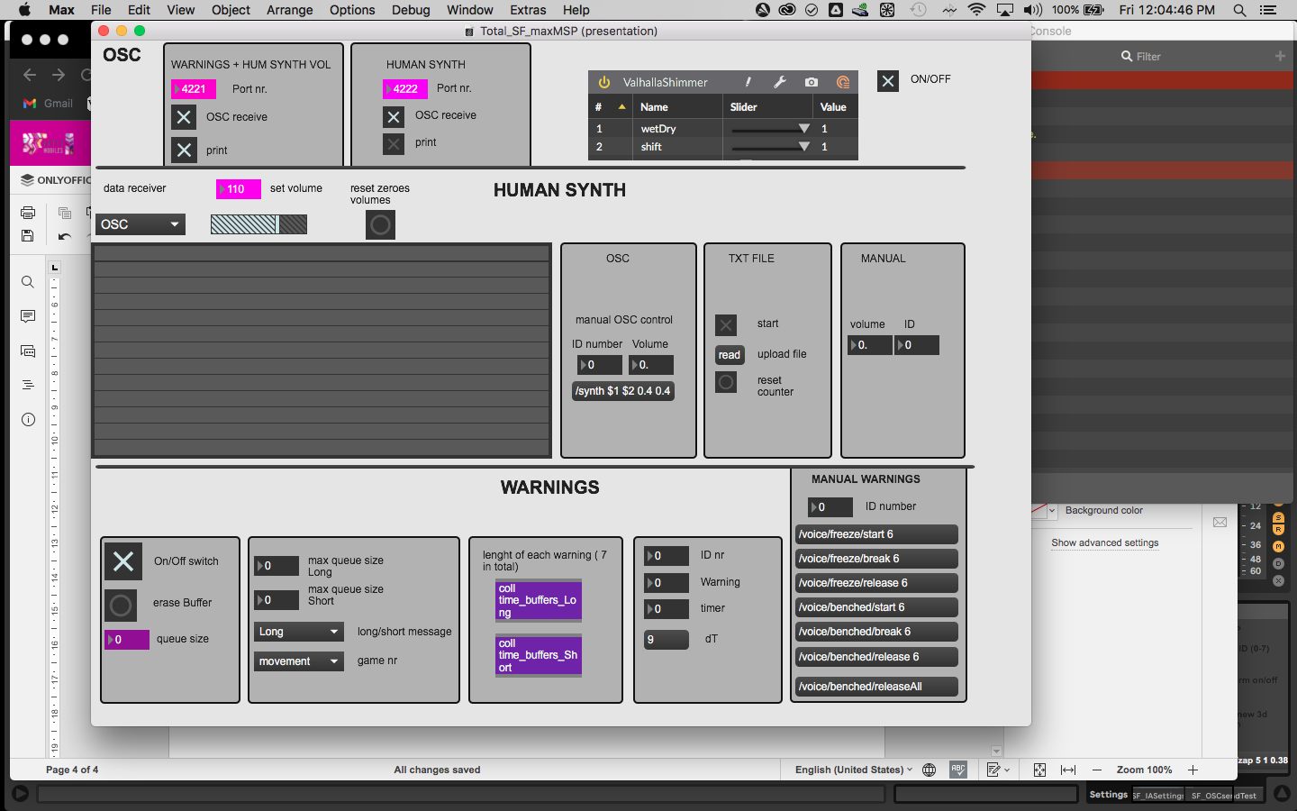

Figure 5

Be careful that if you change the port values, they won’t be saved when you close the software, as they are automatically set to the values you see displayed when opening the patches.

**1.4.2 SEND AND RECEIVE:**

Messages are set to be received from TouchDesigner on 4 different ports. With a toggle you can turn them on or off manually:

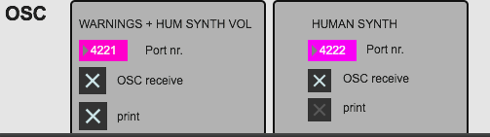

Figure 6

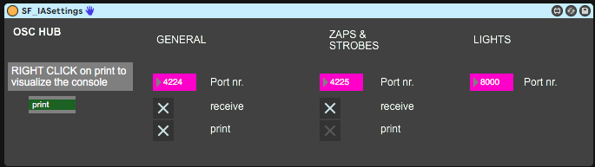

Figure 7

It is better not to print, unless necessary the human synth and the zaps messages as they take out a lot of CPU if printed.

So leave the settings as they are.

It is super important to have a visual perspective of which messages you are receiving, this is why it is important to have always the two windows with the messages opened on your screens in order to understand what is going on:

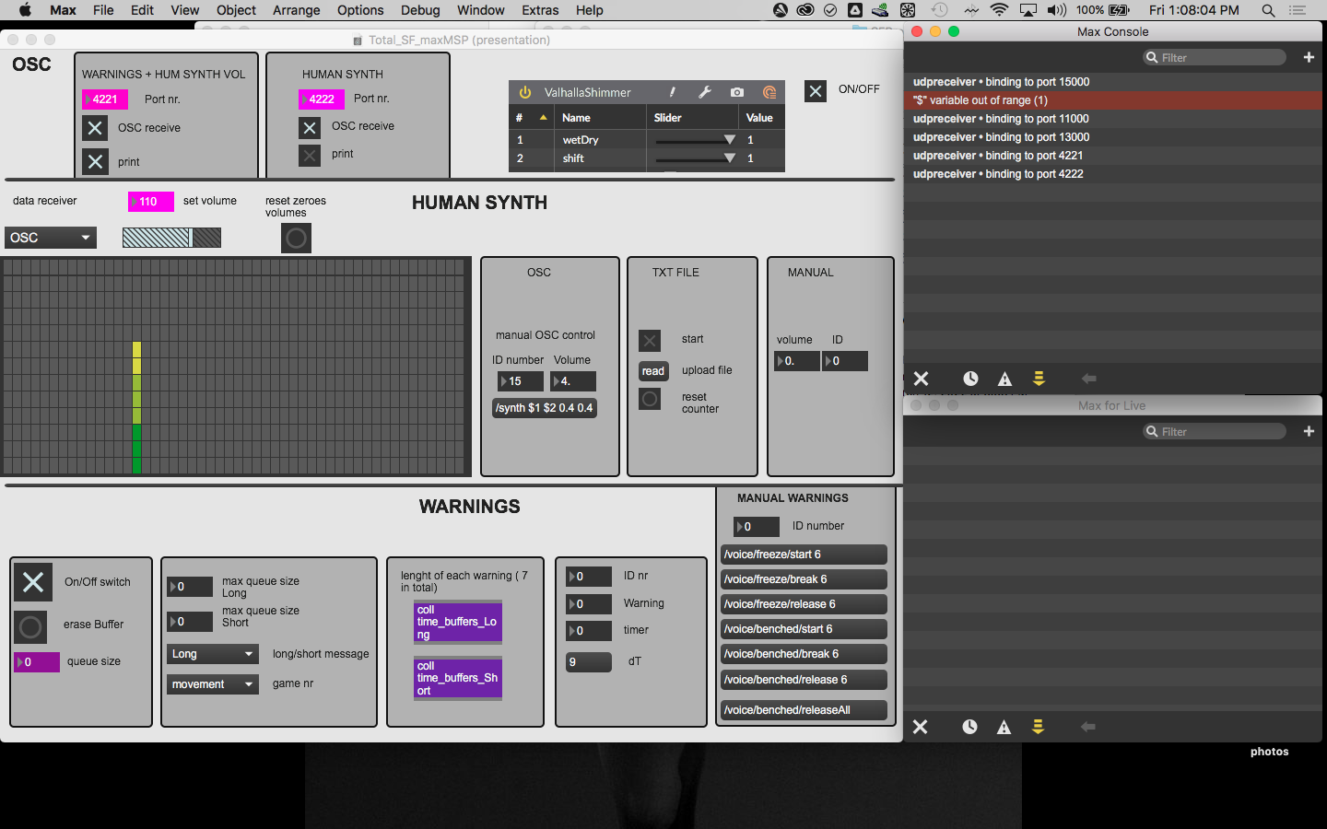

Figure 8

The max console will automatically open when you launch the patch, in order to prompt also the Max for Live Window you have to right click on the green message in the ableton device SF_IASettings (see Fig.7) .

**1.4.3 TEST**

**Test internally if messages are working:**

Ableton : always on the selected track “Settings” close to the device named SF_IAsettings there is also SF_OSCSendTest. If you click on any of the bottons with a command displayed, i.e. /intro/prediction/ 1 you can check if Ableton receives internally messages.

The same goes for Max Msp, you can test manually the Synth by setting a volume and ID number on the OSC manual control. Immediately set all the volumes back to zero when you are done.

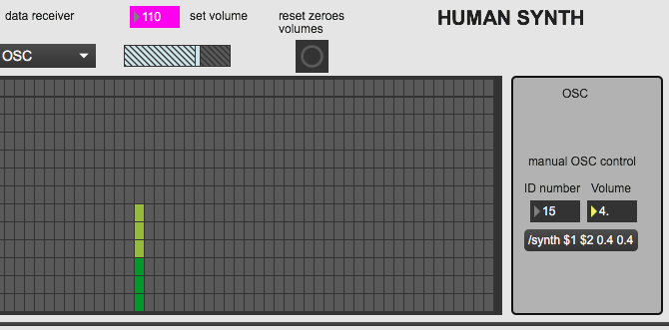

Figure 8

You can also test if the warning messages are working by selecting an ID number and trigger one of the messages:

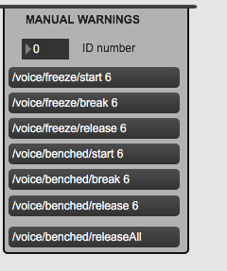

Figure 9

**Test Externally**

Now if everything sounds ok, you can directly test if you are receiving messages from the Touch Designer computer and also if you are sending the AI voice to the light desk.