**SOUND MANUAL**

**1.1 SOFTWARE REQUIREMENTS:**

* Ableton Live 10
* Max MSP 8 ( not required, but if you have it then you can also save changes)
* BlackHole ( preferred over Soundflower, if it is not possible than use Soundflower)
* MaxMSP Packages: CNMAT, ICST Ambisonics (installable over MaxMSP Paket Manager)

**1.2 FILES**

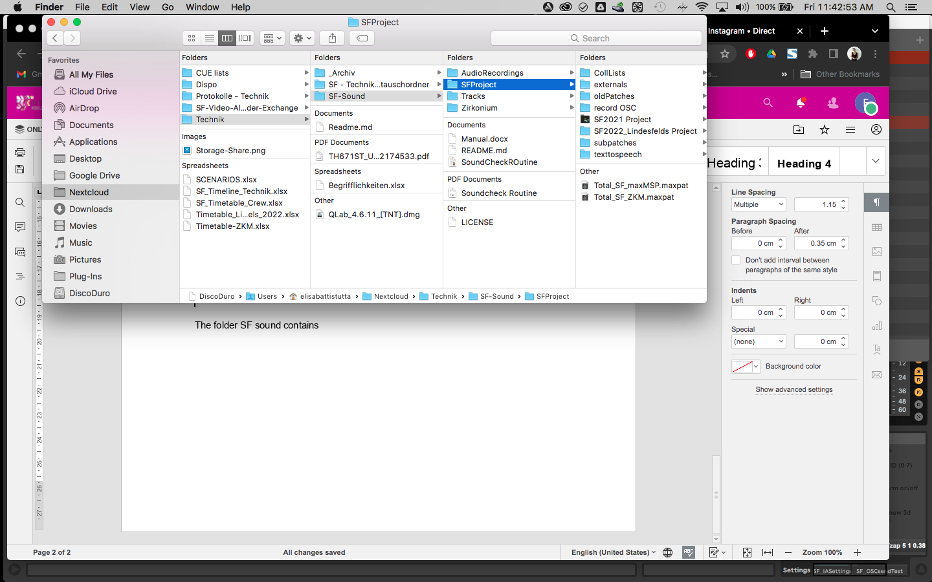

Figure 1

The folder SF sound contains SFProject. In there you find the two files you have to open which are

Total_SF_maxMSP.maxpat

And inside the Ableton folder SF2021, select the file

SF2022.als

**1.3 PLUGINS/EXTERNALS AND LIBRARIES**

* Valhalla Shimmer VST
* Waves Ultrapitch 6 Voices
* Envelope Bundle
* Fiddle, Bonk, Shell Max MSP Objects (these objects are stored in a folder named externals inside the SFProject folder , see Fig. 1)

On MAX MSP you also have to choose the path, in this way, the software knows were to search for files. This process can be set once and for all. If by any chance, you change the location of the project folder, than the path also need to be reset in here.

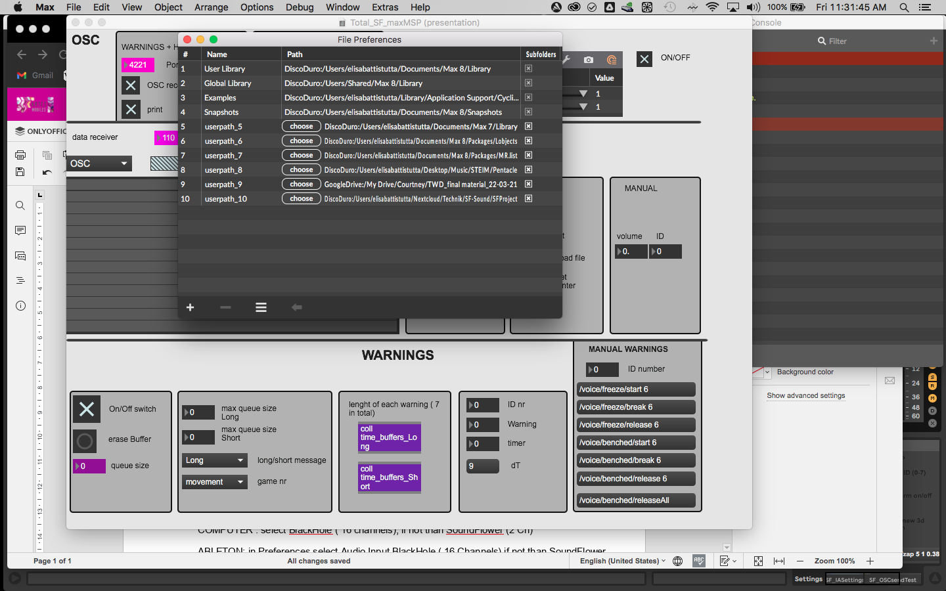

Figure 2

Go to Options -> File Preferences and on the bottom left of the window there is a plus. Toggle it and add your folder (Fig.2)

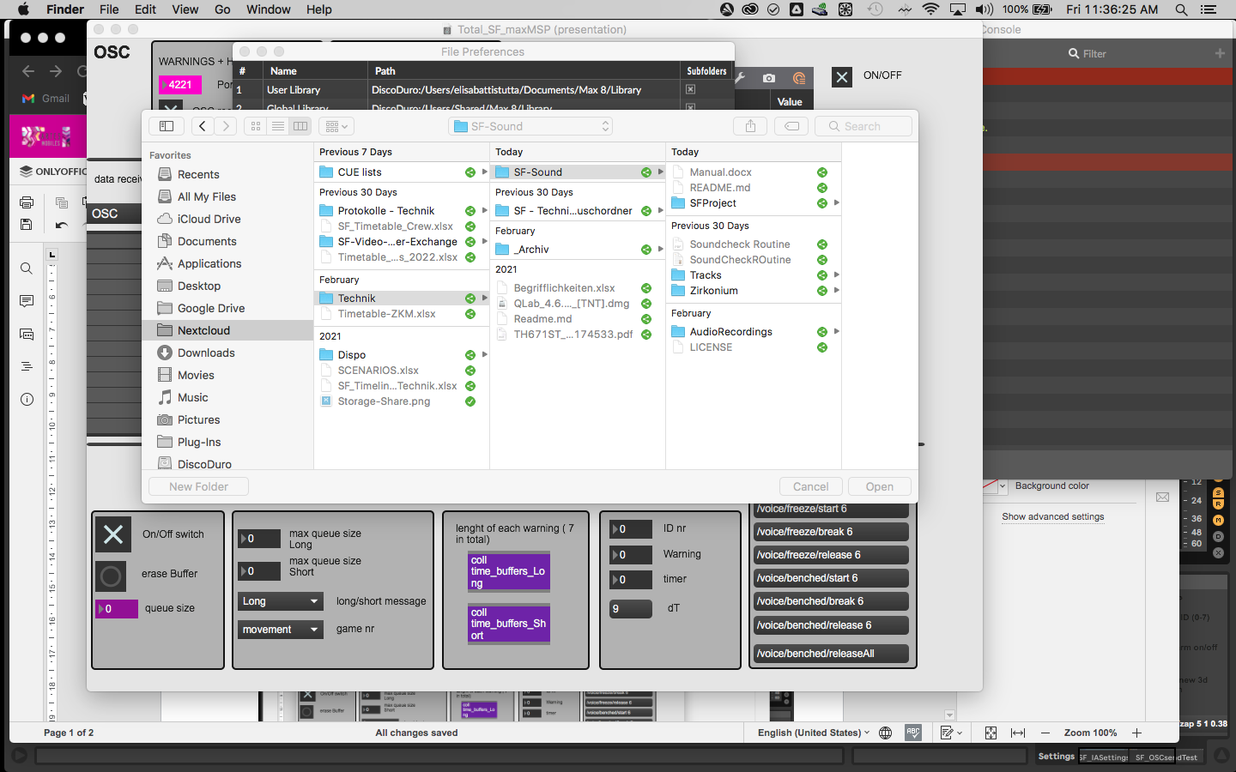

Figure 3

**1.4 AUDIO ROUTING**

MAX MSP: open top menu Options -> Audio Status and select for Output the soundcard

and also click on the audio on (blue botton on the audio status)

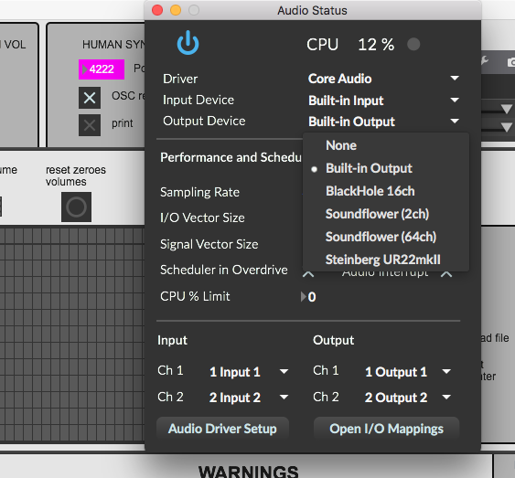

Figure 4

COMPUTER : select BlackHole ( 16 channels), if not than SoundFlower (2 Ch)

ABLETON: in Preferences select Audio Input BlackHole ( 16 Channels) if not than SoundFlower (2 Ch) Output the soundcard

**1.4.1 QUADRAPHONIC SETTINGS**

This Ableton file uses the Envelope plugin in order to recreate a quadraphonic environment.

The speakers must be numbered in order to have such a configuration:

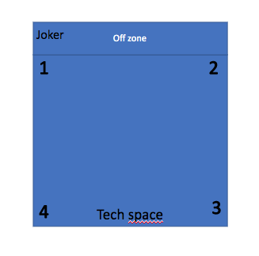

Figure 5

Check that the audio is routed in the following way:

* AI Voices: they are all sent to a bus (A AI Voices) and from that bus back to the track named E4L Master. Check that the “Audio to” menu on each voice (brown and pick tracks) is set to *sends only* option.

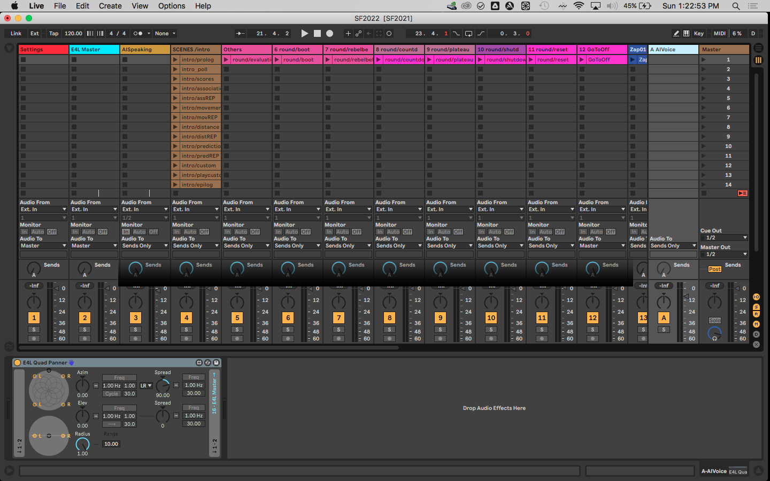

Figure 6

-Zaps: each zap has its own individual panner that is sent to the track E4L Master. All of them must be set as well to *sends only* option in the “Audio to” menu.

-Soundtracks: this one as well has its own individual panner that locate the sound in a stereo manner out of the 4 speakers

All these channel via their specific panners are all sent to the E4L Master and from there, out.

That means (see example in Fig. 7) :

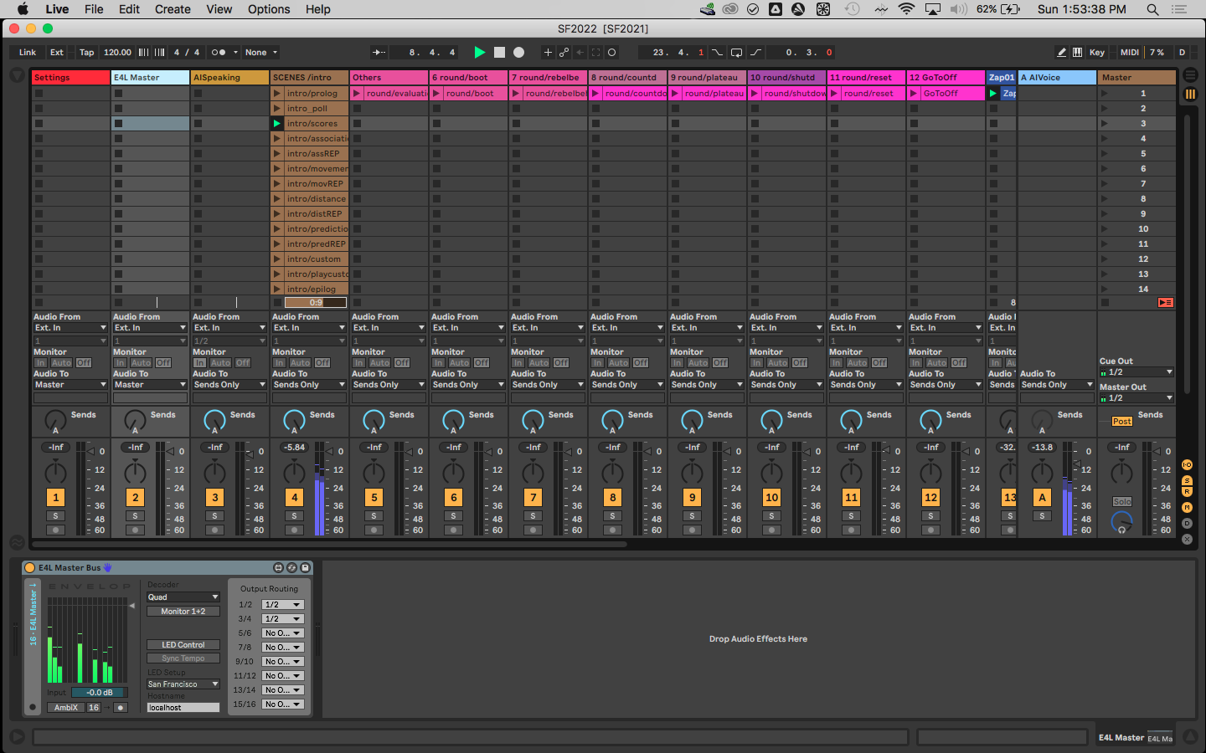

Figure 7

1- the audio in each single channel will be blue (because it is a send channel)

2- No Audio should appear on the ableton Master channel

3- Audio will appear on the E4L Master plugin

**1.5 OSC CONNECTIONS**

Sound computer should be 192.168.0.9

Switch off the wifi connections

**1.5.1 PORTS:**

Check in Ableton that the correct ports are selected ( see pink objects, Fig. 8 )

You can find this window if you select the track named settings

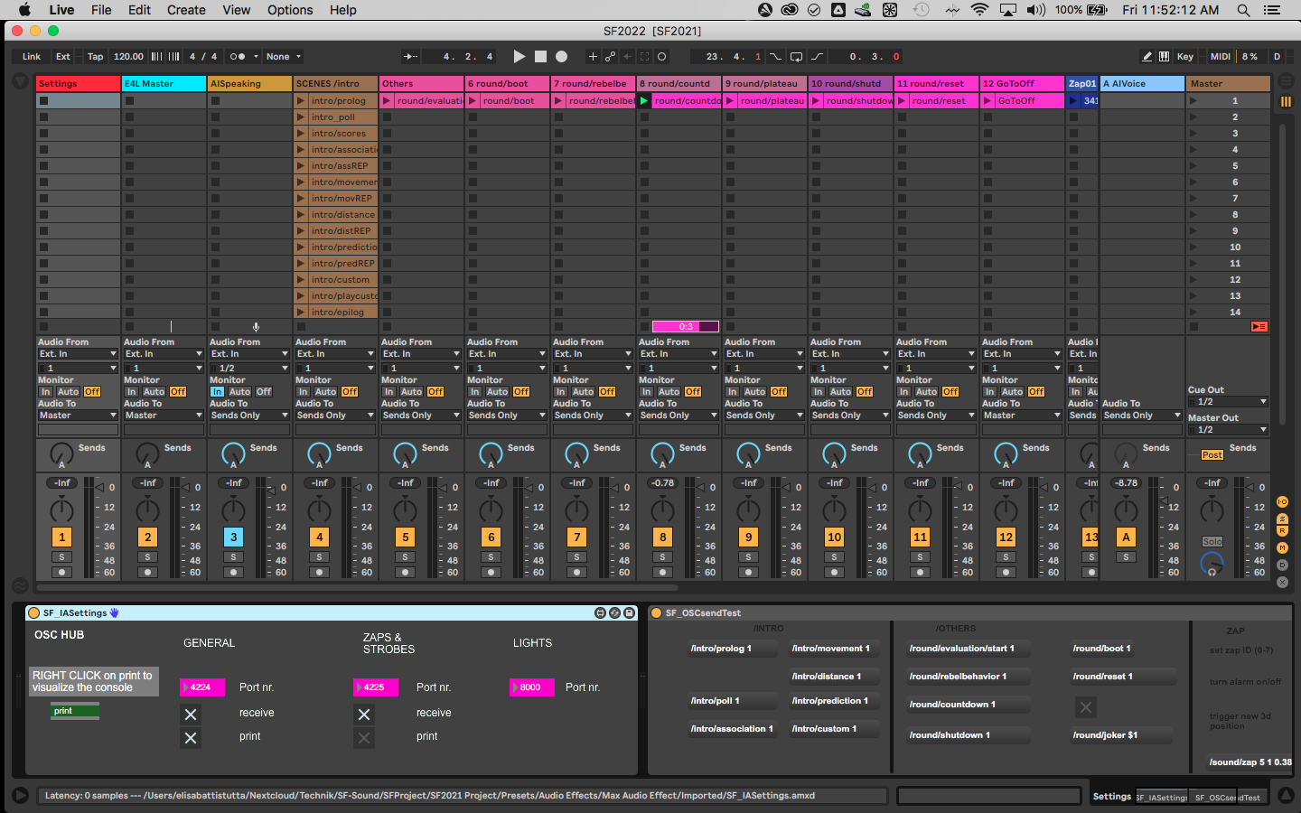

Figure 8

In MAX MSP the ports are also displayed in pink:

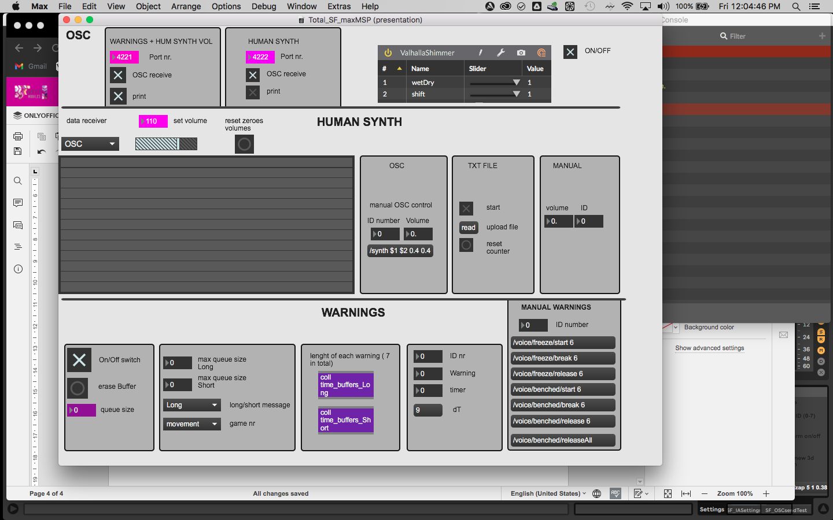

Figure 9

Be careful that if you change the port values, they won’t be saved when you close the software, as they are automatically set to the values you see displayed when opening the patches.

**1.5.2 SEND AND RECEIVE:**

Messages are set to be received from TouchDesigner on 4 different ports. With a toggle you can turn them on or off manually:

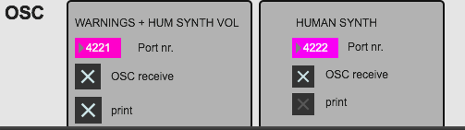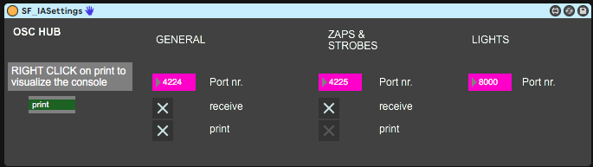

Figure 10

It is better not to print, unless necessary the human synth and the zaps messages as they take out a lot of CPU if printed.

So leave the settings as they are.

It is super important to have a visual perspective of which messages you are receiving, this is why it is important to have always the two windows with the messages opened on your screens in order to understand what is going on:

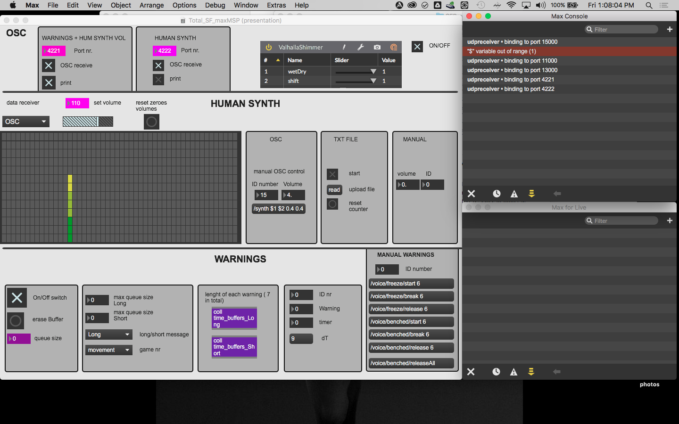

Figure 11

The max console will automatically open when you launch the patch, in order to prompt also the Max for Live Window you have to right click on the green message in the ableton device SF_IASettings (see Fig.10) .

**1.5.3 TEST**

**Test internally if messages are working:**

Ableton : always on the selected track “Settings” close to the device named SF_IAsettings there is also SF_OSCSendTest. If you click on any of the bottons with a command displayed, i.e. /intro/prediction/ 1 you can check if Ableton receives internally messages.

The same goes for Max Msp, you can test manually the Synth by setting a volume and ID number on the OSC manual control. Immediately set all the volumes back to zero when you are done.

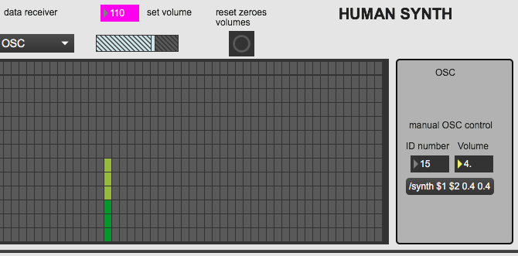

Figure 12

You can also test if the warning messages are working by selecting an ID number and trigger one of the messages:

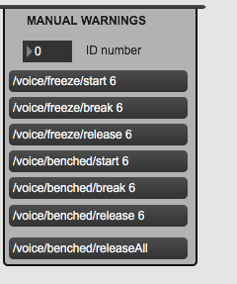

Figure 13

**Test Externally**

Now if everything sounds ok, you can directly test if you are receiving messages from the Touch Designer computer and also if you are sending the AI voice to the light desk.

**1.6 SOUND CHECK**

Start with the microphones to set the volumes.

After that run the Human Synth and set it to a desired Volume on the mixing board accordingly to the microphones volume. All the other volumes are already arranged accordingly to the Human Synth, so they should be already in a good mixed balance.

Note that, depending on the venue (speakers, size of the room, frequencies,.....) some minor changes and adjustments on each single bank of volumes could be needed.

## Known Bugs:

### Max/MSP

* The Valhalla Shimmer has to be turned on/off once at the beginning
* The “HUMAN SYNTH” print has to be toggled once at the beginning