# Bug 1

Describe the bug

Full retirement age calculates incorrectly when using dates before 1899. Returns an invalid date.

EARLIEST_YEAR = 1900

if birth_year < EARLIEST_YEAR:  
 return -1, -1

if we change the earliest year to something like 1500 it would let us have a more flexible program.

Program

Full_retirement_age_calculator_app.py

Component

Full_retiremnet_calc.py

full_retirement_date() method

Error Type

Logic error.

Severity

Minor

Priority

Set by management

## State

Open

To Reproduce

Steps to reproduce the behavior:

1. Enter year before 1899
2. Enter any month
3. Error appears
4. .

Expected behavior

I expected a valid date for my great great grandmother’s retirement date.

Screenshots

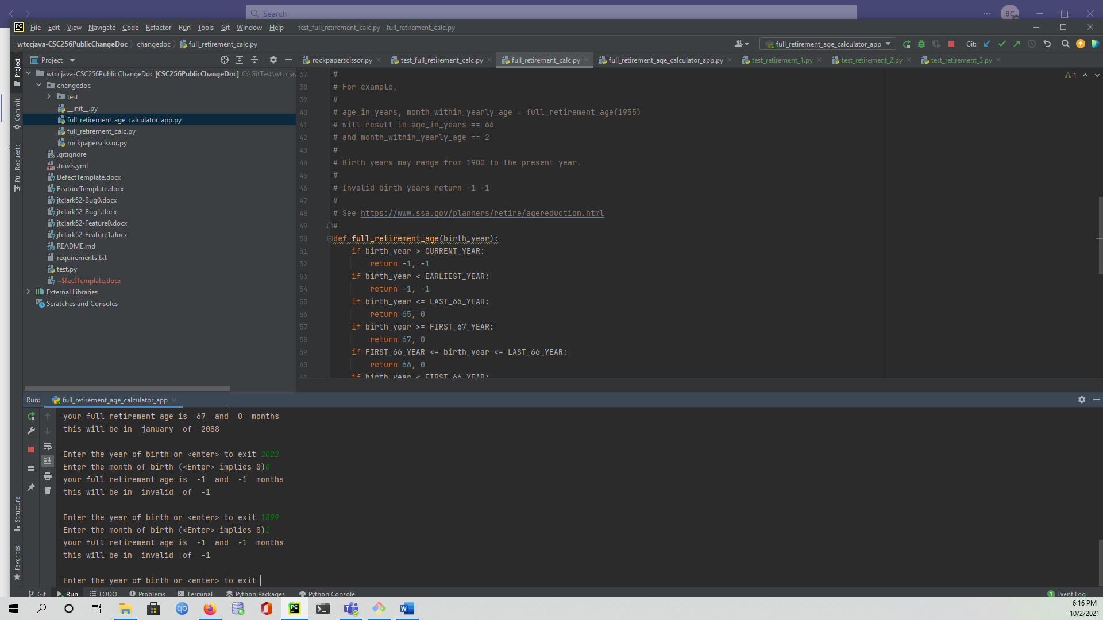Desktop

Please complete the following information:

* OS: Windows
* Browser [Firefox]
* Python
* 3.6

Additional context

Most people born before 1899 are dead or retired so this calculator doesn’t apply to them.

Assigned

Retirement code writer.