# Bug 2

Describe the bug

Full retirement age calculates incorrectly when using dates after current year. Returns an invalid date.

if birth_year > CURRENT_YEAR:  
 return -1, -1

instead just current year we can add 1000 to current year or manually put 3000 so we have a bigger range for the calculator.

Program

Full_retirement_age_calculator_app.py

Component

Full_retiremnet_calc.py

full_retirement_date() method

Error Type

Logic error.

Severity

Minor

Priority

Set by management

## State

Open

To Reproduce

Steps to reproduce the behavior:

1. Enter year after current year
2. Enter any month
3. Error appears
4. .

Expected behavior

I expected a valid date for my yet to be born child’s retirement date.

Screenshots

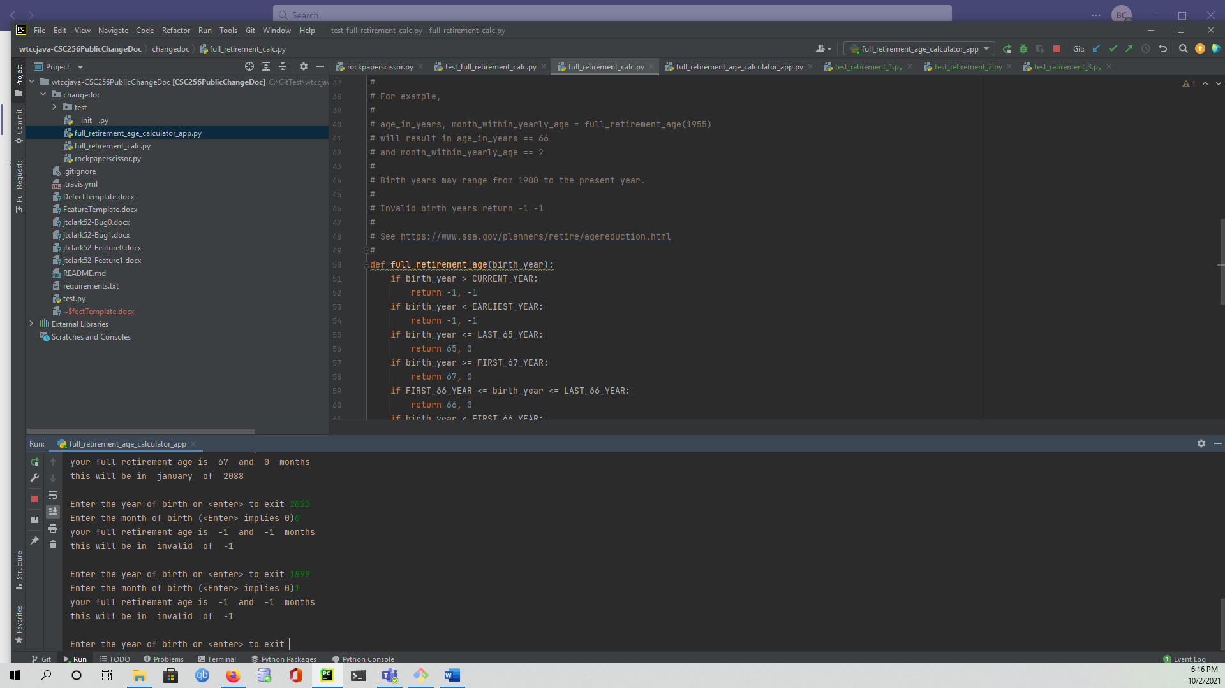Desktop

Please complete the following information:

* OS: Windows
* Browser [Firefox]
* Python
* 3.6

Additional context

No one has been born after the current year. This is a physical impossibility.

Assigned

Retirement code writer.