Bug 3

Describe the bug

Full retirement age calculates incorrectly when entering 13 for month. The program returns invalid and -1.

if age == -1 or birth_month_normalized < 0 or birth_month > 12:  
 return -1, 'invalid'

if we add a check after each input this we don’t have to use this line of logic at all.

Program

Full_retirement_age_calculator_app.py

Component

Full_retiremnet_calc.py

full_retirement_date() method

Error Type

Logic error.

Severity

Minor

Priority

Set by management

State

Open

To Reproduce

Steps to reproduce the behavior:

1. Enter any valid year between 1900 and 2021
2. Enter 13 for month
3. Calculation Error occurs showing invalid dates

Expected behavior

I expected an exception/try catch/ if statement to catch invalid months. The calculator just breaks and gives the wrong retirement age.

Screenshots

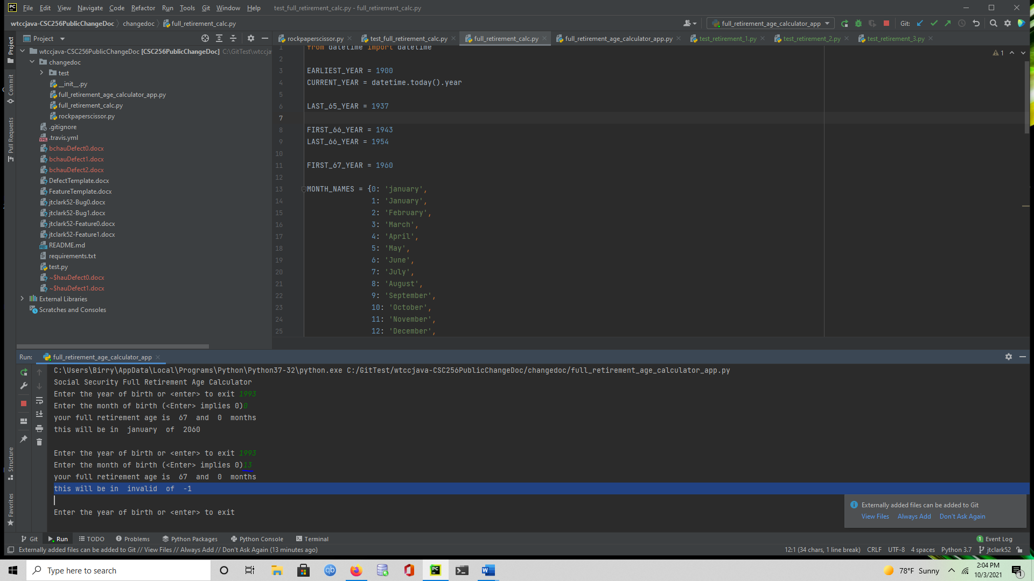

Desktop

Please complete the following information:

* OS: Windows
* Browser [Firefox]
* Python
* 3.6

Additional context

We should only run calculations when we get valid inputs. This is a clearly invalid date.

Assigned

Retirement code writer.