Article

**A Self-powered wireless bolt for smart critical fastener**

Biruk B. Seyoum, 1, Maurizio Rossi 2 and Davide Brunelli 3*

1 University of Trento; birukbelay.seyoum@unitn.it

2 University of Trento; maurizio.rossi@unitn.it

3 University of Trento; davide.brunelli@unitn.it

**\*** Correspondence: davide.brunelli@unitn.it; Tel.: +xx-xxx-xxx-xxxx

Academic Editor:

Received: date; Accepted: date; Published: date

**Abstract:** Thermoelectric generators (TEGs) are now capable of powering the abundant low power electronics from very small (just a few degrees Celsius) temperature gradients. This factor along with the continuously lowering cost and size of TEGs, has contributed to the growing number of miniaturized battery-free sensor modules powered by TEGs. In this paper, we present the design of a self-powered smart bolt for high-end electro-mechanical systems. The bolt is equipped with temperature sensor and a low power RF chip powered from a TEG. A DC-DC converter interfacing the TEG with the RF chip is used to step-up the low TEG voltage. The work includes the characterizations of different TEGs and DC-DC converters. The characterization was mainly done to determine the amount of power that can be generated from a TEG under different loads and at temperature gradients typical of mechanical environments. The power consumption of the prototype system under different conditions was also measured. The obtained result demonstrates that the power generated by the TEG at very low temperature gradients is sufficient to guarantee continuous wireless monitoring of the critical fasteners in critical systems such as avionics, motorsport and aerospace.

**Keywords:** Smart bolt; TEG; Peltier; IoT; Energy harvesting

1. Introduction

The average number of sensors on electromechanical systems (EMS), which includes different aerial and ground vehicles, complex infrastructures such as manufacturing plants, underwater oil & gas pipelines has undergone an exponential increase. Those EMS building blocks that are not fitted with sensors and therefore are not monitored and controlled by an automation system in real-time must undergo a periodic manual inspection and maintenance. This manual inspection which has a probability of being either premature or overdue is unreliable and adds extra cost. The effort of guaranteeing the safety by continuously monitoring the parts of EMS is the reason behind the expansion in the number of on-system sensors.

In EMS, critical fasteners that are located close to a large source of heat, such as an engine are subject to a continuous rapid heating and cooling which will eventually render them brittle [2]. The fasteners (bolts) are also subject to wear and tear caused by being over stressed. Over time and due to movement, the bolts may also become loose and unable to provide the proper tension to hold the parts together. It is therefore important to monitor the health of critical fasteners in EMS, especially those whose failure leads to a total failure or significant reduction in performance of the whole EMS.

The current state, safety and average time before the need for a replacement of critical fasteners can be determined using a continuously recorded temperature data. The tension in the fasteners can also be monitored to have an idea of the loosening of the bolts. Bolts that are crucial for the proper functioning of the whole system usually have a larger diameter which makes them ideal to fit small temperature sensors with an intelligent circuitry on the top.

The purpose of this work is to develop a system which monitors the safety of critical fasteners. The system has a small form factor and is installed on top of the fasteners. It has a temperature and tension sensors. The heart of the system is a low power micro-controller with an integrated radio module to send the sensed data to a central controller. The module will be powered from a TEG that generates electricity from the temperature gradient between the surface of the critical fastener and the environment. Fig. 1 is a schematic representation of the architecture of the system. In-terms of performance the system should fulfill the following requirements

* + 1. Generate its own energy
    2. Monitor available energy before transmission and postpone transmission if available energy is below threshold
    3. Dynamically adjust duty cycle (CPU wakeup frequency) based on available energy from TEG
    4. Dynamically adjust transmission power (above a certain threshold) based on available energy and environmental conditions
    5. Stay alive for as long as possible

The remainder of this paper is organized as follows. Section 2 provides a brief survey of the state of the art in terms of TEG powered applications. In section 3 the experimental setup is explained and the obtained results are demonstrated. The power management section describes the results obtained from the characterization of DC-DC converters. Finally, a conclusion is drawn based on the result.

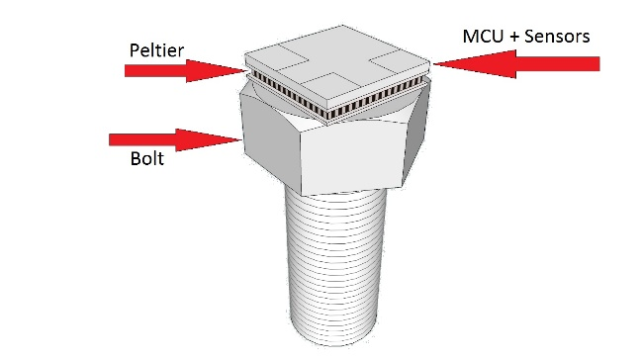

**Figure 1. System Model**

2. Materials and Methods

The purpose of our work is building a self-powered smart bolt which senses its own temperature, tension and other physical parameters and transmit the sensed data to a central controller over a radio. Our approach is first modularizing the system into three units namely the power generation unit i.e. TEG, the power conditioning unit i.e. DC-DC boost converter and storage capacitor and finally the core system which is composed of a CC1310 microcontroller and sensors. The TEGs used in this experiment are Peltier modules or thermoelectric coolers (TECs).

Performing a proper power budget analysis from generation to consumption is crucial step in designing energy autonomous systems. Therefore, the TEGs were characterized to record the amount of power they can generate under different conditions. The power consumption of the rest of the system under different conditions was also measured.

The first part of this section provides a brief review of the state of the art in TEG characterization and applications powered by TEGs. The second section will present our methods and design approaches.

2.1 Related work

Monitoring critical fasteners is an issue which several companies are trying to address. For example, [3] is a company that produces smart bolts with a built in visual tension indicator. This product measures tension on the bolt and displays the result via a shade of red led mounted on the top of the bolt. Although this is an innovative product, it is not suitable for a coordinated sensing as it would be difficult to interface it into an existing closed loop control system. In [4] General Motors employed smart bolts with a combination of small memory and RFID heads. These bolts are mounted on the engine blocks. As the engine passes through the assembly line, data is read and written to the RFID tag by the machines. This data is used at subsequent stages to verify if correct operation were done at the previous stage of assembly. Here the concern was so much into storing state information during the engine assembly rather than monitoring the health of the bolt itself. To the best of our knowledge we have not come across any other publication or product that monitors different properties of bolts in real time and relays gathered data to a central controller.

In terms of characterization of TEGs to find the maximum power, Gao et al. [5] propose an additional numerical analysis to improve the estimation of maximum power by measuring the open circuit voltage and short circuit current. A noninvasive thermal resistance estimation of TEGs is also presented in [6]. The possibility of powering a network of wireless sensors using a combination of TEGs and DC-DC boosters is explored in [10]. In this work the DC-DC booster efficiency was roughly approximated between 10-50% and the sensor module with an on-board ZigBee radio was operating with a 10% duty cycle. In [7] and [8] an interesting application of powering gas sensors in a server farm using heat generated from the servers in the data center is proposed. The experiments include the analysis of performance of a combination of two TEGs as generators and two server boards running benchmark applications as source of thermal energy. The system was functioning with a duty cycle of 0.0027%. An application on [9] demonstrates the use of TEGs to power sensors used in body area networks for assisting healthy aging. The TEGs were powered from body heat. The application scavenges 520 µW of energy at 15° C. The system operated with a 0.4% duty cycle. On [10] TEGs are used as a power source to monitor deep sea pipelines. The TEG was generating energy from the temperature difference between the pipe and the water. The collected temperature and motion data of the pipe was relayed using optical wireless communication. In a different approach [11] presents a model to predict the harvested energy using TEGs and photovoltaics based on factors such as light intensity, temperature gradient, human activity. This model can be adapted to perform theoretical analysis prior to performing any experiment on TEGs.

2.2 *Our Method and Approach*

2.2.1 Characterization of TEGs

The power density and the power density per square temperature gradient (power factor) are the two important parameters that uniquely identify the performance of a TEG. The design of the self-powered bolt started from characterization of three commercial thermoelectric generators from Digi-key namely *926-1216-ND* (**TEG1**), *926-1192-ND* (**TEG2**) and *926-1225-ND* (**TEG3**). Table I contains the summary of the specification of the TEGs. The characterization included measuring (i). the TEG output power at different values of load resistors and at a constant temperature gradient, ΔT, between the faces of the TEG (ii). the TEG output power at different ΔT values at a matched load. The first test had to be done primarily because the input resistance of the TEG was required for the second test.

The first test was done by keeping ΔT constant while varying the load resistance and recording the current and load voltage values to find the maximum power. This test was repeated for three ΔT values. The ranges of the temperature gradients that were tested were made as wide as possible to have a better understanding of the TEGs properties. The values of ΔT ranged from 5°C to 40°C. During these tests, the temperature of the hot side did not exceed 80°C. The resistor values used for this test ranged from 0.8Ω to 10KΩ. Then the gathered data was processed using MATLAB to determine maximum power point of the TEG for each ΔT. The second test was done by recording the output power of the TEG by using a matched resistor load and varying ΔT values.

**Table 1.** Summary of Specifications of TEG from datasheet

|  |  |  |  |  |  |  |  |
| --- | --- | --- | --- | --- | --- | --- | --- |
| **Label** | **Model** | **L**  [mm] | | **H**  [mm] | **Rin**  [Ώ] | **ΔT**max  [K] | **A**  [] |
| TEG1 | 926-1216-ND | | 26 | 14 | 0.25 | 67 | 1507 |
| TEG2 | 926-1192-ND | | 5 | 3.4 | 1.04 | 67 | 17 |
| TEG3 | 926-1225-ND | | 3.9 | 3 | - | 92 | 15.21 |

The current in the circuit and the voltage at the load were continuously recorded using NI LabVIEW USB-6008 acquisition tool from National Instruments. The acquisition board was sampling data at 100Hz and was feeding it to a LabVIEW project on a PC that was sorting and storing the measured values. The temperature at the faces of the TEGs were measured using a NTCLE100E3 thermistors whose R25 = 10 kΩ. The simple circuit used for the acquisition is as depicted on figure 2.

When current starts to flow in the measurement circuit the temperature gradient, ΔT, between the faces of the TEG starts to fluctuate due to the Peltier effect [12]. The fluctuation of ΔT in turn causes the fluctuation of the Seebeck coefficient. Therefore, an external thermostating circuit must be used to keep the temperature at a set point while conducting measurement. In [12] the thermostating was implemented using two extra TEGs, one as a heater and the other as a cooler, controlled in a feedback loop according to the temperatures of the faces of the main TEG. While providing a reliable measurement data, this solution has the disadvantage of adding complexity to the simple circuit used for acquisition. In this work a different approach was followed to remedy this problem. First the fluctuation of ΔT in relation to the current was observed from repetitive measurements using the circuit in figure 2 which is a circuit without thermostating. This led to identification of a pattern as to how ΔT was varying with the current. Then a software filter was implemented in Matlab to correct the fluctuation and gain correct output power values despite the fluctuation. Hence, instead of building a complex thermostating circuit the simple characterization circuit of figure 2 was kept as is.

A heat sink was used for cooling and provide a mechanical load on the TEG. Mechanical pressure on the TEG helps to reduce thermal contact resistance and also creates a uniform temperature distribution on the surface of the TEG.

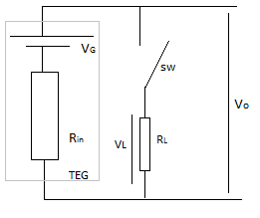

**Figure 2. Circuit used for characterization**

2.2.2 Characterization of DC-DC converters

The characterization of two DC-DC boost converters namely LTC3108 from linear technologies [19] and Nextreme WPG-1 from formerly Nextreme now Laird Technologies [20], was done. A super capacitor was connected to the output of both boost converters to store energy coming from the TEG when the load was in low power mode. The converters were characterized for their efficiency and charging profile of the output 250mF supercapacitor. The converters were supplied once from the TEG and at another time from a dc source while in both cases their input and output powers were recorded simultaneously. The efficiency of DC-DC converters varies in relation to the input power therefore supplying the converter from the DC source was necessary to assess the efficiency of the converter at higher input power. The input resistance of the DC-DC boost converters did not match that of the TEG and both converters that were used did not embed a MPPT module. So, maximum power transfer was not guaranteed in both cases.

2.2.3 Measuring the power requirements of the system

The smart bolt is composed of CC1310 microcontroller [13] interfaced with a temperature sensor and a tension sensor and it was powered from a TEG. The system was running a TI-RTOS based firmware and the MCU was programmed and debugged using SmartRF06 [14] evaluation module. The power consumption of the MCU was measured by varying the transmission power, packet size, duty cycle and type of modulation.

3. Results

3.1. Results from the Characterization of TEGs

The characterization of the thermoelectric modules was conducted to verify the data reported by the manufacturer before employing the TEGs for use and to obtain more information about the power density and the power factor, parameters that were not reported on the technical document provided by the manufacturer. The results from the experiment are summarized on Table 2. The table contains the results obtained from this experiment (the first three entries on table 2) and results reported on other TEG modules (the last 4 entries on table 2) by other authors for comparison. The characterization result of TEG 4 (PE127-14-15) and TEG 5 (Thermolife 009r) are as reported in [1] and the results for TEG 6 (Peltier module 12706AC) and TEG 7 (TEC-12710) are reported in [16] and [17] respectively.

**Table 2** Summary of Experimental Results and Comparisons

|  |  |  |  |
| --- | --- | --- | --- |
| **Label** | **Rin**  [Ώ] | **[** | **PF** |
| TEG1 | 1.4 | 40.625 | 0.0271 |
| TEG2 | 2.3 | 6.94 | 0.404 |
| TEG3 | 2.1 | 6.04 | 0.397 |
| TEG4 | 2.23 | 224 | 0.14 |
| TEG5 | 250K | 1 | 0.015 |
| TEG6 | 1.9 | 5.31 | 0.0033 |
| TEG7 | 1.08 | 0.25 | 0.156 |

Figure 3a also depicts the variation of the output power of TEG 1 with the load resistance under different temperature gradients. As shown in the graph, as the resistance of the load increases the output power is severely reduced. The TEGs used in this work are Peltier modules which are usually designed with a low internal resistance to increase the current flow and therefore to absorb more heat when a constant voltage is applied. There is also a discrepancy between the manufacturer reported internal resistance values as summarized on table 1 and the measured internal resistance in the lab (table 2). This is in part because of the dissimilar testing environment and testing conditions and due to the contact resistances, which were not accurately stated in the data sheet.

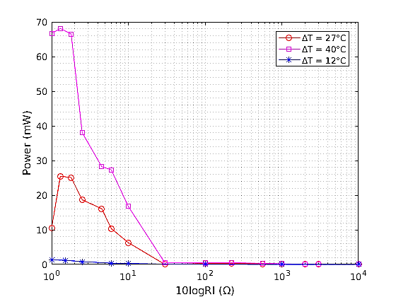 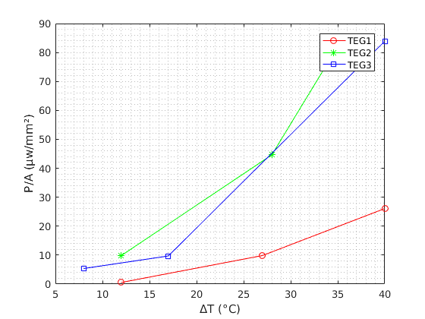

(a) (b)

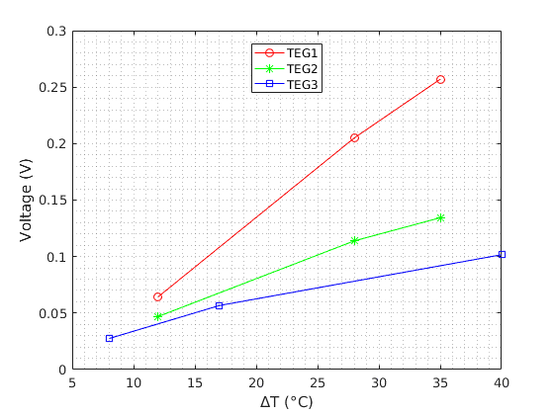

(c)

**Figure 3.** (a)Power vs 10logRL for TEG1; (b) Power vs ΔT at matched load; (c) Open circuit voltage Vs ΔT

The power density (power per unit area) vs ΔT at a matched load for each module is also shown in figure 3b. Even though TEG 1 generates higher power compared to the other TEGs, due to its larger surface area, it has a lower power density compared to the other TEGs. It may be even better to use a combination of TEG 2 and TEG 3 While having information about the maximum power from a TEG is very important to plan the power budget of an application, it is also more important to have a measure of the power factor and power per area to correctly understand the capabilities of a TEG and making the right decision in the design choice stage.

The open circuit voltage and ΔT also have a linear relationship and this is clearly depicted by Fig 3c. TEG 1 has the highest open circuit voltage for a temperature gradient compared to the two TEGs. Knowing the open circuit voltage under different temperature gradients is useful when employing maximum power point tracking (MPPT) on the TEG.

3.2 Results from the Characterization of DC-DC converters

In low energy harvesting, the power scavenged from TEGs is used to supply electronic devices continuously or with some duty cycle. TEGs provide adequate power but with very low nominal voltages. For example, TEG 1 was generating 18mW at a temperature gradient of 20°C at 140mV. This power is considerably large but the low voltage from the TEG is not enough to start almost any kind of electronic device. Hence, to use the TEG power, the TEG voltage needs to be boosted using DC-DC boost converters. A prototype load which replicated the behavior of the MCU with a radio was used for the characterization of the converters. This load was simulating a radio communication with a duty cycle of 0.5% and it was running with a period of 3s. It was consuming 42.15mW in the active mode and 360µW in low power mode. Figure 4 and 5 depict the recorded measurements when the LTC3108 and Nextreme modules were being supplied by a TEG respectively. The result of this characterization is summarized in tables 3 and 4.

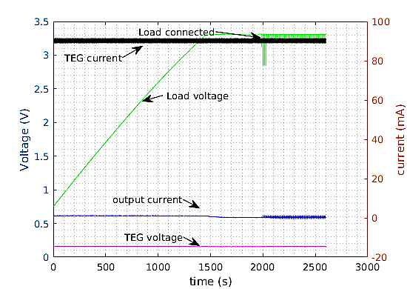

**Figure 4.** LTC3108 supplied from TEG

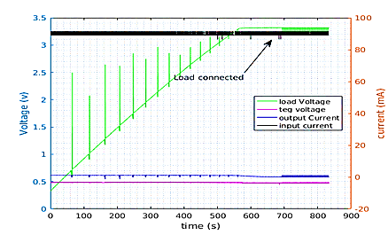

**Figure 5.** Nextreme supplied from TEG

**Table** 3 LTC3108 Characterization Result **Table** 4 Nextreme Characterization Result

|  |  |  |  |  |  |
| --- | --- | --- | --- | --- | --- |
| **Supply** | ***Vin***  ***[mV]*** | ***Iout***  ***[μA]*** | ***Pin***  ***[mW]*** | ***Pout***  ***[mW]*** | ***Η***  ***(%)*** |
| TEG | 78 | 250 | 1.69 | 0.83 | 49.1 |
| DC | 477 | 1000 | 42 | 3.16 | 13.29 |

|  |  |  |  |  |  |
| --- | --- | --- | --- | --- | --- |
| **Supply** | ***Vin***  ***[mV]*** | ***Iout***  ***[μA]*** | ***Pin***  ***[mW]*** | ***Pout***  ***[mW]*** | ***Η***  ***(%)*** |
| TEG | 136 | 380 | 3.4 | 0.95 | 27.1 |
| DC | 477 | 850 | 43.5 | 2.6 | 5.9 |

As the input power increase the efficiency of both converters goes down significantly. For instance, when supplied from the TEG it took the Nextreme module about 25 minutes to charge the supercap to 3V while it took the LTC3108 close to 40 minutes to do the same. Even though the LTC3108 had a higher efficiency (almost a double) it was receiving less input power from the TEG and therefore it took longer time to charge. From the result LTC3108 outperformed the Nextreme-WPG-1 module in both cases.

The supercap charging power was not constant. To calculate the efficiency of the converter the average output power was used. The average power was calculated first by collecting the calculation results of the rate of change of energy at the capacitor every 330ms into a set. The set was then observed to have a normal distribution as depicted in figure 6. The mean of this distribution was then taken as the average power and it was used to estimate the efficiency. Fig 6 (a) and (b) depict the normal distribution of the average output power when the Nextreme module was charging the supercap when the module was supplied from the dc source and the TEG respectively. The mean output powers were around 2.6mW for the dc source and 0.9mW for the TEG.

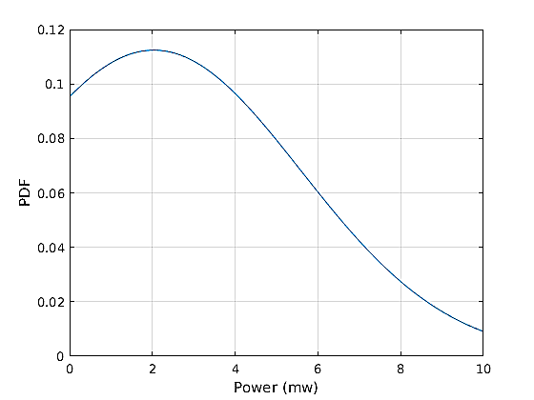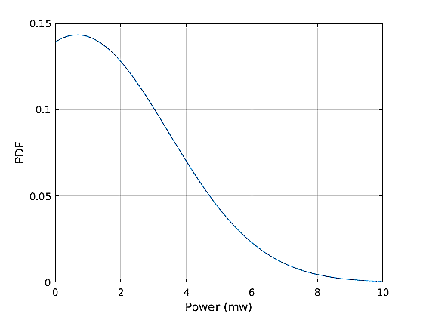

**Figure 6** (a) Probability distribution of output power in the Nextreme WPG-1 module when supplied from (a) dc source (b) TEG

3.3 Results from the Characterization of the system

The smart bolt system consists of a CC1310 low power wireless MCUs from Texas instruments and LTC3108 DC-DC boost converter. For this experiment the system was powered using TEG 1. This TEG has a very small footprint (1.5) that makes it easier to fit on top of most critical fasteners. The CC1310 has an ARM cortex M3 CPU running with 48MHz clock. It also has an ARM M-0 microcontroller which runs the radio firmware. The radio communicates with the software running on the main CPU using a shared memory interface. For this test, another CC1310 module was used as a receiver to record correct reception of transmitted packets.

The energy consumed by the microcontroller was then measured (i) by varying the transmission power and the type of modulation while keeping the packet size and transmission period constant (ii) by varying the packet size and transmission period under a fixed transmission power and modulation (iii) by varying the transmission power, type of modulation and packet size under a fixed transmission period. In all cases the transmission frequency was 868MHz. All the unused GPIOs were connected to the internal pull resistor to protect current leakage. The device power management is handled by TI-RTOS. With minimal or no configuration in the application, the rtos by default invokes a target specific power policy during the idle time of the application. In this test, since the application, running on the Cortex M3 was utilizing only the radio and no other peripheral both CPUs switch into standby mode immediately after transmission. The wakeup time of the radio was observed to be 0.9ms.

In case (i) the power consumption of the system during transmission was measured by varying the transmission power values from -10dbm to 14dbm in GFSK and OOK modulation. The packet size was 32 bytes and the transmission was repeated every second for both modulations. For a fixed transmission power, the amount of current drawn by the system remains constant even when varying the packet size and duty cycle. In fact, the variation of these parameters. The result of this test is represented in figure 5. As depicted in the result the usage of GFSK modulation resulted in a slightly higher power consumption by the system. In case (ii) the power consumption of the system was measured by varying the packet size and the transmission period meanwhile keeping the transmission power constant at 14dbm. The radio was transmitting in GFSK modulation while the packet sizes that were tested were 5, 20 and 64 bytes with transmission duration of 2.96ms, 5.37ms and 12.39ms respectively. The transmission was repeated with periods of 500ms, 1s and 1.5s resulting in duty cycles of [0.592%, 1.074%, 2.47%], [0.296%, 0.537%, 1.23%] and [0.197, 0.358%, 0.826%] respectively for each packet size. Fig 6 shows the relationship between duty cycles and the average power consumption over different packet sizes.

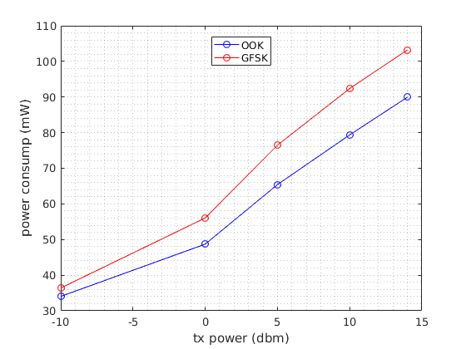

**Figure 5.** Transmitter power consumption under (a) OOK modulation (b) GFSK modulation

Based on the results of the first test, the system was consuming 102mW when transmitting at 14dbm and 240 μW in the low power mode. The power consumption reported in this test is the average of the power consumption in the active and low power modes. As inferred from figure 6 the average power is directly related to the packet size and the duty cycle. As the size of packet increases the current drawn by the MCU and hence the energy consumption increases considerably.

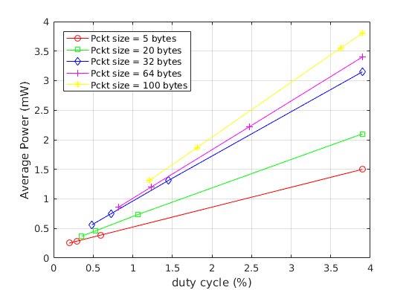

**Figure 6**. Correlation between power consumption, packet size and duty cycle at 14dbm transmission

For case (iii) the power consumption of the system was measured over packets of sizes of 5, 20, 32, 64 and 100 bytes and set of transmission power levels ranging from -10dbm to 14dbm. The purpose of this test was further quantifying the performance of the system by measuring the energy per bit under a set of changing parameters. The energy per bit values obtained from this test will ultimately be used by the microcontroller for a choice of transmission parameters based on the available energy at the supercapacitor. a stage to transition into. will measure th conditions such as measure the energy per bit measurement was done for both the GFSK and OOK modulations. The transmission period was one second. The measured power consumption was then used to calculate the energy per bit. The measurement was done for both the GFSK and OOK modulations. Also in this case the average energy from the average power was used to calculate the energy per bit. As it is evident from the result, the energy per bit is considerably higher when using GFSK instead of OOK modulation.

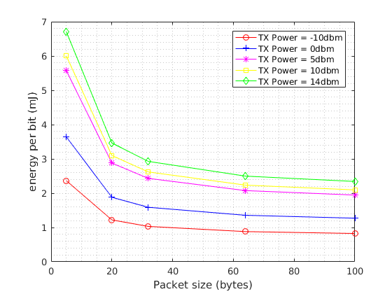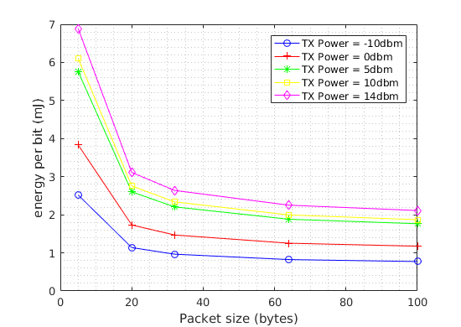

(a) (b)

**Figure 7.** Transmitter power consumption under different packet sizes and transmission power in (a) GFSK modulation (b) OOK modulation

The average power in this case is calculated by first computing the total energy consumed by the module in each period and dividing this energy by the period. As it is evident from the result, the energy per bit is considerably higher when using GFSK instead of OOK modulation.

Table 5 is a summary of the maximum duty cycle the system remains energy autonomous. It is computed by accounting the power generated by the three TEGs at different temperature gradients and the energy consumed by the system when transmitting 32 bytes packets at 14dbm. The transmission time of the packet was 7.26ms. The system was consuming 240 μW in the low power mode. The maximum duty cycle is then calculated using

(1)

(2)

Where E is the energy and T is the total time which is the sum of transmission and sleep times. The efficiency of the DC-DC converter at these temperatures is taken from the characterization of the converters in the previous section and it is used to determine the net power that is delivered to the load. From these results, it is expected to stream temperature data every 468ms (1.55% duty-cycle) with a ∆T as low as 10°C employing TEG 1 as supply of CC1310 MCU through the LTC3801 converter. One interesting result from this summary was understanding that TEG 2 and TEG 3 are not be able to support the application at a temperature below a temperature gradient of 14°C.

**Table** 4. Estimation of Max duty cycle based on input power

| **Label** | **Experimental Result** | | | | | |
| --- | --- | --- | --- | --- | --- | --- |
|  | |  | |  | |
| TEG1 | (mW) | 1.8 | (mW) | 16.4 | (mW) | 44.5 |
|  | 1.55 |  | 18.9 |  | 77 |
| TEG2 | (mW) | 0.18 | (mW) | 0.87 | (mW) | 2.0 |
|  | - |  | 0.62 |  | 1.76 |
| TEG3 | (mW) | 0.15 | (mW) | 0.45 | (mW) | 1.4 |
|  | - |  | 0.2 |  | 1.15 |

4. Discussion

The results of all the experiments done in this work are not used only at the design stage for choosing the right type of TEG or DC-DC converter but are also used by the firmware to adaptively decide radio transmission parameters at run-time. The firmware that is running on the cortex M3 receives a temperature reading of the surface of the bolt and the energy level of the supercap. The temperature reading which is going to be transmitted to a central controller is also used by the application to estimate the amount of power that is being generated by TEG using characterization information in section 3.1. The application then measures the amount of energy stored in the supercapacitor.

Init

Read Temp

Energy <

Calculate.

NO

Yes

Low power mode

Channel condition changed?

NO

Recalculate parameters

Yes

Recalculate parameters

Transmit

**Figure 8**. Flowchart of the adaptive parameter transmission adjustment

Based on these two values (TEG power and energy in the supercap) and assessment of the channel from previous transmissions the application makes a revision on the transmission power and the duty cycle values. If the energy in the supercap is below a threshold , the application takes the system into a low power mode after scheduling the next wakeup to . is the time the TEG takes to charge the supercap to and it is easy to calculate as the application already estimate the amount of power the TEG is generating and the charging profile of the supercap by the DC-DC converter from section 3.2. The flow is depicted in figure 8.

5. Conclusion

In this work the design of smart bolt for critical fasteners was investigated. Critical fasteners that are crucial for the proper performance of EMS should be monitored using different techniques. Three Peltier modules were characterized to evaluate their performance under different temperature gradients and different loads. Two dc-dc converters we also characterized to determine their efficiency. Finally, a sensor module which was composed of an ARM based RF chip was powered using one of the TEGs and temperature readings were transmitted wirelessly. Based on the transmission power, the transmit duration, the total power consumption and efficiency data from the characterization of the dc-dc converters, the maximum duty-cycles each TEG could provide to this system under different temperature gradients is summarized.

Starting from these results, we are going to study how to effectively integrate different sensors, in addition to the temperature one, in the top of the smart bolt to extend the set of industrial target application.

**Acknowledgments:** Authors would like to thank the IEEE Smart City Initialtive and the Fondazione Cassa di Risparmio di Trento e Rovereto – CARITRO that supported this activity.

**Conflicts of Interest:** The authors declare no conflict of interest

References

1. S. Dalola, M. Ferrari, V. Ferrari, M. Guizzetti, D. Marioli and A. Taroni, "Characterization of Thermoelectric Modules for Powering Autonomous Sensors," in IEEE Transactions on Instrumentation and Measurement, vol. 58, no. 1, pp. 99-107, Jan. 2009.
2. <https://depts.washington.edu/matseed/mse_resources/Webpage/Metals/mmetalprocessin.htm>
3. http://www.smartbolts.com/dti/
4. http://www.popularmechanics.com/cars/a9959/this-bolt-is-the-key-to-gms-high-tech-assembly-line-16324897/
5. J. Gao and M. Chen, "Beat the Deviations in Estimating Maximum Power of Thermoelectric Modules," in *IEEE Transactions on Instrumentation and Measurement*, vol. 62, no. 10, pp. 2725-2729, Oct. 2013
6. F. Attivissimo, A. Di Nisio, C. G. C. Carducci and M. Spadavecchia, "Fast Thermal Characterization of Thermoelectric Modules Using Infrared Camera," in *IEEE Transactions on Instrumentation and Measurement*, vol. 66, no. 2, pp. 305-314, Feb. 2017
7. Luca Rizzon , Maurizio Rossi , Roberto Passerone , Davide Brunelli, Wireless sensor networks for environmental monitoring powered by microprocessors heat dissipation, Proceedings of the 1st International Workshop on Energy Neutral Sensing Systems, November 13-13, 2013, Rome, Italy
8. M. Rossi, L. Rizzon, M. Fait, R. Passerone and D. Brunelli, "Energy Neutral Wireless Sensing for Server Farms Monitoring," in IEEE Journal on Emerging and Selected Topics in Circuits and Systems, vol. 4, no. 3, pp. 324-334, Sept. 2014.
9. D.C. Hoang, Y.K. Tan, H.B. Chng and S.K. Panda "Thernal Energy Harvesting from Human Warmth for Wireless Body Area Network in Medical Health System" PED 2009
10. . S. Amara-Madi, C.A. Price, A. Bensaoula, M. Boukadoum, "Autonomous sensor system for deep-sea pipeline monitoring", *New Circuits and Systems Conference (NEWCAS) 2013 IEEE 11th International IEEE*, pp. 1-4, 2013.
11. D. Fan, L. L. Ruiz, J. Gong and J. Lach, "Profiling, modeling, and predicting energy harvesting for self-powered body sensor platforms," *2016 IEEE 13th International Conference on Wearable and Implantable Body Sensor Networks (BSN)*, San Francisco, CA, 2016, pp. 402-407
12. S. Dalola, M. Ferrari, V. Ferrari, M. Guizzetti, D. Marioli and A. Taroni, "Characterization of Thermoelectric Modules for Powering Autonomous Sensors," in *IEEE Transactions on Instrumentation and Measurement*, vol. 58, no. 1, pp. 99-107, Jan. 2009.
13. http://www.ti.com/lit/ds/symlink/cc1310.pdf
14. http://www.ti.com/lit/ug/swru321b/swru321b.pdf
15. Madhal, M., Wagnerova, R., Frischer, R. 2011. "Alternative Methods of Power Supply for Autonomous Intelligent Wireless Sensors" 12th International Carpathian Control Conference ICCĆ2011. Velké Karlovice, Czech Republic, 2011, pp. 262-265
16. S. E. Jo, M. K. Kim, M. S. Kim and Y. J. Kim, "Flexible thermoelectric generator for human body heat energy harvesting," in Electronics Letters, vol. 48, no. 16, pp. 1013-1015, August 2 2012.
17. Leonov V, Torfs T, Fiorini P and Van Hoof C 2007 “Thermoelectric converters of human warmth for self-powered wireless sensor nodes” IEEE Sensors J. 7 650-657
18. G. Pasold, P. Etlin, M. Hahn, U. Muster, V. Nersessian D. Bonfrate, R. Buser, M.Cucinelli, M.Gutsche, M. Kehl, N. Zäch, R. Hazelden “Powering wireless sensors: Microtechnology-based large-area thermoelectric generator for mass applications” sensors, 2011 IEEE.
19. LTC3108 DC-DC converter datasheet available at <http://cds.linear.com/docs/en/datasheet/3108fc.pdf>
20. Nextreme WPG-1 datasheet availabe at <http://www.mouser.com/ds/2/292/Nextreme_Thermobility_WPG-1_Data_Sheet-1931.pdf>

H:\documents\layout\new template June 2014\figures\CC-BY logo original v1.wmf© 2017 by the authors. Submitted for possible open access publication under the   
terms and conditions of the Creative Commons Attribution (CC BY) license (http://creativecommons.org/licenses/by/4.0/).