Use case Diagram Samples for “Selam Transport platform”

1. Customer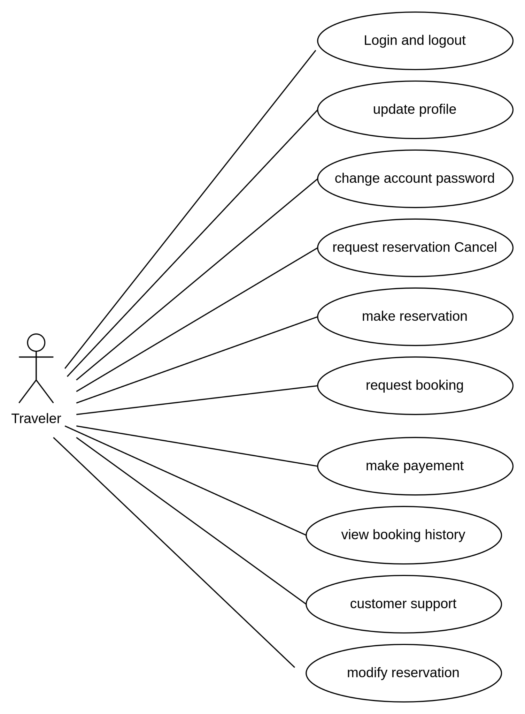

1. Route and Ticket Officer

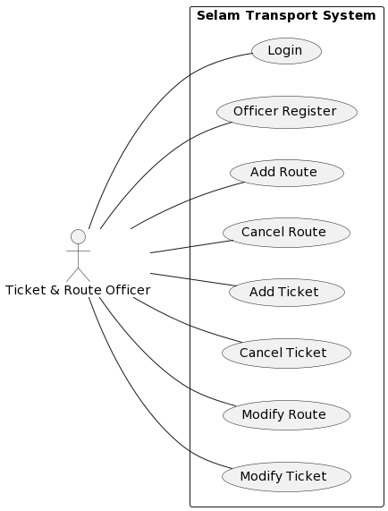

1. Transport provider/Admin

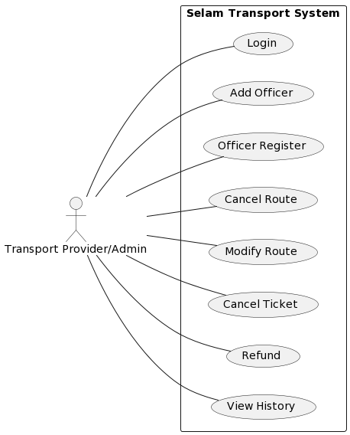

1. Super Admin

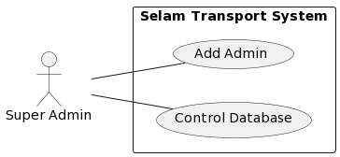

***The Whole System is Depicted in the next page below…..***

