1. First we extract the posts of a channel called afriworks the export chat history option 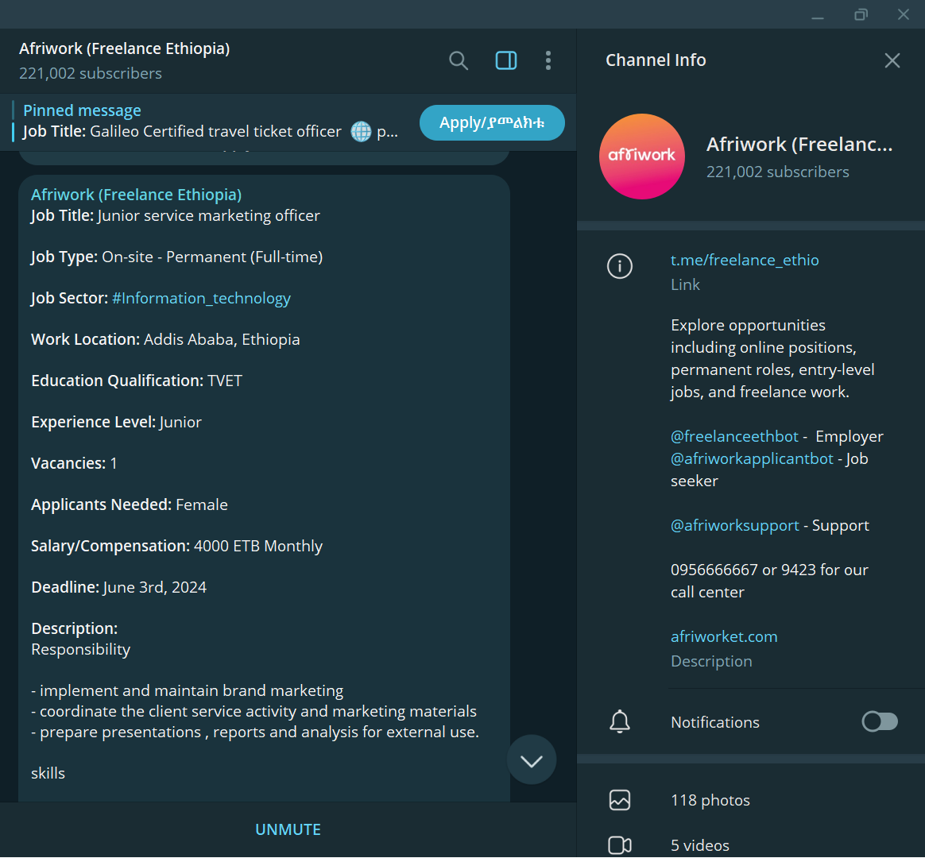 2) this is the html version of the exported chat history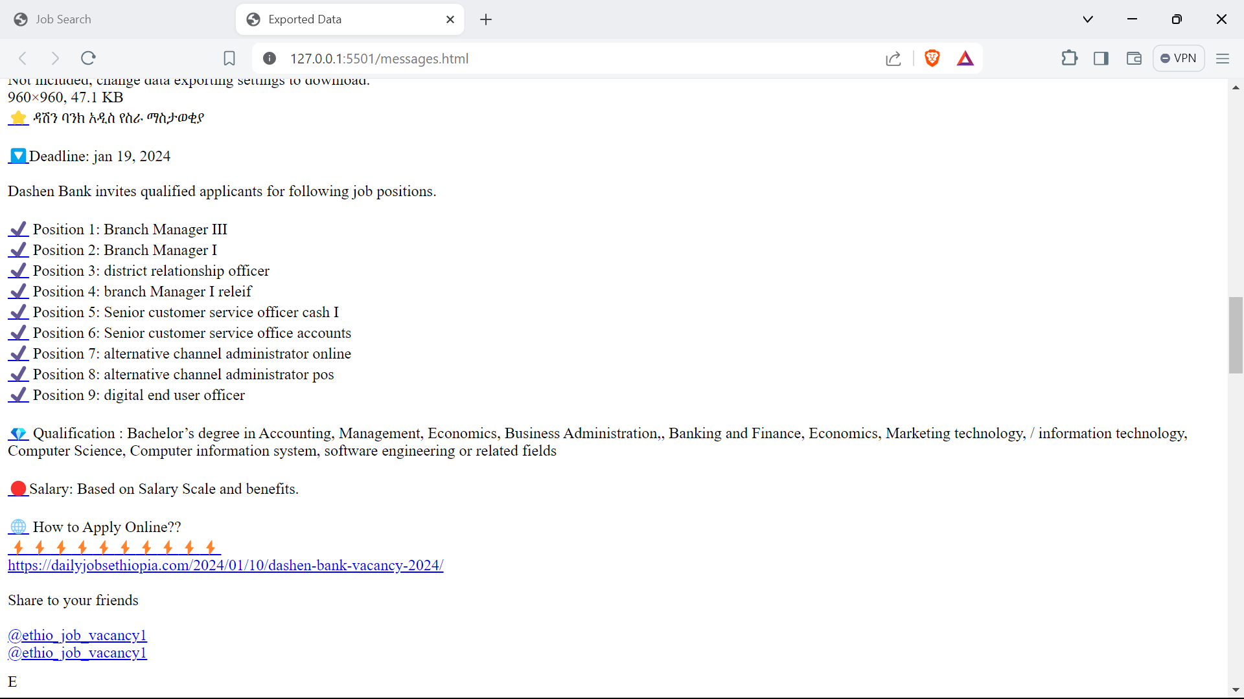
2. We pass this html file into our parse.cpp code and create a db

4)this is the db created

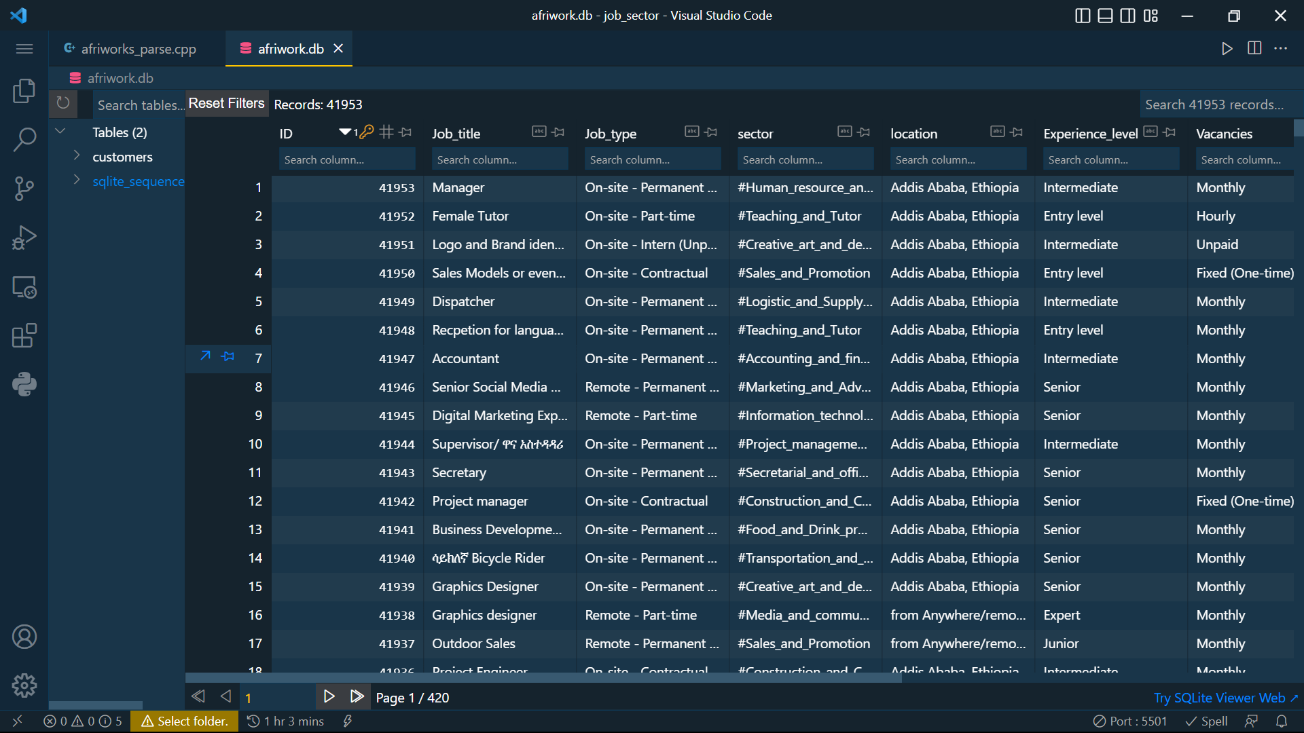

1. Then we created a website that lets us search the database in 2 ways
2. The first method uses node.js and express.js to create the web server.

As shown below

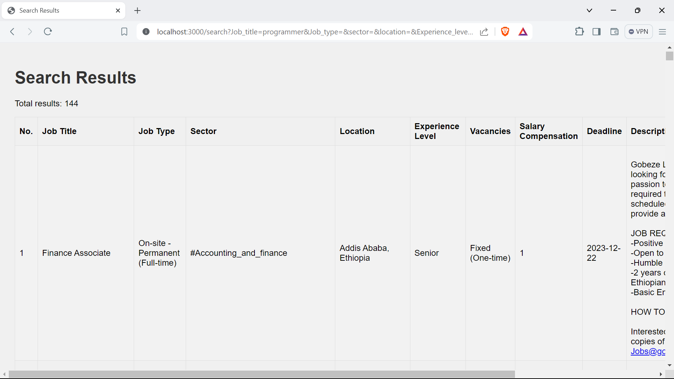

1. The second method uses a cpp framework called Crow to create a web server

As shown below

