Introduction
The internet is a massive network of networks (a networking infrastructure) that connects millions of computers together globally, forming a network in which any computer can communicate with any other computer as long as they are both connected to the internet. The internet had passed through different steps for being better. Its origin traced back to the 1950’s and no one had expected that the internet would look like as it is now. The whole thing was begin because of the competitive nature, in creating new technologies, between USSR and USA. When USSR sent an artificial satellite to space, USA in response celebrates the opening of the Advanced Research Projects Agency (ARPA) with a goal of becoming the leading country in technological advancements. Then, scientists began their work on different networking concepts. Even though, scientists have found a networking concept like, Galactic Networking concept the use of packets instead of circuits to communicate computers to each other was the major footstep towards the path to the new future. Here was the time where the basis for the internet was created which is called ARPANET. But, at this time it was necessary to have communication protocol for the networking system. And, the rise of TCP/IP elevates this problem. But through time things were overloaded at the record-keepers. To send emails, people had to keep an updated map of the entire network and they had to type out the path of their email before they could send it. Subsequently, engineers come up with the Domain Name System (DNS), which groups hosts into domains. After all this basis things, the World Wide Web was created which works under a hypertext system. This was the day were different search engines and websites were created. Like, Google, Facebook, Twitter, etc. Through time, different individuals and organizations come in to competition in the technology part. Because of the presence of a lot of websites in the web, guidelines were written to judge each website and to choose the best websites. Even, categories were given as types of websites and engineers tried to group them in twelve parts. Generally, the internet was the basis for different individual and group inventions.

- The History of Internet
  - 1950’s
The Internet actually got its start over 50 years ago and computers back then filled up entire rooms. Scientists and researchers used it for years to communicate during the Cold War. It was useful because if one computer went down, the others wouldn’t follow. In 1957, USSR launches Sputnik into space. In response, the USA creates the Advanced Research Projects Agency (ARPA) with the mission of becoming the leading force in science and new technologies.
  - 1960’s
In August 1962, a scientist named J.C.R Licklider proposed “Galactic Networking concept”, the idea of a network of computers that could talk to one another. He intended a globally interconnected set of computers through which everyone could quickly access data and programs from any site. Then, the first book on packet switching theory was published at MIT by Leonard Kleinrock in July 1964.This transition, the theoretical feasibility of communications using packets rather than circuits, was a major along the path towards computer networking. The other key step was to make the computer talk together. To explore this, in 1965 Lawerence G.Roberts together with Thomas Merrill connected the TX-2 computer in Mass. To the Q-32 in California with a low speed dial-up telephone line creating the first however small wide-area computer network ever built. The result of the experiment shows that the computers could work well together in running programs and retrieving data as necessary on the remote machine, but that the circuit switched telephone system was totally insufficient for the job. Needless to say, Kleinrock’ packet switching theory was necessary. In late 1966 Roberts went to Defense Advanced Research Projects Agency (DARPA) to develop the computer network concept and quickly put together his plan for the Advanced Research Projects Agency Network (“ARPANET”), publishing it in 1967.At the conference where he presented the paper, the proposed line speed to be used in the ARPANET design was upgraded from 2.4 kbps to 50kbps. In August 1968, after Roberts and the DARPA funded community had sophisticated the overall structure and specifications for the ARPANET, a Request For Quotation (RFQ) was released by DARPA for the development of one of the key components, the packet switches called Interface Message Processors (IMP’s). The RFQ was won in December 1968 by a group headed by Frank Heart at Bolt Beranek and Newman (BBN). As the BBN team worked on the IMP’s with Bob Kahn playing a major role in the overall ARPANET architectural design, the network topology and economics were designed and optimized by Roberts working with Howard Frank and his team at Network Analysis Corporation, and the network measurement system was prepared by Kleinrock’s team at University of California, Los Angeles (UCLA). This network measurement center at UCLA was selected to be the first node on the ARPANET. All this came together in September 1969 when BBN installed the first IMP at UCLA and the first host computer was connected. Doug Engelbart’s project on “Augmentation of Human Intellect” (which included NLS, an early hypertext system) at Stanford Research Institute (SRI) provided a second node. One month later, when SRI was connected to the ARPANET, the first host-to-host message was sent from Kleinrock’s laboratory to SRI. All the message said was “login” and it didn’t crash the network but SRI only received the first two letters of the message. The other letters were transmitted but the system then crashed. Two more nodes were added at UC Santa Barbara and University of Utah. These last two nodes incorporated application visualization projects, with Glen Culler and Burton Fried at UCSB investigating methods for display of mathematical functions using storage displays to deal with the problem of refresh over the net, and Robert Taylor and Ivan Sutherland at Utah investigating methods of 3-D representations over the net. Accordingly, by the end of 1969, four host computers were connected together into the initial ARPANET. Starting from this days, computers were added quickly to the ARPANET and work proceeded on completing a functionally complete host-to-host protocol and other network software.
  - 1970’s
In December 1970 the Network Working Group (NWG) working under S. Crocker finished the initial ARPANET Host-to-Host protocol, called the Network Control Protocol (NCP). As the ARPANET sites completed implementing NCP during the period 1971-1972, the network users finally could begin to develop applications. In 1971, Ray Tomilson was developing the first system to send mail back and forth between the users of ARPANET, motivated by the need of the ARPANET developers for an easy coordination mechanism. In 1972, ARPA officially changes its name to DARPA (Defense Advanced Research Projects Agency).The original ARPANET grew into the Internet. Internet was based on the idea that there would be multiple independent networks of rather arbitrary design, beginning with the ARPANET as the pioneering packet switching network, but soon to include packet satellite networks, ground-based packet radio networks and other networks. Up until Kleinrock’s packet switching theory comes, there was only one general method for federating networks which is the traditional circuit switching method where networks would interconnect at the circuit level, passing individual bits on a synchronous basis along a portion of an end-to-end circuit between a pair of end locations. But, along with packet switching, special purpose interconnection arrangements between networks were another possibility. In 1972 the idea of open-architecture networking was first introduced by Khan shortly after having arrived at DARPA. At the time, the program was called “Internetting”. Key to making the packet radio system work was a consistent end-end protocol that could uphold effective communication in the face of jamming and other radio interference, or withstand irregular blackout such as caused by being in a tunnel or blocked by the local topography. Khan first contemplated to continue using NCP. However, NCP did not have the ability to address networks (and machines) further downstream than a destination IMP on the ARPANET and thus some change to NCP would also be required. If any packets were lost, the protocol would come to a grinding halt. In this model NCP had no end-end host error control, since the ARPANET was to be the only network in existence and it would be so reliable that no error control would be required on the part of the hosts. Thus, Kahn decided to develop a new version of the protocol which could meet the needs of an open-architecture network environment. This protocol would eventually be called the Transmission Control Protocol/Internet Protocol (TCP/IP). While NCP tended to act like a device driver, the new protocol would be more like a communications protocol. Kahn began work on a communications-oriented set of operating system principles while at BBN. Thus, in the spring of 1973, he asked Vint Cerf (then at Stanford) to work with him on the detailed design of the protocol. Cerf had been familiarly involved in the original NCP design and development and already had the knowledge about interfacing to existing operating systems. So armed with Kahn’s architectural approach to the communications side and with Cerf’s NCP experience, they teamed up to explain the details of what became TCP/IP. The first written version of the resulting approach was distributed at a special meeting of the International Network Working Group (INWG) which had been set up at a conference at Sussex University in September 1973. The original Cerf/Kahn paper on the Internet described one protocol, called TCP, which provided all the transport and forwarding services in the Internet. So, this enabled computers across the globe to communicate to each other in a virtual space. Kahn had intended that the TCP protocol support a range of transport services, from the totally reliable sequenced delivery of data to a datagram service in which the application made direct use of the underlying network service, which might imply occasional lost, corrupted packets. This model worked fine for file transfer and remote login applications, but some of the early work on advanced network applications, in particular packet voice in the 1970s, made clear that in some cases packet losses should not be corrected by TCP, but should be left to the application to deal with. This led to a reorganization of the original TCP into two protocols, the simple IP which provided only for addressing and forwarding of individual packets, and the separate TCP, which was concerned with service features such as flow control and recovery from lost packets.
For some applications that did not want the services of TCP, the User Datagram Protocol (UDP) was added in order to provide direct access to the basic service of IP. The internet protocol was a standard way of assigning addresses, so there wasn’t any confusion about where packets were headed. Once two networks used TCP/IP, connecting them became way easier. So all the different networks were connected to one another, forming what became known as the Internet – with ARPANET as the glue holding it all together. So, Khan and Vinton Cerf refer to the system as the Internet for the first time. Bob Metcalfe invented Ethernet in 1973 while at Xerox PARC, and the company patented it in 1975. And, in 1974, Ethernet is demonstrated by networking Xerox PARC’s new Alto computers. At this time, Bob Kahn and Vint Cerf publish "A Protocol for Packet Network Interconnection"" in the May 1974 issue of Institute of Electrical and Electronics Engineers (IEEE) Transactions on Communications Technology. Shortly thereafter, DARPA funds three contracts to develop and implement the Kahn-Cerf TCP protocol described in their paper, one at Stanford (Cerf and his students), one at BBN (Ray Tomlinson), and one at University College London (directed by Peter Kirstein and his students). In 1975, the National Aeronautics and Space Administration (NASA) begins planning its own space physics network, SPAN. These networks have connections to the ARPANET. So, the newly developed TCP protocol begins to get a workout. Following consecutive years, Satellite Network (SATNET), a satellite program is developed to link the United States and Europe. Satellites are owned by a consortium of nations, thereby expanding the reach of the Internet beyond the USA. In 1976, DARPA supports computer scientists at UC Berkeley who are revising a Unix System to incorporate TCP/IP protocols. Berkeley Unix also incorporates a second set of Bell Labs protocols, called Unix-to-Unix Copy Protocol (UUCP), for systems to use dial-up connections. This announces the development of UUCP and UNIX to the growing Internet world.
The Internet Working Group of DARPA publishes a plan for the transition of the entire network from the Network Control Protocol to the TCP/IP protocols developed since 1974 and already in wide use.
  - 1980’s
In 1983, TCP/IP becomes the standard for internet protocol. But, growing ARPANET so quickly and connecting to so many other networks, the record-keepers at Stanford were getting overloaded. Hosts were joining and changing addresses and trying to download the updated address book, and occasionally the Stanford list would have errors that messed up communication throughout the whole network. And sending emails was becoming a real pain. Through time, emails made up more than three quarters of ARPANET’s packet. But, different computers have different email programs, and some required a list of every computer it would pass between sender and receiver. So, people had to keep an updated map of the entire network by their desk, and they had to type out the path of their email before they could send it. And with hundreds of computers on ARPANET and over a thousand across the internet, keeping up those maps was getting impossible. Consequently, ARPANET’s engineers come up with the Domain Name System (DNS). Instead of separating each host and storing their addresses in a random order, the hosts were arranged in into domains. First came the top level domains –those dot-coms and dot-edus at the end of every website and email address. The new top-level domains meant that instead of sending an email to biruk@ITSC like you would’ve before DNS, you were emailing biruk@ITSC.com. Then, within these top-level domains, each host was called a second-level domain. So, ITSC.com, for example meant the second domain “ITSC” within the top-level domain “dot-com”. The domain structure organized all those different hosts from all around the world in a way that computers could handle. Then, DNS added a whole new network to the internet whose whole job was to keep track of addresses and connections. One computer on the new network effectively stored all addresses within the dot-com top-level domain, another got all the dot-edus, and another got all the dot-orgs, and so on. Then, other new computers collectively mapped out the entire network. So when you wanted to send an email, you didn’t have to check your map and plan out all the connections yourself. That became the DNS’s job – and it’s still the DNS’s job today.
In 1980s scientists use Cerf’s protocol to send data back and forth. Australia, Germany, Israel, Italy, Japan, Mexico, Netherlands, New Zealand and the United Kingdom join the Internet. Networks speed up. The National Science Foundation Network (NSFNET T3) (45Mbps) nodes operate. At Interop 100Mbps LAN technology, known as Fiber Distributed Data Interface (FDDI), distributed among several vendors. The telephone companies start to work on their own wide area packet switching service at higher speeds - calling it Switched Multimegabit Data Service (SMDS). But the 1990s is where really all begin.
  - 1990’s
In Switzerland at European Organization for Nuclear Research (CERN) Tim Berners-Lee addresses the issue of the constant change in the currency of information and the turn-over of people on projects. Instead of a hierarchical or keyword organization, Berners-Lee proposes a hypertext system that will run across the Internet on different operating systems in 1990. This was the World Wide Web (WWW). This wasn’t just a data sharing space for scientists anymore. This was an entire network of information that was accessible to anyone within the internet connection. It was the time where the first search engine called Archie was created by Alan Emtage at McGuill University. On December 1990, the first website, nxoco1.cern.ch, goes alive. A years later, The Gopher protocol, designed for distributing, searching, and retrieving documents over the Internet, is released by a University of Minnesota team led by Mark McCahill. On August 6^{th,} 1991, CERN releases the World Wide Web publically (publishes the code for the World Wide Web on the Internet). After a year, Tim Berners-Lee posts the photo uploaded to the web, showing all female parody pop group Les Horribles Cernettes (LHS), consisting of four of his colleagues at CERN. A turning point for the World Wide Web began with the introduction of the Mosaic web browser in 1993, a graphical browser developed by a team at the National Center for Supercomputing Applications at the University of Illinois at Urbana–Champaign (NCSA-UIUC), led by Marc Andreessen. Mosaic's graphical interface soon became more popular than Gopher, which at the time was primarily text-based, and the WWW became the preferred interface for accessing the Internet. However, Mosaic was superseded in 1994 by Andreessen's Netscape Navigator, which replaced Mosaic as the world's most popular browser. While it held this title for some time, eventually competition from Internet Explorer and a variety of other browsers almost completely displaced it. As the Web grew, search engines and Web directories were created to track pages on the Web and allow people to find things. The first full-text Web search engine was WebCrawler in 1994. Before WebCrawler, only Web page titles were searched. Another early search engine, Lycos, was created in 1993 as a university project, and was the first to achieve commercial success. During the late 1990s, both Web directories and Web search engines were popular—Yahoo! (founded 1994) and Altavista (founded 1995) were the respective industry leaders. Besides, the World Wide Web Consortium (W3C) was established in 1994. Brewster Kahle establishes the Internet Archives, to preserve and provide access to nearly every site on the Internet, later evolving to become a comprehensive digital library in 1996. At this moment different organizations and companies were working on how to use the web and the internet to create their own products. Nokia was the one from the competitive companies. Nokia releases the Nokia 9000 Communicator, the first cellphone with a web browser launched in Finland and Japan launched the first mobile Internet service, I-mode, in 1999 and this is considered as the birth of the mobile phone Internet services. The rise of Google (founded in 1998) optimizes the web and internet usage for the users.
  - 2000’s
In the 2000s, the internet grow up and become the basis for most of technological advancements. For instance, internet was applicable in elections (March 2007 in Estonia), online marketing, trainings, etc. It was in this time where many famous websites such as Facebook, YouTube, Twitter, Wikipedia, etc. announced. And, different types of technological advancements like, Skype, iPhones, modernized computers with high speed, etc. were visible. This time was the best because not only did we get so many iconic sites, but people weren’t too obsessed with being online all the time.
- Observing popular websites
  - Yahoo!
In 1997, Yahoo’s page was short in its content and filled with clickable links. The advertisement part was also with in the content. It disturbs the main page focus. But, in 2000, it comes with more clickable links in its contents and the developers tried to remove unnecessary things from the front part by collecting them into a single link. The advertisement parts were collected in a link called Advertisement and the privacy policy and the copyright policy were visible, placed at the footer part. Till 2009, there was not a huge difference in the website except the addition of links containing different information like news, marketing and business, movies and games. But, in 2009, the website was more organized and colorful. Most of the links have icon in front of them. But, the advertisement part was messed up around the content. In 2015, the content was somehow long than the previous ones and some additional advertisements were added. In 2018, its style was changed. There was not links with icons in the left part and it was somehow organized than the previous ones. There was not too match advertisement in its content. In 2020, the website doesn’t have much difference as it was in 2018.
But, something more were added in its content. Like, recent news, sports and business areas. The current Yahoo! Website looks like the following.
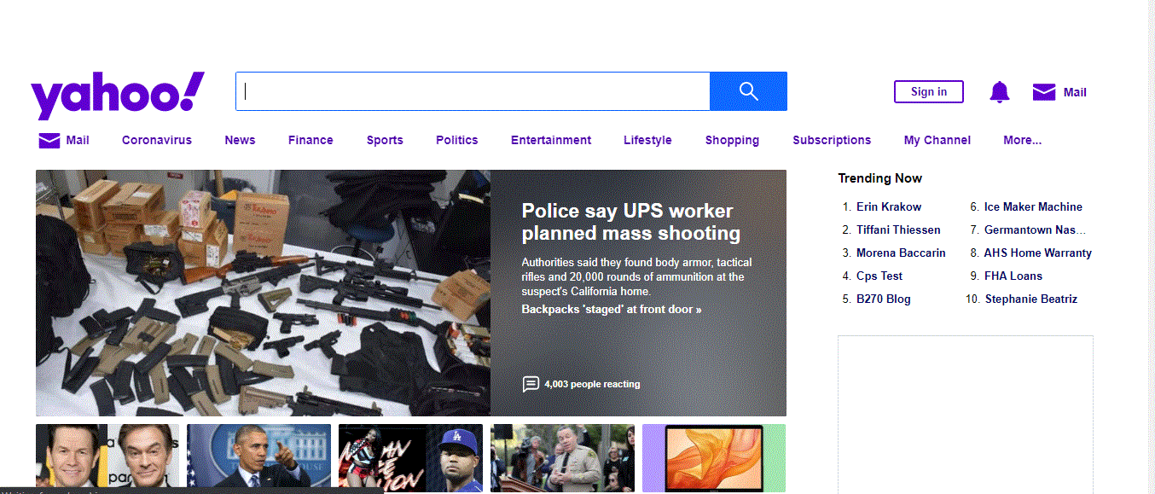
  - Google
In 1998, the Google’s website content was short and its header was “Google! Beta”. The rest thing was a search box, links about google and other information. Besides, there was not advertisement in its content even advertisement link. In 2001, it comes with a new logo “Google” and some links were added below the header part. And, it comes with a better searching method called Advanced Searching, to move exactly where you want. The other things were the same except the position of the links in its content. Until 2010, it was somehow the same except that its content was becoming short through time. But in 2010, it comes with a new header and logo called “GMMXle”. The rest thing was the same. In 2013 also, its header was changed and becomes “GOOGLE 2 0 1 3 4”. In 2016 also its header was changed by a different colored emoji’s inside a net and a clock right side to them. Now, its header is “Google” and its content is clear and it gives comfort when someone accesses it. The current Google website looks like the following.
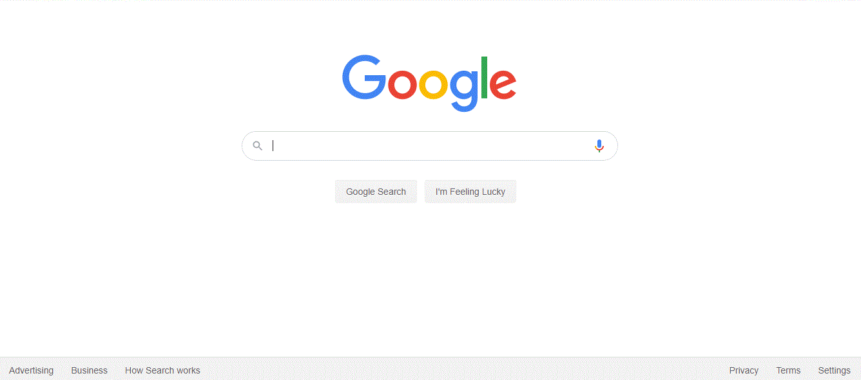

  - Facebook
In 2001, Facebook was known as aboutface. And, in its content there was descriptions about aboutface. There was no much advertisement in its content. In 2004, aboutface was well organized and navigation bar with beautiful contents was added. In 2007, aboutface was replaced by facebook. And in 2010, the content incudes a form for the user to sign up. The form includes: First Name, Last Name, Your Email, New Password, Sex, Birthday, and Sign Up button. And, it was available in different languages as presented in its footer part. Because of the presence of the image in the right side that shows peoples around the world connected to each other, one can guess facebook is designed to create communication around the world. So, this was a good part of its content. There was not much difference in facebook’s content for the next consecutive years. Now, its website is clear and easy to move forward because of the simple language use. At this days, it looks like the following.
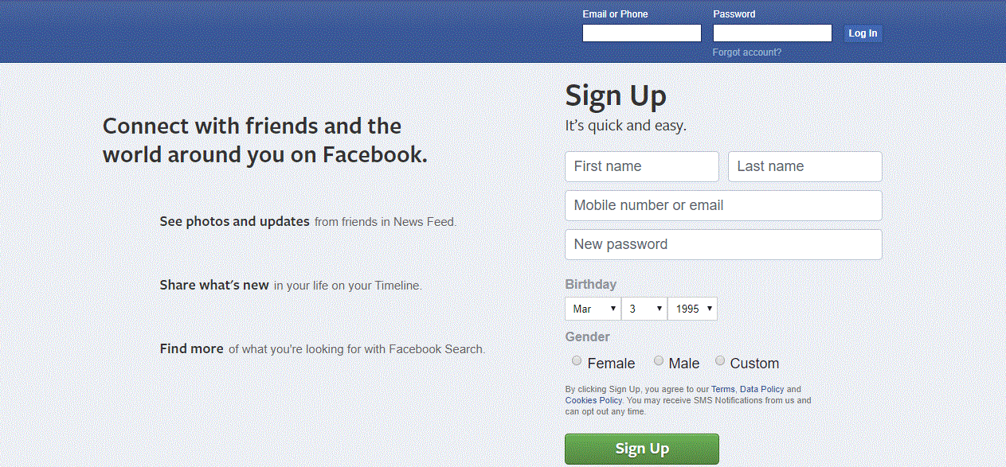

  - Amazon
In 2001, it was filled with a lot of links and information. But, everything was collected in a respective link. So, advertisements and items were not messed up around the body part. In 2005, the links were more organized but there was many type of items to be sold at the body part with their images. Because of these items, it was somehow difficult to get the clear view of the content. For the next years, different items were added with their advertisement in the body part. Means, the number of items to be sold were growing as the years goes on. In 2014, everything was collected and organized. And, the interface was beautiful for eye and it was precise. The items were organized in a link and put in the footer part. This gives a clear view for the central body part. In 2017, its background color and style was changed. And, some more items advertisement was added. Now, the website contains small amount of information, search box and few links. It is easy to move anywhere following the links because it is clear to view. Its current image looks the following.
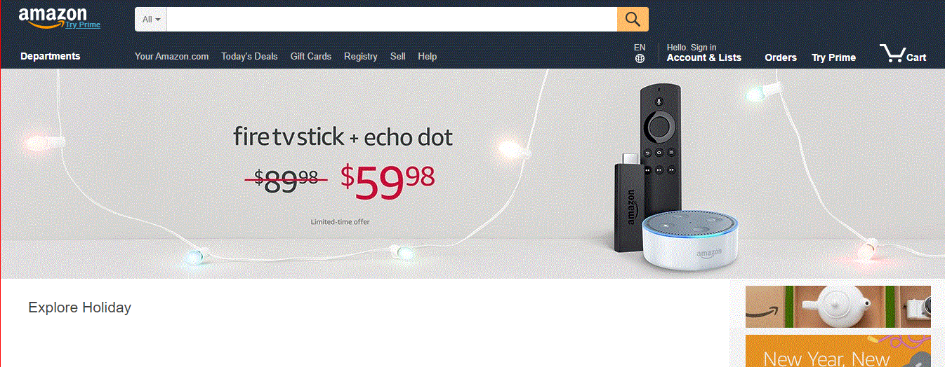

  - Wikipedia
In 2001, the website was filled with many links. There was not a beautiful decoration behind the contents. It contains different fields of study like, Mathematics, Philosophy, Astronomy, Culture, Current Events and Breaking News in its body part. In 2002, it comes with a simple and precise website page. The search box was at the header and the body was filled with other wiki website examples. And, it was possible to search in other languages. In 2004, it becomes somehow wide in its content. It includes articles, sports and news. Its style was also changed. In the next years, Wikipedia comes with a new logo like the current one. And, the page was too precise to look at it. Only, the search box and the logo was at the central part. The rest was moved to the footer part. There was not much difference for the next years except that the languages were increasing proportionally. Now a days, even though it doesn’t have much difference from the past 10 years, its available languages were the main change. The current Wikipedia website looks like the following.
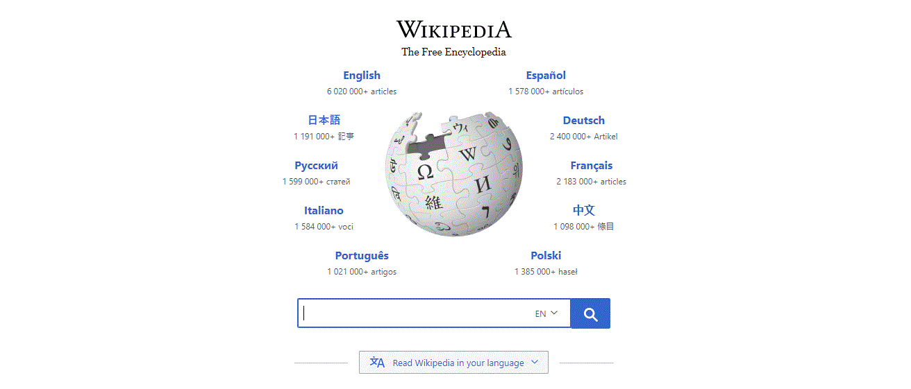

- Types of Website
  - Portal
It is a specially designed website that brings information from diverse sources, like emails, online forums and search engines, together in a uniform way. Or, it is a website that provides a gateway to other resources on the Internet. Web portals are often websites designed for internal purposes at a business, organization, or institution. They collect information in different formats from different sources into one place to make all relevant information accessible to the people who need to see it. They often involve a login and personalized views for different users that ensure the information that’s accessible is most useful to their particular needs.
Portal website Examples:
- Grants.gov-https://www.liferay.com/resource/grants-gov
Its mission is to allow applicants for federal grants to apply for and manage grant funds online through a common website. With a fully-functional government portal, organizations can simplify grant management and eliminate redundancies. Grants.gov is unique in that it sends more than 1 million email notifications at the public’s request and receives more than 4 million page views weekly.

- University of Maine System-https://www.liferay.com/resource/university-of-maine-system
The University Maine System (UMS) integrates distinct campuses, centers and facilities for undergraduate and graduate student opportunities.
- AvMed-https://www.liferay.com/resource/avmed
Through the consolidation of online solutions, AvMed was able to create unique user portals with a single sign on, helping to serve a wide variety of unique users quickly and in a single location. In addition, the portal’s easy-to-use dashboard meant that users could quickly find the information and tools they needed for better self-service, leading to an increase in both unique visitors per month and quarterly savings.
- Financial Customer Self-Service Portal-https://www.liferay.com/resource/carrefour-bank
In order to properly serve a quickly-growing customer base, Carrefour Bank created a new self-service portal for its audience, which gave users the ability to access financial extracts, manage their interactions with the organization and negotiate their debts and credits in a single location.
- Allianz Insurance Portal-https://www.liferay.com/resource/allianz
General insurance company Allianz Group offers a site that is both dynamic and personal. Users have the ability to retrieve historical records of purchased products and services along with integrated features to facilitate policy payments and renewals.
  - News
A news website contains news material including stories and articles relating to current events, life, money, sports and the weather. News Papers, television and radio stations are some of the media that maintain news website.
News Website Examples:
- forbes.com- https://www.forbes.com/#5d22c69d2254
It is an American business magazine. Published bi-weekly, it features original articles on finance, industry, investing, and marketing topics. Forbes also reports on related subjects such as technology, communications, science, politics, and law. Its headquarters is located in Jersey City, New Jersey.
- economist.com- https://www.economist.com/
The Economist is an English-language weekly magazine-format newspaper owned by the Economist Group and edited at offices in London. Continuous publication began under its founder James Wilson in September 1843.
- Hollywood Reporter- https://www.hollywoodreporter.com/
The Hollywood Reporter is your source for breaking news about Hollywood and entertainment, including movies, TV, reviews and industry blogs.
- BBC- https://www.bbc.co.uk/
The British Broadcasting Corporation (BBC) is a British public service broadcaster. Since 1 April 2014, it has also funded the BBC World Service (launched in 1932 as the BBC Empire Service), which broadcasts in 28 languages and provides comprehensive TV, radio, and online services in Arabic and Persian.
- New Republic- https://newrepublic.com/
The New Republic is an American magazine of commentary on politics, contemporary culture, and the arts, published since 1914, with an outsized influence on American political and cultural thinking.
  - Informational Website
Informational websites are those sites which are created in order to provide a customized and branded resource for potential and active customers, members.
An Informational website is one whose purpose is to present factual information. The URL Address frequently ends in .edu or .gov, as many of these pages are sponsored by educational institutions or government agencies. Examples: Dictionaries, thesauri, directories, transportation schedules, calendars of events, statistical data.
Informational Website Examples:
- Mint-https://www.mint.com
The website’s homepage gives you secure and relaxing vibes, which is crucial for the financial firm. It also contains direct and simple Calls to Action (CTA): “Sign up free.” The design of this CTA button is awesome — the secured lock icon enhances the concise copy.
- Dropbox- https://www.dropbox.com/business
The design of the website is simple and user-friendly – you will see nothing but the important info you really need: a huge image with simple and compelling copy and a “Try free for 30 days” CTA.
- Mosaic Art - http://www.mosaicartnow.com
The website is full of meaningful content and you will find plenty of interactive elements here. That accommodates the amazing range of mosaic artists and arts.
- Polygon-http://www.polygon.com
It is a video game review website.
- The verge-http://www.theverge.com
The website’s homepage meets you with a colorful and huge puzzle of hot stories’ headlines, showing a glimpse of the articles.
  - Business/Marketing Website
A business/marketing Website contains content that promotes or sells products or services.
Business/Marketing Website Examples:
- DMN-www.dmnews.com
Dallas Morning News (DMN) is a resource for marketing and sales professionals that explores all realms of digital and data driver marketing in an unbiased and incisive manner. DMN distributes content via newsletters, eBooks, webcasts, podcasts, and custom projects and publications.
- Event Marketer-www.eventmarketer.com
Event Marketer provides the information needed for strategic brand-side event marketers and agency executives ranging from face-to-face to corporate events.
- Chief Marketer-www.chiefmarketer.com
Chief Marketer serves marketing professionals of consumer and business-to-business brands with rich and thorough information on measurable marketing strategies, tactics, and technique. Chief Marketer provides well thought out insights and ideas, accompanied by resources and technologies in a method to measure return on investment.
- Inc-www.inc.com
Inc is the only major brand in the world dedicated exclusively to owners and managers of growing small businesses which aim to provide them with real solutions for their business. Inc has an abundance of small business ideas, information, and inspiration for small businesses.
- Fortune-www.fortune.com
Fortune is one of the world’s leading business media brands which is accompanied by a multinational monthly magazine, daily website and conference series. Fortune is dedicated to assisting its readers, viewers, and attendees to succeed in the business sector.
  - Educational Website
An educational Web site Provides information related to students, teachers and educational institutions.
Educational Website Examples:
- Big Think- https://bigthink.com/
Big Think is a multimedia web portal founded in 2007 by Victoria Brown and Peter Hopkins. The website is a collection of interviews, presentations, and roundtable discussions with experts from a wide range of fields.
- Coursera-http://courser.org/
Coursera is an American online learning platform founded in 2012 by Stanford professors Andrew Ng and Daphne Koller that offers massive open online courses (MOOC), specializations, and degrees.
- Brightstorm-https://www.brightstorm.com/
Brightstorm is an online learning platform for teenagers. It features thousands of study videos as well as other study tools and resources such as Math Genie and College Counseling.
- CosmoLearning-https://cosmolearning.org/
CosmoLearning is a free educational website for students and teachers and offers educational materials in 37 courses. It is also a non-profit educational website committed to improving the quality of homeschooling, teaching and student excellence.
- The Future Channel-https://thefuturechannel.com/
The Futures Channel provides students and educators with an excellent resource collection of inspirational Educational videos about current trends and advancements in Science, Engineering, and Technology.
  - Entertainment Website
An entertainment Website offers an interactive and engaging environment. Popular entertainment Web sites offer music, videos, sports, games, chat rooms, and more.
Entertainment Website Examples:
- Rachel Collis-https://rachelcollis.com/
It is a website which gives access for Rachel Collis music and entertainments.
- Casino Football-https://casinofootball.com
Casino Football provides mobile casino games to the UK & most of Europe.

- Eonline-http://www.eonline.com/
Eonline is the most popular entertainment news source, providing us with information about almost everything that deals with the entertainment world.
- IMDB-http://www.imdb.com/
IMDb (Internet Movie Database) is the world’s most popular and authoritative source for movie, TV and celebrity content.
- Netflix-http://www.netflix.com/
Netflix is the world’s leading Internet television network with more than 36 million members in 40 countries enjoying more than one billion hours of TV shows and movies per month, including original series.
  - Advocacy Website
An advocacy Web site contains content that describes a cause, opinion, or idea. These Web sites usually present views of a particular group or association.

Advocacy Website Examples:
  - Aspca.org-https://www.aspca.org/
The Anti-Cruelty Society is building a community of caring by helping pets. The ASPCA works to rescue animals from abuse and pass human laws.
  - Bestfriends.org – https://bestfriends.org/
Best Friends Animal Society runs the nation's largest sanctuary for abused animals. Best Friends Animal Society–Los Angeles supports programs, shelters and rescues 1,700 animals are turning their lives around, receiving the medical help they need.
  - anticruelty.org- https://anticruelty.org/
The Anti-Cruelty Society is an animal welfare organization and animal shelter in the River North neighborhood of Chicago, Illinois. The Anti-Cruelty Society exists to prevent cruelty to animals and to advance humane education. Their mission is building a community of caring by helping pets and educating people.
  - Barefoot College- https://barefootcollege.com/
The Social Work and Research Centre ("SWRC"), widely known as the Barefoot College is a voluntary organization working in the fields of education, skill development, health, drinking water, women empowerment and electrification through solar power for the upliftment of rural people, which was founded by Bunker Roy in 1972.
  - AFJ- https://www.afj.org/
Alliance for Justice (AFJ) is a progressive judicial advocacy group in the United States. Founded in 1979 by current president Nan Aron, AFJ monitors federal judicial appointments.
  - Blog
A blog, short for Weblog, is an informal Web site consisting of time-stamped articles, or posts, in a diary or journal format.
Blog Website Examples:
- CAPTURE BY LUCY- https://www.capturebylucy.com/blog
Lucy is a photographer, a mom and creator of backdrops for photography usage. Visit her blog to read about her life, her family and if you'd like to work with her. All of her backdrops are photos that she herself has taken and then had printed. It is built with Squarespace using the Mercer template.

- The Good Trade- https://www.thegoodtrade.com/
It is built with Squarespace using a custom theme. The Good Trade is a lifestyle brand born in Los Angeles in 2014. You can read a ton of their articles on the site that all revolve and echo living an intentional lifestyle.
- BENEDICT EVANS- https://www.ben-evans.com/
It is built with Squarespace using the Native template. Benedict Evans is a tech blogger with educational articles on a variety of sub-topics.
- THE SARTORALIST- https://www.thesartorialist.com/
It is built with Word press using a custom theme. Scott Schuman created this blog that is all about high-end fashion combined with real life. He's been featured in huge fashion magazines such as Vogue. Check out press, articles and even find books using this website.
- DENVER DARLING- http://denverdarling.com/
It is built with Squarespace using the Montauk template. She's got a bright and cheerful blog that talks about all things related to her hometown in Denver, gift buying guides and shopping her Instagram.
  - Wiki
A website that allows anyone to add, delete, or revise content by using a web browser. Also called wiki engine, wiki application.
Wiki Website Examples:
- Wikipedia – https://www.wikipedia.org/
It is a free online encyclopedia, created and edited by volunteers around the world and hosted by the Wikimedia Foundation.
- Wikihow- https://www.wikihow.com/
WikiHow (styled as wikiHow) is an online wiki-style community consisting of an extensive database of how-to guides. Founded in 2005 by Internet entrepreneur Jack Herrick, the website aims to create the world's most helpful how-to instructions to enable everyone in the world to learn how to do anything.
- Wiktionary- https://www.wiktionary.org/
Wiktionary is a multilingual, web-based project to create a free content dictionary of terms in all natural languages and a number of artificial languages.

- Wikispecies- https://species.wikimedia.org/wiki/
Wikispecies is a wiki-based online project supported by the Wikimedia Foundation. Its aim is to create a comprehensive free content catalogue of all species; the project is directed at scientists, rather than at the general public.
- WikiBooks- https://en.wikibooks.org/wiki/
Wikibooks is a Wikimedia community creating a free library of educational textbooks that anyone can edit.
  - Social Network
It is a Web site that encourages members in its online community to share their interests, Ideas, stories, photos, music, and videos with other registered users.
Social Network Website Examples:
- Facebook- https://www.facebook.com/
Using Facebook.com you can find friends in several ways, including search engine to look for a specific person and lot more. Facebook has recently crossed 500 million users and is the most popular Social Networking site of the world.
- Twitter- https://www.twitter.com/
Twitter is a very simple service. When you have a Twitter account, you can use the service to post and receive messages to a network of contacts.
- YouTube - https://www.youtube.com/
YouTube is a video sharing service where users can watch, like, share, comment and upload their own videos. The video service can be accessed on PCs, laptops, tablets and via mobile phones.
- LinkedIn- https://www.linkedin.com/
LinkedIn is an American business and employment-oriented service that operates via websites and mobile apps. Founded on December 28, 2002 and launched on May 5, 2003, it is mainly used for professional networking, including employers posting jobs and job seekers posting their CVs.
- Instagram- https://www.instagram.com/
Instagram is an American photo and video-sharing social networking service owned by Facebook, Inc. It was created by Kevin Systrom and Mike Krieger, and launched in October 2010 on iOS.
  - Content Aggregator
A content aggregator is an individual or organization that gathers Web content (and/or sometimes applications) from different online sources for reuse or resale.
Content Aggregator Examples:
- mobilerss.net - http://www.mobilerss.net/
Mobilerss brings Rich Site Summary (RSS-RDF Site Summary) Feeds to mobile users. Mobilerss enables you to view RSS News anywhere on any mobile device.
- PopUrls- http://m.popurls.com/
PopUrls is a mixture of the web's most visited social news sites and portals that encapsulates headlines of its sources in near-real time. Introduced in March 2006 by Thomas Marban, the site created a new trend in the so-called Single Page Aggregators and serves as a case study for Web Syndication.
- Alltop- https://alltop.com/
Alltop is a site that proves complex is not always better. AllTop aggregates all of the top news and information in real time.
- Blog Engage- http://www.blogengage.com/
Blog Engage is a blogging community where all bloggers submit their latest blog articles for exposure and backlinks. When articles receive enough votes they become published and are then found on the Blog Engage home page.
- Travel Blogger Community- http://travelbloggercommunity.com/
It's a travel blogging platform that is built to easily log your trips.
  - Personal Website
A private individual or family not usually associated with any organization may maintain a personal Web site. People publish personal Web pages as they simply want to share life experiences with the world.

Personal Website Examples:
- Tim Harford-http://timharford.com/
Tim Harford, “the Undercover Economist”, is a Financial Times columnist, BBC broadcaster and author of seven books – most recently “Fifty Things That Made the Modern Economy”.
- Joshua McCartney-https://www.joshuamccartney.com/
He is a freelance art director based in Liverpool, UK. On this site you will find a collection of his work from his time in New York & London as a senior art director.
- Nia Shanks- https://www.niashanks.com/
The design is nice and clean and favors a more minimal style. The headline on the homepage is also something we’re a big fan of. It’s direct, conveys value quickly, and doesn’t beat around the bush. She also uses the top navigation really well to point new visitors in the right direction for whatever they might need.
- Simon Sinek-https://startwithwhy.com/
The design really shines here and makes this one of the best personal website examples. There’s great use of whitespace, the layout is clean and readable, and the colors draw in the eye. The button on the top right is a fantastic example of a call to action that doesn’t take things too far.
- Ellen Skye Riley- http://ellensriley.com/
Riley does an excellent job at showcasing her incredibly gifted design skills, and her site is informative and extremely fun to arouse.
- Guidelines for evaluating a website
As the internet grows up, different websites are becoming popular for different purposes. But, not every site makes a good resource. Accordingly, how can someone knows which one is the best website? The following criteria will have answer for this.
- Technical Considerations
- Verify that the Web site's important capabilities, such as graphics or animations critical to the subject matter, can be utilized with the technology you have available.
- The page should be consistently available.
- All the links and special features must be functioning.
- If there is a fee for using the site, the site should provide a secure way to send payment.
- Purpose
- A site's purpose should be clear, and its content should reflect that purpose, be it to entertain, educate, or sell.
- Advertising should not dominate the content.
- Content
- A site's content should be comprehensible, appropriate, and of value to the intended audience. Awards won by a site may suggest quality but may also be little more than advertising banners for the issuing agencies
- There should be enough information to make visiting the site worthwhile. Information on how often the site is visited may indicate its usefulness
- Sites that promote social biases (e.g., gender, racial, or religious biases) should be rejected.
- If there are large amounts of information on the site, there should at least be an outline of topics that allows users to find topics and move among them easily. Example, search function.
- Links to more information on the topic should be provided.
- Graphics should be relevant and appropriate to the content.
- Authorship
- The name of the individual or group creating the site should be clearly stated.
- The publisher (host) should be a reputable organization.
- The Web site author or manager should provide contact information for users to make comments or ask questions.
- Sites that clearly violate copyright statutes or other laws should not be linked, listed, or recommended.
- Functionality
- Language used in messages and instructions should be easy to understand.
- If a search function is available, instructions for conducting searches should be provided.
- There should be consistency in the use of features such as headers, backgrounds, fonts, and colors.
- Design
- The text should be easy to read, and not cluttered with distracting graphics, fonts, and backgrounds. There should be appropriate "white space," that is, space not occupied by text or graphics.
- The site should make use of conventional rather than confusing features. For example, hypertext should be in blue text rather than buttons without accompanying text.
- The color scheme should not be insensitive to the eye and the colors shouldn’t distract from the main message.
- Large images should be presented in thumbnail versions, with links to the larger versions.
  - Evaluating sample websites
- Google.com
- Technical considerations- Googles page is consistent and its all links are functional. So, its technical considerations are applied well.
- Purpose-Its purpose is clear. Anyone can understand Google is waiting us to search something on the web by only seeing its website layout. Besides, advertising didn’t overshadow its content. There is a link for Advertisement. So, anyone interested in the advertisement part will follow the link without disturbing Googles content.
- Content-There is enough information in the footer part about google and how to use it. And, there is a logical ordering of information. As one can see from the advertisement part, google doesn’t promote racism and gender issues. There are also enough links to move to further explanations about something. So, it is content is well organized.
- Authorship-There is no clear description about who had created google. There is no contact information lo leave comment. If it there, it is not visible for the users easily.
- Functionality-The language is clear to understand and it allows different type of languages. There is also consistency in using backgrounds and fonts. But, it doesn’t have a headings. Headings offer important document structure, outlines, and navigation functionality to technology users who need help. And there are links which don’t contain text. They are found inside a dotted square shaped thing on the top corner. If a link doesn’t contain text, the purpose of the link will not be obtainable to the user. This can create confusion for keyboard and screen reader users. Besides, the search box doesn’t have a corresponding label for screen readers.
- Design- The design is good. When People look at its interface, they can assume that it is a search engine. The links doesn’t go far away. They don’t lead to many levels. The color scheme is good for eye and they don’t distract from the main page.
- Yahoo!
- Technical considerations- Its all links are functional. But, the page is not consistent-it needs a high connection to load all the pages at once since its content is somehow long.
- Purpose-Its purpose is clear. Anyone can understand Yahoo is waiting us to search something on the web and to watch news and other extra things by only seeing its website layout. Besides, advertising has overshadowed its content. Sometimes, it is distracting to identify which is news and which is advertisement.
- Content-The content is not well organized and the description about yahoo is not visible to the user. That means there is not logical ordering of information. As one can see from the advertisement part, yahoo doesn’t promote racism and gender issues. There are also enough links to move to further explanations about something.
- Authorship-There is no clear description about who had created yahoo. There is no contact information lo leave comment.
- Functionality-The language is clear to understand and it allows different type of languages. There is also consistency in using backgrounds, font, and headers.
- Design- The design is good. And the color is somehow beautiful for eye. But, the things inside the website doesn’t make the user to follow attentively since many thing are messed up there. The links doesn’t go far away. They don’t lead to many levels.
Conclusion
The internet is the huge move towards the technology world and it is a great comfort zone for the tech-nerd persons and organizations. The invention of the internet had passed a number of levels and disputes regarding patents. But this, doesn’t stop engineers from creating innovations. Before the invention of the internet, the world was not connected and it was not possible to communicate thoroughly. But, the internet paved the way for new innovations, online marketing and business ideas, online news and sports, online advertisements, online educations, online tickets for transportation, etc. This advancement enable users to make their life easier and the world to integrate as one. Now a days, the technology is categorized under different super titles because of the presence of many creativities. Websites are the one from the consequence of internet. And, these sites are different in their content and purpose. Some of them have business idea, some of them have educational purpose and others have a different purpose. Some of the websites with their description are presented in this document. There are also guidelines to test a website whether it is comfortable for the user or not as described in this document. These guidelines are helpful to improve and update once website to be competitive on the web. To conclude, it was the internet that takes out the world from the dark and it was the reason for many individuals and groups creative works.

Reference
- Internet Society, https://www.internetsociety.org/internet/history-internet/brief-history-internet/,February 28, 2020
- Invest Intech, https://www.investintech.com/resources/articles/historyinternet/, March 3, 2020
- Computer History, https://www.computerhistory.org/internethistory/1970s/, March 2, 2020
- Wiki,https://en.wikipedia.org/wiki/History_of_the_Internet#From_Gopher_to_the_WWW , March 3, 2020
- Site Builder Reporter, https://www.sitebuilderreport.com/inspiration/blog-examples , March 1, 2020
- Eric Digests, https://www.ericdigests.org/1999-3/web.htm, February 29, 2020
- Slide Share, https://www.slideshare.net/rushilahmed/types-of-websites-53701681, March 1, 2020
- Host Gator, https://www.hostgator.com/blog/popular-types-websites-create/, March 1, 2020

