An Artificial Intelligence–Based Classification and Ranking System for Border Gateway Protocol Incidents in Enterprise Networks

by Biruk D. Mekonnen

B.S. in Electrical Engineering, July 2007, Mekelle University
M.S. in Network Engineering, May 2023, Southern Methodist University

A Praxis submitted to

The Faculty of
The School of Engineering and Applied Science
of The George Washington University
in partial fulfillment of the requirements
for the degree of Doctor of Engineering

September 05, 2026

Praxis directed by

Timothy Blackburn, PhD
Professorial Lecturer of Engineering Management and Systems Engineering

Amir Etemadi, PhD
Assistant Professor of Engineering and Applied Science
The final approval page should be completed with the official examination date, committee information, and signatures according to program requirements.

An Artificial Intelligence–Based Classification and Ranking System for Border Gateway Protocol Incidents in Enterprise Networks

Biruk D. Mekonnen

Praxis Research Committee:

Dr. Amir Etemadi, Assistant Professor of Engineering and Applied Science, Praxis Director

Dr. Timothy Blackburn, Professorial Lecturer of Engineering Management and Systems Engineering, Praxis Co-director

Additional committee member information to be completed according to program records.

© Copyright 2026 by Biruk Mekonnen
All rights reserved

Dedication

This section may be completed by the author before final institutional submission.

This section may be completed by the author before final institutional submission.

Acknowledgements

This section may be completed by the author before final institutional submission.

Abstract of Praxis
An Artificial Intelligence–Based Classification and Ranking System for Border Gateway Protocol Incidents in Enterprise Networks

Border Gateway Protocol (BGP) incidents can cause significant service disruption, traffic misrouting, and loss of network reachability in enterprise and Internet-connected environments. Although network monitoring platforms can identify routing changes and generate alerts, determining the type and likely cause of a BGP incident often requires network engineers to manually correlate BGP UPDATE messages, routing state, logs, and other operational telemetry. Distinguishing among prefix hijacks, route leaks, and routing outages can be particularly challenging because these incidents may exhibit overlapping control-plane behaviors. This Praxis develops and evaluates an artificial intelligence–based system for classifying BGP incidents and ranking the most probable incident types to support network troubleshooting and incident analysis.

The study uses historical BGP routing data associated with labeled hijack, route-leak, and outage incidents. BGP UPDATE data are processed into non-overlapping five-minute analytical windows from which 44 behavioral features are extracted. These features characterize announcement and withdrawal activity, prefix dynamics, peer visibility, AS-path structure and instability, origin changes, multi-origin behavior, and AS-path prepending. The behavioral representation is enriched with 14 historical Autonomous System relationship features derived from the Center for Applied Internet Data Analysis (CAIDA) and 16 Resource Public Key Infrastructure (RPKI) and Route Origin Validation (ROV) features derived from historical Route Origin Authorization information. The resulting V4 representation contains 74 features per analytical window and incorporates behavioral routing activity, AS-topology context, and route-origin authorization evidence.

The experimental design treats each BGP incident as an independent experimental unit while five-minute windows serve as lower-level machine-learning observations. A development corpus of 993 TRAIN incidents, evenly distributed across 331 hijacks, 331 route leaks, and 331 outages, was used for feature evaluation, model development, grouped cross-validation, feature ablation, imbalance analysis, algorithm comparison, and hyperparameter optimization. Experiments compared behavioral-only and enriched feature variants, Random Forest and XGBoost classifiers, incident-aware weighting strategies, feature-family contributions, and alternative classification architectures. RPKI/ROV information provided particularly useful discriminatory information for hijack classification, while AS-relationship and routing-behavior features contributed to distinguishing route leaks and outages. Experimental Normal-versus-Incident detection was also investigated; however, its probability separation was insufficient for reliable operational use, and it was therefore retained only as an auxiliary experimental component rather than as a mandatory stage of the final classifier.

The final system uses a leakage-safe hierarchical stacking architecture. At the first level, XGBoost models classify five-minute V4 feature vectors and generate probabilities for Hijack, Leak, and Outage. These probabilities are subsequently summarized at the incident level using distributional, confidence, disagreement, and temporal features that characterize how routing evidence evolves across an incident. A second XGBoost classifier uses this incident-level representation to generate final class probabilities and rank the three candidate incident types. Nested cross-validation, multi-seed stability analysis, label-permutation testing, and first- and second-level leakage audits were used to verify the integrity of the stacked architecture before final evaluation.

The frozen final model was evaluated once on a previously sealed Holdout set of 213 incidents containing 71 hijacks, 71 route leaks, and 71 outages. It achieved an incident-level Macro F1 score of 0.9202 with a 95% confidence interval of 0.8801–0.9544, Top-1 accuracy of 0.9202, Top-2 accuracy of 0.9906, and Mean Reciprocal Rank (MRR) of 0.9585. Class-specific F1 scores were 0.8777 for Hijack, 0.9041 for Leak, and 0.9787 for Outage. The correct incident type was ranked first for 196 of 213 incidents and within the top two for 211 of 213 incidents. These results demonstrate that combining BGP behavioral features with AS-relationship and route-origin validation information, followed by incident-level temporal aggregation, can provide accurate classification and highly effective ranking of BGP incident types. The resulting approach provides a reproducible framework for AI-assisted BGP incident analysis that can help enterprise network engineers prioritize likely incident causes during routing investigations.

Table of Contents
Table of Contents.
Section | Page
Chapter 1 - Introduction | 12
Chapter 2 - Literature Review | 19
Chapter 3 - Methodology | 40
Chapter 4 - Results | 62
Chapter 5 - Conclusions | 85
References | 88

List of Tables
List of Tables.
Table | Title
Table 1.1 | Research questions and hypotheses
Table 2.1 | Literature areas supporting the final methodology
Table 3.1 | Frozen incident partition summary
Table 3.2 | Final V4 feature representation
Table 4.1 | Final corpus and feature foundation
Table 4.2 | Final Holdout class and ranking results

List of Figures
List of Figures.
Figure | Title
Figure 4.1 | Feature variant progression
Figure 4.2 | Feature-family ablation results
Figure 4.3 | TRAIN grouped-CV versus independent Validation
Figure 4.4 | Mean probability aggregation versus K1 temporal stacking
Figure 4.5 | K1 multi-seed stability results
Figure 4.6 | Final Holdout primary performance
Figure 4.7 | Final Holdout confusion matrix
Figure 4.8 | Warm downstream K1 latency breakdown

List of Acronyms
List of Acronyms.
Acronym | Meaning
AS | Autonomous System
ASN | Autonomous System Number
BGP | Border Gateway Protocol
CAIDA | Center for Applied Internet Data Analysis
F1 | Harmonic mean of precision and recall
MRR | Mean Reciprocal Rank
MRT | Multi-threaded Routing Toolkit archive format
RIB | Routing Information Base
RIPE RIS | RIPE Routing Information Service
RPKI | Resource Public Key Infrastructure
ROA | Route Origin Authorization
ROV | Route Origin Validation

Chapter 1 - Introduction

Background
Border Gateway Protocol (BGP) is the interdomain routing protocol that allows independently operated networks to exchange reachability information across the Internet. Each Autonomous System (AS) announces the IP prefixes it can reach, attaches AS-path information to those announcements, and uses routing policy to select and export paths. The protocol's flexibility is one reason it scales across competing operators, but that flexibility also means that routing incidents can propagate quickly when a prefix, origin, or path is announced incorrectly (Rekhter et al., 2006; Gao & Rexford, 2001).
Enterprise networks depend on upstream providers, cloud platforms, transit networks, and public routing infrastructure that they do not fully control. When a BGP incident occurs, engineers often need to distinguish whether observed reachability loss or traffic redirection is more consistent with a hijack, a route leak, or an outage. Those categories overlap in observable symptoms, and the first available evidence is often a stream of BGP UPDATE messages rather than a complete root-cause report.

Research Motivation
The motivation for this Praxis is practical. Network engineers need faster and more defensible ways to prioritize investigation when BGP behavior changes. Existing monitoring systems can raise alarms, but an alarm alone does not always explain whether the most likely routing-incident class is Hijack, Leak, or Outage. The operational challenge is not simply detecting that routing changed; it is ranking the likely incident explanation using evidence that is visible in public BGP observations and security context.
This study therefore focuses on post-window incident classification and ranking. The final system assumes that a candidate BGP incident has been identified and that the relevant observation window has been collected. It then uses engineered behavioral, AS-relationship, and RPKI/ROV evidence to rank the incident class. The model does not prove the physical or administrative root cause, and it is not an autonomous mitigation system. Its purpose is to provide a ranked diagnostic hypothesis that can support engineering investigation.

Problem Statement
BGP incident investigation remains difficult because different incident classes can produce similar routing symptoms. A hijack can look like an unexpected origin or path change, a leak can expose routes outside an intended policy boundary, and an outage can create withdrawal and reachability patterns that overlap with other disruptions. Without a reproducible incident-level learning framework, model results can also be distorted by class imbalance, unequal incident duration, duplicate windows from the same event, or leakage between training and evaluation partitions.
The research problem is the need for a reproducible AI-based method that classifies and ranks likely BGP incident classes from observable routing evidence while preserving incident-level experimental separation and transparent evaluation. The method must be accurate enough to be useful, but also honest about its limits: it ranks incident classes from BGP evidence and does not replace operator judgment or end-to-end root-cause analysis.

Thesis Statement
An incident-level machine-learning system that combines BGP behavioral features, CAIDA AS-relationship context, and historical RPKI/ROV evidence can classify and rank Hijack, Leak, and Outage incidents with defensible generalization when the experimental design preserves incident-level separation, controls leakage, and evaluates the frozen model on an untouched Final Holdout corpus.

Research Objectives
- Construct a balanced, quality-controlled incident corpus for Hijack, Leak, and Outage events.
- Extract reproducible five-minute analytical-window features from historical RouteViews data.
- Integrate behavioral, AS-relationship, and RPKI/ROV evidence into a final 74-feature V4 representation.
- Evaluate Random Forest and XGBoost approaches under incident-level grouped cross-validation.
- Develop an incident-level temporal stacking architecture that ranks likely incident classes.
- Validate the final frozen architecture using a sealed Final Holdout evaluation.

Research Questions and Hypotheses
Table 1.1 Research questions and hypotheses.
Research question | Hypothesis | Study response
RQ1 | BGP behavioral evidence can distinguish Hijack, Leak, and Outage better than chance. | Evaluated through baseline and enriched models.
RQ2 | Security and topology context improve classification beyond behavioral features alone. | Evaluated through V1-V4 and feature-family ablation.
RQ3 | Incident-level aggregation improves classification and ranking over simple window aggregation. | Evaluated through K1 stacking versus mean probability aggregation.
RQ4 | A frozen model can generalize to unseen incidents under leakage-safe evaluation. | Evaluated through Validation and Final Holdout.

Scope and Limitations
The study uses public RouteViews observations and external incident labels. The final corpus contains 1,419 incidents, balanced across 473 Hijack, 473 Leak, and 473 Outage incidents. The authoritative split contains 993 TRAIN incidents, 213 Validation incidents, and 213 Final Holdout incidents. The feature representation contains 44 Behavioral features, 14 CAIDA AS-relationship features, and 16 RPKI/ROV features, for a final V4 schema of 74 features.
Several boundaries are important. The system is not a universal anomaly detector, not a complete real-time monitoring platform, and not a proof of physical root cause. Stage 1 Normal-vs-Incident discrimination remained experimental and auxiliary. The latency result measures warm downstream K1 computation after feature availability; it does not include live BGP collection, MRT parsing, feature generation, enrichment, or model startup.

Organization of the Praxis
Chapter 2 reviews the BGP, routing-security, measurement, and machine-learning literature that grounds the study. Chapter 3 describes the final methodology, including corpus construction, RouteViews processing, feature engineering, leakage controls, and modeling. Chapter 4 presents the results from feature development through Final Holdout evaluation. Chapter 5 summarizes the findings, contributions, limitations, and future work.

Condensed Source Synthesis
Border Gateway Protocol (BGP) is one of the dynamic routing protocols which learns routes automatically from neighboring routers and updates networks. What makes BGP different from the other dynamic routing protocol is, it is the only routing protocol in the global public internet. Therefore, BGP carries internet wide routing information between Autonomous Systems. What BGP does is it updates routes when traffic, failures or topology changes occur. There are normal updates of routes that is communicated or passed to the neighbor routers and based on the characteristics of how BGP updates happen the update can be a normal update or anomaly. And these anomalies can be categorized into different BGP incidents.
Modern enterprise networks rely heavily on the global Internet’s interdomain routing infrastructure to maintain availability, performance, and resilience of their services. Enterprise networks advertise their network prefixes to the public global network via BGP, and the core infrastructure of the global network is also used BGP as the def facto standard routing protocol to route the prefixes of the enterprise networks for exchanging reachability information between Autonomous Systems. BGP is designed under the assumptions of trust and cooperation among network operators and Internet Service Providers making it inherently vulnerable to configuration errors, routing policy violations and malicious attacks.
Over the past two decades, BGP-related incidents, including route leaks, prefix hijacks, session instabilities, and misconfigurations, have caused large-scale outages affecting critical services across industries. Notable incidents have demonstrated that even short-lived routing anomalies can disrupt enterprise operations, cloud services, and financial markets. As enterprise networks increasingly depend on multiple Internet Service Providers (ISPs), cloud interconnections, and hybrid architectures, the instability and BGP anomalies affecting those infrastructure affects the stability of the enterprise network.
Network Operations Centers often rely on threshold-based alerts, predefined rules, and manual review of BGP updates to identify routing incidents. While these methods can detect that an abnormal condition exists, they often provide limited help in determining the specific cause of the anomaly. As BGP data continues to grow in volume, speed, and complexity, especially from global collectors such as RouteViews and RIPE RIS, traditional rule-based approaches may not provide enough context for timely and accurate troubleshooting. An AI- or machine-learning-based root-cause analysis approach can improve this process by learning patterns from historical BGP incidents and distinguishing among anomaly types such as hijacks, route leaks, and outages. By identifying and ranking the most likely root causes, the model can help network engineers focus their investigation more quickly and take appropriate corrective action once the probable cause is known.
Border Gateway Protocol (BGP) is fundamental to Internet and enterprise routing, yet diagnosing BGP incidents remains a difficult operational task. Modern network-management and monitoring platforms can detect routing changes, neighbor-state transitions, prefix reachability changes, and abnormal control-plane activity; however, these systems often provide alerts and telemetry rather than a clear interpretation of what type of routing incident is occurring. As a result, network engineers are frequently required to examine BGP UPDATE messages, routing tables, AS-path changes, prefix behavior, peer visibility, security-validation information, and other operational evidence to determine what the routing behavior represents.
This challenge is amplified because different BGP incidents can produce overlapping observable symptoms. Prefix hijacks, route leaks, and routing outages may each involve changes in announcements, withdrawals, AS paths, origin Autonomous Systems, prefix visibility, and routing stability. A single routing symptom therefore may not be sufficient to distinguish one incident type from another. The operational problem is not simply detecting that the routing environment has changed, but interpreting multiple control-plane signals together in a way that supports incident diagnosis and prioritization.
The motivation for this Praxis arises from the gap between the large volume of routing telemetry available to network operators and the limited ability of conventional monitoring systems to transform that telemetry into actionable incident-level intelligence. Existing BGP anomaly research has demonstrated methods for detecting abnormal routing behavior, while operational monitoring platforms provide extensive visibility into network state. However, there remains an opportunity to investigate whether machine-learning techniques can combine heterogeneous BGP signals to classify observed incidents and rank the most plausible incident types for further investigation.
This study therefore examines an AI-based approach that integrates behavioral information extracted from BGP UPDATE messages with Autonomous System relationship information and route-origin validation evidence. Rather than relying on a single routing indicator, the proposed approach evaluates multiple dimensions of BGP behavior and produces a ranked assessment of whether an observed incident is most consistent with a Hijack, Leak, or Outage.
The broader motivation is to provide enterprise network operators with a more structured and evidence-driven method for interpreting BGP incidents. By converting large volumes of routing observations into incident-level classifications and ranked hypotheses, the research seeks to improve the usefulness of BGP telemetry during troubleshooting and to support more informed operational decision-making. The work does not replace the network engineer or claim to determine every underlying physical or configuration-level cause; instead, it provides an AI-assisted mechanism for narrowing the incident space and prioritizing the most likely routing explanations.

Chapter 2 - Literature Review

Introduction
The literature supporting this Praxis falls into eight connected areas: BGP operation and measurement, routing incidents, routing security, AS relationships, anomaly detection, machine learning for network diagnosis, explainability, and research gaps. The review emphasizes studies that justify the final method rather than repeating introductory protocol material.

BGP Operation and Measurement
BGP is a policy-based path-vector protocol. Operators announce reachability to prefixes, select routes according to local policy, and export routes according to business and engineering constraints (Rekhter et al., 2006; Gao & Rexford, 2001). This flexibility allows the Internet to operate without central coordination, but it also means that the protocol accepts information from neighbors unless routing policy, filtering, or validation rejects it.
Public BGP measurement projects make historical interdomain behavior observable. RouteViews provides archived route collector data used widely for routing research, and BGPStream provides a software framework for working with live and historical BGP data (University of Oregon, 2000; Orsini et al., 2016). These datasets do not show every local enterprise routing decision, but they provide a reproducible external view of routing behavior across time.
Prior studies have used BGP measurements to analyze path changes, convergence, route flap behavior, community information, and topology inference (Mao et al., 2005; da Silva Jr. et al., 2022). This study follows that measurement tradition by using historical RouteViews data as the feature source while maintaining strict separation between incident partitions.

Routing Incidents and Outages
BGP incidents include intentional and accidental events. Hijacks involve unauthorized or unexpected origin or path announcements; route leaks involve route propagation outside an intended export policy; outages involve reachability loss or major withdrawal behavior. Misconfiguration has long been recognized as a major source of interdomain routing problems, and prefix hijacking has been studied both as a security threat and as an operational failure mode (Mahajan et al., 2002; Ballani et al., 2007).
Hijack detection literature includes systems that look for suspicious origin changes, prefix ownership conflicts, and control-plane evidence inconsistent with expected authorization (Lad et al., 2006; Shi et al., 2012; Sermpezis et al., 2018; Holterbach et al., 2024). Route leak work emphasizes policy violations, AS-path structure, AS triplets, and export-role semantics (Azimov et al., 2022; Bagnulo et al., 2022; Li et al., 2023; Xie et al., 2025). Outage analysis is more heterogeneous because outages may be caused by power, censorship, provider failure, cable damage, policy changes, or other events that become visible through routing only indirectly.

Routing Security and Validation
The Resource Public Key Infrastructure (RPKI) provides a mechanism for prefix holders to create Route Origin Authorizations (ROAs), allowing routers or measurement systems to classify origin announcements as VALID, INVALID, or NotFound. RPKI architecture and origin validation are defined through RFCs and operational guidance, while deployment and security studies have examined both adoption and limitations (Lepinski & Kent, 2012; Mohapatra et al., 2013; Bush, 2014; Chung et al., 2019; Rodday et al., 2024).
RPKI helps with origin validation but does not solve every routing-security problem. Partial deployment, maxLength choices, relying-party behavior, and authority risks can affect interpretation (Cooper et al., 2013; Gilad, Cohen, et al., 2017; Gilad, Goldberg, et al., 2017; Lychev et al., 2013). BGPsec extends protection toward path validation, but deployment complexity limits its operational role (Lepinski & Sriram, 2017). For this Praxis, RPKI/ROV features provide historical validation context; they are not treated as a complete security oracle.

AS Relationships and Routing Policy
Interdomain routing is shaped by business relationships as well as reachability. Customer-provider and peer-peer relationships influence which paths are plausible, exportable, and policy-consistent. Gao (2001), Gao and Rexford (2001), Dimitropoulos et al. (2007), Giotsas et al. (2014), and Luckie et al. (2013) provide the foundation for relationship inference, valley-free reasoning, and customer-cone context.
CAIDA's AS relationship dataset is widely used for research features that approximate the commercial and topological structure behind observed AS paths (CAIDA, 2023). In this study, CAIDA context is used to add relationship and valley-free evidence. This is especially relevant to route leaks, where unusual propagation through AS relationships can be more informative than raw prefix counts alone.

BGP Anomaly Detection
BGP anomaly detection studies have used statistical, rule-based, graph-based, and machine-learning methods. Early work often focused on instability, volume changes, or path changes, while later work incorporated richer topology, semantic, or graph features (Al-Rousan & Trajkovic, 2012; Cosovic & Obradovic, 2018; Fonseca et al., 2019; Hoarau et al., 2021; Peng et al., 2022; Chen et al., 2024; Scott et al., 2025).
Temporal aggregation is common because BGP UPDATE streams are noisy at message level. Deshpande et al. (2009) used five-minute intervals for BGP instability analysis, and Fonseca et al. (2019) examined BGP feature extraction at multiple time scales, including five-minute windows. This supports the use of five-minute analytical windows in this Praxis, while also leaving shorter observation horizons as future work.

Machine Learning and Explainability
Tree-based models remain strong for tabular data, particularly when features are structured, heterogeneous, and not extremely high dimensional (Breiman, 2001; Chen & Guestrin, 2016; Fernandez-Delgado et al., 2014; Grinsztajn et al., 2022). This literature supports the study's comparison of Random Forest and XGBoost rather than assuming a deep architecture is automatically superior.
Network incident data also creates imbalance and evaluation challenges. Class imbalance can distort model selection, while incident-level grouping is necessary when many windows belong to the same real-world event (He & Garcia, 2009; Saito & Rehmsmeier, 2015; Sokolova & Lapalme, 2009). Probability ranking and calibration are relevant because the final output is a ranked incident hypothesis rather than only a single class label (Fawcett, 2006; Niculescu-Mizil & Caruana, 2005; Van Calster et al., 2019).
Explainability literature is also relevant because network engineers need to understand which evidence influenced a diagnostic ranking. SHAP and tree-explanation methods provide one path for future operational interpretation, although full SHAP analysis is outside the final evaluation scope reported here (Lundberg & Lee, 2017; Lundberg et al., 2020).

Research Gaps and Study Positioning
The literature establishes strong foundations for BGP measurement, routing security, route-leak detection, hijack detection, and anomaly classification. However, several gaps remain for the problem addressed here. Many studies focus on one incident type, use event definitions that are difficult to compare across classes, or evaluate at the window/message level rather than treating the real incident as the independent experimental unit. Others do not combine behavioral, AS-relationship, and historical RPKI/ROV evidence in one leakage-controlled incident-ranking framework.
This Praxis addresses those gaps by constructing a balanced incident-level corpus, freezing TRAIN/Validation/Final Holdout partitions before modeling, using RouteViews-derived five-minute analytical windows, comparing feature variants, and evaluating a final XGBoost-to-XGBoost temporal stacking architecture on an untouched Final Holdout set.
Table 2.1 Literature areas supporting the final methodology.
Area | Role in this Praxis | Representative sources
BGP operation and measurement | Defines observable routing evidence and RouteViews data source. | Rekhter et al.; University of Oregon; Orsini et al.
Routing incidents | Grounds Hijack, Leak, and Outage categories. | Mahajan et al.; Ballani et al.; Azimov et al.; Holterbach et al.
RPKI/ROV | Supports origin-validation features. | Lepinski & Kent; Mohapatra et al.; Chung et al.; Rodday et al.
AS relationships | Supports CAIDA and valley-free features. | Gao; Dimitropoulos et al.; Luckie et al.; CAIDA.
Machine learning | Supports model families and evaluation design. | Breiman; Chen & Guestrin; He & Garcia; Saito & Rehmsmeier.

Literature Synthesis
The final methodology follows directly from the literature. BGP measurement provides reproducible historical observations; routing-security work motivates RPKI/ROV context; AS-relationship research motivates CAIDA and valley-free features; anomaly-detection studies support temporal feature engineering; and machine-learning evaluation literature motivates incident-level grouping, strict partition isolation, and ranking metrics. The study contributes an integrated, incident-level, leakage-controlled framework for ranking Hijack, Leak, and Outage hypotheses from observed BGP evidence.

Condensed Source Synthesis
The Border Gateway Protocol (BGP) is the principal interdomain routing protocol through which Autonomous Systems (ASes) exchange reachability information and implement routing policy across the global Internet. Its path-vector design allows independently administered networks to select and propagate routes according to local economic, engineering, and security objectives rather than according to a single global optimization criterion (Rekhter et al., 2006; Gao, 2001). This flexibility has enabled BGP to support the growth and decentralized administration of the Internet, but it has also preserved important security and operational limitations. Historically, BGP did not provide cryptographic assurance that an announcing AS was authorized to originate a prefix or that an advertised AS path represented an authorized propagation sequence. Consequently, routing instability, configuration errors, route leaks, prefix hijacks, and outages continue to present operational and security risks.
The literature on BGP has developed along several complementary lines. Foundational studies characterize protocol operation, convergence, routing policy, and the measurement of global control-plane behavior. A second body of work examines routing incidents and outages and demonstrates how local configuration errors, unauthorized advertisements, and policy violations can propagate beyond the networks in which they originate. A third line of research focuses on routing-security mechanisms, particularly the Resource Public Key Infrastructure (RPKI), Route Origin Authorizations (ROAs), Route Origin Validation (ROV), and BGPsec. A fourth examines AS-level business relationships and the valley-free routing model, which provide contextual information about whether an observed propagation path is consistent with expected customer-provider and peer-to-peer routing policies (Gao, 2001; Luckie et al., 2013; Giotsas et al., 2014).
These security and policy perspectives are particularly relevant when interpreting BGP incidents. An observed origin change, for example, becomes more informative when considered together with whether the prefix-origin pair is authorized by an available ROA. Similarly, an unusual AS path can be evaluated in the context of inferred relationships among adjacent ASes and whether the path is consistent with expected valley-free propagation. RPKI/ROV and AS-relationship information therefore provide complementary context to behavioral observations derived directly from BGP UPDATE messages. This is important because different routing incidents may exhibit overlapping control-plane characteristics, including bursts of UPDATE activity, withdrawals, origin changes, path changes, and changes in routing visibility (Bagnulo et al., 2022; Xie et al., 2025; Rodday et al., 2024).
Machine-learning research has increasingly sought to exploit these observable characteristics. Prior studies have applied support vector machines, hidden Markov models, decision trees, Random Forests, gradient-boosted models, clustering techniques, recurrent neural networks, and graph-based representations to BGP anomaly detection and classification (Al-Rousan & Trajković, 2012; Sanchez et al., 2019; Dong et al., 2021; Peng et al., 2021; Romo-Chavero et al., 2025). More recent work has explored semantics-aware analysis, topology-aware representations, and incident localization rather than relying exclusively on threshold-based detection (Chen et al., 2024; Xie et al., 2025; Latif-Martínez et al., 2025). Explainable artificial intelligence techniques have also been investigated as a means of relating model predictions to routing characteristics that network operators can examine and interpret (Kyryk et al., 2025).
Despite this progress, important gaps remain between BGP anomaly research and operational incident analysis. Routing-security mechanisms generally validate specific properties of a route, while anomaly-detection approaches frequently focus on identifying deviations from normal routing behavior. Other approaches specialize in individual incident categories, such as route leaks or prefix hijacks. Comparatively less attention has been given to integrating behavioral routing characteristics, AS-relationship context, and route-origin validation evidence within a common machine-learning framework that distinguishes among multiple plausible BGP incident types and ranks those alternatives at the incident level. This distinction is operationally relevant because detecting a routing change or anomaly does not by itself provide an operator with a structured assessment of whether the observed incident is most consistent with a hijack, route leak, or routing outage.
This chapter reviews the literature supporting the development of an artificial intelligence–based classification and ranking system for BGP incidents in enterprise networks. Section 2.2 reviews foundational BGP operation and measurement. Section 2.3 examines routing incidents and outages. Section 2.4 evaluates BGP security mechanisms, with particular emphasis on RPKI, ROA, ROV, and BGPsec. Section 2.5 reviews AS relationships, routing policies, valley-free routing, and AS-relationship inference. Section 2.6 synthesizes BGP anomaly-detection and classification techniques. Section 2.7 examines machine-learning approaches relevant to network fault detection, classification, and diagnosis. Sections 2.8 and 2.9 identify the research gaps and synthesize the literature that informs the feature representation, model families, and experimental design evaluated in this Praxis.
BGP emerged as the Internet evolved from a comparatively simple hierarchy into a federation of independently operated networks. RFC 4271 defines BGP-4 as a path-vector protocol in which routes are associated with path attributes and exchanged over long-lived TCP sessions (Rekhter et al., 2006). Unlike an interior gateway protocol that attempts to optimize a common metric within one administrative domain, BGP allows each AS to express local policy. The resulting route is therefore not necessarily the shortest topological path; it is the path that survives import policy, local preference, path selection, and export policy across a chain of independently controlled networks.
BGP UPDATE messages provide the principal observational unit for many routing studies. An UPDATE can announce Network Layer Reachability Information (NLRI), withdraw previously advertised reachability, and carry path attributes such as AS_PATH, ORIGIN, NEXT_HOP, MULTI_EXIT_DISC (MED), and communities. Of these, AS_PATH is particularly important to anomaly research because it exposes the sequence of AS numbers associated with an advertisement. Changes in path length, path composition, origin AS, or the frequency with which paths change can therefore be transformed into measurable behavioral features. Communities add another policy signal because operators use them to communicate routing intent, traffic-engineering preferences, and propagation controls (Giotsas et al., 2018; Fezeu et al., 2022).
BGP's decision process also explains why control-plane symptoms can be ambiguous. A route may change because of a physical failure, a BGP session transition, a policy modification, a newly preferred path, a more-specific advertisement, or an unauthorized origin. Withdrawals can trigger path exploration, during which routers successively advertise alternate paths before reaching a stable state. Classic work on Internet routing instability demonstrated that convergence can generate substantial update activity even when no malicious event has occurred (Labovitz et al., 2000). For anomaly-detection research, this means that update volume alone is an incomplete indicator: benign convergence and security incidents can occupy overlapping regions of the observable feature space.
Empirical BGP research depends heavily on route collectors. RouteViews and the RIPE NCC Routing Information Service (RIS) maintain distributed collectors that receive routes from participating networks and archive routing table snapshots and UPDATE streams in MRT-compatible formats. These archives enable retrospective reconstruction of incidents and longitudinal measurement of route visibility. BGPStream provides an abstraction layer for accessing and processing such data, while tools such as BML have been developed to simplify the construction of BGP datasets for machine-learning experiments (Hoarau et al., 2021). The availability of public control-plane archives has therefore transformed BGP research from small laboratory experiments into studies based on Internet-scale observations.
Route collector data nevertheless represent a sampled view of the routing system rather than a complete ground truth. Visibility depends on collector placement, participating peers, routing policy, and the routes exported to each monitor. A route visible at one collector may be absent or may appear at a different time at another. This limitation matters when building event windows and comparing incidents. The present study uses RouteViews consistently for BGP UPDATE collection; the methodological rationale and observed archive-timing considerations that led to that choice are described in Chapter 3. In the literature review, the important point is that both RouteViews and RIS are measurement infrastructures whose observations are shaped by vantage-point coverage and collector behavior.
Dataset construction is itself a substantive research problem. Fonseca et al. (2019) and Hoarau et al. (2021) illustrate the need to transform raw routing records into structured observations that can support statistical or machine-learning analysis. Typical derived variables include announcement and withdrawal counts, ratios, unique prefixes, unique ASes, AS-path length statistics, origin changes, and temporal rates. Later studies extend this representation with graph structure, AS-level dynamics, or semantics-aware features (Peng et al., 2021; Liu et al., 2023; Latif-Martínez et al., 2025). These approaches establish the methodological precedent for treating public BGP telemetry as a source from which behavioral features can be engineered.
A further foundational issue is the AS-level topology. The Internet's AS graph is neither random nor static. Siganos et al. (2003) showed structural regularities in AS-level topology, while Gao (2001) demonstrated that the interpretation of AS links requires business relationships, not merely graph adjacency. Consequently, two identical-length AS paths may have very different policy meaning. This insight motivates the later integration of AS-relationship information into anomaly features: path structure describes where a route traveled, whereas relationship semantics help describe whether that propagation is economically and operationally plausible.
Taken together, foundational BGP research provides three building blocks for this praxis. First, the protocol exposes observable behavioral signals through UPDATE messages and path attributes. Second, public collectors make those signals available at Internet scale. Third, AS-level topology and policy determine how those observations should be interpreted. These foundations support a feature-engineering strategy that combines raw behavioral statistics with external security and relationship context rather than treating BGP telemetry as an undifferentiated time series.
The Border Gateway Protocol (BGP) emerged as the Internet evolved from a comparatively simple hierarchy into a federation of independently operated networks. RFC 4271 defines BGP-4 as a path-vector protocol in which routes are associated with path attributes and exchanged over long-lived TCP sessions (Rekhter et al., 2006). Unlike an interior gateway protocol that attempts to optimize a common metric within a single administrative domain, BGP allows each Autonomous System (AS) to apply local routing policy. The selected route is therefore not necessarily the shortest topological path; rather, it is the route that remains after import policy, local preference, path selection, and export policy have been applied across independently administered networks.
BGP UPDATE messages provide a principal source of observable control-plane behavior for routing research. An UPDATE can announce Network Layer Reachability Information (NLRI), withdraw previously advertised reachability, and carry path attributes such as AS_PATH, ORIGIN, NEXT_HOP, MULTI_EXIT_DISC (MED), and communities. AS_PATH is particularly important to BGP incident analysis because it identifies the sequence of AS numbers associated with an advertised route. Changes in path length, path composition, route origin, or path stability can therefore be transformed into measurable behavioral features. Communities provide additional policy context because network operators use them to communicate routing intent, traffic-engineering preferences, and propagation controls (Giotsas et al., 2018; Fezeu et al., 2022).
BGP's decision process also helps explain why control-plane symptoms can be ambiguous. A route may change because of a physical failure, BGP session transition, policy modification, newly preferred path, more-specific advertisement, or unauthorized origin. Withdrawals can trigger path exploration, during which routers advertise alternative paths before reaching a stable routing state. Classic work on Internet routing instability demonstrated that convergence can generate substantial UPDATE activity even when no malicious event has occurred (Labovitz et al., 2000). Consequently, UPDATE volume alone is an incomplete indicator of incident type because benign convergence and routing incidents may produce overlapping observable behavior.
Empirical BGP research depends heavily on public route-collection infrastructures. The University of Oregon RouteViews project and the RIPE NCC Routing Information Service (RIS) maintain distributed collectors that receive routing information from participating networks and archive routing-table snapshots and UPDATE streams in MRT-compatible formats. These archives enable retrospective analysis of routing incidents and longitudinal measurement of route visibility. BGPStream provides a programmatic framework for accessing and processing public BGP data, while tools such as BML have been developed to support construction of machine-learning-ready BGP datasets (Hoarau et al., 2021). Public control-plane archives have therefore enabled BGP research at a scale that would be difficult to reproduce using isolated laboratory environments.
Route-collector observations nevertheless represent partial views of the global routing system rather than complete ground truth. Visibility depends on collector placement, participating peers, routing policy, and the routes exported to each monitor. A route visible from one collector may be absent from another or may be observed at a different time. These limitations are important when reconstructing incidents and defining analytical windows. In the present study, RouteViews serves as the primary source of historical BGP UPDATE observations used for incident reconstruction and feature generation. RIPE RIS remains an important complementary measurement infrastructure in the literature and illustrates the influence of vantage-point coverage and collector behavior on observed routing data.
Dataset construction is itself a substantive methodological problem. Fonseca et al. (2019) and Hoarau et al. (2021) illustrate the need to transform raw routing records into structured observations suitable for statistical and machine-learning analysis. Common derived variables include announcement and withdrawal counts, ratios, unique prefixes, unique ASes, AS-path length statistics, origin changes, and temporal rates. Fonseca et al. also evaluated BGP feature datasets at multiple temporal aggregation intervals, including five-minute bins, providing precedent for minute-scale feature construction. Later studies extend these representations with graph structure, AS-level dynamics, and semantics-aware features (Peng et al., 2021; Liu et al., 2023; Latif-Martínez et al., 2025). Collectively, this literature establishes the methodological basis for engineering behavioral features from public BGP telemetry rather than treating raw UPDATE messages as undifferentiated observations.
A further foundational consideration is AS-level topology and routing policy. The Internet's AS graph is neither random nor static. Siganos et al. (2003) identified structural regularities in AS-level topology, while Gao (2001) demonstrated that interpretation of AS links requires consideration of business relationships rather than graph adjacency alone. Consequently, two AS paths of identical length may have very different policy meanings. This observation motivates the use of AS-relationship context in BGP incident analysis: path structure indicates how a route propagated, while relationship semantics help determine whether that propagation is consistent with expected customer-provider and peer-to-peer routing behavior.
Taken together, foundational BGP research provides three building blocks for this Praxis. First, BGP exposes observable behavioral signals through UPDATE messages and path attributes. Second, public measurement infrastructures make those signals available for historical analysis at Internet scale. Third, AS-level topology, routing-policy relationships, and route-origin authorization provide contextual information for interpreting observed routing behavior. These foundations support the feature-engineering strategy evaluated in this study, which combines BGP behavioral characteristics with CAIDA AS-relationship information and historical RPKI/ROV evidence rather than treating BGP telemetry as an undifferentiated time series.
The operational consequences of BGP's distributed trust and policy model are evident in a long history of routing incidents. These events range from benign convergence and connectivity disruptions to accidental route leaks, prefix hijacks, and large-scale outages. A central lesson from the literature is that similar control-plane symptoms can arise from different incident mechanisms. This many-to-one relationship between observed routing behavior and incident type makes classification and diagnosis more difficult than simply detecting that routing behavior has changed.
Routing instability is often associated with bursts of announcements and withdrawals. When a preferred route disappears, BGP speakers may explore alternative paths, generating transient advertisements and repeated UPDATE messages before convergence. Such behavior can resemble a routing incident because both can produce abrupt deviations from an established baseline. Early studies of Internet routing instability therefore remain relevant to machine-learning research: they demonstrate that UPDATE volume alone is an incomplete indicator and that benign convergence can overlap with incident-related behavior (Labovitz et al., 2000).
Misconfiguration and routing-policy errors are persistent sources of routing disruption. Incorrect prefix advertisements, missing filters, inappropriate export policies, and unintended preference changes can cause routes to propagate outside their intended scope. Route leaks are particularly instructive because the originating AS may be legitimate even though the route is propagated in a manner that violates intended routing policy. Bagnulo et al. (2022), through ASIRIA, emphasize the importance of AS-level relationship context when evaluating suspicious propagation. This distinction makes origin-only validation insufficient for many route-leak scenarios and motivates the use of policy-aware and AS-relationship features.
Prefix hijacking differs from a route leak because the observed routing behavior involves unauthorized or deceptive origination or propagation of address space. Many origin hijacks can be identified through unexpected origin changes and changes in route visibility. ARTEMIS demonstrated that control-plane monitoring and origin information can support rapid detection and mitigation of many hijacking events (Sermpezis et al., 2018). More sophisticated forged-origin attacks can preserve the legitimate origin within a manipulated AS path, making simple origin-change checks insufficient; work such as DFOH addresses this more difficult class of attack (Holterbach et al., 2024). The evolution from straightforward origin hijacks to forged-origin scenarios illustrates why multiple routing signals are needed to characterize BGP security incidents.
Hijacks and route leaks can also interact with more-specific routing. Because forwarding decisions use longest-prefix matching, an unauthorized more-specific route may attract traffic even when a covering aggregate remains correctly originated. RPKI and Route Origin Validation (ROV) can provide important evidence in such cases when Route Origin Authorizations (ROAs) accurately describe the authorized origin and maximum prefix length. However, an RPKI INVALID state is not by itself proof of malicious activity because configuration errors, stale ROAs, or incorrect maximum-length authorization can also produce invalid states (Xu et al., 2019). RPKI/ROV evidence should therefore be interpreted together with behavioral and path-context information rather than treated as a definitive incident label.
Routing outages introduce a different but overlapping control-plane pattern. Loss of upstream connectivity, BGP session failure, or other reachability disruptions can generate withdrawals, path substitutions, reduced visibility, and temporary or sustained loss of reachable prefixes without an unauthorized route advertisement. In multihomed enterprise environments, such behavior is operationally important because external reachability depends on the availability and convergence of BGP paths across multiple providers. These withdrawal- and visibility-oriented patterns can overlap with route recovery, policy changes, or other routing disturbances, making contextual and temporal evidence important when distinguishing outages from hijacks and leaks.
The incident literature also demonstrates the importance of event-level context. A single BGP UPDATE is rarely sufficient to characterize an incident. Investigators instead examine behavior across a period of time, compare route origins and paths, identify affected prefixes and ASes, evaluate changes in visibility, and consult external routing context. Systems such as BEAR seek to automate aspects of BGP event analysis and reporting, while semantics-aware approaches such as BEAM move toward interpreting the structure and context of routing anomalies rather than merely generating alerts (Chen et al., 2024; Li et al., 2025). These directions are consistent with the broader operational goal of transforming BGP telemetry into information that can assist network engineers during incident investigation.
For the present study, this literature motivates the hypothesis that Hijack, Leak, and Outage incidents are distinguishable not by a single deterministic indicator, but by combinations of behavioral, route-origin validation, and AS-policy signals. Hijacks are expected to be particularly associated with origin-related and RPKI/ROV evidence; route leaks with AS-path propagation, relationship sequences, and valley-free behavior; and outages with withdrawal, visibility, and path-instability characteristics. These signals are not treated as fixed rules. Instead, they provide complementary evidence that can be learned and combined by a probabilistic machine-learning classifier to classify and rank BGP incident types.
BGP's original design does not cryptographically validate either an Autonomous System's authority to originate a prefix or the authenticity of the AS path contained in an UPDATE message. Routing-security research has therefore developed mechanisms that introduce verifiable information into the interdomain routing system. Among the most significant are the Resource Public Key Infrastructure (RPKI) and Route Origin Validation (ROV), which provide a framework for validating whether an AS is authorized to originate a prefix, and BGPsec, which was designed to provide cryptographic validation of AS-path propagation (Gilad et al., 2017; Rodday et al., 2024). These mechanisms address different aspects of routing security: RPKI/ROV primarily provides route-origin authorization and validation, whereas BGPsec is intended to provide AS-path validation. This distinction is important to the present study because historical RPKI/ROV information is incorporated as contextual evidence for BGP incident
The Resource Public Key Infrastructure (RPKI) is a specialized public-key infrastructure designed to provide cryptographically verifiable information about Internet number resources. It enables holders of IP address space and Autonomous System (AS) numbers to publish signed objects through a hierarchical trust structure anchored in the Regional Internet Registries. In routing security, one of the most important RPKI objects is the Route Origin Authorization (ROA), which specifies whether an AS is authorized to originate a particular IP prefix. RPKI therefore provides an external source of routing authorization information that is independent of the BGP UPDATE message itself.
The security value of RPKI has been accompanied by extensive research into its deployment and operational effectiveness. Gilad et al. (2017) examined barriers to RPKI adoption and demonstrated how partial deployment limits the protection that origin validation can provide across the Internet. Chung et al. (2019) subsequently documented continued growth in RPKI deployment while also identifying operational issues associated with invalid route origins. More recent measurement studies have examined ROA coverage, ROV enforcement, repository resilience, relying-party behavior, and deployment incentives (Rodday et al., 2024). Collectively, this literature demonstrates the increasing operational relevance of RPKI while also cautioning against treating its coverage or validation outcomes as complete indicators of routing correctness or malicious activity.
RPKI also introduces infrastructure, availability, and governance considerations. Successful validation depends on the availability and correctness of repositories, certificate chains, published objects, and relying-party validation software. Heilman et al. (2014) examined transparency and trust concerns within the RPKI architecture, emphasizing that the security infrastructure itself requires mechanisms for accountability and reliable operation. Consequently, an RPKI-derived validation result should be interpreted as evidence about route-origin authorization at a particular point in time, rather than as definitive evidence that a routing announcement is benign or malicious.
This distinction is particularly relevant to the present study. Historical RPKI information is used as contextual evidence alongside BGP behavioral and AS-relationship features. Because ROAs and RPKI coverage change over time, the study evaluates observed prefix-origin pairs against historical RPKI state corresponding to the time of each BGP observation, rather than against current authorization data. This temporal alignment allows RPKI/ROV information to contribute to incident classification while preserving the routing-security context that existed when the incident occurred.
That final paragraph is worth adding because it connects the literature directly to one of the strongest parts of your actual methodology: you did historical temporal RPKI mapping, rather than checking old BGP incidents against today's ROA state.
A Route Origin Authorization (ROA) is a cryptographically signed RPKI object that specifies which Autonomous System is authorized to originate a particular IP prefix and may also define the maximum prefix length that the authorization covers. A ROA does not directly modify BGP route selection or determine whether a route is accepted. Instead, it provides validated authorization information that a relying party can use to evaluate whether an observed prefix-origin pair is consistent with the resource holder's published authorization. This distinction between authorization and enforcement is important: a ROA provides evidence about an authorized origin, while the routing policy of the receiving network determines how that evidence influences route acceptance.
ROA information is particularly useful for BGP incident analysis because it adds security context to an observed prefix-origin relationship. When Route Origin Validation is performed, an observed route can generally be classified as VALID, INVALID, or NotFound. A route is VALID when an applicable ROA authorizes the observed origin AS and prefix length. A route is INVALID when an applicable ROA exists but the observed route conflicts with the authorization, such as when the originating AS is not authorized or the advertised prefix exceeds the ROA's permitted maximum length. A route is NotFound when no applicable ROA covers the observed prefix. Prior research has demonstrated the value of RPKI authorization information for identifying suspicious origin behavior and strengthening the analysis of potential prefix hijacks (Wählisch et al., 2012).
Importantly, an RPKI INVALID state does not necessarily indicate malicious activity or prove that a prefix hijack has occurred. Operational conditions such as outdated or incorrectly configured ROAs, address transfers, traffic-engineering practices, and prefix-length authorization errors can produce invalid states without malicious intent. Xu et al. (2019) examined false alarms associated with RPKI-invalid routes, while Chung et al. (2019) similarly demonstrated the need to interpret invalid-origin observations carefully. This limitation supports the use of ROA-derived validation states as contextual model features rather than deterministic incident labels.
This distinction directly informs the present Praxis. The RPKI/ROV feature representation preserves not only the overall validation state but also information associated with origin mismatch and maximum-length violations. These authorization signals are combined with BGP behavioral characteristics and CAIDA AS-relationship information, allowing the machine-learning model to evaluate route-origin evidence in the broader context of an observed routing incident rather than assuming that any single RPKI state determines the incident class.
Route Origin Validation (ROV) is the process by which an observed BGP route is evaluated against validated RPKI information to determine whether the originating Autonomous System and advertised prefix length are consistent with applicable Route Origin Authorizations. The resulting validation state is commonly expressed as VALID, INVALID, or NotFound. Networks may then use these validation states as inputs to local routing policy, for example by rejecting or de-preferencing INVALID routes. The effectiveness of ROV therefore depends on both the availability and correctness of ROAs and the extent to which networks enforce validation results through their routing policies.
Empirical research demonstrates that measuring ROV deployment is more difficult than measuring ROA publication. The existence of a ROA can be observed through the RPKI, whereas determining whether an individual network actively rejects, de-preferences, or otherwise treats INVALID routes differently requires additional measurement. Li et al. (2023), through RoVista, developed methods for measuring and analyzing ROV behavior, while Qin et al. (2024) examined real-world ROV deployment and the gap between recommended routing-security practices and observed enforcement. These studies demonstrate that ROV implementation remains heterogeneous and that observed enforcement can depend on routing policy, measurement vantage point, and experimental methodology.
For BGP incident analysis, ROV-derived information remains valuable even when enforcement is incomplete. For example, an unexpected origin that produces an INVALID origin-mismatch state provides different security evidence from an origin change involving a prefix for which no applicable ROA exists. Similarly, an INVALID result caused by a maximum-prefix-length violation provides information that differs from an unauthorized origin. Conversely, a VALID route does not establish that the complete AS path is policy compliant, nor does it eliminate the possibility of more sophisticated routing manipulation in which the legitimate origin is preserved. ROV therefore provides route-origin authorization evidence rather than complete validation of BGP routing behavior.
This complementary role is central to the present study. Historical RPKI/ROV information is combined with BGP behavioral characteristics and CAIDA AS-relationship information so that route-origin authorization can be evaluated together with path structure, routing-policy relationships, visibility, withdrawals, origin changes, and other control-plane behavior. The final feature representation includes 16 RPKI/ROV-derived features that characterize VALID, INVALID, and NotFound observations as well as specific invalidity conditions. This approach allows ROV information to contribute to BGP incident classification without treating the validation state itself as a deterministic indicator of Hijack, Leak, or Outage.
BGPsec extends BGP by providing cryptographic protection for AS-path propagation. RFC 8205 defines the BGPsec protocol and introduces signed path information that allows participating BGPsec speakers to verify that an AS authorized propagation of a route to the next AS in the path (Lepinski & Sriram, 2017). Conceptually, BGPsec addresses an important limitation of route-origin validation: a route may have a legitimate and RPKI-valid origin while still containing a manipulated or unauthorized propagation path. Whereas RPKI/ROV focuses primarily on who is authorized to originate a prefix, BGPsec is designed to provide stronger assurance about how the route is propagated through participating ASes.
Research on secure path validation has identified significant challenges associated with incremental deployment, routing policy, and operational overhead. Lychev et al. (2013) examined BGP security under partial deployment and demonstrated that the benefits of secure routing mechanisms depend strongly on adoption patterns and routing policies. Other research has investigated approaches for reducing the computational, cryptographic, and memory costs associated with path validation. These deployment challenges, together with the limited availability of BGPsec-protected paths in historical routing data, help explain why contemporary BGP incident-analysis systems continue to rely on observable AS-path characteristics and routing-policy context.
BGPsec is therefore relevant to this Praxis primarily as a complementary security mechanism and conceptual boundary. The study does not perform cryptographic AS-path validation and does not use BGPsec information as a model feature. Instead, it analyzes observed AS-path behavior and enriches that information with inferred CAIDA AS relationships and historical RPKI/ROV route-origin evidence. These features cannot provide the cryptographic guarantees offered by BGPsec; however, they can be applied retrospectively to historical RouteViews observations and provide practical routing-security context for the classification and ranking of BGP incidents.
The routing-security literature consistently characterizes deployment as an incremental and uneven process. RPKI coverage has expanded substantially, but ROA publication, ROV enforcement, and operational correctness remain heterogeneous across networks (Chung et al., 2019; Rodday et al., 2024; Qin et al., 2024). BGPsec deployment remains considerably more limited. The Internet therefore operates in a mixed security environment in which some prefixes have cryptographically verifiable origin authorization, some networks apply routing policy based on ROV results, and much of AS-path interpretation continues to depend on conventional routing policy, monitoring, and inferred relationship information.
Several analytical challenges follow from this partial deployment. First, routes without applicable ROAs receive a NotFound validation state and therefore provide no positive or negative origin-authorization verdict. Second, INVALID routes can result from benign operational conditions such as stale or incorrect ROAs, address transfers, or maximum-prefix-length configuration errors. Third, route-origin validation does not identify every route leak, forged-origin attack, or AS-path manipulation. Fourth, ROV enforcement is difficult to measure because routing decisions are distributed and policy dependent. Finally, RPKI and routing-policy information change over time, making temporal alignment essential when historical incidents are analyzed retrospectively.

Chapter 3 - Methodology

Research Design
This Praxis used a quantitative experimental design. The independent experimental unit was the incident, not the five-minute feature row. This choice was central because one incident can generate many windows; splitting by window would allow the same real-world event to influence both development and evaluation. All windows generated from an incident inherited that incident's frozen partition.
The final task was multiclass incident classification and ranking for Hijack, Leak, and Outage. Stage 1 Normal-vs-Incident detection was investigated during development, but it remained experimental and auxiliary. The final reported architecture is post-window incident classification and ranking: it assumes candidate incident observations are available and ranks the likely incident class from engineered evidence.

Incident Corpus and Partitioning
The final frozen roster contained 1,419 independent incidents: 473 Hijack, 473 Leak, and 473 Outage. Duplicate remediation was completed before freezing the v2 roster. The split contained 993 TRAIN incidents, 213 Validation incidents, and 213 Final Holdout incidents, with 331/331/331 incidents per class in TRAIN and 71/71/71 incidents per class in both Validation and Final Holdout.
Table 3.1 Frozen incident partition summary.
Partition | Hijack | Leak | Outage | Total | Purpose
TRAIN | 331 | 331 | 331 | 993 | Model development, grouped CV, ablation, tuning.
Validation | 71 | 71 | 71 | 213 | Single predeclared confirmation of the pre-K1 XGBoost candidate.
Final Holdout | 71 | 71 | 71 | 213 | One-time terminal evaluation of the frozen K1 architecture.

RouteViews Data and Analytical Windows
RouteViews MRT UPDATE archives were used as the historical BGP source. For each incident, acquisition windows were created around documented or detector-supported active intervals. For Hijack and Leak events, long silent gaps in detector spans were not automatically treated as continuous incident activity; active windows were scoped around event-specific evidence. For Outage events, Cloudflare-documented start and end intervals were used as the incident interval when they passed quality checks.
The analytical unit for feature extraction was a non-overlapping five-minute UTC window. Each window preserved its incident UID, partition, category, window start and end time, and source provenance. Silent or unknown periods were not relabeled as Normal. Normal windows were separately curated and remained auxiliary because Stage 1 did not become part of the final architecture.

Feature Engineering
The final V4 feature schema contained 74 features: 44 Behavioral features, 14 CAIDA AS-relationship features, and 16 RPKI/ROV features. Behavioral features summarized BGP UPDATE activity, prefix behavior, peer visibility, AS-path structure, announcements, withdrawals, origin changes, and window-level stability. CAIDA features added relationship, provider/customer, peer, valley-free, and visibility context. RPKI/ROV features added historical origin-validation status, INVALID/NotFound evidence, maxLength evidence, and origin-mismatch signals.
Table 3.2 Final V4 feature representation.
Feature group | Count | Purpose
Behavioral | 44 | BGP UPDATE, prefix, peer, AS-path, and stability evidence.
CAIDA AS relationship | 14 | Relationship, valley-free, and peer/provider/customer context.
RPKI/ROV | 16 | Historical origin-validation and authorization evidence.
Total V4 | 74 | Final model-ready representation.

Feature Variants and Imbalance Strategy
Feature development used four frozen variants. V1 contained Behavioral features only. V2 added CAIDA features. V3 added RPKI/ROV features. V4 combined all 74 features. This structure supported both feature-variant comparison and feature-family ablation without changing the experimental unit.
Three imbalance strategies were considered. I0 used the natural window representation. I1 retained all available windows and used incident-aware weighting so incidents contributed approximately equal aggregate influence. I2 combined incident-aware weighting with a p95 temporal cap. I1 was retained because it addressed unequal incident duration without discarding valid windows through a fixed cap.

Model Families and Evaluation Design
Random Forest and XGBoost were evaluated because both are strong tabular-learning methods and provide practical baselines for structured BGP features (Breiman, 2001; Chen & Guestrin, 2016; Grinsztajn et al., 2022). Grouped cross-validation used incident UID as the grouping key. Hyperparameter tuning, feature comparison, and model comparison were restricted to TRAIN until the predeclared Validation step.
Validation was opened once for the selected pre-K1 XGBoost candidate. After Validation, K1 was developed as a versioned TRAIN-only incident-level stacking experiment and was not described as Validation-confirmed. Final Holdout remained sealed until the final frozen architecture and parameters were locked.

Incident-Level Temporal Stacking
The final architecture was an XGBoost-to-XGBoost incident-level temporal stacker. The first level produced class probabilities for eligible windows. Those probabilities were then transformed into incident-level temporal meta-features using deterministic chronological structure, including early, middle, and late summaries where enough windows were available. The second-level XGBoost model ranked Hijack, Leak, and Outage from those incident-level meta-features.
Nested and cross-fit procedures protected against leakage. For outer TRAIN folds, first-level models were trained only on outer training incidents, and second-level meta-training rows were built from inner out-of-fold probabilities. The held-out incident in a fold could not influence first-level fitting, second-level preprocessing, hyperparameter selection, or second-level fitting.

Quality Gates and Leakage Controls
Quality gates checked incident counts, partition membership, duplicate status, timestamps, ASN and prefix availability where relevant, source provenance, feature schema, row uniqueness, and partition isolation. Validation and Final Holdout were protected from model development decisions. The final Holdout was used once, after the deployable K1 configuration was frozen.

Evaluation Metrics
The primary incident-level metrics were Macro F1, Top-1 accuracy, Top-2 accuracy, and Mean Reciprocal Rank (MRR). Macro F1 was used because class balance alone does not guarantee equal difficulty across Hijack, Leak, and Outage. Ranking metrics were included because the operational use case is diagnostic ranking rather than only hard classification.

Computational Latency Methodology
Phase N measured the warm downstream K1 computation after feature/probability availability. It did not measure end-to-end live detection latency. The benchmark excluded live BGP UPDATE collection, MRT parsing, five-minute observation-window accumulation, Behavioral feature generation, CAIDA enrichment, RPKI/ROV enrichment, model startup/loading, and complete live pipeline overhead.

Methodological Limitations
The methodology depends on public RouteViews visibility and external incident labels. RouteViews may not reflect every enterprise-local routing state. RPKI and CAIDA features depend on historical snapshots and inferred relationships. The Normal-vs-Incident stage remained unresolved, and the final system ranks likely incident classes rather than proving physical root cause. These limitations are carried into the interpretation of results.

Condensed Source Synthesis
This chapter describes the methodology used to develop and evaluate the artificial intelligence–based classification and ranking system for Border Gateway Protocol (BGP) incidents. The study was designed to determine whether historical BGP control-plane observations could be transformed into structured machine-learning representations that distinguish among three operational incident classes: Hijack, Leak, and Outage. The final primary system does not treat Normal routing behavior as a fourth output class. Normal-versus-Incident discrimination was investigated separately as an experimental auxiliary problem but was not retained as a mandatory component of the final architecture.
The research followed a reproducible multi-stage data and machine-learning pipeline. Documented routing incidents were first identified and labeled, after which historical BGP UPDATE data were acquired from the University of Oregon RouteViews archive. Raw MRT records were filtered to retain incident-relevant observations and were subjected to quality-control checks before feature construction. The retained UPDATE observations were then organized into non-overlapping five-minute analytical windows. Each five-minute window served as a lower-level machine-learning observation, while each BGP incident was treated as the independent experimental unit for model development and evaluation.
Feature engineering was performed in three complementary layers. First, 44 behavioral BGP features were derived from UPDATE activity, including announcements, withdrawals, prefix dynamics, peer visibility, AS-path characteristics, origin changes, and path-instability behavior. Second, the behavioral representation was enriched with 14 historical CAIDA AS-relationship features that provided routing-policy and valley-free path context. Third, 16 historical RPKI/ROV features were added to represent route-origin authorization states and related origin-mismatch and maximum-prefix-length evidence. Together, these components formed the final V4 feature representation of 74 features per analytical window.
Model development was conducted primarily within the TRAIN partition using incident-level grouped cross-validation so that windows belonging to the same incident were not split across training and evaluation folds. The methodology evaluated multiple feature variants, imbalance-treatment strategies, Random Forest and XGBoost classifiers, hyperparameter configurations, and model-stability conditions. This controlled development process ultimately selected XGBoost as the preferred model family for the final classification architecture.
The final system uses incident-level temporal stacking. At the first level, XGBoost models generate window-level probabilities for Hijack, Leak, and Outage. These probabilities are then transformed into incident-level meta-features that summarize probability distributions, prediction confidence, disagreement among windows, and temporal behavior across early, middle, and late portions of the incident. A second XGBoost classifier uses this incident-level representation to produce the final class probabilities. The class with the highest probability becomes the Top-1 classification, while the three probabilities are ordered to produce the ranked incident output.
The methodology also incorporated several controls to reduce evaluation bias and data leakage. These included incident-level dataset partitioning, grouped and nested cross-validation, feature and model freezing, threshold-leakage controls for the experimental Normal-versus-Incident stage, multi-seed stability analysis, label-permutation testing, first- and second-level stacking leakage audits, and independent Validation and Final Holdout partitions. The Final Holdout remained sealed until the final deployable model architecture and second-level hyperparameters had been frozen.
The complete methodological workflow therefore progressed through the following stages: incident identification, RouteViews acquisition, quality control, five-minute window construction, Behavioral/CAIDA/RPKI feature engineering, model development, incident-level stacking, Validation and model freezing, and one-time Final Holdout evaluation. The following sections describe each stage in detail and explain the procedures used to maintain reproducibility, temporal consistency, and evaluation integrity throughout the study.
This Praxis used a quantitative experimental design based on supervised machine learning to evaluate whether BGP control-plane observations could be used to classify and rank routing incidents. Historical incidents with documented labels served as the supervised learning units, and each incident was represented by a collection of routing observations gathered from the corresponding event period. The primary classification task focused on three incident classes: Hijack, Leak, and Outage. A separate Normal-versus-Incident experiment was also conducted, but it was treated as an auxiliary analysis rather than as a required stage of the final model.
The research design was selected because the study questions are empirical and measurable. The experiments evaluate whether observable BGP behavior contains sufficient information to distinguish among incident types, whether additional routing-policy and route-origin validation context improves classification, and whether incident-level aggregation of lower-level predictions improves final classification and ranking performance. These questions are addressed through controlled feature comparisons, model comparisons, grouped cross-validation, independent evaluation partitions, and final sealed Holdout testing.
The design was incident based rather than row based. This distinction is critical because multiple five-minute analytical windows from the same incident are highly related and may share prefixes, peers, AS paths, routing-policy characteristics, and temporal patterns. Randomly distributing windows from the same incident across training and evaluation sets could allow the model to learn incident-specific characteristics and later be evaluated on highly similar observations from that same event, creating an overly optimistic estimate of generalization.
To reduce this risk, the methodology treated the BGP incident as the independent experimental unit. Windows belonging to the same incident were kept within the same partition and the same cross-validation group. Model development used incident-level grouped cross-validation within the TRAIN partition, while separate Validation and Final Holdout partitions contained incidents that were not used for fitting the corresponding evaluated model. This structure was intended to measure whether the model could generalize across different incidents, rather than merely across different rows derived from the same incident.
The resulting framework therefore separates two analytical levels. At the lower level, each non-overlapping five-minute window represents a structured machine-learning observation. At the higher level, all windows associated with the same routing incident are treated as members of a single experimental group. This hierarchy supports both leakage-safe model development and the final incident-level stacking architecture, in which evidence from multiple windows is combined to produce a single classification and ranking for each BGP incident.
The methodology distinguishes between the BGP incident as the experimental unit and the five-minute analytical window as the lower-level machine-learning observation. This distinction is necessary because a single routing incident can generate many BGP UPDATE messages over time, and treating each UPDATE or feature row as an independent event would overstate the amount of independent information available for model development and evaluation.
Each documented Hijack, Leak, or Outage incident was therefore assigned a unique incident identifier and treated as an independent experimental group. Historical BGP UPDATE observations associated with the incident were organized into non-overlapping five-minute windows. Feature engineering was then performed at this window level, producing one structured feature vector for each available analytical window. Each feature vector contained behavioral BGP characteristics and, depending on the experimental feature variant, corresponding CAIDA AS-relationship and RPKI/ROV information.
Although five-minute windows served as inputs to the first-level machine-learning models, windows originating from the same incident were not considered statistically independent for dataset partitioning or cross-validation. They can share affected prefixes, Autonomous Systems, peers, AS paths, and temporal characteristics associated with the same underlying routing event. Allowing windows from a single incident to appear in both training and evaluation data could therefore create incident-level data leakage and produce an overly optimistic estimate of model generalization.
To prevent this condition, all windows associated with the same incident were kept within the same dataset partition and cross-validation group. Incident-level grouping was preserved during model development so that a model trained on one set of incidents was evaluated using different incidents rather than different windows from incidents already represented in training. This principle was maintained throughout grouped cross-validation, model comparison, hyperparameter optimization, incident-level stacking, Validation, and Final Holdout evaluation.
The distinction between analytical observations and experimental units also supports the final model architecture. At the first level, individual five-minute windows are classified to generate probabilities for Hijack, Leak, and Outage. These window-level predictions are subsequently combined into an incident-level representation that captures their distribution, confidence, disagreement, and temporal progression. The final classification and ranking are therefore produced once per incident, rather than treating each five-minute window as a separate routing incident.
The study used separate TRAIN, Validation, and Final Holdout partitions to distinguish iterative model development from independent model evaluation. Incidents, rather than individual five-minute analytical windows, were assigned to these partitions so that observations derived from the same routing incident could not appear across development and evaluation datasets. This partitioning strategy was maintained throughout the experimental process to reduce data leakage and provide a more reliable assessment of generalization across independent BGP incidents.
The TRAIN partition served as the primary environment for feature engineering, model development, and experimental comparison. It contained 993 independently labeled incidents, consisting of 331 Hijack, 331 Leak, and 331 Outage incidents. Within TRAIN, incident-level grouped cross-validation was used to compare feature configurations, imbalance-treatment strategies, model families, hyperparameter configurations, and alternative classification architectures. Group assignments ensured that all analytical windows belonging to the same incident remained together within a cross-validation fold. As a result, development decisions were based on performance across previously unseen TRAIN incidents rather than random row-level splits.
A separate Validation partition contained 213 incidents, consisting of 71 Hijack, 71 Leak, and 71 Outage incidents. Validation remained isolated during the primary TRAIN development process and was accessed only after a model candidate and evaluation protocol had been predefined. Its purpose was to provide an independent confirmation of whether the selected TRAIN-developed model generalized to incidents outside the development partition. Feature definitions, model parameters, and evaluation criteria were not modified in response to the Validation results.
Following the initial Validation evaluation, additional architecture research was conducted as a versioned TRAIN-only development phase. This subsequent work did not reuse the Validation partition for model selection. Instead, architecture comparisons and verification procedures continued to use TRAIN data through grouped and nested cross-validation. This preserved the separation between the previously observed Validation results and the development of the later incident-level architecture.
The Final Holdout partition served as the terminal independent evaluation dataset. It contained 213 incidents, equally distributed across 71 Hijack, 71 Leak, and 71 Outage incidents. The Final Holdout remained sealed throughout feature development, model comparison, hyperparameter optimization, Validation, subsequent TRAIN-only architecture development, stability analysis, and final model freezing. Before the Final Holdout was accessed, the final feature schema, model architecture, inference procedure, and deployable hyperparameters were fixed and subjected to a pre-access audit.
This strategy maintained a clear distinction between model development, independent confirmation, and terminal generalization assessment. Most importantly, the Final Holdout incidents were not used to select features, tune hyperparameters, choose the final architecture, or modify the model after evaluation.
The full experiment was implemented in Databricks Serverless Interactive compute running on Amazon Web Services. The environment was CPU backed and provided four logical CPUs and 30.8 GB of RAM. Python 3.12.3 was used with scikit-learn 1.6.1, NumPy 2.1.3, pandas 2.2.3, and joblib 1.4.2. No GPU was required for the final Random Forest pipeline.
Computational and memory considerations influenced several implementation choices throughout the experimental pipeline. Large BGP datasets and intermediate enrichment artifacts were stored primarily in Parquet format to support efficient columnar storage, reduced disk usage, and selective loading during feature engineering and model development. Where appropriate, numerical feature representations used memory-efficient data types to reduce processing overhead. Computationally intensive operations, including CAIDA and RPKI/ROV enrichment, were also designed to reuse previously processed evidence and cached historical data rather than repeatedly parsing the underlying MRT archives.
Model development was structured to preserve experimental integrity while remaining computationally practical. Random Forest and XGBoost experiments used incident-level grouped folds, and later hyperparameter searches were bounded to predefined candidate spaces. Multi-seed stability analysis was applied only to shortlisted model configurations rather than every candidate. These choices reduced unnecessary computation while preserving the incident-level grouping and evaluation procedures required by the research design.
Intermediate and final artifacts were persisted throughout the pipeline so that later experimental stages could reuse verified outputs without repeating earlier data-processing steps. These artifacts included CSV, YAML, JSON, Parquet, model-configuration, notebook, figure, and audit outputs, together with frozen feature schemas and experiment registries. The artifact-based workflow provided traceability across feature engineering, model comparison, ablation, Validation, and Final Holdout evaluation.
Importantly, computational reuse did not include repeated evaluation against the Final Holdout. Model development and comparison were conducted primarily within the TRAIN partition using grouped and nested cross-validation. Validation was accessed under a controlled confirmation protocol, and the Final Holdout remained sealed until the final architecture, feature representation, inference procedure, and deployable hyperparameters had been frozen. This separation allowed previously generated data-processing artifacts to be reused for computational efficiency without compromising the independence of the final evaluation.
The incident corpus was constructed from multiple documented sources to reduce dependence on a single incident list and to provide broader variation across time, networks, and routing conditions. Historical BGP incidents were assembled from previously curated records and publicly documented routing events. For each incident, available metadata such as the incident date, affected prefix or prefixes, involved Autonomous Systems (ASes), incident type, and source reference were standardized before the incident was admitted to the experimental pipeline.
The final labeled corpus contained 1,419 independent BGP incidents, equally distributed across the three target classes: 473 Hijack, 473 Leak, and 473 Outage incidents. These incidents were subsequently divided at the incident level into 993 TRAIN incidents, 213 Validation incidents, and 213 Final Holdout incidents. Each partition preserved an equal class distribution, and no incident was permitted to appear in more than one partition.
A structured incident manifest served as the control record for the data-processing pipeline. The manifest linked each incident to its unique identifier, class label, event date, source provenance, affected routing information where available, partition assignment, and processing status. It also supported the tracking of duplicate records, unavailable routing data, quality-gate outcomes, and incidents requiring additional review. Rather than silently discarding problematic incidents, their status and disposition were recorded so that corpus construction remained auditable and reproducible.
An important distinction was maintained between incident-source information and the BGP telemetry used for feature generation. Public incident reports and curated event records were used to establish incident identity and labeling, whereas the historical BGP UPDATE observations used to construct the machine-learning features were obtained from RouteViews. Additional external datasets, including CAIDA AS-relationship information and historical RPKI/ROV data, were subsequently used as contextual feature-enrichment sources rather than as incident-labeling sources.
This multi-source approach was intended to reduce event-specific bias and expose the models to incidents spanning different networks, routing environments, and historical periods. By treating each documented incident as an independent experimental unit and preserving source provenance throughout the pipeline, the methodology established a traceable foundation for subsequent BGP data acquisition, quality control, feature engineering, model development, and independent evaluation.
Each incident in the final corpus was assigned one of three target labels: Hijack, Leak, or Outage. Labels were derived from the documented incident classification and associated source information maintained in the incident manifest. Labeling was performed at the incident level, meaning that all five-minute analytical windows generated from the same incident inherited the same incident-class label. This preserved the relationship between lower-level BGP observations and the independently labeled routing event from which they were derived.
The final corpus contained 1,419 labeled incidents, with an equal distribution of 473 Hijack, 473 Leak, and 473 Outage incidents. The corpus was partitioned into three mutually exclusive datasets: TRAIN, Validation, and Final Holdout. Partitioning was performed using the incident identifier rather than individual feature rows so that all observations associated with an incident remained within a single partition.
The TRAIN partition contained 993 incidents, consisting of 331 Hijack, 331 Leak, and 331 Outage incidents. TRAIN served as the primary development partition and was used for feature evaluation, imbalance-treatment experiments, model comparison, hyperparameter optimization, grouped cross-validation, and subsequent incident-level architecture development.
The Validation partition contained 213 incidents, consisting of 71 Hijack, 71 Leak, and 71 Outage incidents. Validation was isolated from the primary TRAIN development process and was accessed under a predefined confirmation protocol. Its purpose was to provide an independent assessment of the selected TRAIN-developed model before subsequent versioned architecture development.
The Final Holdout partition also contained 213 incidents, consisting of 71 Hijack, 71 Leak, and 71 Outage incidents. The Final Holdout remained sealed throughout feature engineering, model development, hyperparameter optimization, Validation, subsequent TRAIN-only architecture experiments, stability analysis, and final model freezing. It was accessed only after the final feature schema, model architecture, inference procedure, and deployable hyperparameters had been fixed.
The incident-level partitioning strategy was an important control against data leakage. A single BGP incident can generate many five-minute analytical windows that share affected prefixes, Autonomous Systems, peers, AS paths, and temporal characteristics. If windows from the same incident were distributed across different partitions, the model could be trained and evaluated on highly related observations from the same underlying event, potentially producing an overly optimistic estimate of generalization.
To prevent this condition, an incident was assigned to exactly one partition, and all analytical windows associated with that incident remained within that partition. Within TRAIN, the same principle was applied during grouped cross-validation so that all windows from a given incident remained in the same fold. Consequently, model performance was evaluated across independent incidents rather than across randomly separated rows from the same routing event.
Historical BGP UPDATE data used in this study were obtained from the University of Oregon RouteViews archive. RouteViews maintains distributed BGP collectors that receive routing information from participating networks and preserve historical routing-table and UPDATE data in Multi-Threaded Routing Toolkit (MRT) format. These archives provided the control-plane observations used to reconstruct the routing behavior associated with the documented Hijack, Leak, and Outage incidents in the corpus.
Data acquisition was performed on an incident-specific basis rather than by downloading the complete RouteViews archive. Each incident record contained temporal and routing metadata that identified the period of interest and, where available, the affected prefixes and Autonomous Systems. These metadata were used to determine the RouteViews files required to cover the configured observation period surrounding each incident. This approach reduced unnecessary processing while preserving sufficient pre-event and in-event routing information for subsequent feature construction.
RouteViews publishes UPDATE data from multiple collectors and historical periods. Collector and archive availability were therefore verified before incident processing. The retrieval pipeline resolved the appropriate archive locations and identified the MRT files corresponding to each incident observation period. Downloaded files were tracked so that previously retrieved data could be reused rather than downloaded repeatedly during later processing stages. Duplicate file references and unavailable archive objects were also recorded to maintain a reproducible acquisition history.
The raw RouteViews data were stored in compressed MRT format and required parsing before machine-learning features could be generated. During parsing, BGP UPDATE records were converted into structured observations containing the routing attributes required by the behavioral feature pipeline. Relevant information included timestamps, announcements and withdrawals, advertised prefixes, peer information, origin Autonomous Systems, AS paths, and available BGP path attributes. Records were then filtered according to the routing information associated with the corresponding incident so that unrelated global BGP activity did not dominate the incident representation.
Each incident was processed across its configured observation window, and the resulting BGP observations were subsequently assigned to non-overlapping five-minute analytical windows. The purpose of the incident observation period was to capture the evolution of routing behavior associated with the event, while the five-minute windows provided a consistent lower-level temporal unit for feature engineering and machine-learning analysis. The exact five-minute window construction procedure is described in Section 3.8.
Because the corpus covered a large number of incidents and historical periods, RouteViews retrieval and MRT processing were performed in controlled batches rather than as a single monolithic operation. Batch processing reduced memory and storage pressure, allowed completed work to be preserved incrementally, and made individual incidents easier to recover when downloads or parsing operations failed. Processing state was recorded so that successful incidents did not need to be repeated when a subset of files required additional retrieval or processing.
The pipeline also included recovery procedures for incomplete or unavailable data. Missing archive files, insufficient incident-relevant observations, parsing failures, or other data-quality conditions were recorded rather than silently ignored. Where appropriate, affected files or incidents were retried using the verified RouteViews archive path or reprocessed from previously downloaded MRT data. Incidents that continued to lack sufficient supporting BGP observations were passed to the data-quality process described in Section 3.7 for review and disposition.
A further design objective was to avoid unnecessary repeated parsing of the large historical MRT corpus. Intermediate structured and compact evidence artifacts were persisted after successful processing and reused during later feature-enrichment stages where possible. This was particularly important for historical CAIDA and RPKI/ROV enrichment, which could operate on previously extracted routing evidence without requiring the complete RouteViews corpus to be reparsed for every experiment.
RouteViews therefore served a specific role in the experimental pipeline: it provided the historical BGP control-plane observations used to construct the behavioral representation of each incident. Incident documentation supplied the event identity and labels, while CAIDA and historical RPKI data were incorporated separately as contextual enrichment sources. Maintaining this separation among incident provenance, BGP telemetry, and external enrichment data supported a reproducible and auditable feature-engineering process.
Before feature engineering and model development, the incident corpus was subjected to a pre-training data-quality gate to determine whether each incident had sufficient and reliable BGP evidence for inclusion in the experimental pipeline. The purpose of this process was to prevent incidents with incomplete metadata, unavailable routing archives, insufficient relevant BGP observations, or other processing problems from being treated as equivalent to fully supported incidents.
Quality assessment was performed at the incident level. Each incident was evaluated using its manifest metadata, RouteViews retrieval status, parsing results, and the availability of incident-relevant BGP observations. The quality gate therefore occurred before model fitting and was independent of model performance. An incident was not retained or removed because a classifier predicted it correctly or incorrectly; its disposition depended only on the availability and integrity of the underlying data.
The quality-control process examined several conditions. First, the incident required a valid class label, event date, and sufficient routing information to support historical data retrieval. Second, the required RouteViews MRT data had to be available for the configured observation period. Third, the MRT files had to parse successfully and produce usable BGP observations. Fourth, the resulting observations had to contain sufficient incident-relevant routing information for five-minute feature construction. Finally, generated feature rows were checked for schema consistency, missing values, invalid numerical values, and other conditions that could compromise downstream model development.
Incidents were assigned explicit quality dispositions rather than being silently included or discarded. The principal dispositions were PASS, REVIEW, FAIL, HOLDOUT, and REMOVED. PASS indicated that the incident satisfied the required data-quality criteria and could proceed through the pipeline. REVIEW identified an incident that required additional inspection or recovery before a final decision. FAIL indicated that one or more required quality conditions were not satisfied. HOLDOUT identified incidents intentionally reserved from model development under the partitioning strategy, while REMOVED documented incidents that were excluded from the usable corpus together with the reason for exclusion.
When a quality issue could be corrected without changing the incident definition or label, the pipeline used a recovery process. Examples included retrying unavailable RouteViews files, correcting archive-path resolution, reprocessing failed MRT files, or regenerating intermediate artifacts. Successful recovery returned the incident to the quality gate for reevaluation. This procedure distinguished recoverable processing failures from genuine absence of usable routing evidence and avoided excluding incidents solely because of temporary acquisition or processing errors.
Quality controls were also applied after feature construction. The behavioral feature matrices were checked for expected row counts, schema consistency, and feature integrity before they were frozen for modeling. Similar audits were performed after CAIDA and RPKI/ROV enrichment to verify that the enrichment process did not alter the previously frozen behavioral values. This resulted in explicit corpus and feature-quality audit artifacts that documented whether each stage satisfied its predefined integrity requirements.
The quality-gate methodology was especially important because the study used historical public routing data collected across different time periods and RouteViews collectors. Archive availability, collector visibility, and the amount of incident-relevant routing evidence can vary substantially among incidents. Treating these differences explicitly reduced the risk that missing or incomplete observations would be interpreted as meaningful routing behavior by the machine-learning models.
The resulting quality-control process established a traceable boundary between incident identification and model-ready data. Only incidents and feature representations that satisfied the required quality and integrity checks proceeded to controlled model development, while review, recovery, and exclusion decisions remained documented for reproducibility and later audit.
Following MRT parsing and incident-relevance filtering, the retained BGP UPDATE observations were organized into non-overlapping five-minute analytical windows. The purpose of this step was to transform variable-rate BGP message streams into a consistent temporal representation suitable for feature engineering and machine-learning analysis. Rather than treating every individual UPDATE message as an independent observation, all incident-relevant routing activity occurring within the same five-minute interval was summarized into a structured feature vector.
The five-minute interval provides a practical balance between temporal resolution and evidence accumulation. BGP UPDATE activity can be highly bursty, and individual announcements or withdrawals may reflect transient convergence behavior rather than the broader characteristics of an incident. Aggregating observations over a short temporal interval allows related routing activity to be characterized collectively while preserving sufficient temporal resolution to observe changes as an incident develops.
The use of five-minute aggregation is also supported by prior BGP research. Deshpande et al. (2009) extracted BGP instability features at five-minute intervals in an online instability-detection framework, including announcement and withdrawal volumes, AS-path length, and AS-path edit-distance measurements. Their work demonstrates established precedent for representing BGP control-plane behavior as five-minute feature time series. Similarly, Fonseca et al. (2019) generated machine-learning datasets using 1-, 5-, and 10-minute time bins, demonstrating that five-minute aggregation is an established temporal resolution for transforming BGP observations into structured machine-learning features. These studies provide methodological support for the five-minute interval used in the present Praxis without implying that five minutes is universally optimal for all BGP-analysis tasks.
For each incident, UPDATE timestamps were aligned to the corresponding five-minute interval, and observations falling within the same interval were grouped together before behavioral feature calculation. The resulting analytical windows retained the temporal ordering of the incident while providing a common unit from which announcement, withdrawal, prefix, peer, origin, and AS-path characteristics could be calculated. Windows containing different numbers of raw UPDATE observations therefore produced feature vectors with the same schema, allowing incidents of different sizes and UPDATE volumes to be processed consistently.
Each five-minute window was assigned a unique window identifier and remained associated with its parent incident identifier. This relationship was preserved throughout feature engineering, enrichment, model development, and evaluation. Although the five-minute windows served as lower-level machine-learning observations, they were not treated as statistically independent incidents. All windows belonging to the same incident remained within the same dataset partition and cross-validation group to prevent incident-level leakage.
The five-minute representation also provided the temporal basis for subsequent CAIDA and RPKI/ROV enrichment. Historical contextual information was aligned with the corresponding observation period so that AS-relationship and route-origin validation evidence reflected the routing context available at or near the time of the incident. The resulting Behavioral, CAIDA, and RPKI/ROV values were then combined into the feature variants described later in this chapter.
The selected window size represents a methodological design choice rather than a claim that five minutes is the minimum time required to classify a BGP incident. The final system was trained and evaluated using complete five-minute analytical windows, and its results should therefore be interpreted within that temporal representation. Sub-five-minute classification would require reconstruction and evaluation of features at finer temporal resolutions and is outside the scope of the present study. Incremental or streaming feature computation at shorter observation intervals is identified as an area for future research.
Following construction of the five-minute analytical windows, the next stage transformed the BGP UPDATE observations within each window into a structured set of behavioral features. The purpose of behavioral feature engineering was to characterize how routing behavior changed during an incident using information observable directly from the BGP control plane. These features formed the foundation of the machine-learning representation before external CAIDA AS-relationship and RPKI/ROV information was added.
The final behavioral representation contained 44 features per five-minute analytical window. Rather than relying on a single indicator such as UPDATE volume, the feature set captured multiple dimensions of routing activity. This design was motivated by the fact that Hijack, Leak, and Outage incidents can produce overlapping individual symptoms. For example, increased UPDATE activity may occur during both an outage and a hijack, while AS-path changes may occur during route leaks, convergence, or ordinary routing-policy changes. The behavioral representation therefore used combinations of measurements to characterize each analytical window.
The feature-engineering process aggregated all incident-relevant BGP observations occurring within the same five-minute interval. Count-based features measured the frequency of particular routing behaviors, while ratio, diversity, and statistical features normalized or summarized those observations so that analytical windows with different UPDATE volumes could still be compared. Missing or unavailable observations were handled according to the predefined feature-generation policy rather than being interpreted automatically as evidence of a particular incident class.
Each resulting behavioral feature row retained its window identifier, incident identifier, class label, and temporal position within the parent incident. These identifiers were used for provenance, grouping, and later incident-level aggregation but were not treated as predictive model features. Maintaining this separation prevented incident identity or class metadata from entering the model input while preserving the information necessary for grouped cross-validation and leakage auditing.
The behavioral feature schema was frozen before external enrichment was applied. This produced the V1 feature variant, consisting exclusively of the 44 behavioral features. V1 served as the behavioral baseline against which subsequent enrichment could be evaluated. The same behavioral values and feature ordering were preserved when CAIDA and RPKI/ROV information were added, ensuring that differences among feature variants reflected the added contextual information rather than changes to the underlying behavioral representation.
Behavioral feature engineering therefore established the primary representation of observed BGP activity used throughout the study. CAIDA AS-relationship and RPKI/ROV enrichment, described in subsequent sections, supplemented this representation with routing-policy and route-origin authorization context. This separation enabled controlled ablation experiments to determine how much predictive information was provided by behavioral BGP observations alone and how much additional information was contributed by the external enrichment sources.
Although the primary classification task of the Praxis focused on Hijack, Leak, and Outage, the research also investigated whether BGP observations could first be distinguished as Normal or Incident behavior. Conducting this experiment required a Normal reference corpus that was constructed independently of the labeled incident observations. Normal windows could not simply be defined as periods outside the documented incident interval because the absence of a known incident label does not guarantee that routing behavior was stable or unaffected by another event.
A controlled Normal ground-truth construction process was therefore developed using historical BGP routing evidence. The process combined candidate-period selection, Routing Information Base (RIB) evidence, BGP UPDATE activity, and explicit qualification criteria. The objective was to identify comparison windows that represented observable routing behavior without evidence of the target incident conditions while avoiding assumptions that an arbitrary quiet period was necessarily Normal.
The Normal corpus was used only for the experimental Normal-versus-Incident Stage 1 analyses. It was not added as a fourth class to the final Hijack/Leak/Outage classification and ranking architecture. This distinction allowed the study to evaluate anomaly-screening behavior separately without changing the definition of the primary incident-classification problem.
Normal candidate periods were selected from historical routing intervals associated with the available incident context but outside the target incident activity used for the labeled incident observations. Candidate selection was performed using predefined temporal and routing criteria rather than by searching for periods that produced favorable model performance.
Each candidate period retained provenance linking it to the corresponding routing context and source data. Candidate windows were also assigned identifiers separate from the incident identifiers used for labeled Hijack, Leak, and Outage observations. This allowed Normal observations to be tracked independently while preserving sufficient information to prevent related Normal and incident observations from being separated improperly during grouped model evaluation.

Chapter 4 - Results

Overview
Chapter 4 reports the final experimental sequence from feature development through the one-time Final Holdout evaluation. Results are presented at the incident level unless otherwise stated. Developmental results are included only when they explain a final methodological decision.

Corpus and Feature Foundation
The frozen corpus and V4 feature representation satisfied the study design: 1,419 incidents, balanced across Hijack, Leak, and Outage, with a final 74-feature schema. This provided the stable foundation for all subsequent model comparison and final evaluation.
Table 4.1 Final corpus and feature foundation.
Item | Final value
Incidents | 1,419
Class counts | 473 Hijack / 473 Leak / 473 Outage
TRAIN | 993 incidents
Validation | 213 incidents
Final Holdout | 213 incidents
V4 features | 74 = 44 Behavioral + 14 CAIDA + 16 RPKI/ROV

Feature Variant and Ablation Results
The V1-V4 progression tested whether topology and routing-security context added useful signal beyond Behavioral features. The final representation retained all three families because the combined V4 schema supported the strongest downstream architecture and allowed class-specific evidence to contribute differently across Hijack, Leak, and Outage.
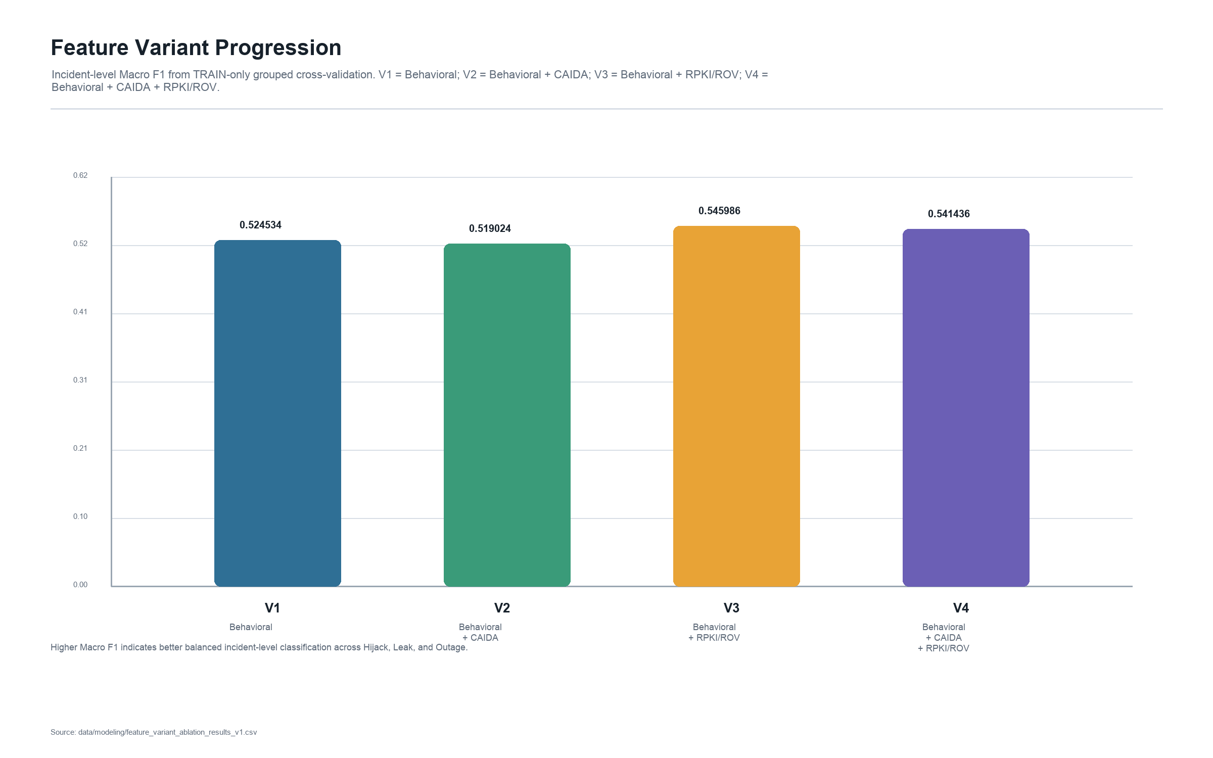
Figure 4.1 Feature variant progression from Behavioral-only evidence to the full V4 representation.
Feature-family ablation showed that feature groups did not contribute uniformly. RPKI/ROV evidence was especially important for Hijack discrimination, while CAIDA and peer-visibility context provided useful signal for Leak and Outage interpretation. This supports the final integrated representation rather than a purely behavioral model.
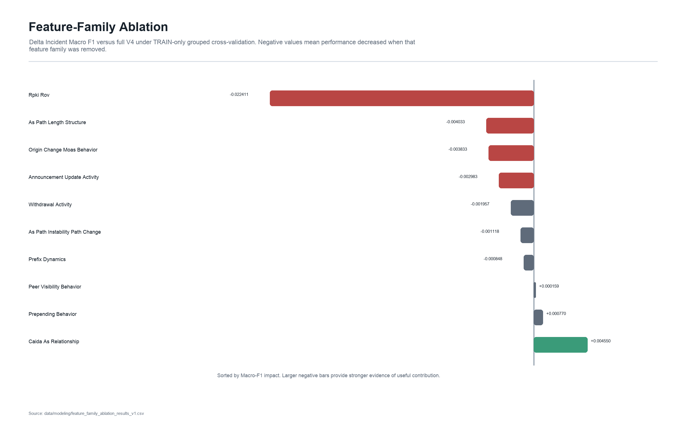
Figure 4.2 Feature-family ablation results.

Incident Imbalance and Stage 1 Findings
Incident-aware weighting was retained as I1 because it reduced unequal incident influence while preserving all valid windows. The p95 cap in I2 was informative but was not adopted as the final strategy because it removed windows by duration rather than by evidence quality.
Stage 1 Normal-vs-Incident discrimination remained unresolved and auxiliary. Weighting improved some aggregate discrimination measures, but Normal precision-recall behavior remained weak. The final K1 system therefore focuses on ranking Hijack, Leak, and Outage after incident windows are available.

Random Forest and XGBoost Development
Random Forest provided a strong benchmark after optimization and refinement, but refined XGBoost produced the stronger TRAIN grouped-CV result under the V4/I1 framework. The refined XGBoost candidate achieved TRAIN grouped-CV Macro F1 of 0.805678 before the single Validation confirmation.
The XGBoost result did not end model development. It established the first-level classifier used later in incident-level stacking, where the model could exploit temporal incident summaries rather than relying only on mean window probabilities.

Independent Validation
The predeclared Validation confirmation evaluated 213 Validation incidents and passed the predefined floors, but performance decreased relative to TRAIN grouped-CV. Validation Macro F1 was 0.713904, Top-2 accuracy was 0.901408, and MRR was 0.842723. This drop is important because it shows why the dissertation should not report TRAIN development results as final generalization.
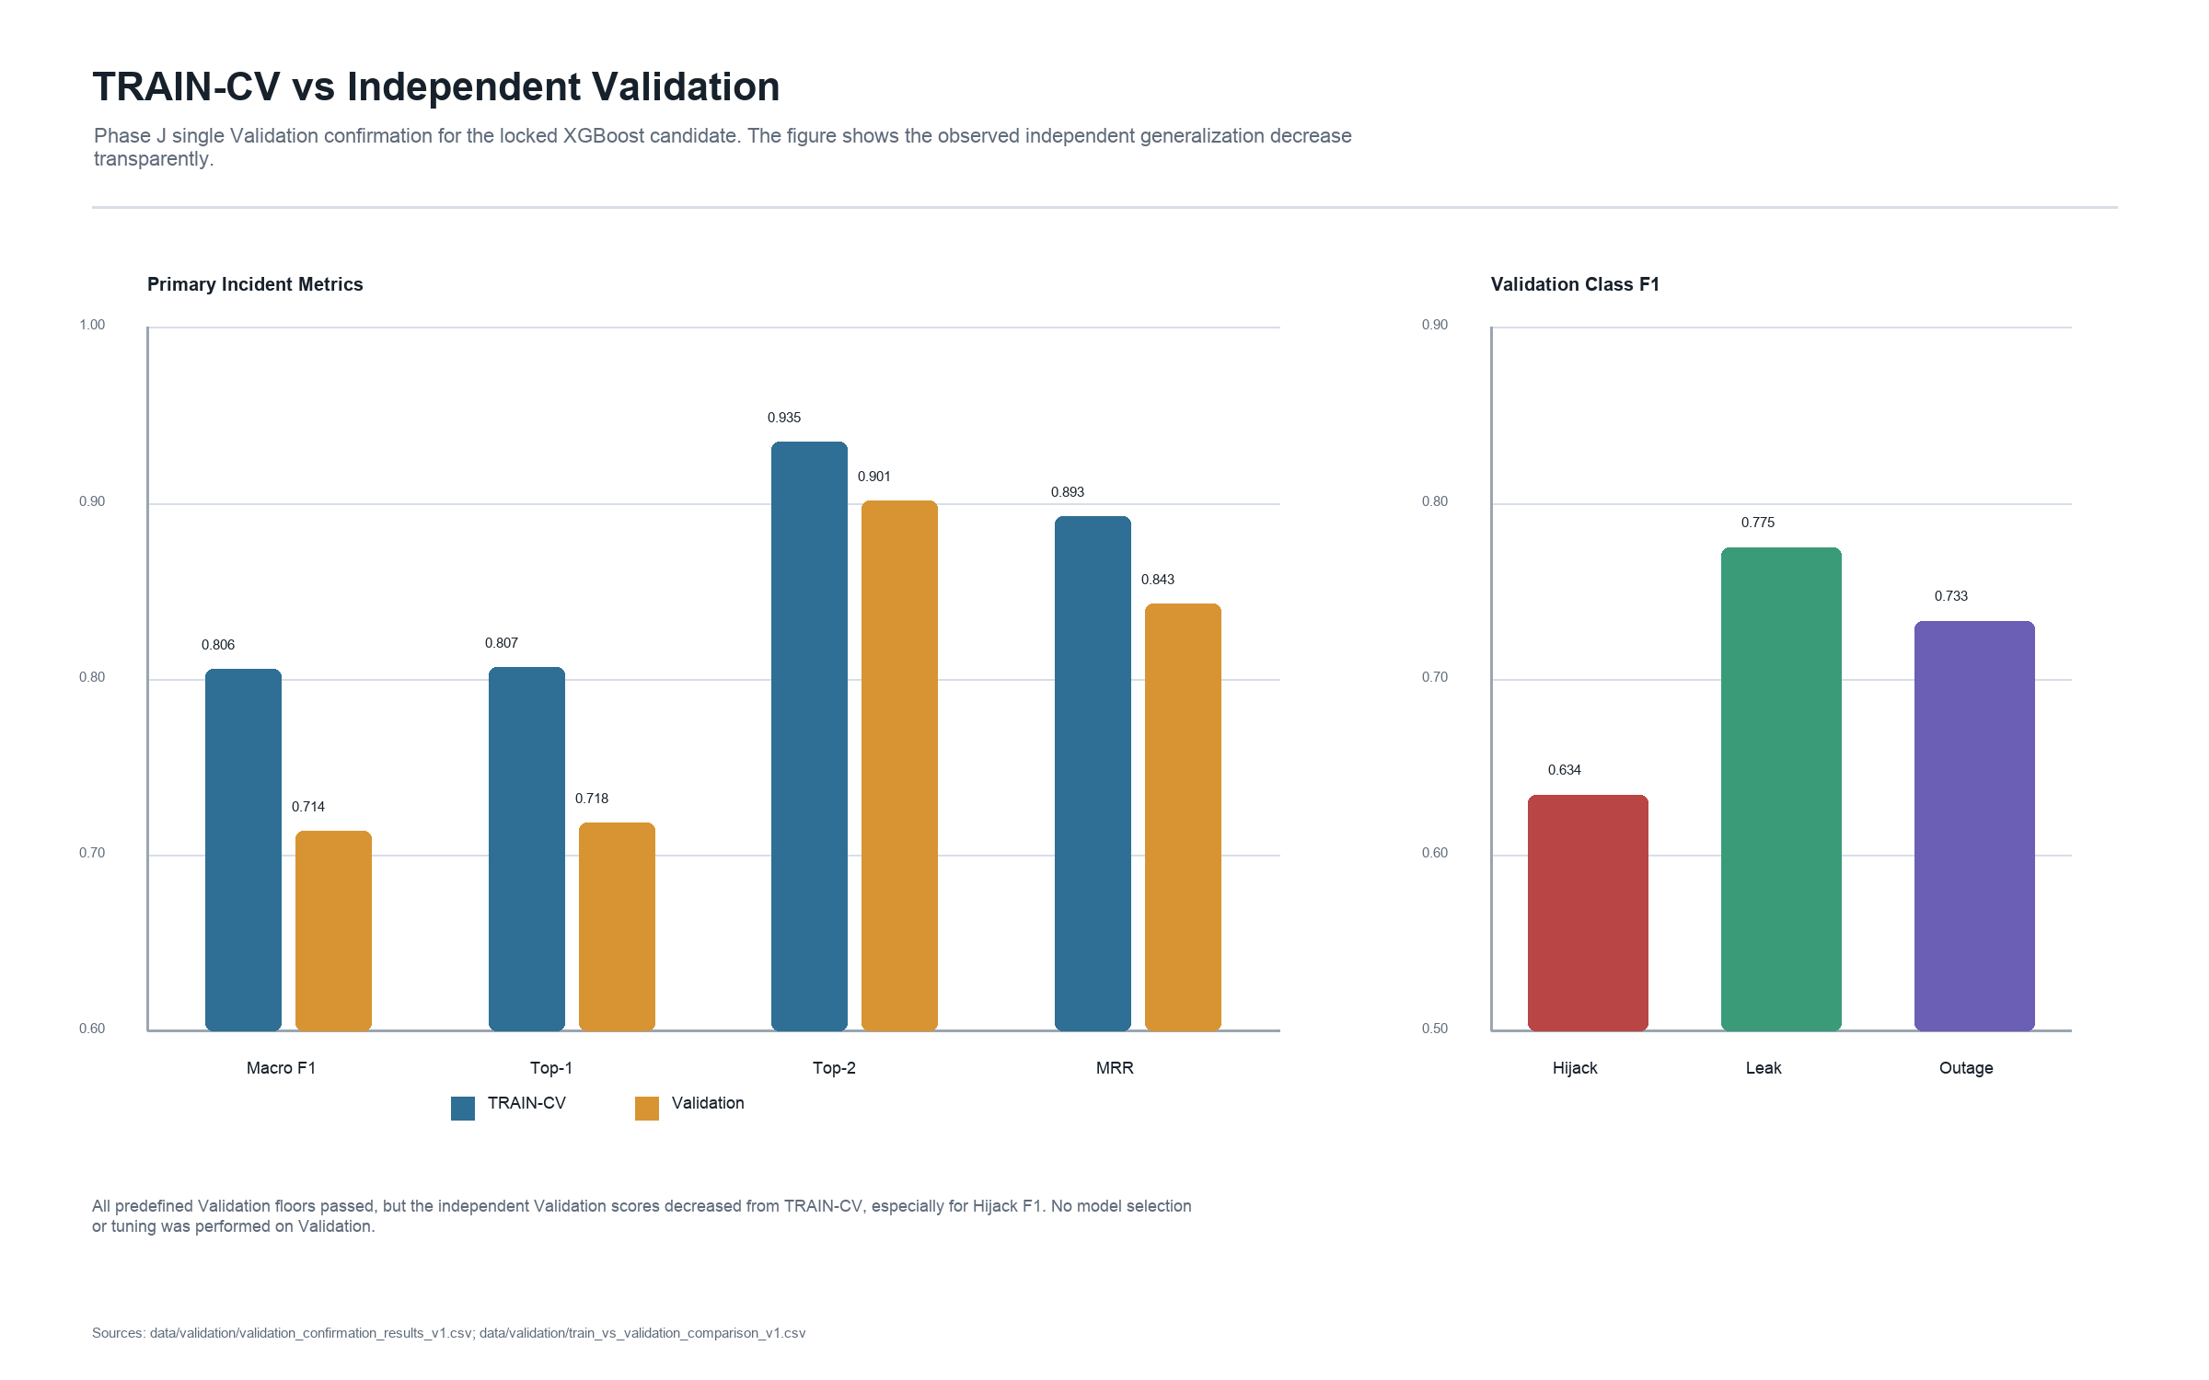
Figure 4.3 TRAIN grouped-CV versus independent Validation performance.

Incident-Level Stacking
K1 incident-level temporal stacking materially improved TRAIN-only nested-CV performance over mean probability aggregation. The stacker used temporal summaries of first-level probabilities and produced stronger classification and ranking results while preserving grouped, leakage-controlled folds.
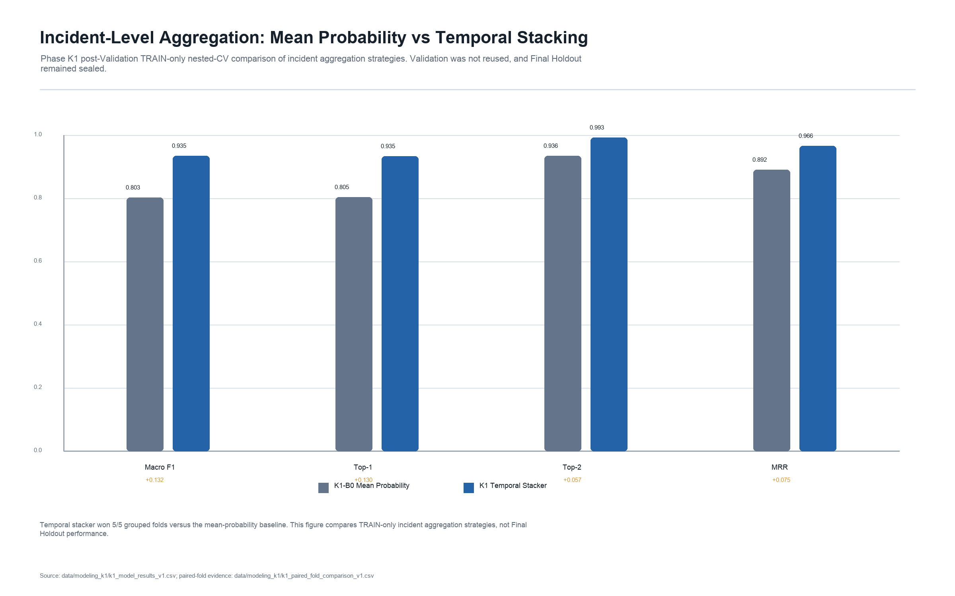
Figure 4.4 Mean probability aggregation versus K1 temporal stacking.
Forensic checks found no detected Level-1 or Level-2 leakage, 993 unique incident meta rows, balanced class counts, no true-class encoded meta-features, and label-permutation collapse near random Macro F1. Multi-seed K2 results supported the stability of the K1 gain.
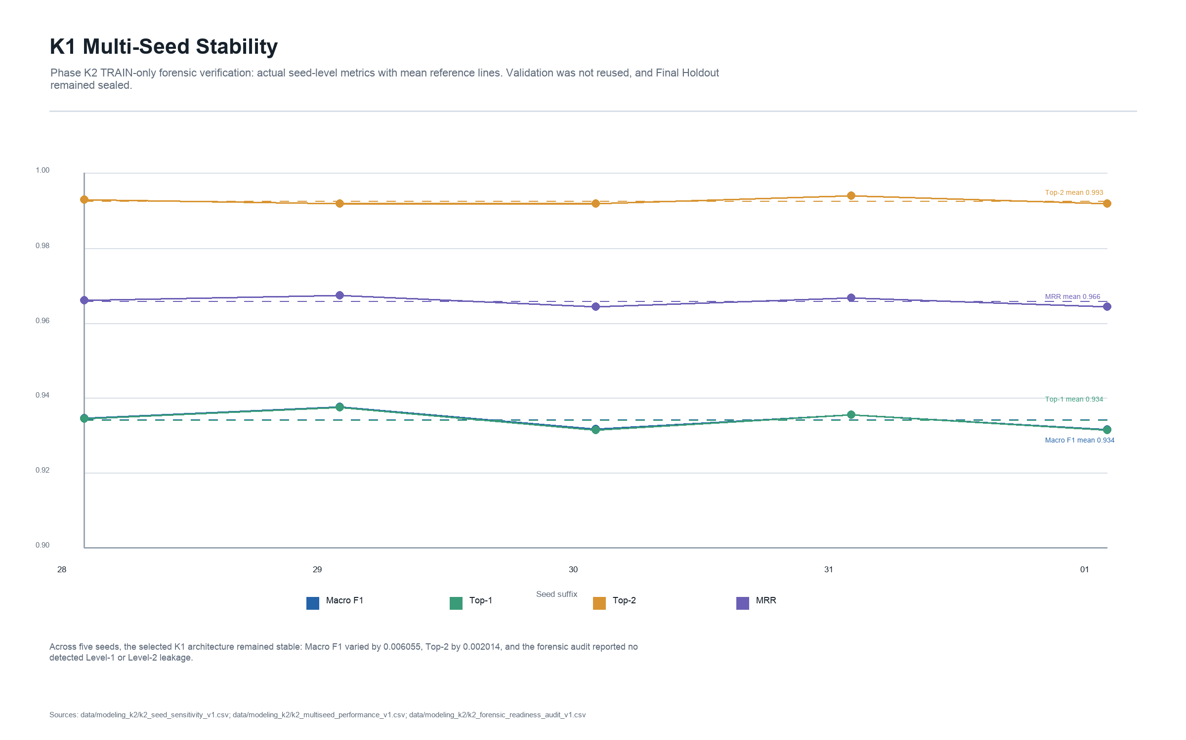
Figure 4.5 K1 multi-seed stability results.

Final Holdout Evaluation
The deployable K1 architecture was frozen before Final Holdout access. The one-time Final Holdout evaluation used 213 incidents, balanced across 71 Hijack, 71 Leak, and 71 Outage incidents, with 14,906 five-minute rows. The model achieved Macro F1 of 0.920177 with a 95% confidence interval of [0.880117, 0.954402], Top-1 of 0.920188, Top-2 of 0.990610, and MRR of 0.958529.
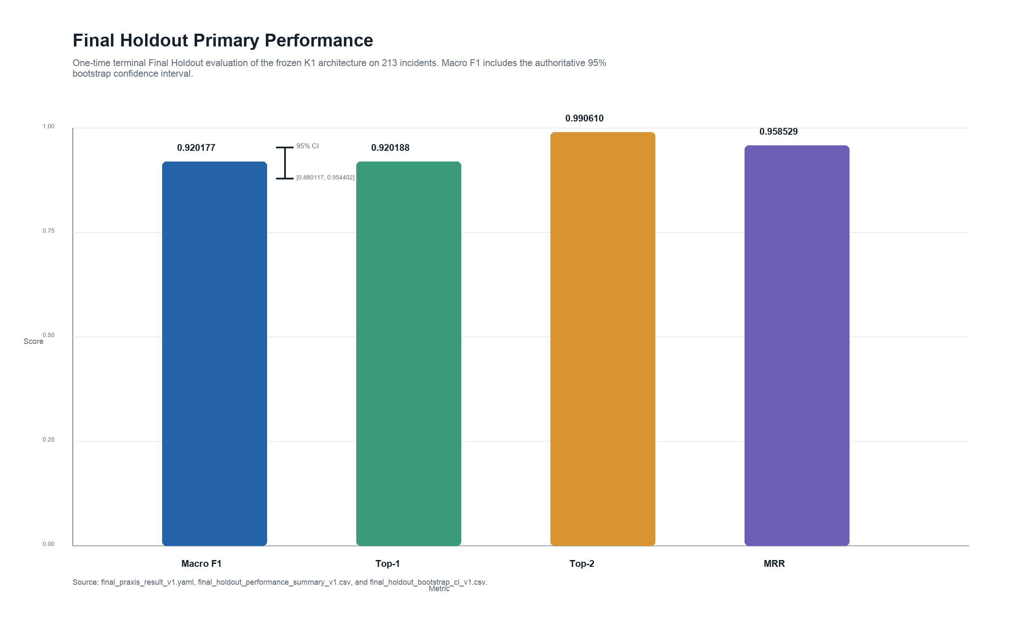
Figure 4.6 Final Holdout primary performance for the frozen K1 architecture.
Table 4.2 Final Holdout class and ranking results.
Measure | Value
Hijack F1 | 0.877698
Leak F1 | 0.904110
Outage F1 | 0.978723
Ranked first | 196/213
Ranked second | 15/213
Ranked third | 2/213
Top-2 correct | 211/213

Final Error and Confusion Analysis
The remaining errors were concentrated primarily between Hijack and Leak. The confusion matrix shows 9 Hijack incidents predicted as Leak and 5 Leak incidents predicted as Hijack. Outage was the strongest class, with 69 of 71 Outage incidents correctly classified.
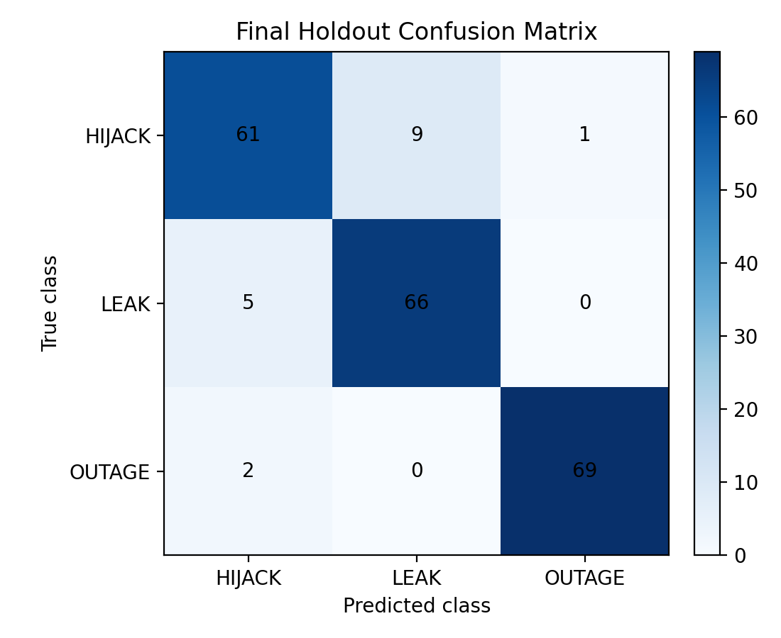
Figure 4.7 Final Holdout confusion matrix for Hijack, Leak, and Outage.
One documented data-quality caveat remained for Hijack:68538, which had a processing REVIEW status because one check identified no directly relevant RouteViews observations. The final evaluation nevertheless completed with valid V4 feature rows and PASS status in the final schema and reproducibility audits. No claim is made that this caveat materially changed the aggregate result.

Latency and Operational Feasibility
The final latency benchmark measured warm downstream K1 computation after feature/probability availability. Mean downstream computation was approximately 25.58 ms per incident, with median 24.77 ms and p95 27.63 ms. This corresponds to an approximate downstream throughput derivative of 39 incidents per second, but it is not end-to-end live BGP detection latency.
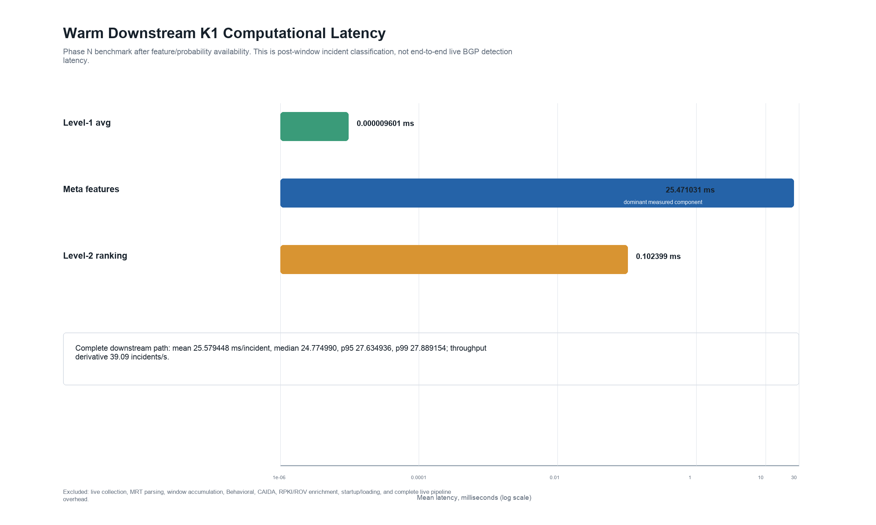
Figure 4.8 Breakdown of warm downstream K1 computational latency.

Research Question Mapping
The results support the central claim that integrated BGP behavioral, AS-relationship, and RPKI/ROV evidence can rank likely BGP incident classes under leakage-safe evaluation. RQ1 was supported by the multiclass results; RQ2 was supported by feature-variant and ablation evidence; RQ3 was supported by K1's improvement over mean aggregation; and RQ4 was supported by the sealed Final Holdout result. The findings do not prove reduced MTTR or human troubleshooting improvement, which remain future operator-study questions.

Chapter Summary
The final system generalized strongly on the untouched Final Holdout while preserving important caveats: Validation performance dropped relative to TRAIN development, Stage 1 remained unresolved, Hijack remained the hardest class, and latency was measured only after feature availability. These constraints make the results more defensible because they separate final evidence from developmental optimism.

Condensed Source Synthesis
This chapter presents the experimental results obtained from the development and final evaluation of the BGP incident classification and ranking system. The results are reported in the order in which the major experimental questions were addressed: feature evaluation, incident-imbalance treatment, Random Forest optimization, XGBoost comparison and refinement, independent Validation, incident-level stacking, forensic and stability verification, final architecture comparison, Final Holdout evaluation, and computational latency assessment.
A clear distinction is maintained between TRAIN development results and independent evaluation results. Model development was performed primarily using the 993 TRAIN incidents, consisting of 331 Hijack, 331 Leak, and 331 Outage incidents. TRAIN results were generated using incident-level grouped or nested cross-validation and were used to compare feature configurations, weighting strategies, algorithms, hyperparameters, and alternative architectures. These results represent model-development evidence and are not reported as final generalization performance.
The experimental progression summarized in Table 4.1 reflects the distinction between model-development evidence and independent evaluation evidence. Feature selection, imbalance treatment, algorithm comparison, hyperparameter optimization, incident-level stacking, and architecture verification were conducted using the TRAIN partition with incident-level grouped or nested cross-validation. Validation and Final Holdout results are therefore reported separately and are not combined with TRAIN cross-validation results when describing final model generalization.
The final labeled corpus contained 1,419 incidents, equally distributed across Hijack, Leak, and Outage. Of these, 993 incidents were assigned to TRAIN, 213 to Validation, and 213 to Final Holdout. The final V4 representation contained 74 features, consisting of 44 behavioral BGP features, 14 CAIDA AS-relationship features, and 16 RPKI/ROV features. The I1 incident-aware weighting strategy was retained for model development to reduce the disproportionate influence of incidents containing large numbers of five-minute analytical windows.
The primary final evaluation measures were Macro F1, Top-1 accuracy, Top-2 accuracy, and Mean Reciprocal Rank (MRR). Class-specific precision, recall, and F1 were used to examine performance for Hijack, Leak, and Outage individually, while confusion matrices and mean true-class rank were used to characterize classification and ranking errors. A 95% confidence interval was calculated for the primary Final Holdout Macro F1 result.
ROC, precision-recall, calibration, and threshold analysis were retained primarily for the experimental Normal-versus-Incident Stage 1 and are reported separately from the final three-class architecture. Likewise, TRAIN cross-validation results are used to explain the experimental progression and model-selection decisions, whereas the previously sealed Final Holdout provides the terminal estimate of final model performance.
The 1,419 incidents were divided into three mutually exclusive partitions. TRAIN contained 993 incidents, with 331 incidents from each class. Validation contained 213 incidents, with 71 incidents from each class. The Final Holdout also contained 213 incidents, equally distributed across the three classes. Partitioning was performed at the incident level so that all five-minute analytical windows belonging to the same incident remained within a single partition.
The feature representation also expanded substantially during the study. The final behavioral feature schema contained 44 features derived directly from BGP UPDATE observations. These features characterized announcement and withdrawal activity, prefix dynamics, peer visibility, AS-path behavior, origin changes, path instability, and related control-plane characteristics.
Two external contextual feature groups were subsequently added. Historical CAIDA AS-relationship information contributed 14 features describing routing-policy and AS-path relationship characteristics, including valley-free behavior. Historical RPKI/ROV information contributed 16 features representing route-origin authorization evidence, including VALID, INVALID, and NotFound states and more specific evidence associated with origin mismatch and maximum-prefix-length violations.
The four controlled feature variants used during development were constructed from these feature groups. V1 contained the 44 behavioral features, V2 contained 58 features after adding CAIDA, V3 contained 60 features after adding RPKI/ROV to the behavioral baseline, and V4 combined all three groups for a total of 74 features. The schemas were frozen before controlled comparison so that differences in model performance reflected changes in available routing evidence rather than unintended changes to the underlying feature definitions.
The feature experiments evaluated whether AS-relationship and route-origin validation information provided additional discriminatory information beyond behavioral BGP features alone. Two complementary analyses were performed. First, the four frozen feature variants, V1 through V4, were compared under the same TRAIN-only evaluation framework. Second, feature-family ablation measured the effect of removing individual feature groups from the complete V4 representation.
The four feature variants represented different combinations of routing evidence. V1 contained the 44 behavioral BGP features. V2 added 14 CAIDA AS-relationship features. V3 added 16 RPKI/ROV features to the behavioral baseline. V4 combined all three information sources for a total of 74 features.
The feature-variant comparison did not show a simple pattern in which adding more features always increased every metric. V3 achieved the highest Macro F1 at 0.545986, representing an improvement of 0.021452 over the V1 behavioral baseline. V4 achieved a Macro F1 of 0.541436, an improvement of 0.016902 over V1 but slightly below V3.
The ranking metrics showed a different pattern. V4 produced the highest Top-2 accuracy at 0.923076 and the highest MRR at 0.851910 among the four variants. V2 also improved Top-2 and MRR relative to V1 despite producing a slightly lower Macro F1. These results indicate that the enrichment sources affected classification and ranking behavior differently.
The RPKI/ROV-enriched V3 representation provided the strongest improvement in Macro F1 relative to the behavioral baseline. However, the combined V4 representation provided the strongest overall ranking performance and retained all three sources of routing evidence. V4 was therefore carried forward into subsequent controlled model-development experiments, where the contribution of its feature groups was examined further through feature-family ablation and later model optimization.
The comparison also demonstrates why feature contribution should not be inferred solely from the total number of features. Adding CAIDA alone did not improve Macro F1 in V2, while adding RPKI/ROV in V3 produced the strongest Macro F1. The combined V4 representation nevertheless improved Top-2 and MRR, suggesting that AS-policy and route-origin evidence contributed complementary information that was not fully reflected by Macro F1 alone.
Feature-family ablation provided a more direct assessment of the contribution of individual information sources within the complete V4 representation. Each feature family was removed while the remaining representation and evaluation procedure were held constant. The resulting change in Macro F1 was measured relative to the full V4 configuration.
The strongest ablation effect occurred when the RPKI/ROV feature family was removed, reducing Macro F1 by 0.022411. This was the largest observed decrease among the evaluated feature families and provides evidence that route-origin validation information contributed useful discriminatory information within the complete representation.
The ablation results therefore show that no single feature family completely determined incident classification. Instead, different feature groups contributed differently across the three incident classes. Most notably, RPKI/ROV produced the strongest overall measurable ablation signal and the largest effect on Hijack F1. This finding should be interpreted as evidence of predictive contribution within the TRAIN-only experimental framework rather than as proof that RPKI/ROV information causally determines whether a routing incident is a Hijack.
Taken together, the feature-variant and feature-family results support the use of a heterogeneous routing representation. Behavioral BGP features provide the underlying control-plane observations, while CAIDA and RPKI/ROV features contribute additional policy and security context. The results also demonstrate that the value of these information sources depends on both the evaluation metric and the incident class being considered.
These findings directly address RQ2/H2 by demonstrating that specific BGP and contextual feature families provide measurable discriminatory information for distinguishing Hijack, Leak, and Outage incidents, with RPKI/ROV showing the strongest overall ablation contribution in this TRAIN-only experiment.
Although the TRAIN corpus was balanced at the incident-class level, individual incidents contributed different numbers of five-minute analytical windows. Without adjustment, incidents containing more windows could exert greater influence during model fitting than incidents represented by fewer windows. Three TRAIN-only strategies—I0, I1, and I2—were therefore evaluated to determine how incident representation should be handled.
I1 retained all available windows while applying incident-aware weighting. Window weights were adjusted inversely to the number of windows contributed by each incident so that incidents had more comparable aggregate influence during model fitting. This approach preserved the complete temporal evidence while reducing the dominance of highly represented incidents.
I2 combined incident-aware weighting with a p95 temporal cap of 164 windows per incident. Incidents exceeding the threshold were represented by a temporally distributed subset of their windows before weighting was applied. This strategy tested whether reducing potentially redundant observations from unusually long incidents could further improve incident-level generalization.
The comparison showed that controlling incident representation was preferable to allowing the natural window distribution to determine training influence. Both I1 and I2 reduced the disproportionate contribution of incidents containing large numbers of analytical windows.
I2 produced slightly stronger group-level results in some TRAIN comparisons, indicating that limiting unusually long incidents could reduce redundant training information. However, the improvement over I1 was not sufficiently large or consistent to justify permanently discarding otherwise valid analytical windows. I2 also introduced an additional temporal-sampling decision into the training pipeline.
In contrast, I1 preserved every available five-minute window while directly addressing the underlying imbalance problem. It therefore provided a simpler and more conservative approach: all available routing evidence remained available to the classifier, while each independent incident contributed more comparable aggregate influence during model fitting.
For these reasons, I1 was selected as the final incident-imbalance strategy and was combined with the V4 feature representation for subsequent Random Forest and XGBoost development. The resulting V4/I1 configuration established the controlled development baseline used for model optimization and algorithm comparison.
Importantly, weighting was applied only during model fitting. Held-out grouped-CV observations remained natural and unweighted, ensuring that the evaluation distribution was not altered to favor the selected strategy. The I0/I1/I2 comparison therefore demonstrated that balancing the influence of independent incidents could be achieved without artificially modifying the evaluation data.
The experimental Stage 1 analysis evaluated whether verified Normal routing windows could be reliably distinguished from windows associated with Hijack, Leak, and Outage incidents. Stage 1 was evaluated separately from the final three-class classification architecture. The results showed that although weighting and threshold adjustments improved some discrimination measures, Normal-versus-Incident separation remained insufficient for use as a mandatory first-stage gate.
The initial Stage 1 classifier was evaluated using leakage-safe TRAIN grouped cross-validation. The analysis revealed substantial overlap between the predicted probability distributions for Normal and Incident observations. As a result, the conventional probability threshold of 0.50 did not provide reliable Normal recognition.
This limitation was particularly evident in the precision-recall behavior of the Normal class. Although the classifier contained some discriminatory information, the probability distributions were not sufficiently separated to produce both acceptable Normal recognition and a low rate of incidents incorrectly classified as Normal.
The results motivated two additional experiments: a controlled TRAIN-only threshold analysis and a class-and-group weighting experiment designed to determine whether the observed limitation resulted primarily from the decision threshold or from unequal effective training influence between Normal and Incident observations.
The Stage 1 decision threshold, τ (tau), determines the probability boundary used to convert model output into a Normal-versus-Incident classification. To prevent threshold-selection leakage, τ was selected using out-of-fold predictions generated exclusively from TRAIN grouped cross-validation.
The TRAIN-CV analysis proposed τ = 0.06. However, the optimal thresholds differed substantially across the five grouped folds: 0.06, 0.62, 0.32, 0.32, and 0.45. This variation demonstrated that the threshold was not stable across independent groups of TRAIN incidents.
The combination of low Normal F1 and substantial fold-to-fold threshold variation indicated that the problem could not be resolved simply by selecting a different value of τ. The analysis therefore shifted to whether the training-weight structure itself was limiting Stage 1 discrimination.
A follow-up weighting experiment evaluated whether the poor Normal performance resulted partly from unequal effective training influence between Normal and Incident observations. The revised condition, designated W1, balanced class-level influence while preserving group-aware weighting.
The weighting adjustment improved ROC-AUC from approximately 0.6963 to 0.7581, indicating better overall separation between Normal and Incident probability distributions. However, PR-AUC increased only from approximately 0.0140 to 0.0162, demonstrating that performance on the difficult Normal class remained weak.
Under W1, the TRAIN-CV threshold shifted to τ = 0.72. Despite the improvement in ROC-AUC, approximately 26.52% of incident observations were incorrectly classified as Normal under the resulting decision rule. For an operational screening stage, this represented an unacceptable failure mode because a mandatory Stage 1 gate could prevent a substantial number of actual incidents from reaching the downstream Hijack/Leak/Outage classifier.
The W1 results therefore demonstrated an important distinction between improved ranking separation and operationally useful binary classification. The increase in ROC-AUC showed that weighting improved the model's ability to order Normal and Incident observations, but the very low PR-AUC and high false-Normal rate showed that the probability distributions remained insufficiently separated for reliable gating.
Stage 1 was not incorporated as a mandatory gate in the final architecture. Instead, the final system assumes that a candidate BGP incident has already been identified and directly classifies and ranks it as Hijack, Leak, or Outage. Consequently, the final XGBoost incident-level stacking architecture does not use τ = 0.06, τ = 0.72, or any other manually selected Normal-versus-Incident threshold.
This negative result is methodologically important. It demonstrates that strong classification among known BGP incident types does not necessarily imply that the same feature representation can reliably distinguish arbitrary Normal routing behavior from incident behavior. Stage 1 therefore remains a separate anomaly-detection problem and is identified as an area for future research.
Random Forest served as the primary tree-based benchmark before comparison with XGBoost. After the V4 feature representation and I1 incident-aware weighting strategy were established, Random Forest optimization was conducted using TRAIN-only incident-grouped cross-validation. The objective was to establish the strongest defensible Random Forest benchmark without changing the feature representation or evaluation framework.
The baseline V4/I1 Random Forest achieved an incident-level Macro F1 of 0.742814. Phase H then applied bounded hyperparameter optimization under the same grouped-CV framework and increased Macro F1 to 0.783443. Phase H2 performed local refinement and multi-seed stability analysis, producing a refined Random Forest Macro F1 of 0.784588.
The refined model also achieved Top-1 accuracy of 0.787513, Top-2 accuracy of 0.932931, and MRR of 0.882578. Class-specific F1 scores were 0.721923 for Hijack, 0.841110 for Leak, and 0.790732 for Outage. These results established the refined H2 model as the strongest Random Forest benchmark carried into the subsequent XGBoost comparison.
Relative to the baseline, Phase H improved incident Macro F1 by +0.040629. Phase H2 added a further +0.001145. The smaller H-to-H2 gain indicates that Random Forest performance had entered a comparatively stable region, while the multi-seed analysis provided additional evidence that the refined result was not dependent on a single favorable initialization.
Runtime increased as the Random Forest became more complex. The recorded fit runtime rose from 18.170 seconds for the baseline to 225.365 seconds for Phase H and 399.192 seconds for the refined H2 model. Recorded inference runtime increased from 0.295 to 1.321 seconds under the corresponding experiment. These timings are specific to the Random Forest development experiment and are distinct from the later end-to-end K1 latency assessment.
The Phase H2 refined Random Forest was therefore retained as the strongest RF benchmark rather than continuing unrestricted hyperparameter searching. This provided a controlled reference for determining whether XGBoost could produce a meaningful improvement under the same V4/I1 TRAIN development framework.
XGBoost was evaluated after establishing the refined Random Forest as the strongest RF benchmark. The comparison used the same V4 feature representation, I1 incident-aware weighting strategy, TRAIN incidents, grouped cross-validation structure, and incident-level evaluation metrics. This controlled design allowed differences in performance to be attributed primarily to the learning algorithm rather than to changes in the data or feature representation.
In Phase I, the optimized XGBoost model achieved an incident-level Macro F1 of 0.799599, exceeding the refined Random Forest benchmark. This result provided initial evidence that gradient boosting was better suited to the nonlinear relationships represented in the combined behavioral, CAIDA, and RPKI/ROV feature space.
Phase I2 then performed bounded local refinement around the strongest XGBoost configuration and evaluated shortlisted models across multiple random seeds. The refined XGBoost achieved an incident-level Macro F1 of 0.805678 ± 0.002042. The small variation across seeds indicated that the improvement was stable rather than dependent on a single favorable initialization.
Compared with the refined Random Forest Macro F1 of 0.784588, the refined XGBoost improved Macro F1 by approximately 0.02109. The comparison also considered Top-1 accuracy, Top-2 accuracy, Mean Reciprocal Rank (MRR), class-specific F1, and computational runtime so that algorithm selection was not based on Macro F1 alone.
The class-specific comparison was included to ensure that improvement in overall Macro F1 did not conceal degradation in one of the three target classes. The refined XGBoost was therefore evaluated for consistency across Hijack, Leak, and Outage together with its ranking behavior. MRR and Top-2 were retained as important secondary measures because the system was designed to provide a ranked list of incident classes rather than only a Top-1 label.
Runtime was also considered in the model-selection decision. Random Forest and XGBoost were evaluated under the same development environment, allowing their computational requirements to be compared alongside predictive performance. The objective was to determine whether the predictive improvement was stable and computationally practical enough to justify carrying XGBoost forward.
Taken together, the Phase I and Phase I2 results showed that XGBoost provided a reproducible improvement over the strongest Random Forest benchmark under the frozen V4/I1 development framework. XGBoost was therefore selected as the preferred window-level model family and carried forward to the independent Validation experiment and subsequent incident-level stacking research.
XGBoost was evaluated after the refined Random Forest had been established as the strongest Random Forest benchmark. To ensure a controlled algorithm comparison, XGBoost used the same V4 feature representation, I1 incident-aware weighting strategy, TRAIN incidents, grouped cross-validation folds, and incident-level evaluation framework. This allowed differences in performance to be attributed primarily to the learning algorithm rather than changes in the underlying experimental design.
In Phase I, XGBoost achieved an incident-level Macro F1 of 0.799599, exceeding the refined Random Forest result of 0.784588. This initial comparison demonstrated that gradient boosting provided stronger incident-level classification under the frozen V4/I1 configuration and justified additional XGBoost refinement.
Phase I2 subsequently performed bounded local refinement around the strongest XGBoost configuration and evaluated shortlisted candidates across multiple random seeds. The refined XGBoost achieved a mean incident-level Macro F1 of 0.805678 ± 0.002042. The relatively small variation across seeds indicated that the improvement was stable rather than dependent on a single favorable model initialization.
Compared with the refined Random Forest, the refined Phase I2 XGBoost improved Macro F1 by approximately 0.021089. Model selection was not based on Macro F1 alone. Top-1 accuracy, Top-2 accuracy, Mean Reciprocal Rank (MRR), and class-specific F1 for Hijack, Leak, and Outage were also compared to determine whether the improvement was consistent across classification and ranking measures.
The ranking comparison was particularly relevant to the objective of the Praxis. Top-2 and MRR measure whether the correct incident type remains highly ranked even when it is not the model's first prediction. These measures were therefore considered alongside Macro F1 when determining which model family should be carried forward.
Class-specific performance was also examined to ensure that improvement in overall Macro F1 did not result from improving one incident class while substantially degrading another. The refined XGBoost was evaluated for consistency across Hijack, Leak, and Outage together with its ranking behavior.
Computational performance provided an additional consideration in the model-selection decision. Random Forest and XGBoost runtimes were compared using the corresponding TRAIN development artifacts. Runtime was treated as a secondary criterion rather than as a substitute for predictive performance, with the objective of confirming that the stronger model remained computationally practical.
Taken together, the Phase I and Phase I2 experiments demonstrated a reproducible improvement over the strongest Random Forest benchmark under the frozen V4/I1 development framework. XGBoost was therefore selected as the preferred window-level model family and carried forward to independent Validation and subsequent incident-level stacking experiments.
After completion of the TRAIN-only feature, weighting, Random Forest, and XGBoost development experiments, the refined XGBoost candidate was evaluated on the independent Validation partition. This evaluation was conducted under the predefined Phase J confirmation protocol and represented the first assessment of the selected candidate on incidents outside the TRAIN development partition.
The Validation dataset contained 213 independent incidents, equally distributed across 71 Hijack, 71 Leak, and 71 Outage incidents. Model fitting was performed exclusively using the 993 TRAIN incidents. No Validation incidents were used for feature selection, hyperparameter optimization, model fitting, or threshold selection.
Performance differed across the three incident classes. Leak achieved the highest class-specific F1 at 0.774648, followed by Outage at 0.732919 and Hijack at 0.634146. Hijack therefore represented the most difficult class for the refined XGBoost candidate on the independent Validation partition.
The Validation results were lower than the corresponding TRAIN grouped-cross-validation estimates. Relative to the TRAIN-CV reference, the absolute decreases were 0.091773 for Macro F1, 0.088739 for Top-1, 0.033335 for Top-2, and 0.049926 for MRR. Class-specific F1 decreased by 0.122050 for Hijack, 0.077275 for Leak, and 0.075994 for Outage.
The decrease in independent Validation performance was retained as an important experimental finding rather than being removed or obscured. It demonstrated that the window-level model generalized less strongly to independent incidents than the TRAIN grouped-CV estimates suggested. The largest degradation occurred for Hijack, indicating that this class remained particularly challenging across unseen routing events.
No model parameters, feature definitions, weighting rules, or decision procedures were modified in response to the Validation results. This preserved the Validation evaluation as an independent confirmation rather than converting it into another model-tuning stage.
The observed generalization gap subsequently motivated examination of whether the information contained across multiple five-minute windows could be represented more effectively at the incident level. That subsequent work was explicitly versioned as post-Validation TRAIN-only development and did not reuse Validation for architecture selection. The incident-level stacking results are presented in Section 4.9.
The magnitude and consistency of the improvement indicate that the way window-level evidence is combined is an important component of the classification problem. Mean aggregation preserves the average probability assigned to each class but loses information about whether predictions are stable, dispersed, conflicting, or changing over the course of an incident. The temporal stacker preserves these additional characteristics and allows the second-level classifier to learn from them.
The K1 results therefore provide evidence that incident-level aggregation can materially improve BGP incident classification and ranking beyond simple averaging of window-level probabilities. Because the improvement was substantial, additional forensic leakage analysis, multi-seed stability testing, and architecture comparison were performed before the stacker was accepted as the final architecture. These verification results are presented in Sections 4.10 and 4.11.
These findings also provide direct evidence relevant to RQ3/H3 by demonstrating that the proposed incident-level ranking architecture improved classification and ranking performance relative to the simpler mean-probability aggregation baseline. Claims regarding operational diagnostic-time reduction, however, are treated separately because this experiment measured predictive improvement rather than a controlled comparison of human troubleshooting time.
Following independent Validation, the study examined whether the predictions generated across multiple five-minute windows could be combined more effectively at the incident level. The refined window-level XGBoost model provided useful classification evidence, but simple aggregation could discard information about probability distributions, prediction confidence, disagreement among windows, and changes in class evidence over time.
Phase K1 therefore compared a simple mean-probability aggregation baseline (K1-B0) with an incident-level temporal stacking architecture. This work was explicitly conducted as post-Validation, TRAIN-only development. Validation was not reused for architecture selection, and the Final Holdout remained sealed.
The baseline demonstrated that aggregating window probabilities could produce a useful incident-level decision. However, averaging reduced each incident to a small number of mean values and did not explicitly represent the distribution, confidence, disagreement, or temporal evolution of predictions across the incident.

Chapter 5 - Conclusions

Overview
This Praxis developed and evaluated an AI-based post-window classification and ranking system for BGP incidents in enterprise-relevant routing contexts. The final system ranks Hijack, Leak, and Outage hypotheses from observable BGP evidence rather than claiming to prove physical root cause.

Interpretation of Findings
The final result shows that incident-level temporal stacking can turn window-level routing evidence into a stronger incident-level diagnosis. On the sealed Final Holdout of 213 unseen incidents, the frozen K1 architecture achieved Macro F1 of 0.920177, Top-2 accuracy of 0.990610, and MRR of 0.958529. The true class was ranked in the top two for 211 of 213 incidents.
The result also shows that the problem is not solved perfectly. Hijack remained the most difficult class, and the principal confusion was between Hijack and Leak. Stage 1 Normal-vs-Incident detection did not become part of the final architecture. These negative findings are important because they define the boundary of what the system can responsibly claim.

Key Contributions
- A reproducible incident-level BGP corpus and leakage-safe partition design.
- A 74-feature V4 representation combining Behavioral, CAIDA, and RPKI/ROV evidence.
- An incident-aware weighting approach that reduces unequal influence from long incidents.
- A K1 incident-level temporal stacking architecture for classification and ranked incident hypotheses.
- A sealed Final Holdout evaluation with transparent error, ranking, and latency evidence.

Practical Implications
For network operations, the most useful output is not a claim of autonomous root-cause proof. It is a ranked hypothesis that can narrow the investigative search space. If integrated into an operational workflow, the model could help engineers prioritize whether observed BGP evidence is more consistent with Hijack, Leak, or Outage while still requiring human validation and additional telemetry.

Limitations
The study depends on public RouteViews observations and external incident labels. Collector visibility varies over time and may not represent enterprise-local routing state. RPKI and CAIDA enrichment are based on historical snapshots and inferred relationships. The final latency measurement excludes live collection and feature generation. Finally, the Final Holdout contains 213 incidents, which is strong for this controlled study but still finite for estimating operational performance across all possible networks and events.

Future Research
Future work should focus on a stronger Normal-vs-Incident formulation, shorter observation horizons, streaming feature updates, additional collectors, enterprise-local telemetry, calibrated ranked probabilities, and operator studies that measure whether ranked incident hypotheses reduce troubleshooting time. The compact evidence-store concept developed during the project could also support future 30-second, one-minute, two-minute, and three-minute sensitivity studies without reparsing all MRT data, if timestamp resolution is captured at the needed granularity.

Conclusion
The Praxis demonstrates that a carefully controlled AI/ML pipeline can classify and rank BGP incident classes with strong final Holdout performance while preserving scientific caution. The final contribution is not only the measured performance, but the complete methodology: incident-level separation, feature enrichment, leakage controls, transparent negative results, and a final evaluation that remained sealed until the model was frozen.

Condensed Source Synthesis
This Praxis investigated whether machine learning can assist enterprise network operations by classifying and ranking the most likely type of a BGP routing incident using evidence derived from BGP UPDATE messages. The research was motivated by the difficulty of interpreting BGP control-plane behavior when different incidents can produce overlapping symptoms, such as changes in AS paths, routing instability, withdrawals, origin changes, and changes in prefix visibility.
The study developed an incident-centered machine-learning framework that combines three complementary sources of routing information: behavioral BGP features, CAIDA AS-relationship and routing-policy context, and RPKI/ROV route-origin validation evidence. These features were evaluated using independently labeled Hijack, Leak, and Outage incidents, with incident-level partitioning and leakage controls used throughout model development and evaluation.
A major finding of the study was that the representation of an incident across time was important. Rather than treating each five-minute analytical window as an independent final decision, the completed architecture uses window-level XGBoost probabilities as evidence for an incident-level temporal stacking model. The final system produces probabilities for Hijack, Leak, and Outage and orders those probabilities to provide a ranked set of incident hypotheses for further investigation by a network engineer.
The scope of the completed system is important to define clearly. The final architecture is not a general-purpose real-time BGP anomaly detector and does not independently determine whether arbitrary routing behavior is Normal or anomalous. The experimental Normal-versus-Incident Stage 1 did not demonstrate sufficient discrimination to be retained as a mandatory component of the final architecture. Instead, the final system assumes that a candidate BGP incident has already been identified and then classifies and ranks that incident as Hijack, Leak, or Outage.

References
Al-Rousan, N. M., & Trajković, L. (2012). Machine learning models for classification of BGP anomalies. In 2012 IEEE 13th International Conference on High Performance Switching and Routing (HPSR). IEEE. https://doi.org/10.1109/HPSR.2012.6260835
Azimov, A., Bogomazov, E., Bush, R., Patel, K., & Sriram, K. (2022). Route leak prevention and detection using roles in UPDATE and OPEN messages (RFC 9234). RFC Editor. https://doi.org/10.17487/RFC9234
Bagnulo, M., García-Martínez, A., Angieri, S., Lutu, A., & Yang, J. (2022). Practicable route leak detection and protection with ASIRIA. Computer Networks, 211, 108966. https://doi.org/10.1016/j.comnet.2022.108966
Ballani, H., Francis, P., & Zhang, X. (2007). A study of prefix hijacking and interception in the Internet. In Proceedings of the 2007 Conference on Applications, Technologies, Architectures, and Protocols for Communications (pp. 265-276). Association for Computing Machinery. https://doi.org/10.1145/1282380.1282411
Breiman, L. (2001). Random forests. Machine Learning, 45(1), 5-32. https://doi.org/10.1023/A:1010933404324
Bush, R. (2014). Origin validation operation based on the Resource Public Key Infrastructure (RPKI) (RFC 7115). RFC Editor. https://doi.org/10.17487/RFC7115
CAIDA. (2023). AS relationships dataset. Center for Applied Internet Data Analysis. https://www.caida.org/catalog/datasets/as-relationships/
Chen, T., & Guestrin, C. (2016). XGBoost: A scalable tree boosting system. In Proceedings of the 22nd ACM SIGKDD International Conference on Knowledge Discovery and Data Mining (pp. 785-794). Association for Computing Machinery. https://doi.org/10.1145/2939672.2939785
Chen, Y., Yin, Q., Li, Q., Liu, Z., Xu, K., Xu, Y., Xu, M., Liu, Z., & Wu, J. (2024). Learning with semantics: Towards a semantics-aware routing anomaly detection system. In 33rd USENIX Security Symposium (pp. 5143-5160). USENIX Association. https://www.usenix.org/conference/usenixsecurity24/presentation/chen-yihao
Chung, T., Aben, E., Bruijnzeels, T., Chandrasekaran, B., Choffnes, D., Levin, D., Maggs, B. M., Mislove, A., van Rijswijk-Deij, R., Rula, J. P., & Sullivan, N. (2019). RPKI is coming of age: A longitudinal study of RPKI deployment and invalid route origins. In Proceedings of the ACM Internet Measurement Conference (pp. 406-419). Association for Computing Machinery. https://doi.org/10.1145/3355369.3355596
Cooper, D., Heilman, E., Brogle, K., Reyzin, L., & Goldberg, S. (2013). On the risk of misbehaving RPKI authorities. In Proceedings of the Twelfth ACM Workshop on Hot Topics in Networks. Association for Computing Machinery. https://doi.org/10.1145/2535771.2535787
Cosovic, M., & Obradovic, S. (2018). BGP anomaly detection with balanced datasets. Technical Gazette, 25(3), 766-775. https://doi.org/10.17559/TV-20170219114900
da Silva Jr., B. A., Mol, P., Fonseca, O. L. H. M., Cunha, I., Ferreira, R. A., & Katz-Bassett, E. (2022). Automatic inference of BGP location communities. Proceedings of the ACM on Measurement and Analysis of Computing Systems, 6(1), Article 3. https://doi.org/10.1145/3508023
Deshpande, S., Thottan, M., Ho, T. K., & Sikdar, B. (2009). An online mechanism for BGP instability detection and analysis. IEEE Transactions on Computers, 58(11), 1470-1484.
Dimitropoulos, X., Krioukov, D., Fomenkov, M., Huffaker, B., Hyun, Y., Claffy, K. C., & Riley, G. (2007). AS relationships: Inference and validation. ACM SIGCOMM Computer Communication Review, 37(1), 29-40. https://doi.org/10.1145/1198255.1198259
Dong, Y., Zhang, H., Zhang, Y., Zhu, Z., & Mao, Z. M. (2021). ISP self-operated BGP anomaly detection based on weakly supervised learning. In 2021 IEEE 29th International Conference on Network Protocols (ICNP). IEEE. https://doi.org/10.1109/ICNP52444.2021.9651954
Fawcett, T. (2006). An introduction to ROC analysis. Pattern Recognition Letters, 27(8), 861-874. https://doi.org/10.1016/j.patrec.2005.10.010
Fernandez-Delgado, M., Cernadas, E., Barro, S., & Amorim, D. (2014). Do we need hundreds of classifiers to solve real world classification problems? Journal of Machine Learning Research, 15, 3133-3181. https://www.jmlr.org/papers/v15/delgado14a.html
Fonseca, P., Mota, E., Bennesby, R., & Passito, A. (2019). BGP dataset generation and feature extraction for anomaly detection. In 2019 IEEE Symposium on Computers and Communications (ISCC). IEEE. https://doi.org/10.1109/ISCC47284.2019.8969619
Gao, L. (2001). On inferring autonomous system relationships in the Internet. IEEE/ACM Transactions on Networking, 9(6), 733-745. https://doi.org/10.1109/90.974527
Gao, L., & Rexford, J. (2001). Stable Internet routing without global coordination. IEEE/ACM Transactions on Networking, 9(6), 681-692. https://doi.org/10.1109/90.974523
Gilad, Y., Cohen, A., Herzberg, A., Schapira, M., & Shulman, H. (2017). Are we there yet? On RPKI's deployment and security. In Proceedings of the Network and Distributed System Security Symposium. Internet Society. https://doi.org/10.14722/ndss.2017.23123
Gilad, Y., Goldberg, S., Saggi, K., & Shulman, H. (2017). MaxLength considered harmful to the RPKI. In Proceedings of the 13th International Conference on Emerging Networking Experiments and Technologies (pp. 101-107). Association for Computing Machinery. https://doi.org/10.1145/3143361.3143364
Giotsas, V., Luckie, M., Huffaker, B., & Claffy, K. C. (2014). Inferring complex AS relationships. In Proceedings of the ACM Internet Measurement Conference (pp. 23-30). Association for Computing Machinery. https://doi.org/10.1145/2663716.2663743
Grinsztajn, L., Oyallon, E., & Varoquaux, G. (2022). Why do tree-based models still outperform deep learning on tabular data? In Advances in Neural Information Processing Systems, 35, 507-520. https://proceedings.neurips.cc/paper_files/paper/2022/hash/0378c7692da36807bdec87ab043cdadc-Abstract-Datasets_and_Benchmarks.html
He, H., & Garcia, E. A. (2009). Learning from imbalanced data. IEEE Transactions on Knowledge and Data Engineering, 21(9), 1263-1284. https://doi.org/10.1109/TKDE.2008.239
Heilman, E., Cooper, D., Reyzin, L., & Goldberg, S. (2014). From the consent of the routed: Improving the transparency of the RPKI. In Proceedings of ACM SIGCOMM 2014 (pp. 51-62). Association for Computing Machinery. https://doi.org/10.1145/2619239.2626293
Hlavacek, T., Shulman, H., Waidner, M., & Streibelt, F. (2022). Stalloris: RPKI downgrade attack. In 31st USENIX Security Symposium (pp. 4455-4471). USENIX Association. https://www.usenix.org/conference/usenixsecurity22/presentation/hlavacek
Hoarau, K., Tournoux, P.-U., & Razafindralambo, T. (2021). BML: An efficient and versatile tool for BGP dataset collection. In 2021 IEEE International Conference on Communications Workshops (ICC Workshops). IEEE. https://doi.org/10.1109/ICCWorkshops50388.2021.9473737
Holterbach, T., Alfroy, T., Phokeer, A., Dainotti, A., & Pelsser, C. (2024). A system to detect forged-origin BGP hijacks. In 21st USENIX Symposium on Networked Systems Design and Implementation (pp. 1751-1770). USENIX Association. https://www.usenix.org/conference/nsdi24/presentation/holterbach
Lad, M., Massey, D., Pei, D., Wu, Y., Zhang, B., & Zhang, L. (2006). PHAS: A prefix hijack alert system. In 15th USENIX Security Symposium. USENIX Association. https://www.usenix.org/legacy/event/sec06/tech/lad.html
Latif-Martinez, H., Paillisse, J., Barlet-Ros, P., & Cabellos-Aparicio, A. (2025). BGP anomaly detection using the raw Internet topology. Computer Networks, 273, 111753. https://doi.org/10.1016/j.comnet.2025.111753
Lepinski, M., & Kent, S. (2012). An infrastructure to support secure Internet routing (RFC 6480). RFC Editor. https://doi.org/10.17487/RFC6480
Lepinski, M., & Sriram, K. (2017). BGPsec protocol specification (RFC 8205). RFC Editor. https://doi.org/10.17487/RFC8205
Li, J., Cao, J., Meng, Z., Xie, R., & Xu, M. (2023). RoLL: Real-time and accurate route leak location with AS triplet features. In 2023 IEEE International Conference on Communications (ICC) (pp. 5240-5246). IEEE. https://doi.org/10.1109/ICC45041.2023.10278878
Li, W., Lin, Z., Ashiq, M. I., Aben, E., Fontugne, R., Phokeer, A., & Chung, T. (2023). RoVista: Measuring and analyzing the Route Origin Validation (ROV) in RPKI. In Proceedings of the ACM Internet Measurement Conference (pp. 73-88). Association for Computing Machinery. https://doi.org/10.1145/3618257.3624806
Lipton, Z. C., Elkan, C., & Naryanaswamy, B. (2014). Optimal thresholding of classifiers to maximize F1 measure. In Proceedings of ECML PKDD (pp. 225-239). https://doi.org/10.1007/978-3-662-44851-9_15
Luckie, M., Huffaker, B., Dhamdhere, A., Giotsas, V., & Claffy, K. C. (2013). AS relationships, customer cones, and validation. In Proceedings of the ACM Internet Measurement Conference (pp. 243-256). Association for Computing Machinery. https://doi.org/10.1145/2504730.2504735
Lundberg, S. M., & Lee, S.-I. (2017). A unified approach to interpreting model predictions. In Advances in Neural Information Processing Systems, 30, 4765-4774. https://proceedings.neurips.cc/paper/2017/hash/8a20a8621978632d76c43dfd28b67767-Abstract.html
Lundberg, S. M., Erion, G., Chen, H., DeGrave, A., Prutkin, J. M., Nair, B., Katz, R., Himmelfarb, J., Bansal, N., & Lee, S.-I. (2020). From local explanations to global understanding with explainable AI for trees. Nature Machine Intelligence, 2, 56-67. https://doi.org/10.1038/s42256-019-0138-9
Lychev, R., Goldberg, S., & Schapira, M. (2013). BGP security in partial deployment: Is the juice worth the squeeze? In Proceedings of ACM SIGCOMM. Association for Computing Machinery. https://doi.org/10.1145/2486001.2486010
Mahajan, R., Wetherall, D., & Anderson, T. (2002). Understanding BGP misconfiguration. In Proceedings of ACM SIGCOMM (pp. 3-16). Association for Computing Machinery. https://doi.org/10.1145/633025.633027
Mao, Z. M., Govindan, R., Varghese, G., & Katz, R. H. (2005). Route flap damping exacerbates Internet routing convergence. In Proceedings of ACM SIGCOMM (pp. 221-233). Association for Computing Machinery. https://doi.org/10.1145/1080091.1080117
Mohapatra, P., Scudder, J., Ward, D., Bush, R., & Austein, R. (2013). BGP prefix origin validation (RFC 6811). RFC Editor. https://doi.org/10.17487/RFC6811
Niculescu-Mizil, A., & Caruana, R. (2005). Predicting good probabilities with supervised learning. In Proceedings of the 22nd International Conference on Machine Learning (pp. 625-632). Association for Computing Machinery. https://doi.org/10.1145/1102351.1102430
Orsini, C., King, A., Giordano, D., Giotsas, V., Dainotti, A., Papale, F., & Claffy, K. C. (2016). BGPStream: A software framework for live and historical BGP data analysis. In Proceedings of the ACM Internet Measurement Conference (pp. 429-444). Association for Computing Machinery. https://doi.org/10.1145/2987443.2987482
Peng, S., Nie, J., Shu, X., Ruan, Z., Wang, L., Sheng, Y., & Xuan, Q. (2022). A multi-view framework for BGP anomaly detection via graph attention network. Computer Networks, 214, 109129. https://doi.org/10.1016/j.comnet.2022.109129
Putina, A., Rossi, D., Bifet, A., Barlet-Ros, P., & Pescape, A. (2020). Online anomaly detection leveraging stream-based clustering techniques. IEEE Transactions on Network and Service Management, 17(2), 839-854. https://doi.org/10.1109/TNSM.2020.2971466
Qin, L., Chen, L., Li, D., Ye, H., & Wang, Y. (2024). Understanding Route Origin Validation (ROV) deployment in the real world and why MANRS Action 1 is not followed. In Proceedings of the Network and Distributed System Security Symposium. Internet Society. https://doi.org/10.14722/ndss.2024.24196
Rekhter, Y., Li, T., & Hares, S. (2006). A Border Gateway Protocol 4 (BGP-4) (RFC 4271). RFC Editor. https://doi.org/10.17487/RFC4271
Reuter, A., Bush, R., Cunha, I., Katz-Bassett, E., Schmidt, T. C., & Wahlisch, M. (2018). Towards a rigorous methodology for measuring adoption of RPKI route validation and filtering. ACM SIGCOMM Computer Communication Review, 48(1), 19-27. https://doi.org/10.1145/3211852.3211855
Rodday, N., Cunha, I., Bush, R., Katz-Bassett, E., Rodosek, G. D., Schmidt, T. C., & Wahlisch, M. (2024). The Resource Public Key Infrastructure (RPKI): A survey on measurements and future prospects. IEEE Transactions on Network and Service Management, 21(2), 2353-2373. https://doi.org/10.1109/TNSM.2023.3327455
Saito, T., & Rehmsmeier, M. (2015). The precision-recall plot is more informative than the ROC plot when evaluating binary classifiers on imbalanced datasets. PLOS ONE, 10(3), e0118432. https://doi.org/10.1371/journal.pone.0118432
Sanchez, O. R., Recalde, L., & Donoso, Y. (2019). Comparing machine learning algorithms for BGP anomaly detection. In Proceedings of the 15th International Conference on Emerging Networking Experiments and Technologies Companion (pp. 35-36). Association for Computing Machinery. https://doi.org/10.1145/3359992.3366640
Scott, B. A., Johnstone, M. N., Szewczyk, P., & Richardson, S. (2025). BGP anomaly detection as a group dynamics problem. Computer Networks, 257, 110926. https://doi.org/10.1016/j.comnet.2024.110926
Sermpezis, P., Kotronis, V., Gigis, P., Dimitropoulos, X., Cicalese, D., King, A., & Dainotti, A. (2018). ARTEMIS: Neutralizing BGP hijacking within a minute. IEEE/ACM Transactions on Networking, 26(6), 2471-2486. https://doi.org/10.1109/TNET.2018.2869798
Shapira, T., & Shavitt, Y. (2020). A deep learning approach for IP hijack detection based on ASN embedding. In Proceedings of the Workshop on Network Meets AI & ML (pp. 35-41). Association for Computing Machinery. https://doi.org/10.1145/3405671.3405814
Shen, C., Wang, R., Li, X., Zhang, P., Liu, K., & Tan, L. (2024). Border Gateway Protocol route leak detection technique based on graph features and machine learning. Electronics, 13(20), 4072. https://doi.org/10.3390/electronics13204072
Shi, X., Xiang, Y., Wang, Z., Yin, X., & Wu, J. (2012). Detecting prefix hijackings in the Internet with Argus. In Proceedings of the ACM Internet Measurement Conference (pp. 15-28). Association for Computing Machinery. https://doi.org/10.1145/2398776.2398779
Siganos, G., Faloutsos, M., Faloutsos, P., & Faloutsos, C. (2003). Power laws and the AS-level Internet topology. IEEE/ACM Transactions on Networking, 11(4), 514-524. https://doi.org/10.1109/TNET.2003.815300
Silla, C. N., & Freitas, A. A. (2011). A survey of hierarchical classification across different application domains. Data Mining and Knowledge Discovery, 22(1), 31-72. https://doi.org/10.1007/s10618-010-0175-9
Sokolova, M., & Lapalme, G. (2009). A systematic analysis of performance measures for classification tasks. Information Processing & Management, 45(4), 427-437. https://doi.org/10.1016/j.ipm.2009.03.002
University of Oregon. (2000). Route Views Project. https://www.routeviews.org/
Van Calster, B., McLernon, D. J., van Smeden, M., Wynants, L., & Steyerberg, E. W. (2019). Calibration: The Achilles heel of predictive analytics. BMC Medicine, 17, 230. https://doi.org/10.1186/s12916-019-1466-7
Wahlisch, M., Schmidt, R., Schmidt, T. C., Maennel, O., Uhlig, S., & Tyson, G. (2012). Towards detecting BGP route hijacking using the RPKI. ACM SIGCOMM Computer Communication Review, 42(4), 103-104. https://doi.org/10.1145/2377677.2377700
Xie, Y., Zhang, Z., Li, N., & Gao, H. (2025). LeakFocus: Catching the perpetrator in routing leak event. Computers & Security, 150, 104300. https://doi.org/10.1016/j.cose.2024.104300
Yang, J., Latif, H., Paillisse, J., Cabellos-Aparicio, A., & Barlet-Ros, P. (2022). Unveiling the potential of graph neural networks for BGP anomaly detection. In Proceedings of the 1st International Workshop on Graph Neural Networking (pp. 7-12). Association for Computing Machinery. https://doi.org/10.1145/3565473.3569188

