JIMMA UNIVERSITY
JIMMA INSTITUTE OF TECHNOLOGY FACULTY OF COMPUTING AND INFORMATICS OF
INFORMATION SCIENCE DEPARTMENT
INTERNSHIP FINAL REPORT
PROJECT TITLE:
NETWORK DESIGN AND CONFIGURATION AT ETHIO TELECOM, JIMMA BRANCH, JIMMA TOWN
A PERIOD OF JULY AND AUGUST FOR TWO MONTHS

PREPARED BY:
NAME ID NO
1.BIRUK TSEGAYE RR0471/15

ADVISOR: Dr.MNIYICHEL BELAY
October 2026




Confirmed by advisor:
Name: Dr. Mniyichel Belay
Signature:
Date:

ACKNOWLEDGEMENT

First and foremost, I would like to extend my deepest gratitude to the Almighty God for granting me the strength, health, and patience to successfully accomplish my internship program at Jimma Ethio Telecom Branch. I am sincerely thankful to the management and staff of Jimma Ethio Telecom Branch, particularly the ICT and Networking Department, for giving me the opportunity to undertake my practical training in such a dynamic and professional environment. Their continuous guidance, encouragement, and cooperation have been invaluable throughout the internship period.
My heartfelt appreciation also goes to my academic instructor, Mr. Libsework G/Mariam, for his constant guidance, valuable advice, and support throughout the internship and during the preparation of this report. His professional supervision has been a great inspiration and motivation for me. I would also like to thank my colleagues, friends, and family who supported me morally and emotionally during this journey. Their encouragement has played an important role in the successful completion of this report.

Finally, my sincere gratitude goes to all individuals who directly or indirectly contributed to the success of my internship program at Jimma Ethio Telecom Branch

Executive Summary
This report presents the outcome of my two-month internship (July and August) at the Jimma branch of Ethio Telecom, carried out in the ICT and Networking Department. The internship aimed to turn the theoretical knowledge gained during my studies into practical experience. My project focused on the design and configuration of a cost-effective computer network that is secure, reliable, and suitable for the daily operations of the branch within limited resources.
During the internship I worked with the Business Applications Development and Administration Team, the Training and Consultancy Team, the Support and Maintenance Team, and the Network Infrastructure and Services Unit. I studied the network infrastructure of Ethio Telecom, including Multi-Service Access Gateways, IP addressing, subnetting, the mobile radio access network, DHCP, and the OSPF and BGP routing protocols. I also worked on network topology, network installation, router and switch configuration, troubleshooting, and the physical components of a network such as UTP and fiber optic cables, using Cisco Packet Tracer and Microsoft Office Visio for simulation and diagrams.
The main challenges were limited practical experience, outdated infrastructure, scarce resources and budget, and limited computer access. The internship improved my practical and technical skills, teamwork, work ethics, and understanding of how a telecom organization operates. The report concludes with recommendations for Ethio Telecom, including upgrading the network infrastructure, strengthening cybersecurity, and adopting modern technologies.

ACRONYMS

ASA Adaptive Security Appliance
CA Category
DHCP Dynamic Host Configuration Protocol
DNS Domain Name System
GC Gregorian calendar
ICT Information and Communication Technology
IP Internet Protocol
IPv4 Internet Protocol Version 4
IPv6 Internet Protocol Version 6
ISO International Organization for Standardization
LAN Local Area Network
NAT Network Address Translation
PC Personal Computer
RJ-45 Registered Jack 45
TCP/IP Transmission Control Protocol/Internet Protocol
STP Shielded Twisted Pair
UTP Unshielded Twisted Pair
VLAN Virtual Local Area Network
WAN Wide Area Network
Table of Contents page

ACKNOWLEDGEMENT ii
List of Figures vi
List of Table vi
CHAPTER ONE 1
INTRODUCTION 1
  - ) Background of the organization 1
  - Mission of the organization 3
  - Vision of the organization 3
  - Values and principles 4
  - Goal of the Company 4
  - Main products or services 4
CHAPTER TWO 5
OVER ALL INTERNSHIP EXPERIENCE 5
  - Objective of internship 5
    - General objective 5
    - Specific objective 5
  - Sections of the Internship and Work Flow in Each Section 5
    - Business Applications Development and Administration Team 6
    - Training and Consultancy Team 6
    - Support and Maintenance Team 6
    - Network Infrastructure and Services Unit 7
  - Overview of Ethio Telecom Network 7
    - Multi-Service Access Gateway (MSAG) 7
2.3.2). IP Address (Internet Protocol) 9
2.3.3). Subnet / Subnet Mask 10
    - Mobile Radio Access Network (RAN) in Ethio Telecom 10
2.3.5). DHCP (Dynamic Host Configuration Protocol) 12
2.3.6). OSPF (Open Shortest Path First) 12
2.3.7). BGP (Border Gateway Protocol) 12
    - Network topology 13
    - Logical component of network 14
    - Network Installation 15
    - Router and Switch Configuration 15
    - Problem with Solution of Computer Networking Troubleshooting 16
    - Components of physical network 16
    - UTP Cable (Unshielded Twisted Pair) 19
    - types of Fiber cables are divided 20
  - How good we have been in performing our work task 21
  - ) Challenges we have been facing while performing our work tasks 21
CHAPTER THREE 23
OVER ALL BENEFIT WE GAIN FROM INTERNSHIP PROGRAM 23
  - Internship and its Benefits 23
  - Major Benefits of the Internship 24
    - Improving practical skill 25
    - Upgrading theoretical knowledge 25
    - Improving team play skill 25
    - Improving leadership skill 26
    - Understanding work ethics and related issues 26
    - ) Personal ethics 27
    - ) Professional ethics 27
CHAPTER four 28
CONCLUSION AND RECOMMENDATION 28
  - Conclusion 28
  - Recommendations for ethio telecom 28
References 30

List of Figures
Figure 1: jimma ethio telecom 2
Figure 2:MSAG 8
Figure3:master shelf and slave shelf on MSAG 9
Figure 4:Network topology 13
Figure 5:logical component f network 14
Fiure 6:router 16
Figure 7: switches 17
Figure 8:Media converter 17
Figure 9: Rack 17
Figure 10:Patch panel 18
Figure 11:Derail 18
Figure 12:RJ4 18
Figure13:Fiber optocs cable 20

List of Table
Table 1:straigt-through cable color 19
Table 2: Crossover cable color 21

CHAPTER ONE INTRODUCTION
The main goal of this internship was to give students practical experience and a chance to apply their academic knowledge in a real workplace. During our two-month attachment at Jimma Ethio Telecom, we learned about networking, communication systems, and how the company manages its services to connect people and businesses efficiently. Our work focused on basic network design, configuration, and installation. We chose networking because we wanted to understand how networks support telecommunications, improve connections, and solve local networking challenges (Ethio Telecom, 2025).

This internship helped us gain hands-on skills, improved our communication and teamwork, and gave us a better understanding of how a professional telecom organization operates. It was a valuable experience that prepared us for future careers in ICT and telecommunications (Tanenbaum & Wetherall, 2011).

Background of the organization

Jimma Ethio Telecom is a regional branch of Ethio Telecom, the national telecommunications provider of Ethiopia. It delivers mobile, internet, and fixed-line services to individuals, businesses, and government institutions across the country.
The Jimma branch serves as a major hub for the Oromia region, covering urban and rural areas and connecting communities through reliable communication networks. The branch manages the installation, maintenance, and operation of telecommunications infrastructure, including mobile towers, fiber-optic networks, Multi-Service Access Gateways (MSAG), routers, and switches.
Its operations ensure uninterrupted service, expand network coverage, and implement modern telecommunication technologies to meet growing regional demands. Over the years, the branch has supported local development by providing services to schools, hospitals, businesses, and government offices, thereby reducing the digital divide and enhancing regional connectivity.
The branch is strategically located in Jimma city, the capital of Jimma Zone in the Oromia Region, approximately 352 km southwest of Addis Ababa (Ethio Telecom, 2025). This central location allows the branch to efficiently serve both the city and surrounding rural areas. Its placement ensures
effective management of network infrastructure, quick deployment of services, and easy accessibility for customers requiring support or consultations (Ethio Telecom, 2025).

Interning at Jimma Ethio Telecom provides students with practical experience in network setup, configuration, and maintenance, as well as an understanding of how telecommunications support regional development and socio-economic growth. The branch’s strategic location and robust infrastructure make it a critical hub for connecting communities across southwestern Ethiopia.
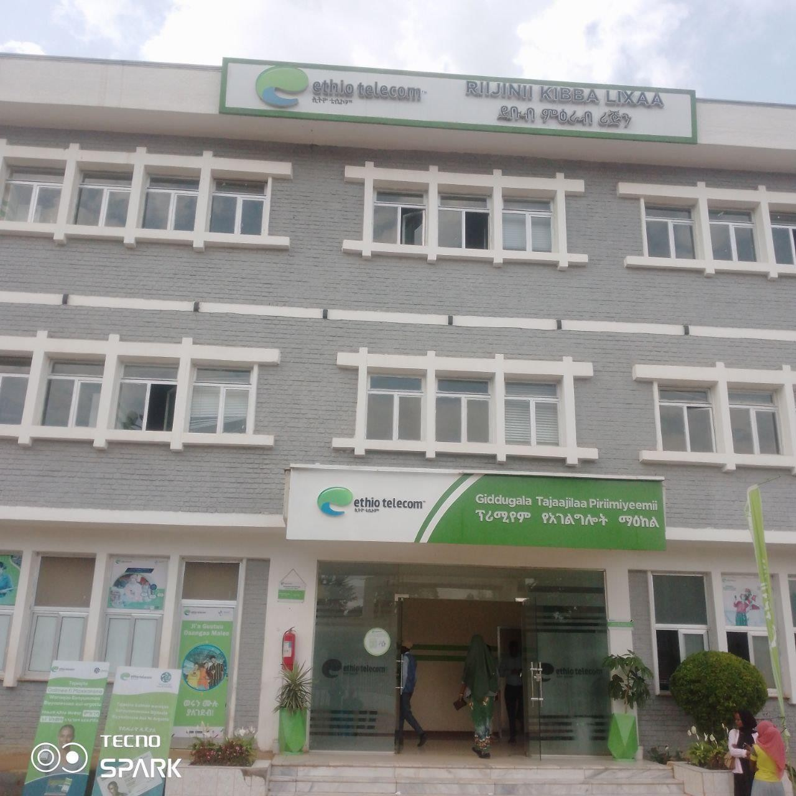
Figure 1: Jimma Ethio Telecom Branch

Mission of the organization
The mission of an organization explains its purpose and what it aims to achieve in its day-to-day operations. For Jimma Ethio Telecom, the mission focuses on providing quality communication services, supporting regional development, and connecting communities. The main points of the mission are as follows:

    - To provide reliable, affordable, and high-quality telecommunications services to individuals, businesses, and government institutions.
    - To connect communities in Jimma and surrounding areas through efficient communication networks.
    - To support economic growth and social development in the region.
    - To expand network coverage and introduce modern telecommunication technologies.
    - To enhance access to information and bridge the digital divide in both urban and rural areas.
    - To maintain excellent service quality and customer satisfaction.

Vision of the organization
The vision of an organization describes its long-term goals and the direction it wants to move toward in the future. For Jimma Ethio Telecom, the vision highlights innovation, excellence, and regional impact. The main points of the vision are as follows:

    - To be a leading telecommunications provider in Ethiopia and the region.
    - To deliver innovative, reliable, and high-quality telecom services.
    - To connect people, businesses, and institutions effectively.
    - To reduce the digital divide and improve access to communication technologies.
    - To support social and economic development through modern telecommunication solutions.
    - To be recognized for excellence, innovation, and contribution to regional development.

Values and principles
Jimma Ethio Telecom follows core values that guide its operations and decision-making. These include:

- Commitment to quality services.
- Customer focus and satisfaction.
- Integrity and ethical conduct.
- Innovation and adoption of new technologies.
- Teamwork and collaboration.
- Social responsibility and community support.
- Reliability and professionalism.

Goal of the Company
The main goal of this organization is to provide reliable and efficient telecommunications services to individuals, businesses, and institutions.

The company aims to:

    - Expand network coverage in Jimma and surrounding areas.
    - Improve access to mobile, internet, and fixed-line services.
    - Support social and economic development through modern communication technologies.
    - Ensure customer satisfaction by maintaining high-quality and uninterrupted services.

Main products or services
This organizations is to provides a variety of telecommunication products and services to meet the needs of individuals, businesses, and institutions. The main services include:

- Mobile phone services (prepaid and postpaid plans)
- Internet services (mobile data and broadband)
- Fixed-line telephone services
- Customer support and service maintenance

CHAPTER TWO

OVER ALL INTERNSHIP EXPERIENCE

Objective of internship

General objective

The general objective of the internship at Jimma Ethio Telecom was to provide practical exposure in the field of telecommunications and to enable students to apply their academic knowledge in a real-world organizational setting.

Specific objective

      - To gain hands-on experience in network design, configuration, and maintenance, and to develop technical skills in using networking equipment and communication systems.
      - To understand the operations and management of a telecommunications organization, including how telecom services are delivered to customers and how operational challenges are managed.
      - To improve problem-solving, teamwork, and professional communication skills.
      - To prepare students for future careers in ICT and telecommunications by applying theoretical knowledge practically.

Sections of the Internship and Work Flow in Each Section
In my internship at Jimma Ethio Telecom, I was assigned to different sections to gain hands-on experience and understand how the company operates. Each section had its own responsibilities and workflow, but all worked together to provide reliable telecom services to customers.

The main sections I participated in were:

- Business Applications Development and Administration Team – focused on automating processes and integrating applications.
- Training and Consultancy Team – provided staff training and guidance to improve services.
- Support and Maintenance Team – handled troubleshooting and maintenance of systems and equipment.
- Network Infrastructure and Services Unit – managed servers, routers, switches, and overall network operations.

Business Applications Development and Administration Team

During the internship, we worked with the Business Applications Development and Administration Team at Jimma Ethio Telecom. This team focuses on analyzing telecom business processes and finding ways to automate tasks for better efficiency.

We used tools like Cisco Packet Tracer and Microsoft Office Visio to simulate network setups and design system diagrams. These helped improve internal operations and support smoother communication between staff and customers.

Training and Consultancy Team
During the internship, we worked with the Training and Consultancy Team at Jimma Ethio Telecom. This team trains staff on new technologies, network systems, and how to serve customers better.

They also give advice on how to improve work processes and solve problems in daily operations. From this team, we learned how training and guidance help the company run smoothly and provide good services to customers.

Support and Maintenance Team
During the internship, we worked with the Support and Maintenance Team at Jimma Ethio Telecom. This team is responsible for keeping the network running smoothly and fixing any technical problems.

They handle tasks like checking network equipment, troubleshooting issues, and maintaining internet, mobile, and fixed-line services. From this team, we learned how regular maintenance and quick problem-solving help ensure reliable services for customers.

Network Infrastructure and Services Unit
We worked with the Network Infrastructure and Services Unit at Jimma Ethio Telecom, which manages the organization’s network systems, including internet, mobile, and fixed-line services.

The team’s tasks include configuring routers and switches, monitoring network performance, managing IP addresses, maintaining servers, and troubleshooting network issues to ensure reliable services. From this unit, we learned how telecom networks are planned, installed, and maintained, and how network infrastructure supports smooth company operations.

Overview of Ethio Telecom Network

Multi-Service Access Gateway (MSAG)
A Multi-Service Access Gateway (MSAG) is a vital device in today’s telecommunication systems. It functions as a local access point that connects subscribers—such as homes, businesses, and institutions—to the core telecom network. The MSAG is designed to integrate multiple services like data, voice, and internet, delivering them efficiently through a single platform.

The MSAG plays a central role in offering voice services, which include both traditional telephone (PSTN) and modern VoIP calls. By supporting both analog and digital communication, it ensures customers can make reliable phone calls with good sound quality.

For data and internet services, the MSAG provides broadband connections using technologies like DSL or fiber optics. This allows users to browse the web, access cloud applications, and use online services seamlessly. It also manages subscriber bandwidth and prioritizes traffic with Quality of Service (QoS) features, ensuring stable internet performance even during heavy use.
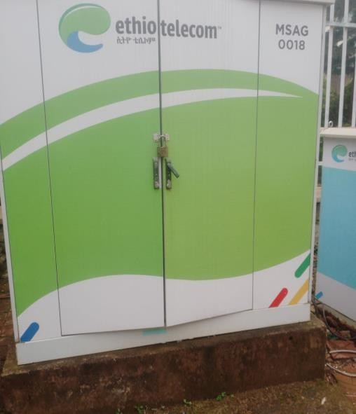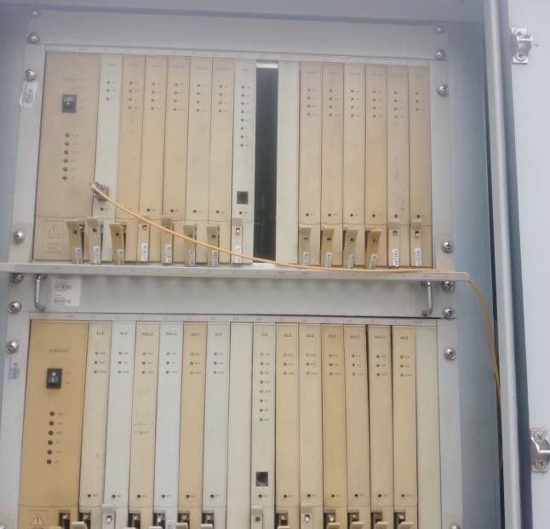

Figure 2: MSAG

MSAG allows Ethio Telecom to efficiently deliver multi-service connectivity, expand its network, and ensure reliable service to subscribers across both urban and rural areas.
Card in MSAG is mainly exist on Master shelf (zero shelf) and four slave shelf part of MSAG, as we see there are many parts of MSAG in which different department of ethio telecom operate on it, let as we see generally about card and its functions
      - zero shelf (main shelf)
      - shelf one
      - shelf two
      - shelf three and
      - shelf four
The MSAG cabinet contains several shelves with distinct roles: the zero (main) shelf is mainly used for core data services; shelf one is primarily for internet services; and shelves three and four are dedicated to voice services. Fiber cables from Ethio Telecom’s NNODC terminate at the MSAG, where lines are split into data, internet and voice and routed to their respective cards.
The
cabinet also includes fiber processing cards for optical-fiber customers, and each shelf holds multiple cards (subscriber line, DSL/ADSL, VoIP and other processing cards) that together
provide the MSAG’s combined voice and broadband functionality
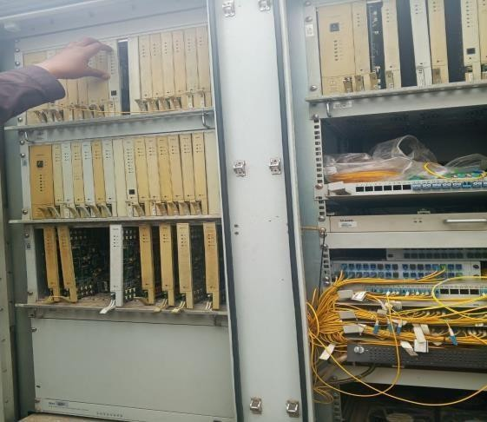

Figure 3: Master shelf and Slave shelf on MSAG

2.3.2). IP Address (Internet Protocol)

An IP address is a unique numerical identifier assigned to each device connected to a network. It allows devices to locate and communicate with one another, just like a home address identifies where a person lives. Without an IP address, devices cannot send or receive data across a network or the internet.

There are two main versions of IP addresses:

- IPv4 – Uses a 32-bit number, written as four groups separated by dots (e.g., 192.168.1.1). It is the most common but limited in available addresses.
- IPv6 – Uses a 128-bit number, written in hexadecimal and separated by colons (e.g., 2001:0db8:85a3::8a2e:0370:7334). It was introduced to provide a much larger address space.

2.3.3). Subnet / Subnet Mask

A subnet (short for sub-network) is a smaller, logical division of a larger network. It is used to organize and manage network traffic more efficiently by grouping devices into segments. Subnetting helps improve performance, security, and the proper use of IP addresses.

A subnet mask is a 32-bit number that works together with an IP address to define which part of the address refers to the network and which part refers to the host (device). For example, in the IP address 192.168.1.10 with subnet mask 255.255.255.0:

- The first three parts (192.168.1) represent the network.
- The last part (.10) represents the host.

By using subnet masks, administrators can create multiple subnets within a single network, control traffic flow, and avoid unnecessary congestion

How subnetting is conducted. Subnetting is done by borrowing bits from the host part of an IP address and using them as extra network bits. The steps are illustrated with the example network 192.168.1.0/24, which has to be divided into four subnets:
Step 1 – Decide the requirement. Four subnets are needed, for example one for each section or department.
Step 2 – Borrow host bits. Borrowing 2 bits gives 2² = 4 subnets, so the mask changes from /24 (255.255.255.0) to /26 (255.255.255.192).
Step 3 – Calculate the block size and hosts. The block size is 256 − 192 = 64 addresses per subnet, which gives 64 − 2 = 62 usable host addresses (the network and broadcast addresses are reserved).
Step 4 – List the subnets. 192.168.1.0/26 (hosts .1 to .62, broadcast .63); 192.168.1.64/26 (hosts .65 to .126, broadcast .127); 192.168.1.128/26 (hosts .129 to .190, broadcast .191); 192.168.1.192/26 (hosts .193 to .254, broadcast .255).
Step 5 – Assign and configure. Each subnet is assigned to a section or VLAN, the router interface is given the first usable address of the subnet as the default gateway, and the matching subnet mask is set on the devices (manually or through a DHCP pool).

Mobile Radio Access Network (RAN) in Ethio Telecom

The Mobile Radio Access Network (RAN) is a key part of Ethio Telecom’s mobile system. It provides wireless connection between mobile devices and the main network. Using radio signals, it allows users to make calls, send messages, and access the internet while moving between areas, a process called handover.

Ethio Telecom’s RAN includes:

      - Radio Components: Antennas, Remote Radio Units (RRUs), and Baseband Units (BBUs) that transmit and receive signals.
      - Transmission Components: Fiber-optic and microwave links that connect RAN sites to the core network for reliable data transfer.

Modern devices can connect to multiple RANs at the same time, such as LTE and Wi-Fi, to improve coverage and service quality.
Ethio Telecom has expanded its RAN coverage to urban and rural areas, increasing network accessibility for millions of subscribers across Ethiopia. The network is continuously upgraded to provide better speed, reliability, and services.

Cellular Network Generations in Ethio Telecom

Ethio Telecom’s mobile networks have evolved through several generations:

      - 1G (Analog): Voice-only service with limited coverage and poor security.
      - 2G (GSM): Introduced digital communication, better call quality, SMS, and low-speed internet access.
      - 2.5G (GPRS): Packet-switched data for mobile internet access.
      - 3G (UMTS, WCDMA): Multimedia services like video calling and faster browsing, with improved network efficiency.
      - 4G (LTE): High-speed broadband with all-IP architecture. Supports HD video, VoLTE, online streaming, low latency, and smooth service.
      - 5G (NR – under trial in Ethiopia): Ultra-fast internet, very low latency, supports IoT applications, smart cities, and millions of connected devices.

Services and Future Plans

Ethio Telecom provides a range of mobile services including voice calls, SMS, mobile internet, mobile money, and enterprise solutions. The company is also focusing on expanding 4G coverage nationwide and preparing for 5G deployment to meet growing data demand and support smart city projects.

The network aims to enhance:

      - Connectivity: Reliable service in urban and remote areas.
      - Speed: Faster internet for browsing, streaming, and downloads.
      - Capacity: Support for more users and connected devices.
      - Innovation: IoT, smart solutions, and digital services for citizens and businesses.

2.3.5). DHCP (Dynamic Host Configuration Protocol)
DHCP is a protocol used in computer networks to automatically provide devices with IP addresses and other necessary network settings, such as the subnet mask, default gateway, and DNS server. Instead of configuring each computer manually, DHCP assigns these values automatically from a central server.

When a device, like a laptop or smartphone, connects to the network, it requests an IP address. The DHCP server responds by leasing an available IP address for a certain period of time. This makes managing large networks easier, prevents address conflicts, and ensures efficient use of available IP addresses.

2.3.6). OSPF (Open Shortest Path First)

OSPF is an internal routing protocol used to optimize packet delivery within Ethio Telecom’s network.

Key Functions:

      - Determines the shortest path for data within the network.
      - Adapts dynamically to network changes or failures.
      - Enhances network efficiency and reliability for internal services.

2.3.7). BGP (Border Gateway Protocol)

BGP is used to manage routing between Ethio Telecom and external networks (other ISPs or global internet).

Key Functions:

      - Exchanges routing information between autonomous systems.
      - Selects optimal paths for internet traffic.
      - Provides redundancy and fault tolerance for wide-area connectivity.

Network topology
The network topology used in Jimma Ethio Telecom is mainly a combination of star and hybrid designs. At the backbone level, core routers are interconnected in a redundant structure that ensures continuous service even if one link fails. This hybrid design enhances fault tolerance, scalability, and reliability of the telecom infrastructure.

At the distribution and access levels, a star topology is commonly applied. In this design, multiple distribution nodes (such as kebele and woreda-level gateways) are directly connected to the main aggregation routers in Jimma town. This simplifies management, monitoring, and troubleshooting.

The uploaded diagram illustrates this structure, showing how Jimma’s core routers connect to various surrounding towns and kebeles. Each node extends connectivity to local customers, ensuring wide service coverage. The redundant interconnection between major routers further improves network stability, minimizing downtime and ensuring efficient service delivery.
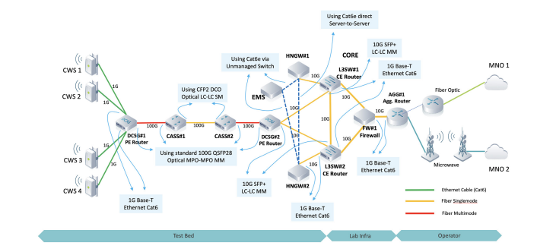
Figure 4: Network topology

Logical component of network
A logical network is a model that represents the connections between entities, where each entity is shown as a node and the links between nodes represent the communication paths. The purpose of using this model is to understand how different parts of an organization are related to one another. In other words, it helps to see how tasks or resources are allocated within an organization based on availability and priority. Logical networks also make it possible to identify patterns in data that may not be visible when looking at individual pieces of information.

A network connects a source and a destination through various elements and components. These elements are generally divided into two categories: physical components and logical components. Each element is represented by its own physical or logical part, except for hosts, which do not have a corresponding physical or logical mapping because they cannot be assigned to another hosting type. Components such as switches, routers, and gateways are considered non-host devices within the network structure.
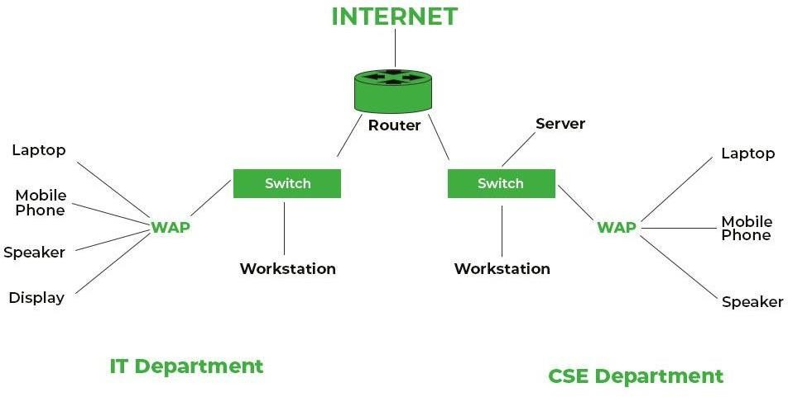

Figure 5: logical component of network

In a network diagram, the logical components represent the flow of information that moves from the source to the destination. User information refers to the data being transported within the network. This data is carried in units called frames.
A frame consists of three main parts:

      - Header – contains control information such as source and destination addresses.
      - Data – the actual user information being transmitted.
      - Trailer – used for error detection to ensure the data arrives correctly.

Network Installation
Network installation is the process of setting up and connecting the physical and logical components of a computer network to ensure smooth communication between devices. In this task, we were involved in:

- Setting up network devices such as routers, switches, and access points.
- Connecting devices with proper cabling (Ethernet cables, fiber optics) and testing the connections.
- Installing and configuring network interface cards (NICs) on computers.
- Checking IP configurations and assigning addresses to ensure proper communication.
- Testing connectivity using commands like ping and troubleshooting when issues appeared.

Router and Switch Configuration
Router and switch configuration is a key step in setting up a functional computer network. In this task, we practiced both basic and essential configurations to ensure proper communication between devices.

Our activities included:

- Assigning IP addresses to routers and switches.
- Configuring routing protocols to enable data transfer between different networks.
- Creating VLANs (Virtual Local Area Networks) for better traffic management.
- Setting up security features such as passwords and access restrictions on network devices.
- Testing connectivity to confirm that devices and users could communicate without interruption.

2.3.12 ) Problem with Solution of Computer Networking Troubleshooting
Troubleshooting is an important part of computer networking because problems can interrupt communication and services. During our internship, we faced some common issues and applied solutions to fix them.

Some examples include:

- IP configuration errors – Some devices failed to connect due to wrong or missing IP addresses.
Solution: We checked the settings and assigned the correct IP addresses.
- Cable and hardware issues – Damaged cables or loose connections caused loss of connectivity.
Solution: We replaced faulty cables and secured connections properly.
- Switch and router misconfigurations – Incorrect setup led to network traffic not flowing properly.
Solution: We reconfigured the devices with correct parameters.
- Connectivity problems – Computers could not reach each other or the server. Solution: We used tools like ping and tracert to test paths, then fixed the underlying errors.

Components of physical network:

Router
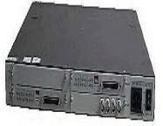
Figure 5: router
A router is switching devices for networks, which can route network packets, based on their addresses to other networks or devices. Among other things, they are used for internet access.
For coupling networks or for connecting branch offices to a central office. Switches
Switches are key building blocks for any network. They connect multiple devices, such as computers, wireless access points, printers, and servers; on the same network within a building or campus. A switch enables connected devices to share information and talk to each other.
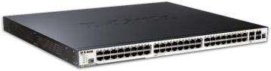

Figure 7: switches

Media converter

A media converter is a device used to convert one data communication port into another data communication data port. Where these communication ports can be fiber ports or electrical ports (RJ-45 Ethernet).
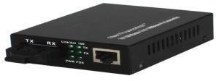

Figure 8: Media converter

Rack

A rack is a metal frame used to hold various hardware devices such as switches, patch panels, SFB modules, cables, and other electronic equipment.

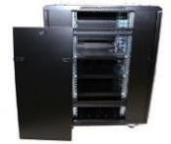
Figure 9: Rack

Patch Panel
A patch panel is a mounted hardware device that has ports for connecting and managing incoming and outgoing LAN cables in a local area network (LAN). Patch cords, a type of jumper cable, are used to construct each interconnection on a patch panel. Patch panels are typically mounted above or below network switches on network racks. Patch panels are classified according to how many ports they have, with 48-port, 24-port, and 12-port panels being the most prevalent. Specific cable requirements, such as cat 5e, cat 6, cat 6a, and cat 7 cables, are also addressed by patch panels.
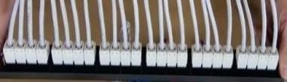
Figure 10: Patch panel

Derail

A component used for grounding and securing cables to prevent electrical interference.
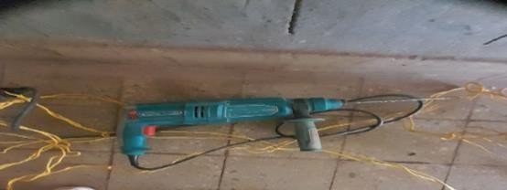
Figure 11: Derail
RJ45

These devices are standardized network interfaces used for connecting voice and data telecommunications equipment.


Figure 12:RJ4
Use in Networking:

Used in computer networking for high-speed data transmission in modern networks.

UTP Cable (Unshielded Twisted Pair)

      - Unshielded Twisted Pair (UTP) is a type of twisted-pair cabling that does not have any internal shielding.
      - UTP cabling is the most common form of network cabling for workgroups and departmental local area networks (LANs) because of its low cost, flexibility, and good performance
      - Twisted-pair cable types:
      - Unshielded Twisted-Pair (UTP)
      - Shielded Twisted-Pair (STP)
      - UTP cables are widely used in networking for Ethernet connections.
      - Twisted-pair cables: use electrical signals over copper to transmit data.
      - Straight-through cable (standard B on both ends):-This cable type has identical wiring on both ends (pin1 on one end of the cable is connected to pin 1 at the other end of the cable, pin 2 is connected to pin 2 …up to pin 8).

Side A | Side B
White Green | White Green
Green | Green
White Orange | White Orange
Blue | Blue
White Blue | White Blue
Orange | Orange
White Brown | White Brown
Brown | Brown

Table 1: Straight-through cable color

Fiber optic cables
Fiber optic cable is the most recent advancement in transmission cable technology. Rather than sending data across copper wires, these cables use optical fibers to send data via light rather than electrical pulses. Each optical fiber is individually coated with plastic layers and housed in a protective tube, making it very resistant to outside interference. The result is a highly dependable and super-fast link with 26,000 times the transmission capacity of twisted-pair cables but at a far greater price.
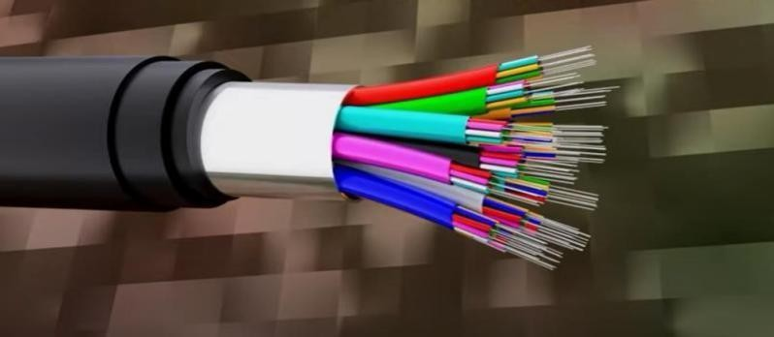
Figure 13: Fiber optic cable

types of Fiber cables are divided

Single-mode
Single-mode fiber has a very small core (about 9 µm) that allows only one mode of light to travel straight through the fiber. Because there is very little reflection of light inside the core, attenuation and dispersion are low, so data can be sent faster and over much longer distances. It is therefore used in long-distance telecommunication links, such as the backbone between exchanges and base stations.

Multimode
Multimode fiber has a wider core (typically 50 µm or 62.5 µm) that allows many modes of light to travel at the same time. As the light travels through the core it is reflected more often, which increases dispersion and attenuation.
As a result, multimode fiber has a lower usable bandwidth over distance and is mainly used for short links, such as connections inside buildings, campuses, and equipment rooms.
1. Crossover cable (Standard A on one end and Standard B anther end): This type of cable is used when you need to connect two devices that use the same wires to send and receive data.

Side A | Side B
White Green | White Orange
Green | Orange
White Orange | White Green
Blue | Blue
White Blue | White Blue
Orange | Green
White Brown | White Brown
Brown | Brown

Table 2: Crossover cable color

How good we have been in performing our work task

During the internship I worked at the Jimma Ethio Telecom Branch in Jimma town, mainly in the ICT and Networking Department and the sections described in Section 2.2. My specific tasks were studying the branch network topology, identifying the physical network components (routers, switches, media converters, racks, patch panels, and cables), practicing the straight-through and crossover UTP cable color standards, working with IP addressing and subnetting, and learning router and switch configuration. I used Cisco Packet Tracer and Microsoft Office Visio to simulate network setups and draw network diagrams.
I carried out my tasks with enthusiasm, effectively, and on time. My supervisor answered my questions courteously, and the company advisor appreciated my effort during the internship period. As a result, the branch manager asked me to continue working with the organization after the internship, and I am willing to do so.

) Challenges we have been facing while performing our work tasks
Challenges are part of every learning process, and our internship was no exception. We faced unexpected obstacles, but instead of seeing them only as difficulties, we took them as opportunities to improve our problem-solving skills. These experiences helped us grow both
personally and professionally, giving us confidence and practical knowledge for our future in the field of information technology

During our internship, we faced several challenges while carrying out our assigned duties. These challenges came from both technical and resource-related issues, and they sometimes slowed down our progress.

The main difficulties included:

- Limited Practical Experience: Most of our knowledge was theoretical, making it difficult to apply concepts in real situations at first.
- Technical Issues: Configuring routers, switches, and troubleshooting network errors required extra effort and practice.
- Poor Network Access: Unstable or slow connections affected our ability to complete tasks efficiently.
- Resource Constraints: Shortages of essential materials like cables, tools, and updated software slowed our work.
- Insufficient Budget: Limited funds made it difficult to access modern equipment and resources.
- Time Limitations: Restricted computer access and limited practice hours hindered our learning progress.
- Financial Challenges: Staff and developers were often engaged in urgent tasks, limiting the support available to us.
- Lack of Prior Exposure: Minimal hands-on experience in networking and practical tasks slowed our learning.
- Outdated Network Topology: Working with old infrastructure made it harder to understand and apply modern networking practices.

CHAPTER THREE

OVER ALL BENEFIT WE GAIN FROM INTERNSHIP PROGRAM

Internship and its Benefits
The primary aim of this internship program is to transform the theoretical knowledge I have gained during my studies into practical, hands-on experience. The main objective of this practical attachment is to equip graduating students with the skills and experience necessary to perform effectively in their respective professions after graduation. This practical exposure is not only enriching but also vital for career readiness, allowing students to adapt to the real work environment and prepare for future challenges.

Internships offer invaluable opportunities for students to observe professional settings, interact with industry experts, and apply their academic learning to solve real-world problems. Additionally, internships serve as a platform to bridge the gap between theoretical knowledge and practical applications. This exposure helps students understand industry expectations and sharpen the skills required in their careers.
Throughout the internship, we have acquired and honed several essential skills that will benefit us in our future endeavors. These include:

    - Network design and planning: Designing a cost-effective network topology, planning IP addressing, and dividing a network into smaller segments through subnetting.
    - Simulation, documentation, and troubleshooting: Using Cisco Packet Tracer and Microsoft Office Visio to simulate networks and draw diagrams, and troubleshooting common network problems.
    - Router and switch configuration: Configuring routers and switches and understanding how DHCP and the OSPF and BGP routing protocols work.
    - Cabling and physical installation: Identifying network components such as routers, switches, racks, and patch panels, making UTP cables with RJ-45 connectors using the straight-through and crossover color standards, and knowing the types of fiber optic cable.
    - Team Collaboration Skills: Understanding the dynamics of working within teams and the importance of cooperation to achieve common goals.
    - Leadership Skills: Taking initiative, leading tasks or small groups, and making decisions to drive project progress.
    - Work Ethic and Professionalism: Adapting to the expectations of the workplace, such as time management, responsibility, and ethical behavior.
    - Entrepreneurship Skills: Learning to think critically and innovatively, and gaining insight into how businesses operate, which is essential for future entrepreneurial ventures.

In return, I contributed the following knowledge and work to Jimma Ethio Telecom Branch:
    - Network design: a cost-effective network design for the branch, simulated in Cisco Packet Tracer and documented with Microsoft Office Visio diagrams.
    - Documentation: this report records IP addressing, subnetting, cabling standards, and router and switch configuration steps that staff and future interns can use as a reference.
    - Recommendations: practical suggestions for improving the network, which are given in Chapter Four.

Major Benefits of the Internship
The key benefits derived from this internship experience can be classified as follows:

    - Career Readiness: The internship prepared us for our professional careers by providing practical experience and helping us understand how to apply theoretical knowledge in real-world scenarios.
    - Skill Development: We gained a variety of new skills and strengthened existing ones, including problem-solving, project management, and the ability to work under pressure.
    - Networking Opportunities: We were able to build valuable professional relationships with industry experts, which could lead to future opportunities for mentorship, employment, or collaboration.
    - Exposure to Real Work Environment: The internship allowed us to familiarize ourselves with workplace culture and processes, making the transition from academia to industry smoother.
    - Problem-Solving: We encountered and resolved real-world challenges, which enhanced our critical thinking and decision-making skills, vital for handling similar issues in our future careers.
    - Increased Confidence: Through practical exposure and interaction with professionals, we developed greater confidence in our abilities and a clearer understanding of our career paths.
    - Understanding Industry Trends: We gained insight into the latest industry trends, technologies, and practices, ensuring that our knowledge remains current and relevant to the job market.

This internship has been an invaluable learning experience, offering a blend of theoretical reinforcement and practical exposure that will serve as a strong foundation for our professional growth.

Improving practical skill
These programs enable us to correlate the theoretical knowledge with practical skills. Work experience offers a really good opportunity to put into practice what you have learned in a real life work environment. As a communication engineer the organization gives an opportunity to contribute in improvement the computer networking technology. Some of the personal skills we developed when we were in the organization can be listed as:
Networking section we were working with troubleshooting project to design the system and understanding the behavior of system. Example: Network installation, router and or switch configuration, network troubleshooting and wireless access point setup configuration.
The major benefits that we get from the internship are classified and stated as below:

Upgrading theoretical knowledge
Even if we have some vision in various courses learn in the class, briefly we know more while we saw really. We recall and relate the theoretical knowledge with practical. While you do something you force to refer about the subject this make you to remember and upgrade yourself. To improve our theoretical knowledge list below. Learn more about various courses like network design, apply class room theoretical part to real work situations, our design project in the company and try to know how to configure and punch network.

Improving team play skill
A team player is a person who plays or works well as a member of a team or group. Teams in an organization need strong team players to perform well to reach their goals. Team work is also needed to share different experience alongside the work. During the internship period we were doing the project in group. When we were doing the entire project we had a role and even if tasks
are done individually by the respective person at different section of the project, there are times at which different individuals come together to communicate with each other in order to reach for the desired goals. And at times where everything becomes very complex team work plays an important role in solving the difficulties.

Improving leadership skill

Leadership is a process of leading the careers of the company. Problems in the company come in all size, shape and color in different period of time. Thus, a person who is in the position of leadership seeks optimal solution to problems and should be smart enough to manage those individuals whom he/she is leading. What was gained from the internship regarding improving leadership is that to inspire workers into higher levels of teamwork. There are:
      - Know our self and seek self-improvement

      - Be technically proficient
      - Make sound and timely decision

      - Know peoples and look out for their well-being
      - Develop a sense of responsibility in workers

Understanding work ethics and related issues

In today’s complex world, Ethical conduct of workers is very important for developing healthy working environment and increasing productivity. The work ethics is a cultural norm that advocates being personally accountable and responsible for the work that one does and is based on a belief that work has intrinsic value. The term is often applied to characteristics of people, both at work and at play. Work ethics include not only how one feels about their job, career or vocation, but also how one does his/her job or responsibilities. These involve attitude, behavior, respect, communication, interaction, and how one gets along with others. Work ethics demonstrate many things about whom and how a person is. Thus employer expects employees to develop certain desirable traits that will help them to perform their jobs well so that the company can succeed. There are two common types of ethics. These are Personal ethics and Professional ethics

) Personal ethics

Personal ethics are values which are expected to be possessed by all individuals in their life, and contribute a lot for a smooth interaction among individuals and peaceful co-existence of a society.
What we gained in the company principles of personal ethics include:

      - Concern for the well-being of other
      - Honesty
      - Integrity
      - Fairness
      - Responsibility
      - Possessing a Positive Attitude
      - Compliant to the law
      - Benevolence (doing well)

) Professional ethics

Professional ethics refers to the standards or a set of moral principles for regulating behaviors of a certain defined profession. The following are some of the common professional ethical principles what we gained in the internship period.
      - Punctuality- means keeping the companies work beginning and ending time and to complete a given task within the given period.
      - Reliability- The worker should be qualified for the part he is supposed to be performing. He/she must have appropriate skill and knowledge for the task assigned.
      - Honesty- Regarding this value each worker regardless of its status should abstain from bad behaviors such as cheating, bias, corruption etc.
      - Cooperation- Each worker should interact and cooperate with each other while working. That is because it is through such system problems could be easily solved. Respect the rule and regulation of the company.

CHAPTER four CONCLUSION AND RECOMMENDATION

Conclusion
This internship was highly successful for us, as it allowed us to cover many different fields and learn new concepts and approaches, especially in networking installation. Through this internship, we gained practical experience to complement the theoretical knowledge from our studies, particularly in setting up networks. The project demonstrated that a standard computer network can be designed at minimal cost while maintaining strong security, even with low-cost devices. For instance, the network's security was enhanced by high-quality firewalls and backup devices. Although we did not implement all possible servers due to budget constraints, essential ones like DNS and DHCP servers ensured smooth operations. We succeeded in designing a cost-effective network, showing that financial limitations do not necessarily hinder the development of a functional and secure technological system. This approach can be especially useful for institutions with limited budgets, such as second-generation universities. Additionally, we acquired valuable knowledge on advanced networking, such as fiber optic media, Cisco’s three-layer hierarchical model, WLAN, and data center security. This experience was immensely beneficial in preparing us for real-world challenges in the IT and networking fields.

Recommendations for ethio telecom:
    - Upgrade Network Infrastructure: Replace outdated routers, switches, and servers, expand fiber optic coverage, and add redundancy to ensure reliable services even during failures.
    - Strengthen Cybersecurity: Implement firewalls, intrusion detection systems, regular security audits, and data backup solutions to protect against cyber threats and service interruptions.
    - Enhance Customer Service: Collect regular feedback, provide faster response to complaints, and train staff to improve communication and service quality.
    - Automate and Improve Operations: Use network management software, monitor performance continuously, and maintain proper documentation to reduce downtime and improve efficiency.
    - Adopt Modern Technologies: Invest in 5G, LTE-Advanced, and cloud-based solutions to expand coverage and provide faster, more reliable services.
    - Community Engagement and Digital Literacy: Conduct awareness programs to educate the public about safe and effective use of telecom services.
    - Sustainability Practices: Use energy-efficient equipment, implement backup power solutions, and ensure environmentally friendly operations.
    - Proactive Problem Solving: Anticipate potential network issues, conduct regular preventive maintenance, and ensure quick recovery from disruptions.

References

      - Ethio Telecom. (2025). Ethio Telecom — Jimma branch. Ethio Telecom website.
      - RFC 2131. Droms, R. (1997). Dynamic Host Configuration Protocol (DHCP). IETF.
      - RFC 2328. Moy, J. (1998). OSPF Version 2. IETF.
      - RFC 4271. Rekhter, Y., Li, T., & Hares, S. (2006). Border Gateway Protocol 4 (BGP-4).
IETF.
      - Cisco Systems. (n.d.). Cisco three-layer hierarchical network model. Cisco documentation.
      - IEEE 802.1Q. (n.d.). VLAN tagging standard. IEEE.
      - Tanenbaum, A. S., & Wetherall, D. J. (2011). Computer Networks (5th ed.). Pearson.
      - Fiber optics overview. (n.d.). Fiber optics fundamentals. (manufacturer/industry guide)

