LocalStore - Project Technical Documentation
Course Code: CoSc3091 - Web Programming
Assignment: Individual Assignment I (Full E-Commerce Web Application)
Project Title: LocalStore E-Commerce Platform
Student Name: Biruk Mola
Student ID: 020/16/ID
Department: Computer Science
Submission Date: October 2026

1. Introduction & Project Purpose

1.1 Project Overview
LocalStore is a feature-rich, dynamic e-commerce web application developed using core web technologies including PHP, MySQL, HTML5, CSS3, and JavaScript. The application serves as a dedicated digital storefront designed to showcase and commercialize authentic Ethiopian products, including traditionally woven clothing, specialty coffees, handcrafted leather goods, and local art.

1.2 Inspiration & Business Objective
Inspired by modern drop-shipping and e-commerce models (such as Lee Dropshipping strategies), LocalStore addresses the gap between local Ethiopian artisans and digitally connected customers. The goal is to provide an intuitive user interface for customers to explore, filter, and inquire about products, alongside a secure authentication system that enables user registration and login management.

2. System Architecture & Technology Stack
The application strictly follows a multi-tier modular architecture:
- Front-End Layer:
  - HTML5: Semantic document structuring across all pages (header.php, footer.php, products.php, etc.).
  - CSS3: Custom responsive design utilizing modern layout engines (Flexbox and CSS Grid), custom capsule filter buttons, and CSS hover transitions without external heavy frameworks.
  - JavaScript (Vanilla JS): Client-side form validation (js/script.js), input sanitization feedback, and interactive UI component management.
- Back-End Layer:
  - PHP 8.x: Handles routing, server-side form validation, session management ($_SESSION), and database communication using standard database connection patterns (db.php).
- Database Layer:
  - MySQL / MariaDB: Relational database storing user profiles, product catalogs, customer messages, and orders.

3. Database Schema & Table Structures
The underlying database for the application is named localstore_db (or local_store). Below are the structures of the key tables implemented in database.sql:

3.1 users Table
Stores user registration details and secure credentials.
- id (INT, Primary Key, Auto Increment)
- username (VARCHAR(50), Unique, Not Null)
- email (VARCHAR(100), Unique, Not Null)
- password (VARCHAR(255), Not Null) — Encrypted using PASSWORD_DEFAULT
- created_at (TIMESTAMP, Default Current Timestamp)

3.2 products Table
Holds product catalog details and categories.
- id (INT, Primary Key, Auto Increment)
- name (VARCHAR(100), Not Null)
- category (VARCHAR(50), Not Null) — (e.g., Clothing, Food & Beverage, Accessories)
- price (DECIMAL(10,2), Not Null)
- description (TEXT, Not Null)
- image_url (VARCHAR(255), Not Null)
- created_at (TIMESTAMP, Default Current Timestamp)

3.3 contact_messages Table
Captures feedback and inquiries submitted via the Contact page.
- id (INT, Primary Key, Auto Increment)
- full_name (VARCHAR(100), Not Null)
- email (VARCHAR(100), Not Null)
- subject (VARCHAR(150), Not Null)
- message (TEXT, Not Null)
- submitted_at (TIMESTAMP, Default Current Timestamp)

3.4 orders Table
Stores customer purchase requests.
- id (INT, Primary Key, Auto Increment)
- user_id (INT, Foreign Key referencing users.id)
- total_amount (DECIMAL(10,2), Not Null)
- status (VARCHAR(20), Default 'Pending')
- created_at (TIMESTAMP, Default Current Timestamp)

4. Key Pages & Features Overview
- Home Page (index.php): Offers a welcome banner, promotional hero section, and highlighted products.
- Product Catalog & Dynamic Filter (products.php): Features dynamic SQL query generation based on selected categories (All, Clothing, Food & Beverage, Accessories, Household) with active visual states.
- Product Details Page (product_details.php): Dynamically loads item attributes using URL query parameters (?id=X).
- User Authentication (login.php & register.php): Provides secure account creation and session authentication.
- About Developer Page (about.php): Details the project purpose, student profile, and educational context.
- Contact Form (contact.php): Features client-side and server-side validation to save inquiries into the database.

5. Key System Screenshots
- Figure 1: Product Catalog with Category Filter (products.php)
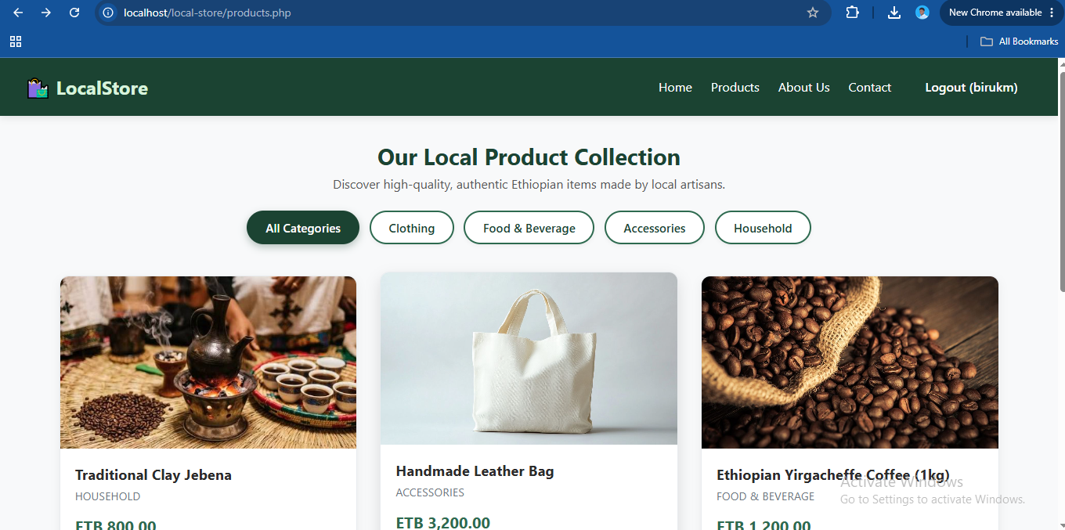
- Figure 2: Product Details View (product_details.php)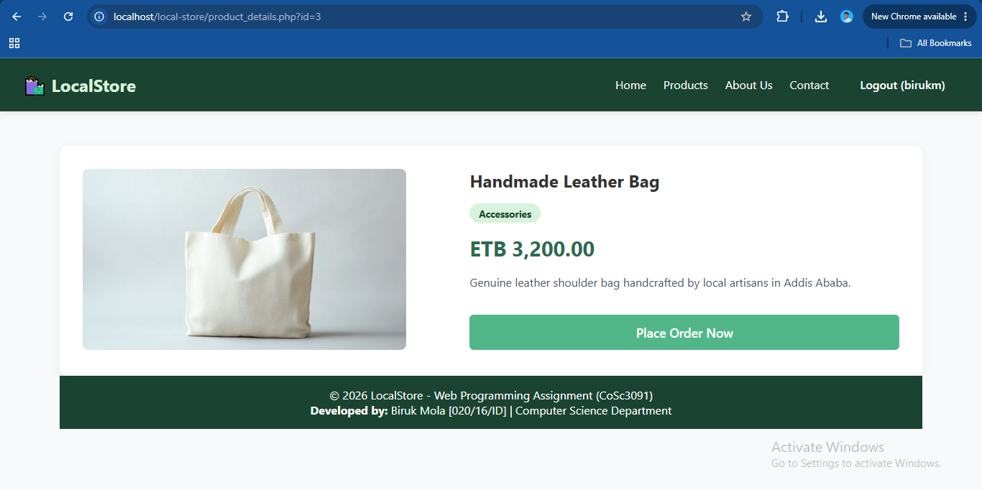
- Figure 3: User Registration & Validation Form (register.php)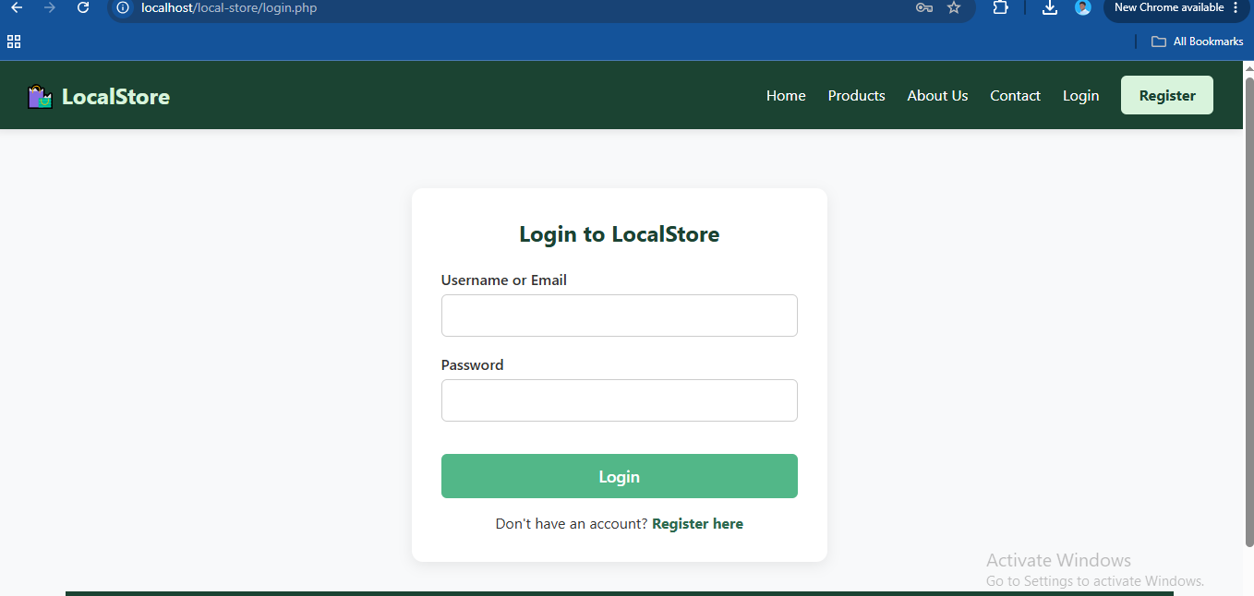
- Figure 4: Developer Profile & Academic Context (about.php)
- 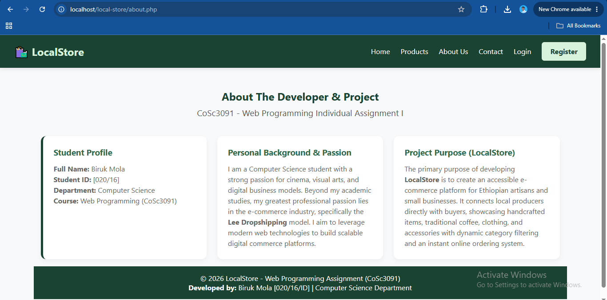

6. Statement of Originality
I hereby declare that this web development assignment titled "LocalStore - E-Commerce Platform" is my own original work created for the course Web Programming (CoSc3091). All front-end structure, back-end logical processing, CSS styling, and database schema integrations were implemented by me, adhering strictly to ethical academic standards.
Student Name: Biruk Mola
Signature: ___BM___________________
Date: October 2026

