HANGA TECHNOLOGIES LTD
Case studies
Website, software, AI and digital systems for public and private organisations.
Kigali, Rwanda · Leipzig, Germany
11 November 2026
info@hangatechnologies.rw
This document contains one published engagement (Medusa) and four labelled sample studies. Sample studies show how Hanga presents its work; they are illustrative and are not published client references.

Contents
01 Medusa: Discovery and Reservations · Published · Leipzig, Germany
02 Citizen Services Portal · Sample · Rwanda
03 Document Intake Automation · Sample · Rwanda
04 Programme Operations Dashboard · Sample · East Africa
05 Cooperative Supply Platform · Sample · Rwanda

CASE STUDY 01 · PUBLISHED
Medusa: Discovery and Reservations
A website and an AI voice assistant that take guests of a Leipzig bar from discovering the venue to planning a visit.
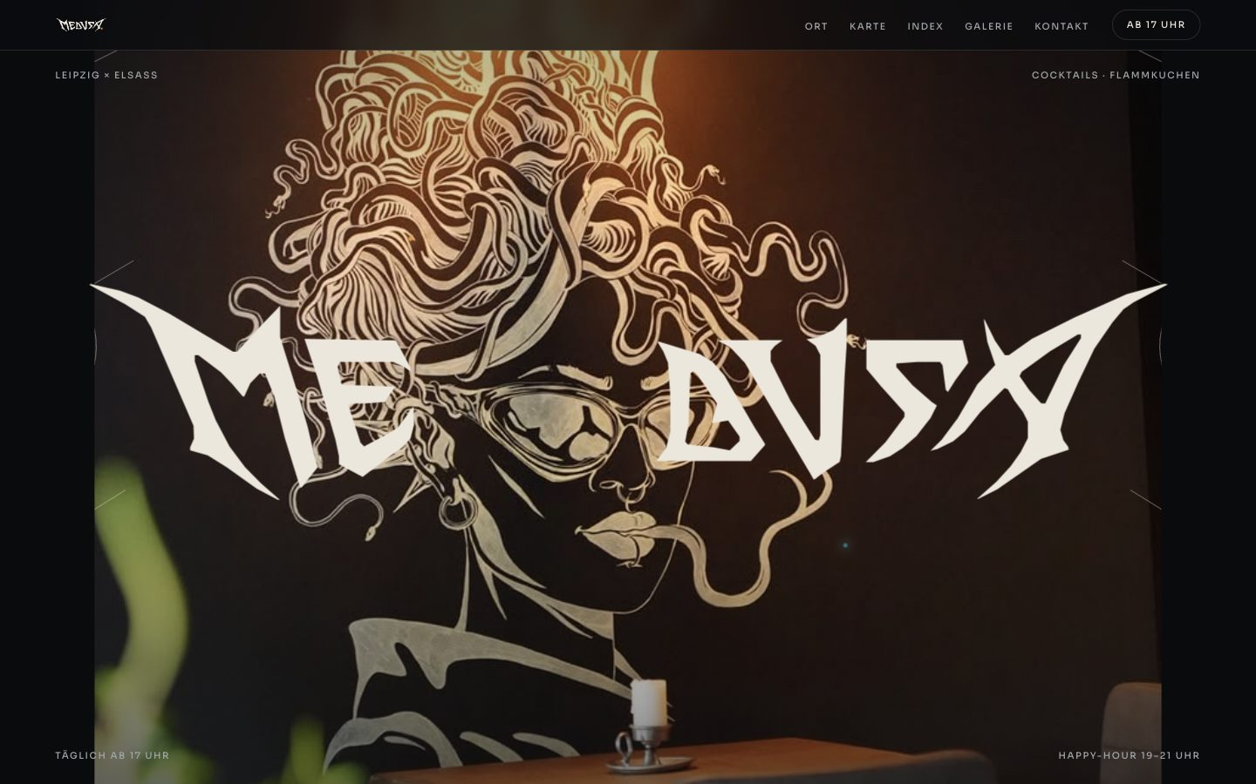
Opening screen of the Medusa website: the Medusa wordmark over a mural of Medusa with snakes for hair
Medusa is a Leipzig venue that brings together Alsatian food, cocktails, and cultural events. We built its website, which presents the venue, its menus, opening hours, happy hour, and contact details in one place, and an AI voice assistant that answers calls and takes booking requests.
Live site: https://medusa-leipzig.de
CLIENT | Medusa
ENGAGEMENT | Website and AI voice assistant
SECTOR | Hospitality: bar and restaurant
REGION | Leipzig, Germany
WEBSITE | https://medusa-leipzig.de

8  MENU CATEGORIES | 2  CHANNELS: WEB AND PHONE | 1  PLACE FOR VENUE, MENU, AND VISIT | 17:00  DAILY OPENING, SHOWN UP FRONT

01 CLIENT
A bar where Alsace meets Leipzig.
Medusa serves traditional and reinterpreted Flammkuchen, French cocktails and spirits, and beer from a small local brewery, at Karl-Liebknecht-Straße 47 in Leipzig.
It is also a setting for art, music, and cultural performances. The website had to carry that character as well as the practical details a guest needs.
02 CHALLENGE
A long menu and a ringing phone.
The menu spans eight categories, from Flammkuchen and tapas to cocktails, wine, and coffee. Presented as one list, it would be long and hard to navigate.
The telephone raised a different problem. A booking call has to capture accurate details, resolve ambiguity, and keep a reservation request distinct from a confirmed reservation.
We treated both as one customer journey: discover the venue, explore the menu, find the practical details, ask a question, request a booking.
03 APPROACH
Start from what a guest asks.
We structured the site around a guest’s questions: what kind of place is this, what is there to eat and drink, when is it open, where is it, and how do I get in touch.
The introduction explains the venue’s character first. The menu and the visit details follow, so the site works as a brand introduction and as a planning tool.
The menu interaction is expressive, so we paired it with a plain alternative. Guests who want to browse can move through the menu panel by panel; guests who want one category can go straight to it from the index.
04 VOICE ASSISTANT
A second way to reach the venue.
Some guests prefer to call. Alongside the website, we created an AI voice assistant that answers incoming calls and takes booking requests.
Its role is deliberately narrow: understand why the customer is calling, collect what is needed to handle the request, and give a clear next step. It supports the venue’s team and does not make commitments on their behalf.
05 THE WEBSITE
Four parts of one visit.
Venue introduction
The link between Leipzig and Alsace, the food and drink, and Medusa as a place for art, music, and culture.
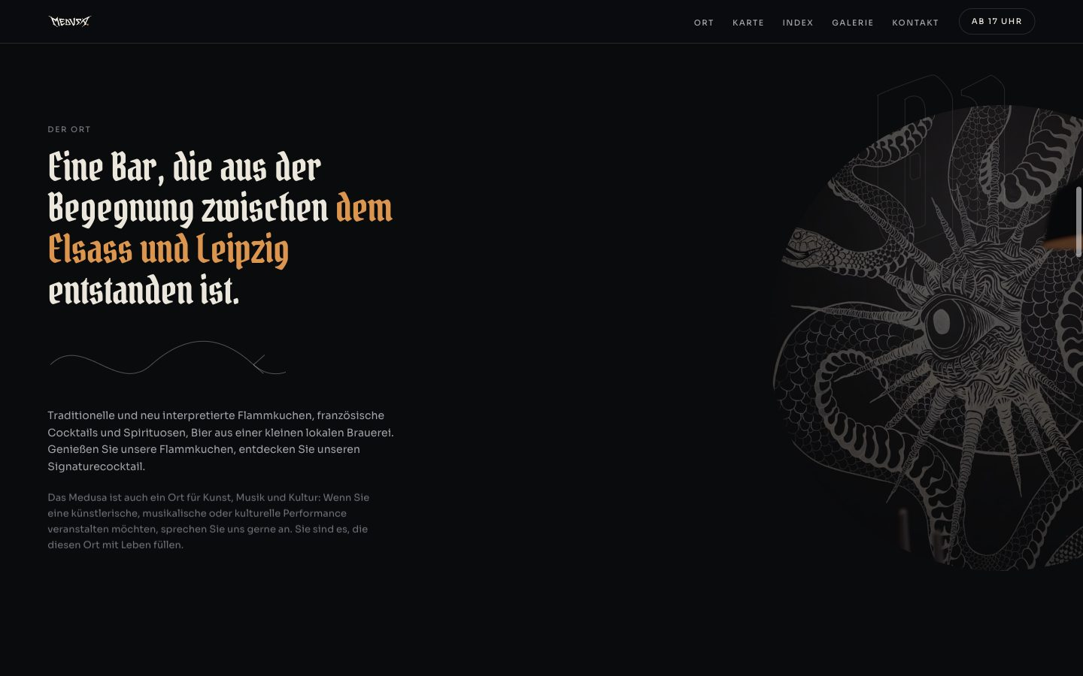
The venue introduction on the Medusa website
Card-stack menu
Eight panels, one per category. Guests swipe the top panel aside or use the arrow keys, and each panel scrolls on its own.
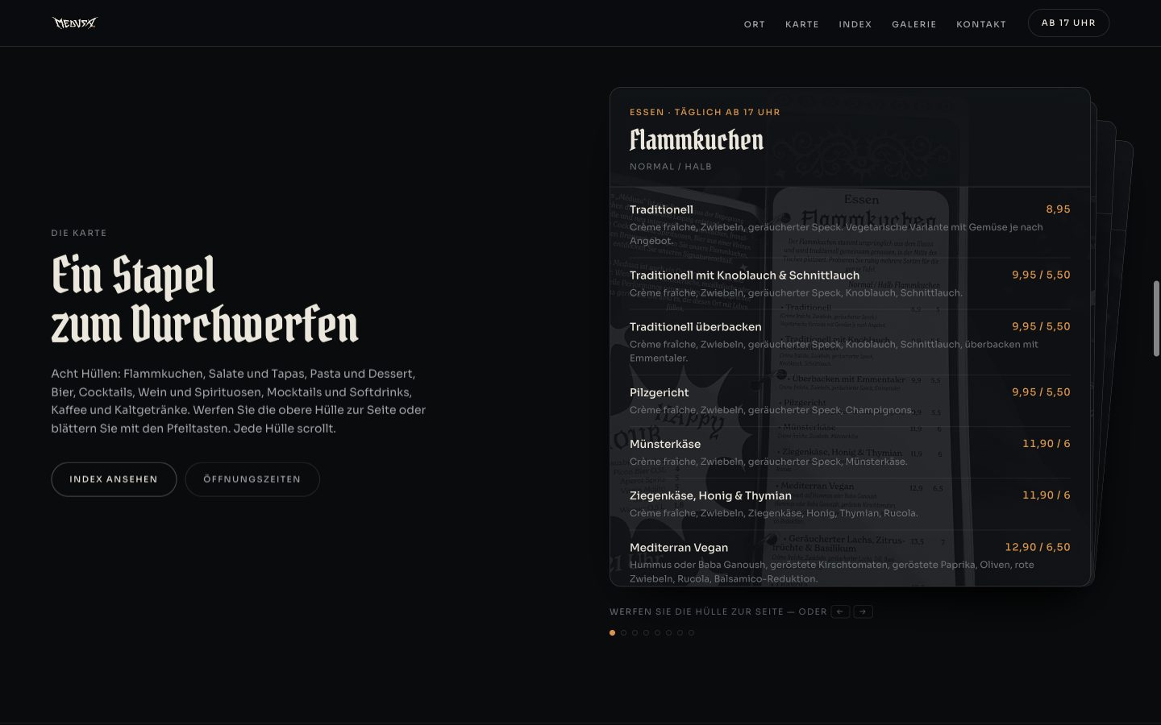
The Medusa menu shown as a stack of panels, with the Flammkuchen panel on top
Menu index
A direct list of all eight categories for guests who know what they are looking for.
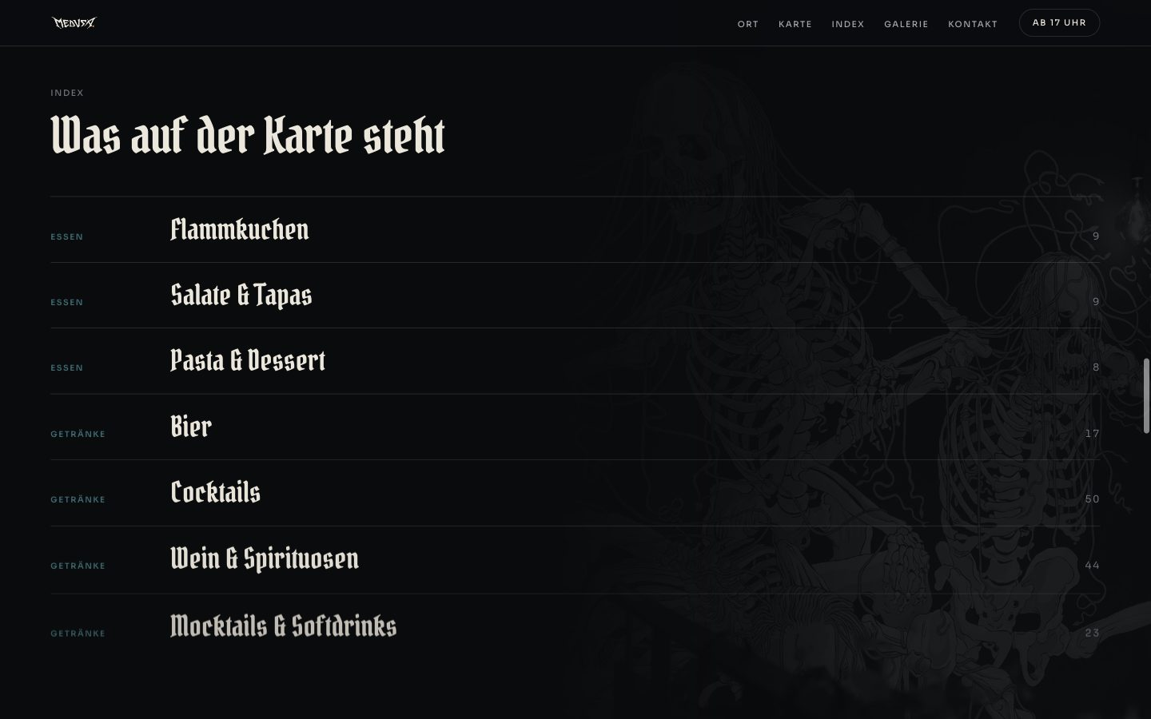
The menu index listing the categories on the Medusa menu
Visit information
Address, telephone number, opening hours, and happy hour together in one section.
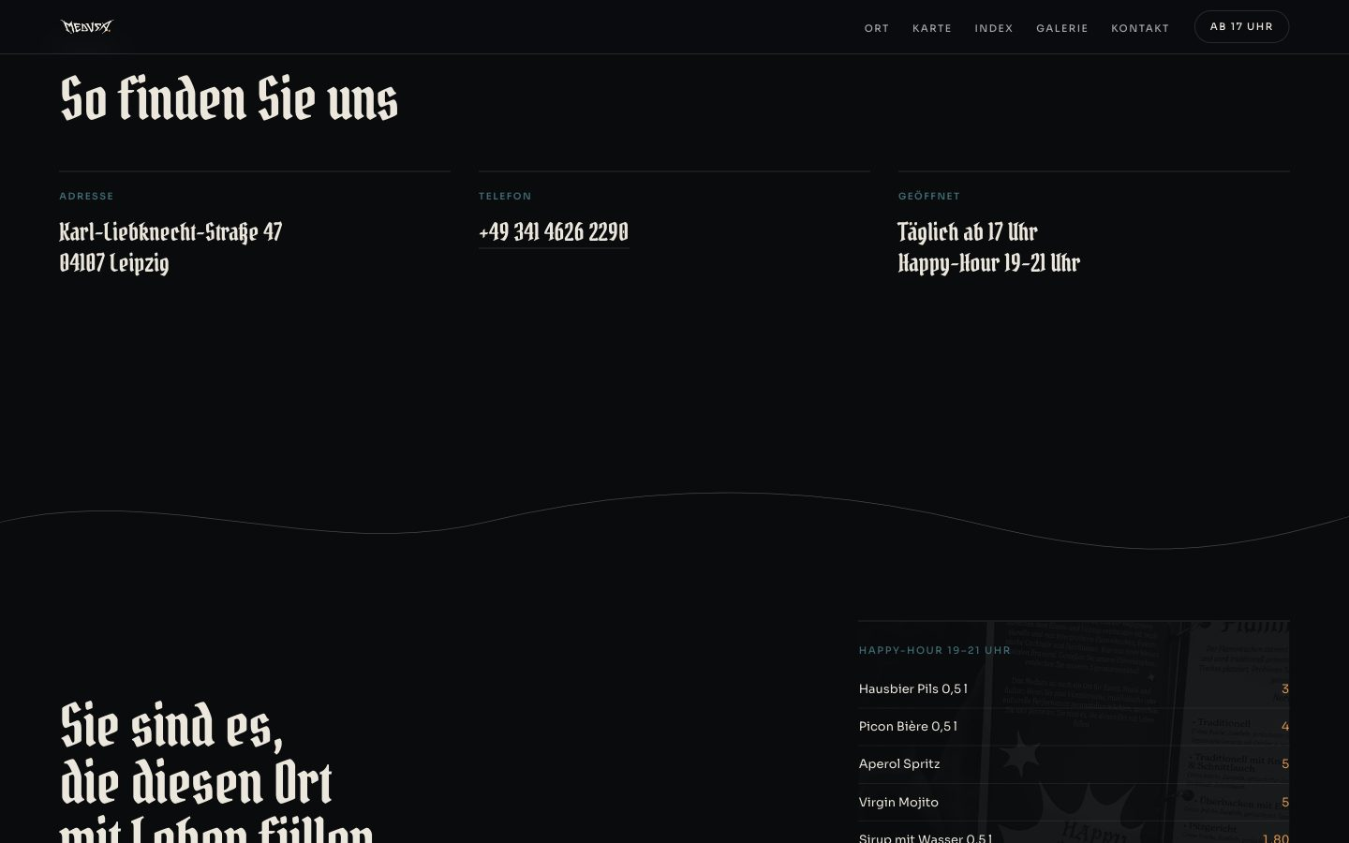
The contact section with address, telephone number, and opening hours
06 TECHNOLOGY
What it runs on
HTML · CSS · JavaScript · Swipe and keyboard navigation · AI voice assistant
07 OUTCOME
From discovery to a planned visit.
- The venue, its menu, and the visit details sit in one customer-facing place.
- All eight menu categories can be reached by swiping, by keyboard, or from the index.
- Guests who prefer to call can ask questions and request a booking by phone.
- We have not published performance figures for this project. They will be added once they have been measured.

CASE STUDY 02 · SAMPLE
Citizen Services Portal
A multilingual portal that lets residents apply, pay, and track requests without a trip to the counter.
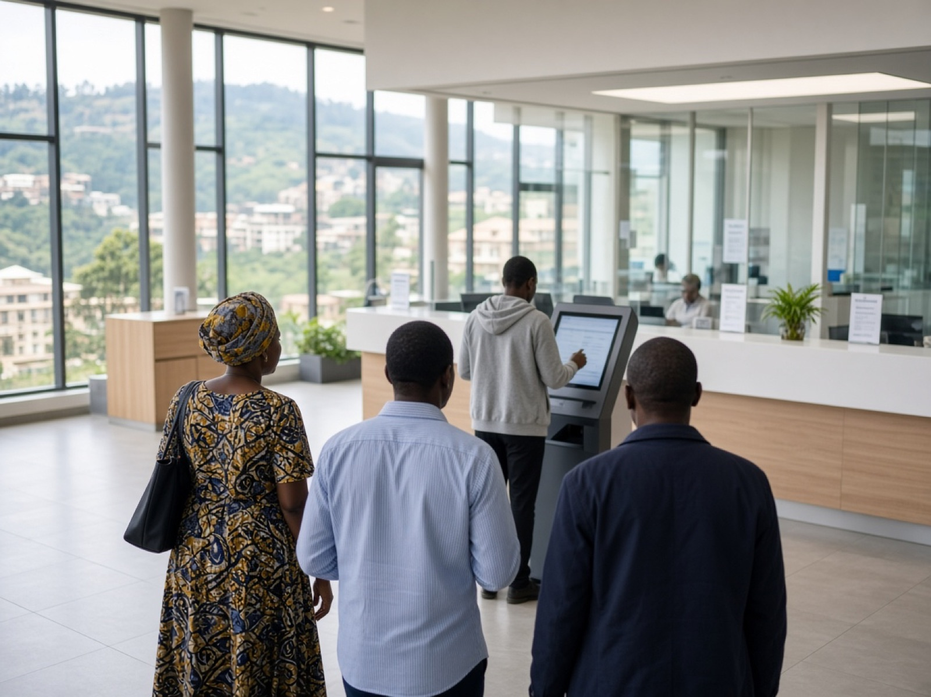
Residents using a self-service screen in a public service hall
A public institution wanted residents to complete common requests online, in the language they prefer, and to see where each request stands. We designed and built the portal, connected it to the systems already in use, and handed it over with the documentation to run it.
CLIENT | Sample client
ENGAGEMENT | Design and build
SECTOR | Public services
REGION | Rwanda

3  LANGUAGES AT LAUNCH | 24/7  ACCESS TO APPLICATIONS | AA  ACCESSIBILITY TARGET, WCAG 2.2 | 1  QUEUE FOR EVERY REQUEST

This is a sample study. The client, figures and details are illustrative and will be replaced by a published engagement.
01 CLIENT
A public institution with services people depend on.
The institution handles permits, certificates, and registrations for residents and businesses. Most requests started at a counter, on paper, during office hours.
Its teams knew the process well. What they lacked was one place where a resident could start a request, pay for it, and follow it to a decision.
02 CHALLENGE
Many forms, many counters, one resident.
Each service had its own form, its own queue, and its own way of telling people what happened next. Residents repeated the same details at every step.
The portal had to work on low-cost phones, in Kinyarwanda, English, and French, and for people who use assistive technology. It also had to sit in front of existing records and payment systems without replacing them.
03 APPROACH
Start from the task, not the org chart.
We mapped the requests residents make most often and designed each one as a short, guided task. Staff reviewed every screen against how the work is actually done.
Integration was built and tested in a controlled environment first. Each release was demonstrated on real scenarios before it reached the public.
04 WHAT WE BUILT
Four parts, one service.
Resident portal
Guided applications with saved progress, document upload, and a status page for every request.
Staff workspace
One queue for incoming requests, with assignment, notes, and decision records.
Payments and notices
Payment through the existing gateway, with SMS and email updates at each stage.
Content management
Service pages that staff can update in three languages without a developer.
05 TECHNOLOGY
What it runs on
TypeScript · React · Node.js · PostgreSQL · REST APIs · Docker · SMS gateway
06 OUTCOME
A service residents can finish online.
- Residents start, pay for, and track a request from one account, in the language they choose.
- Staff work from a single queue instead of separate inboxes and paper files.
- Every decision is recorded with who made it and when.
- The institution holds the source code, architecture notes, and runbooks.

CASE STUDY 03 · SAMPLE
Document Intake Automation
Supervised classification and extraction for application files, with an officer reviewing every record.

An officer feeding application documents into a scanner beside stacks of files
A regulated organisation received thousands of application documents a year and keyed each one by hand. We built a supervised intake workflow that reads and sorts the documents, then puts every record in front of an officer before anything is saved.
CLIENT | Sample client
ENGAGEMENT | Discovery, then delivery
SECTOR | Regulated services
REGION | Rwanda

100%  OF RECORDS REVIEWED BY AN OFFICER | 4  DOCUMENT TYPES AT LAUNCH | 1  AUDIT LOG FOR EVERY DECISION | 0  CHANGES TO THE RECORDS SYSTEM

This is a sample study. The client, figures and details are illustrative and will be replaced by a published engagement.
01 CLIENT
A regulator where every record counts.
The organisation licenses and supervises firms in its sector. Applications arrive as scanned forms, certificates, and supporting letters.
Officers are accountable for each decision. Any automation had to support that accountability, not blur it.
02 CHALLENGE
Skilled officers, hours of retyping.
Officers spent much of their day copying details from documents into the records system. Backlogs grew at peak periods and small errors were hard to trace.
The data is sensitive. It could not leave the organisation's control, and every automated step needed an explanation an auditor could follow.
03 APPROACH
Automate the reading, keep the decision.
A short discovery engagement set the scope: which document types, which fields, and what a correct result looks like. We agreed the evaluation criteria before building.
The workflow proposes a classification and the extracted fields. An officer confirms or corrects each one. Low-confidence items are flagged, never guessed.
04 WHAT WE BUILT
A workflow with a person at every gate.
Classification
Incoming files sorted by document type, with a confidence score an officer can see.
Field extraction
Names, dates, and reference numbers read from each document and shown beside the original.
Review queue
A side-by-side screen where officers accept, correct, or reject each record.
Audit trail
A log of what the system proposed, what the officer decided, and why.
05 TECHNOLOGY
What it runs on
Python · Document OCR · Language models · PostgreSQL · Role-based access · Private hosting
06 OUTCOME
Less retyping, the same accountability.
- Officers review prepared records instead of typing them from scratch.
- Every saved record has a named reviewer and a traceable history.
- The existing records system was integrated, not replaced.
- Evaluation results and the test set were handed over with the system.

CASE STUDY 04 · SAMPLE
Programme Operations Dashboard
Field data from spreadsheets and partner systems brought into one permissioned view for programme teams.
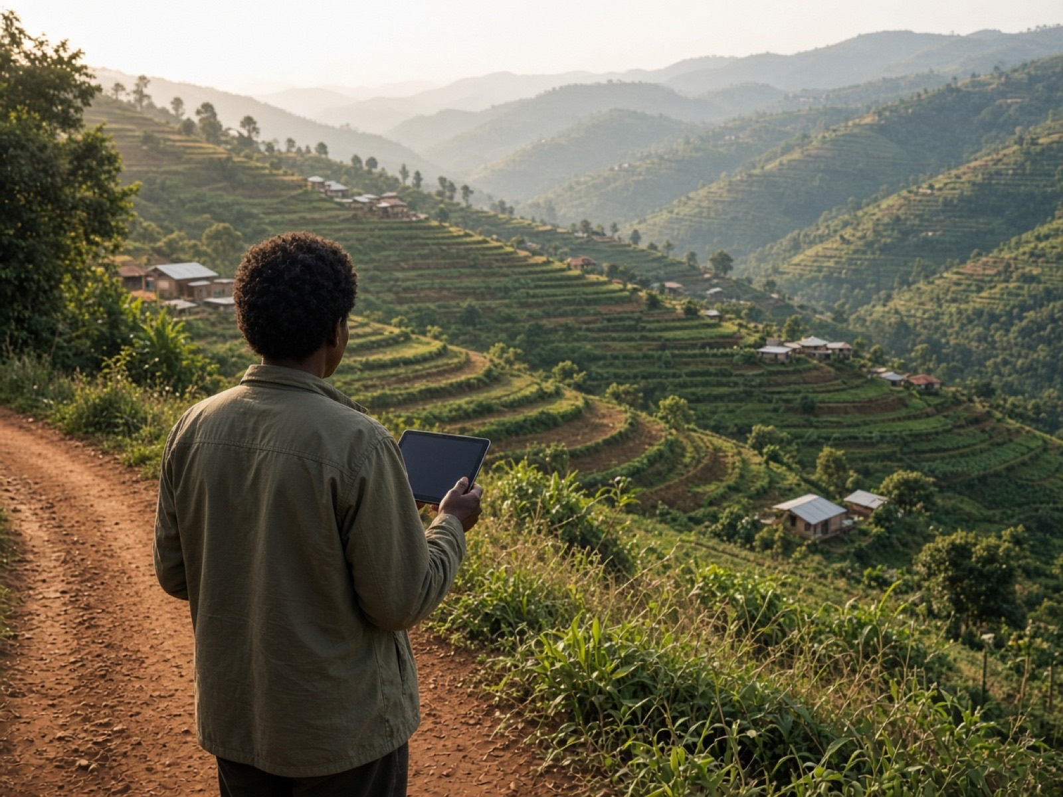
A field worker holding a tablet on a hillside road above terraced farmland
A development programme tracked its field activity in spreadsheets held by several partners. We built a reporting platform that brings that data into one place, checks it, and shows each team the view they are permitted to see.
CLIENT | Sample client
ENGAGEMENT | Phased programme
SECTOR | International development
REGION | East Africa

5  DATA SOURCES CONNECTED | 3  PERMISSION LEVELS | Daily  REFRESH OF FIELD DATA | Offline  CAPTURE FOR FIELD TEAMS

This is a sample study. The client, figures and details are illustrative and will be replaced by a published engagement.
01 CLIENT
A programme run by many partners.
The programme works through implementing partners across several districts. Each partner collects data on activities, participants, and spending.
Programme managers report to funders every quarter and need figures they can stand behind.
02 CHALLENGE
Five spreadsheets, five versions of the truth.
Each partner kept its own files in its own format. Consolidating them took weeks and the totals rarely matched.
Field teams often work without a connection, and some of the data identifies individuals. Access had to be limited by role and by partner.
03 APPROACH
Agree the definitions, then build the pipeline.
We began with the indicators: what each one means, who owns it, and where the number comes from. That became the data model.
Delivery ran in phases. The first connected two sources and one report. Each later phase added sources once the previous one was trusted.
04 WHAT WE BUILT
From field entry to funder report.
Field capture
A mobile form that works offline and syncs when a connection returns.
Data pipeline
Scheduled imports from partner files and systems, with validation and error reports.
Dashboards
Views for field, programme, and management teams, limited to what each may see.
Report exports
Quarterly tables produced in the funder's format, with the source of each figure.
05 TECHNOLOGY
What it runs on
Python · PostgreSQL · dbt · React · Offline-first mobile · Scheduled pipelines
06 OUTCOME
One set of figures, owned by the programme.
- Managers see current field data without waiting for a manual consolidation.
- Each figure in a report can be traced back to its source.
- Partners see their own data and nothing they should not.
- The programme team was trained to add indicators and reports themselves.

CASE STUDY 05 · SAMPLE
Cooperative Supply Platform
Collection, payment, and delivery records for a growers' cooperative, on phones that work without signal.
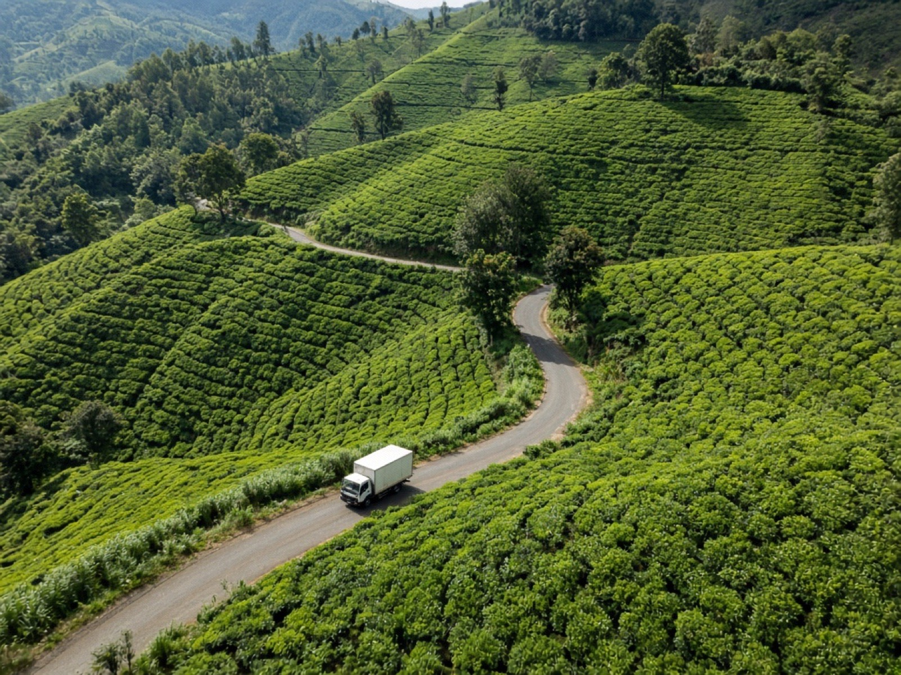
A delivery truck on a winding road through tea plantation hills
A growers' cooperative recorded collections on paper and settled payments weeks later. We designed and built a field app and an office system that record each delivery once and show growers what they are owed.
CLIENT | Sample client
ENGAGEMENT | Product design and build
SECTOR | Agriculture
REGION | Rwanda

2  APPS: FIELD AND OFFICE | Offline  COLLECTION WORKFLOW | SMS  RECEIPTS FOR GROWERS | 1  LEDGER FOR EVERY DELIVERY

This is a sample study. The client, figures and details are illustrative and will be replaced by a published engagement.
01 CLIENT
A cooperative owned by the people who grow.
The cooperative collects produce from member growers at stations across the hills and sells it on to processors.
Members are paid by weight and grade. Trust depends on those records being right and being seen.
02 CHALLENGE
Paper slips, late payments.
Collection clerks wrote each delivery on a slip. Slips were retyped at the office, sometimes days later, and disputes were hard to settle.
Collection stations have little or no signal. Many growers use basic phones, so receipts had to reach them by SMS.
03 APPROACH
Design in the field, with the clerks.
We spent time at collection stations before drawing a screen. The first prototype was tested by clerks during a real collection day.
The field app was built to work fully offline. The office system came second, once the field records were reliable.
04 WHAT WE BUILT
One record, from scale to payment.
Collection app
Weigh, grade, and record a delivery in a few taps, with or without a connection.
Grower receipts
An SMS to the grower for every delivery, with weight, grade, and running total.
Office ledger
Deliveries, advances, and payments in one ledger, ready for mobile money payout.
Transport planning
Daily volumes by station so trucks are sent where the produce is.
05 TECHNOLOGY
What it runs on
Kotlin · Offline sync · Node.js · PostgreSQL · SMS gateway · Mobile money API
06 OUTCOME
Records growers can check.
- Each delivery is recorded once, at the scale, and confirmed to the grower by SMS.
- Office staff settle payments from the ledger instead of retyping slips.
- Disputes are resolved against a shared record.
- The cooperative owns the system, the data, and the documentation.

