PRACTICAL NO.2

A] Configure AAA Authentication
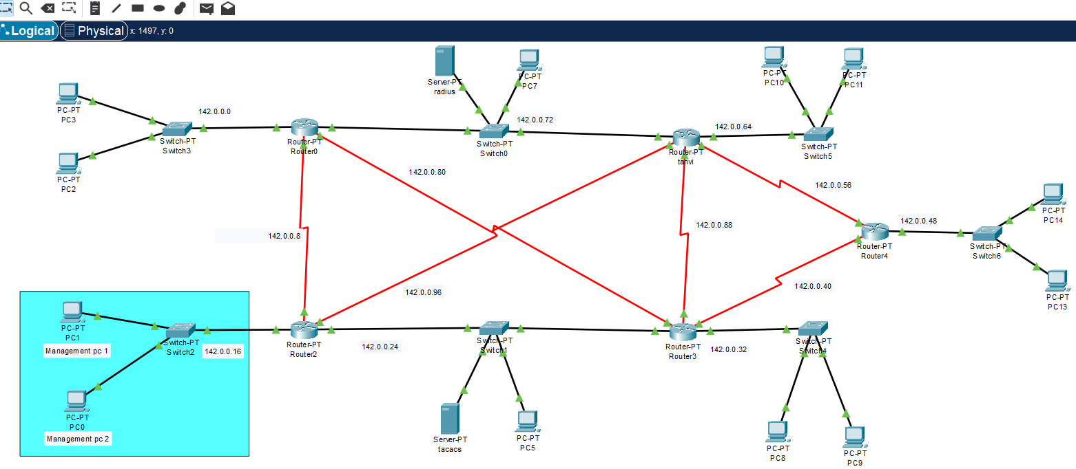

local AAA authentication using the line console

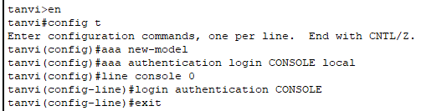

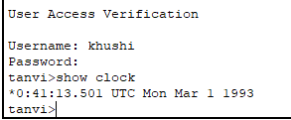

local AAA authentication using the line vty

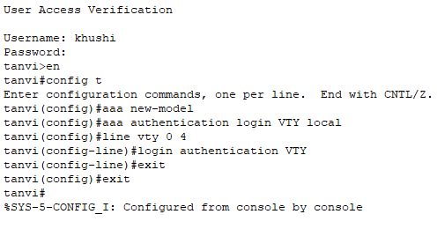

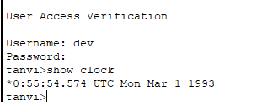

Centralized AAA authentication using the TACACS+ :

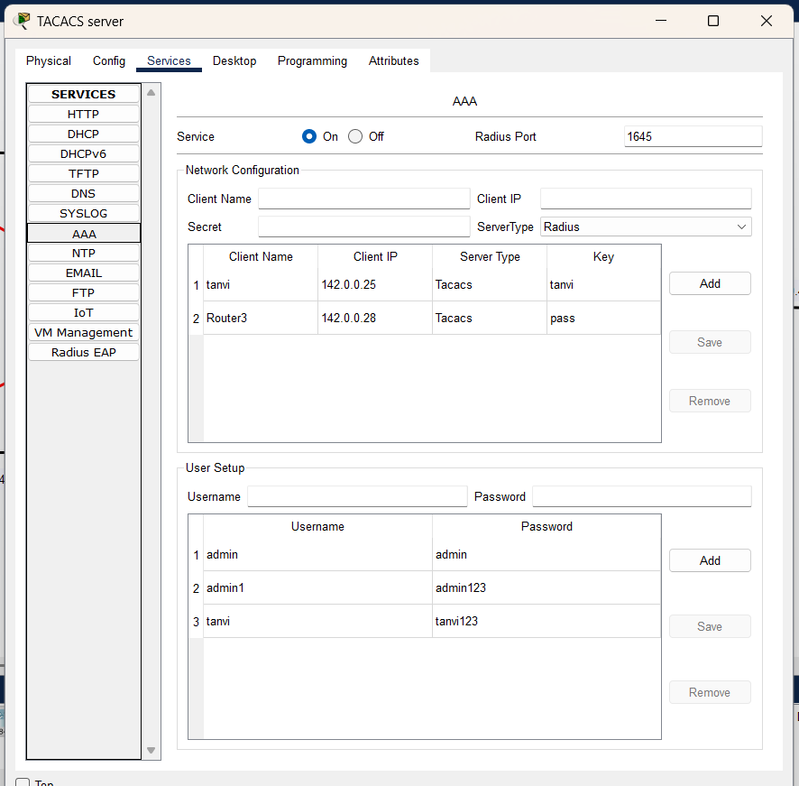

Configure the Router ->
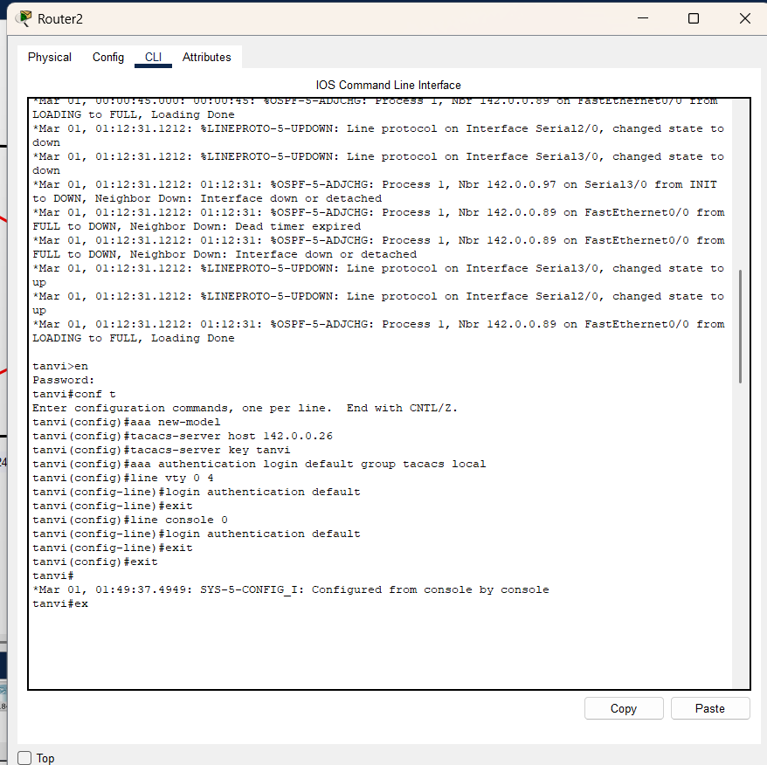

AAA tacacs+ authentication from router

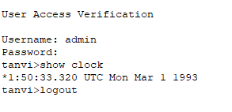

AAA tacacs+ authentication from PC(device)
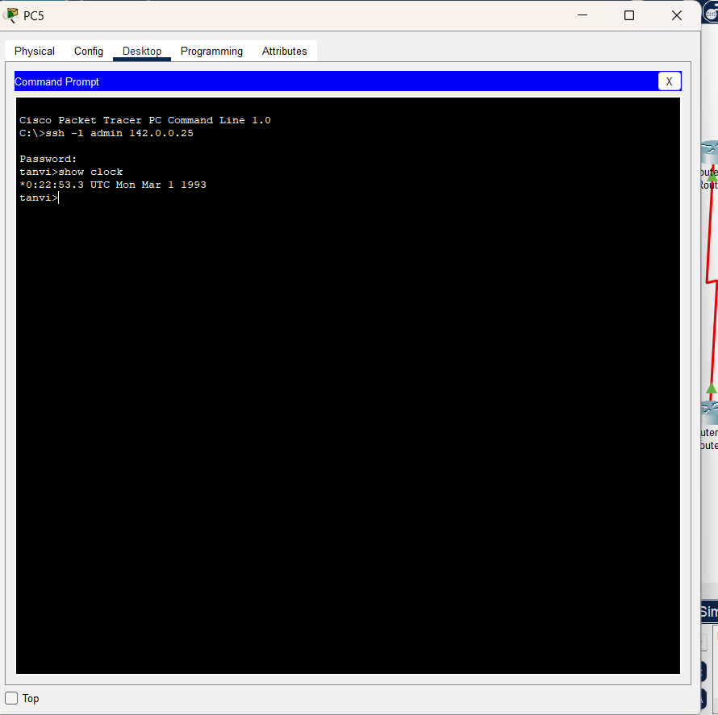

Centralized AAA authentication using the RADIUS :

Configure the AAA server

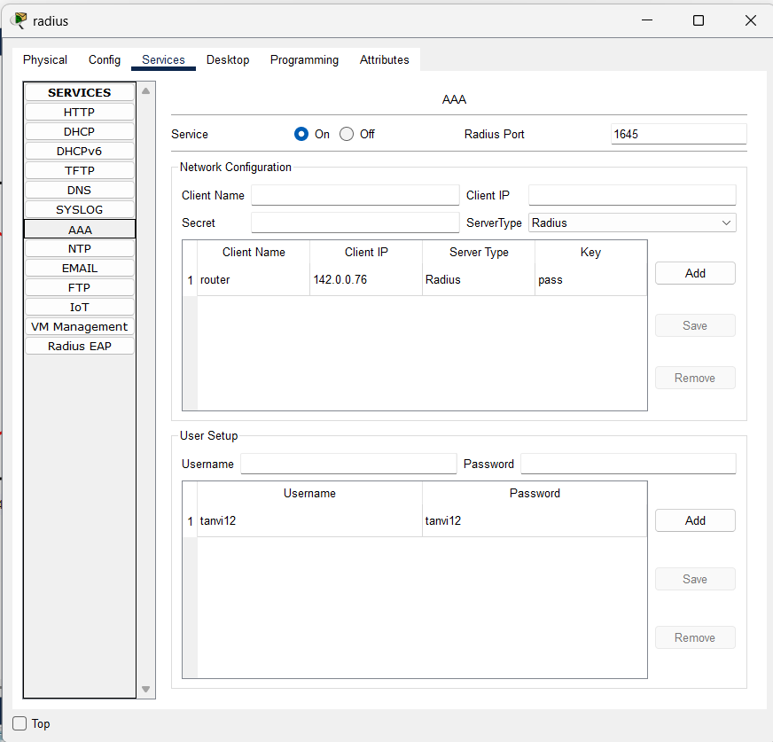

Configure the Router ->

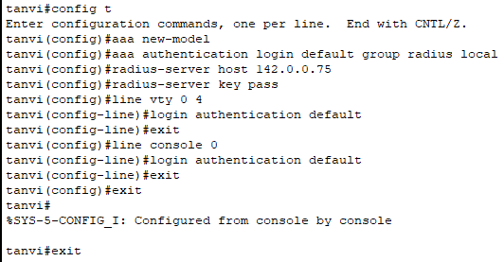

AAA radius+ authentication from router

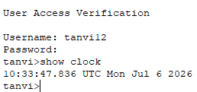

AAA radius+ authentication from PC(device)

