PRACTICAL NO.3

- Configure Routers:

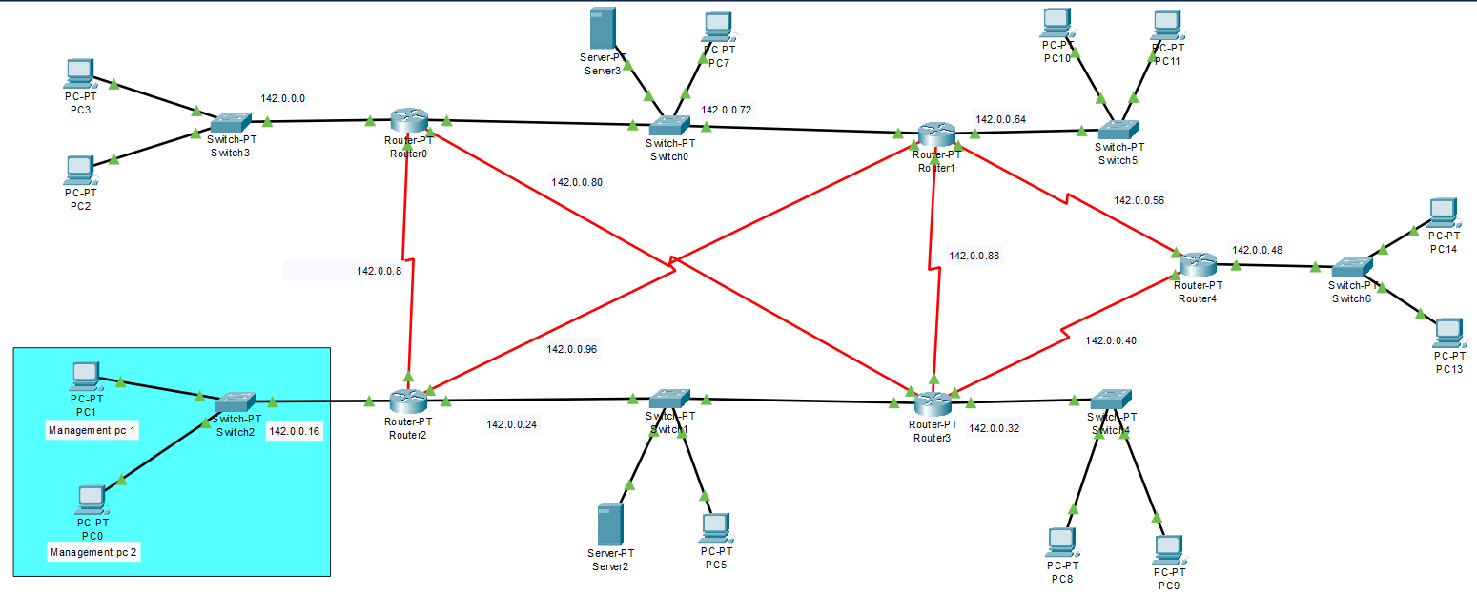

Configure ssh routers:

Router0:
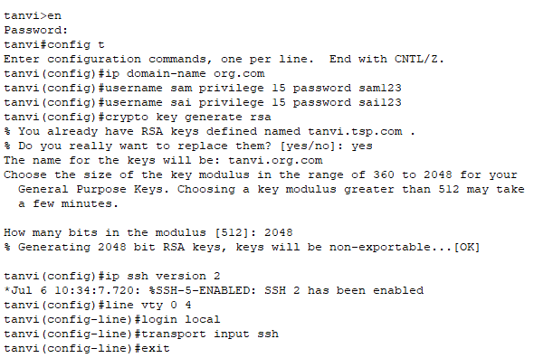

Accessing the ssh using pc:

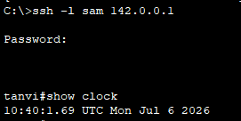

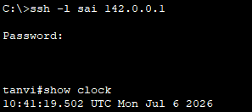

Router1:
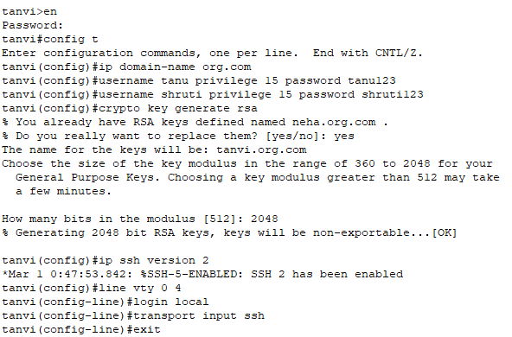

Accessing the ssh using pc:
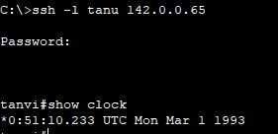

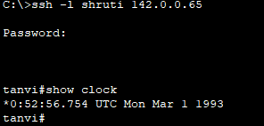

Router2:
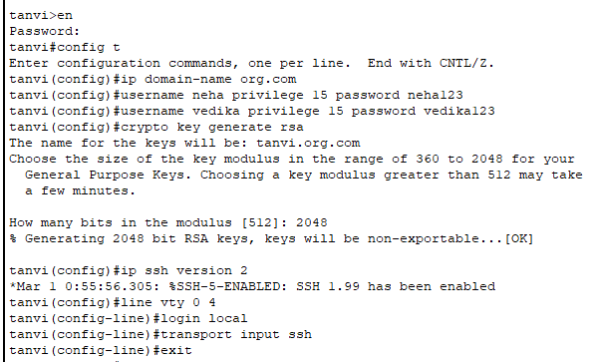

Accessing the ssh using pc:

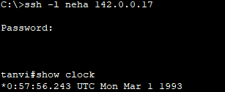

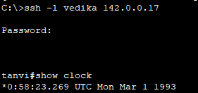

Router3:
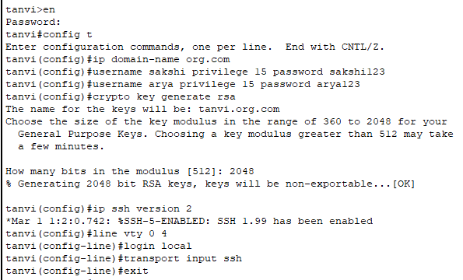

Accessing the ssh using pc:
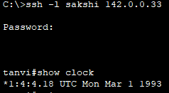

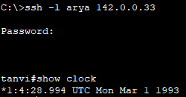

Router4:

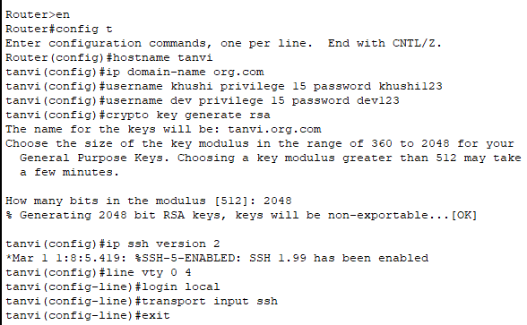

Accessing the ssh using pc:
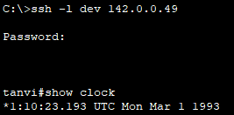
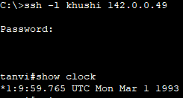

Router | User1 | Password1 | User2 | Password2
Router0 | sam | sam123 | sai | sai123
Router1 | tanu | Tanu123 | shruti | shruti123
Router2 | neha | neha123 | vedika | vedika123
Router3 | sakshi | sakshi123 | arya | arya123
Router4 | khushi | khushi123 | dev | dev123

Extended Access Control List:

- allow the ssh for only 142.0.0.18 and 142.0.0.19 for the router 142.0.0.17
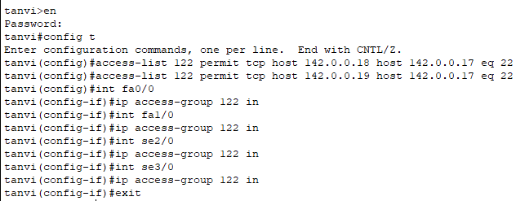

Access the ssh service from the managementPc1 //142.0.0.18

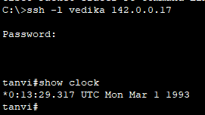

Access the ssh service from the managementPc2 //142.0.0.19

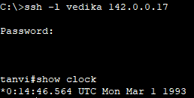

Access the ssh service from the 142.0.0.2

