PRACTICAL NO.5
Configuring a Zone-Based Policy Firewall
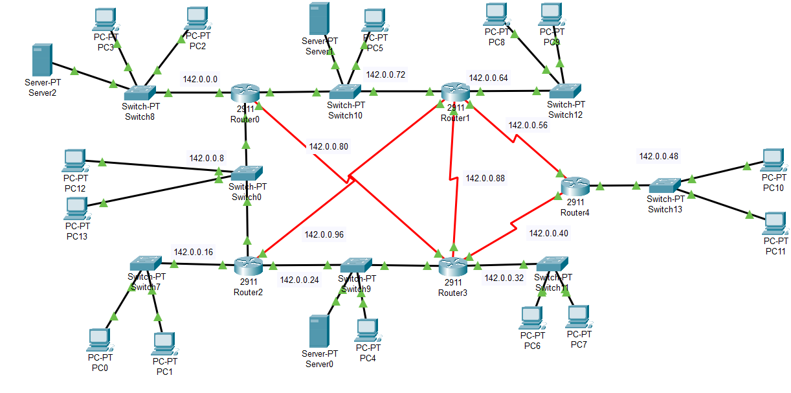
Network:
SSH configuration on router5
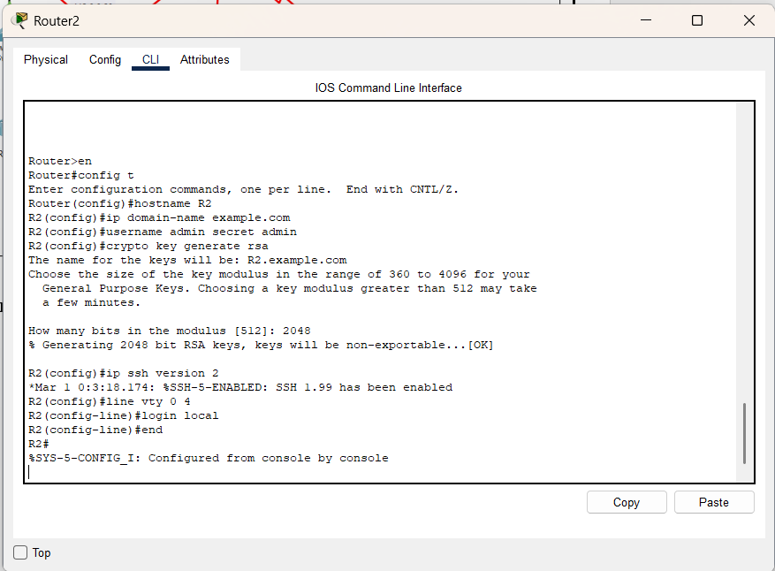
Installing the securityK9 package on router5
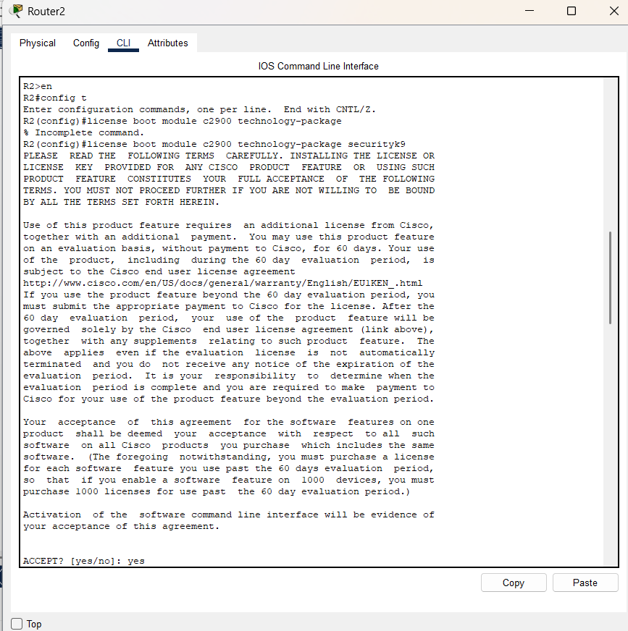

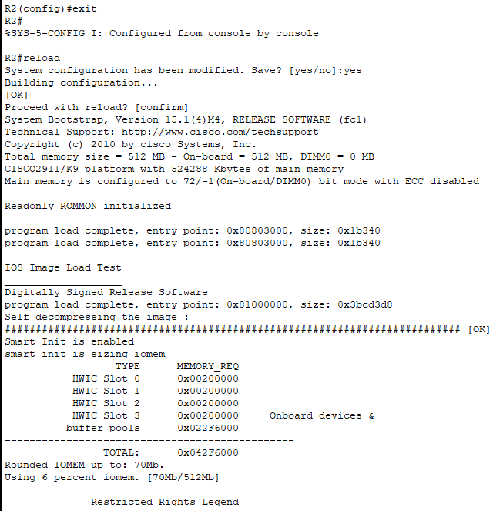

Creating zones for each network.
Router5 has 4 interfaces and for each interface Zone is created with different policies
ZONE-32 denies the icmp(ping) in a network
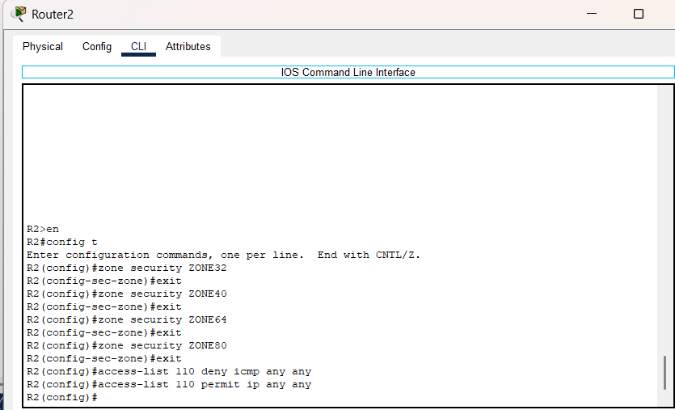

ZONE40 denies the HTTP and FTP service in a network
ZONE64 denies only FTP service in a network
ZONE80 denies the Ssh service in a network

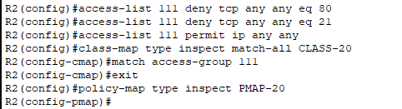
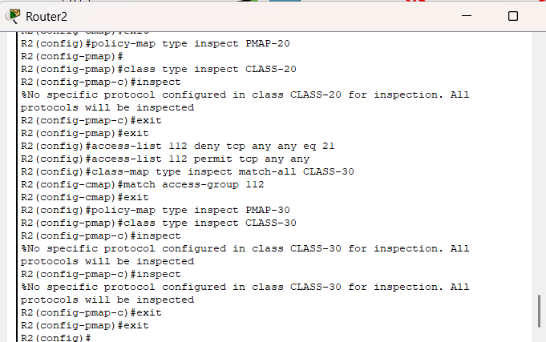
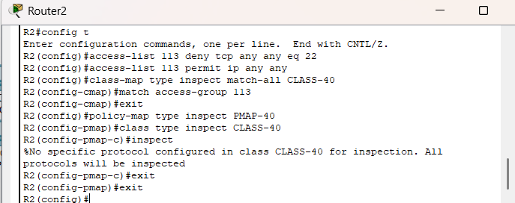
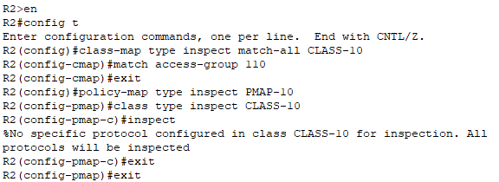
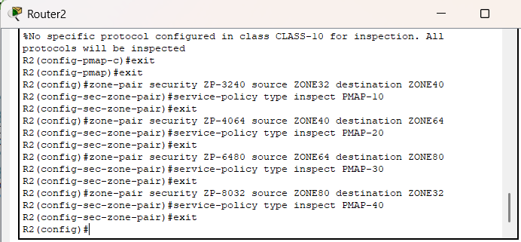

Assigning the zones to the interface
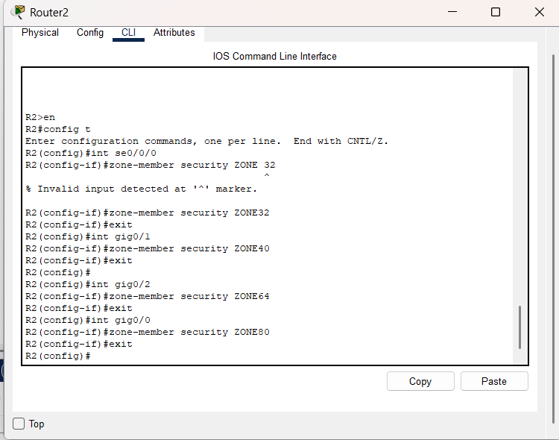
All the policies that are applied on each interface
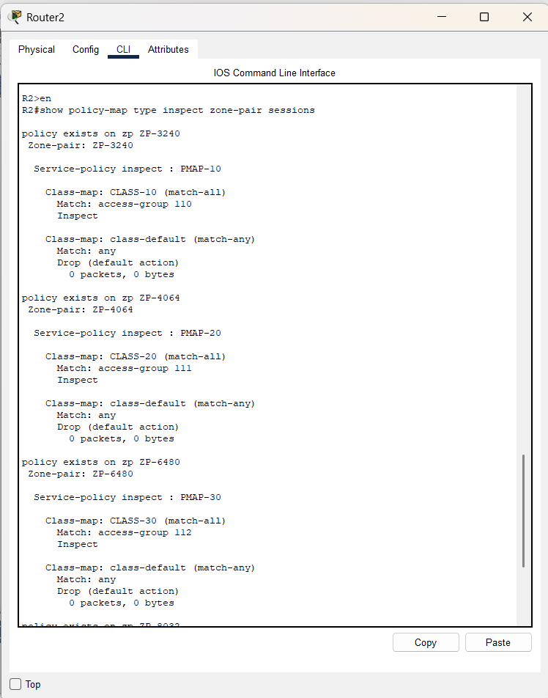
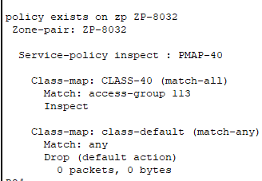

Zone32 policies
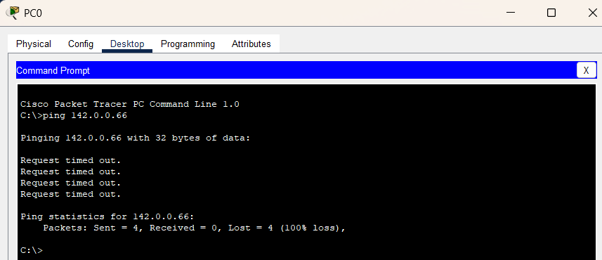

Zone40 policies
Denied the HTTP service
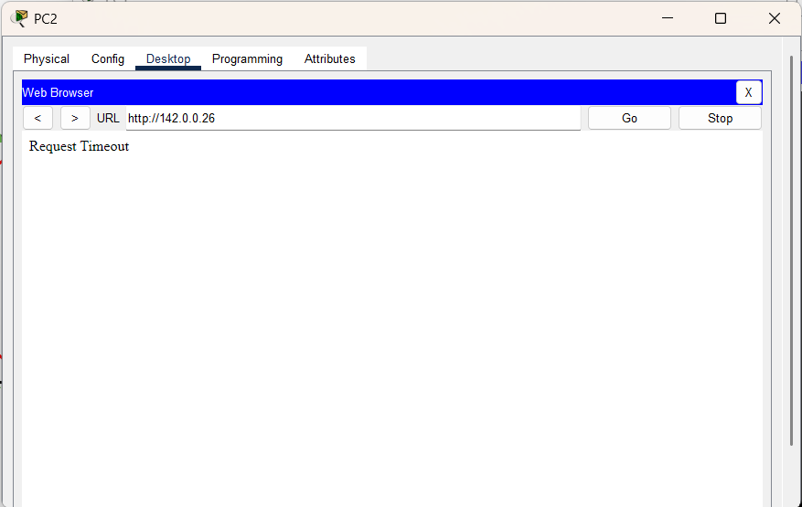
ZONE64
Denied the FTP service from server
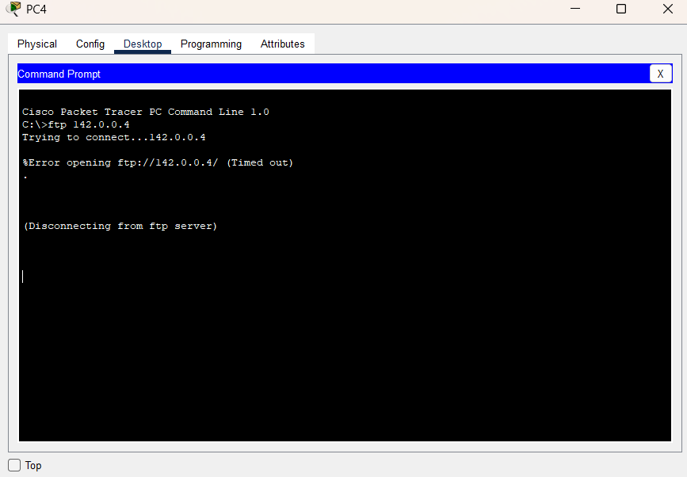
Zone80
Denied the ssh service

