PRACTICAL NO:03
A.Exploring and Managing Raster data: Adding raster layers, raster styling and analysis.
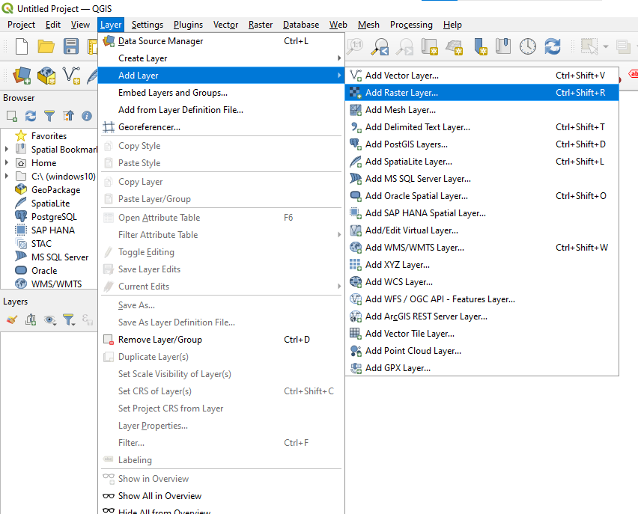

Step 2: Source type->Raster Dataset(s)->glds90ag60.asc

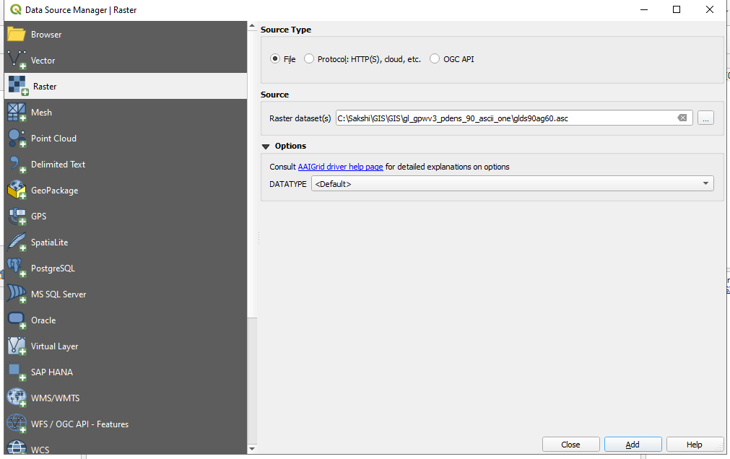

Step 3: Source type->Raster Dataset(s)->glds00ag60.asc
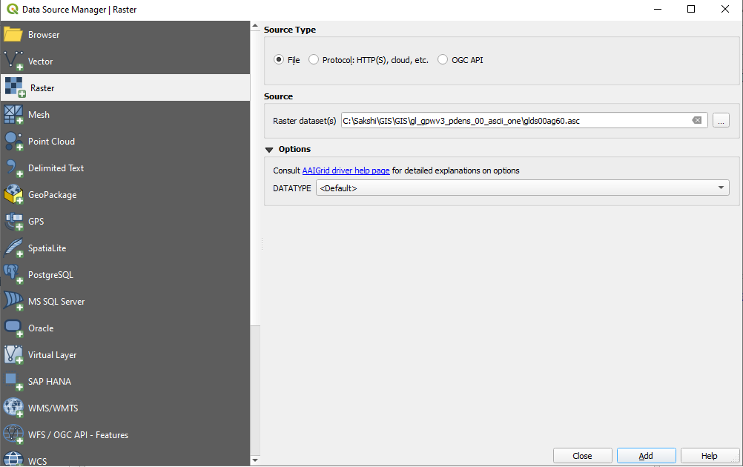

Step 3: Result
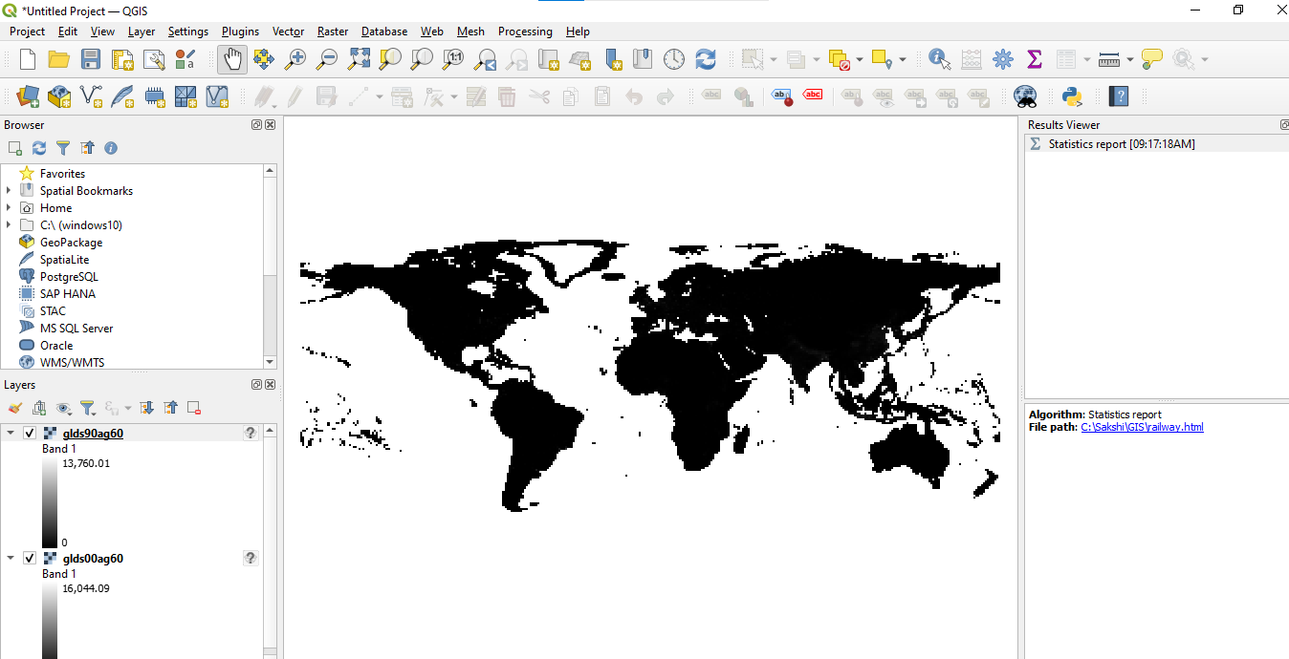

Step 4: To Set Style property For First Layer -> Right click on layer -> click on control feature Symbology -> Set render type > set Min and Max value > Apply > Ok

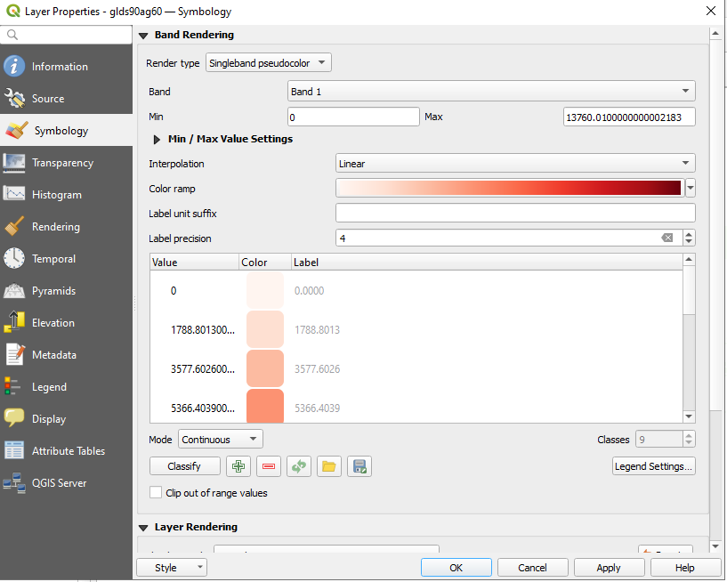

Step 5: Result
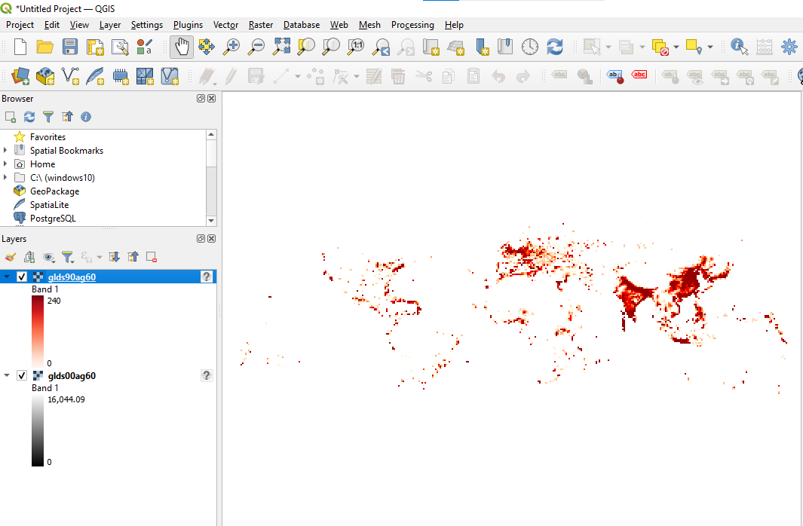

Step 6: To Set Style property For Second Layer -> Right click on layer -> click on control feature Symbology -> Set render type > set Min and Max value > Apply > Ok
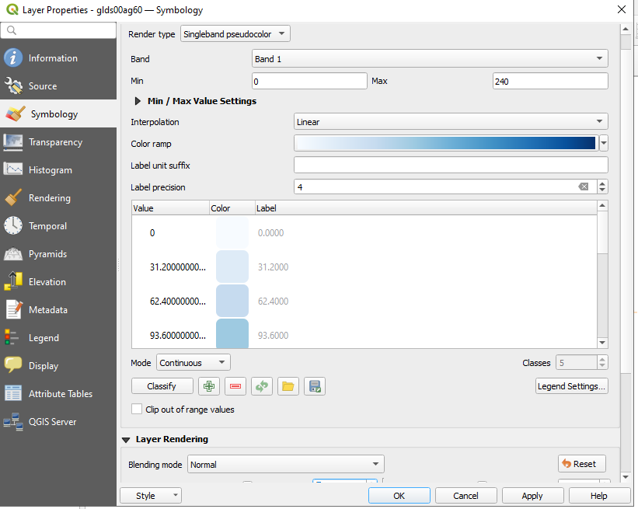
Step 7: Result
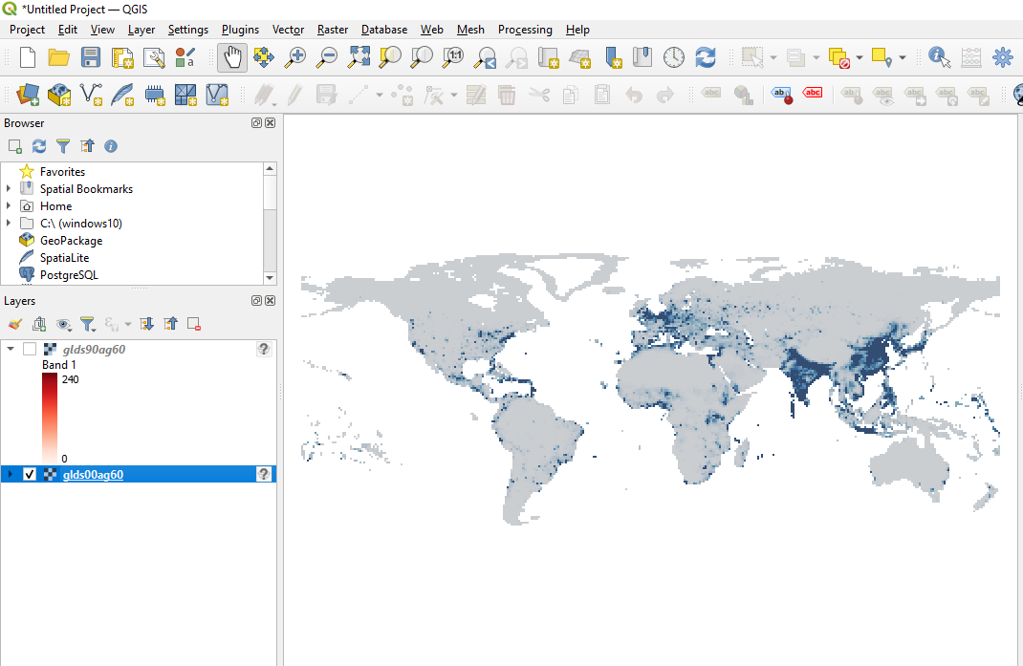
Step 8: Select Raster >Select raster calculator

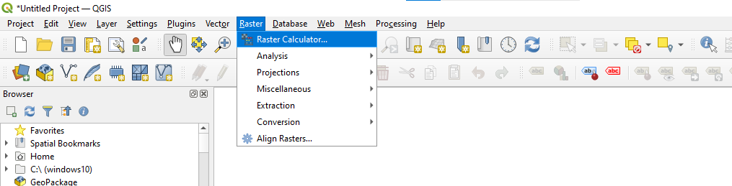
Step 9: Raster Calculator > Set output layer >Set output format to GeoTIFF >Set output CRS to Project CRS:EPSG:4326-WGS84 >Prepare raster expression using raster bands and operator
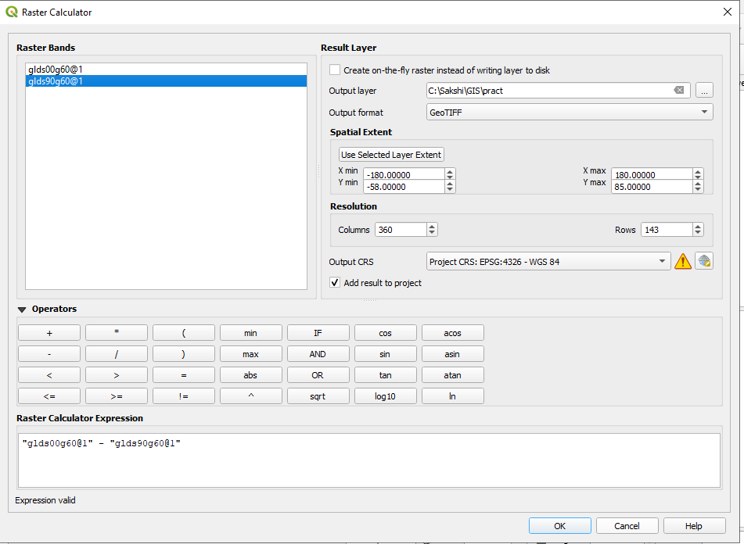
Step 10: Result
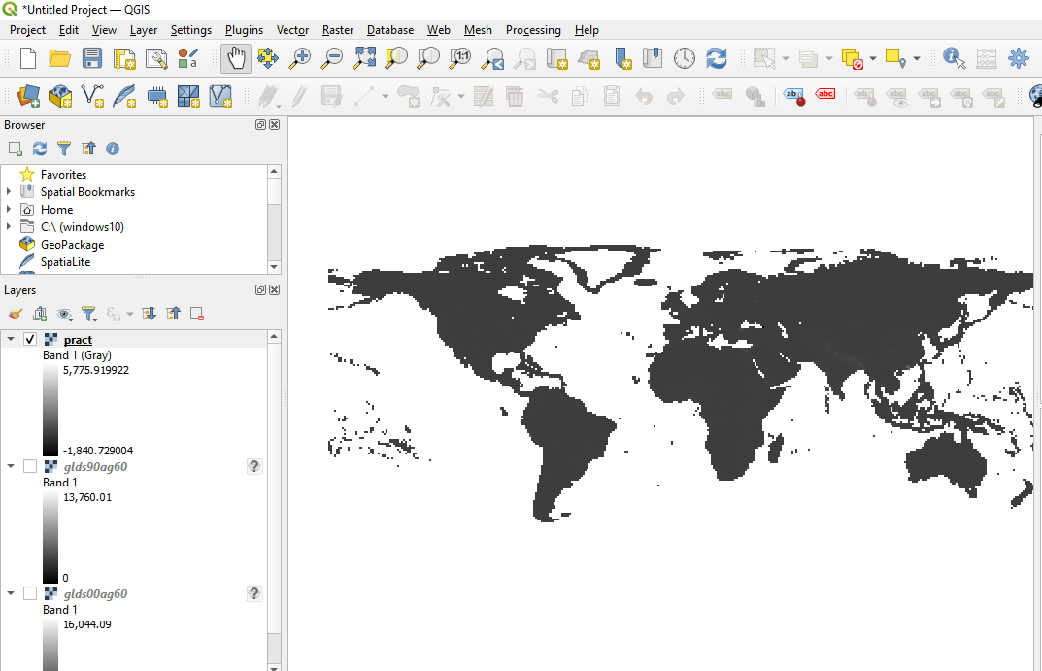

Step 11: To Set Style property Layer -> Right click on layer -> click on control feature Symbology -> Set render type > Set Interpolation > Change values> Apply > Ok

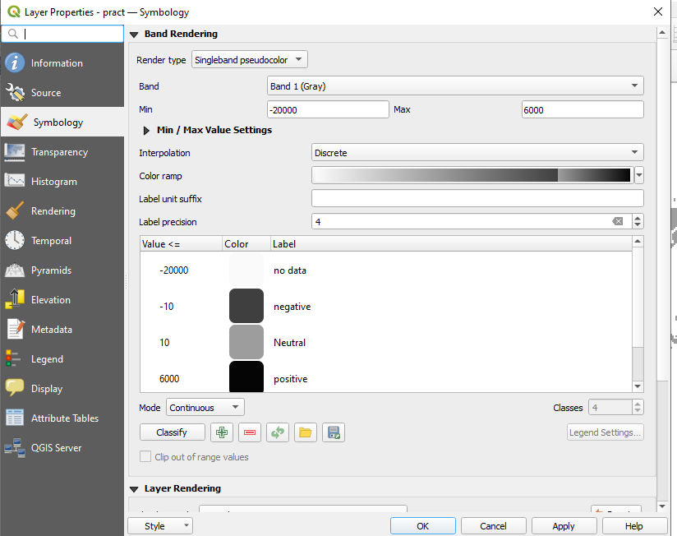
Step 12: Result
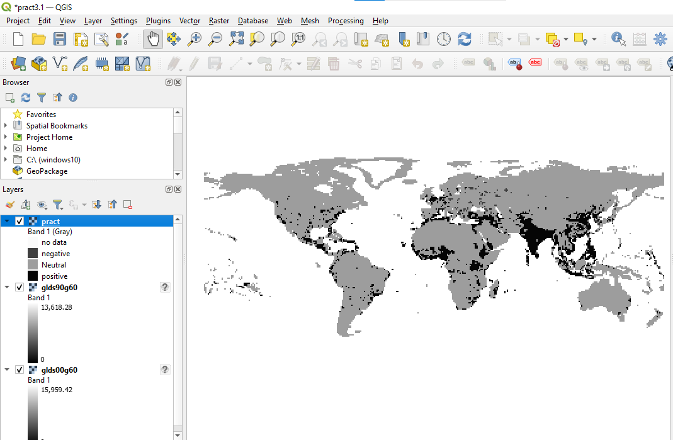

B. Raster mosaicking and clipping
Step 1: Select Raster > Miscellaneous > merge
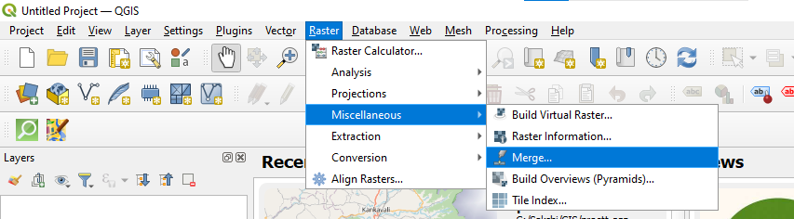
Step 2: Select all .2km files > Open > Add the Selected layers
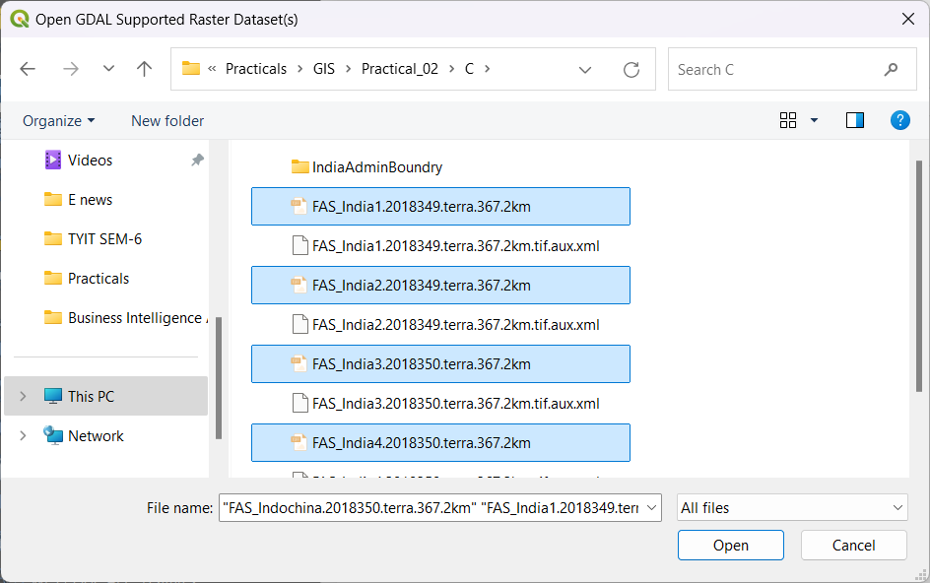

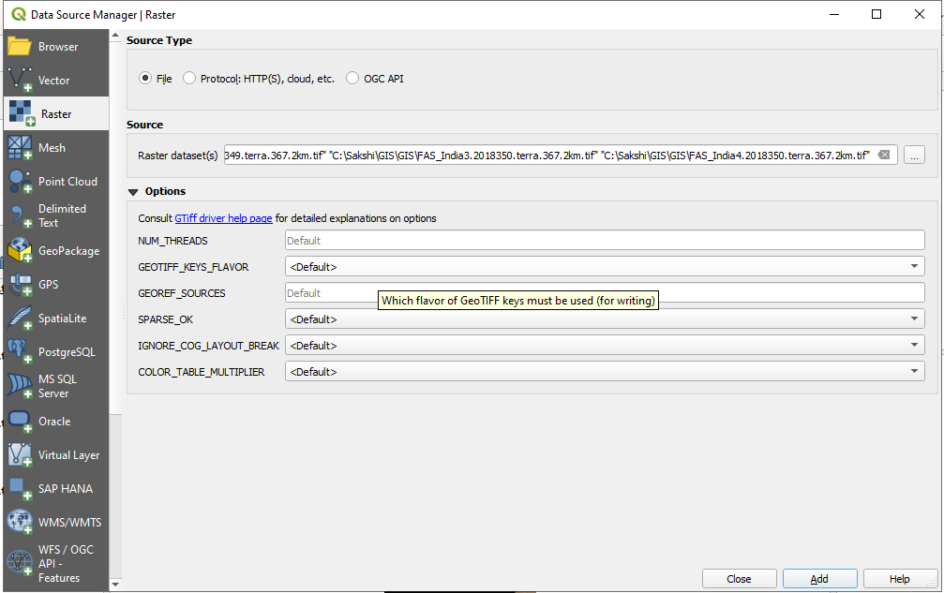
Step 3: Add selected layer

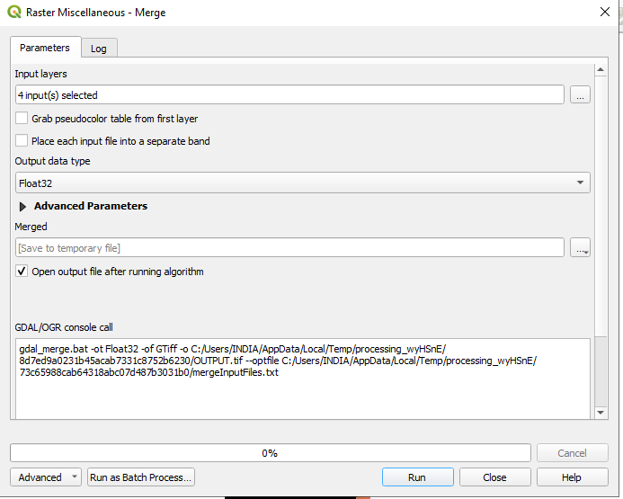
Step 4: Add input layers >set all attributes >Run

Step 5: Result
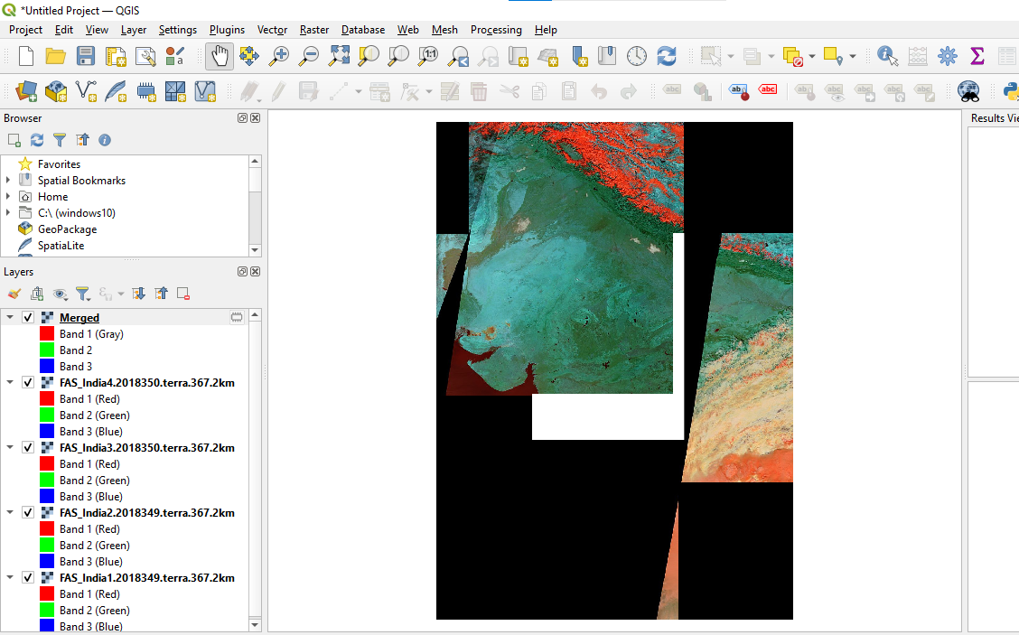

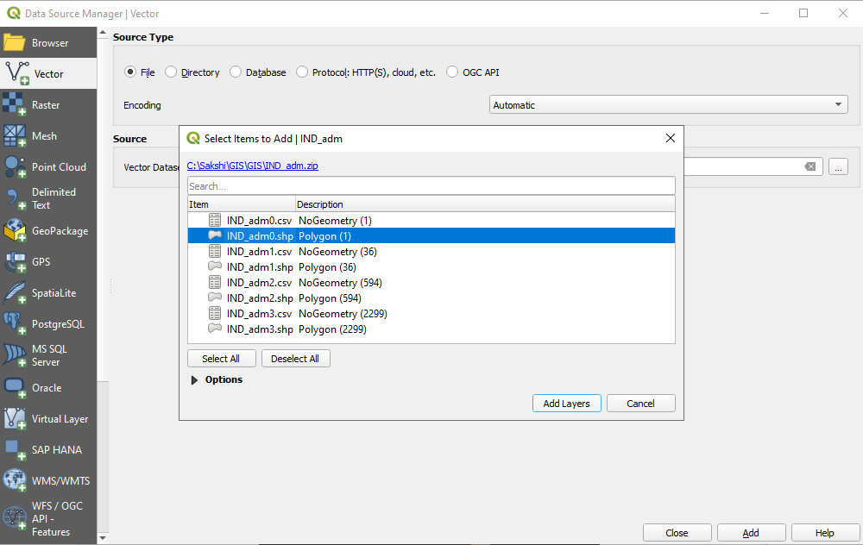
Step 6: Source type->Vector Dataset(s)->IND_adm.shp > add layer >add

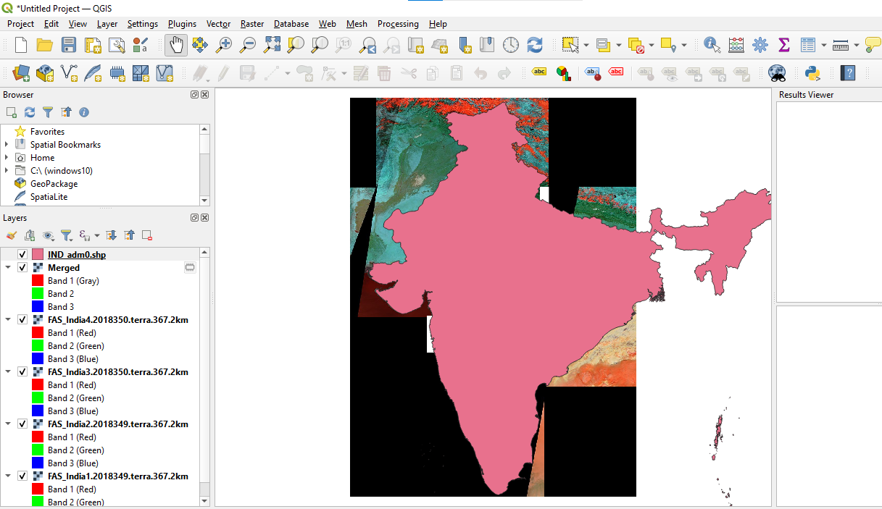
Step 7: Result

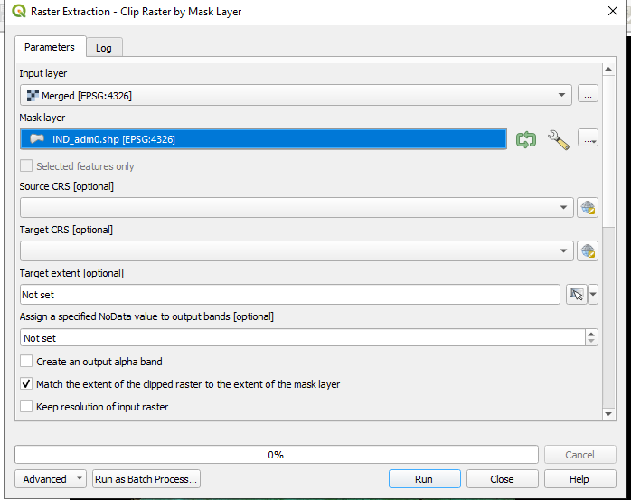
Step 8: Select raster > Raster Extraction > Clip raster by mask layer>Add input layer > Set all attributes > Run
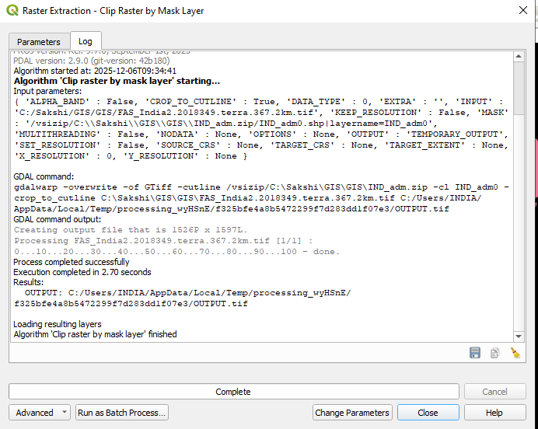
Step 9: Output

Step 10: Result After Clipping and Merging

