

**DEPARTMENT OF ARTIFICIAL INTELLIGENCE AND DATA SCIENCE**

**PRACTIAL RECORD BOOK**

**21AD61 : DIGITAL IMAGE PROCESSING**

NAME : USN : YEAR/SEM : SECTION : BRANCH :

# DEPARTMENT OF ARTIFICIAL INTELLIGENCE AND DATA SCIENCE



**CERTIFICATE**

This is to certify that Mr./Mrs. studying

in semester Branch has satisfactorily completed the course of

experiments in Laboratory for the

academic session 2023-2024 as prescribed by the Visvesvaraya Technological University.

Register Number of the Candidate:

Signature of the Staff Incharge Signature of HOD Date: Date:

|  |  |
| --- | --- |
| **Sl. No** | **Program / Exercise** |
| 1. | **Implementation of Relationships between Pixels Neighbour of 4,8 and Diagonal point.** |
| 2. | **(a).Display color Image, find its complement and convert to gray scale. (b).Simulation and Display of an Image, Negative of an Image(Binary & Gray Scale.** |
| 3. | (a).**Implementation of Transformations of an Image i)Scaling & Rotation. (b).Display the color image and its Resized images by different methods.** |
| 4. | **Contrast stretching of a low contrast image, Histogram, and Histogram Equalization.** |
| 5. | **Display of bit plane of an image.** |
| 6. | **Display of FTT(1D, 2D) of an image.** |
| 7. | **Computation of mean, Standard Deviation, Correlation coefficient of the given Image.** |
| 8. | **Implementation of Image Smoothening Filters(Mean and Median filtering of an Image.** |
| 9. | **Implementation of image sharpening filters and Edge Detection using Gradient Filters** |

|  |  |  |  |  |  |
| --- | --- | --- | --- | --- | --- |
| **INDEX SHEET** | | | | | |
| **SL.N O** | **Programs** | **Page no** | **Date of Execution** | **Staff Signature** |  |
| 1. | **mplementation of Relationships between Pixels Neighbour of 4,8 and Diagonal point.** |  | 02/11/2023 |  |
| 2 | **(a).Display color Image, find its complement and convert to gray scale.**  **(b).Simulation and Display of an Image, Negative of an Image(Binary & Gray Scale.** |  | 07/11/2023 |  |
| 3. | (a).**Implementation of Transformations of an Image**  **i)Scaling & Rotation.**  **(b).Display the color image and its Resized images by different methods.** |  | 21/11/2023 |  |
| 4. | **Contrast stretching of a low contrast image, Histogram, and Histogram Equalization.** |  | 28/11/2023 |  |
| 5. | **Display of bit plane of an image.** |  | 04/12/2023 |  |
| 6. | **Display of FTT(1D, 2D) of an image.** |  | 12/12/2023 |  |
| 7. | **Computation of mean, Standard Deviation, Correlation coefficient of the given Image.** |  | 19/12/2023 |  |
| 8. | **Implementation of Image Smoothening Filters(Mean and Median filtering of an**  **Image.** |  | 26/12/2023 |  |
| 9. | **Implementation of image sharpening filters and Edge Detection using Gradient Filters.** |  | 16/01/2024 |  |
|  | | | | | |

**DIGITAL IMAGE PROCESSING AND COMPUTER VISION LAB PROGRAMS**

# PROGRAM 1

### Implementation of Relationships between Pixels Neighbour of 4,8 and Diagonal point CODE :

import numpy as np

# Create a sample matrix (using a magic square for demonstration) a = np.array([[17, 24, 1, 8, 15],

[23, 5, 7, 14, 16],

[ 4, 6, 13, 20, 22],

[10, 12, 19, 21, 3],

[11, 18, 25, 2, 9]])

print("a =") print(a)

# Get the row and column input from the user

b = int(input("Enter the row < size of the Matrix: "))

c = int(input("Enter the column < size of matrix: ")) print("Element:", a[b, c])

# 4-Point Neighbours

N4 = [a[b+1, c] if b+1 < a.shape[0] else None, # Below a[b-1, c] if b-1 >= 0 else None, # Above

a[b, c+1] if c+1 < a.shape[1] else None, # Right a[b, c-1] if c-1 >= 0 else None] # Left

print("N4 =") print(N4)

# 8-Point Neighbours

N8 = [a[b+1, c] if b+1 < a.shape[0] else None, # Below a[b-1, c] if b-1 >= 0 else None, # Above

a[b, c+1] if c+1 < a.shape[1] else None, # Right a[b, c-1] if c-1 >= 0 else None, # Left

a[b+1, c+1] if b+1 < a.shape[0] and c+1 < a.shape[1] else None, # Below-Right a[b+1, c-1] if b+1 < a.shape[0] and c-1 >= 0 else None, # Below-Left

a[b-1, c-1] if b-1 >= 0 and c-1 >= 0 else None, # Above-Left

a[b-1, c+1] if b-1 >= 0 and c+1 < a.shape[1] else None] # Above-Right

print("N8 =") print(N8)

# Diagonal Neighbours

ND = [a[b+1, c+1] if b+1 < a.shape[0] and c+1 < a.shape[1] else None, # Below-Right a[b+1, c-1] if b+1 < a.shape[0] and c-1 >= 0 else None, # Below-Left

a[b-1, c-1] if b-1 >= 0 and c-1 >= 0 else None, # Above-Left

a[b-1, c+1] if b-1 >= 0 and c+1 < a.shape[1] else None] # Above-Right

print("ND =") print(ND)

**OUTPUT :**

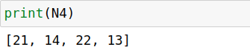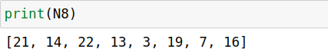

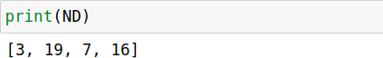

## PROGRAM 2 (a)

### Display color Image, find its complement and convert to gray scale CODE :

import cv2

import numpy as np

import matplotlib.pyplot as plt

# Read the color image

I = cv2.imread('C:/Users/anuam/Downloads/apple.jpg')

# Convert BGR to RGB (OpenCV reads images in BGR format) I_rgb = cv2.cvtColor(I, cv2.COLOR_BGR2RGB)

# Plot original color image plt.subplot(2, 2, 1) plt.imshow(I_rgb) plt.title('Color Image') plt.axis('off')

# Find complement of color image c = cv2.bitwise_not(I_rgb) plt.subplot(2, 2, 2)

plt.imshow(c)

plt.title('Complement of color Image') plt.axis('off')

# Convert color image to grayscale

r = cv2.cvtColor(I_rgb, cv2.COLOR_RGB2GRAY) plt.subplot(2, 2, 3)

plt.imshow(r, cmap='gray') plt.title('Gray scale of color Image') plt.axis('off')

# Find complement of grayscale image b = cv2.bitwise_not(r)

plt.subplot(2, 2, 4) plt.imshow(b, cmap='gray')

plt.title('Complement of Gray Image') plt.axis('off')

# Simulation of an Image (Arithmetic & Logic Operation)

a = np.ones((40, 40), dtype=np.uint8)

b = np.zeros((40, 40), dtype=np.uint8)

c = np.hstack((a, b))

d = np.hstack((b, a))

e = np.vstack((c, d))

A = 10 * (c + d) M = c * d S = np.abs(c - d) D = c / 4 plt.figure()

plt.subplot(3, 2, 1) plt.imshow(c, cmap='gray') plt.subplot(3, 2, 2) plt.imshow(d, cmap='gray') plt.subplot(3, 2, 3) plt.imshow(A, cmap='gray') plt.subplot(3, 2, 4) plt.imshow(M, cmap='gray') plt.subplot(3, 2, 5) plt.imshow(S, cmap='gray') plt.subplot(3, 2, 6) plt.imshow(D, cmap='gray') plt.show()

**OUTPUT :**

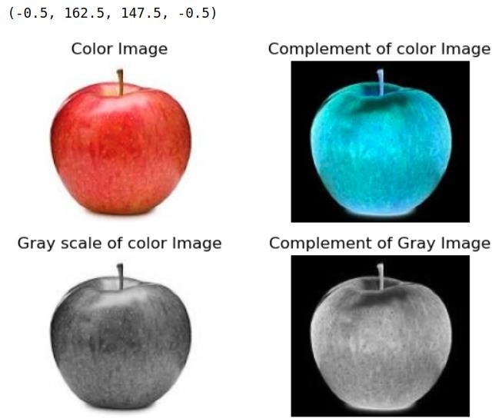

## PROGRAM 2(b)

**Simulation and Display of an Image, Negative of an Image(Binary & Gray Scale**

**CODE :**

import cv2

import matplotlib.pyplot as plt

# Read the image

i = cv2.imread('C:/Users/anuam/Downloads/apple.jpg')

# Convert BGR to RGB (OpenCV reads images in BGR format) i = cv2.cvtColor(i, cv2.COLOR_BGR2RGB)

# Plot original image plt.subplot(3, 2, 1) plt.imshow(i) plt.title('Original Image') plt.axis('off')

# Red Component r = i[:, :, 0]

plt.subplot(3, 2, 2) plt.imshow(r, cmap='gray')

# Displaying in grayscale plt.title('Red Component') plt.axis('off')

# Green Component g = i[:, :, 1]

plt.subplot(3, 2, 3) plt.imshow(g, cmap='gray')

# Displaying in grayscale plt.title('Green Component') plt.axis('off')

# Blue Component b = i[:, :, 2]

plt.subplot(3, 2, 4) plt.imshow(b, cmap='gray')

# Displaying in grayscale plt.title('Blue Component') plt.axis('off')

# Convert to grayscale

rg = cv2.cvtColor(i, cv2.COLOR_RGB2GRAY) plt.subplot(3, 2, 5)

plt.imshow(rg, cmap='gray') plt.title('Gray Image') plt.axis('off')

plt.tight_layout() plt.show()

**OUTPUT :**

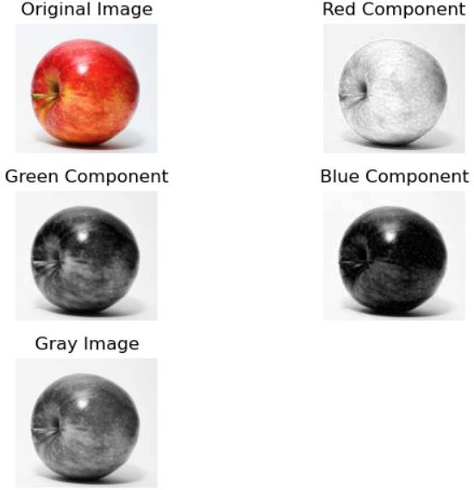

## PROGRAM 3 (a)

**Implementation of Transformations of an Image i)Scaling & Rotation**

**CODE :**

import cv2

import numpy as np

# Load the image

image = cv2.imread('C:/Users/anuam/Downloads/apple.jpg')

# Define scaling factor

scaling_factor = 0.5 # You can change this value

# Perform scaling

scaled_image = cv2.resize(image, None, fx=scaling_factor, fy=scaling_factor, interpolation=cv2.INTER_LINEAR)

# Define rotation angle (in degrees) rotation_angle = 45 # You can change this value

# Perform rotation

height, width = scaled_image.shape[:2]

rotation_matrix = cv2.getRotationMatrix2D((width/2, height/2), rotation_angle, 1) rotated_image = cv2.warpAffine(scaled_image, rotation_matrix, (width, height))

# Display the original, scaled, and rotated images cv2.imshow('Original Image', image) cv2.imshow('Scaled Image', scaled_image) cv2.imshow('Rotated Image', rotated_image) cv2.waitKey(0)

cv2.destroyAllWindows()

**OUTPUT :**

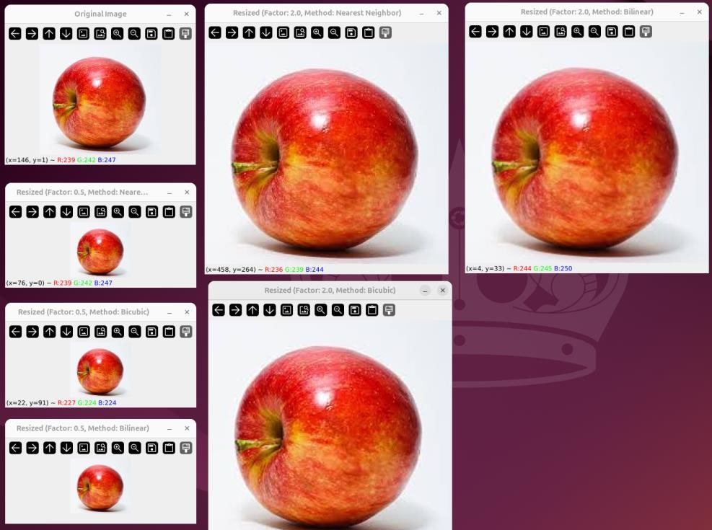

## PROGRAM 3 (b)

**Display the color image and its Resized images by different methods**

**CODE :**

import cv2

import numpy as np

# Load the image

image = cv2.imread('input_image.jpg')

# Define scaling factors

scaling_factors = [0.5, 2.0] # You can add more scaling factors as needed

# Define interpolation methods

interpolation_methods = [cv2.INTER_NEAREST, cv2.INTER_LINEAR, cv2.INTER_CUBIC]

# Display the original image cv2.imshow('Original Image', image)

# Perform resizing with different methods for factor in scaling_factors:

for method in interpolation_methods: # Perform scaling

scaled_image = cv2.resize(image, None, fx=factor, fy=factor, interpolation=method)

# Display the resized image method_name = ""

if method == cv2.INTER_NEAREST: method_name = "Nearest Neighbor"

elif method == cv2.INTER_LINEAR: method_name = "Bilinear"

elif method == cv2.INTER_CUBIC: method_name = "Bicubic"

cv2.imshow(f'Resized (Factor: {factor}, Method: {method_name})', scaled_image) # Wait for a key press and close all windows

cv2.waitKey(0) cv2.destroyAllWindows()

**OUTPUT :**

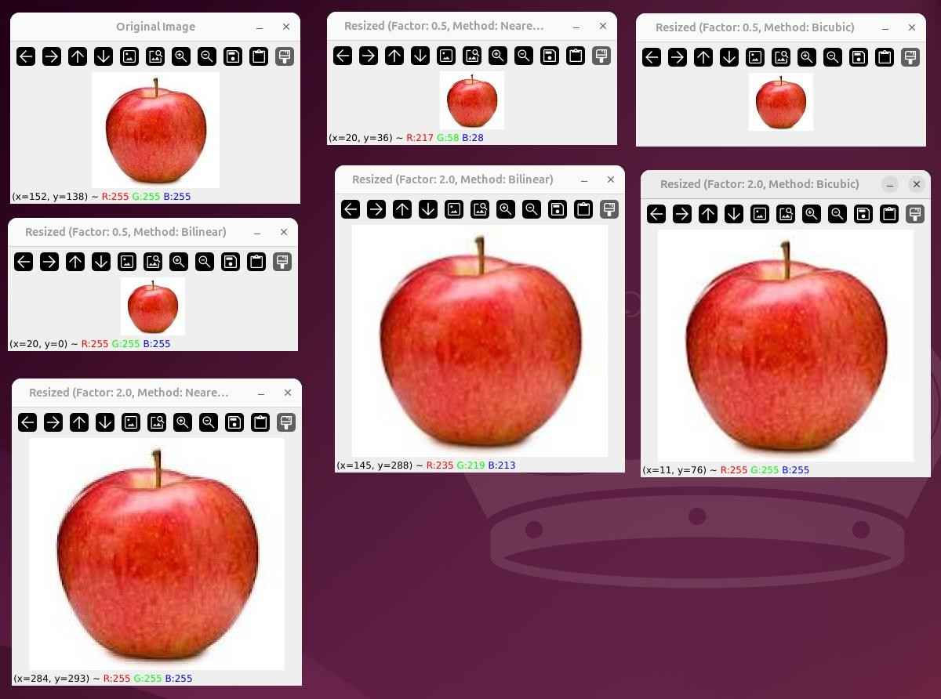

# PROGRAM 4

### Contrast stretching of a low contrast image, Histogram, and Histogram Equalization CODE :

import cv2

import numpy as np

import matplotlib.pyplot as plt

# Load the image

image = cv2.imread('input_image.jpg', cv2.IMREAD_GRAYSCALE)

# Apply contrast stretching min_intensity = np.min(image) max_intensity = np.max(image)

stretched_image = cv2.normalize(image, None, 0, 255, norm_type=cv2.NORM_MINMAX)

# Calculate and plot histograms

hist_original = cv2.calcHist([image], [0], None, [256], [0, 256])

hist_stretched = cv2.calcHist([stretched_image], [0], None, [256], [0, 256])

plt.figure(figsize=(10, 5))

plt.subplot(1, 2, 1) plt.plot(hist_original, color='b') plt.title('Original Image Histogram')

plt.subplot(1, 2, 2) plt.plot(hist_stretched, color='r') plt.title('Stretched Image Histogram')

plt.tight_layout() plt.show()

# Apply histogram equalization equalized_image = cv2.equalizeHist(image)

# Calculate and plot histograms for equalized image

hist_equalized = cv2.calcHist([equalized_image], [0], None, [256], [0, 256])

plt.figure(figsize=(10, 5))

plt.subplot(1, 2, 1) plt.imshow(stretched_image, cmap='gray') plt.title('Contrast Stretched Image')

plt.subplot(1, 2, 2) plt.imshow(equalized_image, cmap='gray') plt.title('Histogram Equalized Image')

plt.tight_layout() plt.show()

**OUTPUT :**

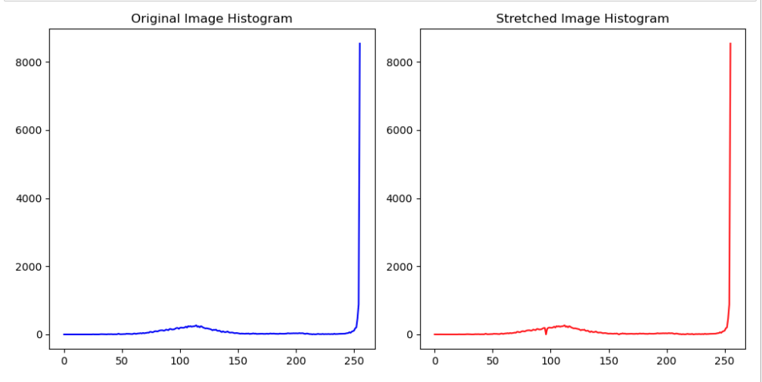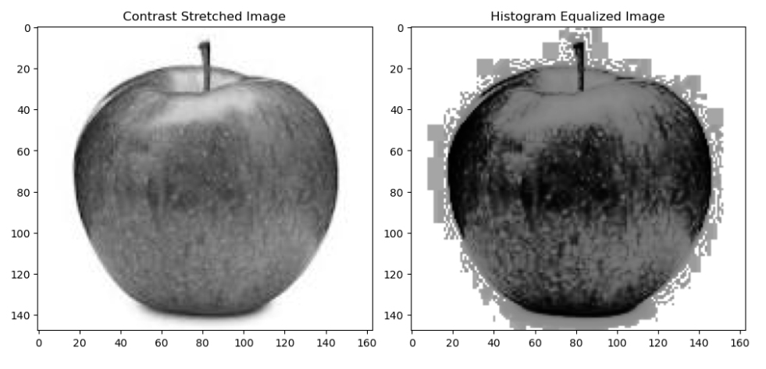

# PROGRAM 5

### Display of bit plane of an image. CODE :

import cv2

import numpy as np

import matplotlib.pyplot as plt

# Load the image in grayscale

image = cv2.imread('input_image.jpg', cv2.IMREAD_GRAYSCALE)

# Get the dimensions of the image height, width = image.shape

# Create an array to store the bit planes

bit_planes = np.zeros((8, height, width), dtype=np.uint8)

# Calculate the bit planes for i in range(8):

bit_planes[i] = (image >> i) & 1 # Extract ith bit plane

# Display the bit planes plt.figure(figsize=(12, 6)) for i in range(8):

plt.subplot(2, 4, i+1) plt.imshow(bit_planes[i], cmap='gray') plt.title(f'Bit Plane {i+1}') plt.axis('off')

plt.tight_layout() plt.show()

**OUTPUT :**

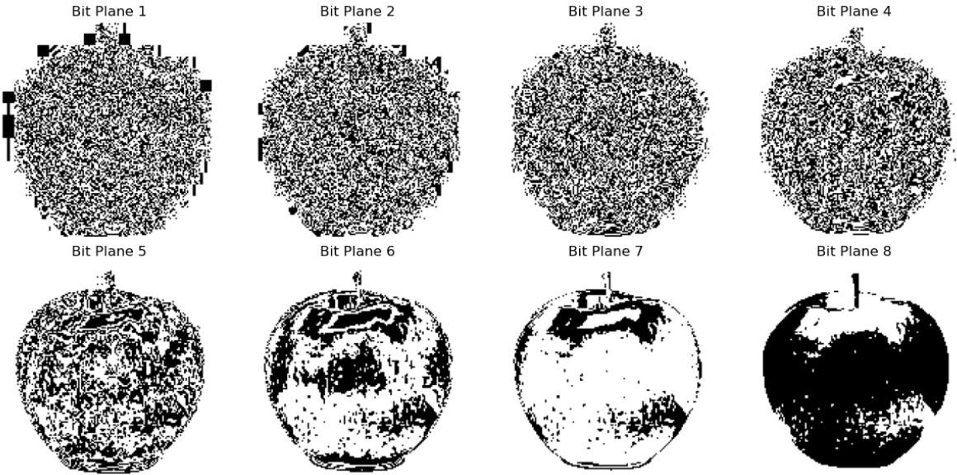

# PROGRAM 6

### Display of FTT(1D, 2D) of an image CODE :

import numpy as np

import matplotlib.pyplot as plt

from scipy.fftpack import fft2, fftshift

# Read the image and convert to double precision array l = plt.imread('cancercell.jpg').astype(float)

# Perform 2-D FFT f1 = np.fft.fft2(l)

# Shift zero frequency component to the center f2 = np.fft.fftshift(f1)

# Display magnitude of frequency spectrum plt.subplot(2, 2, 1)

plt.imshow(np.abs(f1)) plt.title('Frequency Spectrum')

# Display magnitude of centered spectrum plt.subplot(2, 2, 2)

plt.imshow(np.abs(f2))

plt.title('Centered Spectrum')

# Compute log(1 + abs(f2)) f3 = np.log(1 + np.abs(f2))

# Display log(1 + abs(f2)) plt.subplot(2, 2, 3) plt.imshow(f3) plt.title('log(1+abs(f2))')

# Perform 2-D FFT on f1 l_fft = fft2(f1)

# Take real part of the result l1 = np.real(l_fft)

# Display real part of 2-D FFT plt.subplot(2, 2, 4) plt.imshow(l1)

plt.title('2-D FFT') plt.show()

**OUTPUT :**

# 

# PROGRAM 7

### Computation of mean, Standard Deviation, Correlation coefficient of the given Image CODE :

import numpy as np

import matplotlib.pyplot as plt

from skimage import io,.color

from scipy.stats import pearsonr

# Read the image

i = io.imread('cancercell.jpg')

# Display original image plt.subplot(2, 2, 1) plt.imshow(i) plt.title('Original Image')

# Convert to grayscale g = color.rgb2gray(i)

# Display grayscale image plt.subplot(2, 2, 2) plt.imshow(g, cmap='gray') plt.title('Gray Image')

# Crop the image

c = g[100:300, 100:300]

# Display cropped image plt.subplot(2, 2, 3) plt.imshow(c, cmap='gray') plt.title('Cropped Image')

# Calculate mean and standard deviation of the cropped image m = np.mean(c)

s = np.std(c) print('m:', m)

print('s:', s)

# Generate checkerboard patterns

checkerboard = np.indices((400, 400)).sum(axis=0) % 2

# Create checkerboard images with different thresholds k = checkerboard > 0.8

k1 = checkerboard > 0.5

# Display checkerboard images plt.figure()

plt.subplot(2, 1, 1) plt.imshow(k, cmap='gray') plt.title('Image1')

plt.subplot(2, 1, 2) plt.imshow(k1, cmap='gray') plt.title('Image2')

# Calculate Pearson correlation coefficient between the two images

r, _ = pearsonr(k.flatten(), k1.flatten())

print('r:', r)

plt.show()

**OUTPUT :**

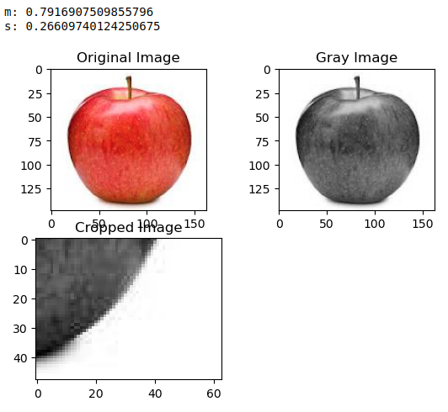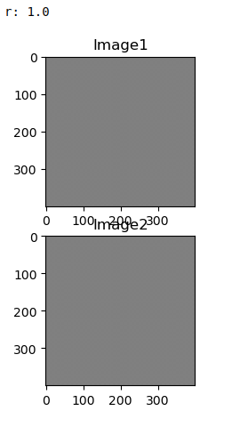

# PROGRAM 8

**Implementation of Image Smoothening Filters(Mean and Median filtering of an Image**

**CODE :**

import cv2

import numpy as np

import matplotlib.pyplot as plt

from scipy.ndimage import convolve from scipy.ndimage import median_filter

# Read the image

I = cv2.imread('C:/Users/anuam/OneDrive/Desktop/neuron.jpg')

K = cv2.cvtColor(I, cv2.COLOR_BGR2GRAY)

# Add salt and pepper noise

J = cv2.randu(K.copy(), 0, 255)

noise = np.random.choice([0, 255], K.shape, p=[0.95, 0.05]) J[noise == 255] = 255

J[noise == 0] = 0

# Apply median filters

f = median_filter(J, size=(3, 3))

f1 = median_filter(J, size=(10, 10))

# Display results plt.figure(figsize=(12, 8))

plt.subplot(3, 2, 1)

plt.imshow(cv2.cvtColor(I, cv2.COLOR_BGR2RGB)) plt.title('Original Image')

plt.axis('off')

plt.subplot(3, 2, 2) plt.imshow(K, cmap='gray') plt.title('Gray Image') plt.axis('off')

plt.subplot(3, 2, 3) plt.imshow(J, cmap='gray') plt.title('Noise added Image') plt.axis('off')

plt.subplot(3, 2, 4) plt.imshow(f, cmap='gray') plt.title('3x3 Median Filter') plt.axis('off')

plt.subplot(3, 2, 5) plt.imshow(f1, cmap='gray') plt.title('10x10 Median Filter') plt.axis('off')

# Mean Filter and Average Filter plt.figure(figsize=(10, 8))

i = cv2.imread('C:/Users/anuam/OneDrive/Desktop/neuron.jpg') g = cv2.cvtColor(i, cv2.COLOR_BGR2GRAY)

# 3x3 Average filter

g1 = np.ones((3, 3)) / 9.0 b1 = convolve(g, g1)

plt.subplot(2, 2, 1)

plt.imshow(cv2.cvtColor(i, cv2.COLOR_BGR2RGB)) plt.title('Original Image')

plt.axis('off')

plt.subplot(2, 2, 2) plt.imshow(g, cmap='gray') plt.title('Gray Image') plt.axis('off')

plt.subplot(2, 2, 3) plt.imshow(b1, cmap='gray') plt.title('3x3 Average Filter') plt.axis('off')

# 10x10 Average filter

g2 = np.ones((10, 10)) / 100.0 b2 = convolve(g, g2)

plt.subplot(2, 2, 4) plt.imshow(b2, cmap='gray') plt.title('10x10 Average Filter') plt.axis('off')

# Implementation of filter using Convolution plt.figure(figsize=(10, 8))

I = cv2.imread('C:/Users/anuam/OneDrive/Desktop/earcell.jpg', cv2.IMREAD_GRAYSCALE) plt.subplot(2, 2, 1)

plt.imshow(I, cmap='gray') plt.title('Original Image') plt.axis('off')

# Convolution with filter a

a = np.array([[0.001, 0.001, 0.001], [0.001, 0.001, 0.001], [0.001, 0.001, 0.001]])

R = convolve(I, a)

plt.subplot(2, 2, 2) plt.imshow(R, cmap='gray') plt.title('Filtered Image') plt.axis('off')

# Convolution with filter b

b = np.array([[0.005, 0.005, 0.005], [0.005, 0.005, 0.005], [0.005, 0.005, 0.005]])

R1 = convolve(I, b)

plt.subplot(2, 2, 3) plt.imshow(R1, cmap='gray') plt.title('Filtered Image 2') plt.axis('off')

plt.tight_layout() plt.show()

**OUTPUT :**

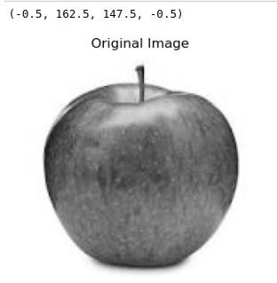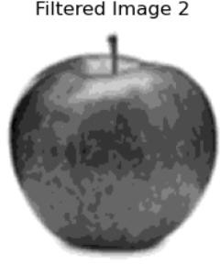

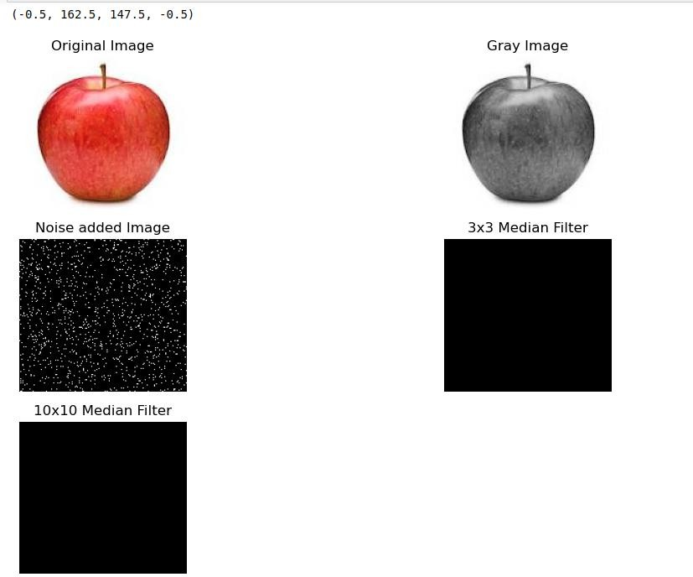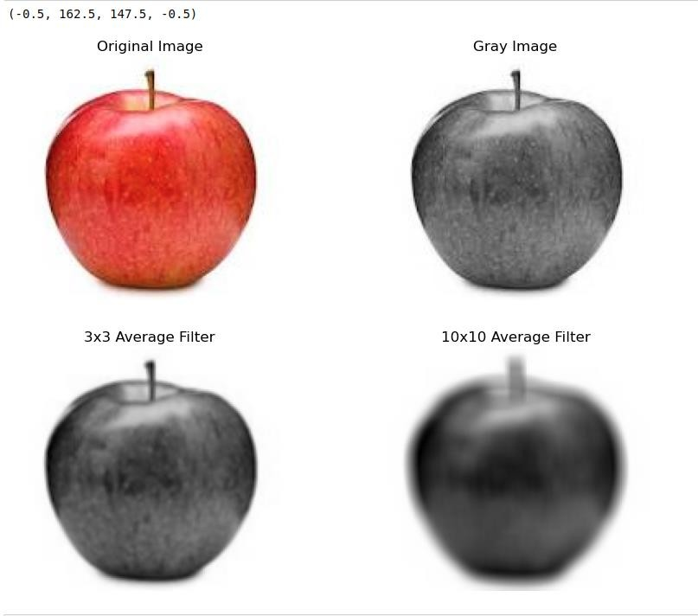

**PROGRAM 9**

**Implementation of image sharpening filters and Edge Detection using Gradient Filters.**

**CODE :**

import cv2

import numpy as np

import matplotlib.pyplot as plt

from scipy.ndimage import convolve from scipy import ndimage

import os

# Define function to read image safely def safe_imread(filename):

if not os.path.exists(filename):

raise FileNotFoundError(f"File '{filename}' not found.") return cv2.imread(filename)

# Define the Laplacian filter

def laplacian_filter(img, alpha=0.05):

kernel = np.array([[0, 1, 0], [1, -4 + alpha, 1], [0, 1, 0]]) return convolve(img, kernel)

# Main script try:

# Read the image

i = safe_imread('C:/Users/anuam/OneDrive/Desktop/neuron.jpg')

# Display the original image plt.subplot(4, 2, 1)

plt.imshow(cv2.cvtColor(i, cv2.COLOR_BGR2RGB)) plt.title('Original Image')

plt.axis('off')

# Convert to grayscale

g = cv2.cvtColor(i, cv2.COLOR_BGR2GRAY)

# Display the grayscale image plt.subplot(4, 2, 2) plt.imshow(g, cmap='gray') plt.title('Gray Image') plt.axis('off')

# Apply Laplacian filter

f = laplacian_filter(g, alpha=0.05)

# Display the Laplacian filtered image plt.subplot(4, 2, 3)

plt.imshow(f, cmap='gray') plt.title('Laplacian') plt.axis('off')

# Apply Sobel edge detection

s = cv2.Sobel(g, cv2.CV_64F, 1, 0, ksize=3) + cv2.Sobel(g, cv2.CV_64F, 0, 1, ksize=3)

# Display the Sobel edge detected image plt.subplot(4, 2, 4)

plt.imshow(s, cmap='gray') plt.title('Sobel') plt.axis('off')

# Apply Prewitt edge detection

kernelx = np.array([[1, 0, -1], [1, 0, -1], [1, 0, -1]])

kernely = np.array([[1, 1, 1], [0, 0, 0], [-1, -1, -1]]) px = convolve(g, kernelx)

py = convolve(g, kernely) p = np.sqrt(px*2 + py*2)

# Display the Prewitt edge detected image plt.subplot(4, 2, 5)

plt.imshow(p, cmap='gray') plt.title('Prewitt') plt.axis('off')

# Apply Roberts edge detection kernelx = np.array([[1, 0], [0, -1]])

kernely = np.array([[0, 1], [-1, 0]]) rx = convolve(g, kernelx)

ry = convolve(g, kernely) r = np.sqrt(rx*2 + ry*2)

# Display the Roberts edge detected image plt.subplot(4, 2, 6)

plt.imshow(r, cmap='gray') plt.title('Roberts') plt.axis('off')

# Apply Sobel edge detection (horizontal)

sobel_horizontal = cv2.Sobel(g, cv2.CV_64F, 1, 0, ksize=3)

# Display the Sobel horizontal edge detected image plt.subplot(4, 2, 7)

plt.imshow(sobel_horizontal, cmap='gray') plt.title('Sobel Horizontal')

plt.axis('off')

# Apply Sobel edge detection (vertical)

sobel_vertical = cv2.Sobel(g, cv2.CV_64F, 0, 1, ksize=3)

# Display the Sobel vertical edge detected image plt.subplot(4, 2, 8)

plt.imshow(sobel_vertical, cmap='gray') plt.title('Sobel Vertical')

plt.axis('off')

plt.tight_layout() plt.show()

except FileNotFoundError as e: print(e)

**OUTPUT :**

