

DEPARTMENT OF ARTIFICIAL INTELLIGENCE AND DATA SCIENCE

PRACTIAL RECORD BOOK

21AD61 : DIGITAL IMAGE PROCESSING

NAME : USN : YEAR/SEM : SECTION : BRANCH :

DEPARTMENT OF ARTIFICIAL INTELLIGENCE AND DATA SCIENCE



CERTIFICATE

This is to certify that Mr./Mrs. studying

in semester Branch has satisfactorily completed the course of

experiments in Laboratory for the

academic session 2023-2024 as prescribed by the Visvesvaraya Technological University.

Register Number of the Candidate:

Signature of the Staff Incharge Signature of HOD Date: Date:
Sl. No | Program / Exercise
1. | Implementation of Relationships between Pixels Neighbour of 4,8 and Diagonal point.
2. | (a).Display color Image, find its complement and convert to gray scale. (b).Simulation and Display of an Image, Negative of an Image(Binary & Gray Scale.
3. | (a).Implementation of Transformations of an Image i)Scaling & Rotation. (b).Display the color image and its Resized images by different methods.
4. | Contrast stretching of a low contrast image, Histogram, and Histogram Equalization.
5. | Display of bit plane of an image.
6. | Display of FTT(1D, 2D) of an image.
7. | Computation of mean, Standard Deviation, Correlation coefficient of the given Image.
8. | Implementation of Image Smoothening Filters(Mean and Median filtering of an Image.
9. | Implementation of image sharpening filters and Edge Detection using Gradient Filters

INDEX SHEET

SL.N O | Programs | Page no | Date of Execution | Staff Signature
1. | mplementation of Relationships between Pixels Neighbour of 4,8 and Diagonal point. |  | 02/11/2023
2 | (a).Display color Image, find its complement and convert to gray scale.  (b).Simulation and Display of an Image, Negative of an Image(Binary & Gray Scale. |  | 07/11/2023
3. | (a).Implementation of Transformations of an Image  i)Scaling & Rotation.  (b).Display the color image and its Resized images by different methods. |  | 21/11/2023
4. | Contrast stretching of a low contrast image, Histogram, and Histogram Equalization. |  | 28/11/2023
5. | Display of bit plane of an image. |  | 04/12/2023
6. | Display of FTT(1D, 2D) of an image. |  | 12/12/2023
7. | Computation of mean, Standard Deviation, Correlation coefficient of the given Image. |  | 19/12/2023
8. | Implementation of Image Smoothening Filters(Mean and Median filtering of an  Image. |  | 26/12/2023
9. | Implementation of image sharpening filters and Edge Detection using Gradient Filters. |  | 16/01/2024

DIGITAL IMAGE PROCESSING AND COMPUTER VISION LAB PROGRAMS

PROGRAM 1

Implementation of Relationships between Pixels Neighbour of 4,8 and Diagonal point CODE :
import numpy as np

# Create a sample matrix (using a magic square for demonstration) a = np.array([[17, 24, 1, 8, 15],
[23, 5, 7, 14, 16],
[ 4, 6, 13, 20, 22],
[10, 12, 19, 21, 3],
[11, 18, 25, 2, 9]])

print("a =") print(a)

# Get the row and column input from the user
b = int(input("Enter the row < size of the Matrix: "))
c = int(input("Enter the column < size of matrix: ")) print("Element:", a[b, c])

# 4-Point Neighbours
N4 = [a[b+1, c] if b+1 < a.shape[0] else None, # Below a[b-1, c] if b-1 >= 0 else None, # Above
a[b, c+1] if c+1 < a.shape[1] else None, # Right a[b, c-1] if c-1 >= 0 else None] # Left

print("N4 =") print(N4)

# 8-Point Neighbours
N8 = [a[b+1, c] if b+1 < a.shape[0] else None, # Below a[b-1, c] if b-1 >= 0 else None, # Above
a[b, c+1] if c+1 < a.shape[1] else None, # Right a[b, c-1] if c-1 >= 0 else None, # Left
a[b+1, c+1] if b+1 < a.shape[0] and c+1 < a.shape[1] else None, # Below-Right a[b+1, c-1] if b+1 < a.shape[0] and c-1 >= 0 else None, # Below-Left
a[b-1, c-1] if b-1 >= 0 and c-1 >= 0 else None, # Above-Left
a[b-1, c+1] if b-1 >= 0 and c+1 < a.shape[1] else None] # Above-Right

print("N8 =") print(N8)
# Diagonal Neighbours
ND = [a[b+1, c+1] if b+1 < a.shape[0] and c+1 < a.shape[1] else None, # Below-Right a[b+1, c-1] if b+1 < a.shape[0] and c-1 >= 0 else None, # Below-Left
a[b-1, c-1] if b-1 >= 0 and c-1 >= 0 else None, # Above-Left
a[b-1, c+1] if b-1 >= 0 and c+1 < a.shape[1] else None] # Above-Right

print("ND =") print(ND)

OUTPUT :

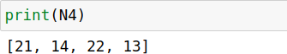
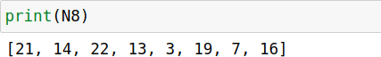

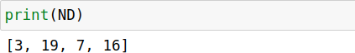

PROGRAM 2 (a)

Display color Image, find its complement and convert to gray scale CODE :
import cv2
import numpy as np
import matplotlib.pyplot as plt
# Read the color image
I = cv2.imread('C:/Users/anuam/Downloads/apple.jpg')

# Convert BGR to RGB (OpenCV reads images in BGR format) I_rgb = cv2.cvtColor(I, cv2.COLOR_BGR2RGB)

# Plot original color image plt.subplot(2, 2, 1) plt.imshow(I_rgb) plt.title('Color Image') plt.axis('off')

# Find complement of color image c = cv2.bitwise_not(I_rgb) plt.subplot(2, 2, 2)
plt.imshow(c)
plt.title('Complement of color Image') plt.axis('off')

# Convert color image to grayscale
r = cv2.cvtColor(I_rgb, cv2.COLOR_RGB2GRAY) plt.subplot(2, 2, 3)
plt.imshow(r, cmap='gray') plt.title('Gray scale of color Image') plt.axis('off')

# Find complement of grayscale image b = cv2.bitwise_not(r)
plt.subplot(2, 2, 4) plt.imshow(b, cmap='gray')
plt.title('Complement of Gray Image') plt.axis('off')

# Simulation of an Image (Arithmetic & Logic Operation)
a = np.ones((40, 40), dtype=np.uint8)
b = np.zeros((40, 40), dtype=np.uint8)
c = np.hstack((a, b))
d = np.hstack((b, a))
e = np.vstack((c, d))
A = 10 * (c + d) M = c * d S = np.abs(c - d) D = c / 4 plt.figure()
plt.subplot(3, 2, 1) plt.imshow(c, cmap='gray') plt.subplot(3, 2, 2) plt.imshow(d, cmap='gray') plt.subplot(3, 2, 3) plt.imshow(A, cmap='gray') plt.subplot(3, 2, 4) plt.imshow(M, cmap='gray') plt.subplot(3, 2, 5) plt.imshow(S, cmap='gray') plt.subplot(3, 2, 6) plt.imshow(D, cmap='gray') plt.show()
OUTPUT :

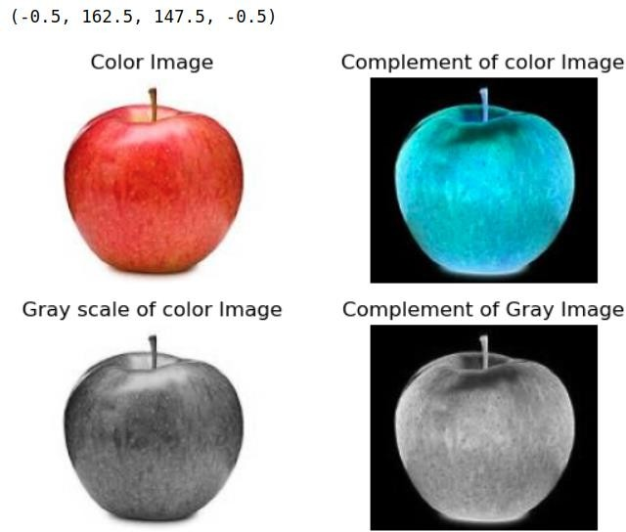

PROGRAM 2(b)
Simulation and Display of an Image, Negative of an Image(Binary & Gray Scale

CODE :

import cv2
import matplotlib.pyplot as plt

# Read the image
i = cv2.imread('C:/Users/anuam/Downloads/apple.jpg')

# Convert BGR to RGB (OpenCV reads images in BGR format) i = cv2.cvtColor(i, cv2.COLOR_BGR2RGB)

# Plot original image plt.subplot(3, 2, 1) plt.imshow(i) plt.title('Original Image') plt.axis('off')

# Red Component r = i[:, :, 0]
plt.subplot(3, 2, 2) plt.imshow(r, cmap='gray')

# Displaying in grayscale plt.title('Red Component') plt.axis('off')
# Green Component g = i[:, :, 1]
plt.subplot(3, 2, 3) plt.imshow(g, cmap='gray')
# Displaying in grayscale plt.title('Green Component') plt.axis('off')
# Blue Component b = i[:, :, 2]
plt.subplot(3, 2, 4) plt.imshow(b, cmap='gray')

# Displaying in grayscale plt.title('Blue Component') plt.axis('off')

# Convert to grayscale
rg = cv2.cvtColor(i, cv2.COLOR_RGB2GRAY) plt.subplot(3, 2, 5)
plt.imshow(rg, cmap='gray') plt.title('Gray Image') plt.axis('off')

plt.tight_layout() plt.show()

OUTPUT :

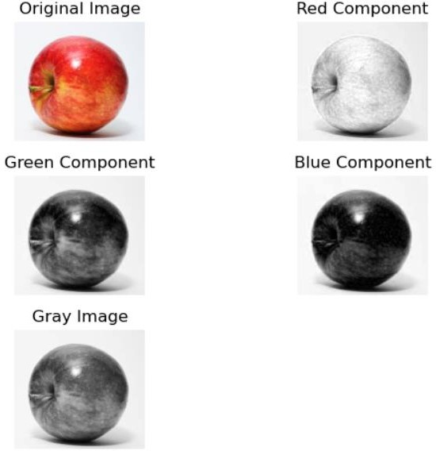

PROGRAM 3 (a)
Implementation of Transformations of an Image i)Scaling & Rotation

CODE :

import cv2
import numpy as np

# Load the image
image = cv2.imread('C:/Users/anuam/Downloads/apple.jpg')

# Define scaling factor
scaling_factor = 0.5 # You can change this value

# Perform scaling
scaled_image = cv2.resize(image, None, fx=scaling_factor, fy=scaling_factor, interpolation=cv2.INTER_LINEAR)

# Define rotation angle (in degrees) rotation_angle = 45 # You can change this value
# Perform rotation
height, width = scaled_image.shape[:2]
rotation_matrix = cv2.getRotationMatrix2D((width/2, height/2), rotation_angle, 1) rotated_image = cv2.warpAffine(scaled_image, rotation_matrix, (width, height))

# Display the original, scaled, and rotated images cv2.imshow('Original Image', image) cv2.imshow('Scaled Image', scaled_image) cv2.imshow('Rotated Image', rotated_image) cv2.waitKey(0)
cv2.destroyAllWindows()

OUTPUT :

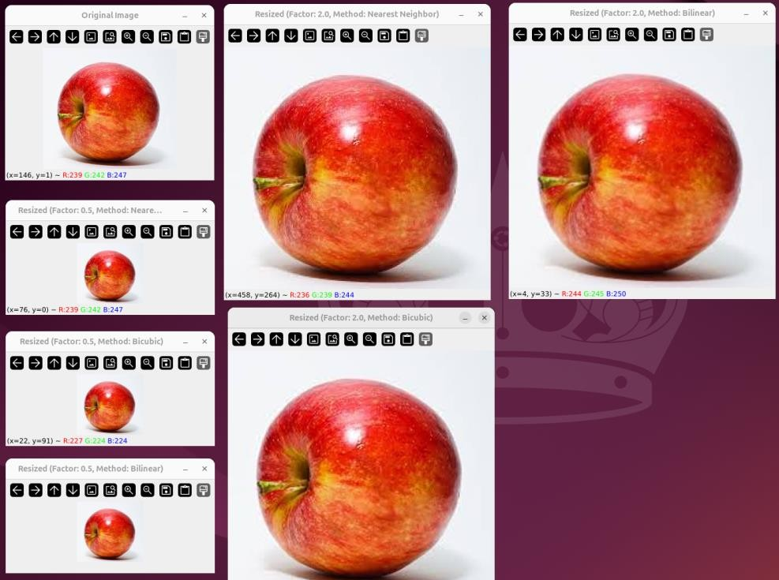

PROGRAM 3 (b)
Display the color image and its Resized images by different methods

CODE :

import cv2
import numpy as np

# Load the image
image = cv2.imread('input_image.jpg')

# Define scaling factors
scaling_factors = [0.5, 2.0] # You can add more scaling factors as needed

# Define interpolation methods
interpolation_methods = [cv2.INTER_NEAREST, cv2.INTER_LINEAR, cv2.INTER_CUBIC]
# Display the original image cv2.imshow('Original Image', image)

# Perform resizing with different methods for factor in scaling_factors:
for method in interpolation_methods: # Perform scaling
scaled_image = cv2.resize(image, None, fx=factor, fy=factor, interpolation=method)
# Display the resized image method_name = ""
if method == cv2.INTER_NEAREST: method_name = "Nearest Neighbor"
elif method == cv2.INTER_LINEAR: method_name = "Bilinear"
elif method == cv2.INTER_CUBIC: method_name = "Bicubic"
cv2.imshow(f'Resized (Factor: {factor}, Method: {method_name})', scaled_image) # Wait for a key press and close all windows
cv2.waitKey(0) cv2.destroyAllWindows()

OUTPUT :
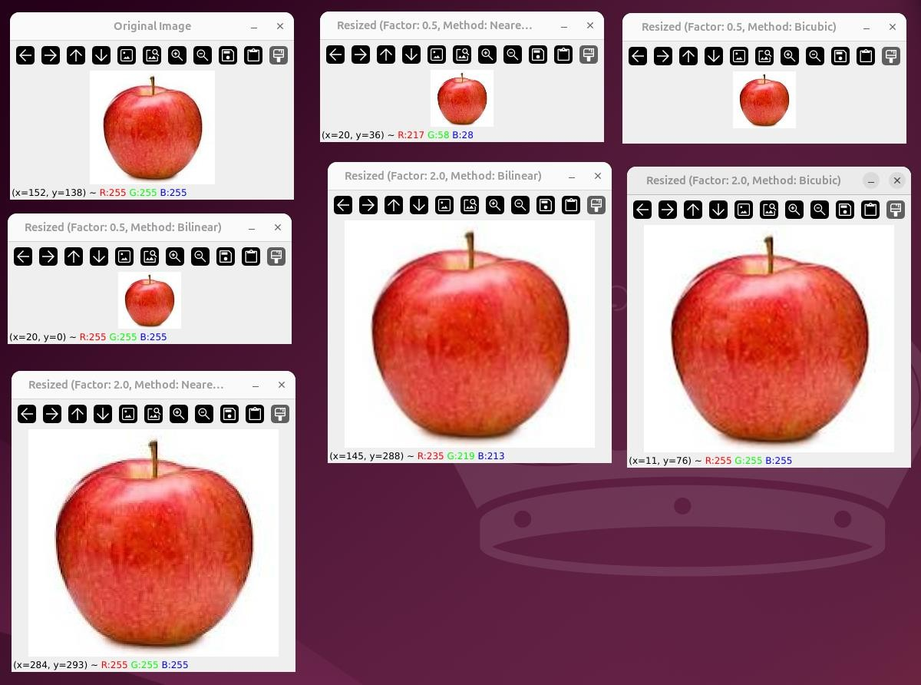

PROGRAM 4

Contrast stretching of a low contrast image, Histogram, and Histogram Equalization CODE :
import cv2
import numpy as np
import matplotlib.pyplot as plt

# Load the image
image = cv2.imread('input_image.jpg', cv2.IMREAD_GRAYSCALE)

# Apply contrast stretching min_intensity = np.min(image) max_intensity = np.max(image)
stretched_image = cv2.normalize(image, None, 0, 255, norm_type=cv2.NORM_MINMAX)

# Calculate and plot histograms
hist_original = cv2.calcHist([image], [0], None, [256], [0, 256])
hist_stretched = cv2.calcHist([stretched_image], [0], None, [256], [0, 256])

plt.figure(figsize=(10, 5))
plt.subplot(1, 2, 1) plt.plot(hist_original, color='b') plt.title('Original Image Histogram')

plt.subplot(1, 2, 2) plt.plot(hist_stretched, color='r') plt.title('Stretched Image Histogram')

plt.tight_layout() plt.show()

# Apply histogram equalization equalized_image = cv2.equalizeHist(image)
# Calculate and plot histograms for equalized image
hist_equalized = cv2.calcHist([equalized_image], [0], None, [256], [0, 256])

plt.figure(figsize=(10, 5))
plt.subplot(1, 2, 1) plt.imshow(stretched_image, cmap='gray') plt.title('Contrast Stretched Image')

plt.subplot(1, 2, 2) plt.imshow(equalized_image, cmap='gray') plt.title('Histogram Equalized Image')

plt.tight_layout() plt.show()

OUTPUT :
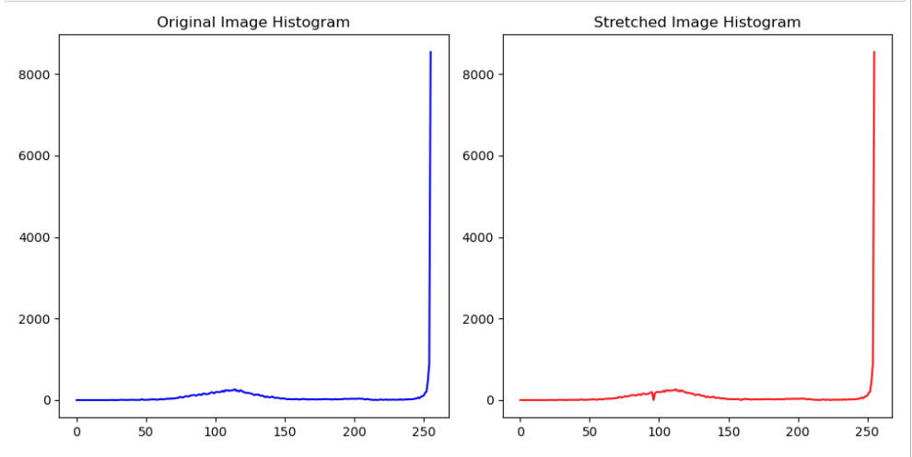
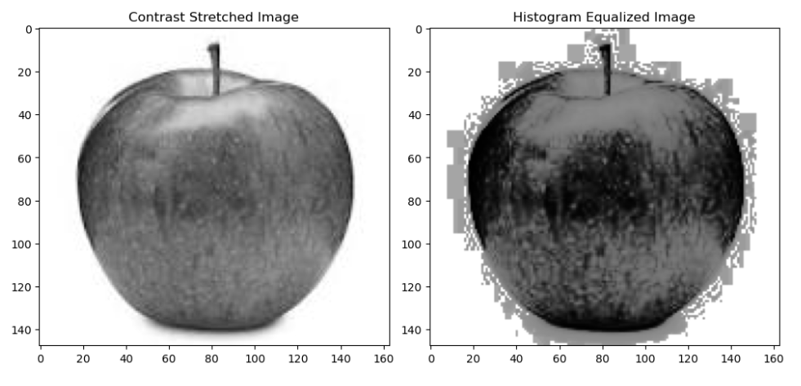

PROGRAM 5

Display of bit plane of an image. CODE :
import cv2
import numpy as np
import matplotlib.pyplot as plt
# Load the image in grayscale
image = cv2.imread('input_image.jpg', cv2.IMREAD_GRAYSCALE)
# Get the dimensions of the image height, width = image.shape
# Create an array to store the bit planes
bit_planes = np.zeros((8, height, width), dtype=np.uint8)

# Calculate the bit planes for i in range(8):
bit_planes[i] = (image >> i) & 1 # Extract ith bit plane

# Display the bit planes plt.figure(figsize=(12, 6)) for i in range(8):
plt.subplot(2, 4, i+1) plt.imshow(bit_planes[i], cmap='gray') plt.title(f'Bit Plane {i+1}') plt.axis('off')

plt.tight_layout() plt.show()

OUTPUT :
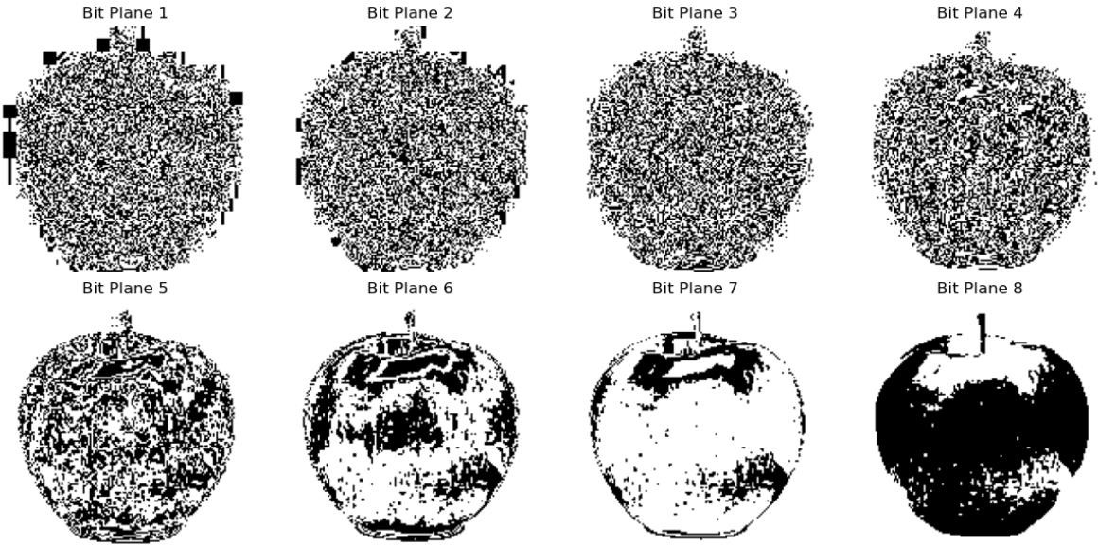

PROGRAM 6

Display of FTT(1D, 2D) of an image CODE :
import numpy as np
import matplotlib.pyplot as plt
from scipy.fftpack import fft2, fftshift
# Read the image and convert to double precision array l = plt.imread('cancercell.jpg').astype(float)
# Perform 2-D FFT f1 = np.fft.fft2(l)

# Shift zero frequency component to the center f2 = np.fft.fftshift(f1)

# Display magnitude of frequency spectrum plt.subplot(2, 2, 1)
plt.imshow(np.abs(f1)) plt.title('Frequency Spectrum')

# Display magnitude of centered spectrum plt.subplot(2, 2, 2)
plt.imshow(np.abs(f2))
plt.title('Centered Spectrum')

# Compute log(1 + abs(f2)) f3 = np.log(1 + np.abs(f2))

# Display log(1 + abs(f2)) plt.subplot(2, 2, 3) plt.imshow(f3) plt.title('log(1+abs(f2))')

# Perform 2-D FFT on f1 l_fft = fft2(f1)

# Take real part of the result l1 = np.real(l_fft)

# Display real part of 2-D FFT plt.subplot(2, 2, 4) plt.imshow(l1)
plt.title('2-D FFT') plt.show()

OUTPUT :

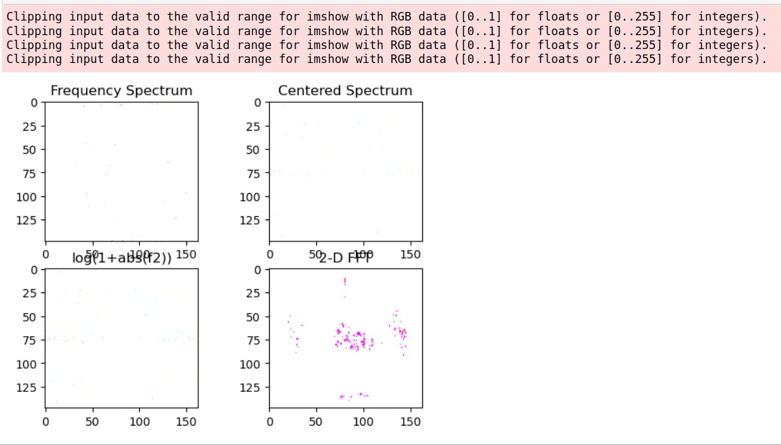

PROGRAM 7

Computation of mean, Standard Deviation, Correlation coefficient of the given Image CODE :
import numpy as np
import matplotlib.pyplot as plt
from skimage import io,.color
from scipy.stats import pearsonr

# Read the image
i = io.imread('cancercell.jpg')

# Display original image plt.subplot(2, 2, 1) plt.imshow(i) plt.title('Original Image')

# Convert to grayscale g = color.rgb2gray(i)

# Display grayscale image plt.subplot(2, 2, 2) plt.imshow(g, cmap='gray') plt.title('Gray Image')

# Crop the image
c = g[100:300, 100:300]

# Display cropped image plt.subplot(2, 2, 3) plt.imshow(c, cmap='gray') plt.title('Cropped Image')

# Calculate mean and standard deviation of the cropped image m = np.mean(c)
s = np.std(c) print('m:', m)
print('s:', s)

# Generate checkerboard patterns
checkerboard = np.indices((400, 400)).sum(axis=0) % 2

# Create checkerboard images with different thresholds k = checkerboard > 0.8
k1 = checkerboard > 0.5

# Display checkerboard images plt.figure()
plt.subplot(2, 1, 1) plt.imshow(k, cmap='gray') plt.title('Image1')

plt.subplot(2, 1, 2) plt.imshow(k1, cmap='gray') plt.title('Image2')

# Calculate Pearson correlation coefficient between the two images
r, _ = pearsonr(k.flatten(), k1.flatten())
print('r:', r)
plt.show()

OUTPUT :

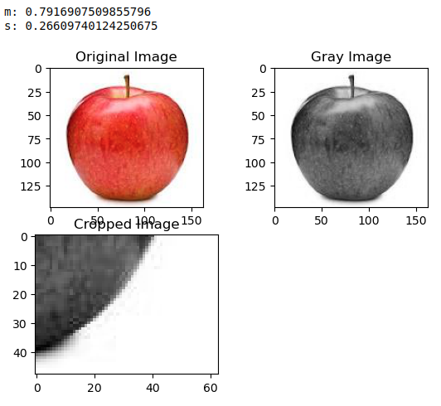
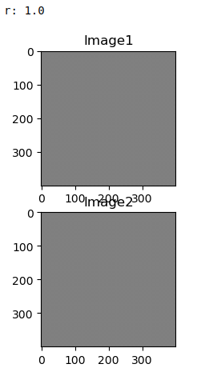

PROGRAM 8
Implementation of Image Smoothening Filters(Mean and Median filtering of an Image

CODE :

import cv2
import numpy as np
import matplotlib.pyplot as plt
from scipy.ndimage import convolve from scipy.ndimage import median_filter

# Read the image
I = cv2.imread('C:/Users/anuam/OneDrive/Desktop/neuron.jpg')
K = cv2.cvtColor(I, cv2.COLOR_BGR2GRAY)

# Add salt and pepper noise
J = cv2.randu(K.copy(), 0, 255)
noise = np.random.choice([0, 255], K.shape, p=[0.95, 0.05]) J[noise == 255] = 255
J[noise == 0] = 0

# Apply median filters
f = median_filter(J, size=(3, 3))
f1 = median_filter(J, size=(10, 10))

# Display results plt.figure(figsize=(12, 8))
plt.subplot(3, 2, 1)
plt.imshow(cv2.cvtColor(I, cv2.COLOR_BGR2RGB)) plt.title('Original Image')
plt.axis('off')
plt.subplot(3, 2, 2) plt.imshow(K, cmap='gray') plt.title('Gray Image') plt.axis('off')

plt.subplot(3, 2, 3) plt.imshow(J, cmap='gray') plt.title('Noise added Image') plt.axis('off')

plt.subplot(3, 2, 4) plt.imshow(f, cmap='gray') plt.title('3x3 Median Filter') plt.axis('off')

plt.subplot(3, 2, 5) plt.imshow(f1, cmap='gray') plt.title('10x10 Median Filter') plt.axis('off')

# Mean Filter and Average Filter plt.figure(figsize=(10, 8))

i = cv2.imread('C:/Users/anuam/OneDrive/Desktop/neuron.jpg') g = cv2.cvtColor(i, cv2.COLOR_BGR2GRAY)

# 3x3 Average filter
g1 = np.ones((3, 3)) / 9.0 b1 = convolve(g, g1)

plt.subplot(2, 2, 1)
plt.imshow(cv2.cvtColor(i, cv2.COLOR_BGR2RGB)) plt.title('Original Image')
plt.axis('off')

plt.subplot(2, 2, 2) plt.imshow(g, cmap='gray') plt.title('Gray Image') plt.axis('off')

plt.subplot(2, 2, 3) plt.imshow(b1, cmap='gray') plt.title('3x3 Average Filter') plt.axis('off')

# 10x10 Average filter
g2 = np.ones((10, 10)) / 100.0 b2 = convolve(g, g2)

plt.subplot(2, 2, 4) plt.imshow(b2, cmap='gray') plt.title('10x10 Average Filter') plt.axis('off')

# Implementation of filter using Convolution plt.figure(figsize=(10, 8))

I = cv2.imread('C:/Users/anuam/OneDrive/Desktop/earcell.jpg', cv2.IMREAD_GRAYSCALE) plt.subplot(2, 2, 1)
plt.imshow(I, cmap='gray') plt.title('Original Image') plt.axis('off')

# Convolution with filter a
a = np.array([[0.001, 0.001, 0.001], [0.001, 0.001, 0.001], [0.001, 0.001, 0.001]])
R = convolve(I, a)

plt.subplot(2, 2, 2) plt.imshow(R, cmap='gray') plt.title('Filtered Image') plt.axis('off')

# Convolution with filter b
b = np.array([[0.005, 0.005, 0.005], [0.005, 0.005, 0.005], [0.005, 0.005, 0.005]])
R1 = convolve(I, b)

plt.subplot(2, 2, 3) plt.imshow(R1, cmap='gray') plt.title('Filtered Image 2') plt.axis('off')

plt.tight_layout() plt.show()
OUTPUT :

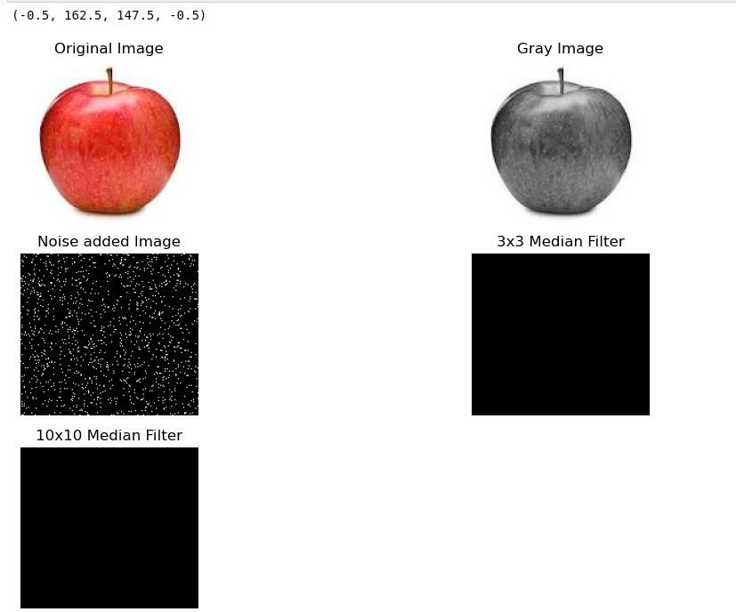
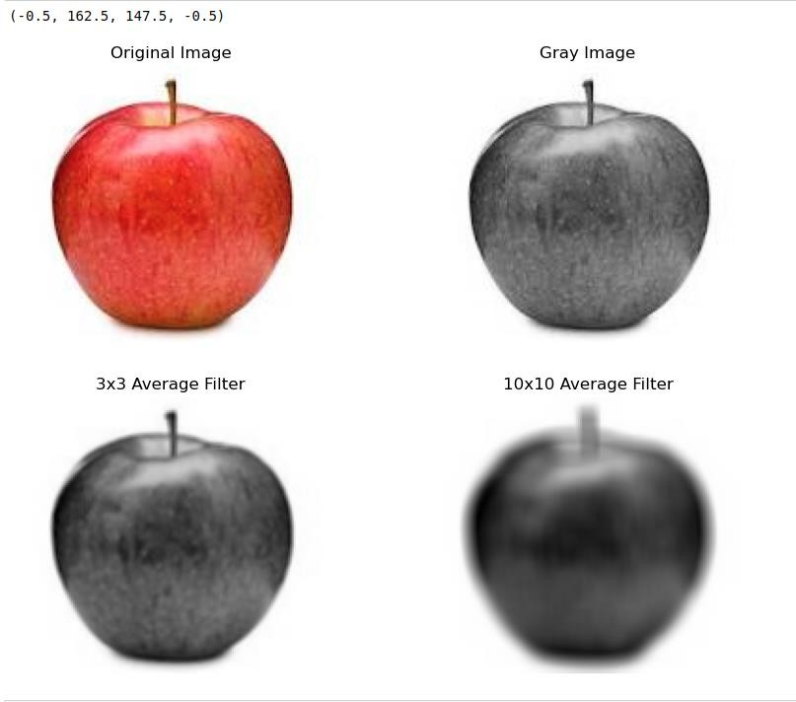
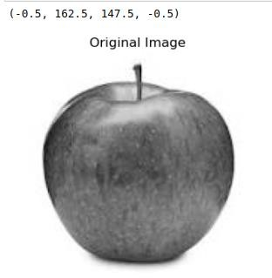
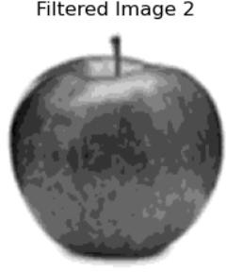
PROGRAM 9
Implementation of image sharpening filters and Edge Detection using Gradient Filters.

CODE :

import cv2
import numpy as np
import matplotlib.pyplot as plt
from scipy.ndimage import convolve from scipy import ndimage
import os

# Define function to read image safely def safe_imread(filename):
if not os.path.exists(filename):
raise FileNotFoundError(f"File '{filename}' not found.") return cv2.imread(filename)

# Define the Laplacian filter
def laplacian_filter(img, alpha=0.05):
kernel = np.array([[0, 1, 0], [1, -4 + alpha, 1], [0, 1, 0]]) return convolve(img, kernel)

# Main script try:
# Read the image
i = safe_imread('C:/Users/anuam/OneDrive/Desktop/neuron.jpg')

# Display the original image plt.subplot(4, 2, 1)
plt.imshow(cv2.cvtColor(i, cv2.COLOR_BGR2RGB)) plt.title('Original Image')
plt.axis('off')
# Convert to grayscale
g = cv2.cvtColor(i, cv2.COLOR_BGR2GRAY)
# Display the grayscale image plt.subplot(4, 2, 2) plt.imshow(g, cmap='gray') plt.title('Gray Image') plt.axis('off')
# Apply Laplacian filter

f = laplacian_filter(g, alpha=0.05)

# Display the Laplacian filtered image plt.subplot(4, 2, 3)
plt.imshow(f, cmap='gray') plt.title('Laplacian') plt.axis('off')

# Apply Sobel edge detection
s = cv2.Sobel(g, cv2.CV_64F, 1, 0, ksize=3) + cv2.Sobel(g, cv2.CV_64F, 0, 1, ksize=3)

# Display the Sobel edge detected image plt.subplot(4, 2, 4)
plt.imshow(s, cmap='gray') plt.title('Sobel') plt.axis('off')
# Apply Prewitt edge detection
kernelx = np.array([[1, 0, -1], [1, 0, -1], [1, 0, -1]])
kernely = np.array([[1, 1, 1], [0, 0, 0], [-1, -1, -1]]) px = convolve(g, kernelx)
py = convolve(g, kernely) p = np.sqrt(px*2 + py*2)

# Display the Prewitt edge detected image plt.subplot(4, 2, 5)
plt.imshow(p, cmap='gray') plt.title('Prewitt') plt.axis('off')

# Apply Roberts edge detection kernelx = np.array([[1, 0], [0, -1]])
kernely = np.array([[0, 1], [-1, 0]]) rx = convolve(g, kernelx)
ry = convolve(g, kernely) r = np.sqrt(rx*2 + ry*2)

# Display the Roberts edge detected image plt.subplot(4, 2, 6)
plt.imshow(r, cmap='gray') plt.title('Roberts') plt.axis('off')

# Apply Sobel edge detection (horizontal)
sobel_horizontal = cv2.Sobel(g, cv2.CV_64F, 1, 0, ksize=3)

# Display the Sobel horizontal edge detected image plt.subplot(4, 2, 7)
plt.imshow(sobel_horizontal, cmap='gray') plt.title('Sobel Horizontal')
plt.axis('off')

# Apply Sobel edge detection (vertical)
sobel_vertical = cv2.Sobel(g, cv2.CV_64F, 0, 1, ksize=3)

# Display the Sobel vertical edge detected image plt.subplot(4, 2, 8)
plt.imshow(sobel_vertical, cmap='gray') plt.title('Sobel Vertical')
plt.axis('off')

plt.tight_layout() plt.show()

except FileNotFoundError as e: print(e)

OUTPUT :

