Unit 10 – SocioTechnical Systems

## Topics covered

* **Background**
* **Complex Systems**
* **Systems engineering**
* **Systems procurement**
* **System development**
* **System operation**

## Systems

* Software engineering is not an isolated activity but is part of a broader systems engineering process
* Software systems are therefore not isolated systems but are essential components of broader systems that have a human, social or organizational purpose
* Example
  + Wilderness weather system is part of broader weather recording and forecasting systems
  + These include hardware and software, forecasting processes, system users, the organizations that depend on weather forecasts, etc.

## The sociotechnical systems stack

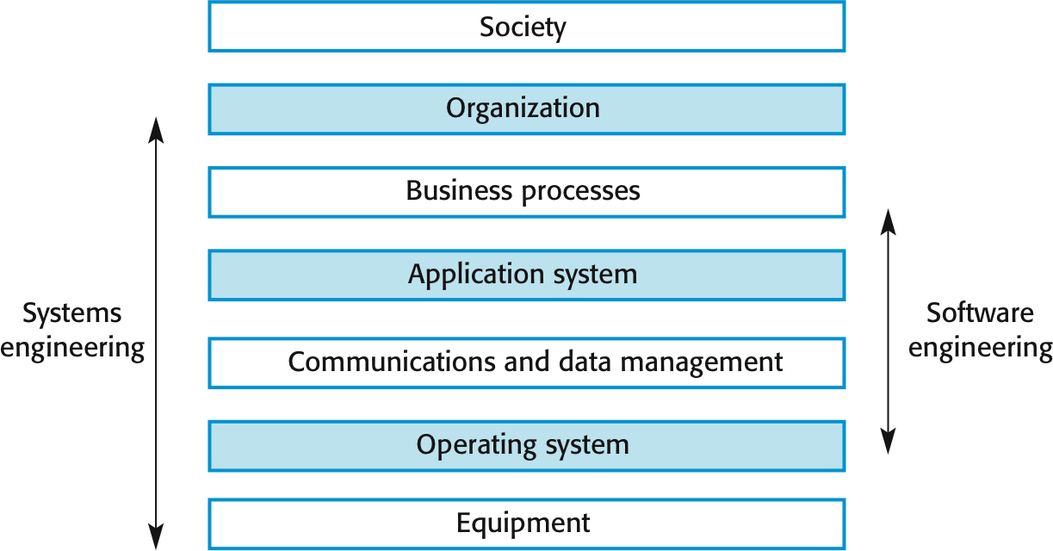

Unit 10 Sociotechnical Systems

## Layers in the STS stack

* Equipment
  + Hardware devices, some of which may be computers. Most devices will include an embedded system of some kind.
* Operating system
  + Provides a set of common facilities for higher levels in the system
* Communications and data management
  + Middleware that provides access to remote systems and databases
* Application systems
  + Specific functionality to meet some organization requirements

Chapter 10 Sociotechnical Systems

## Layers in the STS stack

* Business processes
  + A set of processes involving people and computer systems that support the activities of the business
* Organizations
  + Higher level strategic business activities that affect the operation of the system
* Society
  + Laws, regulation and culture that affect the operation of the system

Chapter 10 Sociotechnical Systems

## Complex systems

* A *system* is a purposeful collection of inter-related components working together to achieve some common objective
* A system may include software, mechanical, electrical and electronic hardware and be operated by people
* System components are dependent on other system components
* The properties and behaviour of system components are inter-mingled; this leads to complexity

# System categories

* Technical computer-based systems
  + Systems that include hardware and software but where the operators and operational processes are not normally considered to be part of the system. The system is not self- aware.
  + Example: A television set, a mobile phone, or a word processor used to write a book
* Socio-technical systems
  + Systems that include technical systems but also operational processes and people who use and interact with the technical system. Socio-technical systems are governed by organizational policies and rules.
  + Example: A publishing system to produce a book

## Socio-technical system characteristics

* Emergent properties
  + Properties of the system of a whole that depend on the system components and their relationships
* Non-deterministic
  + They do not always produce the same output when presented with the same input because the system’s behaviour is partially dependent on human operators
* Complex relationships with organizational objectives
  + The extent to which the system supports organizational objectives does not just depend on the system itself rather depends on rules/regulations etc. as well.

Qn. **Write the necessary characteristics of sociotechnical system for developing secure system.**

## Emergent properties

* Properties of the system as a whole rather than properties that can be derived from the properties of components of a system

Examples of emergent properties

|  |  |
| --- | --- |
| **Property** | **Description** |
| Volume | The volume of a system (the total space occupied) varies depending on how the component assemblies are arranged and connected. |
| Reliability | System reliability depends on component reliability but unexpected interactions can cause new types of failures and therefore affect the reliability of the system. |
| Security | The security of the system (its ability to resist attack) is a complex property that cannot be easily measured. Attacks may be devised that were not anticipated by the system designers and so may defeat built-in safeguards. |

|  |  |
| --- | --- |
| Repairability | This property reflects how easy it is to fix a problem with the system once it has been discovered. It depends on being able to diagnose the problem, access the components that are faulty, and modify or replace these components. |
| Usability | This property reflects how easy it is to use the system. It depends on the technical system components, its operators, and its operating environment. |

Chapter 10 Sociotechnical Systems 10

## Types of emergent property

* + Functional properties
    - These appear when all the parts of a system work together to achieve some objective.

For example, a bicycle has the functional property of being a transportation device once it has been assembled from its components.

* + Non-functional emergent properties
    - Examples are reliability, performance, safety, and security. These relate to the behaviour of the system in its operational environment. They are often critical for computer-based systems as failure to achieve some minimal defined level in these properties may make the system unusable.

## Reliability as an emergent property

* + Because of component inter-dependencies, faults can be propagated through the system
  + System failures often occur because of unforeseen( Unexpected) inter-relationships between components
  + It is practically impossible to anticipate all possible component relationships
  + Software reliability measures may give a false picture of the overall system reliability

## Influences on reliability

* + *Hardware reliability*
    - What is the probability of a hardware component failing and how long does it take to repair that component? *Software reliability*
    - How likely is it that a software component will produce an incorrect output.
  + *Operator reliability*
    - How likely is it that the operator of a system will make an error?
  + Failures are not independent and they propagate from one level to another

## Failure propagation

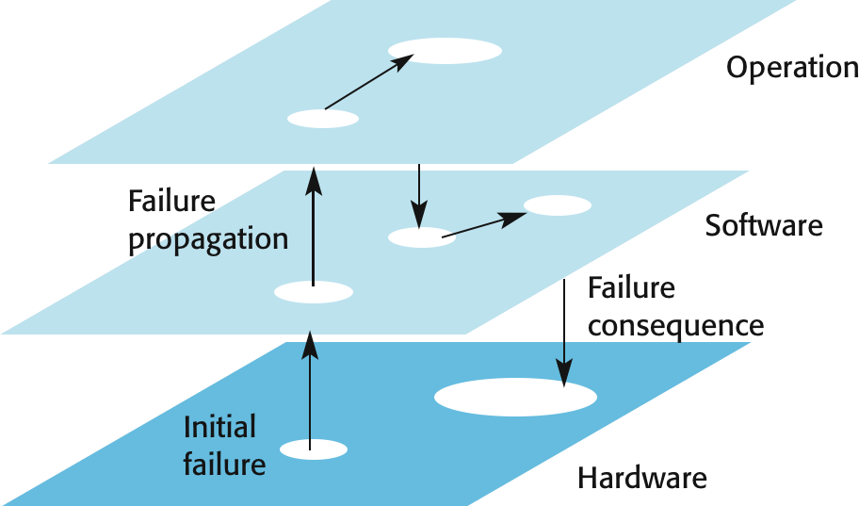

1. Non-determinism
   * A deterministic system is one where a given sequence of inputs will always produce the same sequence of outputs
   * Software systems are deterministic; systems that include humans are non-deterministic
     + A socio-technical system will not always produce the same sequence of outputs from the same input sequence
     + Human elements
       - People do not always behave in the same way
     + System changes
       - System behavior is unpredictable because of frequent changes to hardware, software and data

## Systems engineering

* + Procuring, specifying, designing, implementing, validating, deploying and maintaining socio-technical systems.
  + Concerned with the services provided by the system, constraints on its construction and operation and the ways in which it is used to fulfill its purpose or purposes

## Stages of systems engineering

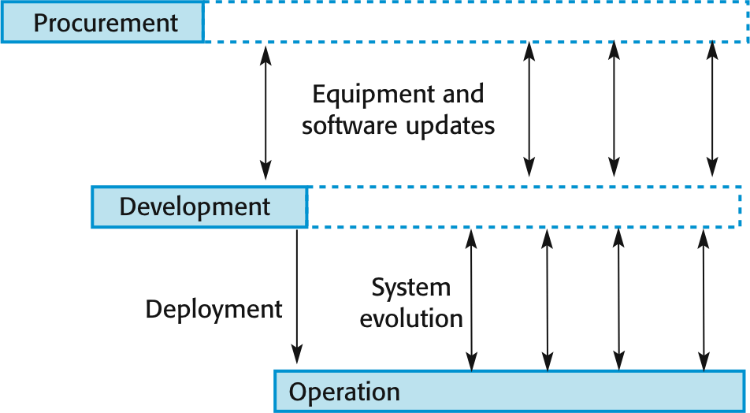

Systems engineering stages

* Procurement (acquisition)
  + The purpose of the system is established,
  + high-level system requirements are defined,
  + decisions are made on how functionality is distributed and
  + How the system components are purchased
* Development
  + The system is developed – requirements are defined in detail, the system is implemented and tested and operational processes are defined
* Operation
  + The system is deployed and put into use. Changes are made as new requirements emerge.

## Professional disciplines involved in systems engineering

System procurement

* + - Acquiring a system (or systems) to meet some identified organizational need.
    - Before procurement, decisions are made on:
      * Scope of the system
      * System budgets and timescales
      * High-level system requirements
    - Based on this information, decisions are made on whether to procure a system, the type of system and the potential system suppliers

# Decision drivers for procurements

* + - The state of other organizational systems
    - The need to comply(follow) with external regulations
    - External competition
    - Business re-organization
    - Available budget

## Procurement and development

* + - Some system specification and architectural design is usually necessary before procurement
      * You need a specification to let a contract for system development
      * The specification may allow you to buy a commercial off-the-shelf (COTS) system. Almost always cheaper than developing a system from scratch
    - Large complex systems usually consist of a mix of off the shelf and specially designed components. The procurement processes for these different types of component are usually different

## System procurement processes

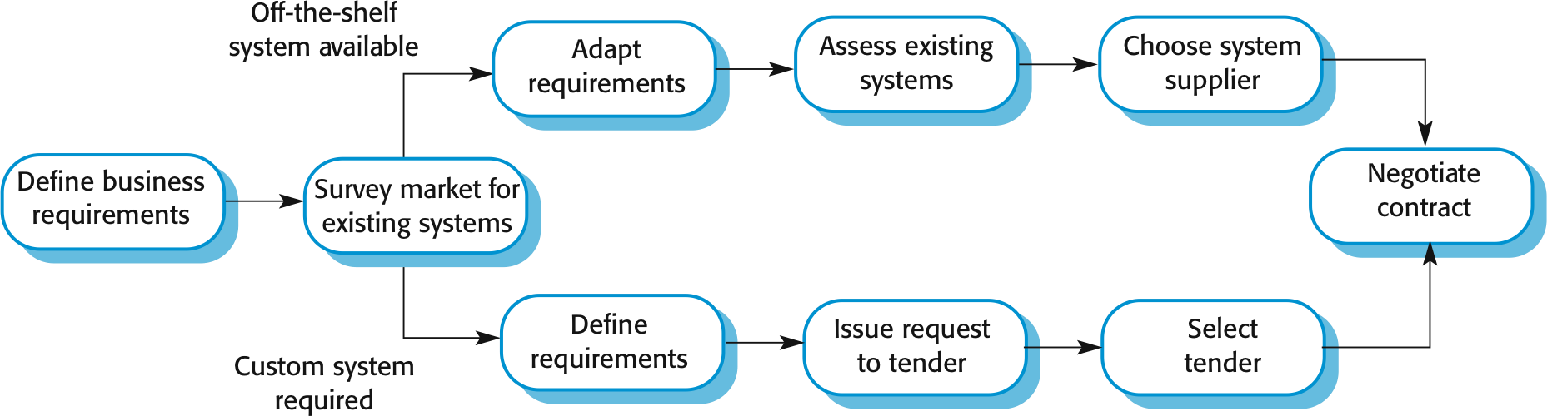

Chapter 10 Sociotechnical Systems 23

## Procurement issues

* + - Requirements may have to be modified to match the capabilities of off-the-shelf components
    - The requirements specification may be part of the contract for the development of the system
    - There is usually a contract negotiation period to agree changes after the contractor to build a system has been selected

## System development

* + - Usually follows a plan-driven approach because of the need for parallel development of different parts of the system
      * Little scope for iteration between phases because hardware changes are very expensive. Software may have to compensate for hardware problems.
    - Inevitably involves engineers from different disciplines who must work together
      * Much scope for misunderstanding here
      * As explained, different disciplines use a different vocabulary and much negotiation is required.

Engineers may have personal agendas to fulfil

## Systems development

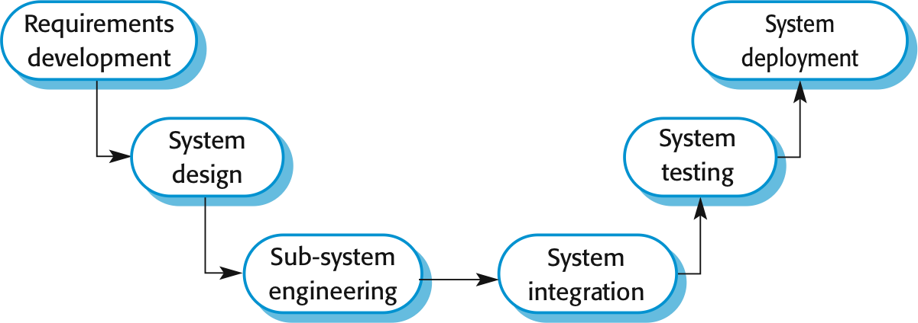

Chapter 10 Sociotechnical Systems 26

## System requirements definition

* + - Three types of requirement defined at this stage
      * Abstract functional requirements. System functions are defined in an abstract way;
      * System properties. Non-functional requirements for the system in general are defined;
      * Undesirable characteristics. Unacceptable system behaviour is specified.
    - Should also define overall organizational objectives for the system

## The system design process

* + - Partition requirements
      * Organize requirements into related groups
    - Identify sub-systems
      * Identify a set of sub-systems which collectively can meet the system requirements
    - Assign requirements to sub-systems
      * Causes particular problems when COTS are integrated
    - Specify sub-system functionality
    - Define sub-system interfaces
      * Critical activity for parallel sub-system development

## Requirements and design

* Requirements engineering and system design are inextricably linked
* Constraints posed by the system’s environment and other systems limit design choices so the actual design to be used may be a requirement
* Initial designmay be necessary to structure the requirements
* As you do design, you learn more about the requirements

## Requirements and design spiral

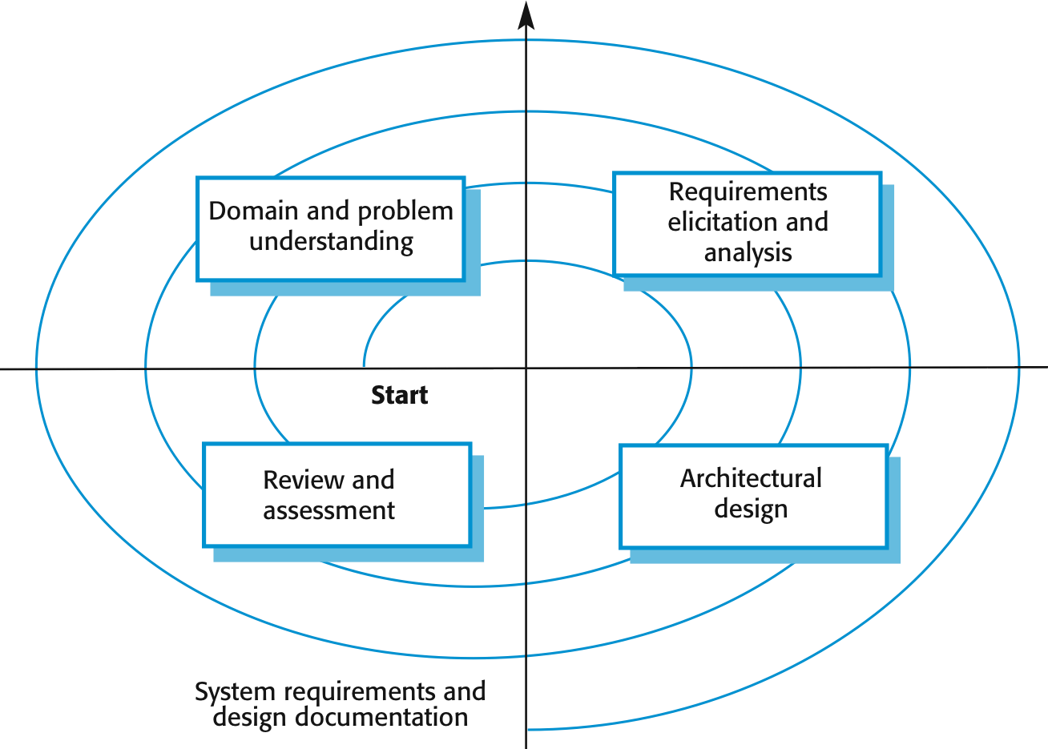

Chapter 10 Sociotechnical Systems 30

# Sub-system development

* + Typically parallel projects developing the hardware, software and communications
  + May involve some COTS (Commercial Off-the-Shelf) systems procurement
  + Lack of communication across implementation teams can cause problems
  + There may be a bureaucratic and slow mechanism for proposing system changes, which means that the development schedule may be extended because of the need for rework

# System integration

* + The process of putting hardware, software and people together to make a system
  + Should ideally be tackled incrementally so that subsystems are integrated one at a time.
  + The system is tested as it is integrated
  + Interface problems between sub-systems are usually found at this stage
  + May be problems with uncoordinated deliveries of system components

# System delivery and deployment

* + After completion, the system has to be installed in the customer’s environment
    - Environmental assumptions may be incorrect
    - May be human resistance to the introduction of a new system
    - System may have to coexist with alternative systems for some time
    - May be physical installation problems (e.g. cabling problems)
    - Data cleanup may be required
    - Operator training has to be identified

# Development and dependability

* + Decisions are made on dependability and security requirements and trade-offs made between costs, schedule, performance and dependability
  + Human errors may lead to the introduction of faults into the system
  + Testing and validation processes may be limited because of limited budgets
  + Problems in deployment mean there may be a mismatch between the system and its operational environment

# System operation

* + Operational processes are the processes involved in using the system for its defined purpose
  + For new systems, these processes may have to be designed and tested and operators trained in the use of the system
  + Operational processes should be flexible to allow operators to cope with problems and periods of fluctuating workload

# Human error

* + Human errors occur in operational processes that influence the overall dependability of the system.
  + Viewing human errors:
    - The person approach makes errors the responsibility of the individual and places the blame for error on the operator concerned. Actions to reduce error include threats of punishment, better training, more stringent procedures, etc.
    - The systems approach assumes that people are fallible and will make mistakes. The system is designed to detect these mistakes before they lead to system failure. When a failure occurs, the aim is not to blame an individual but to understand why the system defenses did not trap the error.

# System defenses

* + To improve security and dependability, designers should think about the checks for human error that should be included in a system
  + There should be multiple (redundant) barriers which should be different (diverse)
  + No single barrier can be perfect
    - There will be latent conditions in the system that may lead to failure
  + However, with multiple barriers, all have to fail for a system failure to occur

## System evolution

* + Large systems have a long lifetime. They must evolve to meet changing requirements.
  + Evolution is inherently costly
    - Changes must be analysed from a technical and business perspective
    - Sub-systems interact so unanticipated problems can arise
    - There is rarely a rationale for original design decisions
    - System structure is corrupted as changes are made to it
  + Existing systems which must be maintained are sometimes called legacy systems

# Evolution and dependability

* + Changes to a system are often a source of problems and vulnerabilities
  + Changes may be made without knowledge of previous design decisions made for security and dependability reasons
    - Built-in safeguards may stop working
  + New faults may be introduced or latent faults exposed by changes
    - These may not be discovered because complete system retesting is too expensive

Chapter 10 Sociotechnical Systems 39