# Puppies PDF file for Testing

Thanks to **Greenfield Puppies** for these cuties.

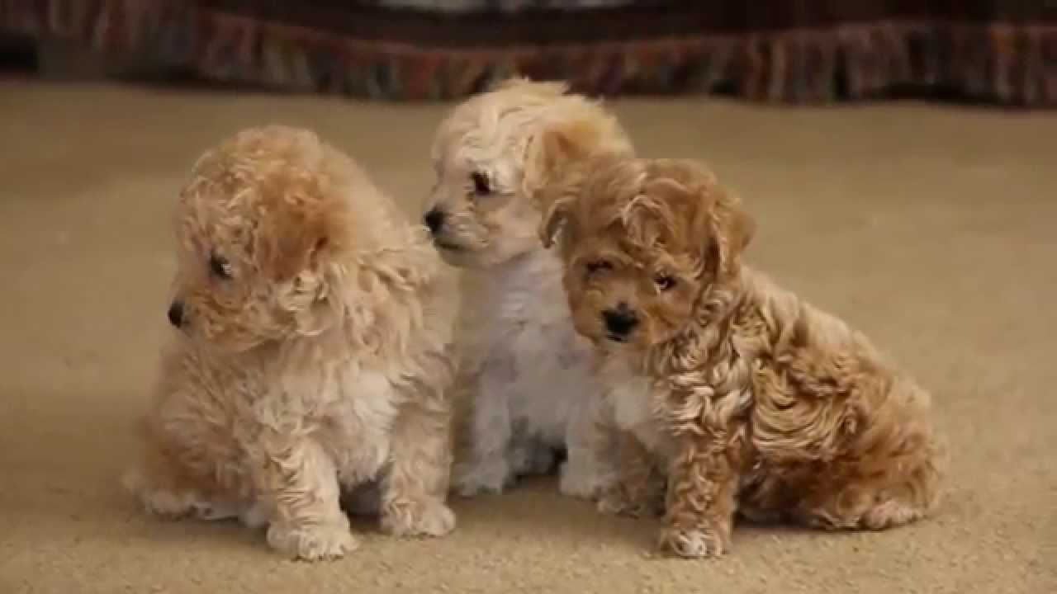

They are Bich-Poo puppies, by the way. That’s a mix of a Bichon Frise and a Poodle.

Greefield Puppies:

https://www.youtube.com/channel/UCQaLjISpp1LjO_CvJlXy_qA

Bich-Poo on Animaroo.com

https://www.animaroo.com/dog-breeds/bichon-poos.html