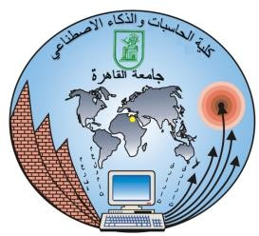

**Cairo University**

**Faculty of Computers and Artificial Intelligence**

**BCS241 Operating Systems**

2nd Semester – 2020 - Research Description

Cairo University, Faculty of Computers and Artificial Intelligence

**CS342**

Operating Systems (2)

2nd Semester 2020 Research

File Allocation

|  |  |  |
| --- | --- | --- |
| ID | Name | Email |
| 20170079 | Peter Malak Mikael | Pmalak14@gmail.com |

Contents

Team 1

Introduction .3

Document Purpose and audience 3

Software Purpose 3

Software Scope 3

Requirements 5

Functional Requirements 5

Non Functional Requirements 12

System Models 13

Use Case Model 13

Use Case Tables 14

Class Diagram 43

Traceability Matrix 44

# Introduction

# File system is used to define storage devices and control how data is stored and retrieved. From the system view, file system helps to arrange and distribute storage spaces by some allocation methods. Allocation refers to the methods of assigning secondary storage space (Hard disk) in files. The direct access gives us the flexibility to implement the files. In some cases, different files or many files are stored on the same disk. The main problem that occurs in the operating system is that how we allocate the spaces to these files so that the utilization of disk is efficient and the quick access to the file is possible. The allocation method is responsible for mapping a file’s logical blocks into the actual physical blocks on the secondary storage device There are three major methods of allocating disk space to files. Each method has its advantages and disadvantages.

# Contiguous allocation

# Indexed allocation

# Linked List allocation

**Operating Systems**

**Windows**

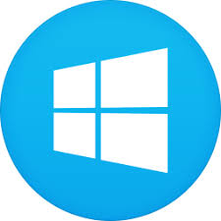Windows OS, computer OS developed by Microsoft to run personal computers. Featuring the primary GUI for IBM-compatible PCs, the Windows OS soon dominated the PC market. About 90% of PCs run some version of Windows. It is most generally used OS for desktop and laptop computers. It runs on x86-based computers, although previous versions ran on Intel Itanium CPUs. Windows also used to run on ARM CPUs, and Windows on ARM is making a comeback (see Windows 10 on ARM). Each version of Windows includes a GUI, with a desktop that allows users to view files and folders in windows. Microsoft Windows is meant for both home computing and professional purposes. The first version of Microsoft Windows was version 1.0, released in 1985, past versions of Windows home editions include Windows 3.0 released in 1990, Windows 3.1 released in 1992, Windows 95 released in 1995, Windows 98 released in 1998, Windows Me released in 2000, Windows XP released in 2001, and Windows Vista released in 2006. Windows 7, was released in 2009, an OS whose interface was similar to that of Vista but was met with enthusiasm for its noticeable speed improvement and its modest system requirements. Windows 8 in 2012 offered a start screen with applications appearing as tiles on a grid and the ability to synchronize settings so users could log on to another Windows 8 machine and use their preferred settings. In 2015 Microsoft released Windows 10, which came with Cortana, a digital personal assistant like Apple’s Siri, and the Web browser Microsoft Edge, which replaced Internet Explorer. Microsoft also announced that Windows 10 would be the last version of Windows, meaning that users would receive regular updates to the OS but that no more large-scale revisions would be done. Before the release of Microsoft Windows, Microsoft users were used to the single task command line operating system MS-DOS. Because Microsoft names most of its products with one word, it needed a word that best described its new GUI operating system. Microsoft chose "Windows" because of the multiple windows that allow different tasks and programs to run at the same time. You can’t trademark a typical name like "Windows," it's officially called as "Microsoft Windows".

**Unix**

UNIX development was started in 1969 at Bell Laboratories in New Jersey. Bell Laboratories was (1964–1968) involved on the launch of a multi-user, time-sharing operating system called Multics (Multiplexed Information and Computing System). Multics was a failure. In early 1969, Bell Labs withdrew from the Multics project. The primary version of Unix was written within the low-level PDP-7 assembler language. Later, a language called TMG was developed for the PDP-7 by R. M. McClure. Using TMG to develop a compiler, Ken Thompson instead ended up developing a compiler for a new high level language he called B, supported the sooner BCPL language developed by Martin Richard. When the PDP-11 computer found at Bell Labs, Dennis Ritchie built on B to make a replacement language called C. Unix components were later rewritten in C, and eventually with the kernel itself in 1973.Unix systems are characterized by a modular design that’s sometimes called the "Unix philosophy". In step with to this philosophy, the OS should provide a group of easy tools, each of which performs a limited, well-defined function. A unified filesystem (the Unix filesystem) and an inter-process communication mechanism called "pipes" function the most means of communication, and a shell scripting and command language (the Unix shell) is employed to mix the tools to perform complex workflows.

UNIX could be a multi-user, multi-tasking OS. Multiple users may have multiple tasks running simultaneously. This is often very different from PC operating systems like MS-DOS or MS-Windows (which allows multiple tasks to be carried out simultaneously but not multiple users). UNIX could be a machine independent OS. Not specific to simple one variety of element. Designed from the start to be independent of the PC hardware. The Unix OS could be a set of programs that act as a link between the OC and the user. The PC programs that allocate the system resources and coordinate all the small print of the PC's internals is named the OS or the kernel. Users communicate with the kernel through a program called the shell. The shell could be a command line interpreter; it translates commands entered by the user and converts them into a language that’s understood by the kernel. There are various Unix variants available within the market. Solaris Unix, AIX, HP Unix and BSD are some examples. Linux is additionally a flavor of Unix which is freely available.

**MS-DOS**

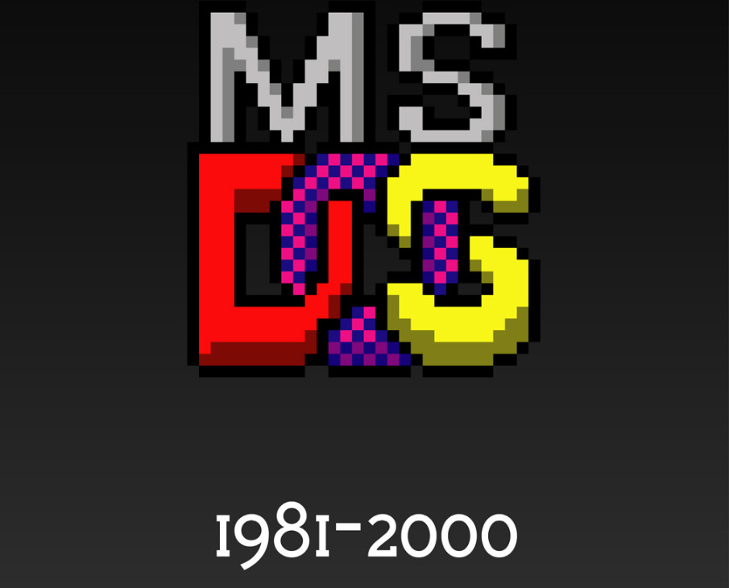MS-DOS (Microsoft Disk Operating System) was the Microsoft-marketed version of the first widely-installed operating system in personal computers. It was essentially the same operating system that Bill Gates's young company developed for IBM as Personal Computer - Disk Operating System (PC-DOS). Most users of either DOS system simply referred to their system as Disk Operating System. Like PC-DOS, MS-DOS was (and still is) a non-graphical line-oriented command-driven operating system, with a relatively simple interface but not overly "friendly" user interface. The first Microsoft Windows operating system was really an application that ran on top of the MS-DOS operating system. Today, Windows operating systems continue to support DOS (or a DOS-like user interface) for special purposes by emulating the operating system. During its lifetime, several competing products were released for the x86 platform, and MS-DOS went through eight versions, until development ceased in 2000. Initially, MS-DOS was targeted at Intel 8086 processors running on computer hardware using floppy disks to store and access not only the operating system, but application software and user data as well. Progressive version releases delivered support for other mass storage media in ever greater sizes and formats, along with added feature support for newer processors and rapidly evolving computer architectures. Ultimately, it was the key product in Microsoft's development from a programming language company to a diverse software development firm, providing the company with essential revenue and marketing resources. It was also the underlying basic operating system on which early versions of Windows ran as a GUI. It is a flexible operating system, and consumes negligible installation space. Technically, MS-DOS has been retired and Microsoft has made it clear there will be no more iterations or updates to the operating system. But MS-DOS still has a place in the computing landscape, even beyond its attraction to hobbyists and niche programmers. MS-DOS continues to be used around the world, and is responsible for many of the embedded applications that we all take for granted. MS-DOS may not be the vital operating system that it once was, but it still has merit and deserves the attention of serious programmers.

/////Online

MS-DOS (Microsoft Disk Operating System) was the Microsoft-marketed version of the primary widely-installed software package in personal computers. it absolutely was essentially the identical software package that Bill Gates's young company developed for IBM as notebook computer - Disk software package (PC-DOS). Most users of either DOS system simply spoken their system as Disk software package. Like PC-DOS, MS-DOS was (and still is) a non-graphical line-oriented command-driven software package, with a comparatively simple interface but not overly "friendly" interface. the primary Microsoft Windows software package was really an application that ran on top of the MS-DOS software package. Today, Windows software packages still support DOS (or a DOS-like user interface) for special purposes by emulating the operating system. During its lifetime, several competing products were released for the x86 platform, and MS-DOS went through eight versions, until development ceased in 2000. Initially, MS-DOS was targeted at Intel 8086 processors running on constituent using floppy disks to store and access not only the software package, but application software and user data yet. Progressive version releases delivered support for other mass storage media in ever greater sizes and formats, together with added feature support for newer processors and rapidly evolving computer architectures. Ultimately, it absolutely was the key product in Microsoft's development from a artificial language company to a various software development firm, providing the corporate with essential revenue and marketing resources. it absolutely was also the underlying basic software package on which early versions of Windows ran as a GUI. it's a versatile software package, and consumes negligible installation space. Technically, MS-DOS has been retired and Microsoft has made it clear there'll be no more iterations or updates to the software package. But MS-DOS still contains a place within the computing landscape, even beyond its attraction to hobbyists and niche programmers. MS-DOS continues to be used round the world, and is liable for many of the embedded applications that we all view granted. MS-DOS might not be the vital software package that it once was, but it still has merit and deserves the eye of great programmers.

**Techniques**

**Contiguous allocation**

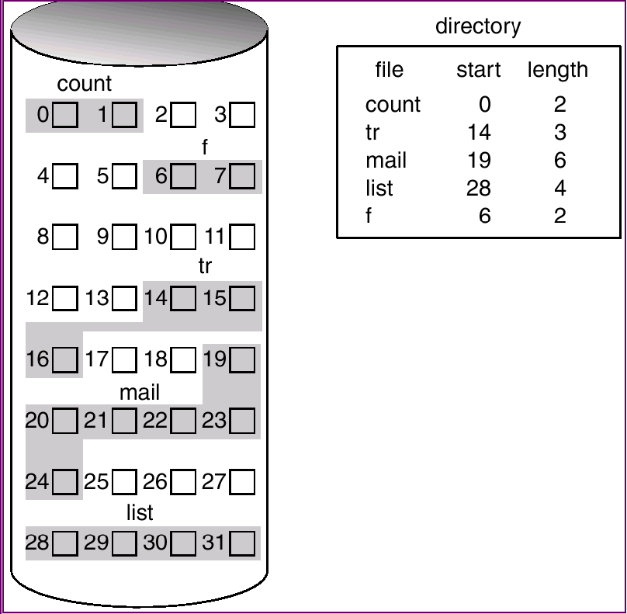We already know that the entire available disk space is divided into a set of blocks. In contiguous allocation, a file occupies contiguous blocks of memory. For example, if a file requires n blocks and is given a block b as the starting location, then the blocks assigned to the file will be: b, b+1, b+2,……b+n-1. This means that given the starting block address and the length of the file (in terms of blocks required), we can determine the blocks occupied by the file.

The directory entry for a file with contiguous allocation contains

1- Address of starting block

2- Length of the allocated portion.

**Advantages:**

1. In the contiguous allocation, sequential and direct access both are supported.
2. For the direct access, the starting address of the kth block is given and further blocks are obtained by b+K,
3. This is very fast and the number of seeks is minimal in the contiguous allocation method.

**Disadvantages:**

1. This method suffers from both internal and external fragmentation. This makes it inefficient in terms of memory utilization In terms of memory utilization, this method is inefficient.
2. Increasing file size is difficult because it depends on the availability of contiguous memory at a particular instance

**Systems using technique**

Microsoft is using contagious file allocation method in its operating system windows.

**Indexed allocation**

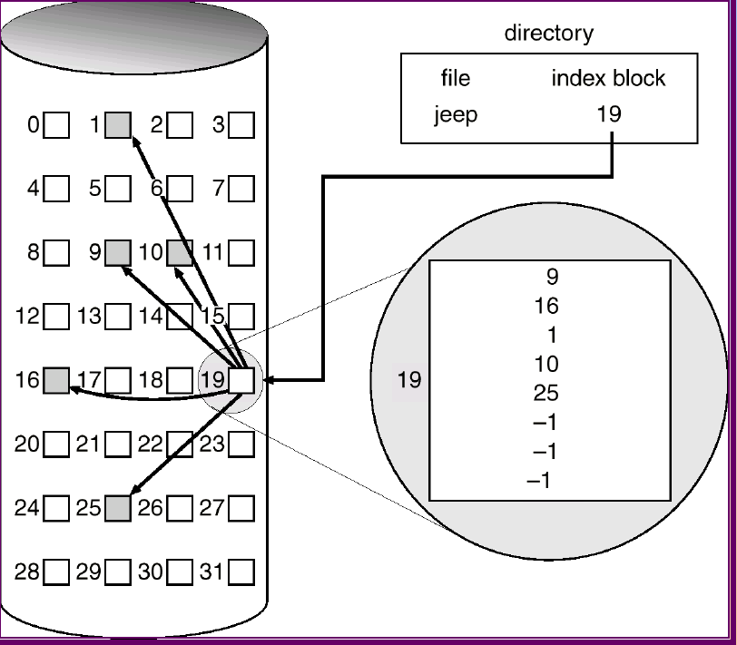In this scheme, a special block known as the index block contains the pointer to all the blocks occupied by a file. each file contains its index which is in the form of an array of disk block addresses. The ith entry of index block point to the ith block of the file. The address of the index block is maintained by the directory. When we create a file all pointer is set to nil. A block is obtained from the free space manager when the first ith block is written. When the index block is very small it is difficult to hold all the pointers for the large file. to deal with this issue a mechanism is available. Mechanism includes the following:

* Linked scheme
* Multilevel scheme
* Combined scheme

**Advantages:**

1. This supports direct access to the blocks occupied by the file and therefore provides fast access to the file blocks.
2. This scheme is free from the problem of external fragmentation.

**Disadvantages:**

1. The pointer head is relatively greater than the linked allocation of the file.
2. Indexed allocation suffers from the wasted space.
3. For the large size file, it is very difficult for single index block to hold all the pointers.
4. For very small files say files that expend only 2-3 blocks the indexed allocation would keep on the entire block for the pointers which is insufficient in terms of memory utilization.

**Systems using technique**

Unix is using Indexed file allocation method in its file management system Inode.

**Linked List allocation**

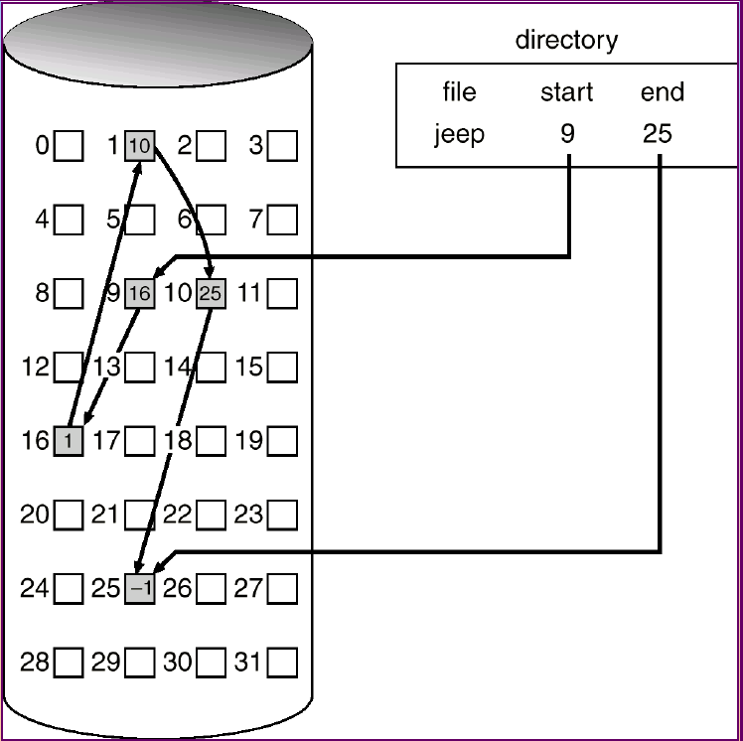The problems of contiguous allocation are solved in the linked allocation method. In this scheme, disk blocks are arranged in the linked list form which is not contiguous. The disk block is scattered in the disk. In this scheme, the directory entry contains the pointer of the first block and pointer of the last block. These pointers are not for the users. For example, a file of 6 blocks starts at block number 10 and end at the block 16. Each pointer contains the address of the next block. When we create a new file, we simply create a new entry with the linked allocation. Each directory contains the pointer to the first disk block of the file. when the pointer is null then it defines the empty file.

**Advantages:**

1. This is very flexible in terms of file size. File size can be increased easily since the system does not have to look for a contiguous chunk of memory.
2. This method free from external fragmentation this makes it better in terms of memory utilization.

**Disadvantages:**

1. Because the file blocks are distributed randomly on the disk, a large number of seeks are needed to access every block individually. This makes linked allocation slower.
2. It does not support random or direct access. We can’t directly access the blocks of a file. A block k of a file can be accessed by traversing k blocks sequentially (sequential access) from the starting block of the file via block pointers.
3. The pointer is extra overhead on the system due to the linked list.

**Systems using technique**

MS-Dos is using Indexed file allocation method in its file allocation table (FAT).

FAT is a method of keeping track of the contents of a hard drive used by early Microsoft operating systems that was first introduced in 1977.Its developed for hard drives that originally used 12 or 16 bits for each cluster entry into the file allocation table. It is used to manage files on hard drives and other computer systems. It is often also found on in flash memory, digital cameras and portable devices. It is used to store file information and extend the life of a hard drive. Most hard drives require a process known as seeking; this is the actual physical searching and positioning of the read/write head of the drive. The FAT file system was designed to reduce the amount of seeking and thus minimize the wear and tear on the hard disc.