Material Culture Networks in Tonto Basin

Network analysis has a strong foundation in Southwest archaeology, yet the combination of multiple types of artifacts in one analysis–multilayer network analysis–has not been formally applied except within a single artifact type. Many studies consider material culture holistically, yet network analysis has the advantage of focusing specifically on the relationships between entities (often communities) and how the structure of a network can benefit particular entities. This study takes architecture, ceramic, projectile point, and site location data from the Roosevelt Platform Mound Study and combines these data into a multilayer network analysis. This analysis provides a way to test the co-variance of these types of material culture with each other and with spatial variation. The results demonstrate a strong association between projectile points and spatial distance. Sites containing roomblock architecture are highly central in the ceramic network but have low centrality in the projectile point network. Overall, the ceramic and projectile point networks exhibit significant differences. This indicates that the social networks that created these patterns had different social mechanisms. One potential cause of these differences is gendered spheres of interaction with men exchanging projectile points and women exchanging ceramics.

Table of Contents

# Introduction

Network science has many applications for archaeologists. It can be particularly useful for breaking out of traditional spatial categories and examining data through new lenses (Feinman and Neitzel 2020; Holland-Lulewicz 2021). Multilayer network analysis combines multiple networks into one analytical framework (Kivelä et al. 2014). Social systems are complex webs of interrelations. There is too much involved to model the material culture of even a technologically simple society. But certainly analyzing more than one type of material culture provides a more complete understanding of the social dynamics involved in the networks of interaction we wish to understand. Yet, there are few examples of multilayer networks in archaeology (Giomi 2022; Upton 2019) and none I am aware of that extend beyond ceramics.

Network studies are particularly prominent in the Southwest and there are examples of network studies that consider multiple types of material culture. For example, Mills and colleagues (2013) used ceramics and obsidian to understand the transformation of large scale social networks. Peeples (2018) used ceramics and architecture to understand identity and social change in the Cibola region. This paper is an application of multilayer network analysis that seeks to further network research by examining multiple types of material culture in one framework. Given the frequent focus on single types of artifacts in network research, a primary question I seek to address is whether networks based on different types of material culture are positively correlated. This is an important question because archaeologists often make inferences based solely on ceramics or other types of material culture. Evidence regarding the ways material culture co-vary will help archaeologists direct future research. Furthermore, I also seek causal explanations for the co-variance, or lack thereof, for material culture in the case study I present here.

Tonto Basin holds great potential for archaeological research due to the large cultural resource management projects conducted in the region primarily in the 1980s-1990s (Ahlstrom et al. 1991; Ciolek-Torrello et al. 1994; Doelle et al. 1992; Rice 1998), as well as the large number of syntheses and other studies focusing on the area (e.g., Clark and Vint 2004; Dean 2000; Elson et al. 1995, 2000; Hill et al. 2015; Huntley et al. 2016; Lange and Germick 1992; Lyons 2003; Lyons and Lindsay 2006; Lyons and Clark 2012; Neuzil 2008; Oliver 2001; Stark et al. 1998; Watts 2013). This analysis uses data from the Roosevelt Platform Mounds Study (RPMS), the largest of these projects (Rice 1998), to examine basic architectural data, typed ceramics, and a recent projectile point analysis (Bischoff 2022). There are two null hypotheses tested in this analysis: (1) that the data is spatially correlated–meaning that sites nearest to each other will be most alike–and (2) that the architecture, ceramics, and projectile points will all be positively correlated–meaning that similar types of architecture, ceramics, and projectile points will be found at the same sites. In reality, I expected significant variation between these types of material culture. As will be demonstrated, the results indicate a positive correlation between projectile point similarity and spatial distance. Furthermore, ceramic and projectile point networks (hereafter point networks) exhibit significant differences. I posit that the differences in these networks are connected to the identities of the individuals creating the original social networks: particularly that of gender.

## Tonto Basin

Tonto Basin is located in east-central Arizona and features Tonto Creek flowing from the Mogollon Rim into the Salt River (figure 1). Parts of the region have been intensively studied, while certain time periods and much of the uplands have been less intensively sampled (see Clark and Caseldine 2021 for a recent overview). The basin was also conveniently located along regional travel routes, allowing major settlements–particularly those with platform mounds–to participate and benefit from this exchange (Caseldine 2022; Wood 2000:129–133). The junction of the Salt River and Tonto Creek now forms Roosevelt Lake since the damming of the confluence of the Salt River and Tonto Creek. It was the expansion of the dam that precipitated the RPMS and its related projects in the late 1980s-1990s. Some important regional differences may have differentiated sites along the Salt River and Tonto Creek arms of Roosevelt Lake (Lyons 2013; Simon and Gosser 2001) based on non-local ceramics and obsidian. All of the artifacts/data from the RPMS project are hosted at the Center for Archaeology and Society at Arizona State University, and the data in this study come exclusively from this project.

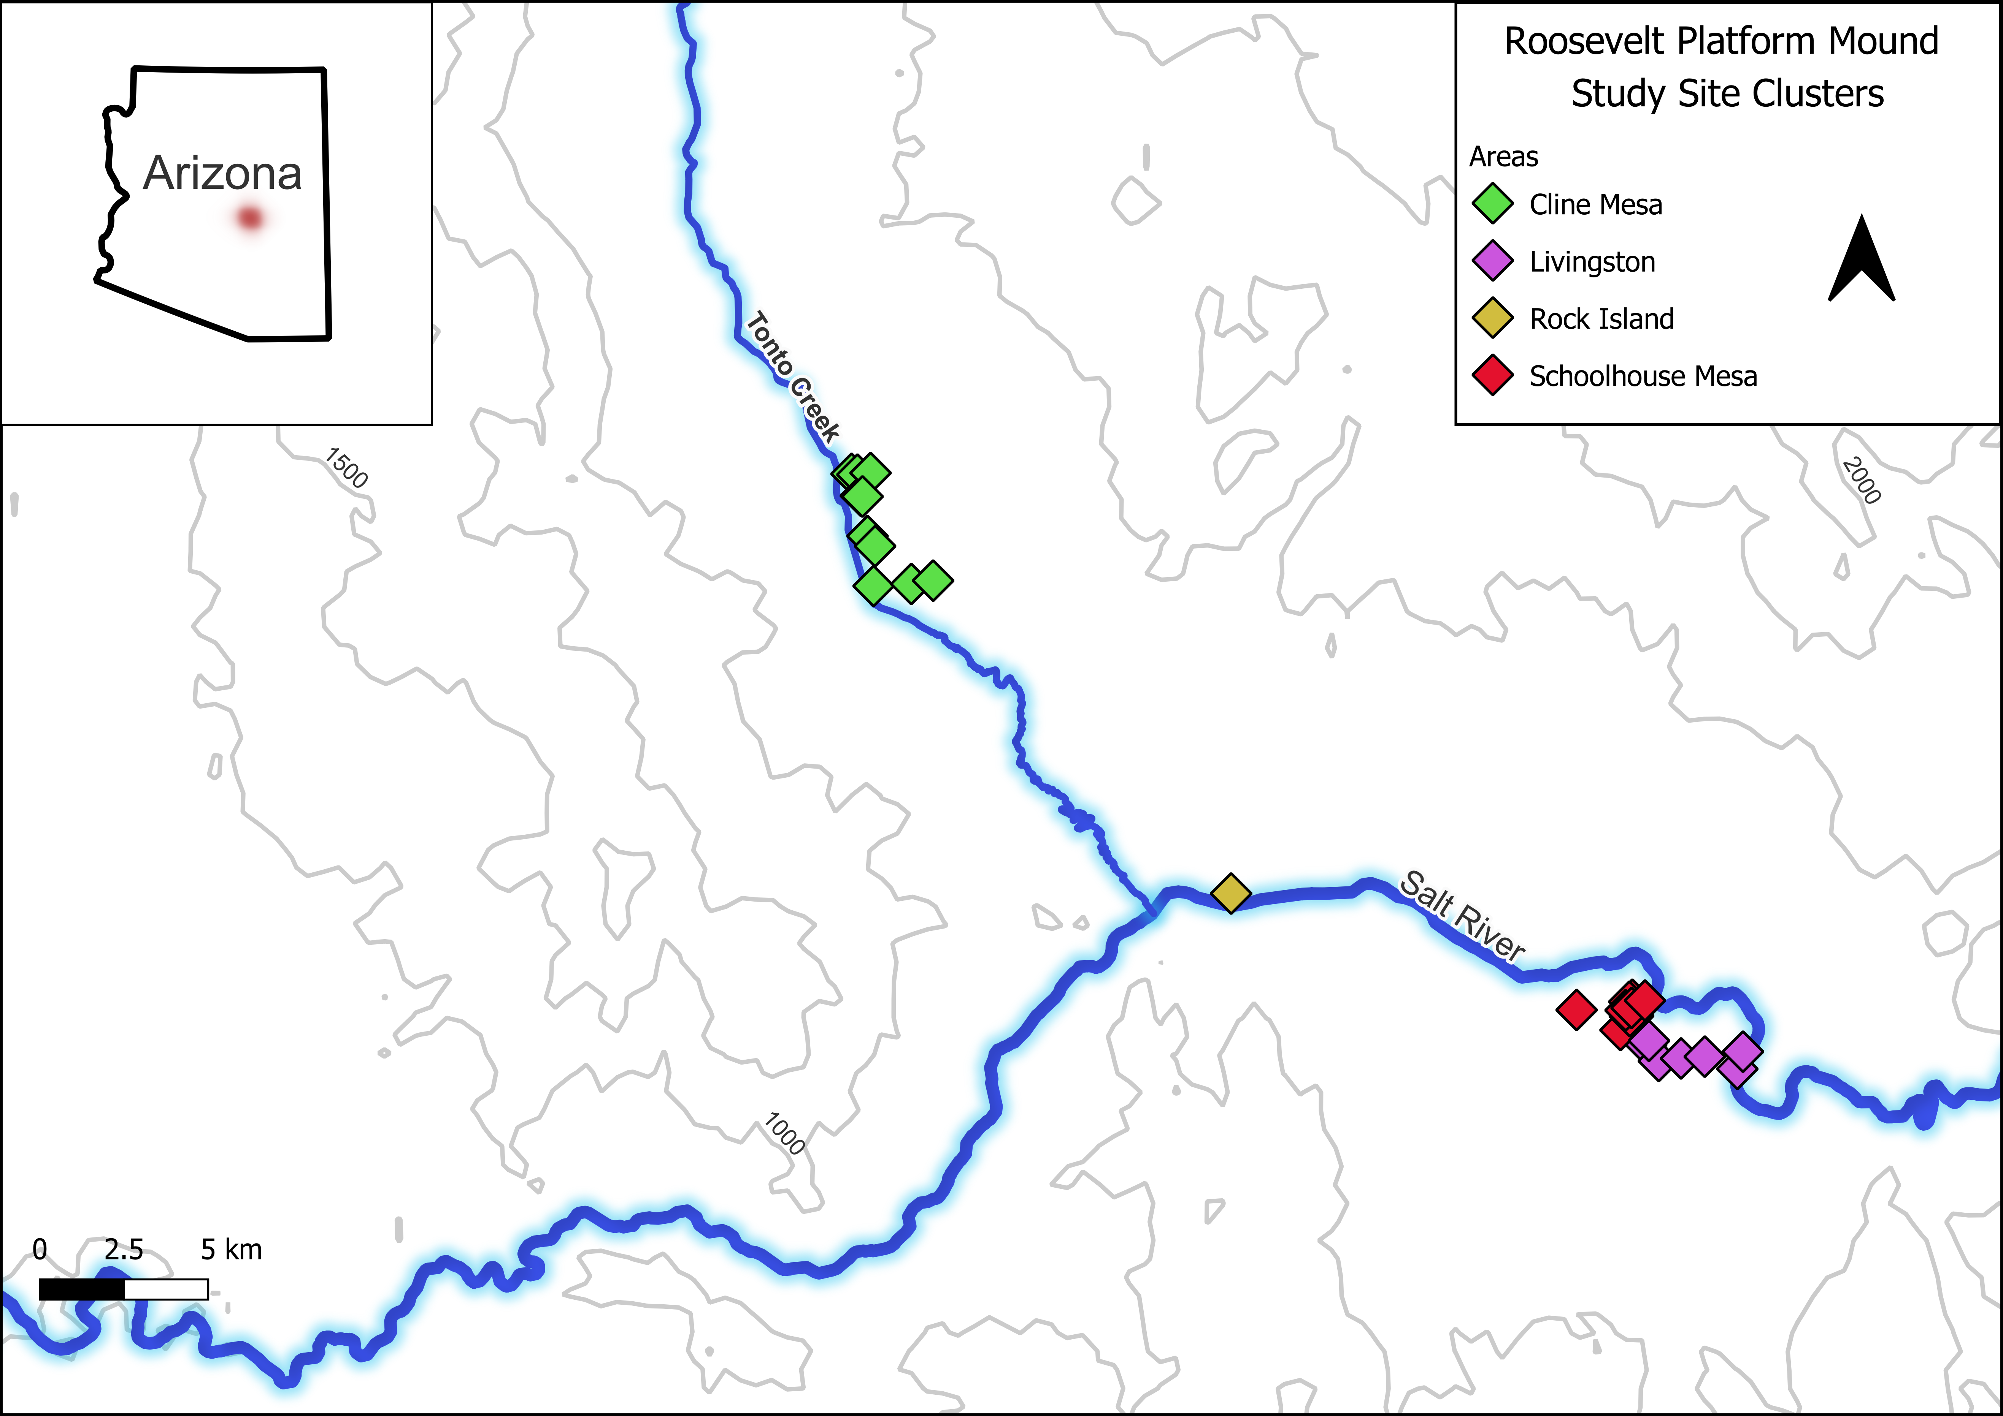

Figure 1: Map of archaeology sites from the Roosevelt Platform Mounds Study in Tonto Basin. Groups use the original assignments.

Tonto Basin was occupied, although likely not continuously, from the Archaic through the late Classic period. The height of occupation, particularly the sites excavated during the project, dates between AD 1275 and 1325, which corresponds to the Roosevelt Phase. The Roosevelt phase is notable for the appearance of Salado pottery and platform mounds–probably introduced from the Phoenix Basin (Elson 1996). Moderate occupation continued into the Gila phase (AD 1325-1450), which was characterized by population loss and aggregation into larger sites. This phase marks the end of recognizable occupation in the area until the historic period.

One aspect of Tonto Basin that has caught the attention of researchers is its location in a border zone between the Hohokam, Mogollon, and Ancestral Pueblo regions (e.g., Caseldine 2022; Clark 2001; Elson and Lindeman 1994; Hill et al. 2015; Huntley et al. 2016; Lyons and Clark 2012; Lyons 2013; Neuzil 2008; Wood 2000). Of particular note is the presence of masonry roomblock architecture and pottery uncharacteristic of the local Hohokam traditions, which has been interpreted as Kayenta immigration into Tonto Basin (Clark 2001; Lyons 2003; Lyons and Lindsay 2006; Stark et al. 1998). This migration into the Tonto Basinwas part of a larger migration from north to south and is associated with the origin of the Salado phenomenon. Salado pottery production was widespread across southern Arizona, but often the largest sources of production was centered at the location of a former Kayenta enclave (Hill et al. 2015; Huntley et al. 2016; Lyons and Clark 2012; Neuzil 2008). The connection between immigration and an important type of decorated pottery in the region suggests that sites with roomblocks may have higher centrality in ceramic networks. Having high centrality means they have more connections to other nodes (i.e., sites). The presence of migrant communities in Tonto Basin invites questions regarding the relationship between sites–particularly between migrant and local communities. A network approach is an ideal way to examine the relationships between sites. Evidence that projectile points move between sites (e.g., Watts 2013) indicates that this is also a productive line of analysis, and one that is less-commonly pursued compared to architecture and ceramics.

# Network Analysis

Network analysis is a flexible tool for analyzing many types of data (see Brughmans and Peeples 2023). The key element is that some way must be determined to tie each entity together. This analysis uses sites as nodes in the network and some type of similarity as a tie to connect each node. Each type of similarity depends on the type of data. Table 1 lists the 11 sites with sufficient data to include in this study with the types of architecture present, periods occupied, and total number of ceramics and complete projectile points found at each site. The lack of complete projectile points at some sites is the largest caveat in this study, but complete points were necessary for the type of projectile point analysis used. The periods, architecture types, and ceramic types were assigned during the RPMS project and can be found in the project reports (Rice 1998). This is not a random sample of Tonto Basin sites. It is merely a sample of convenience. Sampling can have a major impact on conclusions. In this case, I am not drawing conclusions based on a complete network or the existence of a random sample (though biases can still affect the results). Rather, I am interested in whether the types of material culture present in this study co-vary with each other and with space. These questions do not require a complete network.

## Defining Networks and Relations

Network approaches are best suited where the relationships between entities are of primary interest. In this case, the entities are defined as archaeology sites. The archaeology sites in turn represent a group of individuals who lived or visited the area of the site and left material remains behind. Ideally, studying social relations would be approached at the individual level, but rarely can archaeologists address archaeological data with that level of specificity. Watts (2013) used projectile points from Tonto Basin in just such a study. His analysis of flake scar patterning identified individual knappers, or at least clusters of knappers with similar knapping styles, and the distribution of their projectile points around Tonto Basin. He found strong connections between many parts of the eastern Tonto Basin. Unfortunately, this study will only attempt a site-level analysis. Watt’s study does, however, illustrate how relations can be defined between nodes in a network analysis. He used similarity networks where the points that had similar flaking styles were connected together. Similarity networks are a commonly used type of network in archaeology (e.g., Birch and Hart 2018; Borck et al. 2015; Cochrane and Lipo 2010; Golitko and Feinman 2015; Lulewicz 2019; Mills, Roberts, et al. 2013; Peeples 2018; Terrell 2010). These studies use a variety of artifacts and methods to construct their networks, but each has demonstrated the utility of network methods within archaeological contexts. This study also uses similarity networks to group sites by similarity in ceramic assemblages and similarity in projectile point forms.

Yet, it can be difficult to understand how a similarity network is related to a past social network. What kinds of interactions are represented by similarities in projectile points or in ceramics? Answering this question is also a crucial step in interpreting networks. One way to examine relations between individuals who make or use similar types of projectile points or pots is to talk about identity. Identity can be a troubling topic for anthropologists. There are numerous meanings given to it and numerous scales at which it applies (Brubaker and Cooper 2000), but Peeples (2018) has introduced archaeologists to a more practical approach that is useful here. This approach views identity as existing along two axes: one categorical and the other relational. Relational identification is the process of identifying with someone due to frequent interaction. Categorical identification is the process of identifying with someone because you belong to a recognized social group. For example, members of the same moiety would share a categorical identity. They would likely also share a relational identity if they frequently interacted. These identities can be reflected in material culture. Pottery makes a good example. Peeples (2018:151) notes that bowls in the Cibola region were sometimes painted with a bright, red slip with designs painted on the interior and they were among the first in the Southwest to have designs on the exterior. This is a strong indication of categorical identity. The potters were attempting to make a clear signal for whoever saw the pot. Relational identity can be seen in the way the potter prepares the clay recipe and smooths the coils. The particulars of these actions would be learned from close interaction with a teacher or other potters. In this way, relational identity can be compared to communities of practice (Lave and Wenger 1991; Wenger 1998).

In this analysis, I argue that ceramics and architecture are more likely to represent categorical identity. The architecture discussed is highly visible and representative of historical group membership. The ceramics are grouped into types based primarily on decoration, which is strongly indicative of group membership. What this means is that links between nodes in the cer The details of architecture and ceramics used in this study are discussed in a future section, but it is important to note that these designations as categorical or relational are contextually dependent on this study. Clark (2001) has an excellent discussion on material culture and its relationship to identity. He identifies certain patterns, but his synthesis and other research (Carr 1995a, 1995b; Dietler and Herbich 1998; Gosselain 1998, 2000; Gosselain 2016; Hodder 1982; Huntley 2008; Lemonnier 1986; Lyons 2003; Neuzil 2008; Sassman and Rudolphi 2001; Stark et al. 1998; Wiessner 1983, 1997) strongly indicates that the relationship between material culture and identity is culturally relative. Projectile points can in some cases indicate group membership (Wiessner 1983, 1997), but in this case the triangular and side-notched points were likely used for different purposes (see Loendorf et al. 2015; Sliva 2002). Styles were difficult to determine for the original researchers (Rice 1994), and I had the same difficulty. In my opinion, the subtle differences between projectile point outlines are more representative of interactions between knappers than markers of group identity for this particular case. This is indicative of relational identity. There are no environmental reasons to assume differences in projectile points, as each site was in a similar ecozone. Each hunter would have been using the points for the same game and differences in point styles would have been primarily cultural (Sliva 2002).

There is one other aspect to these relations that I believe played an important role. A central way people identify themselves is by gender. Gender roles, like identity, can also vary in complex ways, but for the purposes of this analysis I will use a simplified model. Women made pottery and men made projectile points. This was not always true of course, but this fits the available data for the Hohokam (Crown and Fish 1996; VanPool and Savage 2010:253). An examination of the burial record for the RPMS study shows no obvious indication that women made pottery, only that both men and women were buried with pottery (Loendorf 1998, Table 10.7). On the other hand, projectile points were almost exclusively buried with males. This does not mean that a man could not move pots from one site to another or that a woman could not do the same with a projectile point, but, in general, differences in point and ceramic networks are most likely to indicate differences in gender networks.

From this discussion, I expect the ceramic and point networks to differ in two ways. I expect the ceramic network to represent categorical identity among women, and I expect the point network to represent relational identity among men. This makes the networks somewhat more difficult to compare. Ideally, we would have networks of the same identity type, but it does provide the expectation that we should see significant differences in the networks.

The network for architecture, ceramics, and projectile points, were created using the Jaccard similarity coefficient (Jaccard 1912) to determine the links between each site. This is a simple measure of similarity that does not take into account abundance. It was chosen due to the large differences in sample sizes between sites for the ceramics and projectile points and because count data were irrelevant or not readily available for the architectural data.

Table 1: Project Sites and Data

|  |  |  |  |  |  |
| --- | --- | --- | --- | --- | --- |
| **Site** | **Area** | **Architecture** | **Phase** | **Ceramics** | **Points** |
| AZ U:3:128 (ASM) | Cline Mesa | compound | Roosevelt, Gila | 7,522 | 5 |
| AZ U:4:032 (ASM) | Cline Mesa | compound | Sacaton, Roosevelt | 5,352 | 3 |
| AZ V:5:119 (ASM) | Livingston | compound | Roosevelt | 1,679 | 3 |
| Bass Point Mound | Rock Island | platform mound | Roosevelt | 27,602 | 13 |
| Cline Terrace Mound, Monster Ruin | Cline Mesa | platform mound | Roosevelt, Gila | 169,567 | 45 |
| Indian Point Complex | Cline Mesa | compound, roomblock | Roosevelt, Gila | 39,493 | 14 |
| Pinto Point Mound | Livingston | compound, platform mound | Roosevelt | 19,174 | 21 |
| Saguaro Muerto | Livingston | roomblock | Roosevelt | 13,458 | 5 |
| Sand Dune Site | Livingston | compound | Roosevelt | 10,545 | 12 |
| Schoolhouse Point Mesa Complex | Schoolhouse Mesa | compound | Roosevelt | 74,592 | 12 |
| Schoolhouse Point Mound | Schoolhouse Mesa | platform mound | Roosevelt, Gila | 240,635 | 36 |

The types of similarity used in this study are varied depending on the type of network. Part of this analysis is a visual approach and some of the methods require non-weighted links, thus I will be only using the strongest links. There is rarely a clear dividing line between similar and not similar. This can be a challenge for network analysis, because we can end up with networks where every node is connected to every other node. The decision to binarize a network–remove the weakest links and then consider each link of equal value–has its drawbacks (Peeples and Roberts 2013), but is necessary in this case. A solution is to assign weights to each link that defines the strength of the tie. These networks are often difficult to visualize, and some network algorithms do not allow for weights. A common approach is to keep only the strongest ties by either ranking the ties or using a cutoff value.

I used ranked links to keep consistent values between networks. This involved calculating the strength of similarity between each site in the network and then ranking the strength of similarity. The top **n** connections between each site were kept and the rest were discarded. In practice, not every node will have the same number of connections. Some may have fewer ties if there are not enough nodes that are similar. More ties can exist when there are ties in the ranks. Because the network is not directed (meaning the ties indicate similarity in both directions) one node can have several ties pointing to it because that node was in the top **n** of multiple other nodes. In the latter case, this is a good indication of a central node in the network. Because I am using several types of networks, there is no common cutoff value I can use for the number of ties to keep. Instead of arbitrarily picking one value, I have calculated each metric using networks composed of the top 3-10 ties. Meaning that each metric is calculated for a network composed of ties with the top 3 connections, and the process is repeated for new networks composed of ties with the top 4 connections, and so forth. Examining the range of these metrics provides a more robust analysis.

Two network metrics are discussed in this analysis: eigenvector centrality and multilayer network correlation–the second will be discussed in the next section. Node centrality is a common way to quantify networks (Borgatti 2005). Centrality is a measure of the influence of the node on the network. Nodes with higher centrality generally derive or generate greater benefits from the network. For example, if I have many friends, then I can call in more favors. Eigenvector centrality is one way to measure node centrality and is commonly used in archaeology. This metric describes how well a node is connected to the network as a whole and is helpful in comparing different networks containing the same nodes. For example, if my friends have many friends, then I will have a greater advantage then someone with an equal number of friends, but whose friends have few friends. Essentially, this is a way of measuring second-order and beyond connections. Eigenvector centrality is also more robust to missing nodes than other measures (Peeples 2017), a major problem in most archaeological studies.

A single network is typically used in network analyses, but multilayer networks can be more informative. Multilayer networks are layered networks where nodes have different types of connections (Kivelä et al. 2014). In this analysis, each network has the same nodes–each archaeological site–but different types of relationships between them. The combination of these individual networks is a multilayer network (also called a multiplex network). Multilayer networks allow for methods to be applied on multiple networks at once (see Bródka et al. 2018). The method applicable to this analysis is layer correlation. Either Pearson or Spearman rank correlation can be computed to determine the strength and direction of correlation between each layer. Bródka and colleagues (2018) have provided an R package to compute these statistics, which I have used in this study. They recommend the Pearson correlation in most circumstances. I will display the results of the Pearson correlation, but the Spearman correlation provided similar results. Eigenvector centrality was mentioned in the previous section, but it is also calculated as a multilayer eigenvector centrality. In this case the centrality measure is simply the mean of the eigenvector centraliy for each separate layer, as the layers are not interdependent (Frost 2022). Multilayer eigenvector centrality results are only presented for the combination of ceramic and point layers. These networks can be thought of as dependent variables for the spatial and architectural networks–meaning spatial distance and architecture are considered to be important variables determining the structure of the ceramic and point networks.

The robustness of results were tested by randomly sampling the underlying network matrices 10,000 times and comparing the results to the random samples to obtain a p-value. This provides a baseline that determines how likely it is to obtain a given result by chance.

Certain caveats must be acknowledged. All archaeologists deal with missing data, which can greatly affect the results of analysis. Network analysts have grappled with this question and often use resampling or similar methods to deal with this problem (Bischoff et al. 2021; Bolland 1988; Borgatti et al. 2006; Brughmans and Peeples 2023; Costenbader and Valente 2003; Galaskiewicz 1991; Gjesfjeld 2015; Lee et al. 2009; Rivera-Hutinel et al. 2012). Regardless of statistical methods, unaccounted for biases will still produce invalid results (Bischoff et al. 2021). The most important bias that may affect these findings is chronology. For example, Bass Point Mound and Cline Terrace Mound were probably not occupied at the same time (Jacobs 1997; Lindauer 1995). Does that invalidate the network analysis? I do not think so. While the networks involve nodes as sites, what the networks are really meant to represent are groups of people. Furthermore, they are not individuals, but the aggregate decisions of people over more than one generation. Current models of Hohokam social groups suggest a certain residential stability (Craig and Woodson 2017:336). Perhaps the residents of these sites were not physically located at the site at the same time as the other inhabitants were located at their site, but they may have been at another nearby location. The spacing of settlements may indicate a corporate form of social organization (Clark and Vint 2004; Rice and Oliver 1998:96). If this is accurate, then the communities inhabiting the sites may likely have existed in some form prior to the establishment of any particular site and have continued on. It is these communities that the network analysis is attempting to capture. Still, evidence indicates that most sites were contemporaneous. For example, Cline Terrace Mound and Schoolhouse Point were most probably occupied at the same time (Lyons 2013). It is best, though, to think of these interpretations as estimations based on incomplete data.

## Spatial

The simplest network is the spatial network. This network was created by calculating the Euclidean distance from every site to every other site. Euclidean distance is a shortcut that does not represent actual travel routes. Least cost paths provide more accurate data (see Caseldine 2022 for an application in Tonto Basin), yet an analysis in similar terrain indicates that for distances longer than those in this study the benefits of least cost path distances in place of Euclidean distance are negligible (Bischoff 2017). Least cost paths are also hampered by the presence of Roosevelt Lake and other modern impacts on the landscape. The spatial network created here is equivalent to proximal point analysis, which was used in one of the earliest network studies in archaeology (Terrell 1977) and continues to be used to study potential pathways of interaction (see Broodbank 2000; Collar 2013). The inclusion of a spatial network serves as a null hypothesis to test the other networks against.

## Architecture

The architectural components consisted of compounds, roomblocks, and platform mounds. Compounds were the typical residential structures in the area and featured multiple houses built from masonry and/or adobe around a courtyard. Platform mounds were formed from large masonry and adobe retaining walls with a cell-like interior filled with trash and rubble. They were common in the Hohokam region throughout the Classic period. Some sites had pit houses from earlier occupations, but most excavation was focused on the Roosevelt and Gila phases so these few pit houses were removed from the analysis (see Rice 1998). Each site was classified as a platform mound if one was present regardless of other architecture or as a roomblock if a platform mound was not present regardless of other architecture. Thus, if a site is labeled a platform mound it may have other architecture. Sites were thus labeled to emphasize the most distinctive form of architecture, but all types of architecture were present in the analysis, and all architectural features included in the analysis can be seen in Table 1.

## Ceramics

The ceramic network consists of 55 types–plainware and decorated–ranging from 181,666 Plain Brown Ware sherds to a single Black Mesa Black-on-white sherd. A single sherd is not much, but it is still indicative of trade or movement. The median sherd count was 157 for all types. The ceramic data was accessed from the cyberSW database (Mills et al. 2020), which keeps the full citations for the ceramic data. The standard caveats for ceramic analysis apply to this analysis as well: problems with sherd misidentification and data errors.

## Projectile Points

The ceramic and architectural data are available in suitable formats for analysis, but the original projectile point analysis was too general for the purposes of this study (see Rice 1994 for details). Points were divided into longer or shorter categories and subdivided by several attributes (e.g., blade, base, or notch shape). Geometric morphometrics (GM) is a set of methods designed to quantitatively analyze shapes and is ideal for projectile point analysis. See Bischoff (2022) for details on GM and the methods used to analyze these projectile points. A GM analysis was conducted on the 2D outlines of each complete triangular or side-notched projectile point. The majority of projectile points were triangular or side-notched. The few other points were likely curated points from earlier periods. Figures 2 and 3 show the results of these analyses. These figures demonstrate how GM methods can calculate the similarity between each projectile point shape. These results were classified into closely related clusters and used in the same way as ceramic types.

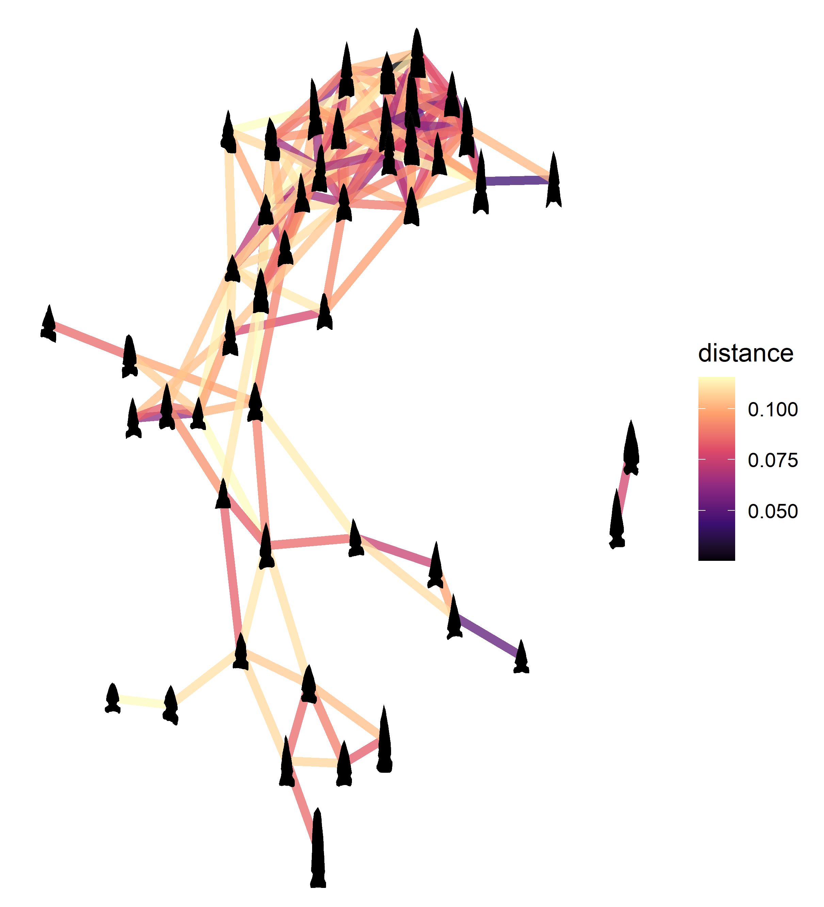

Figure 2: Network graph displaying side-notched points from Tonto Basin as nodes with ties showing the morphometric distance between points. Darker colors represent stronger ties. Note that only the strongest 10% of ties are shown. From Bischoff (2022: Figure 14).

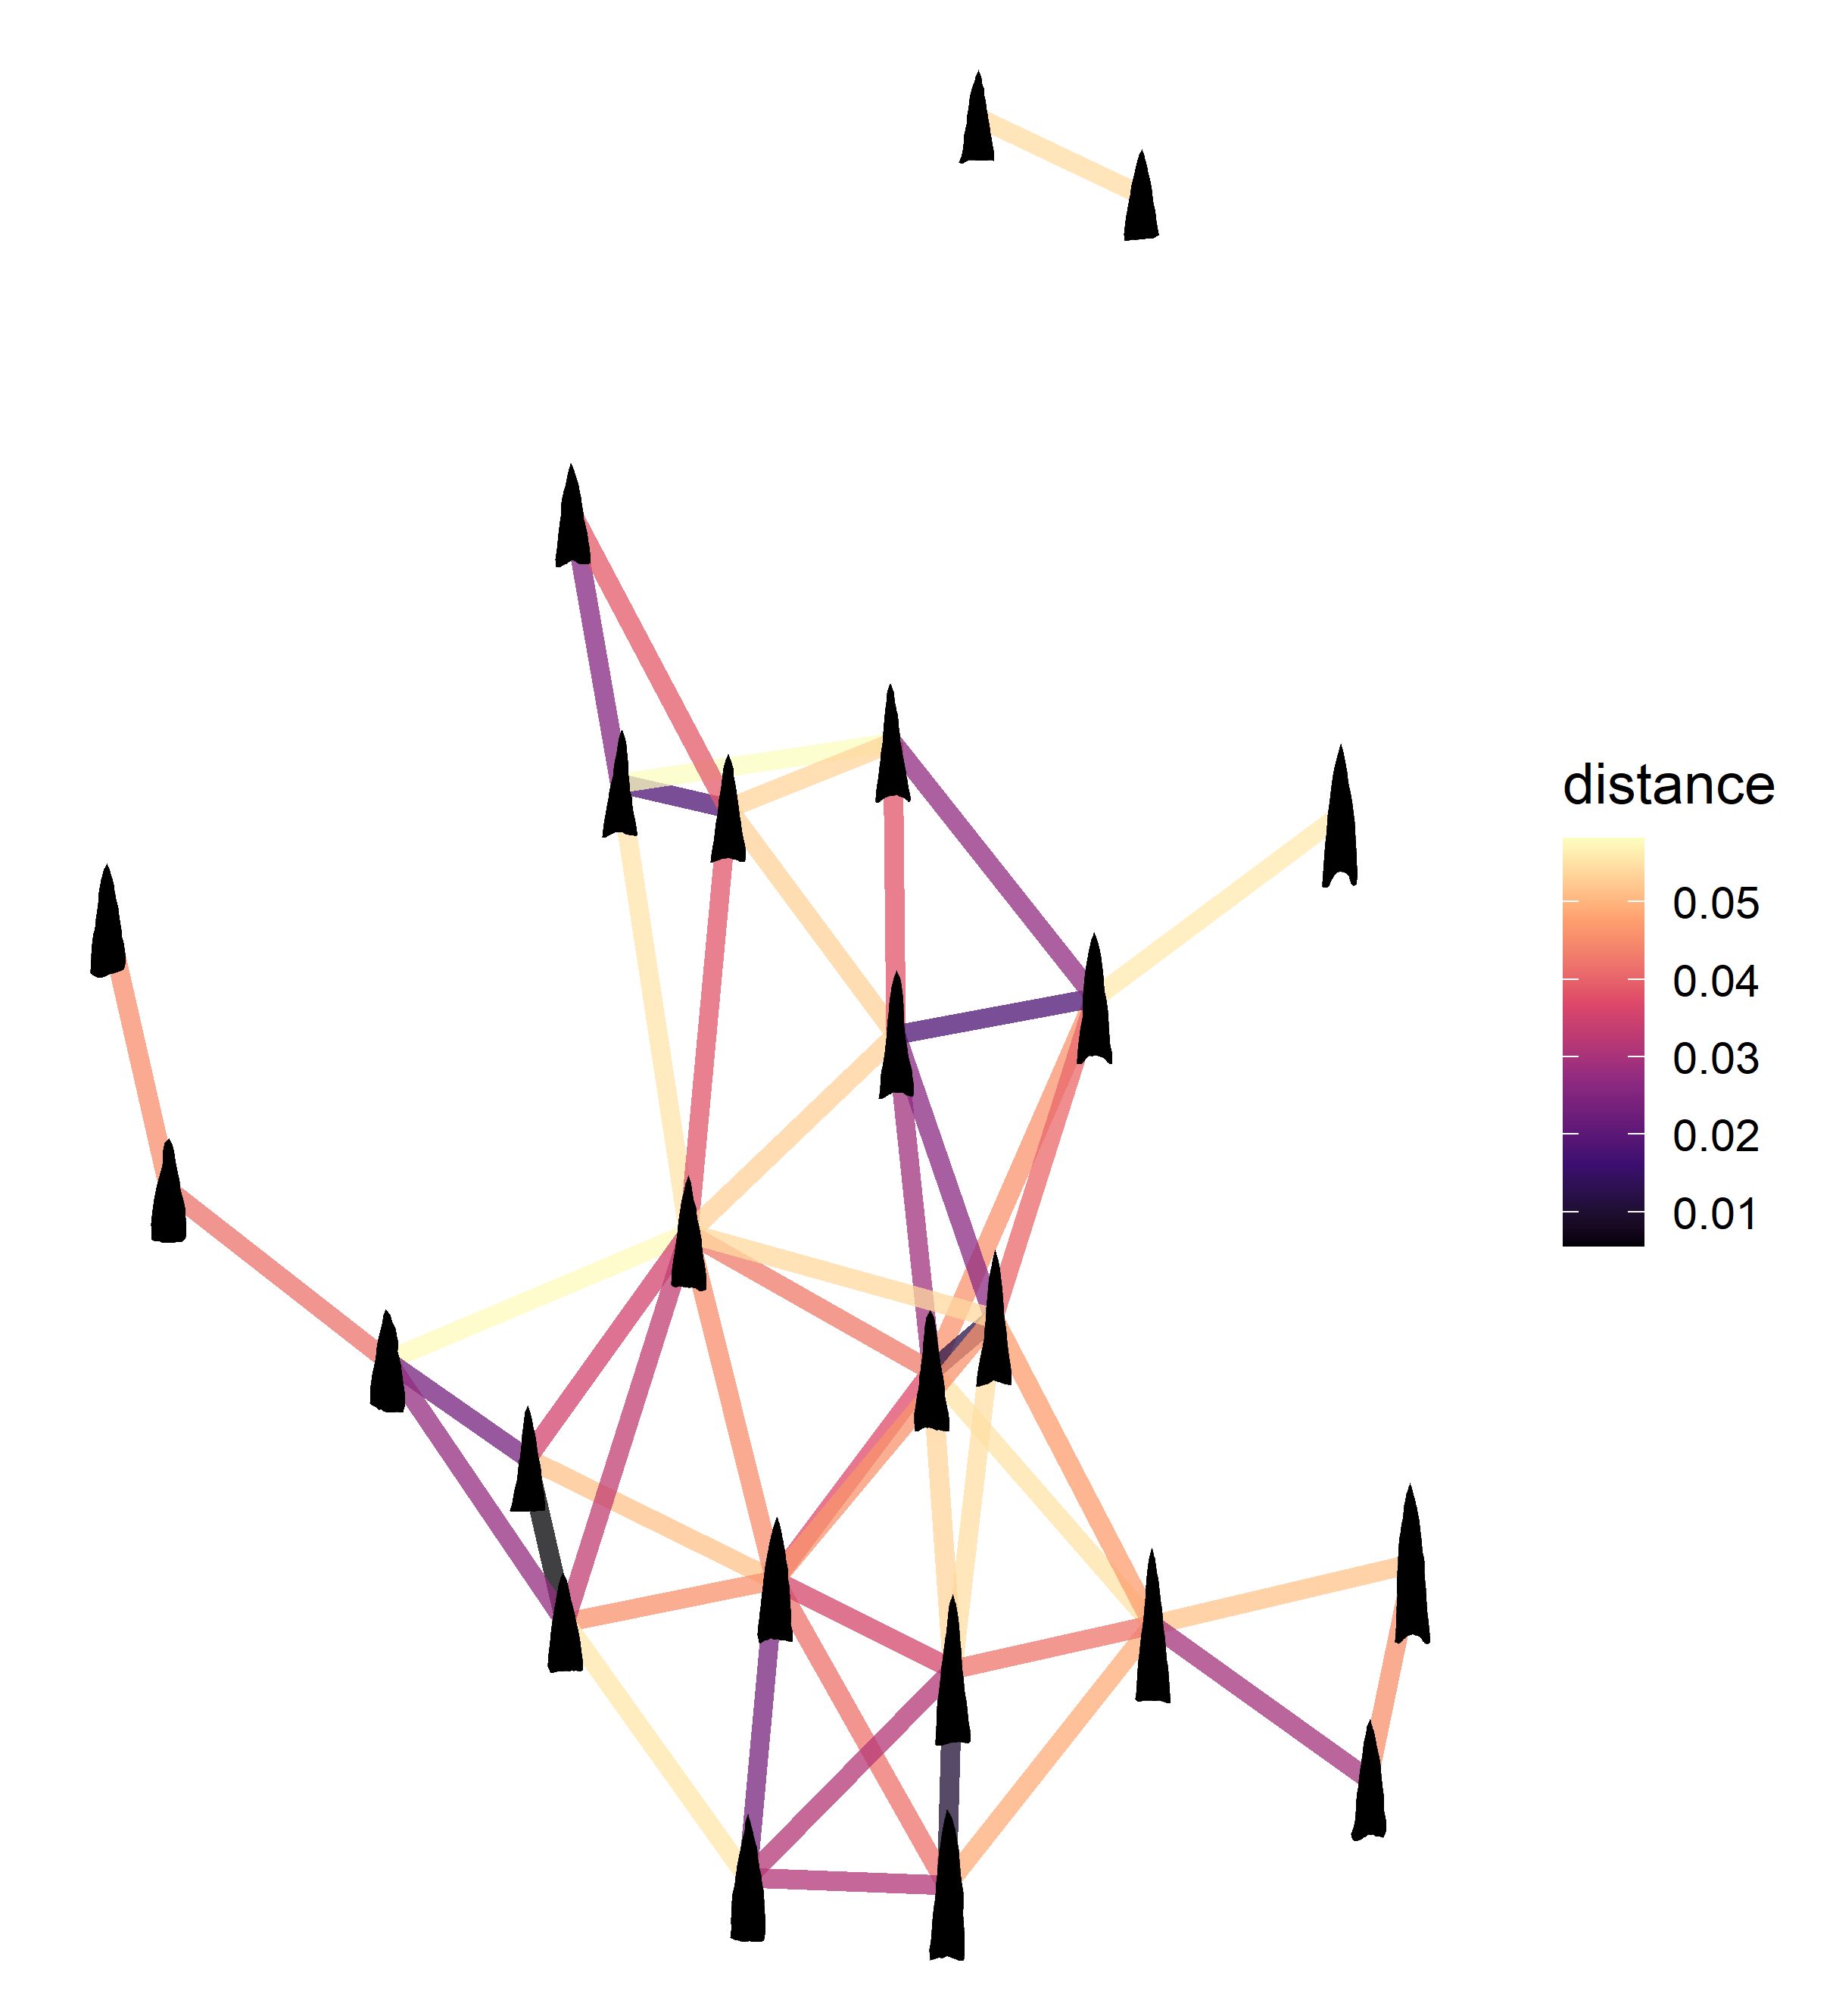

Figure 3: Network graph displaying triangular points from Tonto Basin as nodes with ties showing the morphometric distance between points. Darker colors represent stronger ties. Note that only the strongest 10% of ties are shown. From Bischoff (2022: Figure 15).

# Results

A major benefit of network analysis is the visual exploration of the network. The results of the network analysis are provided partially to address the major questions of this paper–the correlations between types of material culture and their potential causes–and partially as a visual exploration with corresponding evidence from network metrics.

Figure 4 shows the networks with the top five strongest ties between each node. This number of ties represents the fewest ties that connects all nodes in the spatial network. Fewer ties leaves the Cline Mesa sites disconnected from the rest of the network. Bass Point Mound forms a crucial bridge between the Cline Mesa sites and the rest of the network. Because the network is not complete, one cannot argue that there were not other sites between Cline Mesa and the Schoolhouse Mesa sites, but it still represents an intermediary location. Its geographic position overlooking the confluence of the Salt River and Tonto Creek would make an ideal meeting place for parties coming down from the Tonto Creek arm of what is now Roosevelt Lake or coming up from the Salt River arm. The Rock Island area consists of a single site, Bass Point Mound (a platform mound), although it was not heavily excavated. If spatial distance was an important factor in social interaction, then we would expect Bass Point Mound to consistently be a highly central node due to its central location. Table 2 shows the multilayer eigenvector centrality for points and ceramics only. Bass Point Mound has the highest multilayer network centrality with 0.95 (p = 0.87). Figure 5 provides the eigenvector data by type of network. Bass Point Mound has low centrality in the architectural network and the networks that do not connect the spatial components (three and four closest connections), which gives it a lower spatial centrality as well. The ceramic and point networks provide strong evidence that Bass Point Mound’s spatial location was advantageous for forming connections between the sites in this study.

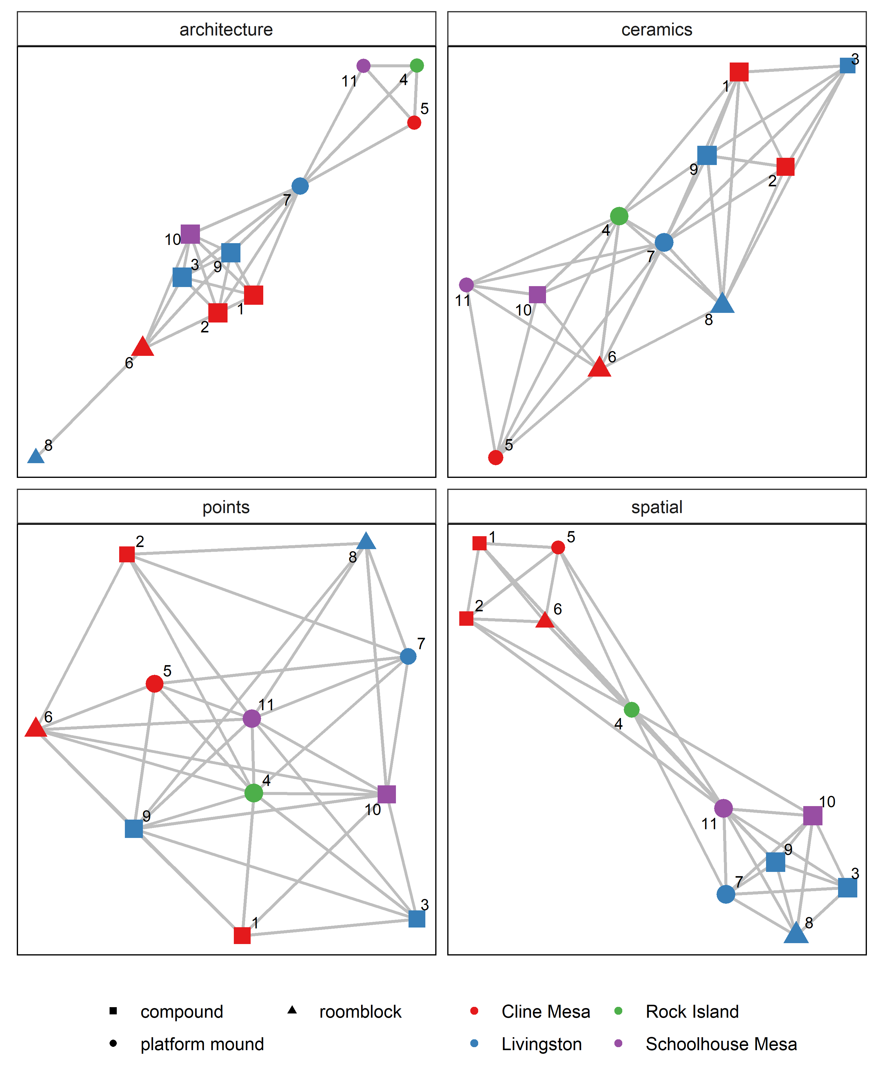

Figure 4: Graphs showing the networks used in this analsyis. Each network is displayed with the five strongest ties between each node. Legend: 1: AZ U:3:128 (ASM); 2: AZ U:4:032 (ASM); 3: AZ V:5:119 (ASM); 4: Bass Point Mound; 5: Cline Terrace Mound, Monster Ruin; 6: Indian Point Complex; 7: Pinto Point Mound; 8: Saguaro Muerto; 9: Sand Dune Site; 10: Schoolhouse Point Mesa Complex; 11: Schoolhouse Point Mound

Table 2: Multilayer Eigenvector Centrality for Ceramics and Points

|  |  |
| --- | --- |
| **Site** | **Centrality** |
| Bass Point Mound | 0.95 |
| Sand Dune Site | 0.84 |
| Pinto Point Mound | 0.76 |
| Indian Point Complex | 0.65 |
| AZ U:3:128 (ASM) | 0.64 |
| Schoolhouse Point Mesa Complex | 0.59 |
| Schoolhouse Point Mound | 0.55 |
| Cline Terrace Mound, Monster Ruin | 0.5 |
| Saguaro Muerto | 0.49 |
| AZ U:4:032 (ASM) | 0.46 |
| AZ V:5:119 (ASM) | 0.3 |

Visual inspection of the network graphs provides several other observations. One is that the four geographic areas represented do not form strong components in the non-spatial networks like they do in the spatial network. The architecture is thoroughly mixed, and the ceramics and points form single component networks. The formation of single components–rather than distinct sections of the graph–is typical of artifact similarity networks. The Livingston sites exhibit the most clustering in the ceramic network, although some of the connections go through Cline Mesa sites, which are as geographically distant as possible for these sites. The Schoolhouse Mesa sites always group together in the ceramic and point networks, as do the Livingston compound sites and separately the Livingston roomblock and platform mound. The Cline Mesa sites exhibit more variability.

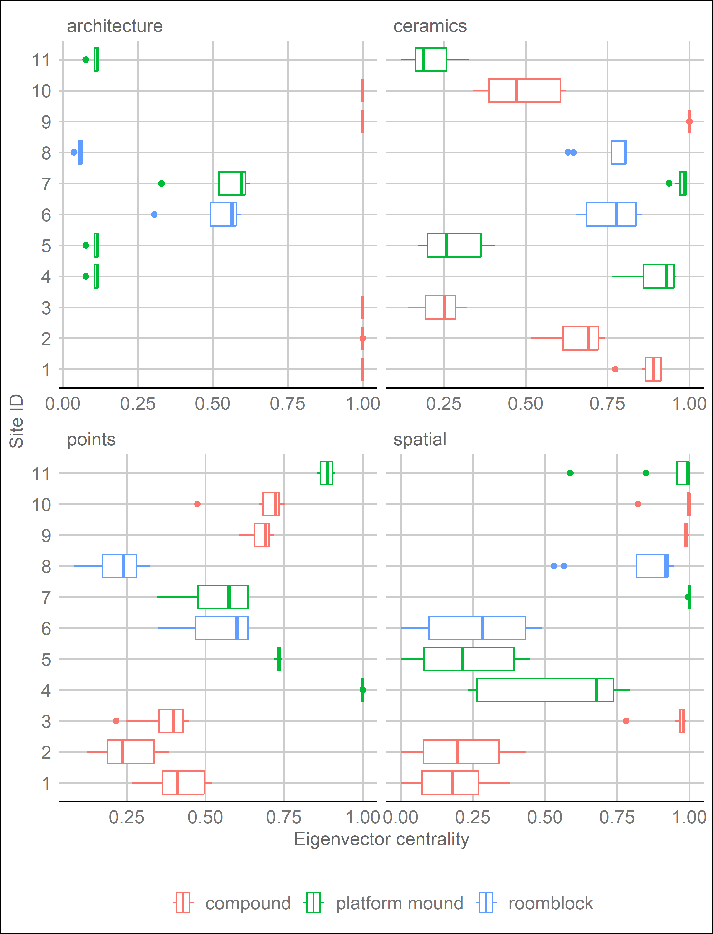

Figure 5: Boxplots showing the eigenvector centrality for each network. Values were calculated using networks created using between 3 to 10 of the strongest ranking ties. Legend: 1: AZ U:3:128 (ASM); 2: AZ U:4:032 (ASM); 3: AZ V:5:119 (ASM); 4: Bass Point Mound; 5: Cline Terrace Mound, Monster Ruin; 6: Indian Point Complex; 7: Pinto Point Mound; 8: Saguaro Muerto; 9: Sand Dune Site; 10: Schoolhouse Point Mesa Complex; 11: Schoolhouse Point Mound.

Another observation from the visual inspection of these networks is that there is some clustering due to architecture in the ceramic and point networks. Four of the five compound-only sites cluster at one end of the ceramic network, and a different mix of four out of five cluster together at one end of the projectile point network. The platform mounds are split in the ceramic network, but all cluster together in the projectile point network. Table 3 shows the mean eigenvector centrality vectors for the ceramic and point networks by type of architecture. Surprisingly the platform mounds are the least central, on average, for the ceramic network, but they are the most central for the projectile point network. The roomblocks, on the hand, are the most central for the ceramic network and by far the least central in the projectile point network. They take a larger drop in centrality in the projectile point network than the platform mound sites do in the ceramic network. It is expected that roomblocks have high centrality in the ceramic network, but not that platform mounds should have the lowest centrality. Clearly, centrality in the projectile point network does not equal centrality in the ceramic network.

Table 3: Mean Eigenvalues for Ceramic and Point Networks by Type of Architecture

|  |  |  |  |
| --- | --- | --- | --- |
| **Architecture** | **ceramics** | **points** | **mean** |
| platform mound | 0.59 | 0.79 | 0.69 |
| roomblock | 0.76 | 0.38 | 0.57 |
| compound | 0.65 | 0.48 | 0.56 |

The visual analysis, combined with the eigenvector centrality, indicated some spatial and architectural correlation. The multilayer Pearson correlation provides a more direct way to compare these layers, as shown in figure 6. This analysis provides a clear contrast between layers. None of the results, on average, showed a negative correlation–meaning that ties existed in one network where ties did not exist in the other network. Only one comparison had a strong correlation–the point and spatial networks were strongly correlated (**x** = 0.63; p = 0.98). The visual inspection and centrality analysis provided some indication of this, but the multilayer network comparison provides strong verification. All other layer comparisons had an approximately equivalent, positive correlation, but with only a weak strength. The one exception was architecture and points where the correlation was approximately zero. The visual inspection and eigenvector analysis demonstrated some interesting interactions with architecture in the network, but the overall correlation demonstrates that architecture cannot be used to predict the presence or absence of network ties in the projectile point network.

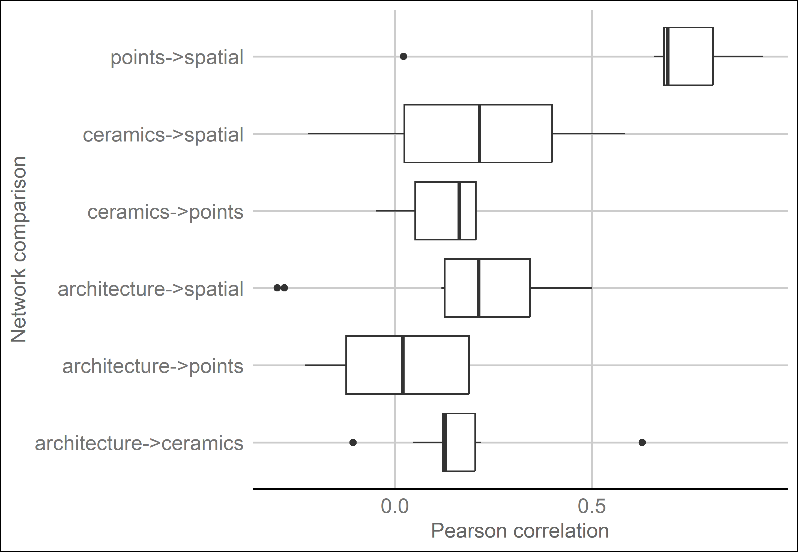

Figure 6: Boxplots showing the Pearson correlation between each network. Values were calculated using networks created from 3 to 10 of the strongest ranking ties.

# Discusssion

This analysis has three main findings regarding networks in Tonto Basin: (1) that point networks correlate with space; (2) that roomblock sites are highly central in the ceramic network and have low centrality in the point network; and (3) that ceramic and point networks are significantly different from each other. In terms of the null hypotheses stated in the introduction, only one of the networks exhibited strong spatial correlation and while all but one pairing (architecture and points) exhibited some positive correlation, all of the correlations except the points and space were weak. Given these network results, how might they be interpreted in terms of social behavior?

Exchange would be a primary driver in these network dynamics, and clear evidence exists for exchange of several types of material culture. Trade within the basin does not appear to have been dominated by any one group and may have been competitive in nature (Rice et al. 1998:127–128). Ceramic exchange certainly occurred at a regional level, but even local ceramics were circulated within the basin (Heidke and Miksa 2000; Miksa and Heidke 1995; Stark and Heidke 1992), possibly in return for food (Clark and Vint 2004:290–291). Projectile points (either as part of the arrow or separately) may have also been commonly exchanged. There are several examples of the exchange of bows and arrows ethnographically throughout the world (e.g., Mauss 1966; Nishiaki 2013; Wiessner 1983), in North America generally (e.g., Hoffman 1896; Radin 1923), and in the Southwest specifically (e.g., Beaglehole 1936; Dittert 1959; Fewkes 1898; Griffen 1969; Parsons 1939; Simpson 1953). Besides Watt’s study of knappers, Sliva’s (2002:539) analysis of sites from the Roosevelt Community Development Study suggests craft specialization in projectile point production. Mortuary offerings were possibly the intended function for many points (Sliva 2002:543), which may have spurred the increased craft specialization. Shell and stone jewelry, among other artifacts were also produced and exchanged within the basin. A potential loci for exchange are the platform mound sites. The purpose of these sites is still debated, but many argue that they served an integrative function (e.g., Abbott et al. 2006; Adler and Wilshusen 1990; Clark and Vint 2004; Craig 1995; Craig and Clark 1994:112–165; Doelle et al. 1995:439). If platform mounds were places where exchange between communities regularly took place, then we would expect platform mounds to have higher centrality. Centrality varied among the platform mounds, but on average, platform mounds did have the highest centrality.

As discussed previously, cultural differences were expected between the Tonto Creek and Salt River arms of Roosevelt Lake. This was due in part to differences in long-distance ceramic exchange and obsidian sourcing (Lyons 2013; Simon and Gosser 2001). This analysis did not use obsidian or focus on non-local ceramics and therefore did not capture differences based on these factors. There was some expectation that more separation in the material networks would be apparent between the Cline Mesa sites in the Tonto Creek arm and the other sites (minus Bass Point Mound that lies at the confluence). This was not born out in the visual inspection of the analysis with significant mixing of the areas in the network. There were, however, indications that spatial distance was an important factor. Spatial distance would align with the proposed differences in the Tonto Creek and Salt River arms of the lake. The only strong correlation between networks was the point and spatial network, which indicates that being near another site is a good indication of the shape of a projectile point. There was however, little correlation overall between ceramics and spatial distance.

There is a potential chain of association between immigrants and roomblocks, roomblocks or locations with roomblocks as centers of Salado production, and Salado pottery as a widespread phenomenon that provides an expectation for roomblock sites to be central to pottery networks. While this association is circumstantial and not expected to be uniform across the Hohokam region, roomblocks did have the highest centrality in the ceramic networks. Another reason for the high centrality of roomblock sites is that they lacked access to adequate farmland and had to trade pottery for food (Clark and Vint 2004:291). This second explanation may help explain why roomblock sites had low centrality in the point networks, presuming that points were not exchanged for food. It is beyond this simple analysis to determine the precise reasons, but it is clear that roomblock sites were important for ceramic circulation in Tonto Basin. On the other hand, sites with roomblocks had the lowest centrality in the point networks. This suggests that the influence the occupants of roomblock sites had in pottery networks may not have extended to other spheres of interaction.

As discussed previously, my simplistic model of interaction in Tonto Basin assumes that the ceramic network represents categorical identification among women. Recall also that I expected architecture to represent categorical identity. Thus, the correlation between architecture and ceramics, at least as represented by roomblocks, is an expected find and good corroborating evidence that these types of material culture represent markers of identity demonstrating belonging to a particular social group.

The point networks were expected to represent relational identification among men, at least in this case study. Because relational identification is related to frequent interaction, spatial distance is a crucial component. It is much harder to interact with someone when they are far away. Thus, the correlation between the point and spatial networks also makes theoretical sense.

Perhaps the reason roomblocks were more central to the ceramic network is because immigrants to the basin had less access to farmland and had to make pottery to get food, as mentioned. This would explain higher centrality for roomblocks and lower centrality for point networks. It does not explain the remaining differences between point and ceramic networks. Projectile points at least were highly gendered, and ceramics probably were as well. The evidence presented here demonstrates that ceramic and point networks vary significantly, and I believe gender likely played an important role.

# Conclusion

This is one of the first archaeological applications of multilayer network analysis to consider multiple types of material culture. This is advantageous for studying how types of material culture do or do not co-vary, which aids interpretations of the social interactions that created these patterns. This analysis used architectural, ceramic, projectile point, and spatial data from 11 sites in Tonto Basin. The data come primarily from occupations between AD 1275 and 1325. A network was created for each type of data and combined into a multilayer network. Visual network analysis, eigenvector centrality, and multilayer network Pearson correlation were used to study and compare the networks. The findings indicate that the projectile point network was strongly correlated with the spatial network–indicating that sites near each other were more likely to have similar projectile points. Furthermore, sites with roomblocks indicative of immigrants from the north and east of Tonto Basin were, on average, the most highly central sites in the ceramic network; however, they were the least central in the point network. Immigrants may have relied on pottery production to integrate with the local networks, but this relationship did not hold for projectile points. Finally, the results demonstrate major differences between the ceramic and point networks. This findings has major implications for network studies, because many rely on only a single artifact type. If different types of material culture do not co-vary regularly, then that indicates archaeologists must do more to include other types of material culture to better understand the complex social networks that existed in the past. Furthermore, projectile points and ceramics have strong associations with gender. Differences in the ceramic and point networks suggest differences existed between the social networks of each gender.

This analysis uses a handful of sites from Tonto Basin. Much more data exists and the results discussed here would be greatly strengthened by including more sites and data. What would be perhaps even more useful would be to include sourced obsidian and ceramics. Networks created from artifacts where the origin is known can be used to more strongly infer various types of social interaction. This type of multilayer analysis would also be useful to conduct in other regions. It would be particularly useful for comparative studies to know in what circumstances different types of material culture do or do not co-vary.

# Acknowledgements

Josh Watts, Matt Peeples, Melissa Powell, Chris Caseldine, and several volunteers assisted with this research. Chris Caseldine’s comments greatly improved this paper. All mistakes are my own. The many individuals who contributed to the Roosevelt Platform Mound Study also deserve recognition.

# Disclosure Statement

The author declares no conflicts of interest.

# References

Abbott, David R, Scott E Ingram, and Brent G Kober. 2006 [Hohokam Exchange and Early Classic Period Organization in Central Arizona: Focal Villages or Linear Communities?](https://doi.org/10.1179/009346906791071909) *Journal of Field Archaeology* 31(3): 285–305.

Adler, Michael A, and Richard H Wilshusen. 1990 Large-Scale Integrative Facilities in Tribal Societies: Cross-Cultural and Southwestern U.S. Examples. *World archaeology* 22(2): 133–144.

Ahlstrom, Richard V N, Mark L Chenault, and Kirk C Anderson. 1991 *The Roosevelt Bajada Survey, Tonto Basin, Gila County, Arizona*. Report no. 91-24. SWCA, Inc. Environmental Consultants, Tucson.

Beaglehole, Ernest. 1936 *Hopi Hunting and Hopi Ritual*. Yale university publication in anthropology no. 4. Yale University Press, New Haven, CT.

Birch, Jennifer, and John P Hart. 2018 [Social Networks and Northern Iroquoian Confederacy Dynamics](https://doi.org/10.1017/aaq.2017.59). *American Antiquity* 83(1): 13–33.

Bischoff, Robert J. 2017 A Spatial Analysis of San Juan Red Ware: Evaluating Fall-off Curves with Straight-line or Least Cost Path Distance. Poster presented at the 82nd Annual Meeting of the Society for American Archaeology, Vancouver, BC. March 31, 2017.

2022 [Geometric Morphometric Analysis of Projectile Points from the Southwest United States](https://osf.io/preprints/socarxiv/a6wjc/). *SocArXiv Papers*. September.

Bischoff, Robert J, Cecilia Padilla-Iglesias, and Claudine Gravel-Miguel. 2021 [Evaluating the Effects of Randomness on Missing Data in Archaeological Networks](https://doi.org/10.31235/osf.io/vdy9b). *SocArxiv*.

Bolland, John M. 1988 [Sorting out centrality: An analysis of the performance of four centrality models in real and simulated networks](https://doi.org/10.1016/0378-8733(88)90014-7). *Social networks* 10(3): 233–253.

Borck, Lewis, Barbara J Mills, Matthew A Peeples, and Jeffery J Clark. 2015 [Are Social Networks Survival Networks? An Example from the Late Pre-Hispanic US Southwest](https://doi.org/10.1007/s10816-014-9236-5). *Journal of Archaeological Method and Theory* 22(1): 33–57.

Borgatti, Stephen P. 2005 [Centrality and Network Flow](https://doi.org/10.1016/j.socnet.2004.11.008). *Social Networks* 27(1): 55–71.

Borgatti, Stephen P, Kathleen M Carley, and David Krackhardt. 2006 [On the robustness of centrality measures under conditions of imperfect data](https://doi.org/10.1016/j.socnet.2005.05.001). *Social networks* 28(2): 124–136.

Bródka, Piotr, Anna Chmiel, Matteo Magnani, and Giancarlo Ragozini. 2018 [Quantifying Layer Similarity in Multiplex Networks: a Systematic Study](https://doi.org/10.1098/rsos.171747). *Royal Society Open Science* 5(8): 171747.

Broodbank, Cyprian. 2000 [*An Island Archaeology of the Early Cyclades*](https://play.google.com/store/books/details?id=qbYiW13TJ6UC). Cambridge University Press.

Brubaker, Rogers, and Frederick Cooper. 2000 [Beyond ’identity’](https://www.jstor.org/stable/3108478). *Theory and Society* 29(1): 1–47.

Brughmans, Tom, and Matthew A Peeples. 2023 *Network Science in Archaeology*. Cambridge manuals in archaeology. Cambridge University Press.

Carr, Christopher. 1995a [Building a Unified Middle-Range Theory of Artifact Design](https://doi.org/10.1007/978-1-4899-1097-4_6). In *Style, Society, and Person*, edited by Carr C. and J E Neitzel, pp. 151–170. Interdisciplinary contributions to archaeology. Springer, Boston.

1995b [A Unified Middle-Range Theory of Artifact Design](https://doi.org/10.1007/978-1-4899-1097-4_6). In *Style, Society, and Person*, edited by Carr C. and J E Neitzel, pp. 171–258. Interdisciplinary contributions to archaeology. Springer, Boston.

Caseldine, Christopher R. 2022 [Least Cost Paths and Movement in Tonto Basin, Central Arizona](https://doi.org/10.1080/00231940.2021.1996517). *The Kiva* 88(1): 112–141.

Ciolek-Torrello, Richard, Steven D Shelley, and Su Benaron. 1994 The Roosevelt Rural Sites Study: Prehistoric Rural Settlements in the Tonto Basin. *Statistical Researh Technical Series*(28).

Clark, Jeffery J. 2001 [*Tracking Prehistoric Migrations: Pueblo Settlers Among the Tonto Basin Hohokam*](https://play.google.com/store/books/details?id=27Tk3xNT-6UC). Vol. 65. Anthropological papers of the university of arizona. University of Arizona Press, Tucson.

Clark, Jeffery J, and Christopher R Caseldine. 2021 *Research Design for Late Pre-Hispanic Backcountry Sites on Tonto National Monument: Contextualizing the Monument in Tonto Basin and Beyond*. Vol. Technical Report No. 2021–101. Archaeology Southwest, Tucson.

Clark, Jeffrey J, and James M Vint (editors). 2004 *2000 Years of Settlement in the Tonto Basin: Overview and Synthesis of the Tonto Creek Archaeological Project*. Center for Desert Archaeology.

Cochrane, Ethan E, and Carl P Lipo. 2010 [Phylogenetic analyses of Lapita decoration do not support branching evolution or regional population structure during colonization of Remote Oceania](https://doi.org/10.1098/rstb.2010.0091). *Philosophical transactions of the Royal Society of London. Series B, Biological sciences* 365(1559): 3889–3902.

Collar, Anna. 2013 [*Religious Networks in the Roman Empire: The Spread of New Ideas*](https://play.google.com/store/books/details?id=Av5GAgAAQBAJ). Cambridge University Press, December.

Costenbader, Elizabeth, and Thomas W Valente. 2003 [The stability of centrality measures when networks are sampled](https://doi.org/10.1016/S0378-8733(03)00012-1). *Social networks* 25(4): 283–307.

Craig, Douglas B. 1995 The Social Consequences of Irrigation Agriculture: A Perspective from Meddler Point. In *The Roosevelt Community Development Study: New Perspectives on Tonto Basin Prehistory*, edited by M D Elson, M T Stark, and D A Gregory, Anthropological Papers No. 15:pp. 227–249. Center for Desert Archaeology, Tucson.

Craig, Douglas B, and Jeffery J Clark. 1994 The Meddler Point Site, AZ V:5:4/26 (ASM/TNF). In *The Roosevelt Community Development Study: Vol. 2. Meddler Point, Pyramid Point, and Griffin Wash Sites*, edited by M D Elson, D L Swartz, D B Craig, and J J Clark, Anthropological Papers No. 13:pp. 1–198. Center for Desert Archaeology, Tucson.

Craig, Douglas B, and M Kyle Woodson. 2017 Preclassic Hohokam. In *The Oxford Handbook of Southwest Archaeology*, edited by Barbara J Mills and Severin Fowles, pp. 323–351. Oxford University Press.

Crown, Patricia L, and Suzanne K Fish. 1996 Gender and Status in the Hohokam Preclassic to Classic Transition. *American anthropologist* 98(4): 803–817.

Dean, Jeffrey S. 2000 *Salado*. Amerind Foundation, Dragoon, Arizona; University of New Mexico Press, Albuquerque.

Dietler, Michael, and Ingrid Herbich. 1998 Habitus, Techniques, Style: An Integrated Approach to the Social Understanding of Material Culture and Boundaries. In *The Archaeology of Social Boundaries*, edited by Miriam T Stark, pp. 232–263. Smithsonian Institution, Washington, DC.

Dittert, Alfred E. 1959 Culture Change in the Cebolleta Mesa Region Central Western New Mexico. Unpublished PhD thesis, Ph.D. dissertation, Department of Anthropology, University of Arizona, Tucson, Arizona.

Doelle, William H, David A Gregory, and Henry D Wallace. 1995 Classic Period Platform Mound Systems in Southern Arizona. In *The Roosevelt Community Development Study: New Perspectives on Tonto Basin Prehistory*, edited by M D Elson, M T Stark, and D A Gregory, Anthropological Papers No. 15:pp. 385–440. Center for Desert Archaeology, Tucson.

Doelle, William H, Henry D Wallace, Mark D Elson, and Douglas B Craig. 1992 *Research Design for the Roosevelt Community Development Study*. Vol. Anthropological Papers ,12. Center for Desert Archaeology, Tucson, Arizona.

Elson, Mark D. 1996 [A Revised Chronology and Phase Sequence for the Lower Tonto Basin of Central Arizona](https://doi.org/10.1080/00231940.1996.11758328). *The Kiva* 62(2): 117–147.

Elson, Mark D, David A Gregory, and Miriam T Stark. 1995 *The Roosevelt Community Development Study: New Perspectives on Tonto Basin Prehistory*. Center for Desert Archaeology, Tucson.

Elson, Mark D, and Michael Lindeman. 1994 The Eagle Ridge Site, AZ V:5:104/1045 (ASM/TNF. In *The Roosevelt Community Development Study: Vol. 1. Introduction and Small Sites*, edited by M D Elson and D L Swartz, Anthropological Papers No. 13:pp. 23–116. Center for Desert Archaeology, Tucson.

Elson, Mark D, Miriam T Stark, and David A Gregory. 2000 Tonto Basin Local Systems: Implications for Cultural Affiliation and Migration. In *Salado*, edited by J S Dean, pp. 167–192 4. Amerind Foundation Publication, Dragoon, Arizona. University of New Mexico Press, Dragoon, Albuquerque.

Feinman, Gary M, and Jill E Neitzel. 2020 [Excising Culture History from Contemporary Archaeology](https://doi.org/10.1016/j.jaa.2020.101230). *Journal of Anthropological Archaeology* 60: 101230.

Fewkes, Jesse Walter. 1898 Archaeological Expedition to Arizona in 1895. In *Seventeenth Annual Report of the Bureau of American Ethnology*, edited by J W Powell. Smithsonian Institution, Washington, D.C.

Frost, Robert H. 2022 [Eigenvector centrality for multilayer networks with dependent node importance](http://arxiv.org/abs/2205.01478).

Galaskiewicz, Joseph. 1991 [Estimating point centrality using different network sampling techniques](https://doi.org/10.1016/0378-8733(91)90002-B). *Social networks* 13(4): 347–386.

Giomi, Evan. 2022 [Exploring the development and persistence of the Eastern Puebloan economy: Rio Grande glaze ware as a window on regional interaction](https://repository.arizona.edu/bitstream/handle/10150/663236/azu_etd_19397_sip1_m.pdf?sequence=1). PhD dissertation, Department of Anthropology, University of Arizona, Tucson.

Gjesfjeld, Erik. 2015 [Network Analysis of Archaeological Data from Hunter-Gatherers: Methodological Problems and Potential Solutions](https://doi.org/10.1007/s10816-014-9232-9). *Journal of Archaeological Method and Theory* 22(1): 182–205.

Golitko, M, and G M Feinman. 2015 Procurement and distribution of pre-Hispanic Mesoamerican obsidian 900 BC–AD 1520: A Social Network Analysis. *Journal of Archaeological Method and Theory* 22: 206–247.

Gosselain, O P. 2016 [The World is Like a Beanstalk: Historicizing Potting Practice and Social Relations in the Niger River Area](https://muse.jhu.edu/book/44808). In *Knowledge in Motion: Constellations of Learning Across Time and Place*, edited by Andrew P Roddick and Ann B Stahl, pp. 36–66. University of Arizona Press, Tucson.

Gosselain, Olivier P. 1998 Social and Technical Identity in a Clay Cristal Ball. In *The Archaeology of Social Boundaries*, edited by Miriam Stark, pp. 78–106. Smithsonian Institution Press, Washington, D.C.

2000 [Materializing Identities: An African Perspective](https://doi.org/10.1023/A:1026558503986). *Journal of Archaeological Method and Theory* 7(3): 187–217.

Griffen, William B. 1969 *Culture Change and Shifting Populations in Central Northern Mexico*. University of Arizona, Press, Tucson, AZ.

Heidke, James M, and Elizabeth J Miksa. 2000 Ceramic Temper Provenance Studies. In *Tonto Creek Archaeological Project: Artifact and Environmental Analyses*, edited by J M Vint and J M Heidke, pp. 95–146. Center for Desert Archaeology, Tucson.

Hill, J Brett, Patrick D Lyons, Jeffery J Clark, and William H Doelle. 2015 [The ’collapse’ of cooperative Hohokam irrigation in the Lower Salt River Valley](https://www.jstor.org/stable/26310200). *Journal of the Southwest* 57(4): 689–716.

Hodder, Ian. 1982 [*Symbols in action: Ethnoarchaeological studies of material culture*](https://market.android.com/details?id=book-TSE9AAAAIAAJ). Cambridge University Press, Cambridge, January.

Hoffman, Walter James. 1896 The Menomini Indians. In *The Fourteenth Annual Report of the Bureau of Ethnology to the Secretary of the Smithsonian Institution 1892–1893 pt 1*, edited by J W Powell, pp. 11–338. Government Printing Office, Washington, D.C.

Holland-Lulewicz, Jacob. 2021 [From Categories to Connections in the Archaeology of Eastern North America](https://doi.org/10.1007/s10814-020-09154-w). *Journal of Archaeological Research*.

Huntley, Deborah L. 2008 *Ancestral Zuni Glaze-Decorated Pottery: Viewing Pueblo IV Regional Organization through Ceramic Production and Exchange*. Vol. No. 72. Anthropological papers. University of Arizona Press, Tucson.

Huntley, Deborah L, Jeffery J Clark, Mary Ownby, Cynthia L Herhahn, and Ann F Ramenofsky. 2016 Movement of people and pots in the Upper Gila Region of the American Southwest. In *How, Why and Beyond: Exploring Cause and Explanation in Historical Ecology, Demography and Movement*, pp. 275–295. University Press of Colorado, Boulder.

Jaccard, Paul. 1912 [The distribution of the flora in the alpine zone](https://doi.org/10.1111/j.1469-8137.1912.tb05611.x). *The New Phytologist* 11(2): 37–50.

Jacobs, David. 1997 *A Salado Platform Mound on Tonto Creek, Roosevelt Platform Mound Study: Report on the Cline Terrace Mound, Cline Terrace Complex*. Vol. Rooseelt Monograph Series 7. Department of Anthropology, Arizona State University, Tempe.

Kivelä, Mikko, Alex Arenas, Marc Barthelemy, James P Gleeson, Yamir Moreno, and Mason A Porter. 2014 [Multilayer Networks](https://doi.org/10.1093/comnet/cnu016). *Journal of Complex Networks* 2(3): 203–271.

Lange, Richard C, and Stephen Germick (editors). 1992 *Proceedings of the Second Salado Conference, Globe, Arizona, 1992*. Arizona Archaeological Society, Phoenix.

Lave, Jean, and Etienne Wenger. 1991 [*Situated Learning: Legitimate Peripheral Participation*](https://market.android.com/details?id=book-CAVIOrW3vYAC). Cambridge University Press, Cambridge.

Lee, S, S-H Yook, and Y Kim. 2009 [Centrality measure of complex networks using biased random walks](https://doi.org/10.1140/epjb/e2009-00095-5). *The European physical journal. B* 68(2): 277–281.

Lemonnier, Pierre. 1986 [The Study of Material Culture Today: Toward an Anthropology of Technical Systems](https://doi.org/10.1016/0278-4165(86)90012-7). *Journal of Anthropological Archaeology* 5(2): 147–186.

Lindauer, Owen. 1995 *Where the Rivers Converge: Roosevelt Platform Mound Study: Report on the Rock Island Complex*. Vol. Rooseelt Monograph Series 4. Department of Anthropology, Arizona State University, Tempe.

Loendorf, Chris, Lynn Simon, Daniel Dybowski, M Kyle Woodson, R Scott Plumlee, Shari Tiedens, and Michael Withrow. 2015 [Warfare and Big Game Hunting: Flaked-Stone Projectile Points Along the Middle Gila River in Arizona](https://doi.org/10.15184/aqy.2015.28). *Antiquity* 89: 940–953.

Loendorf, Christopher. 1998 Salado Burial Practices and Social Organization. In *A Synthesis of Tonto Basin Prehistory: The Roosevelt Archaeology Studies, 1989 to 1998*, edited by Glen Rice, pp. 193–230. Roosevelt monograph series 10 anthropological field studies 40. Arizona State University, Office of Cultural Resource Management, Dept. of Anthropology, Tempe.

Lulewicz, Jacob. 2019 [The social networks and structural variation of Mississippian sociopolitics in the southeastern United States](https://doi.org/10.1073/pnas.1818346116). *Proceedings of the National Academy of Sciences of the United States of America* 116(14): 6707–6712.

Lyons. 2013 *Placing the Tonto Cliff Dwellings in the Larger Context of Tonto Basin and the Southern US Southwest*. Western National Parks Association, Tucson.

Lyons, Patrick D. 2003 *Ancestral Hopi Migrations*. First Edition edition. Anthropological paper number 68. University of Arizona Press, Tucson.

Lyons, Patrick D, and Jeffery J Clark. 2012 Ceramic Typology, Chronology, Production, and Circulation. In *Mounds and Migrants: Late Prehistoric Archaeology of the Lower San Pedro River Valley, Arizona*, edited by Jeffery J Clark and Patrick D Lyons, pp. 211–308. Archaeology Southwest, Tucson.

Lyons, Patrick D, and Alexander Johnston Lindsay Jr. 2006 Perforated Plates and the Salado Phenomenon. *The Kiva* 72(1): 5–54.

Mauss, Marcel. 1966 *The Gift: Forms and Functions of Exchange in Archaic Societies*. Cohen & West, London.

Miksa, Elizabeth, and James M Heidke. 1995 Drawing a Line in the Sands: Models of Ceramic Temper Provenance. In *The Roosevelt Community Development Study*, edited by J M Heidke and M T Stark, Anthropological Papers No. 14:pp. 133–204. Center for Desert Archaeology, Tucson.

Mills, Barbara J, Jeffery J Clark, Matthew A Peeples, W R Haas, John M Roberts, J Brett Hill, Deborah L Huntley, Lewis Borck, Ronald L Breiger, Aaron Clauset, and M Steven Shackley. 2013 [Transformation of social networks in the late pre-Hispanic US Southwest](https://doi.org/10.1073/pnas.1219966110). *Proceedings of the National Academy of Sciences of the United States of America* 110(15): 5785–5790.

Mills, Barbara J, John M Roberts Jr., Jeffery J Clark, William R Haas Jr., Deborah L Huntley, Matthew A Peeples, Meaghan Trowbridge, Lewis Borck, Susan C Ryan, and Ronald L Breiger. 2013 The Dynamics of Social Networks in the Late Prehispanic U.S. Southwest. In *Network Analysis in Archaeology: New Approaches to Regional Interaction*, edited by Carl Knappett, pp. 181–202. Oxford University Press, Oxford.

Mills, Barbara, Sudha Ram, Jeffery Clark, Scott Ortman, and Matthew Peeples. 2020 [CyberSW Version 1.0](https://cybersw.org/). Archaeology Southwest, Tucson.

Neuzil, Anna A. 2008 *In the Aftermath of Migration: Renegotiating Ancient Identity in Southeastern Arizona*. Anthropological papers of the university of arizona no. 73. University of Arizona Press, Tucson.

Nishiaki, Yoshihiro. 2013 [“Gifting” As a Means of Cultural Transmission: The Archaeological Implications of Bow-and-Arrow Technology in Papua New Guinea](https://doi.org/10.1007/978-4-431-54511-8_10). In *Dynamics of Learning in Neanderthals and Modern Humans Volume 1: Cultural Perspectives*, edited by Takeru Akazawa, Yoshihiro Nishiaki, and Kenichi Aoki, pp. 173–185. Springer Japan, Tokyo.

Oliver, Theodore J. 2001 Warfare in Tonto Basin. In *Deadly Landscapes: Case Studies of Prehistoric Southwestern Warfare*, edited by G E Rice and S LeBlanc, pp. 195–217. University of Utah Press, Salt Lake City.

Parsons, Elsie Clews. 1939 *Pueblo Indian Religion*. University of Chicago Press, Chicago.

Peeples, Matthew A. 2017 Network Science and Statistical Techniques for Dealing with Uncertainties in Archaeological Datasets. Electronic document, http://www.mattpeeples.net/netstats.html, accessed April, 21, 2018.

2018 [*Connected Communities: Networks, Identity, and Social Change in the Ancient Cibola World*](https://market.android.com/details?id=book-fyw-DwAAQBAJ). University of Arizona Press, Tucson.

Peeples, Matthew A, and John M Roberts. 2013 [To Binarize or not to Binarize: Relational Data and the Construction of Archaeological Networks](https://doi.org/10.1016/j.jas.2013.03.014). *Journal of Archaeological Science* 40(7): 3001–3010.

Radin, Paul. 1923 The Winnebago Tribe. In *Thirty Seventh Annual Report of the Bureau of American Ethnology to the Secretary of the Smithsonian Institution 1915–1916*, edited by F W Hodge, pp. 33–560. United States Government Printing Office, Washington, D.C.

Rice, Glen E. 1994 [Projectile Points, Bifaces, and Drills](https://doi.org/10.6067/XCV8HT2R9N). In *Archaeology of the Salado in the Livingston area of Tonto Basin, Roosevelt Platform Mound Study: Report on the Livingston Management Group, Pinto Creek Complex. Part 2*, edited by Glen E Rice, pp. 727–738. Roosevelt monograph series 3. Department of Anthropology, Arizona State University, Tempe.

Rice, Glen E. (editor). 1998 *A Synthesis of Tonto Basin Prehistory: The Roosevelt Archaeology Studies, 1989 to 1998*. Roosevelt monograph series 10 anthropological field studies 40. Arizona State University, Office of Cultural Resource Management, Dept. of Anthropology, Tempe.

Rice, Glen E, and Theodore J Oliver. 1998 Settlement Patterns and Subsistence. In *A Synthesis of Tonto Basin Prehistory: The Roosevelt Archaeological Studies, 1989-1998*, edited by Glen E Rice, pp. 85–104. Arizona State University, Office of Cultural Resource Management, Dept. of Anthropology, Tempe.

Rice, Glen E, Arleyn Simon, and Christopher Loendorf. 1998 Production and Exchange of Economic Goods. In *A Synthesis of Tonto Basin Prehistory: The Roosevelt Archaeology Studies, 1989 to 1998*, edited by Glen Rice, pp. 105–130. Roosevelt monograph series 10 anthropological field studies 40. Arizona State University, Office of Cultural Resource Management, Dept. of Anthropology, Tempe.

Rivera-Hutinel, A, R O Bustamante, V H Marı́n, and R Medel. 2012 [Effects of sampling completeness on the structure of plant-pollinator networks](https://doi.org/10.1890/11-1803.1). *Ecology* 93(7): 1593–1603.

Sassman, Kenneth E, and Wictoria Rudolphi. 2001 Communities of Practice in the Early Ceramic Traditions of the American Southeast. *Journal of Anthropological Research* 57: 407–425.

Simon, Arelyn W, and Dennis C Gosser. 2001 Conflict and Exchange among the Salado of Tonto Basin: Warfare Motivation or Alleviation? In *Deadly Landscapes: Case Studies of Preshistoric Southwestern Warfare*, edited by G E Rice and S LeBlanc, pp. 219–238. University of Utah Press, Salt Lake City.

Simpson, Ruth Deette. 1953 The Hopi Indians. *Southwest Museum Leaflets* 1(25).

Sliva, R Jane. 2002 Temporal, Spatial, and Functional Variability in the Flaked Stone Assemblage. In *Tonto Creek Archaeological Project: Artifact and Environmental Analyses. Vol. 2: Stone Tool and Subsistence Studies*, edited by J J Clark, Anthropological Papers No. 23:pp. 487–558. Center for Desert Archaeology, Tucson.

Stark, Miriam T, Mark D Elson, and Jeffrey J Clark. 1998 Social Boundaries and Technical Choices in Tonto Basin Prehistory. In *The Archaeology of Social Boundaries*, edited by Miriam T Stark, pp. 208–231. Smithsonian Institution Press, Washington, D.C.

Stark, Miriam T, and James M Heidke. 1992 The Plainware and Redware Ceramic Assemblages. In *The Rye Creek Project: Archaeology in the Upper Tonto Basin: Vol. 2. Artifact and Specific Analyses*, edited by M D Elson and D B Craig, Anthropological Papers No. 11:pp. 89–214. Center for Desert Archaeology, Tucson.

Terrell, J E. 2010 Language and Material Culture on the Sepik Coast of Papua New Guinea: Using Social Network Analysis to Simulate, Graph, Identify, and Analyze Social and Cultural Boundaries Between Communities. *The Journal of Island and Coastal Archaeology* 5(1): 3–32.

Terrell, John E. 1977 Human biogeography in the Solomon Islands. *Fieldiana. Anthropology* 68(1): 1–47.

Upton, Andrew James. 2019 Multilayer Network Relationships and Culture Contact in Mississippian West-central Illinois, A.D. 1200 - 1450. Unpublished PhD thesis, PhD dissertation, Department of Anthropology, Michigan State University, East Lansing.

VanPool, Todd L, and Chet Savage. 2010 [War, women, and religion: The spread of Salado Polychrome in the American Southwest](https://books.google.com/books?hl=en&lr=&id=IOoiwbJg1jUC&oi=fnd&pg=PA251&ots=7umBczM58w&sig=bf3gC1eMgm3SAZW3IECYyVpC7L0). *Innovation in Cultural Systems: Contributions from Evolutionary Anthropology*: 251–265.

Watts, Joshua. 2013 [Traces of the Individual in Prehistory: Flintknappers and the Distribution of Projectile Points in the Eastern Tonto Basin, Arizona](https://doi.org/10.7183/2326-3768.1.1.25). *Advances in Archaeological Practice* 1(1): 25–36.

Wenger, Etienne. 1998 [*Communities of Practice: Learning, Meaning, and Identity*](https://valenciacollege.edu/faculty/development/teaching-learning-academy/documents/CommunityofPractice.pdf). Vol. 9. Cambridge University Press, Cambridge.

Wiessner, Polly. 1983 [Style and Social Information in Kalahari San Projectile Points](https://doi.org/10.2307/280450). *American Antiquity* 48(2): 253–276.

1997 Seeking Guidelines through an Evolutionary Approach: Style Revisited among the !Kung San of the 1990s. In *Rediscovering Darwin*, edited by C Michael Barton and Geoffrey A Clark, 7:pp. 157–176. Archeological papers of the american anthropological association. American Anthropological Association, Arlington.

Wood, J Scott. 2000 Vale of Tiers Palimpsest: Salado Settlement and Internal Relationship in the Tonto Basin Area. In *Salado*, edited by Jeffrey S Dean, pp. 107–142. Amerind Foundation Publication; University of New Mexico Press, Dragoon, Arizona; Albuquerque.