CPE301 – SPRING 2019

Design Assignment 1B

Student Name: Kyungseo Yun

Student #: 2001091216

Student Email: yunk93@unlv.nevada.edu

Primary Github address: <https://github.com/biscuit0x/submission_yun.git>

Directory: submission_yun/DesignAssignments/DA1B/

**1. Assembly Code**

.include <m328pdef.inc>

.EQU STARTADDS = 0x200

.DEF ZERO = R2

.ORG 0

LDI XL, LOW(STARTADDS)

LDI XH, HIGH(STARTADDS)

LDI YL, LOW(0X0300)

LDI YH, HIGH(0X0300)

LDI ZL, LOW(0X0500)

LDI ZH, HIGH(0X0500)

LDI R20, 0X0F

LDI R21, 125

POPULATE : //populate [STARTADDS] with random 250 numbers

ST X+, R20

ST X+, R20

INC R20

DEC R21

BRNE POPULATE

LDI XL, LOW(STARTADDS) //reset X pointer to STARTADDS

LDI XH, HIGH(STARTADDS)

LDI R23, 250 //counter

CLR R20 //R20 = quotient

LDI R21, 5 //R21 = denominator = 5

DIVISION :

LD R22, X //load number from X

CLR R20

DIV_LOOP : //division loop

INC R20 //increase quotient

SUB R22, R21

BRCC DIV_LOOP

DEC R20

ADD R22, R21

BREQ DIVISIBLE

LD R22, X+ //if not divisible,

ST Z+, R22 //store into 0x500

INC R25

DEC R23 //decrease counter

BRNE DIVISION

JMP ADDITION1

DIVISIBLE :

LD R22, X+ //if divisible,

ST Y+, R22 //store into 0x300

INC R24

DEC R23 //decrease counter

BRNE DIVISION

ADDITION1 :

LD R20, -Y

ADD R16, R20

ADC R17, ZERO

DEC R24

BRNE ADDITION1

ADDITION2 :

LD R20, -Z

ADD R18, R20

ADC R19, ZERO

DEC R25

BRNE ADDITION2

DONE : JMP DONE

**2. Simulation result**

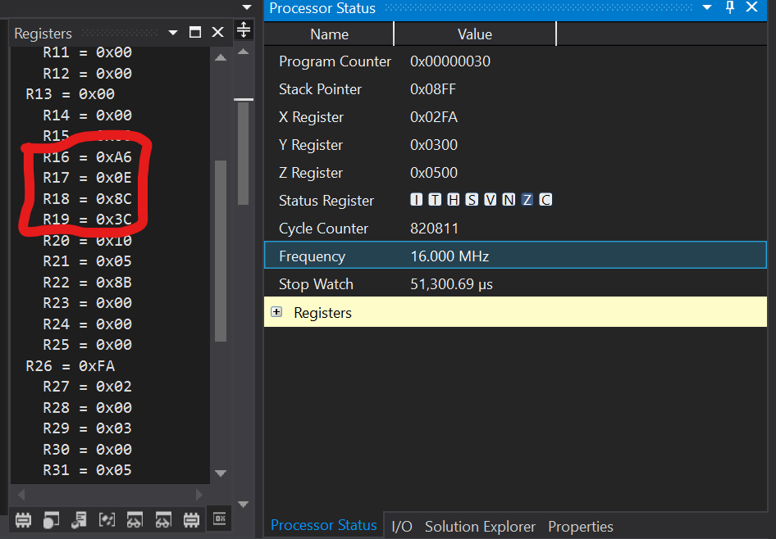sum :

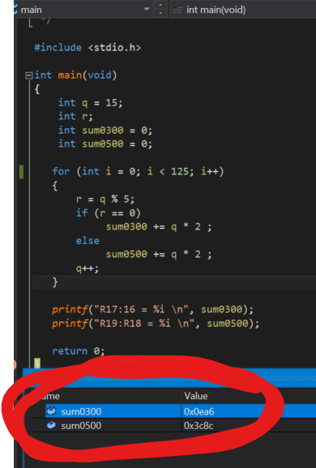c code verification :

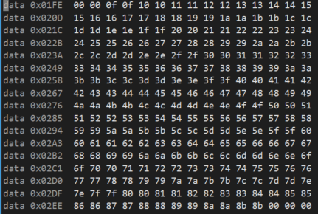0x200 :

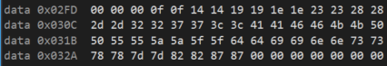0x300 :

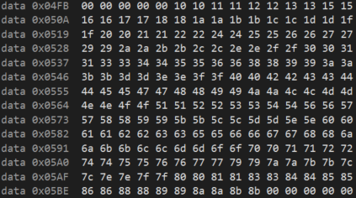0x500 :