CPE301 – SPRING 2019

Design Assignment 1B

Student Name: Kyungseo Yun

Student #: 2001091216

Student Email: yunk93@unlv.nevada.edu

Primary Github address: <https://github.com/biscuit0x/submission_yun.git>

Directory: submission_yun/DesignAssignments/DA1B/

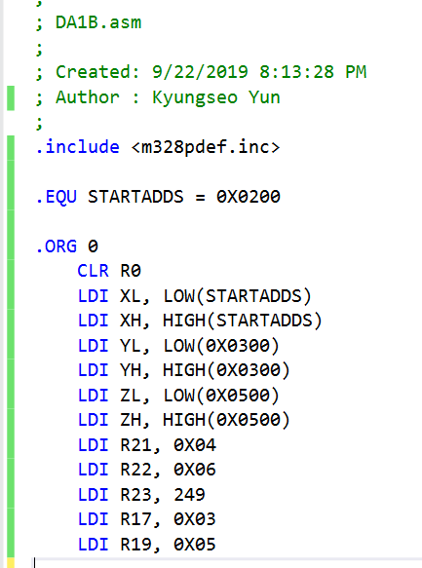1. Code

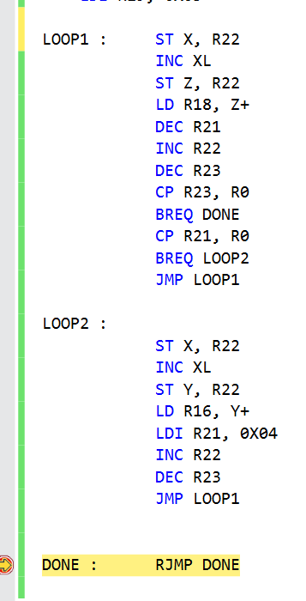

2. Screenshots

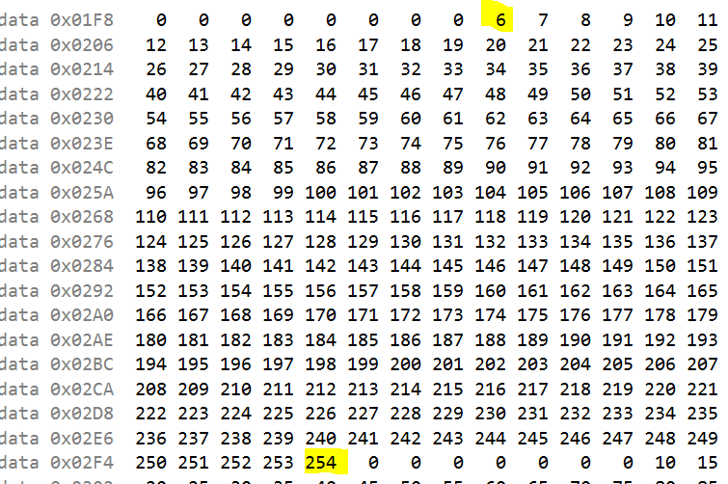0x0200

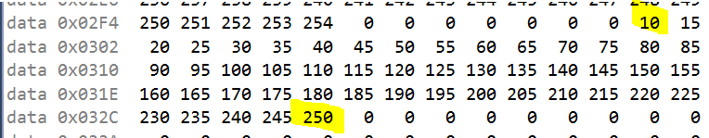0x0300

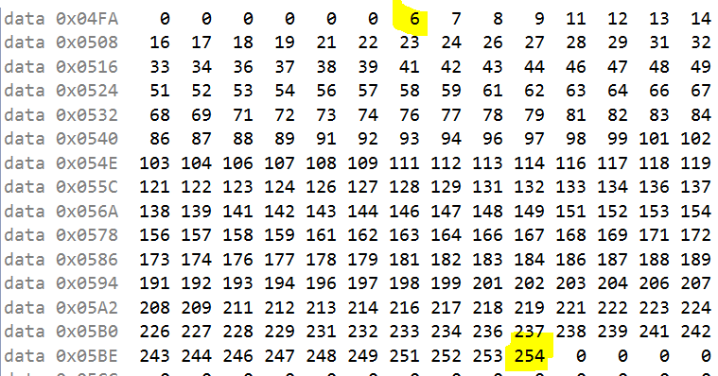0x0500

3. Execution time

