CPE301 – SPRING 2019

Design Assignment 3A

Student Name: Kyungseo Yun

Student #: 2001091216

Student Email: yunk93@unlv.nevada.edu

Primary Github address: <https://github.com/biscuit0x/submission_yun.git>

Directory: submission_yun/DesignAssignments/DA3A/

**1. Components**

-Atmega 328p Xplained mini

-USB

**2. C code**

#define F_CPU 16000000UL

#define BAUDRATE 9600

#define BAUD_PRESCALLER (((F_CPU / (BAUDRATE * 16UL)))-1)

#include <avr/io.h>

#include <avr/interrupt.h>

#include <util/delay.h>

char* string; //string pointer

void USART_init ( void )

{

UBRR0H = (uint8_t)(BAUD_PRESCALLER >> 8); /*set BAUD rate*/

UBRR0L = (uint8_t)(BAUD_PRESCALLER);

UCSR0C = _BV(UCSZ01) | _BV(UCSZ00); /* 8bit data */

UCSR0B = _BV(RXEN0) | _BV(TXEN0); /* Enable RX and TX */

}

void USART_send (char ch)

{

//wait until UDR0 is empty

while (! (UCSR0A & (1<<UDRE0)));

UDR0 = ch ; //transmit ch

}

void USART_putstring (char* StringPtr )

{

while (*StringPtr != 0x00){

USART_send(*StringPtr); //send one character at a time

StringPtr++;

}

}

ISR (TIMER1_OVF_vect)

{

string = "random string \n"; //print random string

USART_putstring(string);

string = "1234 \n"; //print random integer

USART_putstring(string);

string = "5.6789 \n\n";//print random float

USART_putstring(string);

TCNT1 = 49911; //reset timer

}

int main(void)

{

USART_init(); //UART initialization

TIMSK1 = (1<<TOIE1); //enable overflow interrupt

TCNT1 = 49911; //set counter value for 1 sec

TCCR1B = 0X05; //begin counter with prescalar = 1024

sei(); //enable interrupts

while (1)

{

}

}

**3. Schematic**

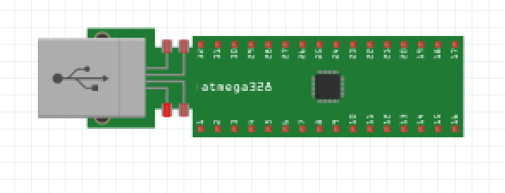

(No FTDI required as Xplained board was used)

**4. Screenshot**

Terminal window :

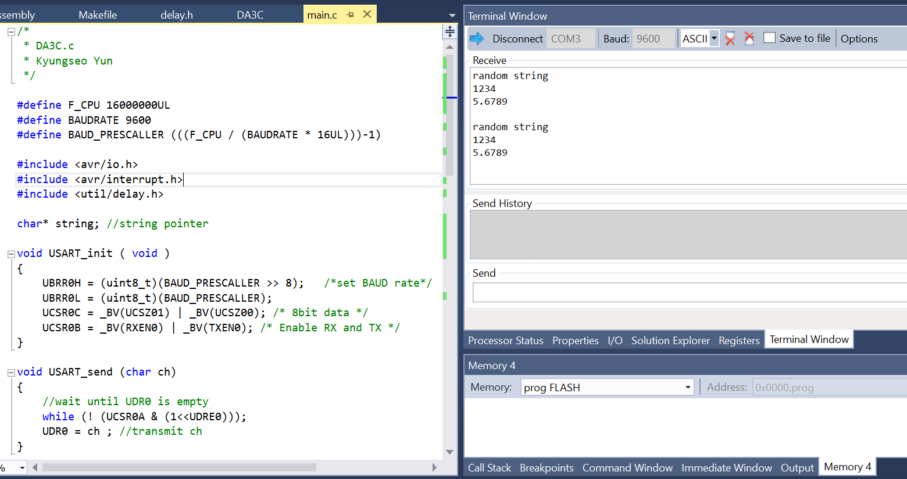

**5. Photo / Video**

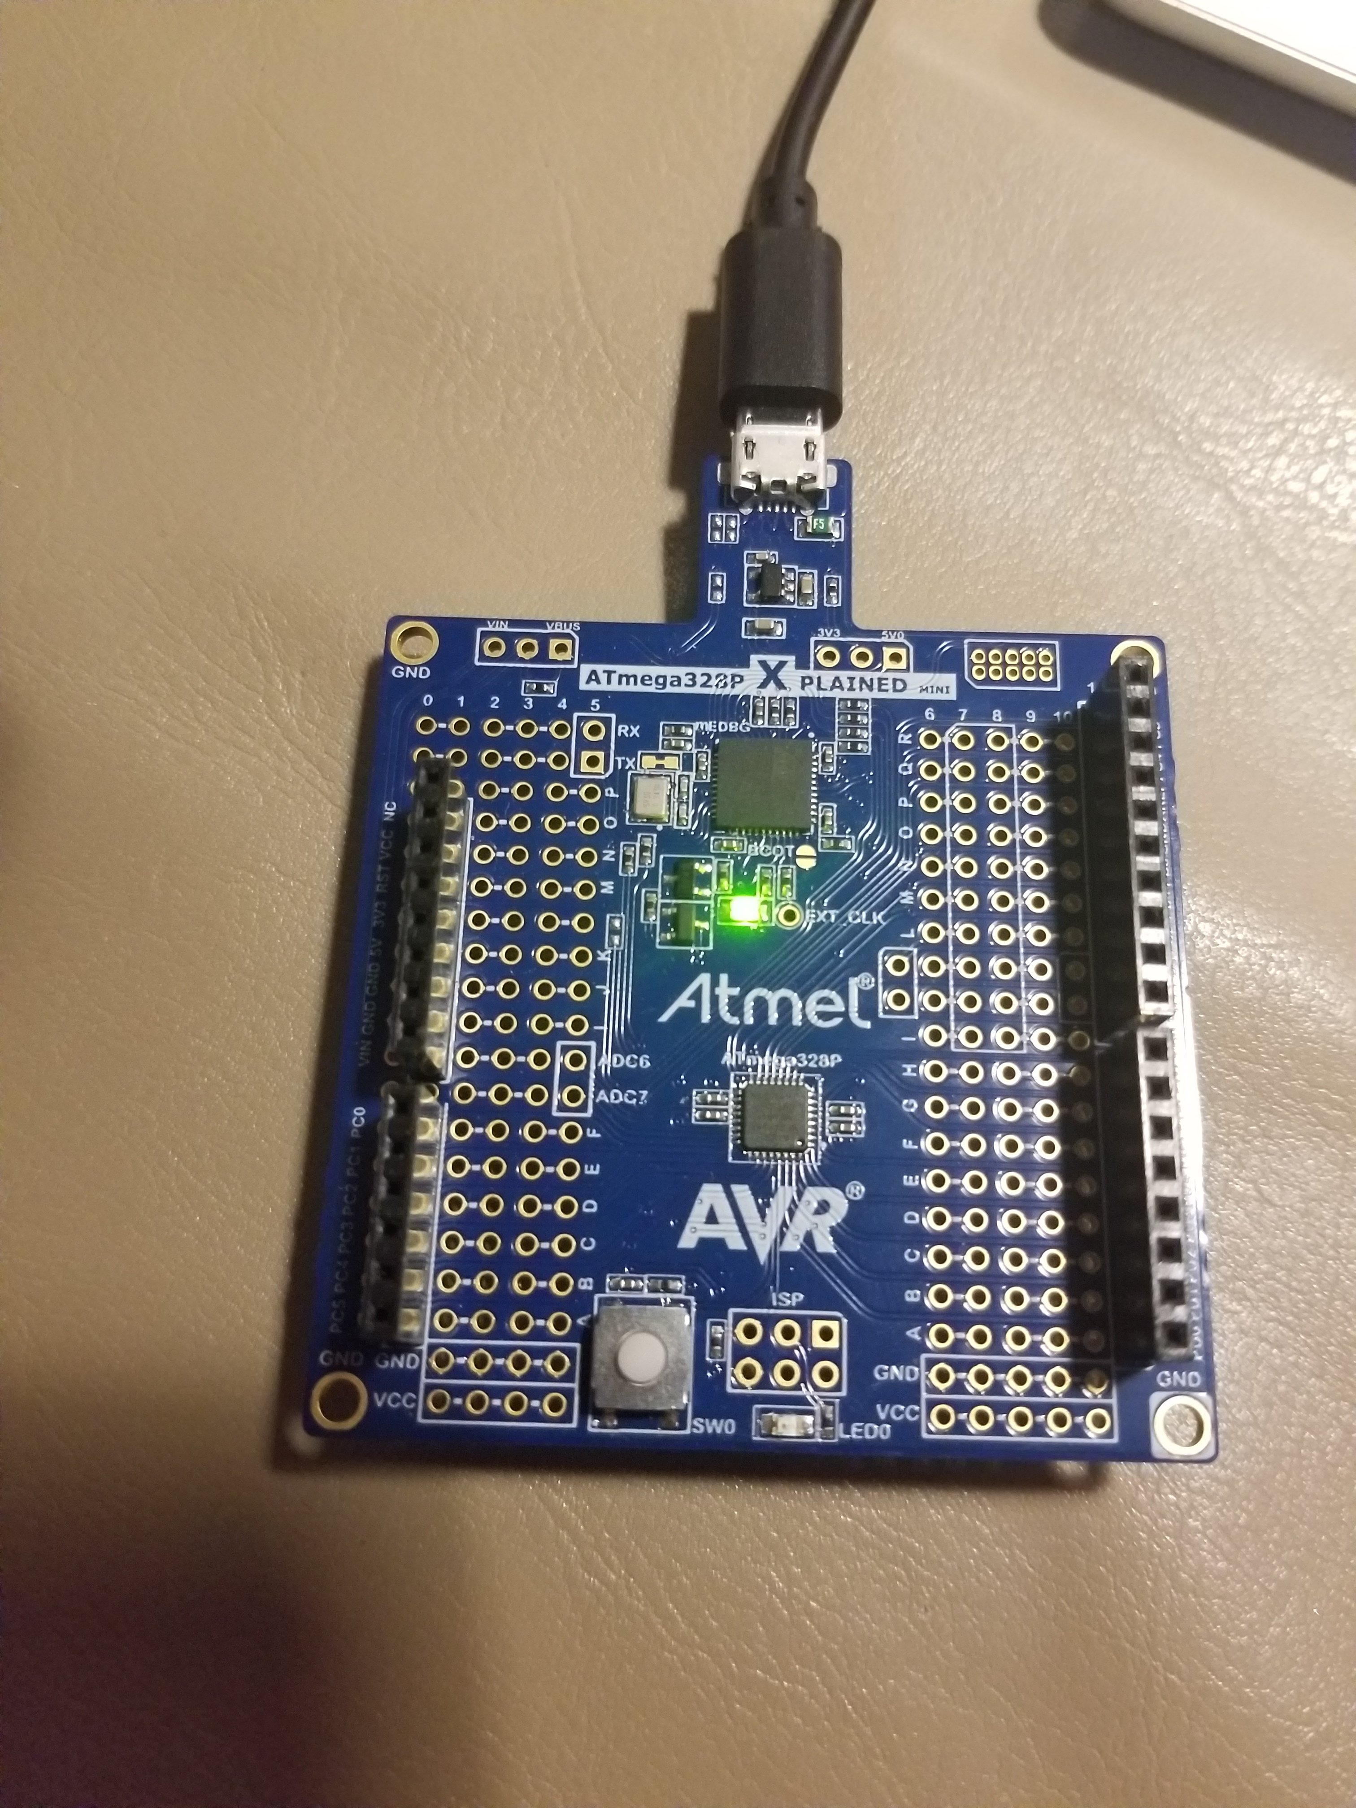

video : https://youtu.be/BMZ2OXb7_5g

**5. Github address**