**SECOND TERMINAL EXAM**

**SESSION: 2022-2023**

**Class: XII**

**SUBJECT: PHYSICS**

**Time Allowed: 3 hours. Maximum Marks: 70 Marks**

***General Instructions:***

1. *There are 35 questions in all. All questions are compulsory*
2. *This question paper has five sections: Section A, Section B, Section C, Section D and Section E. All the sections are compulsory.*
3. *Section A contains eighteen MCQ of 1 mark each, Section B contains seven questions of two marks each, Section C contains five questions of three marks each, section D contains three long questions of five marks each and Section E contains two case study based questions of 4 marks each.*
4. *There is no overall choice. However, some internal choice has been provided in section B, C, D and E. You have to attempt only one of the choices in such questions.*
5. *Use of calculators is not allowed. LOG and trigonometric tables can be used whenever necessary.*

**SECTION-A**

1. **A coil having 500 sq. loops of side 10 cm is placed normal to magnetic flux which increases at a rate of 1 T/s. The induced emf is**

a) 0.1 V b) 0.5 V c) 1 V d) 5 V (1)

1. Lenz’s law is a consequence of law of conservation of

a) charge b) mass c) energy d) momentum (1)

1. In an ac circuit an alternating voltage, e =200 $\sqrt{2}$ Sin 100t volts is connected to a capacitor of capacity 1 µF. The rms value of the current in the circuit is

a) 20 mA b) 200 mA c) 10 mA d) 100mA (1)

1. In an AC circuit the voltage applied is E =E0sinωt. The resulting current in the circuit is I = I0sin(ωt-π/2). The power consumption in the circuit is given by

a) P= √2E0I0 b) P= E0I0/√2 c) P=0 d) P = E0I0/2 (1)

1. The component of EM wave, used for treating muscular strain is

a) Infra Red b) Microwave c) Ultra violet d) Radio Wave (1)

1. Which is the correct order of energy of X rays (EX), radio waves (ER), Ultra Violet waves (EU) and microwaves (EM)?

a) EX > EU > EM > ER b) ER > EU > EM > EX

c) EM < EX < EU < ER d) EX < EU < EM < ER (1)

1. The final image formed in an astronomical refracting telescope with respect to the object is

a) Real inverted b) Real erect c) Virtual erect d) Virtual inverted (1)

1. **A diverging lens of power 6.5 D is combined with a convex lens of focal length, f = 20 cm. What are the power and focal length of the combination?**

a) 5 D, 33.7 cm b) 5 D, 66.7 cm c) 1.5 D, 33.7 cm d) -1.5 D, 66.7 cm (1)

1. Which of the following phenomenon is used in optical fibre?

a) Refraction b) diffraction c) total internal reflection d) scattering (1)

1. Four independent waves are expressed as

(i) y1 = a1 sin(ωt) (ii) y2 = a2 sin(2ωt) (iii) y3 = a3 cos2(ωt) (iv) y4 = a4 sin(ωt + π/3)

Interference is possible between:

a) (i) and (iii) b) (i) and (iv) c) (iii) and (iv) d) Not possible at all (1)

1. Two coherent monochromatic light beams of intensities I and 4I are superimposed. The maximum and minimum possible intensities in the resulting beams are

a) 5I and I b) 5I and 3I c) 9I and I d) 9I and 3I (1)

1. Photoelectric effect experiments are performed using three different metal plates p,q and r having work functions of 2 eV, 2.5 eV and 3 eV respectively. A light beam containing wavelengths of 550 nm, 450nm and 350 nm with equal intensities illuminates each of the plates. The correct I-V graph is

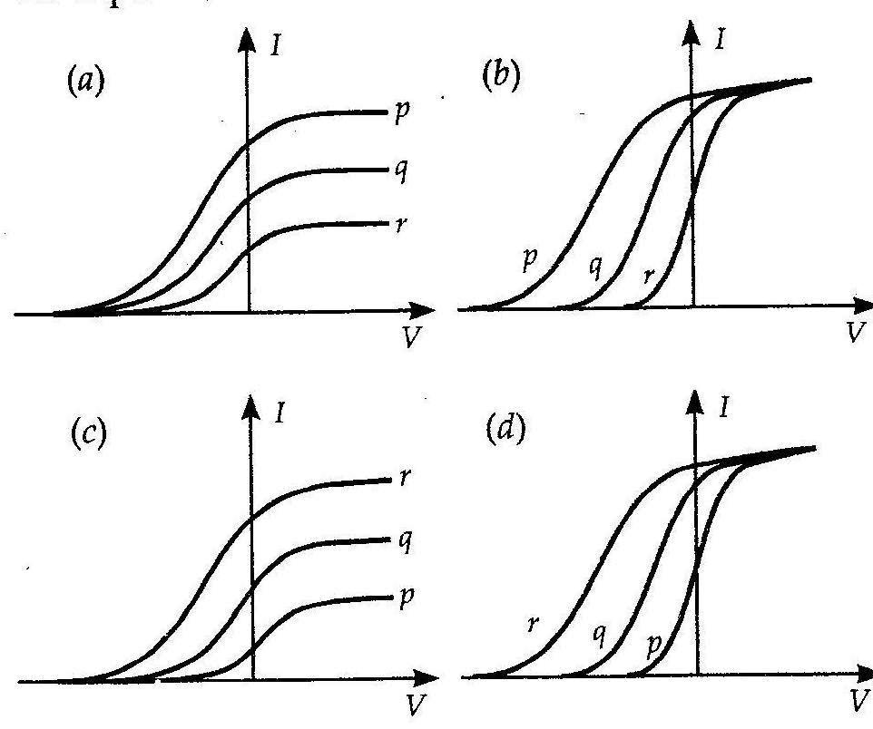 (1)

1. A photon beam of energy 12.1eV is incident on a hydrogen atom. The orbit to which electron of H-atom in ground state be excited is

a) 2nd b) 3rd c) 4th d) 5th (1)

1. The radius of the innermost electron orbit of a hydrogen atom is 5.3 x 10-11 m. The radius of the n =3 orbit is

a)1.01 x 10-10m b) 1.59 X 10-10m c) 2.12 x 10-10m d) 4.77 X 10-10m (1)

1. Which of the following statements about nuclear forces is not true?

a) The nuclear force between two nucleons falls rapidly to zero as their distance is more than a few femto-metres.

b) The nuclear force is much weaker than the Coulomb force.

c) The force is attractive for distances larger than 0.8 fm and repulsive if they are separated by distances less than 0.8 fm.

d) The nuclear force between neutron-neutron, proton-neutron and proton-proton is approximately the same. (1)

**ASSERTION REASONING QUESTIONS**

Directions: These questions consist of two statements, each printed as Assertion and Reason. While answering these questions, you are required to choose any one of the following four responses.

**a) If both Assertion and Reason are correct and the Reason is a correct explanation of the Assertion.**

**b) If both Assertion and Reason are correct but Reason is not a correct explanation of the Assertion.**

**c) If the Assertion is correct but Reason is incorrect.**

**d) If both the Assertion and Reason are incorrect.**

1. **Assertion:** The photoelectrons produced by a monochromatic light beam incident on a metal surface have a spread in their kinetic energies.

**Reason:** The energy of electrons emitted from inside the metal surface, is lost in collision with the other atoms in the metal.

1. **Assertion:** Density of all nuclei is same.

**Reason:** Radius of nucleus is directly proportional to cube root of mass number.

1. **Assertion:** The electrical conductivity of a semiconductor increases on doping.

**Reason:** Doping always increases the number of electrons in the semiconductor.

**SECTION-B**

1. A current carrying wire and rod AB are in the same plane. If the rod moves parallel to wire with velocity ϑ, which end of the rod is at higher potential? Justify your answers.

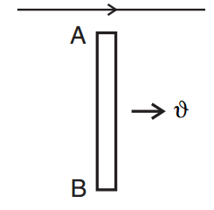 (2)

OR

The magnetic field through a circular loop of wire, 12cm in radius and 8.5Ω resistance, changes with time as shown in the figure. The magnetic field is perpendicular to the plane of the loop. Calculate the current induced in the loop.

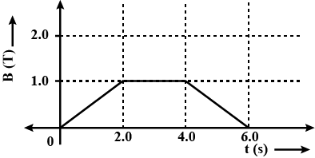 (2)

1. How does a charge q oscillating at certain frequency produce electromagnetic waves? Sketch a schematic diagram depicting electric and magnetic fields for an electromagnetic wave propagating along the Z-direction.  (2)
2. A biconvex lens made of a transparent material of refractive index 1.25 is immersed in water of refractive index 1.33. Will the lens behave as a converging or a diverging lens? Justify your answer. (2)
3. A ray of light passing through an equilateral triangular glass prism from air undergoes minimum deviation when angle of incidence is 3/4th of the angle of prism. Calculate the speed of light in the prism. (2)
4. The short wavelength limit for the Lyman series of the hydrogen spectrum is 913.4 Ao. Calculate the short wavelength limit for the Balmer series of the hydrogen spectrum. (2)
5. What is the nuclear radius of 125Fe, if that of 27Al is 3.6 fermi? (2)
6. A piece of pure semiconductor S in series with a variable resistor R and a source of constant voltage V. Should the value of R be increased or decreased to keep the reading of the ammeter constant, when semiconductor S is heated? Justify your answer. (2)

OR

The graph of potential barrier versus width of depletion region for an unbiased diode is shown in graph A. In comparison to A, graphs B and C are obtained after biasing the diode in different ways. Identify the type of biasing in B and C and justify your answer. (2)

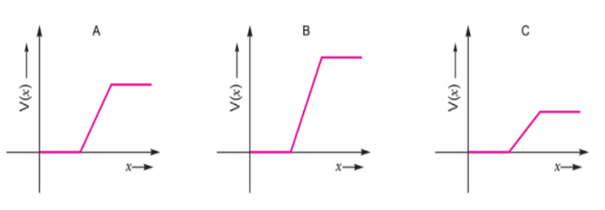

**SECTION-C**

1. Define the term self-inductance of a solenoid. Obtain the expression for the magnetic energy stored in an inductor of self-inductance L to build up a current I through it. (3)

OR

Obtain the expression for mutual inductance of a pair of long coaxial solenoids each of length l and radii r1 and r2 (r2 >> r1). Total number of turns in the two solenoids are N1 and N2 respectively.  (3)

1. a) Plot a graph showing variation of capacitive reactance with the change in the frequency of the AC source.

b) A capacitor ‘C’, a variable resistor ‘R’ and a bulb ‘B’ are connected in series to the ac mains in a circuit as shown. The bulb glows with some brightness. How will the glow of the bulb change if  
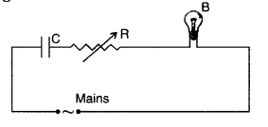

(i) a dielectric slab is introduced between the plates of the capacitor, keeping resistance R to be the same;   
(ii) the resistance R is increased keeping the same capacitance? (1+2)

1. a) What is the relation between critical angle and refractive index of a material?  
   b) Does critical angle depend on the colour of light? Explain.

c) What are the conditions to obtain Total internal reflection? (1+1+1)

1. In Young’s double slit experiment using mono-chromatic light of wavelength X, the intensity of light at a point on the screen where path difference is X, is K units. Find out the intensity of light at a point where path difference is 2λ/3. (3)
2. Using Bohr’s postulates, obtain the expression for the total energy of the electron in the stationary states of the hydrogen atom. Hence draw the energy level diagram showing how the line spectra corresponding to Balmer series occur due to transition between energy levels. (3)

OR

Using Bohr’s postulates of the atomic model, derive the expression for radius of nth electron orbit. Hence obtain the expression for Bohr’s radius.

**SECTION D**

1. a) Discuss how Faraday’s law of e.m. induction is applied in an ac-generator for converting mechanical energy into electrical energy. Obtain an expression for the instantaneous value of the induced emf in an ac generator.

b) A 100-turn coil of area 0.1 m2 rotates at half a revolution per second. It is placed in a magnetic field 0.01 T perpendicular to the axis of rotation of the coil. Calculate the maximum voltage generated in the coil. (3+2)

OR

a) An a.c. source of voltage V = V0 sin ωt is connected to a series combination of L, C and R. Use the phasor diagram to obtain expressions for impedance of the circuit and phase angle between voltage and current. Find the condition when current will be in phase with the voltage. What is the circuit in this condition called?  
b) In a series LR circuit XL = R and power factor of the circuit is P1. When capacitor with capacitance C such that XL = XC is put in series, the power factor becomes P2. Calculate P1/P2. (3+2)

1. a) What do you mean by interference of light? Mention two conditions necessary for sustained interference pattern on a screen. Why two different sources of same frequency cannot produce interference pattern?

b) Laser light of wavelength 640 nm incident on a pair of slits produces an interference pattern in which the bright fringes are separated by 7.2 mm. Calculate the wavelength of another source of light which produces interference fringes separated by 8.1 mm using same arrangement. (3+2)

OR

What do you mean by diffraction of light? Obtain expressions for angular position of secondary minima’s and secondary maxima’s in a single slit diffraction pattern.

Plot graphs showing variation of intensity with distance from the centre of the screen for interference pattern and diffraction pattern. Mention the difference between the two patterns in terms of fringe width. (3+2)

1. a) Draw a labelled ray diagram to show the formation of image in an astronomical telescope for a distant object.  
   b) Write two distinct advantages of a reflecting type telescope over a refracting type telescope.  
   c) A convex lens of focal length 10 cm is placed coaxially 5 cm away from a concave lens of focal length 10 cm. If an object is placed 30 cm in front of the convex lens, find the position of the final image formed by the combined system. (2+1+2)

OR

a) Draw a ray diagram showing the image formation by a compound microscope. Obtain expression for total magnification when the images is formed at least distance of distinct vision.  
b) You are given two converging lenses of focal lengths 1.25 cm and 5 cm to design a compound microscope. If it is desired to have a magnification of 30, find out the separation between the objective and the eyepiece. (3+2)

**SECTION – E**

1. **Case study: Light emitting diode**.

Read the following paragraph and answer the questions

LED is a heavily doped P-N junction which under forward bias emits spontaneous radiation. When it is forward biased, due to recombination of holes and electrons at the junction, energy is released in the form of photons. In the case of Si and Ge diode, the energy released in recombination lies in the infrared region. LEDs that can emit red, yellow, orange, green and blue light are commercially available. The semiconductor used for fabrication of visible LEDs must at least have a band gap of 1.8 eV. The compound semiconductor Gallium Arsenide –Phosphide is used for making LEDs of different colours.

(a). Why are LEDs made of compound semiconductor and not of elemental semiconductors?

(b) What should be the order of band gap of an LED, if it is required to emit light in the visible range?

(c) A student connects the blue coloured LED as shown in the figure. The LED did not glow when switch S is closed. Explain why?

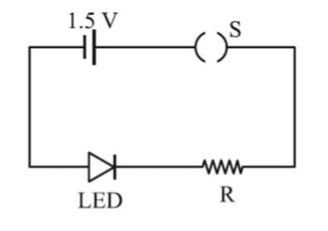

OR

(c) Draw V-I characteristic of a p-n junction diode in (i) forward bias and (ii) reverse bias (1+1+2)

1. **Case study: Light emitting diode**.

Read the following paragraph and answer the questions

Dual nature of matter was proposed by de Broglie in 1923, it was experimentally verified by Davisson and Germer by diffraction experiment. Wave character of matter has significance only for microscopic particles. de Broglie wavelength or wavelength of matter wave can be calculated using the following relation: λ=h/mv where, 'm' and 'v' are the mass and velocity of the particle.

1. Draw a plot showing the variation of de Broglie wavelength of electron as a function of its K.E.
2. State one reason to explain why wave theory of light does not support photoelectric effect.
3. Figure shows a plot of 1/ $\sqrt{V}$, where V is the accelerating potential, vs. the de-Broglie wavelength ‘λ’ in the case of two particles having same charge ‘q’ but different masses m1 and m2. Which line (A or B) represents a particle of larger mass?  
    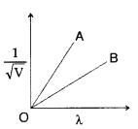

OR

A proton and a deuteron are accelerated through the same accelerating potential. Which one of the two has less momentum? Give reasons to justify your answer.  (1+1+2)