Name: Vishal Radheshyam Bisen

**How can you help Sunita Sharma (65+ years old) to live a healthier and better life?**

I can suggest some general tips to help Sunita Sharma lead a healthier and better life

**1.Regular Exercise**: Encourage Sunita Sharma to engage in regular physical activity such as walking, yoga or stretching exercises. This can help her maintain a healthy weight, improve her mood and reduce the risk of chronic diseases.



**2.Balanced Diet**: Suggest Sunita Sharma to have a balanced and nutritious diet with plenty of fruits, vegetables, whole grains, lean proteins and healthy fats. She should avoid processed foods and sugary drinks.

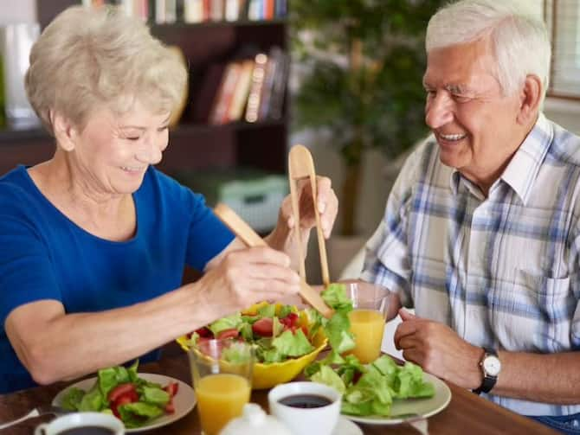

**3.Regular Health Checkups**: Encourage Sunita Sharma to have regular health check-ups with her doctor. This can help detect any health problems early and improve the chances of successful treatment.

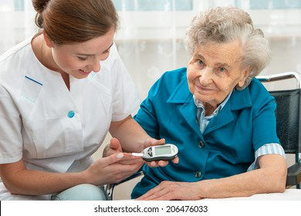

**3.Mental Health**: Sunita Sharma should also pay attention to her mental health. Encourage her to engage in activities that promote relaxation and stress relief such as meditation or spending time with loved ones.

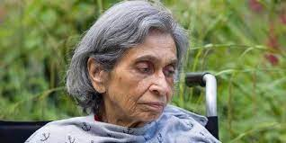

**4.Social Connections**: Sunita Sharma should maintain social connections with friends and family as social isolation can lead to depression and other health problems.



**5.Healthy Habits**: Encourage Sunita Sharma to adopt healthy habits such as getting enough sleep, avoiding smoking and excessive alcohol consumption, and maintaining good hygiene.



**6.Activities**: Engage Sunita Sharma in activities that interest her and keep her engaged. Encourage her to explore new hobbies or learn new skills.

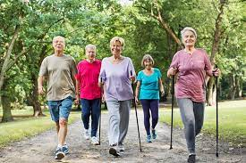

It's important to note that Sunita Sharma's health needs may vary based on her individual circumstances, so it's important to consult with her doctor or a healthcare professional to develop a personalized health plan.

**Medication Management**

One use case for elderly care for the age group of 65+ could be medication management. Many seniors need to take multiple medications each day, and it can be challenging to keep track of which medications to take at what times. This can lead to missed doses, incorrect dosages, and potentially dangerous interactions.

To address this challenge, I propose a working prototype of a medication management app that uses technology known to me. The app would have the following features:

1. **Medication reminders**: The app would remind Sunita Sharma to take her medications at the appropriate times each day. She could set the reminders for each medication she takes, including the dosage and frequency.

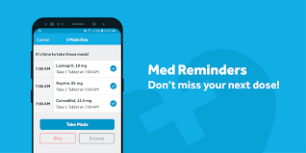

2. **Medication tracking**: The app would keep track of which medications Sunita Sharma has taken and when, to help her avoid accidentally taking a double dose.

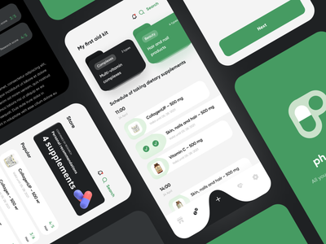

3**. Medication information**: The app would provide information about each medication Sunita Sharma is taking, including the dosage, side effects, and potential drug interactions.

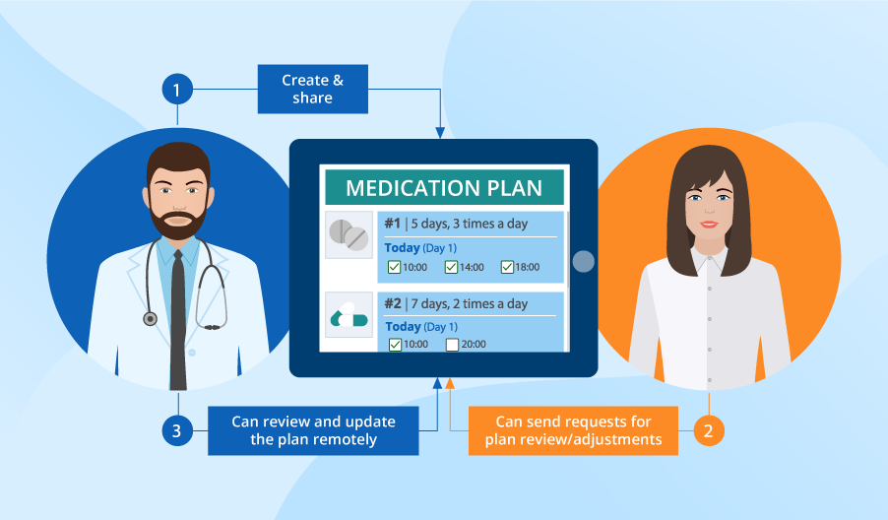

4**. Doctor communication**: The app would allow Sunita Sharma to communicate with her doctor about her medications and any concerns she has.

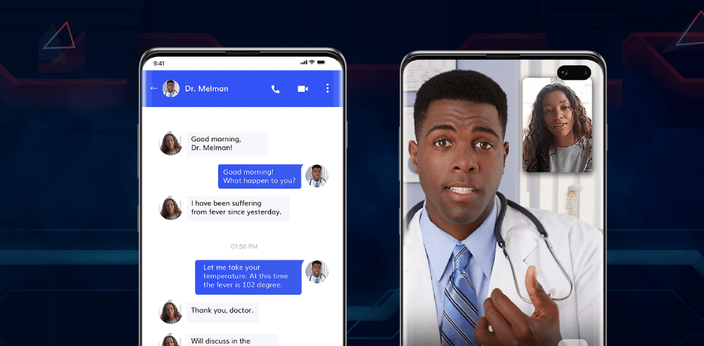

The app would have a simple and easy-to-use interface with large text and buttons to make it accessible for seniors. It could be used on a smartphone or tablet device.

When Sunita Sharma logs into the app, she would see a list of her medications and the times she needs to take them. The app would also display any notes or reminders from her doctor. To mark a medication as taken, Sunita Sharma would simply tap a button next to the medication.

If Sunita Sharma misses a dose, the app would send her a notification reminding her to take her medication as soon as possible. The app could also send a notification to her caregiver or family member to let them know that she has missed a dose.

Overall, a medication management app could help Sunita Sharma and other seniors manage their medications more effectively, reducing the risk of missed doses and medication errors. It could also provide valuable information and communication tools to help seniors stay on top of their health.

There are many ways that technology can be used to support the health and well-being of older adults. Here are a few additional examples:

1. Telehealth: Telehealth technology can enable seniors to receive medical care and consultations from the comfort of their own homes. This can be especially useful for those who have mobility or transportation challenges.



2. Wearable Technology: Wearable devices such as fitness trackers can help seniors monitor their physical activity, heart rate, and sleep patterns. This can encourage them to stay active and healthy, and also provide valuable information to their healthcare providers.

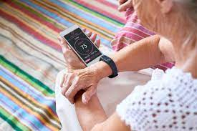

3. Smart Home Technology: Smart home technology can make it easier for seniors to manage their daily activities and stay safe. For example, smart home devices can automate tasks such as turning on lights, adjusting thermostats,

and locking doors. They can also provide alerts for falls, accidents, and other emergencies.

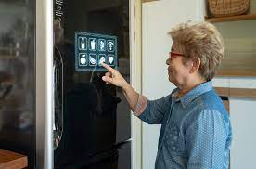

4. Social Networking: Social networking sites can help seniors stay connected with friends and family members who live far away. They can also provide opportunities for social interaction and engagement with others who share similar interests.



5. Cognitive Training: Technology-based cognitive training programs can help seniors maintain cognitive function and delay the onset of dementia. These programs can include games, puzzles, and other activities designed to stimulate the brain.

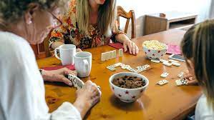 Overall, technology can be a powerful tool for supporting the health and well-being of older adults. By leveraging technology in creative and innovative ways, we can help seniors live more independent, fulfilling, and connected lives.