*#include <stdio.h>*

*int euclidean(int a, int b) {*

*while (b != 0) {*

*int r=a%b;*

*a=b;*

*b=r;*

*}*

*return a;*

*}*

*int main() {*

*int x, y, result;*

*printf("Enter two integers: ");*

*scanf("%d %d", &x, &y);*

*result = euclidean(x, y);*

*printf("GCD(%d,%d)=%d", x, y, result);*

*return 0;*

*}*

***Output:***

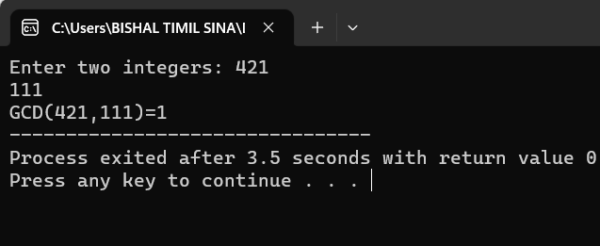

*#include <stdio.h>*

*void extended_euclidean(int a, int b, int *x, int *y, int *gcd) {*

*int x0 = 1, y0 = 0, x1 = 0, y1 = 1;*

*int q, r, xn, yn;*

*while (a != 0) {*

*q = b / a;*

*r = b % a;*

*xn = x0 - q * x1;*

*yn = y0 - q * y1;*

*x0 = x1;*

*y0 = y1;*

*x1 = xn;*

*y1 = yn;*

*b = a;*

*a = r;*

*}*

*\*x = x0;*

*\*y = y0;*

*\*gcd = b;*

*}*

*int main() {*

*int a, b, x, y, gcd;*

*printf("Enter two numbers: ");*

*scanf("%d %d", &a, &b);*

*extended_euclidean(a, b, &x, &y, &gcd);*

*printf("Extended Euclidean algorithm:\n");*

*printf("gcd(%d, %d) = %d\n", a, b, gcd);*

*printf("%d * %d + %d * %d = %d\n", a, x, b, y, gcd);*

*return 0;*

*}*

**Output:**

