Radiation Safety and Protection Plan

FBFV-Roma, QLD

RSPP Rev1.1

Huracan Pty Ltd

20-Sep-19

Revision 1.1

Document Control: Public

**Document Control**

Document Owner: Jon Hollingworth

Document Approver: Paul Nunn (RSO)

**Revision History**

|  |  |  |  |  |
| --- | --- | --- | --- | --- |
| **Rev** | **Reviewer** | **Approver** | **Date** | **Revision Comments** |
| 1.0 | J. Hollingworth | P. Nunn (RSO) | 20-May-19 | First edition of RSPP |
| 1.1 | J. Hollingworth | P. Nunn (RSO) | 20-Sep-10 | Initial review. |
|  |  |  |  |  |
|  |  |  |  |  |

Table of Contents

1. Intent 3

2. Definitions 3

3. Responsibilities 3

3.1 Consignor 3

3.2 Carrier 3

3.3 Possession Licensee 4

3.4 Radiation Safety Officer (RSO) 5

3.5 Operators 5

4. Hazard Assessment 6

5. Control of Access 6

5.1 Storage 7

5.2 Transportation of Radioactive Materials Legislated Requirements 7

5.3 Source Leakage Tests 8

6. Training 9

7. Safe work practices 9

7.1 General Safe Practices 9

7.2 Transportation of Radioactive (Legislative Requirements) 10

8. Monitoring requirements 11

8.1 Personal Radiation Monitoring 11

8.2 Personal Alarm Monitoring Devices 12

8.3 Safety Devices 12

8.4 Personal Protective Equipment 12

8.5 Radiation Survey Meter 12

9. Repairs and Maintenance 13

9.1 Source Leakage Tests 13

10. Compliance Checks 13

11. Reporting Requirements 14

12. Acquisition, supply and relocation of radioactive substances 15

13. Incident Procedures 16

14. Reference library 16

Appendices 18

15.1 Appendix A - Relevant Contact Details 18

15.2 Appendix B - Radioactive Source Details 18

15.2.1 Cs-137 Roxar Source General Overview 18

15.2.2 Cs-137 Roxar Source Removal and Controlled Installation 18

15.3 Appendix C - Authorised Personnel 18

15.4 Appendix D - Radiation Survey Meters Register 19

15.5 Appendix E Radioactive Materials Store 19

15.6 Appendix F Roxar Cs-137 Gamma Ray Source Declaration of Conformity 20

15.7 Appendix G - Roxar Cs-137 Gamma Ray Source Drawing 0

# Intent

Huracan recognises the prescribed obligation to implement a radiation safety and protection plan for the management of operations involving radioactive sources. This plan has been formulated to provide guidance for all sealed source apparatus Industrial gauging practices are conducted as safely as possible and in compliance with Radiation Safety Act 1999 and the Radiation Safety Regulation 1999.

This plan applies to all Huracan operations for surface fluid density characterisation containing radioactive sealed sources the possession licensee is in possession of, further detail of gauges and premises are included within Appendix B.

Compliance with this plan is mandatory to help ensure any radiation exposure to workers and/or the public is managed to comply with or be less than the prescribed limits.

# Definitions

|  |  |
| --- | --- |
| Carrier | An individual or organisation transporting radioactive materials |
| Consignment | A package, or load of radioactive materials, which is presented by a consignor for transport |
| Consignor | An individual or organisation who prepares a consignment of radioactive materials for transport, and who is named as consignor in the transport documents |
| Package | This includes the packaging together with its radioactive contents as presented for transport |
| Transport Index (TI) | A number assigned to a package, over-pack or freight container, or to unpackaged LSA-1 or SCO-1, to assist in providing control over radiation exposure. In general, the TI corresponds to the radiation level (in units of millisieverts per hour) at 1 metre from the surface of a package multiplied |
| Possession Licensee | Approved person or company, by the Chief Executive of Queensland Health |
| Radiation Safety Officer | RSO. Competent person to perform the duties of RSO as nominated by the Possession Licensee. The Possession Licensee may appoint themselves as the RSO if they are competent to perform the duties outlined under Responsibilities. |

# Responsibilities

## 3.1 Consignor

To ensure that packages containing radioactive materials are safe to handle under normal conditions, the consignor is responsible for:

* Packaging and labelling radioactive materials for transport in accordance with the Transport Code; and
* Preparing and certifying the transport documentation as required by the Transport Code

## 3.2 Carrier

* Checking that appropriate documentation is provided with the package, and has been completed in accordance with the Transport Code
* Verifying that the information on the consignment note, consignor’s declaration for dangerous goods (if applicable) and the package containing the radioactive materials is consistent;
* Identifying labels to ensure appropriate decisions are made about storage, loading and transport;
* The loading, unloading, handling, transport and interim storage of packages where appropriate, including any directions given by the consignor such as special stowage provisions for the safe dissipation of heat; and
* Emergency procedures in the event of an incident while loading, transporting, unloading or storage of a package.

## 3.3 Possession Licensee

Huracan is applying for a license to possess sealed radioactive sources for surface logging, see Appendix A for further detail.

* Hold a license, issued under the Radiation safety Act 1999, with an authority to possess sealed radioactive substances used for surface well monitoring requiring the use of a radioactive source;
* Ensure that all users of radiation sources hold licenses, including initial installation, repair and maintenance operations as issued by the relevant authority, allowing them to use such equipment for surface fluid density characterisation;
* Ensure the radiation doses arising from the radiation practice/s are kept below the limits specified in prescribed regulations and are as low as reasonably achievable;
* Ensure this Radiation Protection and Safety Plan is available and adhered to, that there is adequate resources for the implementation of this plan and all necessary records are kept;
* Ensure radiation sources are not relocated from a place in Queensland to a place outside Queensland (whether in or outside Australia), without holder an approval to relocate the source and where relocation occurs, must advise the Chief Executive within seven (7) days. The radiation source shall remain on the possession licensee’s inventory until such time as satisfactory evidence that this relocation has occurred has been received.
* Must not supply, without permission, a radiation source to another person, unless the other person is a possession licensee for the source and the holder of an approval to acquire the source;
* Must dispose of, without permission, radioactive material in accordance with the prescribed regulation/s including, the notification to the Chief Executive within the designated timeframe;
* Must not abandon a radiation source;
* Ensure radiation monitoring is carried out in accordance with this plan;
* Provide personal monitoring devices to monitored persons as required by this plan and ensure that:
  + Personal monitoring devices are handled properly;
  + Monitored persons are advised of their personal monitoring assessment results; and
  + Copies of the personal monitoring assessment results are submitted to the Chief Executive at Queensland Health.
  + A personal monitoring record is kept for each person monitored
* Ensure compliance with any conditions imposed on the possession license by the chief executive of Queensland Health and with any other prescribed or regulatory obligation;
* Appoint a Radiation Safety Officer (RSO)
* Ensure the RSO is completing their functions properly so the possession licensee is adequately apprised of the radiation safety status of the practice at all times;
* Ensure the radiation sources continue to comply with radiation safety standard *NM009:2010 Standard for sealed radioactive substances incorporated in sealed source apparatus used to carry out industrial gauging,* including obtaining certificates of compliance from an appropriately accredited person before initial use and every three (3) years thereafter;
* Ensure that the premises where radioactive substances are stored continue to comply with radiation safety standard *PR002:1999 Standard for premises at which radioactive substances are stored,* and obtain the necessary certificates of compliance form an appropriately accredited person, before initial use and every five (5) years thereafter;
* Ensure that the premises where radioactive sources are used continue to comply with the specified radiation standards, and obtain certificates of compliance from an appropriately accredited person, before initial use and every five (5) years thereafter;
* Ensure that, where there is a change in location of a radiation source, an appropriately accredited person performs an assessment of the premises for compliance with specific radiation safety standards before the source is used.
* Ensure reporting requirements are met to the Chief Executive in the event an incident involving a radioactive source occurs.

## 3.4 Radiation Safety Officer (RSO)

* Identify ways, consistent with this plan for minimising the radiation doses received by persons from the source;
  + Provide or arrange for the provision of training about radiation hazards, safe working practices and precautions required, to workers carrying out operations involving radiation or, any other persons who may be working for the licensee who may be exposed to radiation emitted from the source
* Identify if this plan is being complied with;
* Review the plan in accordance with company processes, to ensure its continued effectiveness:
  + All licenses and compliance certificates are maintained as current;
  + Details of the gauges including maintenance, repair and safety checks are conducted and records maintained;
  + Radiation monitoring devices are calibrated and in good working order with all records maintained
* Identify if the relevant radiation safety standard for the source, or premises is being complied with;
* Report, to the possession licensee any:
  + Radiation incidents immediately;
  + Contravention of this plan and or relevant safety standards and any subsequent actions required to re-achieve compliance;
  + Determine the effectiveness and extent of compliance with this plan and regulatory obligations by way of auditing as required; and
  + Recommendations for changes as required to ensure continued compliance and effectiveness in the management of radiation safety and protection.

## 3.5 Operators

* Take all reasonable steps to ensure that a person’s health and safety are not adversely affected by exposure to radiation exposure from operations conducted;
* Hold and maintain the relevant license for the operations required;
* Ensure they are authorised by the possession licensee to use and transport the radioactive substance;
* Understand this radiation safety and protection plan, their obligations and commit to complying with this plan and any safe systems of work required;
* Actively participate in the required training and maintain the necessary competence to conduct operations;
* Wear any personal protection supplied i.e. personal dosimeter;
* Account for and maintain the handling, transport and use of any radioactive sources in accordance with this plan i.e. log-out of source, ensure the continued security of the source whilst in transport or as operationally required and return of the source as required;
* Ensure that repairs and maintenance of the source is conducted in accordance with the RSO;
* Report any incidents or contravention with this plan and subsequent regulatory standards to the RSO.

# Hazard Assessment

Huracan may utilise radioactive sources for surface density measurement as operations require, to determine certain characteristics of the produced fluid from a well. The radioactive sources are present in, or attached to, the surface inline flowmeter which are in a solid sealed source state.

If incorrectly handled or inadequately shielded, the radioactive substances incorporated in the Industrial sources present the potential for exposure to the radioactive sources. The access to and handling of are identified health hazards which require strict controls to ensure unauthorised exposure does not occur.

A number of variables should be considered in regards to the management of radiation doses to persons involved in the practice or other persons such as members of the public including the type of radioactive substances to be used, compliance with work practices, this plan and any other prescribed standards or directions by regulatory bodies. Limits set are detailed within the *Radiation Safety Regulation 2010,* which prescribes:

* the average of the annual total effective dose for the person, over a 5-year period, must not be more than 20mSv per year;
* the total effective does limit applying to the public exposure of a person must not be more than 1mSv per year; and
* the total effective does for a pregnant woman (where reasonably aware) involved in carrying out the practice is a total effective does of 1 mSv per year.

In Queensland, the personal radiation monitoring results of persons employed where industrial gauging occurs, indicate that radiation doses above 1mSv per year are seldom received. By comparison, the annual average natural background radiation dose to a person is 2mSv per year. Where poor work practices or where gauges do not comply with the relevant standards occurs, results in higher radiation doses may occur.

# Control of Access

Control of access to all radioactive materials must be strictly managed including its use, transport and storage. Only authorised personnel are permitted (by the possession licensee) to use the surface fluid density characterisation radioactive sources. Details of authorised personnel is available in Appendix C – Authorised Personnel.

In the event of Huracan operations requiring a radioactive source, all due diligence checks shall be conducted in accordance with this plan to ensure the relevant persons are authorised by the possession licensee to use, store and handle radioactive materials.

## 5.1 Storage

All radioactive sources must be stored in accordance with the relevant safety standard such as:

* Up to 30 days temporary storage i.e. Production Package at wellsite
* Premises which has been certified as meeting relevant radiation safety standard.

## 5.2 Transportation of Radioactive Materials Legislated Requirements

People involved in the transport of radioactive materials must receive the appropriate training on radiation hazards that may be encountered during the transport of radioactive materials, including the precautions that must be observed to restrict their own exposure and the exposure of other persons who might be affected by their actions. Additionally, in accordance with the Radiation Safety Act 1999, section 14, a license must be held by persons required to transport radioactive substances in compliance with the Transport Code, with an exemption under section 70 of the Radiation Safety Regulation 2010, as is applicable to Huracan operations:

* A transport license is not required if a radioactive substance is transported in accordance with the Transport Code if:
  + A sealed radioactive substance, incorporated in a sealed source apparatus, is transported by a person who is licensed to use the apparatus to carry out one of the following radiation practices:
    1. Borehole logging
    2. Industrial gauging, Density-gauging or moisture-gauging, for geo-technical purposes
    3. Industrial radiography

Those who are exempt from the requirement to hold a transport license by virtue of holding a use license for a prescribed radiation practice, are considered to be adequately trained to transport specific radioactive materials under industry specific conditions as, the training received during the radiation safety training required as a pre-requisite for obtaining a license is adequate. Additionally, the licensed Huracan workers are required to comply with the possession licensee’s approved radiation safety and protection plan (this Radiation Management Plan) as approved by the Chief Executive of the Department of Health.

Additionally, radiation monitoring may be required to ensure that radiation exposure to any person involved in the transport of radioactive material does not exceed those permitted for members of the public. Therefore, provided safe working practices and the relevant code is adhered to, there is no requirement for personal radiation monitoring of carriers.

In the event that an authorised person, as nominated by the possession licensee (Huracan worker) is not transporting the radioactive material, the following documentation is required for the transport of radioactive material including:

* A movement order i.e. consignment note. (Not required if Huracan is transporting the radioactive material)
* Details of the consignment (including radionuclide, total activity, number of packages:
* A consignment declaration (Not required if Huracan is transporting the radioactive material)
* Package certification as required;
* Special form certificate, as applicable for sealed source;
* Competent authority approval, as required; and
* Any supplementary information for carriers i.e. additional handling requirements, emergency arrangement, restrictions on loading etc.

NOTE: Where Huracan is transporting the radioactive material on a company approved vehicle, a consignment note or consignor’s declaration for dangerous goods is not required.

In general, radiation exposure to personnel is dependent upon the amount of time they spend near the packages containing radioactive materials. All persons should ensure:

* To minimise contact with the package;
* Not stand or sit near or on the package; and
* Keep as far away as practicable form the package.

Additionally, the carrier must ensure that:

* Packages stay in good condition and that packaging seals remain intact during the loading , transporting, unloading and storage prior to delivery at the destination of the package;
* For category II-Yellow or III-Yellow radioactive materials:
  + Except for the driver and assistants, no person is carried in vehicle carrying packages of radioactive materials;
  + Packages of radioactive materials bearing these labels are not carried in compartments occupied by passengers;
  + The number of labelled packages is limited so that the sum of transport indices is not more than 50.
* Placards are placed on both sides and the rear of the vehicle when transporting packages of radioactive materials bearing a category label;
* Packages of radioactive materials are securely stowed in the vehicle to prevent movement during transport;
* Packages of radioactive materials are not loaded in the same vehicle as goods which could damage the packaging of the radioactive materials in the event of an accident;
* Ensure that the package is placed in the vehicle as far as practicable from the driver to ensure the driver’s exposure to radiation is minimised while en-route; and
* Packages are segregated from other dangerous goods during transport, in compliance with the *Australia Code for the Transport of Dangerous Goods by Road and Rail.*

## 5.3 Source Leakage Tests

Source leakage tests, otherwise known as wipe testing, should be conducted under the guidance of the RSO and in accordance with the relevant safety standard. Source leakage testing should be conducted:

* As a precautionary measure to service maintenance;
* For cause (after every incident);
* Every six (6) months after a sealed radioactive substance reaches the end of its recommended working life, as set by the manufacturer.
* Sources other than ceramic pellets (i.e. CsCI or other chemical compounds) should be leak tested once a year.

The dose rates of all radioactive sources kept in shielded containers shall be checked by a competent person (i.e. qualified field engineer) on a regular basis using a calibrated survey meter. The dose rates must not exceed:

* 2000uSv/h at any point 5cm from the container surface;
* 100uSv/h at any point 100cm from the container surface.

NOTE: 1mRad = 10 uSv/h

# Training

Training is necessary to ensure that all persons are aware of the radiation hazards for surface fluid density characterisation operations, and are provided with the necessary knowledge and skills to manage these hazards. The RSO shall provide, or arrange for the provision of appropriate training to users and other person in radiation safety matters. The RSO must also ensure that users understand and comply with this radiation safety and protection plan.

The radiation safety training provided shall include, but is not limited to:

* A description of the hazards in the practices;
* How to avoid the identified hazards;
* Minimising radiation doses;
* Legislative and regulatory obligations personnel must abide by;
* The content of this radiation safety and protection plan; and
* Remedial procedures.

As Huracan do not currently possess any radioactive sources, the relevant licensee procedures may also be applicable to include within the training requirements.

Additionally, field personnel such as surface well testing technicians who are associated with the use of radioactive sources in surface fluid density characterisation, hold a usage license and attaned an inhouse training course at Huracan’s training location. Upon successful completion of this course, additional supervision in field shall be completed for the first months before a radiation use license can be applied for. The RSO shall complete a VOC on the worker to complete the training and competency process.

# Safe work practices

All personnel should abide by the three simple rules to minimise personal radiation doses:

1. **Time:** Minimise exposure times
2. **Distance:** Keep as far away as practicable from the radioactive substance
3. **Shielding:** Add additional shielding

## 7.1 General Safe Practices

A radioactive source may only be used and stored if it is compliance with the relevant radiation safety standard. The transfer of radioactive sources to the surface well monitoring equipment should be executed in the least possible timeframe and should follow the specific source Safe Handling Procedure. Sources shall only be removed from the shielded container for the purpose of installation into the surface test unit for operation or calibration. All sources shall remain in the appropriate locked container within its shield when not in use with the key on the persons. Upon arrival at site, and exclusion zone of 10 metres with signage should be set around the vehicle transporting the source. Before removing a source from its shielded container, a pre job safety meeting should be conducted and the area cleared of unnecessary personnel. The handling of the source shall be done using the appropriate handling tool for the source if required.

## 7.2 Transportation of Radioactive (Legislative Requirements)

People involved in the transport of radioactive materials must receive the appropriate training on radiation hazards that may be encountered during the transport of radioactive materials, including the precautions that must be observed to restrict their own exposure and the exposure of other persons who might be affected by their actions. Additionally, in accordance with the Radiation Safety Act 1999, section 14, a license must be held by persons required to transport radioactive substances in compliance with the Transport Code, with an exemption under section 70 of the Radiation Safety Regulation 2010, as is applicable to Huracan operations:

* A transport license is not required if a radioactive substance is transported in accordance with the Transport Code if:
  + A sealed radioactive substance, incorporated in a sealed source apparatus, is transported by a person who is licensed to use the apparatus to carry out one of the following radiation practices:

1. Borehole logging
2. Industrial gauging, Density-gauging or moisture-gauging, for geo-technical purposes
3. Industrial radiography

Those who are exempt from the requirement to hold a transport license by virtue of holding a use license for a prescribed radiation practice, are considered to be adequately trained to transport specific radioactive materials under industry specific conditions as, the training received during the radiation safety training required as a pre-requisite for obtaining a license is adequate. Additionally, the licensed Huracan workers are required to comply with the possession licensee’s approved radiation safety and protection plan (this Radiation Management Plan) as approved by the Chief Executive of the Department of Health.

Additionally, radiation monitoring may be required to ensure that radiation exposure to any person involved in the transport of radioactive material does not exceed those permitted for members of the public. Therefore, provided safe working practices and the relevant code is adhered to, there is no requirement for personal radiation monitoring of carriers.

In the event that an authorised person, as nominated by the possession licensee (Huracan worker) is not transporting the radioactive material, the following documentation is required for the transport of radioactive material including:

* A movement order i.e. consignment note. (Not required if Huracan is transporting the radioactive material)
* Details of the consignment (including radionuclide, total activity, number of packages:
  + A consignment declaration (Not required if Huracan is transporting the radioactive material)
  + Package certification as required;
  + Special form certificate, as applicable for sealed source;
  + Competent authority approval, as required; and
  + Any supplementary information for carriers i.e. additional handling requirements, emergency arrangement, restrictions on loading etc.

NOTE: Where Huracan is transporting the radioactive material on a company approved vehicle, a consignment note or consignor’s declaration for dangerous goods is not required.

In general, radiation exposure to personnel is dependent upon the amount of time they spend near the packages containing radioactive materials. All persons should ensure:

* To minimise contact with the package;
* Not stand or sit near or on the package; and
* Keep as far away as practicable form the package.

Additionally, the carrier must ensure that:

* Packages stay in good condition and that packaging seals remain intact during the loading , transporting, unloading and storage prior to delivery at the destination of the package;
* For category II-Yellow or III-Yellow radioactive materials:
  + Except for the driver and assistants, no person is carried in vehicle carrying packages of radioactive materials;
  + Packages of radioactive materials bearing these labels are not carried in compartments occupied by passengers;
  + The number of labelled packages is limited so that the sum of transport indices is not more than 50.
* Placards are placed on both sides and the rear of the vehicle when transporting packages of radioactive materials bearing a category label;
* Packages of radioactive materials are securely stowed in the vehicle to prevent movement during transport;
* Packages of radioactive materials are not loaded in the same vehicle as goods which could damage the packaging of the radioactive materials in the event of an accident;
* Ensure that the package is placed in the vehicle as far as practicable from the driver to ensure the driver’s exposure to radiation is minimised while en-route; and
* Packages are segregated from other dangerous goods during transport, in compliance with the Australia Code for the Transport of Dangerous Goods by Road and Rail.

# Monitoring requirements

The RSO is responsible for ensuring that the use of radioactive sources is monitored so that the radiation exposure levels to users and other persons, are below the allowable radiation dose limits as specified by the prescribed regulations. All results shall be recorded and retained including instance where any action is taken/required. The frequency, nature and assessment criteria are detail below.

## 8.1 Personal Radiation Monitoring

Persons who use the radioactive sources are to be provided with personal monitoring devices which are capable of measuring both gamma and neutron radiation. The following personal monitoring program shall be implemented:

* All uses of radioactive sources are required to wear an appropriate personal monitoring device at chest or waist height whenever they use a radioactive source;
* Personal monitoring devices shall be obtained from and assessed by ARPANSA;
* Personal monitoring devices shall be worn for 2 month cycles;
* Monitoring devices must not be tampered with or misused;
* Prior to leaving work daily, the devices must be stored well away from the radiation sources;
* All personal monitoring records shall be kept, in accordance with the Company record management process for:
  + the duration of the wearer’s working life; and
  + not less than 30 years; and
  + at least until the person has reached the age of 75 years.
* Personal monitoring records shall be checked by the RSO to ensure the results of doses recorded are below the prescribed limits allowable and are as low as reasonably achievable. If any unusual doses are identified, the work practices of the wearer shall be investigated to determine if remedial action is required;
* The control device/s are the dose meter used to detect background radiation and any radiation received during mailing. This dose meter must be stored away from sources of radiation and extremes in the environment at all times. The control device/s shall be located in the head office as required (should Huracan be in possession of radioactive material).

## 8.2 Personal Alarm Monitoring Devices

The use of personal alarm monitoring devices otherwise known as personal alarm dose meters are not required to be worn for the practices Huracan may conduct.

## 8.3 Safety Devices

Safety handling devices are not required for the installation of the gamma ray source. Safety signage & exclusion zone shall be clearly displayed to warn other persons that radioactive operations are occurring.

## 8.4 Personal Protective Equipment

There is no additional specific personal protective equipment suitable to minimise the exposure to the radioactive source in industrial meter usage.

## 8.5 Radiation Survey Meter

A radiation survey meter, otherwise known as a radiation monitoring device, shall be provided by the licensee in the event Huracan are in possession of radioactive sources:

* Has a radiation dose rate range between (at least) 1 uSv/h and 1000 uSv/h, or the equivalent for the radiations emitted from the radioactive substances;

Note: 1 mRad = 10 uSv/h

* Has appropriate energy response;
* Has a measurement uncertainty not greater than ± 25% over the energy range of the radiations emitted from the radioactive substances; and
* Continues to indicate, either visibly or audibly, when radiation levels exceed the maximum allowable readings within their measurement range.

The radiation survey meter shall be easily accessible, but as far as possible from the radioactive source, such as kept in the front cabin of the vehicle, and must not be tampered with or misused. Prior to use, the radiation survey meter must be function tested (battery test) to ensure it is working and responds to radiation. The survey meters response to radiation is tested by measuring the dose rate 5cm from the surface of one of the shielded containers within the vehicle.

# Repairs and Maintenance

Records shall be kept of all maintenance procedures in the event Huracan is in possession of radioactive material and can be accessed from the equipment log upon request of the possession licensee.

Routine maintenance shall be completed by a competent person (licensed technician etc.) a list of approved persons is included within Appendix C. Maintenance expected would include:

* Wipe tests
* O-ring changes

Any non-routine maintenance shall be completed by an approved service provider.

A calibration check of the radiation survey meter should be conducted every annually, or following suspected damage or repair. The survey meter is to be calibrated if the calibration check yields erroneous results. This check shall be performed by an approved provider that has a calibration service that users reference sources traceable to the Australian National Standards as required by the relevant prescribed regulation.

## 9.1 Source Leakage Tests

Source leakage tests, otherwise known as wipe testing, should be conducted under the guidance of the RSO and in accordance with the relevant safety standard. Source leakage testing should be conducted:

* As a precautionary measure to service maintenance;
* For cause (after every incident);
* Every six (6) months after a sealed radioactive substance reaches the end of its recommended working life, as set by the manufacturer.
* Sources other than ceramic pellets (i.e. CsCI or other chemical compounds) should be leak tested once a year.

The dose rates of all radioactive sources kept in shielded containers shall be checked by a competent person (i.e. qualified field engineer) on a regular basis using a calibrated survey meter. The dose rates must not exceed:

* 2000uSv/h at any point 5cm from the container surface;
* 100uSv/h at any point 100cm from the container surface.

NOTE: 1mRad = 10 uSv/h

# Compliance Checks

Compliance or safety checks shall be conducted by a competent person as listed in Appendix C. Records of all checks, including any action/s taken, shall be kept in the equipment log provided by the possession licensee:

* Three Monthly Checks:
  + Radiation warning sign, as required by the prescribed standard NM010:1999, are displayed on each apparatus containing a source, and are in a clean, intact and legible state;
  + An area warning sign for the radioactive substances stores, as required by the prescribed standard PR002:19999, is available and is in good condition;
  + The condition of the gamma source equipment by checking:

1. radiation dose rates around the device;
2. for any corrosion, damage or wear;
3. that the device performs satisfactorily when used in accordance with manufacturer’s instructions.

* Six Monthly Checks:
  + Any radioactive substances have passed the end of their recommended working life, as set by the manufacturer, a source leakage test is to be conducted every six months by an approved facility to analyse the results.
* Annual Check:
  + Radioactive substances other than ceramic pellets (i.e. CsCI) are to be leak tested in accordance with Annex A.3 of ISO9978 to confirm they are not leaking with an approved facility to analyse the leakage tests.

# Reporting Requirements

Specific reporting requirements, shall be conducted in accordance with prescribed regulations including:

* A dangerous event happens:
  + The source is, or appears to have been lost or stolen;
  + A radiation incident occurs, in relation to the source, where no remediation procedures are in place within this Safety and Protection Plan for the practice being carried out with the source at the time;
  + Equipment that uses, measures or controls radiation emitted from the source malfunction with the result, or likely result that there is/will be, an unintended emission of the radiation or a person is/will be, unintentionally exposed to radiation
* The source is damaged;
* Unauthorized access (not provided for within this plan) to the source is identified.

Notification must be given to the State Chief Executive immediately, orally or in writing, and shall state the following:

* Particulars of the source (adequate to identify);
* The location of the source (if known by the licensee), or if unknown, the last known location of the source;
* The circumstances surrounding the dangerous event;
* Mitigation steps taken or proposed to contain the situation (remedy the consequences of the dangerous event and re-occurrence);
* In the event a source is lost or stolen, any other information relevant to the recovery of the source.

Where notice is given orally, written notification containing the above required information must be provided to the Chief Executive within seven (7) days of dangerous event occurring i.e. the Huracan Incident Investigation Report may be provided.

The following records are to be maintained by the possession licensee, and shall be available at the Huracan Head Office, 151 Warooby Lane, Euthulla, Queensland 4455:

* Possession license issued under the Radiation Safety Act 1999;
* This radiation safety and protection plan as approved by the Chief Executive of Queensland Health;
* Approvals to acquire radioactive substances;
* Reports by the radiation safety officer;
* Equipment maintenance logs;
* Results of all safety checks performed;
* Inventory and location of radioactive sources;
* Assessment reports of the sources and premises at which the radioactive source is stored;
* Results of source leakage test;
* Calibration check certificates of the radiation survey meters;
* Training conducted;
* Radioactive material store log; and
* Incident reports.

# Acquisition, supply and relocation of radioactive substances

In accordance with legislative requirements, acquisition, supply and relocation of radioactive substances must be managed including:

* Acquisition:
  + Approval from the Chief Executive of Queensland Health must be obtained prior to acquiring radioactive substances on the approved form available from Radiation Health, Queensland.
* Supply:
  + If the radioactive source is to be sold, lent or hired to another person in Queensland, the possession license must ensure that the proposed new owner has:

1. A license to possess radioactive sources for an industrial gauge; and
2. An approval to acquire the radioactive source.

* Relocation:
  + Prior to the relocation of any radioactive substance, approval must be granted from the Chief Executive of Queensland Health to a place outside of Queensland. Application forms are available from Radiation Health, with written notification provided to the Chief Executive within seven (7) days after the device has been relocated.

# Incident Procedures

In the event that Huracan is in possession of radioactive substances, and, a radiation incident occurs which may adversely affect the health or safety of any person because of the emission of radiation, the following procedure shall be implemented:

* Immediately take action to protect human life, limit injury, activate the emergency response plan and administer first aid measures as required;
* Allay panic (you may engage the assistance of the RSO as support for this process)
* Erect an exclusion zone of at least 10 meters to prevent unauthorized & unnecessary access to the secured area;
* Contact the RSO (if not already done so)
* Do not attempt to move or interfere with the apparatus unless directed by the RSO;
* The RSO is to conduct or direct a radiation survey around the radioactive source and compare the results with previous monitoring results:
  + If the radiation measure are not significantly different from established values, and the radioactive substance is in the shielded position, the source is to be returned to the radioactive materials store.
  + If the measurements differ significantly from the established values, or the radioactive substance cannot be returned to the shielded position, the RSO should determine the course of action to be taken to render the situation safe i.e. placing additional shielding over the radioactive source. Pending advice from the RSO, access control must be maintained.
* The RSO is to immediately notify the possession licensee and the Chief Executive of Queensland Health of the incident, see Section 10 for further detail;
* The source involved in an incident is to be excluded from use in an appropriate manner until the RSO confirms the safety of the source by obtaining a certificate of compliance for the source from an appropriately accredited person;
* The possession licensee and the Chief Executive of Queensland Health must be immediately advised if a radioactive substance in unaccounted for.

# Reference library

Legislation, regulatory and other references are consulted to ensure the Company is complying with all due obligations and our commitment for continual improvement. Change and updates are communicated to the Company via a number of methods including, but not limited to:

* Radiation Safety Act 1999
* Radiation Safety Regulation 2010
* ISO9978 Radiation protection – Sealed radioactive sources – Leakage test methods.
* PR002:1999 Standard for premises at which radioactive substances are stored
* NM009:2010 Standard for sealed radioactive substances incorporated in sealed source apparatus used to carry out industrial gauging
* Radiation Protection Plan for the Transport of Radioactive Materials (Qld).
* Safe Transport of Radioactive Material COP (Federal) ARPNSA No.2
* Australian Code of Transport of Dangerous Goods by Road & Rail Edition 7.4
* National Measurement Act 1960

# Appendices

* Appendix A - Relevant Contact Details
* Appendix B - Radioactive Source Details
* Appendix C - Authorised Personnel
* Appendix D - Radiation Survey Meters Register
* Appendix E - Radioactive Materials Store
* Appendix F - Roxar Cs-137 Gamma Ray Source Declaration of Conformity
* Appendix G - Roxar Cs-137 Gamma Ray Source Drawing

## 15.1 Appendix A - Relevant Contact Details

|  |  |  |  |
| --- | --- | --- | --- |
| **Company** | Huracan Pty Ltd | 151 Warooby Lane, Euthulla, QLD, 4455 | Contact: 0414 717 907 |
| **Possession Licensee** | Jon Hollingworth | PO Box 1070, Roma, QLD 4455 | Mobile: 0414 717 907 |
| **Radiation Safety Officer (RSO)** | Paul Nunn | 9 McDowell St, Roma, QLD 4455 | Mobila: 0408 686 616 |
| **Chief Executive of Queensland Health** | Director | C/- Director  Radiation Health  450 Gregory Terrace  Fortitude Valley Qld 4006 | Work: (07) 3406 8000  Fax: (07) 3406 8030  Mobile: 0413 279 672 (emergencies & after hours) |
| **Radiation Health** | Radiation Health Advisor | Radiation Health Advisor  Radiation Health  450 Gregory Terrace  Fortitude Valley Qld 4006 | Work: (07) 3406 8000  (9-5, Weekdays)  Fax: (07) 3406 8030 |

## 15.2 Appendix B - Radioactive Source Details

Huracan do not currently possess any radioactive substances for industrial gauging. The details of the source required for surface well test operations is outline below.

## 15.2.1 Cs-137 Roxar Source General Overview

The isotope used in the Roxar mini gamma source container is Cs-137. Only sealed radioactive

sources with double source capsules are used. The nominal activity of the source is 2.00 mCi (74MBq). The capsules are classified according to the ISO 2919 standard and leakage tested according to ISO 9978.

## 15.2.2 Cs-137 Roxar Source Removal and Controlled Installation

Ensure that when the Roxar Cs-137 source is removed from the source container it is pointed away from personnel and installed into the surface meter in a timely manner.

Return to the source shield as soon a reasonably practicable.

## 15.3 Appendix C - Authorised Personnel

Other than the possession licensee and RSO, Huracan do not currently have any authorised personnel as we are not in possession of radioactive substances. In the event this changes, the below details will be included.

|  |  |
| --- | --- |
| **Name** | **Queensland License Number** |
| **Possession Licensee** | |
| Jon Hollingworth | TBA |
|  |  |
| **Radiation Safety Officer (RSO)** | |
| Paul Nunn | 809524-5619780R |
| **Operators** | |
| Jon Hollingworth | TBA |
| Glen Humphreys | TBA |
| Matt Auld | TBA |
| Kurt Rowbotham | TBA |

## 15.4 Appendix D - Radiation Survey Meters Register

In the event Huracan is in possession of radioactive substances, the following list shall be populated for the radiation survey meter details.

|  |  |  |
| --- | --- | --- |
| **Manufacturer** | **Model** | **Serial Number** |
| Tracerco | Roxar Cs-137 | TBA |
|  |  |  |
|  |  |  |
|  |  |  |
|  |  |  |
|  |  |  |
|  |  |  |
|  |  |  |

## 15.5 Appendix E Radioactive Materials Store

Insert authorised radioactive materials storage plan/map here in the event Huracan are in possession of radioactive substances.

Address – 151 Warooby Lane, Euthulla, QLD, 4455.

(Map / Diagram)

## 15.6 Appendix F Roxar Cs-137 Gamma Ray Source Declaration of Conformity

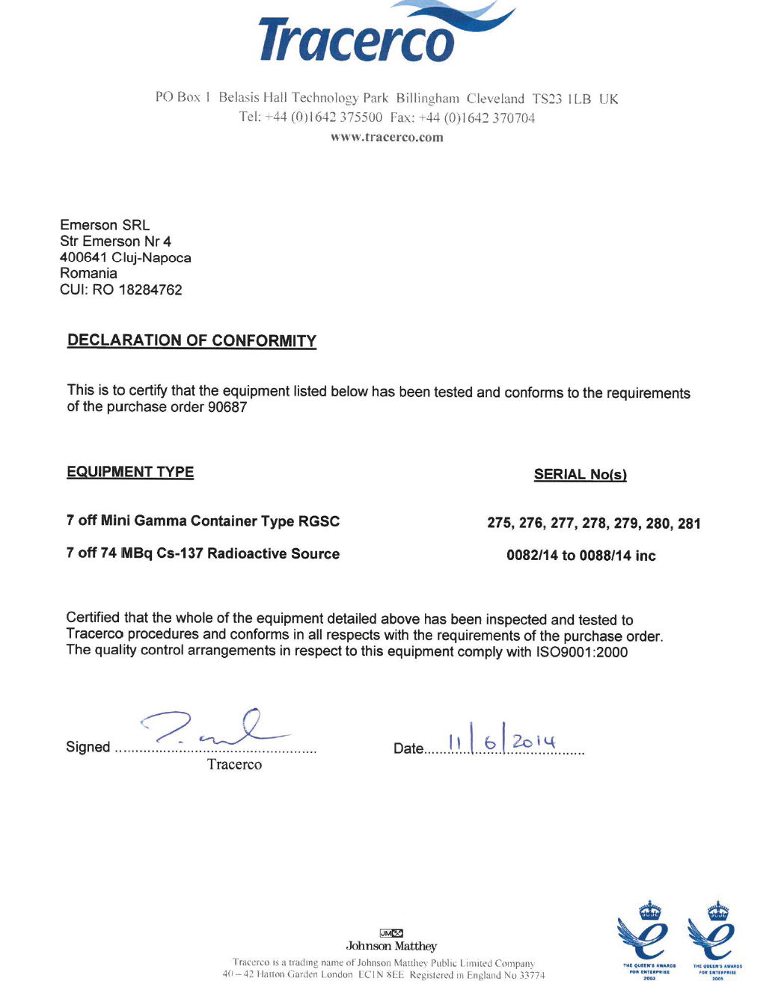

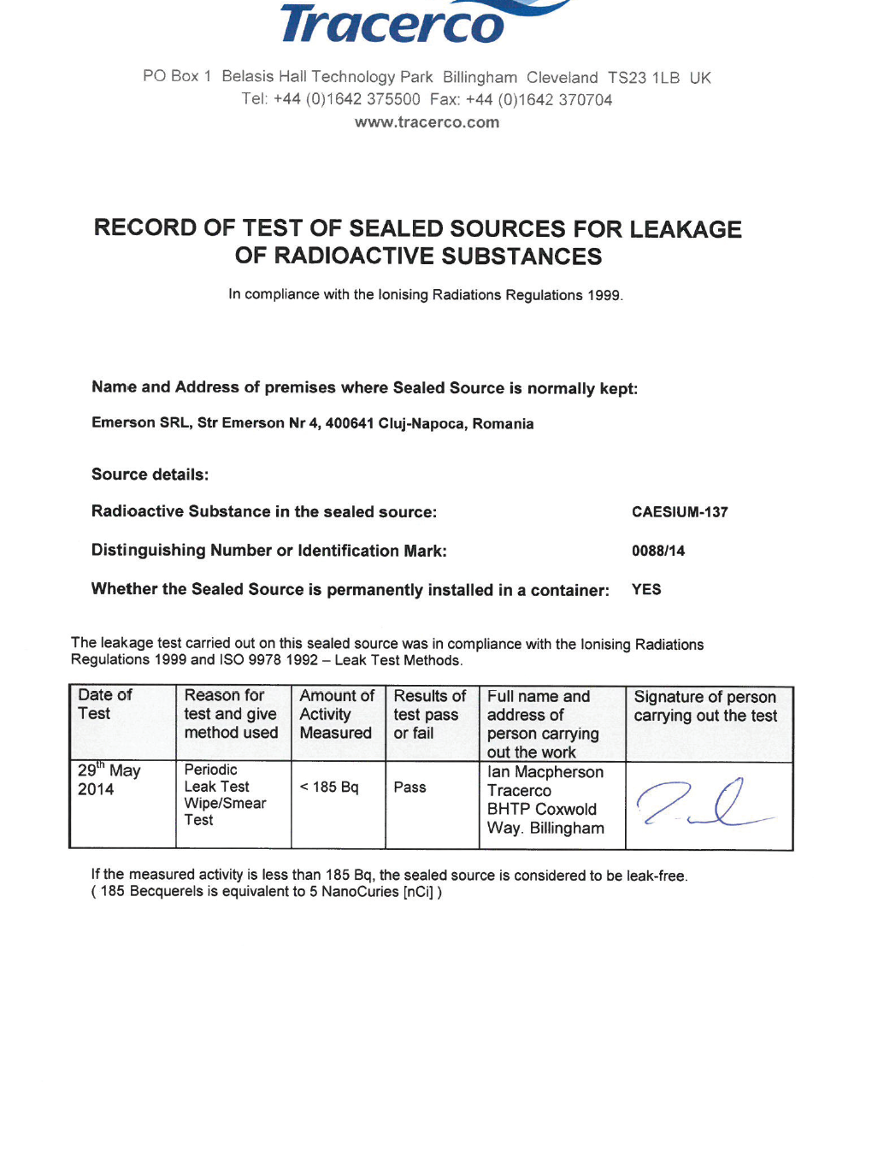

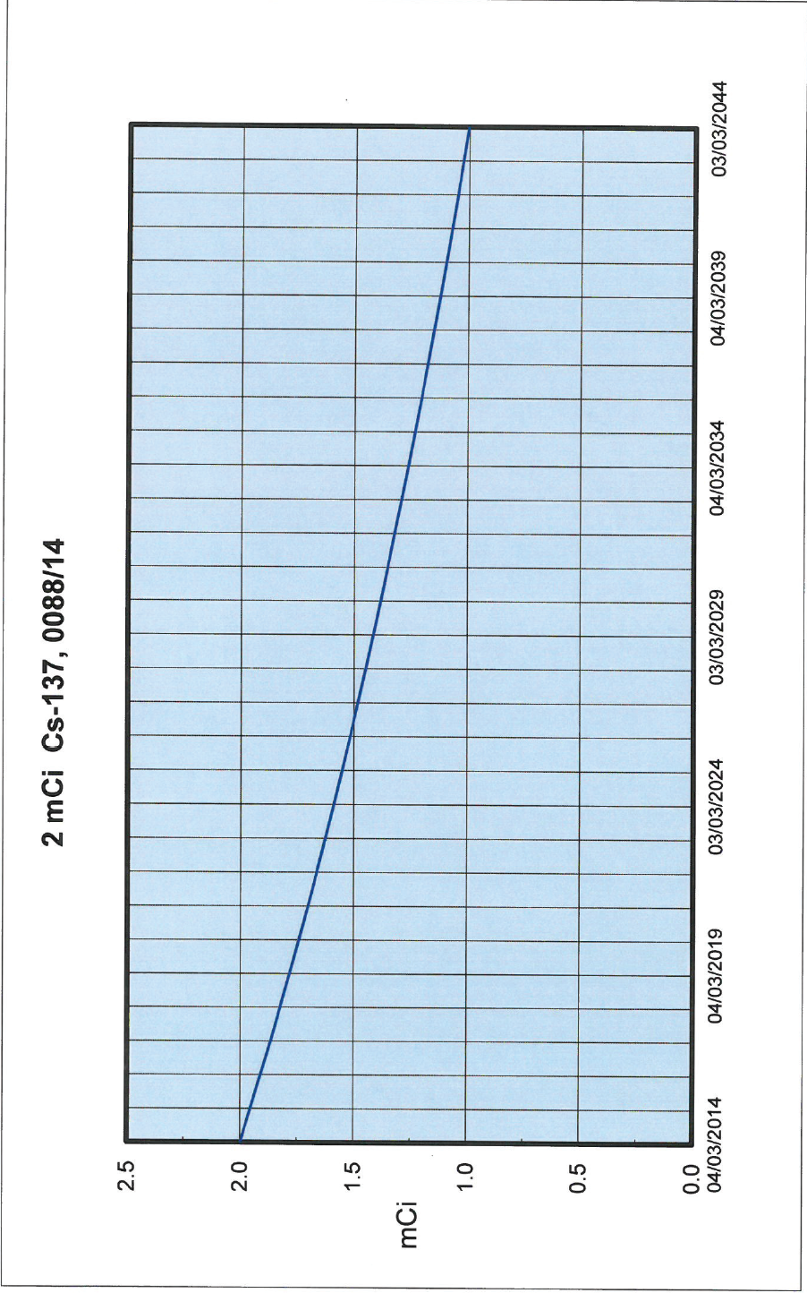

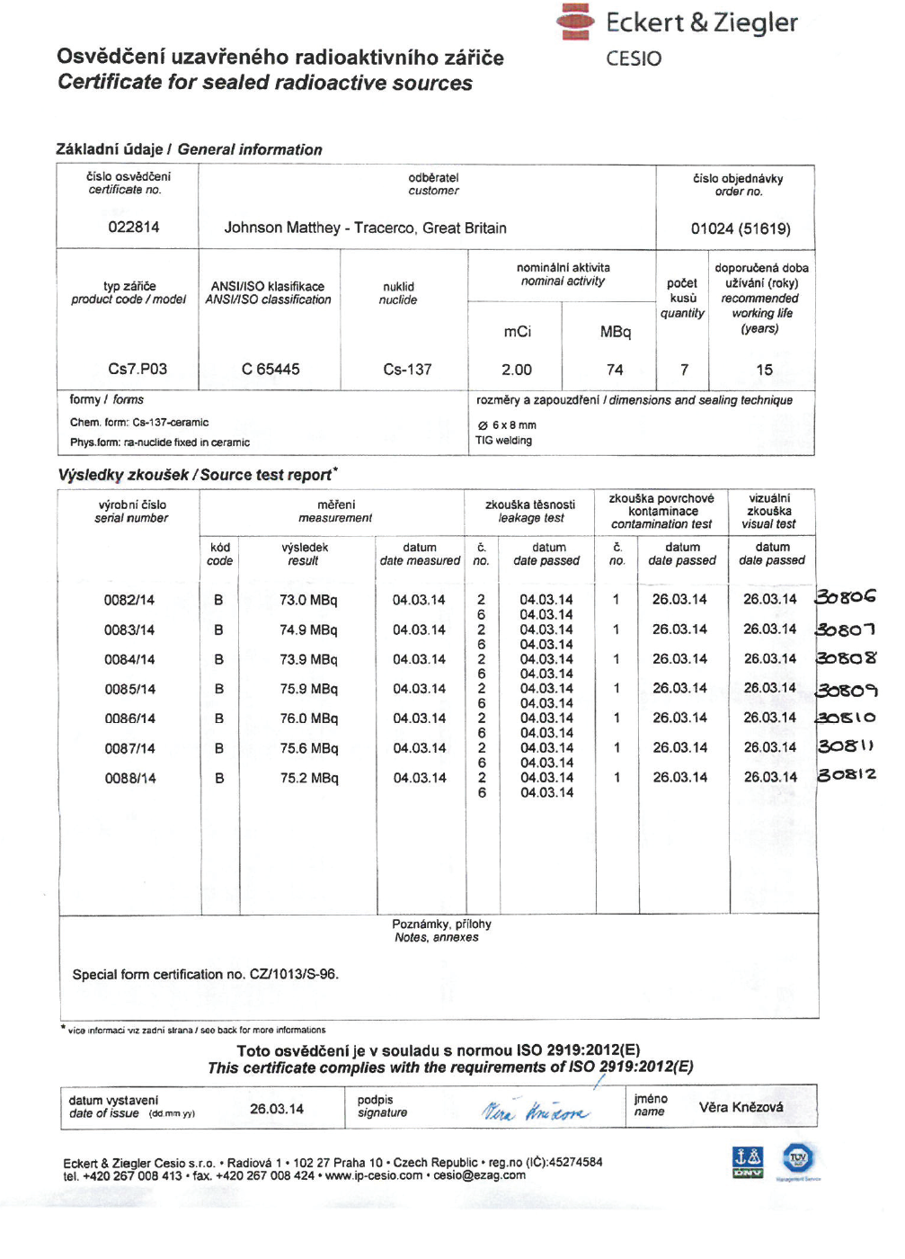

## 15.7 Appendix G - Roxar Cs-137 Gamma Ray Source Drawing

