FFWMP Rev1.1

Huracan Pty Ltd

6-Feb-2020

Revision 1.1

Fitness For Work Management Plan

FBFV-Roma, QLD

Document Control: Public

Huracan Pty Ltd

9-Mar-2015

Revision 1.1

Document Control: Public

**Roma – Fitness for Work Management Plan**

|  |  |  |  |  |
| --- | --- | --- | --- | --- |
| **Rev** | **Author** | **Reviewer** | **Date** | **Revision Comments** |
| **1.0** | **K. Hollingworth** | **J. Hollingworth** | **6-Feb-2018** | First Edition of Fitness for Work Plan |
| **1.1** | **K. Hollingworth** | **J. Hollingworth** | **6-Feb-2020** | Minor format changes and review |
|  |  |  |  |  |
|  |  |  |  |  |
|  |  |  |  |  |

Table of Contents

1 Document Control 3

1.1 Review and Update Procedures 3

2 Overview 3

2.1 Huracan Gerneral Code of Behaviour 3

2.2 Terminology 3

3 Statement of Plan 3

4 Objective 3

5 Scope 4

6 Responsibility 4

6.1 Managers 4

6.2 Employees 4

7 Fitness for Work Management Plan 4

7.1 Alcohol and Other Drugs 4

7.1.1 Awareness and Training 5

7.2 Fatigue and Hours of Work Management 5

7.3 Working in Extreme Conditions 5

7.3.1 Working in Hot Conditions 5

7.3.1 Safe Team 9

7.3.2 Inclement Weather 9

7.3.3 Awareness and Training 9

Appendix A Heat Induced Illness Flowchart 11

Appendix B Steadman Apparent Temperature Graph (from temperature and relative humidity) 12

Appendix C Work / Rest Cycles Guide for working in hot conditions 12

# 1 Document Control

## 1.1 Review and Update Procedures

This document is a ‘live’ document that shall be reviewed and updated as per the Huracan Document Control and Review Standard.

# 2 Overview

## 2.1 Huracan Gerneral Code of Behaviour

Huracan Management requires full compliance with this plan. Failure to adhere to this document shall be regarded as a serious breach of the Huracan code of behaviour and shall result in disciplinary action, which may include counselling or dismissal. Failing to follow safety instructions, deliberately interfering with safety equipment and systems, deliberate damage to equipment, stealing, vandalism, fighting, practical jokes and horseplay shall not be tolerated and are considered to be serious breached of the Huracan Code of Behaviour.

## 2.2 Terminology

|  |  |
| --- | --- |
| **Term** | **Definition** |
| Fitness For Work | A worker is in a state (physically, mentally and /or emotionally) enables them to perform their assigned tasks competently and in a manner which does not compromise or threaten the health and safety of themselves or others. |
| On Duty | A worker is on-duty any time they are undertaking the duties and responsibilities  associated with their contract of employment / job. |
| Heat Induced Illness | Your bodies inability to cope with excessive heat both influenced by both internal and external factors |
| Contraband | Illicit substances including drugs, alcohol and prohibited items such as firearms and weapons |

# 3 Statement of Plan

This document is intended to serve as the minimum Huracan requirements for management and mitigation of Land Transport risk.

# 4 Objective

To ultimately eliminate driving related crashes that cause fatalities and injuries to employees, families, contractors and third parties and minimize damage to equipment through careful management of all phases of the transportation process by:

* Identifying and managing hazards and unnecessary exposure through active journey management
* Preventing and mitigating the residual risk through the proper selection and preparation of people, vehicles, equipment and routes.

# 5 Scope

This local Fitness for Work Management Plan applies at all times to all Huracan, contractors and third party personnel working or contracted to FBFV – Roma location.

# 6 Responsibility

## 6.1 Managers

All Managers with the integral support of HSE staff shall implement and enforce this local plan and demonstrate active leadership and participation in all aspects of the Fitness for Work Managment Plan while ensuring that all personnel under their responsibility demonstrates similar leadership.

## 6.2 Employees

Present themselves fit to undertake their engaged duties including, but not limited to being at work or on call, driving a company vehicle or operating plant and equipment, or representing the company in any capacity; and

Notifying their relevant Manager of any restrictions or potential factors which may contribute to their impairment to perform their duties i.e. any medication / drugs taken (prescribed or otherwise), under the influence of alcohol, any health or fatigue related issues; and

Raising any concerns about another person’s fitness for work to the relevant manager; and

Notifying their relevant manager of any changes to license or competence requirements i.e. loss of driver’s license, high risk work license revoked or not renewed by the relevant state authority

# 7 Fitness for Work Management Plan

## 7.1 Alcohol and Other Drugs

Huracan has a ZERO tolerance to drug and alcohol abuse as outlined in the Company’s Contraband Policy. Management recognises that inappropriate use of alcohol and other drugs can have a detrimental effect on individuals, the company and on company services. Alcohol and other drug use, both legal and illegal, may contribute to health and safety risks, workplace accidents and poor work performance.

To achieve our QHSE mission of providing a healthy and safe workplace for all personnel, a number of controls shall be applied including but not limited to:

• All personnel are required to undertake a pre-employment medical and provide a negative urine drug screen (UDS) prior to commencing work with the company;

• Any worker found under the influence of drugs and /or alcohol during work hours, while on company premises, while responsible for the operation of any company vehicles or mechanical equipment or while conducting work or representing our company in any capacity shall be subject to disciplinary action at management’s discretion;

• Participate in drug and alcohol testing performed randomly, as requested by the client or for cause

• Agree to abide by client’s policies regarding alcohol consumption during rest times if the employee is required to stay at the client’s location;

• Advise management if under the influence of drugs and / or alcohol exceeding permissible standards during work hours including prescription or over-the-counter medication which may affect the person’s ability to work normally or operate plant and equipment.

Random drug and alcohol testing may be conducted by the QHSE Rep with the results recorded on the Drug

& Alcohol Testing Register. Where an incident occurs or there is reason to suspect a person is under the influence of drugs or alcohol, for cause testing shall be carried out. This testing shall be recorded on the For Cause Drug Test Form or the For Cause Breath Alcohol Test Form.

If a person returns a positive reading whilst on shift, that person will be stood down immediately with a second test conducted in 30 minutes time. Should the second test result return positive to drugs and / or alcohol, the person shall be stood down for the rest of the shift / day and escorted from site to a suitable resting / recovery place. A negative test result will need to be provided before the person will be allowed to work again.

### 7.1.1 Awareness and Training

All Huracan workers shall be required to read, understand and aide by the Contraband Policy as communicated during the induction process and repeated via re-familiarisation training as required. Any person conducting drug and alcohol testing shall be suitably competent to ensure the testing is conducted in accordance with the relevant requirements and not breach any rules or obligations.

## 7.2 Fatigue and Hours of Work Management

All personnel have a duty to manage themselves to be fit for work. In the event that fatigue poses risk to the individual, they must report it to their Manager to enable suitable controls to be implemented. Further detail on Fatigue Management can be found within the Fatigue Management Procedure.

## 7.3 Working in Extreme Conditions

### 7.3.1 Working in Hot Conditions

Heat induced illness occurs when your body is unable to cool itself sufficiently and body temperature rises; when heat is absorbed from the environment faster than the body can get rid of it. There are several factors which may contribute to heat-induced illness such as:

* Type of work you do;
* high air temperature/humidity levels;
* radiant heat (e.g. working outdoors);
* Physical condition you're in.
* Individual factors that may increase your risk of heat stress include:
* medical conditions (like heart problems, diabetes or hypertension)
* medication that may affect your body's temperature regulation
* Your age, weight and level of physical fitness.

Huracan recognise operations conducted within hot conditions poses considerable risk and as such, commit to reducing the risk using effective controls including re-familiarisation training (conducted annually), work / rest cycles and what to do in the event of an emergency. For further information, refer to the Huracan internal Training program (Work in Hot Conditions).

There are 3 levels of heat-induced illness including:

• Level 1: Heat Cramps

− Heat cramps often affect people who have sweated a lot during strenuous activity. These painful muscle cramps usually affect the abdomen, arms or legs. Cramps may be an early symptom of the more severe condition of heat exhaustion.

− Tiredness, weakness, nausea / vomiting, dizziness, moist cool skin, may faint

− Stop all strenuous activity and rest in a quiet, cool place

− Seek medical attention if symptoms continue for more than one (1) hour

• Level 2: Heat Stress / Exhaustion

− The body’s heat control mechanism becomes over-active

− Heat stress warning signs may include:

i. heavy sweating;

ii. headaches;

iii. tiredness and weakness;

iv. dizziness or fainting;

v. slurred speech or blurred vision;

vi. nausea and vomiting;

vii. painful muscles spasms or cramps;

viii. rapid pulse, confusion & irritability.

− Stop all strenuous activity and rest in a quiet, cool place

− increase fluid intake using cool water

− lay down in the shade

− remove outer clothing (e.g. hard hat, boots, shirt)

− fan vigorously to increase evaporation.

• Level 3: Heat Stroke

− First and foremost, Heat Stroke is a  *medical emergency*, caused by a rise in core body temperature, is potentially lethal or can cause permanent injury to the brain & kidneys!

− Heat stroke warning signs may include:

i. heavy sweating

ii. nausea and vomiting

iii. mental confusion, aggression, & visual disturbance;

iv. seizures & loss of consciousness;

v. strong pounding pulse, hot dry flushed skin vi. cardiac arrest

− Activate the Huracan Field Ops – ERP immediately including:

i. Follow basic life support (DRSABCD) as required;

ii. Loosen clothing & remove unnecessary items i.e. hard hat, gloves, boots & socks

iii. Lay patient down in a cool environment & apply cold compressions to the neck, armpit and groin areas;

iv. Moisten skin with a cool, wet cloth and fan to lower temperature & absorb moisture;

v. Have patient sip fluids slowly if conscious;

To help prevent heat-induced illness incidents occurring, the following should be followed:

• ensure you are suitably acclimatised to the weather you are working within;

• maintain adequate hydration i.e. drink plenty of water to keep pace with sweat loss, a poor diet and consuming alcohol or caffeine can cause dehydration);

− During prolonged work in the heat our body can sweat up to one litre an hour. Unless this fluid is replaced by drinking, progressive dehydration will result.

− You won’t feel thirsty until you have lost one to 2% of your body weight in fluid. By this time, you will have an increased risk of developing a heat-related illness. Food must be consumed at meal breaks in order to replace electrolytes and maintain energy.

• Check your urine colour every time & adjust your fluid intake accordingly

• Check the apparent temperature (use the Steadman Chart) & implement controls as required

• In the event of a heat-induced illness occurring, provide first aid treatment immediately. If the patient does not improve within 20 minutes, or where more/new symptoms present, assume heat stroke and immediately activate the Huracan Field Operations ERP for emergency response (continuing first aid measures) and evacuate immediately to medical facility;

• Keep an eye on each other – often, the individual does not comprehend they are suffering from heat- induced illness until it is too late and symptoms have progressed.

**Minimum Controls for Heat Exposure:**

**Safe Worksite:**

• Monitor temperature & communicate to crew;

• Cool drinking water &/or low carbohydrate electrolyte replacements available;

• Minimise heat sources & have shelter available where practicable;

• Cool refuges available;

• Increase air movement by fans or evaporative systems

• Camp / Accommodation equipped to enable cool sleep & pre / post work hydration

**Safe Team:**

• Buddy system;

• Rotate personnel (on activities);

• First aid trained personnel;

• Promote safe hydration;

**Safe Worker:**

• Self-assess as fit-for-work;

• Acclimatise to the heat;

• Drink cool water & as needed, low-carb electrolyte replacements;

• Use PPE appropriate for working in hot environments;

• Early identification & treatment of heat stress symptoms.

**Red Alert Day Controls for Heat Exposure (in addition to Minimum Controls):**

**Safe Worksite:**

• Declare Red Alert Day for location when the apparent temperature reaches 40 C or above;

• Ensure there is adequate amount of ice available at site for the crew;

**Safe Worker:**

• Adhere to work / rest cycle guidelines for work timing & hydration requirements;

• Early identification & treatment of heat stress symptoms

### 7.3.1 Safe Team

• Review the manning levels & rotation of personnel on activities (where possible)

• Review work timing i.e. schedule night work & avoid the hottest part of the day where possible;

• Minimise working at height, on ladders & within confined or restricted spaces where possible;

• Minimise heavy manual labour including hand digging, & hammering star pickets etc. where practicable.

### 7.3.2 Inclement Weather

Working in inclement weather conditions may increase the risk of injury &/or illness to personnel such as:

• Making manual handling tasks more difficult i.e. item is hot to handle, slippery from rain; or reduced feeling in extremities in cold conditions

• Increasing the risk of slips and trip hazards i.e. muddy under-foot conditions

• Increasing operational risks i.e. lightning strike may inadvertently activate explosives; short out electrical equipment

• Accessibility &/or driving hazards from flash flooding, heavy rain & other storm elements and bush fire

• Illness trigger from atmospheric contamination i.e. smoke may increase risk of asthma attack

To manage the risk/s posed, Huracan commit to analysing risk identified for business operations and applying adequate controls in accordance with risk management principles. This includes the assessment of site-based risk i.e. using / reviewing JSA’s and adding controls as required. In accordance with this Fitness for Work Procedure, all workers must declare any factors which may pose risk to the health and safety whilst conducting their tasks which shall also be considered by management during scheduling.

### 7.3.3 Awareness and Training

Huracan workers shall participate in any client required training for heat-induced illness and shall also participate in the review of this procedure annually during the month of September (before the extreme heat / summer months) to ensure they understand the risks associated with heat-induced illness, how to identify the warning signs and the response/s required in the event of an emergency.

# Appendix A Heat Induced Illness Flowchart

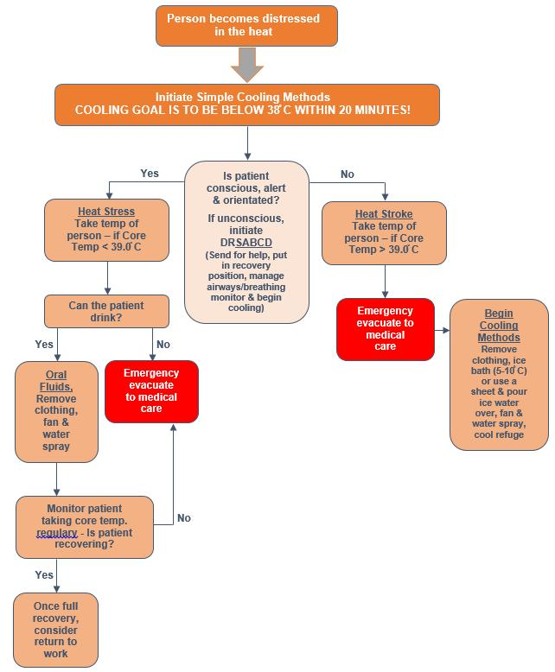

# Appendix B Steadman Apparent Temperature Graph (from temperature and relative humidity)

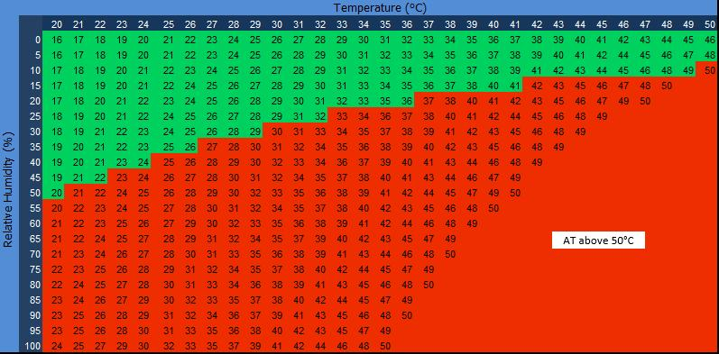

# Appendix C Work / Rest Cycles Guide for working in hot conditions

