**Hand Safety**

The hand is one of the most complex parts of your body - the movement of the tendons, bones, tissues and nerves allows you to grip and do a wide variety of complex jobs. Without your hands, fingers and wrist it would be extremely difficult to do routine simple tasks, such as opening doors, using a fork, or tying your shoes, most injuries are serious, and can include including loss of fingers.

The most common causes of hand, fingers and wrist injuries are:

* Carelessness
* Lack of awareness
* Boredom
* Disregard for safety procedures
* Distractions

To avoid hand injuries:

Know the hazards and dangers in the job to be done

* ***Be aware*** of pinch points
* ***Be aware*** of hot areas
* ***Be aware*** of rotating or moving surfaces
* ***Remember*** that automated machinery may be controlled by remote control, or delayed timing devices that cause the machine to start automatically
* Loose clothing and jewellery may be caught up in moving machinery

Pinch points, cut points, and crush points are created when two objects move together. Workers who use machinery with moving parts that can pinch, cut, or crush hands and fingers can also injure fingers and hands by using them inappropriately as tools. To protect fingers and hands, workers must be aware of a variety of hazards and use safe practices by being vigilant in risk management i.e. conduct stepback or review the JSA and then ensuring the controls are effective or add / change controls as required to reduce the risk to ALARP.

Common pinch points can be found on:

* Mechanically moved loads
* Loads being lowered
* Metal drums
* Any moving parts (manual or automatic)
* Good Hand Safety Practice includes, but is not limited to:
* Keep fingers and hands away from all pinch points, cut points, and crush points!
* Where possible, adopt the “hands off” method which distances hands from the direct line of fire i.e. tool extensions, tag lines, push bars etc.
* Perform maintenance only when tools or machinery are effectively isolated
* Know when to wear gloves. Gloves should be worn when exposed to hazards that cause cuts, scrapes, chemical burns or absorption, or injuries. Do not wear loose-fitting gloves around reciprocating or rotating machine parts.
* Ensure all required guards are installed and effective
* Do not disengage safety shut-offs or “dead-man switches”.
* Do not wear jewellery or other loose items which may get caught in rotating equipment.

**PPE – Gloves**

As described within the Managing WHS Risk Code of Practice, Administrative and Personal Protective Equipment controls are the two (2) lowest forms of controlling risks and should be used as an additional barrier in conjunction with more effective controls. Glove type and requirement to use as a control shall be identified during the risk management process, below is an overview of types of gloves available.

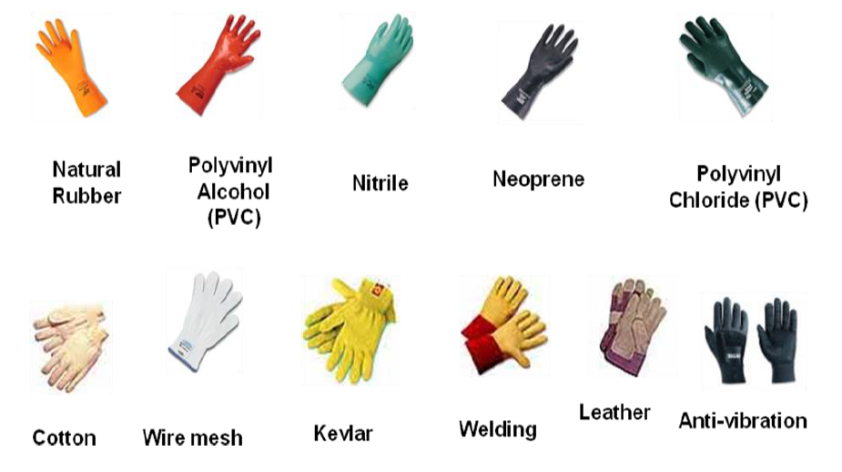

**Maintaining Gloves and Hand Care**

* Inspect gloves before use for tears, excessive wear, and punctures
* Store in a clean, dry location
* Discard leather and cloth gloves if they become saturated with oil or other chemicals
* Leak test chemical gloves by sealing the wrist and filling the glove with air (i.e. use a clean plastic tube or low-pressure air-line – not your mouth!)
* Avoid washing your Hands, Fingers and Wrist with solvents, harsh soaps, or abrasives
* Clean and bandage all cuts and abrasions
* Hands Free Program
* Immediately remove any imbedded foreign materials
* Wash immediately after using any chemical – Even if you did not detect leakage
* Pay attention to skin rashes—get an immediate medical evaluation
* Wear cotton gloves under rubber gloves to reduce sweating

**Hand Free Tool Program**

Hands Safety Tools for Hands free Operation should be used when - lifting, guiding, handling and maneuvering suspended loads, drill pipes or tubing to mitigate the risk of crush or pinch point injuries.

Tag lines should be placed on suspended loads to reduce the risk of injury.

Different hands free tools are available on the wellsite and should be used when Huracan aids rig personnel with the rig tasks not normally part of our operations.

Examples of hands free tools are below.

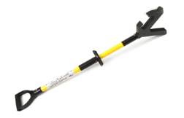

Stiffy Stick – Used to steer loads such as containers or pipe into position

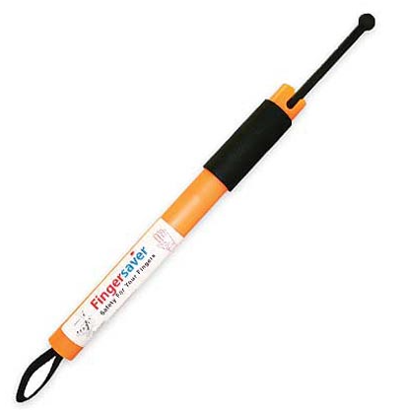

Finger Saver – Used to attached to a flogging spanner while nippling up equipment

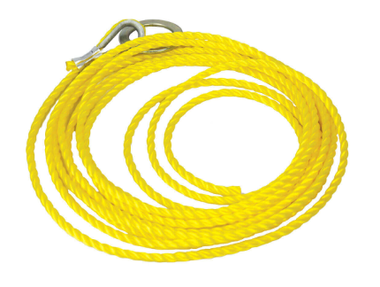

Tag Lines – Attached to loads and used to steer a load into position

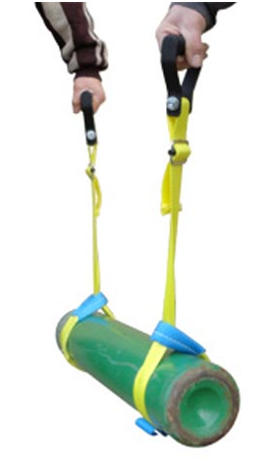

Other lifting aids are available onsite and should be used when available

As part of the Hands Free Program all suggestions on the mitigation of risk through hands free tools should be entered into Huracan Information Management System.