Health & Safety Management Plan

FBFV-Roma, QLD

HSMP Rev3.4

Huracan Pty Ltd

13-Jan-25

Revision 3.4

Document Control: Public

**Document Control**

Document Owner: Katrina Hollingworth

Document Approver: Jon Hollingworth

**Revision History**

|  |  |  |  |  |
| --- | --- | --- | --- | --- |
| **Rev** | **Reviewer** | **Approver** | **Date** | **Revision Comments** |
| 1.0 | K. Hollingworth | J. Hollingworth | 1-Aug-2012 | First edition of HSEP |
| 1.1 | K. Hollingworth | J. Hollingworth | 27-Oct-2012 | Document review and minor changes |
| 2.0 | K. Hollingworth | J. Hollingworth | 22-May-2014 | Removal of Environmental Management Plan to separate document |
| 2.1 | K. Hollingworth | J. Hollingworth | 20-Oct-2015 | Document review with minor changes |
| 2.2 | K. Hollingworth | J. Hollingworth | 11-Oct-2017 | Document review with minor changes |
| 2.3 | B. Arnold | J. Hollingworth | 5-Jul-2019 | Document review with minor changes |
| 2.4 | B. Arnold | J. Hollingworth | 3-Jun-2021 | Added specific role certification requirements and updated policies. |
| 3.0 | M. Dixon | J. Hollingworth | 6-Jan-2022 | Third party compliance review to Work Health & Safety Act and Regulations. |
| 3.1 | D. Evans | J. Hollingworth | 26-Sep-2023 | Client review and updates. |
| 3.2 | K. Hollingworth | J. Hollingworth | 7-Oct-24 | Addition of Huracan Driving LSR’s and compliance with Customers LSR’s. |
| 3.3 | K. Hollingworth | J. Hollingworth | 30-Nov-24 | Bushfire Management and Awareness added. |
| 3.4 | K. Hollingworth | J. Hollingworth | 13-Jan-2025 | Noise Management |

Table of Contents

1.0 Document Control 5

1.1 Review and Update Procedures 5

1.2 Document Distribution 5

1.3 Document Updates 5

1.4 Document Publication and Display 5

1.5 Notice - Display Locations 5

2.0 Overview 6

2.1 Introduction & Purpose of Document 6

2.2 HSE Objectives, Goals and Targets 6

2.3 Scope of Services and Description of the Plant 8

2.4 Code of Conduct 8

2.5 Terminology 8

3.0 Safety Management 10

3.1 Health, Safety & Quality Policies 10

3.1.1 Health and Safety Policy 10

3.1.2 Substance Abuse Policy 11

3.1.3 Driving and Journey Management Policy 12

3.1.4 Training Policy 13

3.1.5 Rehabilitation Policy 14

3.1.6 Right to Stop Work Policy 15

3.1.7 Heat Stress Management Policy 16

3.1.8 Cultural Heritage Policy 17

4.0 HSE Responsibilities & Organisation 18

4.1 Organisational Chart 19

4.2 Responsibilities & Organisation 20

4.2.1 Board of Directors - Is responsible for: 20

4.2.2 Executaive Safety Manager (Operations Manager) – Is responsible for: 20

4.2.3 Location Managers – are responsible for: 20

4.2.4 Site SAFETY Manager - Is responsible for: 21

4.2.5 Employees and Contractors - Are responsible for: 21

4.2.6 HSE Advisor - Is responsible for: 22

4.2.7 Visitors 22

4.3 Health Safety & Environmental Documentation 23

5.0 Procedures 24

5.1 General and Site Based Employee Inductions 24

5.2 New and inexperienced employee mentoring system 24

5.3 Training and Development 24

5.3.1 Qualifications, Certificates and Licenses 25

5.4 Substance Abuse (Drug and Alcohol) 25

5.5 Personal Protective Equipment 26

5.6 Safety and Hazard Warning Signs 27

5.7 HSE Meeting Requirements during Operations 27

5.8 Inspections and Audits 27

5.8.1 Internal Inspections and Audits 27

5.8.2 External Inspections and Audits 28

5.9 Hazard and Incident Reporting 28

5.9.1 Individual Obligations 29

5.9.2 Huracan Wellsite Supervisor Obligations 29

5.9.3 Huracan Senior Management Obligations 29

5.10 Incident Investigation 29

5.10.1 Responsibilities 30

5.11 Hazard and Risk Assessment 30

5.12 Hazardous Materials 32

5.13 Noise management and The Prevention of Hearing Loss 32

5.13.1 Personnel Audiometric Testing 33

5.13.2 Plant Equipment Design and Manufacturing 33

5.13.3 Building Structures and Design 33

5.13.4 Sound-Insulating Sperate Rooms 34

5.14 Fire Prevention 34

5.15 Compressed Gas Cylinders 35

5.16 General Housekeeping 35

5.17 Work Permits 35

5.17.1 Pressure Testing 36

5.17.2 Hot and Cold Work 36

5.17.3 Confined Space Entry 36

5.17.4 Working at Heights 37

5.17.5 Electrical Work >24v DC 37

5.18 Inspection, Testing and Maintenance of Plant & Equipment 38

5.19 Excavations 38

5.20 Safe Work Procedures (SWP’s) 38

5.21 Vehicle, Plant and Equipment Movements and Control 39

5.22 Lifting and Hoisting Equipment 40

5.23 Mobile Lifting Equipment 40

5.24 Operating Mobilisation Procedures 41

5.25 Working in Hot Environments 41

5.26 Stepping, Handling and Lifting 41

5.27 Management of Change 41

5.28 Fatigue Management 42

5.29 High Risk Work 42

5.30 Huracan Life Saving Rules 43

5.30.1 Huracan Life Saving Rules 43

5.30.2 Santos Life Saving Rules 43

5.30.3 QGC/Shells Life Saving Rules 44

5.31 Bushfire Management and Awareness 46

5.31.1 Understanding the Fire Danger Rating and Preparing to Evacuate 46

5.31.2 Bushfire Warnings 48

5.31.3 Bushfire - Prepare 49

5.31.4 Bushfire - Monitor 49

5.31.5 Bushfire - Respond 49

5.31.6 Bushfire Emergency on Location 50

5.31.7 Personnel Bushfire Awareness Training 51

6.0 Injury Management 51

7.0 First Aid 52

8.0 Emergency Management 52

9.0 Business Continuity Management 53

10.0 Contractor Management 53

11.0 Statutory Acts & Regulations 54

Appendix A – Huracan Risk Matrix 55

Appendix B – Residual Risk Approval 56

Appendix C – HSE Classification 57

# 1.0 Document Control

## 1.1 Review and Update Procedures

This document is a ‘live’ document that shall be reviewed and updated as per the Huracan Document Control and Revision Standard.

It is also to be reviewed immediately after any of the following occur;

• Major operational incident (i.e. increased apparent risk)

• Significant operational, procedural, work practice or technology change

• New or amended safety codes, safety requirements or standards are issued.

• When required by relevant State and Federal Government legislation.

Huracan Management is responsible for the review and revision of this document. The updated document is to carry a new revision date, and are circulated once the revision has been approved, by the following levels of Management:

• Operations Manager – Huracan.

• HSE Manager – Huracan.

## 1.2 Document Distribution

Requested changes to the Distribution List are to be addressed to Huracan Management.

|  |  |  |  |
| --- | --- | --- | --- |
| **Copy** | **Name** | **Position** | **Company** |
| 1 | Jon Hollingworth | Operations Manager | Huracan Pty Ltd |
| 2 | Katrina Hollingworth | HSE Manager | Huracan Pty Ltd |

## 1.3 Document Updates

Only registered copies of the document shall be updated. This document becomes uncontrolled when printed.

## 1.4 Document Publication and Display

This document shall be displayed at all times and shall be open for inspection by anyone to whom the plan or part of the plan may affect or apply to.

## 1.5 Notice - Display Locations

This document shall be available for display at the following locations;

* Huracan Office
* Huracan Internal Website

# 2.0 Overview

## 2.1 Introduction & Purpose of Document

The purpose of this document is to detail the Health, Safety and Environment Management requirements for Huracan Management, Employees, Contractors and Site Visitors whilst performing operations on any Huracan work sites.

The document aims to provide procedures and standards to reduce identified risks at Huracan work sites to “as low as reasonably possible”, (ALARP).

This document aims to identify and clarify the critical responsibilities where there are multiple plant and contractor/owner relationships or coordination arrangements and to establish the Health, Safety and Environmental management for contractor’s/plant owners whilst performing operations on a worksite.

The HSEMP implemented, is designed to meet the requirements of;

• Petroleum & Gas Act 2004

• Petroleum and Gas (Safety) Regulation 2018

• Workplace Health and Safety Act 2011

• Workplace health & Safety Regulations 2011

• AS/NZS Standards 9000-2016

• AS/NZS 4801

• ISO 14001:2015

## 2.2 HSE Objectives, Goals and Targets

Huracan Pty Ltd is aware of its obligation to provide a safe work environment for all personnel associated with its operations. To meet this objective, Huracan is committed to developing and maintaining an environment that ensures the Safety and Health of all employees, contractors, visitors and communities associated with our operations.

To achieve this, Huracan shall maximise the integration of HSE policies into all its activities by ensuring that:

• Systems and resources are in place to enable effective and appropriate HSE performance.

• Plant and equipment is maintained and operated in compliance with approved practices and procedures.

• Contractors and visitors reciprocate this integral involvement and commitment to HSE management.

• Employees and contractors at every level understand their responsibility and accountability and have the skills to deliver the required HSE performance.

• A culture is fostered and maintained at Huracan that values HSE commitment, teamwork and performance.

**Key components to the above objectives are:**

• Senior Management demonstrating strong leadership and participation in a robust and proactive approach to HSE management.

• Management at all levels setting goals, plans and appropriately maintained and monitored performance measures to achieve desired HSE outcomes.

• Huracan shall assess its success in achieving HSE objectives by using performance indicators such as:

o LTIFR - Lost Time Injury Frequency Rate

o MTIFR - Medical Treatment Injury Frequency Rate

o HPIFR - High Potential Injury Frequency Rate

o TRIFR - Total Recordable Injury Frequency Rate

• Management, employees and contractors integrating HSE into all aspects of planning, operational decisions and change management.

• The identification, assessment and appropriate control of the hazards and risks associated with every task.

• Developing Hazard Management Plans for hazards assessed as having high inherent risk.

• Consultation and two-way communication across all levels, all relevant information should be shared and every opportunity should be given for employees and contractors to;

* express their views and raise health or safety issues
* contribute to the decision-making process.

• Management to advise workers of outcomes of any consultation if the workers are represented by a health and safety representative, consultation must involve that representative.

• Reporting and adequately investigating and addressing all hazards and incidents (including near miss, property damage and interruption to process) based on potential rather than actual outcome.

• Empowering the workforce with the accountability that if something cannot be done safely then it shall not be done.

• Maintaining a system for appropriately recording, identifying, and tracking site HSE trends, actions, accountabilities and outcomes and to ensure site retention of learning’s.

• Document control to ensure the maintenance, currency and availability of critical HSE information.

• The continuous monitoring, including regular internal and external safety audits, review and improvement of HSE management systems at Huracan.

In addition to the primary and proactive focus on the prevention of all incidents, Huracan shall have in place systems enabling the identification of and timely and appropriate levels of response to any adverse or potentially adverse HSE related matters, which may arise.

To achieve this Huracan shall maintain, continuously monitor and regularly test a site Emergency Management Plan which shall include:

• The provision of adequate plans, maps, training and drills to ensure all person’s working in Huracan operations are aware of and able to comply with their applicable responsibilities for relevant emergency response procedures.

• The identification and maintenance of appropriate levels of qualified first aid coverage on site.

• Place plans or programs aimed at enabling the timely and appropriate response to matters involving:

o Rehabilitation and Return to Work;

o Workers Compensation Management;

## 2.3 Scope of Services and Description of the Plant

Huracan is supplying contract services to the client. The services provided may comprise of, but not limited to the following;

• Machinery mobilisation to well/work sites.

• Working In Hazardous Areas

• Pressure testing operations.

• Other operations as requested by the client and agreed to by Huracan.

## 2.4 Code of Conduct

Huracan Management requires full compliance with the HSE Plans, Emergency Response Plans and Safe Work Procedures. Infringement of the Policies contained in the HSMP, EMP, ERP and Safe Work Procedures shall be regarded as a serious breach of the Huracan code of behaviour and shall result in disciplinary action, which may include counselling or dismissal. Failing to follow safety instructions, deliberately interfering with safety equipment and systems, deliberate damage to equipment, stealing, vandalism, fighting, practical jokes and horseplay shall not be tolerated and are considered to be serious breached of the Huracan’s Code of Conduct.

Additional information can be in Huracan’s Code of Conduct Policy and Standard.

## 2.5 Terminology

|  |  |
| --- | --- |
| **Acronym** | **Meaning** |
| SWP | Safe Work Procedures |
| HSMP | Health & Safety Management Plan |
| HIMS | Huracan Information Management System |
| EMP | Environmental Management Plan |
| JSA | Job Safety Analysis |
| TBM | Tool Box Meeting |
| ALARP | As Low as Reasonably Practicable |
| API | American Petroleum Institute |
| APPEA | Australian Petroleum Production & Exploration Society |
| IADC | International Association of Drilling Contractors |
| AQTF | Australian Quality Training Framework |
| AFD | Incident Free Days |
| ERP | Emergency Response Plan |
| PPE | Personal Protective Equipment |

# 3.0 Safety Management

## 3.1 Health, Safety & Quality Policies

Huracan Pty Ltd has policies to emphasise the importance Huracan Management places on the Health, Safety and Environment in which it operates.

These policies form the basis of Huracan’s Health and Safety Management plan.

### 3.1.1 Health and Safety Policy

Huracan places utmost importance on the health and safety of its personnel. The Management, Employees and Contractors of Huracan recognises its obligation to take all reasonable precautions to provide and maintain an environment that is safe and without risks or injury.

**Management Responsibility**

• Establish and maintain a Health, Safety & Environmental Management system that facilitates a structured approach to the management of risk.

• Provide adequate human, financial and time resources to ensure the effectiveness of the system.

• Remain up-to-date with relevant health and safety legislative obligations and achieve and maintain compliance with these obligations.

• Promote a Safety Culture that encourages people to proactively manage risk through education, instruction, information and supervision.

• Clearly define and communicate to staff, contractors and contractors, their responsibilities in relation to health and safety.

• Proactively identify and manage health and safety risk via a documented hazard identification, risk assessment, risk control and monitoring process.

• Improve processes to ensure that incidents and hazards are promptly reported, investigated and control measures are put in place to eliminate or minimise a repeat event.

• Maintain building infrastructure, plant and equipment in a safe condition with documented safe systems of work.

• Routinely monitor and review HSE performance to achieve continual improvement.

**Employees Responsibility**

All employees shall comply with the HSE Manual generally and:

• Shall take all reasonable care for their own health and safety and that of others who may be affected by their conduct at the workplace.

• Shall not recklessly interfere with or misuse anything provided in the interests of health and safety or welfare and shall co-operate with Huracan in relation to actions taken by Huracan to comply with workplace health and safety legislation.

• Shall not place at risk, the health and safety of any person in the workplace.

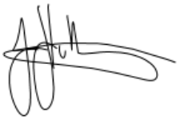

**Signed: Date: 26-Sep-2023**

**Jon Hollingworth**

**Managing Director**

### 3.1.2 Substance Abuse Policy

Under the Workplace Health and Safety ACT 1995, Huracan accepts our responsibility to ensure environments are safe for employees as well as all others on site. In doing so, Huracan is striving to create a workforce of the highest professional conduct, who are committed to excellence in their manner and conduct. To ensure these standards are met, management acknowledges the importance of ensuring that all employees undertake their duties in a professional manner, free from the influence of alcohol and other drugs.

This policy applies to all employees of Huracan including those staff who are itinerant.

**OUR PRINCIPLES ARE:**

• The misuse or abuse of alcohol and other drugs is of concern to Huracan when workplace safety, illegal activities in the workplace or an employee’s performance or conduct is an issue

• Managers and staff have obligations and responsibilities as set out in this policy in relation to dealing with performance or conduct issues in the workplace that arise from the effects of alcohol or other drugs.

• Staff dealt with in terms of this policy shall receive appropriate assistance and support in order to attain an acceptable standard of work performance and conduct. This may include participation in counselling, treatment or rehabilitation programs. Any evidence of possible criminal activities in regard to the use of illegal drugs shall be dealt with in accordance with Huracan statutory and legal obligations.

• *Personal information received from staff shall be dealt with relating to this policy shall be treated in strict confidence.*

Huracan recognises that the misuse of alcohol and other drugs can often be due to associated emotional, physiological and psychological factors. Therefore, this policy shall be applied with consideration for the individual, maintaining confidentiality and respecting the rights of staff who may have physical or psychological condition associated with alcohol and/or drug abuse.

**Huracan does not permit:**

The consumption of alcohol or other drugs while on our worksites or premises, or at any facilities to which we supply, except with the approval of Management, which is to be given in advance.

**Huracan reserves the right to:**

• Implement performance management programs, counselling and/or disciplinary action in respect to any staff in breach of this policy.

All employees are required to be familiar with this procedure and act in accordance with their responsibilities as set out in the Drug and Alcohol Policy.

Any grievances resulting from the implementation of this Policy shall be dealt with under our Staff Resolution Procedures.



**Signed: Date: 26-Sep-2023**

**Jon Hollingworth**

**Managing Director**

### 3.1.3 Driving and Journey Management Policy

HURACAN PTY LTD recognises that driving is a high risk activity. To minimise this risk and ensure consistent standards for driving qualification and practices are followed, this Policy applies for all business activities. This policy also provides the foundation for building a driver improvement program at the field level.

**OUR PRINCIPLES ARE:**

• Journey management must be planned and approved prior to conducting trips of a distance greater than 50km from point of origin.

• The driver must have an appropriate, valid license for the vehicle they are driving.

• Seat belts are a condition of employment and must be worn by the driver and passengers at all times.

• Driving improvement monitors will be used in all company vehicles and driver performance reviewed on a monthly basis. Tampering with driving improvement monitors is strictly prohibited.

• Driving under the influence of drugs and / or alcohol over legal limits is strictly prohibited.

• The use of mobile phones / hand free while driving is strictly prohibited.

• Speed limits are to be adhered to at all times.

Failure to comply with HURACAN PTY LTD driving and journey management principles is disciplinary action up to and including termination of employment.



**Signed: Date: 26-Sep-2023**

**Jon Hollingworth**

**Managing Director**

### 3.1.4 Training Policy

Huracan is committed to Continuous Improvement and Effective Employee Workplace Training and Self Advancement Programs to ensure the highest standards in Safety, Efficiency and Productivity across all Operations.

**To meet its Training Policy Commitment Huracan shall:**

• Ensure all Employees are properly trained in all workplace procedures they are asked to perform.

• Give priority to incorporating relevant work related training programs for all Employees and Management.

• Implement accredited Employee Workplace Training that aligns with National Competency Standards where applicable.

• Conduct regular performance reviews with all Employees and Management to identify training and development needs to meet the individual and Huracan Drilling’s business objectives.

• Evaluate training and development activities to monitor their effectiveness.

• Promote a culture that values training and development, so that Employees have the opportunity to reach their potential.

• Support employees who of their own initiative undertake and successfully complete accredited work related educational courses.

• Maintain all Employees’ training records and utilise those records to perform ‘gap analysis’ to ensure that Employees receive relevant training needs.



**Signed: Date: 26-Sep-2023**

**Jon Hollingworth**

**Managing Director**

### 3.1.5 Rehabilitation Policy

HURACAN PTY LTD recognises that there are substantial benefits to be gained from rehabilitation principles and practices and is committed to implementing them at this workplace. We recognise that the **Workers’ Compensation and Rehabilitation Act 2003 and the Workers' Compensation and Rehabilitation Regulation 2014** provide the legislative support for workplace rehabilitation activities.

Experience has shown that workplace rehabilitation assists the healing process and helps restore the worker’s normal function sooner. Workplace rehabilitation includes early provision of timely and adequate services, including suitable duties programs, and aims to:

• Maintain injured or ill workers at work.

• Ensure the worker’s earliest possible return to work.

• Maximise the worker’s independent functioning.

• Provide for durable employment.

This policy has been developed as a joint worker-management agreement.

**HURACAN PTY LTD is committed to:**

• Providing a safe and healthy work environment, but in the event of an injury or an illness, making sure workplace rehabilitation is started as soon as possible in accordance with medical advice.

• Ensuring appropriate suitable duties are made available to injured or ill workers to facilitate their safe and early return to work. These duties shall be consistent with the current medical certificate and shall be time limited.

• Respecting the confidential nature of medical and rehabilitation information and ensuring there shall be both verbal and written confidentiality.

• Ensuring all workers are aware that in the event of injury or illness, they shall be consulted to ensure a structured and safe return to work that shall not disadvantage them.

• Complying with legislative obligations with respect to the standard for rehabilitation.

• Adopting a multidisciplinary approach to rehabilitation as required.

• Workplace rehabilitation procedures have been developed to support this policy. The procedures define key terms, describe key roles and outline steps in the return to work process.

Our rehabilitation and return to work coordinator is Katrina Hollingworth..............**insert**



**Signed: Date: 26-Sep-2023**

**Jon Hollingworth**

**Managing Director**

### 3.1.6 Right to Stop Work Policy

Huracan Management supports the policy that any person has the right to stop work and seek further clarification about a task, without fear of reprisal, if they feel that their Health, Safety or Welfare is compromised whilst working on Huracan operations.

**To meet its Right to Stop Work Policy Huracan shall:**

• Immediately investigate work procedures, controls and review the level of risk of any work that has been halted by any person as a result of Health, Safety and Welfare concerns.

• Give Health and Safety first priority in all Plans, Operating Procedures, Training Programs and Job Instructions.

• Ensure that all Risks and Hazards associated with its Operations are identified and eliminated through the use of appropriate Risk Management techniques.

• If a hazard cannot be practically eliminated, best practice controls shall be adopted to ensure the Risks and Hazards identified are reduced to as Low as Reasonably Practical.

• Educate its Personnel, Contractors and Management about this Policy.

**All Employees, Contractors and Management are obliged to:**

• Integrate Health and Safety Considerations into all aspects of their work.

• Immediately Report, Investigate and rectify unsafe Practices and Conditions.



**Signed: Date: 26-Sep-2023**

**Jon Hollingworth**

**Managing Director**

### 3.1.7 Heat Stress Management Policy

Huracan Management shall ensure that the potential for Heat Stress is minimised in all

Huracan operations and work locations.

**To meet its Heat Stress Management Policy Huracan shall;**

• Review this Policy biennially or immediately following a Heat Stress related illness.

• Give Health and Safety of Employees first priority by considering the potential for Heat Stress in all Huracan Operations and communicate this to Employees regularly (e.g. tool box meetings).

• Consider the potential for Heat Stress in all Huracan operations and equipment designs and mitigate the potential for Heat Stress by use of appropriate Risk Management techniques.

• Ensure that all Employees receive regular training regarding Heat Stress and ensure that all Employees are aware of the early warning signs of Heat Stress (tiredness, irritability, dark urine colour, headaches, faintness, cramps, etc) and the importance of stopping work, taking relevant preventative action and reporting Heat Stress symptoms early.

• Ensure all Employees are aware of the need and their responsibility to watch over fellow Employees for the early warnings of Heat Stress.

• Provide adequate facilities such as appropriate clothing, water, electrolyte supplements, appropriate shading, cool down areas and appropriate rest periods to minimise the potential for Heat Stress events.

**All Employees, Contractors and Management are obliged to;**

• Attend Heat Stress Training sessions.

• Ensure that all personnel watch over co-workers for early signs of Heat Stress.

• Integrate Heat Stress considerations into all aspects of their work.

• Immediately Report and take preventative action when symptoms of Heat Stress become apparent.



**Signed: Date: 26-Sep-2023**

**Jon Hollingworth**

**Managing Director**

### 3.1.8 Cultural Heritage Policy

Huracan Management recognises the need, and is committed to the preservation of Indigenous artefacts and culture.

**To meet its Cultural Heritage Policy Huracan shall:**

• Conduct Operations in accordance within Tenure Holder requirements and policies and by giving due consideration to relevant Cultural Heritage legislation.

• Ensure that all Employees, Contractors and Management are aware of their obligation to not disturb or remove items of cultural significance, (e.g. skeletal remains, stone artefact scatters, stone tools, shell middens, scarred trees, stone arrangements and rock art).

• Ensure that all Employees, Contractors and Management are aware of their obligation to immediately report discoveries of items of cultural significance.

**All Employees, Contractors and Management are obliged to;**

• Give due consideration to cultural heritage issues and their significance in the wider community.

• Immediately report any discoveries of items of cultural significance, (e.g. skeletal remains, stone artefact scatters, stone tools, shell middens, scarred trees, stone arrangements and rock art).

• Conduct Operations in accordance within Tenure Holder requirements with regard to areas of cultural significance.

• Never disturb or remove items of cultural significance.



**Signed: Date: 26-Sep-2023**

**Jon Hollingworth**

**Managing Director**

# 4.0 HSE Responsibilities & Organisation

All Employees, Contractors and Management shall comply with and share responsibility for Health, Safety and Environmental Management as outlined in this document whilst conducting operations at Huracan work sites.

The following sections outline the Organisational Structure of Huracan and the relevant HSE responsibilities of each level in the Organisational structure.

**Huracan HSMP**

## 4.1 Organisational Chart

Jon Hollingworth

Operations Manager

Executive Safety Manager

Bill Arnold

HSE Advisor

Katrina Hollingworth

Administrator

Matt Auld

Location Manager

Field Direct Personnel

## 4.2 Responsibilities & Organisation

### 4.2.1 Board of Directors - Is responsible for:

• Providing direction and endorsement of the Safety Management Plan and ensure its adequacy and the commitment of Management.

• Providing adequate human and financial resources to meet the requirements of the Safety Management Plan and associated programs.

### 4.2.2 Executaive Safety Manager (Operations Manager) – Is responsible for:

• Communication to the Board of Directors of all HSE matters to enable the board to discharge its responsibilities listed above.

• Developing, Endorsing and Promoting HSE Policies in the workplace.

• Consult, cooperate and communicate with the Location Manager, HSE Advisor and other relevant state holders on HSE matters.

• Monitoring workforce compliance with this HSE Plan.

• Promoting communication on safety issues to and from the workforces.

• Allocation of resources as approved by the Board to ensure adequate HSE performance and compliance as outlined in this HSE Plan with a ratio of no greater than 40 field personal to 1 dedicated HSE role.

• Staying abreast of legislative and Client Safety requirements and ensuring these are communicated to the workforce.

• Ensure that operations have been adequately risk assessed and relevant controls identified to manage hazards and risks to a level as low as reasonably practicable.

• Keep up-to-date with knowledge of health and safety matters

• Appropriate processes for receiving and considering information regarding incidents, hazards and risks (such as Incident Alerts and Management Meetings) and escalating to Board of Directors as required and responding in a timely way

• Ensure compliance with the Work Health & Safety Act

### 4.2.3 Location Managers – are responsible for:

• Developing, Endorsing and Promoting HSE Policies in the workplace.

• Consult, cooperate and communicate with the Operations Manager, HSE Advisor and other relevant state holders on HSE matters.

• Monitoring workforce compliance with this HSE Plan.

• Promoting communication on safety issues to and from the workforces.

• Ensuring that all Supervisors have the skills and competencies to perform their duties and HSE responsibilities.

• Ensuring that all Supervisors understand their obligations as the most Senior Site based personnel and their responsibility as the designated ‘Site Safety Manager’ as described in the **Queensland Petroleum & Gas (Production and Safety) Regulation 2018.**

• Ensure that operations have been adequately risk assessed and relevant controls identified to manage hazards and risks to a level as low as reasonably practicable.

• Keep up-to-date with knowledge of health and safety matters

• Appropriate processes for receiving and considering information regarding incidents, hazards and risks (such as Incident Alerts and Management Meetings) and escalating to Executive Safety Manager as required and responding in a timely way

• Ensure compliance with the Work Health & Safety Act

### 4.2.4 Site SAFETY Manager - Is responsible for:

• If directly responsible for the site then ensuring that each person who enters the site is given an appropriate site induction that enables that person to comply with all relevant HSE Policies, Procedures, Safety Management and Emergency Management Plans for the site and that the Induction is relevant to the work/visit that the person shall be undertaking whilst on site.

• Implementing and monitoring for compliance of all HSE Policy, procedures, and the Safety Management Plan for all site based operations.

• Promoting a safe working culture on site.

• Documenting any safety information within the Huracan Information Management System.

• Conducting risk assessments and producing site-specific procedures for review and endorsement of Senior Management.

• Monitoring employees' fitness for work and administering appropriate disciplinary procedures in relation to safety breaches.

• Ensuring that all employees are properly supervised and trained to safely carry out their work.

• Ensure all site based Employees are provided with, and use the appropriate PPE and safety equipment provided, including first Aid equipment.

• Ensuring all equipment is fit for purpose.

• Ensuring that emergency procedures are in place and followed as per the HSE plan.

• Conducting inspections and maintaining the site in safe condition.

• Acting on any liaison for site safety issues as they arise and keeping Huracan Senior Management informed.

• Conducting regular Toolbox Meetings and promote communication and feedback to both the workforce and Senior Management on all matters relating to operations and safety.

### 4.2.5 Employees and Contractors - Are responsible for:

• Complying with all reasonable directions of the Site Supervisor and Site Manager and the HSE Plan.

• Their own safety and for those around them.

• Understanding, familiarising themselves and comply with Safe Work Procedures and the HSE Plan.

• Seeking clarification on work instructions and requirements if unsure how to proceed with any task.

• Reporting, and immediately acting on any unsafe practices, unhealthy conditions and hazards as they are identified.

• Practicing safe work methods.

• Correctly using and maintaining all tools, equipment, plant and materials.

• Correctly using and maintaining all safety devices and personal protective equipment.

• Reporting all injuries, equipment damage and near miss incidents to their supervisor.

### 4.2.6 HSE Advisor - Is responsible for:

• Review and update of the HSE Plan.

• Regular site visits as required by Senior Management to review compliance with the HSE Plan.

• Advising Senior Management on HSE responsibilities.

• Preparing formal audits of the HSE plan and advising Senior Management of necessary action plans.

• Identify hazards and risks

• Report in writing any hazards and risks

• To immediately notify management about:

• any incident that has occurred

• any immediate or imminent risk to health and safety

• To investigate, or assist in the investigation of, any incidents

### 4.2.7 Visitors

Visitors to Huracan worksites have an obligation to report all hazards and incidents and also,

• Must take reasonable care for their own health and safety.

• Take reasonable care their acts or omissions do not adversely affect the health and safety of other persons.

• Comply, so far as the worker is reasonably able, with any reasonable instruction.

## 4.3 Health Safety & Environmental Documentation

Huracan shall record and document HSE information via HIMS and the following reporting mechanisms;

• Work/Well Site Safety Induction.

• Journey Management procedure and use of the Site Safety Board System.

• Pre Job Toolbox Meetings & Stepback.

• JSA documentation and Risk Assessment via approved Risk Matrix.

• Hazard identification and reporting procedure in HIMS (Huracan Information Management System).

• Use of the Wellsite Permit to Work System.

• Monthly Safety Meeting (documented).

• Site Supervisor (Site Safety Manager) documented Handover.

• Adherence to the requirements of this HSE Plan, Emergency Response Plan and Safe Work Procedures.

• Distribution of relevant Industry related Safety Alerts and Publications.

# 5.0 Procedures

## 5.1 General and Site Based Employee Inductions

All personnel are required to complete a general induction prior to commencement of work in the field. Records of attendance and assessment shall be held in each employee’s personnel file.

All personnel are also required to complete a Site based (Level 3) induction program. The induction program shall cover the following:

• General Site Safety Requirements (both Huracan and Client requirements).

• Chain of command on site and identification of the designated Site Safety Manager.

• Requirement to abide with safety and general work instructions.

• Existence and location of the HSE Plan, Emergency Response Plan, Safe Work Procedures and general Company Policies (Huracan and Client policies).

• Emergency signals, Muster Point locations, location of emergency shut downs, location and use of emergency numbers and communication equipment and emergency procedures in use on site.

• The requirement for all personnel to report all hazards and incidents immediately to the Site Safety Manager, (Site Supervisor).

Induction records shall be kept on site and in the main Roma Office for a period of 12 months. Personnel who have not attended a Huracan work site for a period greater than 6 months shall be obliged to complete site the induction process.

## 5.2 New and inexperienced employee mentoring system

New and inexperienced employees are considered at higher risk of incidents and as a result Huracan has a New and Inexperienced Employee mentor system. During the period of the induction process the Operations Manager will assign a mentor to the new hire employee. The mentor will be responsible for assisting the New Employee in orientation of Huracan work practices and policies for the period of time as deemed by the Operations Manager.

If the new / inexperienced employees is to work in the field then a Safer Together - Industry Safety Induction is to be undertaken prior to undertaking work in the field. Also the Huracan - Introduction to Oil and Gas one day course is to be completed.

The new employee will also be required to wear a Green Hardhat for a period as specified below:

• One year for a new employee with no previous industry or trade experience

• Six months for new employee with more than two years of trade experience

• Three months for a new employee with less than two years of industry experience

• One month for a new employee with greater than two years of industry experience

## 5.3 Training and Development

Ongoing training and development of all personnel irrespective of position, is central to Huracan’s vision of providing an efficient organisation and workforce.

Through training and development, Huracan hopes to assist employees to achieve personal achievement and development, job and career satisfaction and a Healthy and Safe work environment.

Competency based training of Huracan personnel shall involve a mixture of classroom based training modules, on the job training and self-study programmes where appropriate.

Training and Certification requirements have been defined by role review and analysis and is outlined as per the “Personnel Training and Competency Requirement” document found in HIMS. This document must be reviewed within revision date or when additional competencies are required.

A training matrix is used to record both training requirements and training that has been completed by all Huracan personnel (Copies of the training matrix shall be held on the Huracan internal website).

Each employee position description shall identify the requisite knowledge requirements, skill set and experience required for that position.

An employees shall not be placed in a position where they do not have the necessary skills to complete a task safely and skills training shall be competency based and assessed accordingly.

Prior to an individual’s competency breakout, a final assessment of the individuals skills will be assessed by the Operations Manager at the wellsite using the appropriate role evaluation sheet.

### 5.3.1 Qualifications, Certificates and Licenses

Huracan senior management shall confirm the validity of potential employee’s qualifications, certificates and licences.

Prior to and during ongoing site operations, the HSE Manager shall be responsible for carrying periodic checks (incoming crew change day is a good time) to ensure that personnel hold the relevant certificates and qualifications for tasks that they shall be performing and that those certificates and qualifications have not expired.

Huracan senior management shall be immediately informed of any non-compliance before those personnel are authorised to commence operations.

Any personnel not holding the relevant certificates, licences or qualifications may only continue with operations if approved by Huracan senior management or they are undergoing approved training and are appropriately supervised.

## 5.4 Substance Abuse (Drug and Alcohol)

A “Zero Tolerance” to drug and alcohol shall apply to all Huracan field operations as per the Huracan Drug & Alcohol Policy to ensure the Health, Safety and Welfare of all personnel is maintained.

In accordance with the Huracan Drug and Alcohol Policy, pre-employment screening, ongoing random screening and ‘for cause’ testing shall be implemented to ensure compliance with the policy.

Non-compliance with the Policy shall lead to serious disciplinary action or termination of employment.

Refusal to undertake requested testing is considered a breach of the Drug and Alcohol Policy and persons refusing to test shall be removed from site shall be subject to counselling and/or further disciplinary action which may include termination of employment.

## 5.5 Personal Protective Equipment

Huracan shall supply the relevant PPE to ensure that tasks are able to be carried out safely. The relevant PPE shall be identified during JSA and risk assessments and shall be outlined in the relevant SWP for the particular task. Management is responsible for scheduling maintenance of PPE to ensure it is in good working order or ensuring adequate supply and replacements available. Huracan will ensure that personnel are provided adequate training on the use of PPE.

All Huracan personnel and contractors should ensure care is taken with PPE to not reduce the expected useful life.

The minimum PPE whilst on any Huracan work site shall be:

• Long sleeve cotton shirts and long cotton trousers.

• Steel capped safety boots.

Additional protective clothing or equipment shall be worn where required for specific tasks as defined by JSA’s, MSDS’s and SWP’s. These may include but are not limited to.

• Hand protection.

• Hard Hat.

• Safety Glasses.

• Hearing protection in areas above 82dB and in signed areas.

• Radiation Dosimeter.

• Face Shields.

• Breathing apparatus.

• Aprons.

• Rubber gloves and/or boots.

• Fall protection equipment.

The minimum PPE whilst on any Client wellsite shall be:

* Wrist to ankle, antistatic Cotton or Flame Resistant (FR) clothing as per AS/NZS 60079
* Long sleeve cotton shirts and long cotton trousers with high-visibility strip.
* Steel capped safety boots with lace-up/zip up.
* Hand protection.
* Hard Hat.
* Safety Glasses.
* Hearing protection (Origin Energy Requirement).

Electrical insulating gloves while handling logging tools attached to EcoSeal cable must meet or exceed AUS standard - AS-60903:2022.

Failure to comply with safety warnings or failure to use PPE, tampering with PPE or other safety equipment shall lead to serious disciplinary action and the possibility of termination of employment.

## 5.6 Safety and Hazard Warning Signs

Safety and hazard warning signs shall be displayed as appropriate throughout the worksites and shall conform to the requirements of **AS 1319 - Safety Signs for the Occupational Environment**.

**Note: Signs may be symbolic (picture) only, text only or a combination of the two forms and warning signs shall be displayed to ensure the greatest visibility within the work area.**

Condition and placement of signs shall be checked during every rig and workplace inspection. The Driller and Site Supervisor are responsible for ensuring the replacement or relocation of signs as necessary.

The removal, intentional damage or defacement of warning signs may result in disciplinary action.

## 5.7 HSE Meeting Requirements during Operations

The Huracan Supervisor shall be responsible for the allocation of adequate time for Safety Meetings to occur on site prior to and during site operations.

Safety Meetings shall be held as follows:

• Pre-spud inspection and Pre-Spud Safety meeting (Huracan shall attend if work tasks permit).

• Daily Toolbox meetings prior to the commencement of the days shift.

• Toolbox meetings prior to the commencement of a new task.

• Toolbox meeting when operations call for deviation from SWP’s (a written JSA is also required).

## 5.8 Inspections and Audits

### 5.8.1 Internal Inspections and Audits

An Audit and inspection schedule is to be developed at the beginning of the year to include location specific requirements to be compliant to Huracan HSE management system.

The Operations Manager shall be responsible for conducting regular site inspections and audits to ensure all operations comply with HSE requirements.

Inspections and audits shall include (but is not limited) the following documents:

• Daily Start-Up Checklists.

• Emergency Response Drills.

• Fire Extinguisher checklist.

• First Aid Kit checklist.

• Gas monitoring register.

• Harness & Lanyard checklist.

• Lifting Gear checklist.

• Site Inspection checklist.

• Third Party Contractor audit.

Audits and inspections shall be recorded with applicable action items in HIMS.

### 5.8.2 External Inspections and Audits

Action items from all audits shall form the basis of Huracan s commitment to continuous improvement with regard to HSE issues. The audit process shall also ensure that operations comply with the requirements of the **Queensland Petroleum and Gas (Production and Safety) Act and Regulation**.

## 5.9 Hazard and Incident Reporting

An incident is defined as an unintended outcome or situation that caused or had the potential to cause a HSE or SQ accident.

All employees and visitors have an obligation to report all hazards and incidents to Huracan senior management via the Site Supervisor.

Huracan Senior Management shall then report as necessary to client management and Government Regulatory Authorities depending on the nature and severity of the incident as soon as reasonably practicable including but not limited to;

* death of a person
* a serious injury or illness of a person
* a dangerous incident

Definitions of serious injury or illness and dangerous incident are provided in the [WHS Act](https://www.worksafe.qld.gov.au/safety-and-prevention/incidents-and-notifications/notify-us-of-an-incident/notify-workplace-health-and-safety-queensland-or-electrical-safety-office/confirm-if-an-incident-is-notifiable). If you're still unsure if an incident is notifiable or you need to notify the authorities call on 1300 362 128.

When a notifiable incident occurs Huracan management must take all action to prevent disturbance of the site until an inspector arrives so far is reasonably practicable.

All hazards and incidents shall be reported via the HSE report in HIMS.

### 5.9.1 Individual Obligations

Individuals have an obligation to eliminate, guard against or protect themselves and others from any hazards as soon as they are recognised.

Recognised hazards shall be reported immediately to the Site Supervisor.

If there is imminent danger, the person recognising the danger shall:

• Immediately take all reasonable steps to isolate the danger by stopping work and/or evacuating the area.

• Immediately report all hazards and incidents to the Site Supervisor for immediate investigation.

### 5.9.2 Huracan Wellsite Supervisor Obligations

• The Wellsite Supervisor shall immediately carry out investigations to control or remove any hazards that are specific to Huracan’s wellsite role.

• Where a hazard cannot be immediately removed or controlled the site supervisor shall ensure that all work is suspended.

• The Huracan Wellsite Supervisor shall also report any Huracan hazard immediately to Operating Company Representative, Site Safety Manager and Huracan Senior Management.

• The Huracan Wellsite Supervisor in conjunction with Huracan Senior Management shall then perform the necessary Risk Assessment, recommend and approve control or substitution methods before work is approved to re-commence.

### 5.9.3 Huracan Senior Management Obligations

Huracan senior management shall immediately investigate all hazards/incidents and incident reports and approve any changes to SWP’s, control measures or modifications to plant before work re-commences.

Additionally, senior management shall ensure that the relevant statutory authorities are informed of all incidents particularly with respect to prescribed incidents as outlined in the **Queensland Petroleum and Gas (Production and Safety) Act and Regulation**.

The main Huracan office in Roma shall maintain the following records;

• All Hazard, incident and Incident forms

• All Hazard, incident and Incident investigations

• All JSA, risk assessment reports and records

• Workers compensation reports

• Reports to and from the relevant statutory authorities

## 5.10 Incident Investigation

All recordable incidents, high risk and near miss incidents shall be investigated by Huracan Senior Management.

Incident investigations are required to determining causes of these events and to assist with continuous improvement of operations and prevent re-occurrence of these events.

The investigation and report shall be completed within 48 hours of the incident and shall include written statements from all personnel involved.

On review of the initial report, Huracan Senior management shall determine if further investigation is required, (e.g. causal analysis/tap root).

Incident reports shall also be copied to the Chief Inspector of the Queensland Department of Resource Safety and Health as required by the **Petroleum and Gas (Production and Safety) Act and Regulation**.

All initial incident investigation reports shall be initiated by the Site Supervisor on site using the Incident investigation report form. These reports shall be immediately forwarded to Huracan Senior management.

### 5.10.1 Responsibilities

**Huracan Senior Management (Executive Safety Manager, Location Manager)**

• Ensure all incidents and injuries are properly investigated.

• Ensure immediate and long term corrective actions are taken to prevent reoccurrence of incidents and incidents.

• Maintain Incident Reports permanently on file.

• Consult with employee’s and contractors on all remedial work plans and changes to the HSE management plan prior to implementation.

**Huracan Site Managers**

• Conduct immediate initial Incident investigations.

• Report all incidents to Huracan Senior Management with one (1) after the event.

• Collect and preserve all evidence that may be useful in an investigation.

• Conduct interviews of witnesses in a professional manner.

• Do not attempt to find or assign blame for incidents.

• Take action to protect people and property from secondary effects of incidents.

**Employees/Contractors**

• Assist as requested in all incident investigations.

• Provide statements as requested.

## 5.11 Hazard and Risk Assessment

The Manager, Site Manager and Crew shall identify hazards and potential consequences of identified hazards by analysis of the proposed work to be performed.

The purpose of hazard identification, assessment and control is to minimise the likelihood of an incident occurring.

The potential consequences of each hazard observation shall be assessed and a control strategy developed to eliminate the occurrence of the hazard, and/or minimise its effect to a level that is “As Low as Reasonably Practicable” (ALARP).

Selection of the Hazard Identification and assessment process may be by one or a combination of any of the following techniques:

• Workplace Inspections.

• Job Safety Analysis (JSA).

• Hazard Analysis Workshop.

**Important Notes:**

For any new activity or non-routine/standard work, a task specific JSA shall be prepared at the worksite.

The JSA can be generic but must be reviewed to ensure relevance by the work group or personnel involved with performing the task.

The Site Supervisor and Crew are required to conduct JSA’s in accordance with the Permit/SWP/JSA Flowchart.

The Site Supervisor shall specify the most appropriate Hazard Identification and assessment process to be used in any analysis, and ensure that where possible it is carried out consultatively with the workgroup. The HSE advisor or Executive Safety Manager will make themselves available for consultation and review of a hazard identification assessment.

The Hierarchy of Control should be used to implement control measures.

• Eliminate

• Substitute

• Isolate

• Engineering Controls

• Administrative Controls

• Personal Protective Equipment

Matters to be considered shall include:

• The type of hazard.

• The size and layout of the workplace.

• The frequency potential of the hazard.

• The consequence of injury, damage or loss likely to occur as a result of being exposed to a hazard.

• The number of employees and where they are located.

• The distance from the workplace to the nearest available emergency service.

• Systems of communication for all employees to enable contact with emergency services.

• Information available on Material Safety Data Sheets (MSDS) relating to first aid measures.

• Journey Management.

Hazards associated with specific tasks shall be assessed consultatively using experienced personnel and personnel required to carry out the activity.

The identified hazards are to be documented and alongside them possible risk, consequences, and control strategies noted in the Hazard Register.

The Hazard Register shall be maintained and available to all personnel within HIMS under the document report menu. HSE Hazard Observations should be recorded as HSSE Report within HIMS and advise the Site Supervisor of identified hazards/near miss situations.

A Hazard & Corrective Actions Register (HCAR) has been developed for Huracan operations and this shall be updated monthly with information from HIMS. An updated HCAR shall be circulated monthly to each item of Plant.

The Executive Safety Manager along with the HSE Advisor shall review the HCAR register annually and identify trends that require action or a review of a specific task.

## 5.12 Hazardous Materials

The Executive Safety Manager will ensure that all hazardous chemicals are assessed for necessity before approval for use and storage in a Huracan facility. At this time the requirements for training will be assessed and formally agreed and if required added to the hazardous material register. The combinability of hazardous chemicals will also be evaluated at this time and noted in the hazardous material register.

Personnel who use a hazardous chemical must review the hazardous material register and the associated MSDS sheet to ensure the correct training, handling, use and storage of the chemical.

Huracan shall maintain material data safety data sheets (MSDS) for all chemicals held on site. The MSDS’s shall be available to all site personnel for review to ensure that correct chemical handling procedures and PPE requirements are being met.

All hazardous chemicals used, handled, or stored at the workplace must be correctly labelled.

The Site Supervisor shall ensure the hazardous material register to be kept up to date.

All flammable and hazardous goods shall be stored in accordance with relevant government legislative requirements and relevant Australian Standards and should be at the lowest practicable quantity.

For additional details please refer to section 5.3.1 Hazardous Substance Management & Storage Program in the Huracan Environmental Management Plan.

## 5.13 Noise management and The Prevention of Hearing Loss

Machinery noise emitted from plant shall be monitored by the Location Manager. Excessive noise shall be considered a hazardous to personnel and be entered on the Hazard Register.

The Location Manager shall either suspend operations and/or implement appropriate control procedures and mechanisms if work activities and plant emit noise at levels beyond those permitted or recommended. Recommendations should be reviewed against the current Managing Noise and Preventing Hearing Loss at Work - Code of Practice.

Each item of Plant and Equipment shall have a noise level monitoring and mapping study performed. Re-testing shall occur as required and if changes are made to equipment or additional equipment is introduced.

### 5.13.1 Personnel Audiometric Testing

Audiometric testing must be performed on all employees where employees are exposed to >85dB. Testing should be performed within 3 months of employment and every 2 years. Results are to be discussed with the employee and records are retained within the employee personnel file.

### 5.13.2 Plant Equipment Design and Manufacturing

Designers must provide information on the noise emission values of the plant (for example data on sound power level or sound pressure level), the operating conditions of the plant when the noise emission is measured, and the methods used to measure the noise emission. They must also provide information on any conditions required for safe use. The designer must provide the information with the design. If you Huracan design the plant, consideration should be given to the following:

− preventing or reducing the impact between machine parts

− replacing metal parts with quieter plastic parts

− combining machine guards with acoustic treatment

− enclosing particularly noisy machine parts

− selecting power transmission that permits the quietest speed regulation, for example rotation-speed-controlled electric motors

− isolating vibration-related noise sources within machines

− good seals for doors for machines

− machines with effective cooling flanges that reduce the need for air jet cooling

− quieter types of fans or placing mufflers in the ducts of ventilation systems

− quiet electric motors and transmissions

− pipelines for low flow speeds (maximum 5 m/sec), and

− ventilation ducts with fan inlet mufflers and other mufflers to prevent noise transfer in the duct between noisy and quiet rooms.

Methods of maintenance and servicing should be taken into account in noise control design.

### 5.13.3 Building Structures and Design

Designers of buildings and structures must take noise control into account from the beginning of the planning process and minimise the noise transmitted through the structure to the lowest level that is reasonably practicable. For new buildings or structures, designers should consider:

− the effect on noise levels of building reverberation

− the building layout and location of workstations relative to any plant

− selecting the frame, floor and machine bases so that all sources of disturbance can be provided with effective vibration isolation. Heavy, noisy equipment requires rigid, heavy bases. It is also possible to isolate machine bases from direct contact with the rest of the building frame

− isolating noise sources such as plant rooms

− designing acoustic treatments for noisy areas, for example cover ceilings (and walls in the case of very high ceilings) with sound-absorbing material, use floating floors

− using flexible construction joints as building elements

− designing walls, floors, windows and doors to provide the necessary sound transmission loss, and

− covering floors of office areas with carpet.

### 5.13.4 Sound-Insulating Sperate Rooms

With the automation of processes, remote control from a separate room may be possible. Some control measures may include:

− designing control rooms with materials having adequate transmission loss

− providing good sealing around doors and windows, and

− providing openings for ventilation with passages for cables and piping equipped with good seals.

Control rooms should be adequately ventilated with air-conditioning in hot working areas. Otherwise, there is a risk that the doors will be opened for ventilation, which would spoil the effectiveness of the room in reducing the noise level.

## 5.14 Fire Prevention

**The Site Supervisor and HSE Manager shall ensure that:**

• There is adequate Fire Protection measures in place on site.

• Adequate numbers and the correct type of fire extinguishers are available on site and are properly maintained (as per the audit and inspect schedule).

• The Crew are aware of general fire restrictions, the risk of ignition and the potential spread of fire throughout the various areas of the operation.

• All vehicles, plant and equipment have appropriate fire extinguishers and are correctly maintained.

• Wellsite plant and equipment are to have an Ignition Risk Assessment performed and documented in HIMS.

The Site Supervisor and Contact Safety Advisor shall ensure that all personnel on site are aware of the location of all firefighting equipment and the correct use of the equipment.

The Site Supervisor and HSE Manager shall ensure that there is documented evidence of employee training in the use of firefighting equipment and shall be responsible for conducting inspections as per the Audit and Inspection Schedule, using the Extinguisher Checklist and Fire Extinguisher Register.

## 5.15 Compressed Gas Cylinders

All compressed gas cylinders are to be secured by means of a chain, clamp or rope in an upright position. Empty cylinders may be laid down provided that valves are protected from possible damage and suitably chocked to prevent rolling. Empty cylinders shall be clearly marked with chalk as “empty”. Gas cylinders require a current inspection mark.

Cylinders shall be stored in a ventilated area out of direct sunlight, secured in the upright position and have signage displaying the class of the gas stored.

Signage can be placed on designated cylinder storage areas or in a storage pallet designed for the purpose of storing compressed gas cylinders. A fire extinguisher shall be within close proximity of oxy-acetylene sets and cylinders.

## 5.16 General Housekeeping

All personnel are responsible for ensuring that their work areas and vehicles are kept clean and tidy at all times.

The Site Supervisor shall be responsible for ensuring that all waste material is segregated and disposed of correctly at the rig and camp sites.

## 5.17 Work Permits

Huracan shall utilise the Onshore Wellsite Permit to Work Systems on all well sites. The Site Supervisor shall approve permits as required by the permit system.

A permit/SWP/JSA Flowchart shall be posted on notice boards in the Site Managers Office and in the site ‘smoko’ shack.

The objectives of the Permit System are to ensure that:

• People, environment, equipment and product are protected.

• Safe working practices are followed.

• The work site is inspected and all necessary precautions have been considered and implemented before work commences.

• The work is performed only on the specified equipment.

• The location of people and the type of work being carried out are always known shall an emergency occur.

• The person(s) carrying out the work understands the conditions under which work may be carried out.

• The equipment to be worked on has been correctly prepared for the work to be carried out.

• Correct protective measures are available and are being used.

• The work being done is carefully monitored.

• The work site is left in a clean and safe condition upon completion of the work.

• The details of non-completed work are documented and communicated to the Permit Authority.

• Equipment left unserviceable is correctly tagged and identified for incoming shifts.

The Site Supervisor shall ensure that requirements of the Wellsite Permit to Work System are followed.

The WSPTW system shall be used for the following activities;

• Pressure Testing

• Hot and Cold Work

• Confined Space Entry

• Handling of Explosive or Radioactive Substances/Tools

• Working at Heights

• Electrical Work

### 5.17.1 Pressure Testing

A Pressure Systems Work Permit is required for any work involving equipment which is under pressure, may be under pressure, or any work involving pressurised operations.

Toolbox meetings in conjunction with permit preparation as per the WPTW system are required before commencing any pressure testing operations.

Before commencement of any pressure test, the Site Supervisor shall:

• Review with crews any SWP’s for pressures testing of particular equipment

• Issue a pressure systems work permit as per the requirements of the WPTWS and ensure all controls are in place before work commences

• Ensure that all instruments and gauges are suitable for the expected pressure

Certified pressure vessels should be NDT tested minimum every 5 years by a third party inspector and pressure tested annually when in regular use or prior to mobilisation to a work site to test pressure at the Huracan workshop.

### 5.17.2 Hot and Cold Work

Cold work permits are required for work carried out that is non-standard, shall not generate any source of ignition, such as flame, spark or temperature sufficient to ignite any flammable material and is not covered by any other permits.

A toolbox meeting in conjunction with permit preparation as per the WPTW system is required. Hot work permits are required for work which could generate fire, naked flame, heat, spark or other source of ignition, and is located anywhere on the Wellsite other than within an approved maintenance or welding workshop or designated smoking area, provided that workshop or area is not within 45 metres of the well or other source of flammable vapour.

A toolbox meeting in conjunction with permit preparation as per the WPTW system is required.

### 5.17.3 Confined Space Entry

Huracan does not undertake any confined space entry.

### 5.17.4 Working at Heights

Huracan aims to minimise the requirement for its personnel to work at heights. Where possible, these activities shall be eliminated from operations.

Where working at heights cannot be avoided, then this work shall be carried out in accordance with the Safe Working at Height Code.

A Working at Heights Permit is required whenever personnel or objects are at risk of falling into or through one level to another and the work cannot be performed from a permanent platform or other access way.

Where possible, all Work at Heights shall be conducted from within edge protection of permanent or temporary work platforms.

Should edge protection not be possible, then a combination of a harness, a line and a line anchorage point which shall prevent a person from free falling shall be used.

When working at heights with tools and equipment;

* Hand tool management is required with the following;
  + Tool tie off to tool belt or harness using clips, harness or other tendering aids.
  + A working at hieghts, tool register.

Working at heights could include but is not limited to;

* Dipping frac tanks
* Working from trailers or backs of trucks
* Climbing wellheads
* Accessing objects during rig ups and rig downs
* Making up assemblies on catwalks

All drop object incident reporting **must** include a dropped object consequence calculator. Any incident where the potential severity is above slight must be investigated by management and reported to the appropriate parties involved in the operation (client, third parties) as soon as practicable.

A Dropped Object Inspection should be performed whenever the potential exists. Personnel should use the appropriate Dropped Object Inspection Register for the associated task.

Management will perform DROPS inspection audit at a minimum frequency of once per year to confirm compliance. Audit results are to be recorded in HIMS, and all action items are communicated to appropriate personnel.

### 5.17.5 Electrical Work >24v DC

All electrical work >24V DC requires an **ELECTRICAL WORK PERMIT.** This work shall be carried out by a person holding formal electrical qualifications applicable to the state or territory the work is being conducted in and comply with AS/NZS 3000.

**ELECTRICAL WORK** includes, but is not limited to:

* Work on generators,
* Work on electrical panels,
* Work on silicon controlled rectifier units,
* Work on electric motors,
* Work on live electrical circuits which are not in electrical substations, and
* Repair, maintenance, testing and connection.
* Equipment Test and Tag.

All personnel assisting with or undertaking LV electrical work must be trained and hold current competency in LV rescue, resuscitation and first aid. LV rescue kits must be available at work site when testing or live work activities are in progress.

Any fuelling systems must be earthed and all earth bonding leads fitted and being used for refuelling. All refuelling systems must have regular maintenance and a safety inspection checklist is to be recorded in HIMS.

## 5.18 Inspection, Testing and Maintenance of Plant & Equipment

Procedures for inspection, testing and maintenance of plant and equipment shall be implemented by the Operations and General Managers.

Procedures shall be typically applied to:

• Land Transport Vehicles.

• Mobile Plant and Equipment.

• Stationary Motorised Equipment.

• Portable Electrical equipment.

• Lifting Equipment.

• Test Equipment.

• Fire Protection equipment.

The Operations & Site Supervisor shall maintain a Register of plant maintenance.

Plant or equipment that is undergoing maintenance or found to be faulty or in an unsafe condition, shall be taken out of service and tagged appropriately (i.e. tagged as "Dangerous", "Not for Use" or "Out of Service".

The Operations Manager shall ensure that all plant and equipment is accompanied by Operating Instructions, Maintenance and Inspection records and that only qualified/competent persons operate, maintain and test such plant and equipment.

## 5.19 Excavations

Huracan personnel are not trained for excavation work and should not participate in such events. In the even that Huracan personnel are to work around excavations at well and camp sites for effluent processing systems flow and flare lines, mud pits, buried cabling, shall be in accordance with client requirements.

The Site Supervisor shall ensure that client instruction and approval has been obtained before commencing any excavation work.

## 5.20 Safe Work Procedures (SWP’s)

Safe Work Procedures shall be prepared for all drilling activities that are considered as standard or routine work.

The Site Supervisor is responsible for ensuring that SWP’s are followed and is responsible for initiating development of new SWP’s (with assistance from the HSE Manager if present and the work party) as new tasks are introduced to the work sites.

For new tasks for which SWP’s do not exist, JSA’s in conjunction with risk assessment methods shall be used as the initial basis to develop SWP’s.

The draft SWP’s developed from this process require the review and approval of Senior

Management before finalisation of the draft SWP’s and inclusion into the SWP manuals.

SWP’s shall be developed that are specific to each particular rig and the specific equipment in use on that rig.

The process used to develop an SWP is as follows:

• Job specific SWP’s developed (via JSA and risk assessment methods) and approved by the Operations Manager.

• Job specific SWP’s issued to relevant Operator.

• Job specific SWP’s further developed and reviewed by Site Supervisor and work party.

• Changes or improvements made to SWP’s.

• Approval and revision by Senior Management and reissue of SWP’s.

Revisions of SWP’s shall be conducted monthly as a minimum, or as required by changes to operations. SWP’s are ‘live’ documents.

## 5.21 Vehicle, Plant and Equipment Movements and Control

Operators of vehicles, plant and equipment shall be licensed and competent to operate the vehicle, plant or machinery in question and observe local Road Laws at all times.

All vehicles shall be fitted with a two-way radio. Personnel are not permitted to drive any vehicle in operating companies “field locations” unless they have successfully completed an accredited 4WD training course.

Plant and equipment when coming in close proximity of wellsite equipment such as a wellhead or process equipment, must have a spotter when the equipment operator does not have a clear line of site.

A suitable barrier will be used to exclude personnel from entering the exclusion zone during operation.

Huracan Senior Management shall arrange for personnel to undertake an approved 4WD training course. Records of training shall be uploaded to the Huracan Information Management System HIMS.

Vehicles carrying hazardous goods or chemicals shall carry appropriate signage, which is to be clearly visible and mounted correctly to the vehicle.

All personnel shall utilise journey management procedures as per the Huracan Land Transport Vehicles with loads extending beyond the length of the vehicle shall be flagged. Similarly, loads extending beyond the width of any vehicle shall be clearly indicated by a notice on the front and rear of the vehicle, and such loaded vehicles shall be escorted with a vehicle pilot.

Pilot vehicle drivers shall remain in continuous radio communication with the vehicle's driver as per Road Transport Legislative requirements.

All vehicles and plant to have suitable weed hygiene for the location of work.

## 5.22 Lifting and Hoisting Equipment

A Critical Lifting Register shall be maintained at all operating Plant indicating all critical lifting equipment on site, equipment serial numbers, load ratings, test dates and relevant certificates. Copies of the Lifting Register shall also be held in the Roma Office and a copy stored on the Huracan Information Management System under Audit / Inspection Reports.

Lifting equipment shall be inspected annually by a third party accredited for compliance with ISO/IEC 17020 – Inspection standard.

Lifting equipment shall only be used for the purpose designed and within rated capacity of the equipment. Equipment shall only be operated as per manufactures instructions.

Only qualified operators, who correctly trained in the operation of the relevant equipment, shall be permitted to operate the equipment.

Personnel who are responsible for rigging equipment for use with cranes or certified lifting equipment, shall be licensed Dogmen or Riggers, unless the load is pre-slung, is fitted with a permanent lifting attachment, or using a truck/self-loading crane (HIAB). When a HIAB has a lift rating greater than 10 tonnes the operator shall be suitably qualified.

Concealed loads shall be controlled by the use of an additional dogman, communicating with the Crane Operator by means of an appropriate hand held communication device.

At no time are loads to be lifted over personnel or personnel permitted to work beneath suspended loads.

During hoisting operations where a load requires control during the lift or has the potential to shift, with the potential of damaging equipment or causing injury to personnel, then the load shall be controlled by means of one or more ropes (tag lines).

The Site Supervisor is responsible for ensuring that any critical lift risk assessments are performed, any SWP’s are used and the relevant approvals obtained prior to such lifts commencing.

Any lift over 10 tonnes to be conducted over a wellhead using a crane requires a critical lifting study and shall be approved by Huracan Senior Management and the relevant Operating Company/Client that operations are being performed for.

Please refer to Huracan Lifting Management Plan for additional details.

## 5.23 Mobile Lifting Equipment

Mobile plant shall not be used as a crane device unless it is legally certified to operate as such. The plant shall be inspected and found to meet the statutory requirements for performing the required lift.

The operating types or buckets of mobile plant shall not be left raised with the controls unattended.

No item of mobile plant may operate within 6 metres of high voltage lines unless such lines have been isolated by the proper authority. Work shall then be carried out under the required Permit to Work conditions.

Licensed Mobile equipment shall be maintained in a safe, roadworthy condition and comply with local Road Traffic Authority requirements.

Trainees may operate load shifting or lifting equipment only if they complete a daily logbook, and are under the supervision of a person that holds the certification for the item of Plant the trainee is operating. Logbooks shall be signed off by the certified person at the completion of each operation.

## 5.24 Operating Mobilisation Procedures

Prior to mobilisation to location a pre-job briefing shall be performed with an SME or peer and the relevant procedures and checklists completed and reviewed. A de-brief shall be performed on all jobs with any HSE or SQ incident.

## 5.25 Working in Hot Environments

Work conducted in Hot Environments shall be in accordance with Huracan Policies and Procedures, please refer to Fitness For Work Management Plan document.

## 5.26 Stepping, Handling and Lifting

All personnel will undertake the Huracan Injury Prevention Program in order to prevent injuries associated with stepping, handling and lifting. In addition to the program Huracan shall provide safe equipment for manual handling tasks. Huracan personnel will also undertake an initial Refer to the Huracan Injury Prevention Standard for personnel requirements and details.

## 5.27 Management of Change

Huracan operations are subject to change, implying that associated risk levels also evolve. It is essential that these changes are managed in a controlled manner so that risk is always maintained at an acceptable level.

The management of change processes shall be followed to manage operational and commercial risk by ensuring that all significant changes to design, equipment, operations, modifications, and deviations from policies are justified, approved, recorded, and monitored in a controlled and effective manner, and that relevant parties are identified and advised of changes as needed, including during personnel handovers.

Management of Change Procedure

1. The Originator identifies and acknowledges the deviation and the nature of the significant change.

2. The direct line manager of the Originator set up a risk assessment team.

3. The risk assessment team performs a comprehensive risk assessment to determine the initial (before any risk reduction measures are taken) and ultimately residual risk levels.

4. The risk assessment team develops a risk control plan to lower the risk to ALARP (As Low As Reasonably Practicable), including all prevention and mitigation measures specified in the risk assessment.

5. The Originator obtains the approval from the Operations Manager. Requests are initiated before a point of no return is reached, i.e. before any irreversible option is taken that would leave the approver no option but to approve the request;

* Enough lead time is given so as to allow sufficient time for review and approval;
* Appropriate technical expertise, if required, is consulted;
* Requests are approved and the risk prevention and mitigation measures and additional requirements specified in the approval process are implemented before exempted activity is started or before the revised procedure/work instruction is performed;
* The risk prevention and mitigation measures do not imply another deviation, which should then be addressed with the same methodology.

6. The Approver reviews all the details of the request and in this process must ensure that:

* The request is justified and that proposed risk prevention and mitigation measures are adequate;
* Advice is obtained from concerned functions (both internal and external)
* The approval does not ratify de facto (known) violation of policies, procedures or work instructions, or endorse a fait accompli (existing and acknowledged) situation;
* The legal department is consulted, as deemed necessary, to ascertain the nature and scope of applicable laws and regulations and to avoid non-compliance therewith in connection with a management of change or exemption request.

**7.** Upon approval, the Originator must ensure that the management of change details are thoroughly communicated to all those involved, including third parties, and also including any newcomers that may arrive after its initial implementation.

**8.** The activity is performed.

**9.** Upon completion of the activity, the Originator must ensure that the management of change is closed out and documented in HIMS.

## 5.28 Fatigue Management

Huracan works in an industry with a 24hr lifestyle. This requires special considering when management risk from fatigue. Please review the Fatigue Management Plan to mitigate risk associated with fatigue.

## 5.29 High Risk Work

Personal must not carry out high risk work unless the person holds a high-risk licence for that class of high risk work Licence required to carry out high risk work. The following are classes as high risk activities;

* Operation of cranes and hoists
* Dogging and rigging work
* Driving a forklift truck
* Erecting or dismantling scaffolding
* Operation of boilers or other pressure equipment
* Operation of concrete placing booms
* Operation of an elevated work platform
* Operation of a reach stacker.

Personnel performing High-Risk work activities must have their licence reviewed by the Executive Safety Manager and recorded within HIMS.

A High Risk, Verification of Competency (VOC) is required when personnel have been inactive for a period greater than 6 months for the applicable High Risk Certification. The VOC can be undertaken by a current, competent person with the same high risk competency. The VOC is to be recorded on the Huracan VOC template and uploaded to HIMS under Audit and Inspection.

## 5.30 Huracan Life Saving Rules

### 5.30.1 Huracan Life Saving Rules

Life Saving Rules (LSR’S) are a condition of employment, at all times Huracan personnel must abide by our and our clients LSR’s.

Huracan has the following Driving Life Saving Rules.

1. I follow journey management requirements for Huracan and Operating Companies.
2. I am fit, rested and fully alert while driving
3. I confirm my vehicle is safe to use prior to my journey
4. I confirm loads are properly restrained before driving
5. I always wear my seatbelt
6. I do not exceed the speed limit and drive to the weather and road conditions
7. I do not overtake unless I can complete it safely
8. I do not allow distractions while driving a vehicle

### 5.30.2 Santos Life Saving Rules

The following are Santos LSR’s included in the EHS at Santos mandatory training.

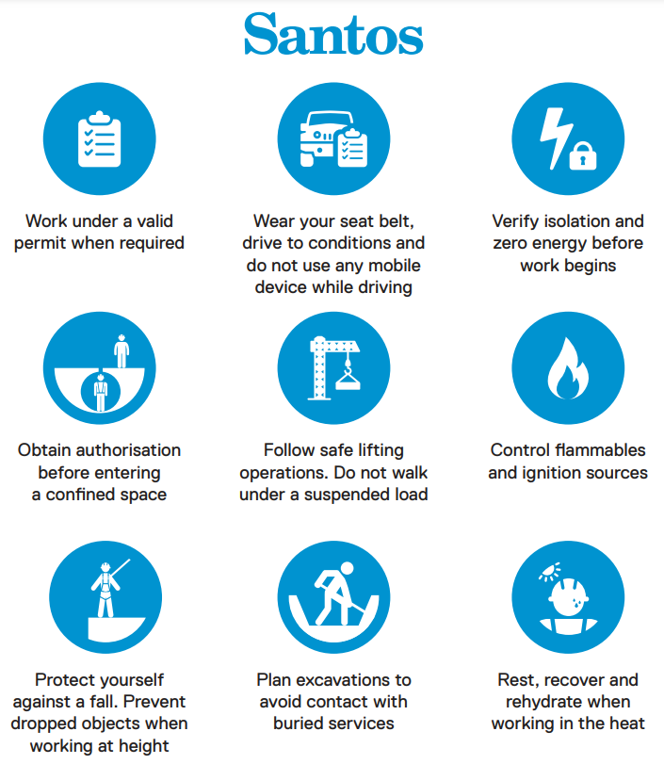

### 5.30.3 QGC/Shells Life Saving Rules

The following are QGC/Shells LSR’s;

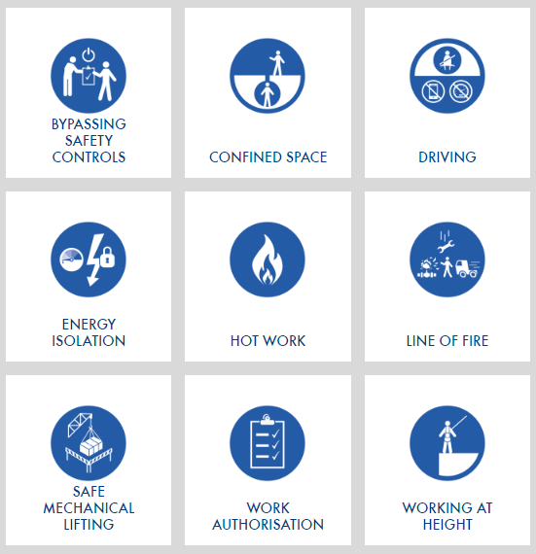

## 5.31 Bushfire Management and Awareness

Fire season in Queensland often begins in July and runs through until October, and can extend through to February. However, bushfires in Queensland can occur at any time.

These times can vary each year depending on the condition of local bushland, long-term climate conditions, and short-term weather events.

During heightened bushfire risk, the Fire Danger Rating (FDR) must be monitored by the Location Manager and communicated to any Huracan crews working as a standalone unit in client’s fields when the rating is above Moderate. The current FDR for Queensland can be found at [fire.qld.gov.au/prepare/bushfire/fire-danger-ratings](https://www.fire.qld.gov.au/prepare/bushfire/fire-danger-ratings). A link to the Current Bushfire Warnings and Incidents is available at [fire.qld.gov.au/Current-Incidents](https://www.fire.qld.gov.au/Current-Incidents). When there is a potential heightened risk of bushfire, the wellsite crew must communicate with the Operating Company Representative and review the Emergency Response Plan and agree on an evacuation plan.

### 5.31.1 Understanding the Fire Danger Rating and Preparing to Evacuate

The FDR is divided into 4 categories and commonly identified by the signs below.

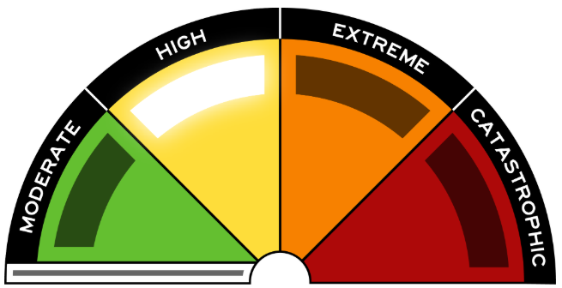

Figure - Fire Danger Rating Sign

Risk by Category

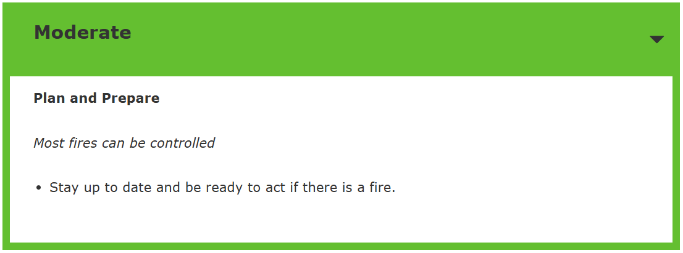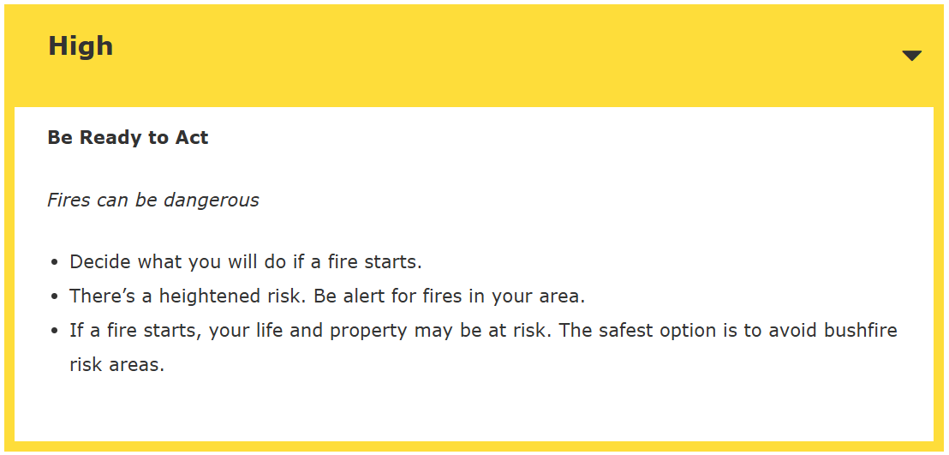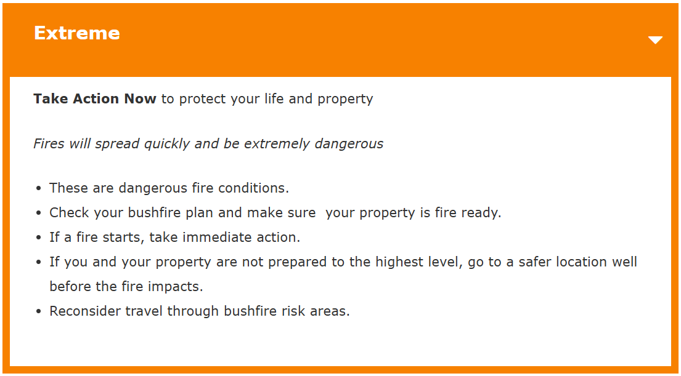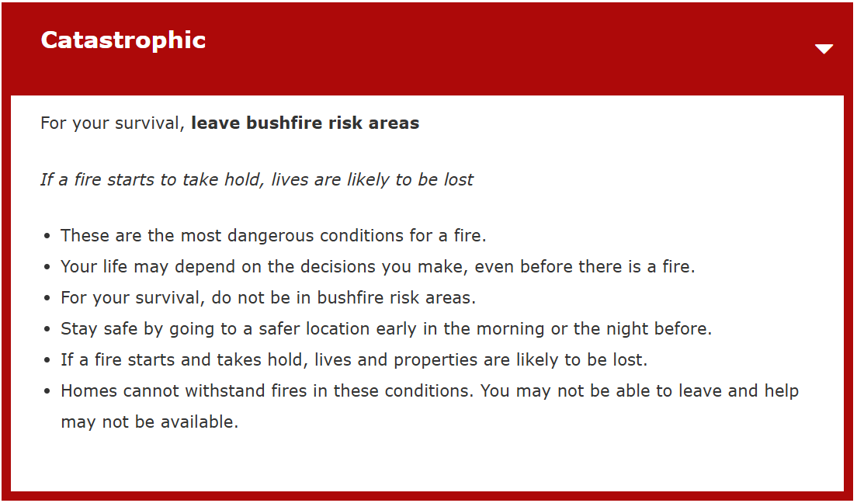

Below figure is an image from the link and can show the expected FDR for up to 4 days.

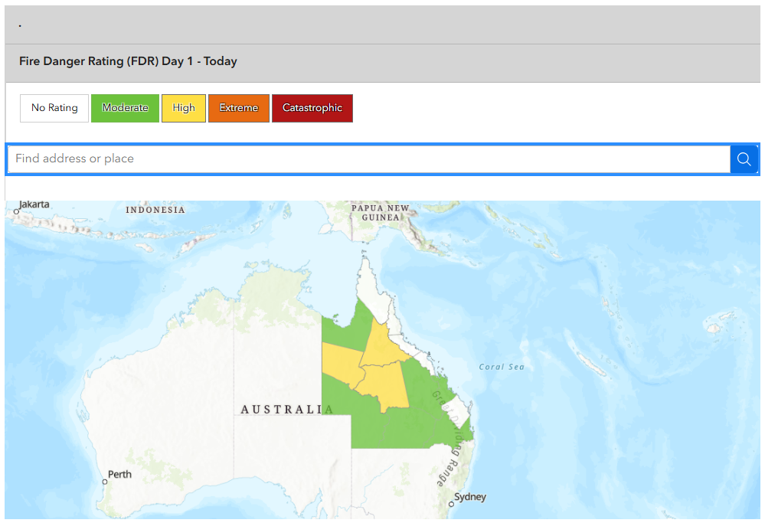

Figure - FDR Map

### 5.31.2 Bushfire Warnings

Personnel should be familiar with the official Bushfire Warning system. When there's a bushfire in your area monitor the Current Bushfire Warnings through the current QLD Warnings Map, Social Media and Local Radio Station. The following are the three levels of warnings and associated recommendations.



**Advice** warnings are yellow.

Advice warnings mean you are not in danger but you need to be alert and listen for warnings in case the hazard gets worse or closer to you.

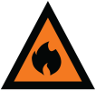

**Watch and Act** warnings are orange.

If there is a Watch and Act warning issued for your area, you could be in danger because conditions are changing. You need to act now to be safe.



**An Emergency Warning** is red.

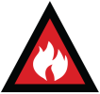

This is the highest level of warning. Emergency Warnings mean you are in danger and you need to act IMMEDIATELY to be safe. The warning will list the actions you need to take to survive.

### 5.31.3 Bushfire - Prepare

Prior to Bushfire Season, a preparedness Audit will be performed to ensure;

* Suitable Personnel Training has been undertaken
* Emergency Management Plan is current and suitable
* Equipment has been inspected for fire risk
* All applicable risk action items have been addressed, and mitigation measures are in place

### 5.31.4 Bushfire - Monitor

During Bushfire Season, the Location Manager is responsible for Monitoring remote crew locations and associated FDR’s for working area of the crews.

[Fire Danger Rating Map](https://www.fire.qld.gov.au/prepare/bushfire/fire-danger-ratings).

[Current Fire Incidents and Location Map](https://www.fire.qld.gov.au/Current-Incidents).

The Location Manager is responsible for alerting the crews of;

* Any change to the crews associated Fire Danger Rating
* Alerting the crew of any fires in the area
* Advising any Watch and Act and Emergency Warnings

### 5.31.5 Bushfire - Respond

Once it has been assessed by the crew on location and the Location Manager that there exists a potential for personnel danger, the Huracan Emergency Management Bushfire Plan should be executed.

### 5.31.6 Bushfire Emergency on Location

In the event of a bush fire generating in the area in which Huracan is operating:

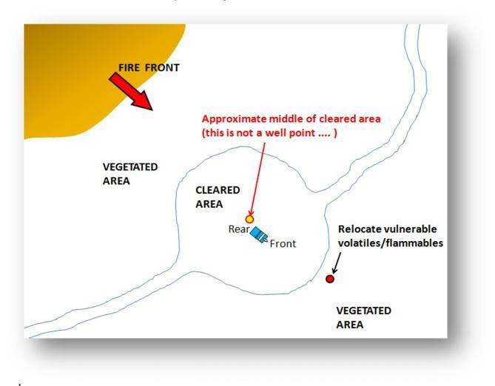

* + - Secure vehicle by parking in a safe place as far away from danger as possible;
    - Raise the alarm by UHF Radio to all operators in the immediate area;
    - Alert the Huracan Office who will activate the Emergency Team and notify the Client Field Representative (Santos, QGC, Origin etc) to ensure that the landowner is aware of the fire (the Landowners often have access to additional bush fire-fighting equipment and have direct contact with their local Rural Fire Group which are in the best position of providing immediate and experienced assistance);
    - Follow instructions from Client Representative e.g. evacuate or assist in fighting / monitoring the situation;
    - Evacuation of the site by vehicle is to be on a route away from the direction in which the fire is travelling and ALL vehicles are to leave the site together and travel where possible in a group to the agreed secondary muster point;
    - Prior to evacuation of the site personnel are to agree on a secondary muster point that is to be reached away from the site;
    - If you are required to travel near a bushfire to evacuate the area and visibility is reduced due to smoke, ensure the vehicles lights and hazard warning lights are turned on and utilise the UHF to remain in contact with emergency services,
    - Early evacuation should be promoted over staying as it is the much safer option;
    - Should you be unable to evacuate the area, employ the following survival guidelines:
      * Note the advice being provided by the UHF radio
      * Note the direction of the smoke plume & select the closest refuge point in the safest direction from where you are. Avoid driving in a direction that will take you through smoke/across the path of the fire and never drive through smoke if you can’t see through to the other side
      * Park the vehicle in the centre of the cleared area clear of trees etc, slightly further back from the side of the approaching fire and greatest fuel. Ensure that the least exposed part of the vehicle faces the fire (Usually the rear with a smaller window area). Any flammable or volatile fuels exposed in the back of the utility should be carried into the bush downwind;
      * Close all windows and vents;
      * Notify the Office of your location;
      * Headlights and hazard lights on;
      * Start drinking water;
      * Cover your body with a fire blanket or cotton/wool blankets to protect from radiant heat;
      * As the fire approaches, engine on and AC on full (recycle mode), keep drinking water, get down low with the fire blanket covering you;
      * After the fire front passes, notify the Office of your situation, only leave the safety of your refuge when smoke thickness and heat have sufficiently subsided, keep wearing your PPE & note the advice provided by the radio

### 5.31.7 Personnel Bushfire Awareness Training

All personnel working in the field must undertake bushfire seasonal awareness training (annual) and updated certification in HIMS. Additionally, all new field-based employees must review the Huracan Emergency Management Plan and understand Huracan Bushfire procedures. Bushfire Awareness covers the following topics, followed by a knowledge test.

* Fire behaviour and suppression
* Risk management and personal protection
* Fire Danger Ratings and Bushfire Warnings
* Incident Management
* Principles of Prepare, Act and Survive (PAS)

Please use the link below for self paced training and update management with certification once complete. [Bushfire Awareness](https://rise.articulate.com/share/8txG_Uprn_W17uSbGvz-HR5bqUl4dHOP#/)

# 6.0 Injury Management

In the event that personnel sustain an injury, Huracan Management requires personnel to immediately report the injury to their supervisor.

The Site Supervisor shall notify Huracan Senior Management within one (1) hour after any incident involving an injury that requires medical treatment via direct phone contact and a Huracan HSE report started with sufficient details to be filled within 24hrs of the incident.

A full incident investigation shall be conducted and a Hazard/Incident/Near Miss Report completed. Huracan Senior Management shall then notify regulatory authorities (as per the requirements of the Queensland Petroleum and Gas (Production and Safety) Regulations 2018).

In the event of a serious injury incident, written signed and dated statements shall be recorded as soon as practical following the incident.

The original copy of any statement shall be uploaded as an attached to the HSE Report and duplicate copies distributed to the client as soon as practicable.

Those injured (if their condition permits) shall be interviewed regarding specific details leading up to the incident. Each statement shall be accurately recorded and signed as a true and correct record and witnessed.

Unless further danger exists, any serious injury/incident scene shall not be disturbed until the required drawings and/or photographs are recorded and any relevant investigators (Police, Government Inspectors, etc) have attended the scene.

The Site Supervisor shall make arrangements with the Client for the provision of emergency assistance, including ambulance service in the case of serious injury/illness, shall co-ordinate medical treatment in conjunction with RFDS Medical Staff and utilise RFDS services when necessary.

Employees shall be responsible to ensure their employer receives a copy of a doctor's Medical Certificate for any time lost from work due to a work associated injury or illness.

Personnel shall not be permitted to return to work until such time as a clearance is issued by a qualified medical advisor declaring them fit for suitable duties or able to resume normal duties.

# 7.0 First Aid

Appropriate First Aid facilities are to be maintained by the Site Supervisor and the HSE Manager.

As a minimum, two persons in each separate worksite shall hold a current senior first Aid certificate/qualification.

Nominated first aiders shall be indicated on the site safety board and made aware to all site personnel via the Site Specific Induction.

Where an assessment of a workplace identifies significant risk, additional trained first aid and/or medical personnel shall be provided as necessary.

The Site Supervisor shall monitor supplies of first aid equipment and ensure all first aid boxes are sufficiently maintained. All Huracan vehicles shall carry an appropriate first aid kit.

The Site Supervisor shall record First Aid Treatments and use the First Aid Kit Check List for recording items required for replenishment first aid kits.

All fist aid treatments shall be entered into the incident register by the Site Supervisor and forwarded to Huracan Senior Management as soon as possible to allow update of LTI and MTI statistical data.

# 8.0 Emergency Management

The Huracan Emergency Management Plan (EMP) details responsibilities, procedures, reporting requirements, training and the resources necessary to ensure effective and timely management of emergencies during Huracan operations.

The EMP shall detail procedures for medical evacuations, chemical and oil spills, containment of hydrocarbon release, fire, equipment damage and general emergencies. The ERP shall also be reviewed to ensure that it bridges adequately with Client ERP’s.

The EMP details the following information;

• Roles and Responsibilities of supervisory personnel on site and in Head Office in Roma.

• Procedures to deal with emergencies affecting personnel, equipment, the environment, and contractors.

• Describes the external resources available to the Company for use in an emergency and how these resources shall be contacted.

# 9.0 Business Continuity Management

Each location will develop a Business Continuity Management Plan (BCMP). It is a document that identifies potential significant impacts on Huracan and provides the capability for an effective response that protects its key business processes, assets, reputation and stakeholders’ interests.

The objective of this plan is to enable Huracan to continue to manage its business under adverse conditions by the introduction of appropriate strategies including business continuity planning and emergency and crisis management planning as key components of the Huracan risk management process.

Key components to achieving the above objectives are;

* Establish a Business Continuity Management Team (BCMT) that will be in charge of developing the Business Continuity Management Plan;
* Identifying the key business processes;
* Analysing the impact of the business disruption to the location;
* Assessing and controlling the risk threatening the key business processes;

Ensure the continuous administration of this BCP through distribution, training, drill and maintenance.

# 10.0 Contractor Management

Huracan Management shall perform appropriate pre-qualification assessments long term (greater than 3 months) Contractors to ensure that Contractors work policies, systems and safety management plans align with those of Huracan.

Only contractors assessed as having adequate plans and systems shall be engaged in Huracan operations.

Where a Contractor is regarded as a ‘Major’ Contractor then the following is required:

• Safety management plan and policies.

• Historical LTI and MTI performance indicators.

• Internal and external audits of management systems.

• Operating and maintenance records for relevant plant.

• Training and qualification records of relevant personnel.

• Third Party Contractor SMP to ensure integration with Huracan plans.

Where a Contractor is regarded as a ‘Minor’ Contractor then the Contractor shall be obligated to comply shall all aspect of Huracan’s HSE procedures and systems as outlined in this document.

A register of preferred Contractors is maintained by Huracan.

Contractors who subsequently fail to meet the relevant commitments of Huracan’s Health, Safety and Environmental performance requirements shall be removed from the preferred list of Contractors.

# 11.0 Statutory Acts & Regulations

The Huracan SMP encompasses compliance requirements to but not exclusively the following legislation and Australian Standards. Click on relevant title for the document link. Please check for [repealed legislation](http://www.legislation.qld.gov.au/Repealed/repealed_home.htm) prior to review of the relevant document.

In particular:

• [Petroleum & Gas Act 2004](http://www.legislation.qld.gov.au/LEGISLTN/ACTS/2004/04AC025.pdf) Act

• [Petroleum & Gas (Production and Safety) Regulations 2018](http://www.legislation.qld.gov.au/LEGISLTN/CURRENT/P/PetroleumR04.pdf)

• [Work Health & Safety Act 2011](http://www.legislation.qld.gov.au/LEGISLTN/CURRENT/W/WorkHSA11.pdf)

• [Work Health & Safety Regulation 2011](http://www.legislation.qld.gov.au/LEGISLTN/CURRENT/W/WorkHSR11.pdf)

• [Workers’ Compensation and Rehabilitation Act 2003](http://www.legislation.qld.gov.au/LEGISLTN/ACTS/2003/03AC027.pdf)

• [Workers' Compensation and Rehabilitation Regulation 20](http://www.legislation.qld.gov.au/LEGISLTN/CURRENT/W/WorkersCompR03.pdf)14

• [Australian Standards.](http://www.standards.org.au/Pages/default.aspx)

• [Work Health & Safety (Codes of Practice) Notice 2022](http://www.legislation.qld.gov.au/LEGISLTN/CURRENT/W/WorkHSCPN11.pdf)

These Acts & Regulations impose a **“Duty of Care”** on all employers and employees.

# Appendix A – Huracan Risk Matrix

|  |  |  |  |  |  |  |  |  |  |
| --- | --- | --- | --- | --- | --- | --- | --- | --- | --- |
|  | |  | **Consequence** | | | | | | |
| **HEALTH AND SAFETY** | First Aid Injury (FAI) | Medical Treatment (MTI) | | Lost time Injury (LTI) | Permanent Disability / Fatality | | Fatalities (multiple) |
| **FINANCIAL IMPACT** | < $20K | $20K - $200K | | $200K - $2M | $2M - $20M | | $20M+ |
| **REPUTATION** | Minimal impact on business reputation, land holder only | Some impact on business reputation, local community exposure | | Moderate impact on business reputation, local media exposure | Significant impact on business reputation, national media exposure | | Critical impact on reputation, international media exposure |
| **ENVIRO.** | Incident. No breach of regulations / EA. Minimal and short term impact to any local environment. | Minor breach of regulations / EA resulting in notification to regulator.  Localised, short term, recoverable minor impact on flora and fauna | | Serious breach of regulations / EA resulting in reporting to regulator, investigation, environment notice or fines. Significant localised but short term environmental impact | Major breach of legislation resulting in prosecution or litigation and regulatory intervention.  Serious and long term ecological impact and environmental harm.  Emergency Management activated. | | Significant compliance breach resulting in prosecution / class action or loss of licence. Severe environmental harm with widespread or permanent Impact Crisis Management activated. |
|  |  |  | **1. Insignificant** | **2. Minor** | | **3. Moderate** | **4. Major** | | **5. Catastrophic** |
| **Likelihood** | A common event that is likely to occur in the industry many times per year | **A. Highly Likely** | **Medium  (A1)** | **Medium  (A2)** | | **High  (A3)** | **Extreme  (A4)** | | **Extreme  (A5)** |
| An event likely to occur more than once a year in the industry | **B. Likely** | **Low  (B1)** | **Medium  (B2)** | | **Medium  (B3)** | **High  (B4)** | | **Extreme  (B5)** |
| An event that may occur in the industry over 10 years | **C. Possible** | **Low  (C1)** | **Low  (C2)** | | **Medium  (C3)** | **Medium  (C4)** | | **High  (C5)** |
| An event not likely to occur in the industry over 10 years | **D. Unlikely** | **Negligible  (D1)** | **Low  (D2)** | | **Low  (D3)** | **Medium  (D4)** | | **Medium  (D5)** |
| An event that has not previously been experienced in the industry but may occur in exceptional circumstances | **E. Remote** | **Negligible  (E1)** | **Negligible  (E2)** | | **Low  (E3)** | **Low  (E4)** | | **Medium  (E5)** |
|  |  | | | | | | | | |
|  | **Hierarchy of Controls** | | **Level 1 – Eliminate the Hazard** | | **Level 2 – Substitute, Isolate & Wireline Technician** | | | **Level 3 - Admin & PPE Controls** | |
|  |  | | | | | | | | |
|  | **Reporting Requirements** | | **Report Only – All Negligible Classifications** | | **Investigate – All Low to Medium** | | | **TapRoot – High or above, or any Hi-Po** | |
|  |  |  |  |  | |  |  | |  |

**NOTE:** Using the Risk Matrix below, identify the Consequence & Probability of each risk occurring and enter the risk score in the Inherent column. Review the consequence, probability and risk score after appropriate controls have been agreed upon. Remember, the consequence does not change unless you eliminate the hazard (only the probability may change!

# Appendix B – Residual Risk Approval



# Appendix C – HSE Classification

