Document Control: Public

Huracan Pty Ltd
20-Mar-2019
Revision 1.1
Huracan Injury Prevention Standard
Huracan Pty Ltd

HSE_HIPS_Rev1.1

Document Control: Public

Huracan Pty Ltd
9-Mar-2015
Revision 1.1

Document Control
Document Owner: Katrina Hollingworth
Document Approver: Jon Hollingworth
Revision History

Rev | Author | Reviewer | Date | Revision Comments
1.0 | K. Hollingworth | J. Hollingworth | 13-Apr-15 | First Edition of Document
1.0 | K. Hollingworth | J. Hollingworth | 18-May-17 | Document Review
1.1 | K. Hollingworth | J. Hollingworth | 20-Mar-19 | Document Review against QLD Legislation

Document Control: Public
Table of Contents
1 Document Control 3
1.1 Review and Update Procedures 3
1.2 Distribution 3
1.3 Document Updates 3
1.4 Document Publication and Display 3
1.5 Display Locations 3
2 Overview 3
2.1 Huracan Gerneral Code of Behaviour 4
2.2 Terminology 4
3 Statement of Standard 4
4 Objective 4
5 Scope 5
6 Responsibility 5
6.1 Managers 5
6.2 Employees 5
7 Identifying Hazardous Manual Handling Tasks 6
7.1 How to identify hazardous manual tasks 6
7.2 Review available information 6
7.3 Look for trends 6
7.4 Observe manual tasks 7
8 Assessing the Risk 11
8.1 When should a risk assessment be conducted? 11
8.2 How to do a risk assessment for hazardous manual tasks 11
8.3 What are the risk factors? 12
8.4 What are the sources of the risk? 16
9 Controlling the risks 19
9.1 The hierarchy of control 19
9.2 Purchasing to eliminate or minimise risks 20
9.3 Changing the design or layout of work areas 20
9.4 Changing the nature, size, weight or number of items handled 22
9.5 Using mechanical aids 24
9.6 Changing the system of work 26
9.7 Changing the work environment 27
9.8 Using administrative control measures 28
9.9 Implementing control measures 30
10 Huracan Injury Prevention Program 31

1 Document Control

1.1 Review and Update Procedures

This document is a ‘live’ document that shall be reviewed and updated as per the Huracan Document Control and Revision Standard.
It is also to be reviewed immediately after any of the following occur;
• Major operational incident (i.e. increased apparent risk)
• Significant operational, procedural, work practice or technology change
• New or amended safety codes, safety requirements or standards are issued.
• When required by relevant State and Federal Government legislation.
Huracan Management is responsible for the review and revision of this document. The updated document is to carry a new revision date, and are circulated once the revision has been approved, by the following levels of Management:
• Operations Manager – Huracan.
• HSE Manager – Huracan.

1.2 Distribution

Requested changes to the Distribution List are to be addressed to Huracan Management.

1.3 Document Updates

Only registered copies of the document shall be updated. This document becomes uncontrolled when printed.

1.4 Document Publication and Display

This document shall be displayed at all times and shall be open for inspection by anyone to whom the plan or part of the plan may affect or apply to.

1.5 Display Locations

This document shall be available for display at the following locations;
- Huracan Office
- Huracan Internal Website

2 Overview

2.1 Huracan Gerneral Code of Behaviour
Huracan Management requires full compliance with the Standard. Infringement of the standards contained in this document shall be regarded as a serious breach of the Huracan code of behaviour and shall result in disciplinary action, which may include counselling or dismissal. Failing to follow safety instructions, deliberately interfering with safety equipment and systems, deliberate damage to equipment, stealing, vandalism, fighting, practical jokes and horseplay shall not be tolerated and are considered to be serious breached of the Huracan Code of Behaviour.

2.2 Terminology

Term | Definition
Commuting Driver | Any employee who does or may operate any means of motorized transportation to commute to/from work but who does not fit the definition of a Huracan Driver
Company Employee | Any person employed by and on the payroll of the company, including corporate and management personnel. Persons employed under short-service contracts (more than 90 days) are included as company employees provided they are paid directly by the company.
Journey Management and Driving Standard Assessment | A team based verification that this Standard is understood and followed, resulting in a Remedial Work Plan that is monitored by line management through to closure.
Light Vehicle | A vehicle with a gross domestic weight of <4.5 tonnes.
Huracan Driver | Any employee that has access to a Huracan Vehicle, as defined below, or is reimbursed for mileage/kilometres driven while using a private vehicle.  Any employee that may be required to drive a Huracan  Vehicle as part of their duties.  Spot hire type land transportation service providers including  non-contract personnel transport (e.g. general-public taxi cabs and buses), courier services, restaurant delivery, and other services of this type as well as Contractors assessed as Low Risk, are not considered Huracan Drivers.
Huracan Trailer | Any trailer owned, leased, rented or contracted by, and additionally, any trailer for which a regular transportation allowance is received.
Huracan Vehicle | Any motor vehicle, including Huracan Trailers above, owned, leased, rented or contracted by Huracan. Exceptions include forklifts, mobile yard cranes and contractor vehicles assessed as low risk.
Vehicle Passenger | Any employee who is or may be a passenger on any means of motorized transportation while on company business or while commuting to/from work.

3 Statement of Standard
This document is intended to serve as the minimum Huracan requirements for management and mitigation of Manual Handling Injury risk.

4 Objective
Most jobs involve carrying out some type of manual task using the body to move or hold an object, people or animals. Manual tasks cover a wide range of activities including stacking shelves, working on a conveyor line and entering data into a computer. Some manual tasks are hazardous and may cause musculoskeletal disorders. These are the most common workplace injuries across Australia. This manual objective is to aid in the mitigation of manual handling injuries in the Huracan workplace.

5 Scope
This Standard applies at all times to all Huracan locations, Huracan employees and relevant contractors.

6 Responsibility

6.1 Managers
All Managers with the integral support of HSE staff shall implement and enforce this plan and demonstrate active leadership and participation in all aspects of the Huracan Injury Prevention Standard while ensuring that all personnel under their responsibility demonstrates similar leadership.
Consultation involves sharing of information, giving workers a reasonable opportunity to express views and taking those views into account before making decisions on health and safety matters.
Consultation with workers and their health and safety representatives is necessary at each step of the risk management process. Your workers know which tools and activities contribute to their discomfort and may have practical suggestions or potential solutions.
It is important to consult your workers as early as possible when planning to:
- Introduce new tasks or change existing tasks
- Select new equipment
- Refurbish, renovate or redesign existing workplaces
- Carry out work in new environments.
Encourage our employees to report problems with manual tasks and signs of discomfort immediately so that risks can be managed before an injury occurs.

6.2 Employees
Employees have a duty to take reasonable care for their own health and safety and that they do not adversely affect the health and safety of other persons. Huracan Personnel must comply with any reasonable instruction and cooperate with any reasonable policy or procedure relating to health and safety at the workplace.

7 Identifying Hazardous Manual Handling Tasks
The first step in managing risks from carrying out manual tasks is to identify those tasks that have the potential to cause MSDs. Hazards that arise from manual tasks generally involve interaction between a worker and:
- the work tasks and how they are performed
- the tools, equipment and objects handled
- the physical work environment.

7.1 How to identify hazardous manual tasks
Workers who perform manual tasks can provide valuable information about discomfort, muscular aches and pains that can signal potential hazards. For example, you could ask workers to identify tasks that:
- are difficult to do (or appear harder than they should be)
- are very tiring (muscle fatigue reduces work capacity)
- are awkward or dangerous (for example, difficulty controlling loads)
- cause discomfort.

7.2 Review available information
Records of workplace injuries and incidents, inspection reports and any workers compensation claims made for MSDs should be reviewed to help identify which manual tasks may cause harm. However, not all hazardous manual tasks will be associated with reported incidents, therefore it is important to gather additional information.
Information and advice about hazardous manual tasks and risks relevant to particular industries and work activities is available from regulators, industry associations, unions, technical specialists and safety consultants.

7.3 Look for trends
You may be able to identify trends or common problems from the information you collect. Trends may show that certain tasks have more characteristics that make them hazardous or that some characteristics are more common in certain jobs. Trends may also show that workers in a particular location are exposed to more hazardous manual tasks than in other areas and this could indicate a problem with the design and layout of that work area or the way work is carried out there. These trends may help in deciding which manual tasks should be addressed as a priority.

7.4 Observe manual tasks
Hazardous manual tasks can also be identified by looking at how people actually work and focussing on their postures and movements. A manual task is hazardous if it involves any of the following characteristics (described in section 2.2):
- repetitive or sustained force
- high or sudden force
- repetitive movement
- sustained and/or awkward posture
- exposure to vibration.
Things to look out for include:
- any changes that have resulted in new manual tasks or a changed environment
- tasks involving tools, machinery or equipment that do not work properly or are difficult to
- use
- if workers have made improvisations to tasks to avoid discomfort (such as stacking mats
- or flattened cartons to stand on).
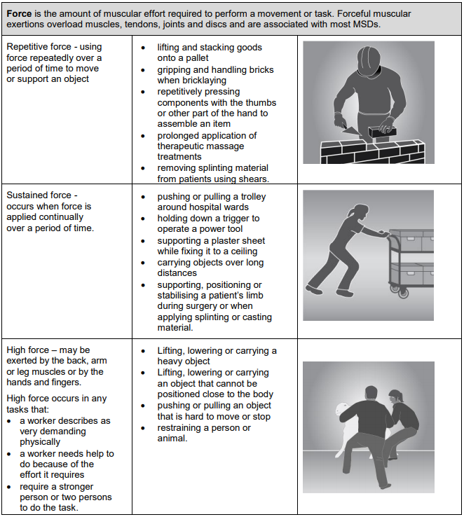
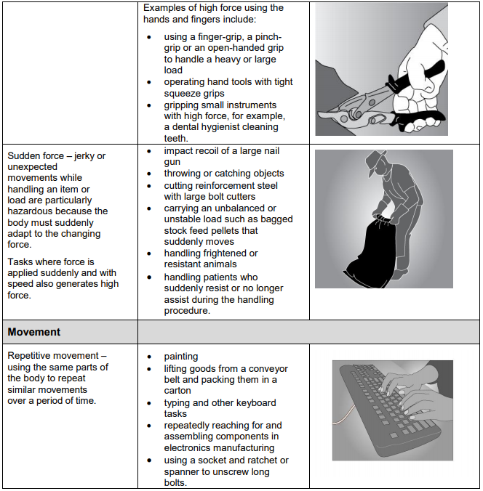
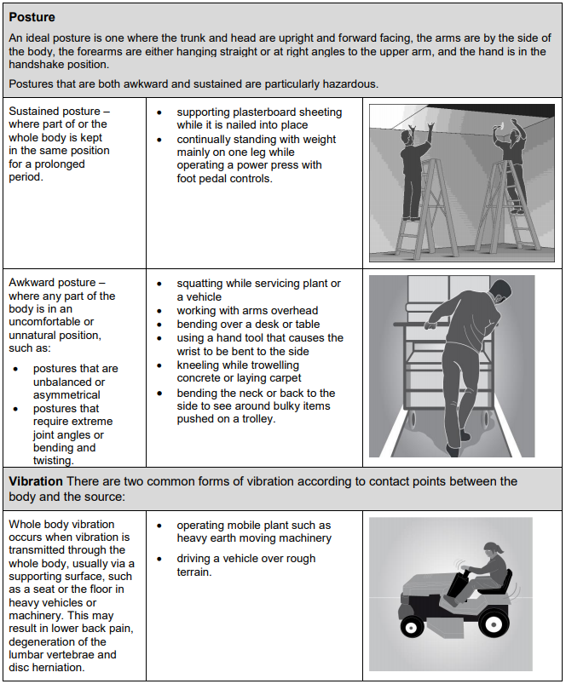
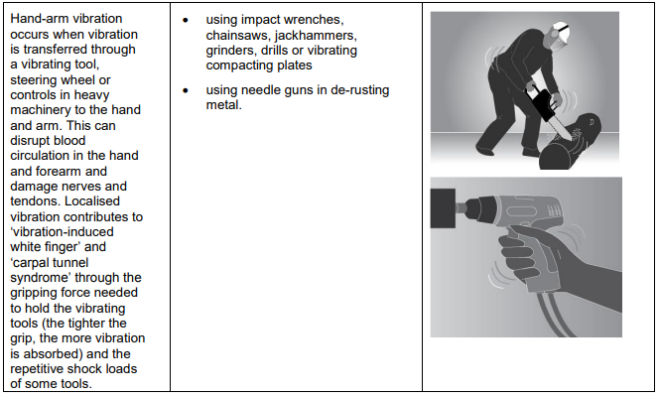

8 Assessing the Risk
A risk assessment involves examining the characteristics of the hazardous manual task in more detail to assess whether the forces, movements and postures are undertaken in such a way that they give rise to the risk of MSDs.

8.1 When should a risk assessment be conducted?
You should carry out a risk assessment for any manual tasks that you have identified as being hazardous, unless the risk is well-known and you know how to control it. A risk assessment can help you determine:
- which postures, movements and forces of the task pose a risk
- where during the task they pose a risk
- why they are occurring
- what needs to be fixed.

8.2 How to do a risk assessment for hazardous manual tasks
Identify who should participate in the risk assessment, for example those workers who do the task or their health and safety representative, and management who have control over how the task is done. Describe the task and area where the manual task is performed. Note which body parts are likely to be at risk of injury, then work through the assessment together to determine which risk factors pose a risk and why the risk exists.
The whole task should be examined, although it may help to look at the task in stages to identify all of the risk factors. For example, the task of putting stationery items away in a storage cabinet may involve the following steps:
- collecting boxes of stationery supplies from the delivery dock – handling boxes that are bulky
- may increase the risks associated with this task
- transporting stationery supplies to the storage area – using a trolley with poorly maintained
- wheels may increase effort
- unpacking boxes of stationery supplies – unpacking boxes from the floor may increase
- awkward postures
- placing supplies on storage shelves – shelving heights that are too high or too low may
- increase awkward postures.
Looking at each of the steps identifies the different sources of risk, which are the things that should be changed to control the risks.

8.3 What are the risk factors?
Working through the following questions will assist in determining which postures, movements and forces of the task pose a risk.
Question 1: Does the task involve any of the following:
- repetitive movement?
- sustained or awkward postures?
- repetitive or sustained forces?
As a general guideline, ‘repetitive’ means that a movement or force is performed more than twice a minute and ‘sustained’ means a posture or force is held for more than 30 seconds at a time. Examples of postures and movements that pose a risk if they are repetitive or sustained are:
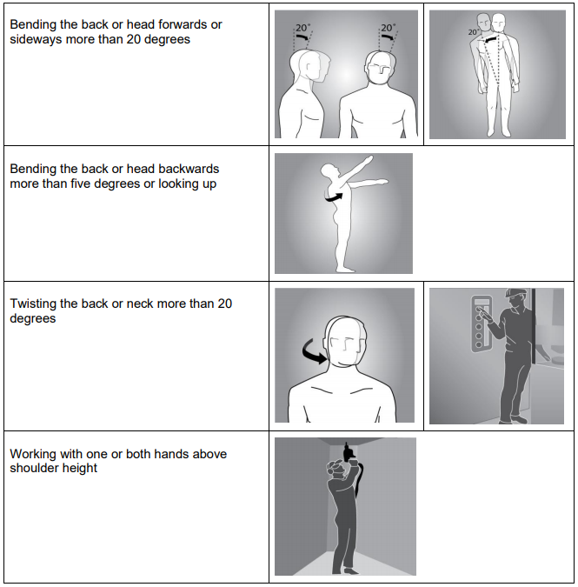
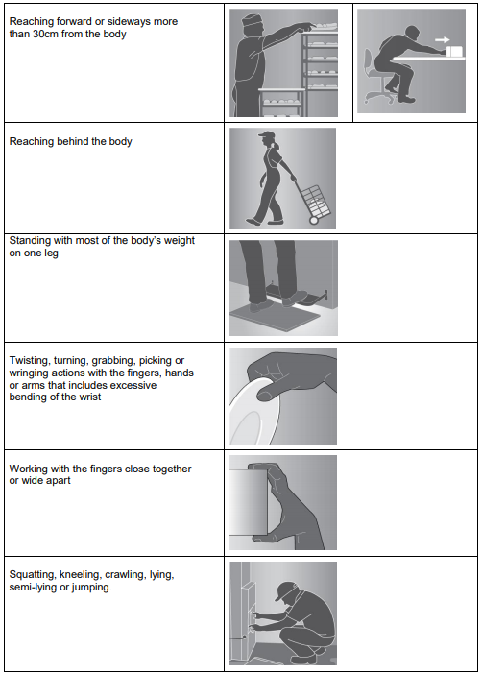
The risk increases as the degree of bending and twisting increases. The risk is greatest when the postures and movements are extreme, that is, toward the end of the movement range, and when they feel uncomfortable for the worker.
Question 2: Does the task involve long duration?
If you have assessed a task as involving postures, movements or forces that are also repetitive (more than two per minute) and/or sustained (held for more than 30 seconds), you should determine the duration of the task. The duration of the task is how long the task is carried out over a whole shift or continually at any time during a shift. Tasks that continue over a long period or are repeated over the work day increase the risk of injury. As a general guideline, long duration means the task is done for more than a total of two hours over a whole shift or continuously for more than 30 minutes at a time. Keep in mind that workers may use the same parts of the body to repeat similar movements when carrying out various tasks that are similar in nature over time.
Question 3: Does the task involve high or sudden force?
High forces can cause MSDs even if they are not repetitive or sustained. This means that any task involving high force may be a risk, even if it is only done occasionally or for short periods. The longer and more often force is applied and the higher the force, the greater the risk. The risk in tasks involving high force is related to:
- the intensity of the force needed - forceful muscular exertions place high stress on the muscles, tendons, joints, ligaments and vertebral discs.
- the speed involved - fast movements (particularly if repeated) can injure muscles, tendons and ligaments. The rapid or sudden speed changes caused by sudden or unexpected movements are high risk.
- whether the force is jerky or sudden - forces suddenly applied or stopped can overload the muscles, tendons, joints, ligaments and vertebral discs. This can occur when throwing or catching loads, or when the load or item worked on moves unexpectedly (for example, when pulling up a fence post that suddenly comes free, or assisting and holding a walking patient who suddenly falls).
High and sudden forces are commonly associated with the handling of live persons or animals and loads that are unstable, unbalanced or difficult to hold.
Question 4: Does the task involve vibration?
Prolonged exposure to whole-body or hand-arm vibration increases the risk of MSDs and other health problems. The degree of risk increases as the duration of exposure increases and when the amplitude of vibration is high. Some examples of sources of vibration are:
- driving, particularly on rough roads
- frequent or prolonged use of hand powered tools
- use of machines or tools where the manufacturer’s handbook warns of vibration
- workers being jolted or continuously shaken
- use of a vehicle or tool not suitable for the environment or task
Question 5: Is there a risk?
The task involves a risk of MSD if you have answered ‘yes’ to either:
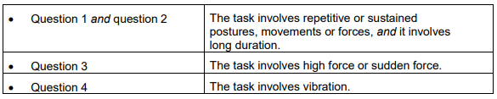
A task may involve more than one risk factor. Where a number of risk factors are present and interact within a task, the risk of MSD increases significantly.

8.4 What are the sources of the risk?
When conducting the assessment, think about the sources of any risks that are present in the task. These will be the things that you may be able to change to eliminate or reduce the risk of MSD. For example, poor postures and movements may be due to the layout of the workplace, high forces may be due to the loads being handled, and the frequency and duration of the task may be due to the work organisation, limited staff numbers or increased work pace to meet tight deadlines. The main sources of risk are:
• work area design and layout
• the nature, size, weight or number of things handled in performing the manual task,
• systems of work
• the environment in which the manual task is performed. These sources of risk can also make the task more difficult to perform and therefore increase the risk of MSD. For each risk factor, you should ask:
• where in the task are they occurring
• why each of these actions is occurring (source of the risk).
The answers to these questions will provide the information on how to fix the source of the risk and hence control the risk of MSD.
Consider the work area design and layout
A work area includes work benches, conveyors, furniture and fittings and the equipment used by workers doing that job. The positioning and relationship of the different elements in a work area to each other and to the worker are important because of the effect on working postures. A work area that is designed without consideration of the risks that arise from hazardous manual tasks may impose awkward postures on workers undertaking manual tasks, for example, bent and twisted positions with shoulders raised and the need to reach for items or carry loads over long distances. Consider the nature, size, weight or number of persons, animals or things handled Loads
Loads can be a source of risk due to the amount of muscular effort needed to handle them. The harder to grip and control a person, animal or thing, the greater the force required to handle them. The risk can arise from:
- size, shape and weight of load – loads that are large, bulky, or heavy and cannot be held close to the body or are asymmetric and put uneven forces on the spine
- loads that are difficult to grip through unsuitable handles, handholds or surface textures
- unstable or unwieldy loads can create sudden high muscle forces and result in overloading of muscles, tendons or discs
- handling people or animals – both the physical and behavioural nature of people or animals can be a source of risk, for example unpredictable movements requiring sudden forces to control.
Tools
Tools that are unsuitable for the task can be a source of risk by increasing the force required, or by promoting sustained or awkward postures. Risks can arise from:
Weight – heavy hand tools, particularly if held for long periods of time, increase the force and effort required to perform a task, for example, a three kilogram power drill used on an assembly line. Balance – if the heaviest part of the tool is in front of the wrist, the force required to grip the tool and stop it tilting forward is increased.
Handle design – if the handle diameter is too large or too small, the grip span of the hand will create awkward postures and greater force will be required to control the tool. A handle that is too short or has prominent edges, can result in damaging compression of the palm.
Handle orientation – if the handle design does not place the wrist in a handshake position, the worker will need to use an awkward posture to operate the tool. Tools that cannot be adapted for use by both hands or are designed for right-handed use only can result in awkward postures and increased force.
Shock loading and impact – tools that deliver impacts such as hammers, hammer drills, and nail guns transmit impact forces to various ligaments and can require the use of a firmer grip to maintain control. They are a particular source of risk if used repetitively and for long periods.
Prolonged use – continued use of any hand tool (even tools that are well suited to the user and designed for the task) without adequate time to recover will increase risk of injury due to the sustained force to support it. In particular, vibrating tools increase risk.
Maintenance – poorly maintained or irregular service of tools and equipment may increase the effort needed to use them. For example, an unsharpened knife will increase the force required to bone and slice meat.
Consider the systems of work
Systems of work, or the way work is organised, can influence the physical and mental demands that a manual task places on a worker. The fatigue and strain (physical and mental) that may arise from the aspects of work (task demands, task control and resources and support provided) bring on physiological responses such as increased muscular tension and affect the function of muscles, nerves and blood vessels, increasing the risk of the worker developing an MSD. The sources of risk include:
- time constraints
- pace and flow of work across the working day or shift
- ability for workers to influence workload or work methods and changes in the workplace
- the level of resources and guidance
- consultation processes
- work roles and performance requirements or processes for dealing with conflicts
- staffing levels, skill mix and shift arrangements.
Remember that workers will also have different physical and psychological characteristics and these individual factors may increase the risk, for example:
• Skills and experience – being inexperienced in a job may increase the risk
• Physical characteristics – an overload situation may result from a mismatch between the worker and the task
• Unaccustomed work – workers who are new, have transferred from another job or are returning from extended leave and whose muscles are not conditioned to the work.
Consider the workplace environment
The sources of risk in the work environment include:
- Cold environments such as in cool rooms, freezers, cold stores or working outside in cold and/or wet weather can lower body and hand temperature and make handling and gripping objects more difficult. Increased grip force can also result from reduced sensitivity in cold hands or from wearing gloves. Cold can also significantly increase the risk of hand-arm vibration. Working in a cold environment requires thick or heavy protective clothing that restricts movement which can increase the risk of MSD. It can also cause overheating of the body as the clothing does not allow heat or sweat to dissipate and may decrease the blood flow to muscles, increasing fatigue.
- High temperatures - (including radiant heat), for example, in foundries, laundries, bakeries, kitchens, or working in hot weather can make handling and gripping objects more difficult. Workers may have difficulty grasping objects due to perspiration on the hands or there may be sudden or unexpected forces due to loads slipping.
- Humid environments - caused by processes such as steam cleaning, cooking or the weather can also increase the risk of developing MSD. Handling wet or damp objects may require increased force. Humidity may also increase discomfort and fatigue.
- Wind - may increase the force required to handle items and reduce control while handling large objects, especially those that are flexible and have a large surface area. When working in windy conditions and in low temperatures that are also windy, the resultant wind chill may lower the body temperature further.
- Slippery and uneven floor surfaces - may increase the exertion required to perform manual tasks due to difficulty maintaining stability. Unsuitable floor coverings (for example carpet) may increase friction when moving objects such as trolleys Hazardous manual tasks.
- Obstructions – caused by poor housekeeping and cleaning can lead to awkward postures such as reaching or bending over obstacles
- Lighting - low or high levels of lighting, as well as glare and reflection, may lead to awkward or sustained postures to either improve vision or to avoid glare.

9 Controlling the risks
Now you know which risk factors are present, where they are present and why they are present (sources of the risk), you are in a position to know what must be controlled and work out how to do it.

9.1 The hierarchy of control
The ways of controlling the risk of MSDs are ranked from the highest level of protection and reliability to the lowest. This ranking is known as the hierarchy of risk control. The WHS Regulation requires duty holders to work through this hierarchy to choose the control that most effectively eliminates or minimises the risk in the circumstances. This may involve a single control measure or a combination of two or more different controls.
Eliminate the risk
The most effective control measure involves eliminating the hazardous manual task and its associated risk. Eliminating hazards and risks is usually easier and cheaper to achieve in the planning or design stage of an item, process or place used for work.
Minimise the risk
If it is not reasonably practicable to eliminate the risk, then you must minimise the risks so far as is reasonably practicable by:
• substituting the hazard with something that gives rise to a lesser risk
• isolating the hazard from any person exposed to it
• implementing engineering controls.
If there is a remaining risk, it must be minimised so far as is reasonably practicable by implementing administrative controls, and if a risk still remains, then suitable personal protective equipment must be provided and used. These two types of control measures, when used on their own, tend to be least effective in minimising risks because they rely on human behaviour and supervision.
Control measures should be aimed at eliminating or minimising the frequency, magnitude and duration of movements, forces and postures by changing the source of risk: the work area, tool, load, environment, method of handling and/or the way work is organised
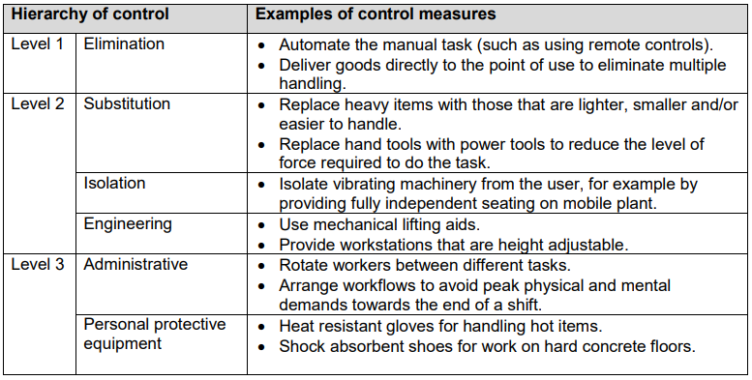

9.2 Purchasing to eliminate or minimise risks
Before purchasing equipment, such as tools, containers, workstations, machinery and vehicles, you should always check whether the item has been designed so that it can be used safely and best matches the needs of your workers. Where possible, you should:
• brief designers and engineers so that consideration can be given to the design implications on the manual tasks performed
• liaise with manufacturers and suppliers about handling, delivery and storage requirements
• purchase ergonomically designed tools and equipment that suit the work being carried out and the physical characteristics of the workers
• check any vibration specifications

9.3 Changing the design or layout of work areas
A well-designed work area will assist in eliminating or reducing the risk factors associated with a hazardous manual task, such as the degree of reaching, twisting or bending.
Workstation design
Workstations should be designed to allow workers to work in an upright position, shoulders in a natural position (not elevated) and upper arms close to the trunk most of the time without large reaches to perform the task. Work surfaces should be easily adjustable to suit a range of workers and the tasks they perform. Where it is not possible to provide adjustable workstations consider altering the design so that:
• the workstation height suits the widest range of physical characteristics of workers
• reaching distances suit shorter workers
• knee and leg clearances suit larger workers.
Working heights
Tasks with high visual demands should be performed above elbow height and work surfaces may need to be tilted, for example, for tasks involving delicate or precise manipulation. Tasks where the hands make a narrow range of movements and can rest on the work surface should be performed at, or just above, elbow height. A sloping surface may reduce the amount of neck flexion required to perform desk-based tasks, such as drafting. Light manipulative tasks or tasks involving the use of a keyboard should be performed at just below elbow height. Tasks incorporating a range of arm movements using the shoulder should be performed at between hip and shoulder height, for example taking items from a stack and placing them on a conveyor. Tasks requiring considerable muscular effort or use of the body for leverage, for example, drilling at a workbench, should be performed at hip height and no higher. Where possible, place items used in manual tasks so they are:
- in front of the worker
- between waist and shoulder height
- close to the midline of workers and orientated towards the worker
- on the worker’s preferred side
- positioned within comfortable reaching distance
- positioned to avoid double handling and to avoid moving loads manually over long distances.
Displays and controls should be positioned to encourage comfortable head and neck postures, comfortable hand and arm reach and efficient use. You should:
- place frequently used displays and controls, including keyboards and other input devices, directly in front of the worker
- position controls at comfortable elbow height
- select electronic or foot controls rather than hand controls if high force is required
- place pedals so that workers can operate them from a comfortable seated position.
Working position
Workers should not remain in a seated, standing or otherwise static posture for prolonged periods. Design the workstation to provide opportunities for workers performing seated or standing tasks to vary their postures and movements
For seated tasks, seating should have the following features:
- adjustable seat height and angle
- a contoured backrest with a lumbar curve except those where the backrest would interfere with the actions to be performed
- a swivel action to prevent the worker from twisting to reach workstation components
- rounded seat edges
- a five-point base with casters to allow movement on carpet, and gliders fitted to the base for low-resistance flooring, where access to work items located beyond normal reach is required
- a footrest or foot ring fitted on drafting or higher chairs to support the feet.
A seated work position is best for:
- work that requires fine manipulation, accurate control or placement of small objects
- close visual work that requires prolonged attention
- work that involves operating a foot pedal.
Workers carrying out standing tasks should be provided with:
- a chair, stool or support so that the worker can alternate between sitting and standing
- a footrest (large enough for the whole foot) to allow the worker to stand with either foot raised
- where possible, suitable floor covering to cushion concrete and other hard floors.
A standing work position is best when:
- large, heavy or bulky loads are handled
- forceful movements are required
- reaching is required
- movements away from the working position are frequent
- there is no knee room
- there is limited space.
Work space
Work areas should have enough space to accommodate the number of workers and other people involved in the task, any equipment that might be required and space to operate the equipment safely.

9.4 Changing the nature, size, weight or number of items handled
Handling loads
Examples of control measures that should be considered when handling loads include:
- purchasing products in smaller loads for manual handling or larger loads to be shifted mechanically
- reducing the size or capacity of containers
- using handheld hooks or suction pads to move loads such as sheet materials
- using grip devices adapted to the particular object to be carried.

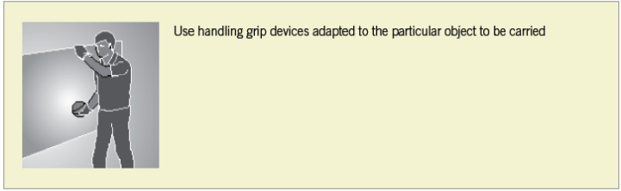
Tools and equipment Hand tools should be designed to:
- be held in a neutral wrist or handshake position
- allow the hand to retain a comfortable grip span
- be well-balanced (the heaviest part of the tool needs to be behind the wrist)
- be suitable for use by either hand
- provide a good grip surface
- prevent a worker from adopting a pinch grip with high force or for prolonged periods.
Minimise the level of muscular effort, particularly of the shoulder and wrist, needed to use hand tools by:
- using power tools where possible
- suspending or supporting heavy tools where they are used repetitively and in the same place
- counterbalancing heavy tools that are used repetitively and need to be kept away from the body
- using trigger locks where the grip has to be sustained for more than 30 seconds
- holding the work piece in place with either jigs or fixtures selecting tools that produce the least amount of vibration
- reducing impact shocks
- limiting torque or ‘kick back’ reactions.
Maintenance Tools and equipment should be well maintained by carrying out regular inspections and servicing in accordance with the manufacturer’s specifications.

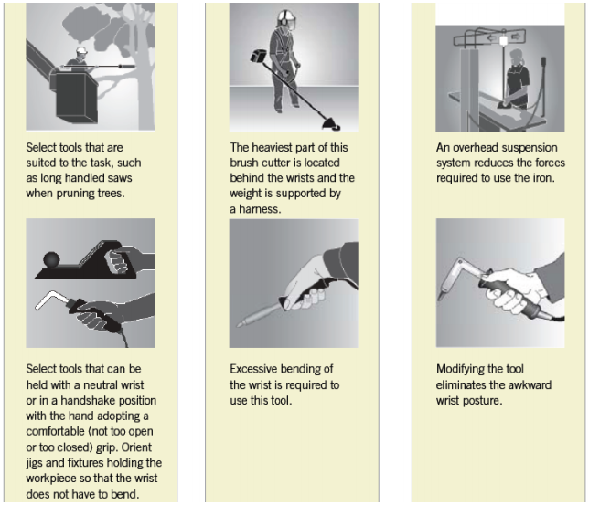

9.5 Using mechanical aids
Mechanical equipment may eliminate or reduce the need for workers to lift, carry or support items, animals or people. A wide range of mechanical aids is available for various industries, for example:
• conveyors such as roller conveyors, elevating conveyors, belt conveyors, screw conveyors, chutes, monorails or trolley conveyors
• cranes such as overhead travelling cranes, gantry cranes or jib cranes, stacker cranes, industrial manipulators and articulating arms
• lifting hoists
• loading dock levellers
• turntables
• springs or gas struts, mechanical devices such as hand winches, hydraulic pumps, and battery powered motors
• forklifts, platforms trucks, tractor-trailer trains, tugs and pallet trucks

• lift tables, mechanical and hand stackers, lift trolleys, two-wheel elevating hand trucks, and vacuum or magnet assisted lifters
• glass panel, duct and plaster lifters.
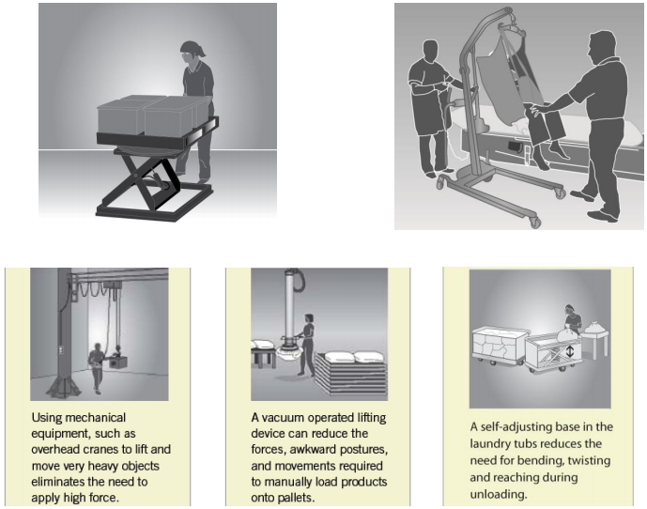
Mechanical aids should be:
- designed to suit the load and the work being done
- as light as their function will allow
- adjustable to accommodate a range of users
- easy to use
- suited to the environment in which the task is performed
- located close to the work area so they are readily available but do not cause an obstruction
- supported by a maintenance program to ensure they are safe and that the required effort to use them is kept at the lowest possible level
- introduced with suitable instruction and training in their use.
When you introduce a mechanical aid into the workplace, you must provide adequate information, instruction, training and supervision to ensure that new arrangements do not introduce any additional risks to workers, for example, a forklift operated in the same workspace used by other workers.

9.6 Changing the system of work
Workload and pace of work The workload and pace should accommodate the physical demands of the manual task. Where possible, work should be organised to minimise multiple handling and improve the flow of work by:
- having raw materials delivered, located or transferred mechanically to the location or work area where they will be used. For example, building supplies can be delivered by truck or crane to the on-site location where they will be used or to the external lift, rather than being delivered to the front gate
- delivering materials, tools and items on mobile systems, for example, on roller pallets
- processing and packaging items in the same location or on the same workbench
- locating storage areas close to distribution areas
- changing the distribution of work across the work day or week to avoid high peak workloads
- using systems that minimise the need for storage and additional handling
- asking suppliers to deliver products, items or tools in a way that allows them to be used without the need for additional handling, for example, flat packs delivered on a vertical frame or table tops facing the right way up for use.
Workers should not have to work at a rate that is at the limit of their ability. When you establish a work rate, you should consult with the workers affected and their health and safety representatives. Set realistic work rates by:
- allowing workers to control the pace for critical or physically demanding tasks
- providing adjustability in the line speed, for example, reduce the speed when conditions are altered, such as when new products are introduced or poor quality materials are used
- providing buffers to allow material to be taken off-line, for example, ‘holding’ bins or benches off the main processing conveyor
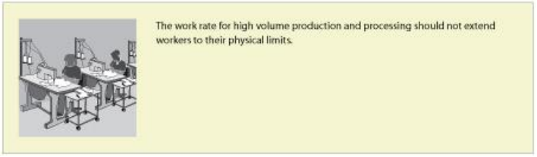

9.7 Changing the work environment
Vibration
Whole-body vibration – the design of vibration damped equipment and engine mountings are the most effective methods of controlling vibration exposure. Other strategies to reduce exposure include:
- improving vehicle suspension and installation of operator seats mounted on suspension systems which incorporate spring and damper elements
- ensuring that equipment and control measures implemented to reduce vibration are well maintained
- ensuring workers adjust their seats appropriately and equipment is operated within the speed suggested by the manufacturer or to a speed that reduces vibration levels
- training workers about the risks associated with whole-body vibration, the controls that have been implemented and how they should be used.
Hand-arm vibration – substitute alternative manufacturing methods or processes to eliminate the need for vibrating equipment. Where this is not possible, the best strategy is to purchase tools and equipment that produce less vibration.
Cold conditions
To control exposure to cold conditions you should:
- ensure your workers take regular rest breaks in a warm place
- ensure your workers wear non-slip footwear and clothing that is fitted and not too bulky or restrictive
- provide personal protective equipment suitable for the task (for example, gloves to provide protection from the cold and also allow a good grip of the objects being handled).
Heat and humidity
For workers in hot and humid conditions, reduce temperature and humidity during manual tasks where possible by:
- relocating work away from sources of heat
- providing fans or air-conditioning
- using screens, awnings and clothing to shield workers from radiant heat sources such as ovens, furnaces and the sun
- enclosing hot processes and increasing ventilation
- altering work schedules so that work is done at cooler times
- providing a cool, well-ventilated area where workers can take rest breaks
- ensuring that workers work at a sensible pace
- providing a supply of cool drinking water.
Windy conditions
Consider minimising the risk of exposure to windy conditions by:
- planning the route of work through protected pathways
- using vehicles to transport items in outdoor conditions
- co-ordinating tasks during low wind conditions.
Floors and surfaces
Keeping work areas clean, tidy and free of clutter or obstacles prevents workers from adopting awkward postures and reduces the level of exertion that may be required to reach over or around obstacles. Clean, smooth and flat surfaces can also reduce forces required to push and pull objects and prevent slips, trips and falls.
Lighting
Select lighting to suit the task performed. To prevent awkward or sustained postures that may arise from low or excessive levels of lighting, glare or reflection:
- provide additional lighting, such as a lamp on a movable arm, where required
- improve the layout of existing lights by lowering or raising them or changing their position in the work area
- increase or decrease the number of lights
- change the diffusers or reflectors on existing lights
- change the lights to improve light levels or improve colour perception
- change the orientation or position of the item to avoid shadows, glare or reflections
- clean lights and light fittings regularly
- use screens, visors, shields, hoods, curtains, blinds or external louvers to reduce reflections, shadows and glare
- control natural light sources (particularly bright sunshine) on work pieces, screens and work surfaces by orientation and placement at 90 degrees to the source and/or by providing screening and louvers.

9.8 Using administrative control measures
Administrative control measures do not address the risk factors or source of the risk – they only attempt to reduce risk by reducing exposure to those risk factors.
Job rotation
The risk of MSDs may be minimised by rotating staff between different tasks to increase task variety. Job rotation requires the tasks to be sufficiently different to ensure that different muscle groups are used in different ways so they have a chance to recover. To increase task variety, you should consider:
- combining two or more tasks so both are done by one worker and alter the workstation and items used accordingly
- providing breaks doing another task when the job is monotonous.
Rest breaks
Regular rest breaks provide opportunities for workers to prevent the build-up of, or recover from the effects of, fatigue in muscle groups used during hazardous manual tasks that involve:
- repetitive awkward postures or sustained postures
- application of high force
- vibration
- long duration
- high levels of mental demand combined with hazardous manual tasks, for example inspection work.
The frequency and duration of rest breaks will be dependent on the nature of the task. Generally, the greater the force required, or the longer a posture is sustained, the greater the recovery time. More frequent and shorter rest breaks are better for rest and recovery than fewer, longer breaks. Build short breaks into task rotation arrangements where work is of a similar nature, for example process production or hand tool use. Micro-pauses (very short intermittent breaks) in physical activity are also beneficial. Build these into the design of tasks and methods of work, for example:
- workers put down hand tools or release them (suspension) between operations
- keyboard operators remove hands from keyboards during natural keying breaks
- stagger manual tasks over the full work shift.
Team handling
Team handling is manual handling of a load by two or more workers. Team handling brings its own risks and requires coordination. It should only be used as an interim control measure. You should redesign manual tasks to allow the use of mechanical equipment, or eliminate the need to lift, if there is a regular need for team handling. Team lifting can increase the risk of MSD if:
- the load is not shared equally
- workers do not exert force simultaneously
- individual workers need to make foot or hand adjustments to accommodate other team members, reducing the force each can exert
- performed on steps or on a slope where most of the weight will be borne by handlers at the lower end
- individual workers unexpectedly lose their grip, increasing or changing the balance of the load on other team members.
Whenever team handling is used it is essential to match workers, co-ordinate and carefully plan the lift. You should ensure that:
- the number of workers in the team is in proportion to the weight of the load and the difficulty of the lift
- one person is appointed to plan and take charge of the operation
- enough space is available for the handlers to manoeuvre as a group
- team members are of similar height and capability, where possible
- team members know their responsibilities during the lift
- training in team lifting has been provided and the lift rehearsed, including what to do in case of an emergency
- aids to assist with handling (a stretcher, slings, straps, lifting bars, lifting tongs, trolleys, hoists) are used where possible and training is provided in their use.
Information, training and instruction
If a risk of MSDs remains after implementing higher level control measures, then the risk must be minimised by providing information, training and instruction. Training in lifting techniques must not be used as the sole or primary means to control the risk of MSDs.

9.9 Implementing control measures
Risk control may initially involve using short term, interim measures while a long term solution is developed. For example, temporarily raise the bench until it can be replaced or altered permanently, or rotate employees through a production line to reduce the time spent working at a low bench until it can be changed.
To implement the most effective risk controls, you should:
- allow workers to trial solutions before decisions are made to make the solution permanent
- review controls after an initial testing period, as they may need modification
- develop work procedures to ensure that controls are understood and responsibilities are clear
- communicate the reasons for the change to workers and others
- provide training to ensure workers can implement the risk controls for the task competently
- ensure that any equipment used in the manual task is properly maintained.
You should not make final decisions on the effectiveness of the control measures that you have implemented until enough time has passed for your workers to adjust to the changes. Workers should be given a chance to practice using the new workstation, tool, mechanical device or new work method. Some modifications may require workers to use new muscle groups or different parts of the body and they may initially feel some discomfort. At this stage, you should frequently check with your workers how they feel the improvements are working.
Training
Training in the type of control measures implemented should be provided during induction into a new job and as part of an on-going manual task risk control program. Training should be provided to:
- workers required to carry out, supervise or manage hazardous manual tasks
- in-house designers, engineers and officers responsible for the selection and maintenance of plant and/or the design and organisation of the job/task
- any health and safety representatives.
The training should include information on:
- manual task risk management, including the characteristics of hazardous manual tasks
- specific manual task risks and the measures in place to control them
- how to perform manual tasks safely, including the use of mechanical aids, tools, equipment and safe work procedures
- how to report a problem or maintenance issues.
You should review your training program regularly and also when there is change to work processes, plant or equipment, implementation of new control measures, relevant legislation or other issues that may impact on the way the task is performed.
You should keep records of induction and training given to your workers. The records can include information such as the date of the session, the topics dealt with, and the name and signature of the trainer and each of the workers who attended the session.

10 Huracan Injury Prevention Program
All new employee’s must undergo the Huracan Injury Prevention Traing Program. This invlolves the classroom presentation and practical application of the classroom learnings through demonstration of manual handling tasks.

