Document Control: Public

Huracan Pty Ltd
7-Jul-22
Revision 1.3
Huracan Incident Management Standard
Huracan Pty Ltd

IMP Rev1.3

Document Control: Public

Huracan Pty Ltd
9-Mar-2015
Revision 1.1
Incident Management Standard Revision History

Rev | Author | Reviewer | Date | Revision Comments
1.0 | K. Hollingworth | J. Hollingworth | 23-Jul-2014 | First Edition of Document
1.1 | K. Hollingworth | J. Hollingworth | 15-Jul-2016 | HIMS added and minor format changes
1.2 | K. Hollingworth | J. Hollingworth | 13-Jul-2018 | Document review and minor format changes
1.2 | K. Hollingworth | J. Hollingworth | 13-Jul-2020 | Document review
1.3 | K. Hollingworth | B. Arnold | 7-Jul-2022 | Minor changes and document review

Table of Contents
1 Document Control 3
1.1 Review and Update Procedures 3
1.2 Distribution 3
1.3 Document Updates 3
1.4 Document Publication and Display 3
1.5 Display Locations 3
2 Overview 3
2.1 Huracan General Code of Behaviour 3
2.2 Terminology 4
3 Statement of Standard 4
4 Objective 4
5 Scope 5
6 Responsibility 5
6.1 ManagEment 5
6.2 HSE 5
6.3 Workers 5
7 Incident management Procedure 5
7.1 Immediate Response following an Incident 5
7.2 Notifications and Classification 6
7.2.1 Incident Notification 6
7.2.2 Incident Classification 6
7.2.3 Reportable and Notifiable Incidents 6
7.3 Investigation 8
7.4 Actions and Reporting 9
7.4.1 Records and Documentation 9
Appendix A – Huracan Risk Matric 10
Appendix B – Residual Risk Approval 11
Appendix C – HSE CLassification 12
Appendix D – Witness Statement 13

1 Document Control

1.1 Review and Update Procedures

This document is a ‘live’ document that shall be reviewed and updated as per the Huracan Document Control and Revision Standard.
It is also to be reviewed immediately after any of the following occur;
• Major operational incident (i.e. increased apparent risk)
• Significant operational, procedural, work practice or technology change
• New or amended safety codes, safety requirements or standards are issued.
• When required by relevant State and Federal Government legislation.
Huracan Management is responsible for the review and revision of this document. The updated document is to carry a new revision date, and are circulated once the revision has been approved, by the following levels of Management:
• Operations Manager – Huracan.
• HSE Manager – Huracan.

1.2 Distribution
Requested changes to the Distribution List are to be addressed to Huracan Management.

1.3 Document Updates
Only registered copies of the document shall be updated. This document becomes uncontrolled when printed.

1.4 Document Publication and Display
This document shall be displayed at all times and shall be open for inspection by anyone to whom the Standard or part of the Standard may affect or apply to.

1.5 Display Locations
This document shall be available for display at the following locations;
- Huracan Office
- Huracan Internal Website

2 Overview

2.1 Huracan General Code of Behaviour
Huracan Management requires full compliance with the Standard. Infringement of the standards contained in this document shall be regarded as a serious breach of the Huracan code of behaviour and shall result in disciplinary action, which may include counselling or dismissal. Failing to follow safety instructions, deliberately interfering with safety equipment and systems, deliberate damage to equipment, stealing, vandalism, fighting, practical jokes and horseplay shall not be tolerated and are considered to be serious breached of the Huracan Code of Behaviour.

2.2 Terminology
Term | Definition
Incident | Any unplanned event resulting in, or having the potential for, damage to people, property or the environment.
Event | An occurrence which interferes with normal operations
Hazard | A situation in the workplace that has the potential to harm the health and safety of people, the environment or to damage plant and equipment.
Injury | Any physical or mental damage to the body caused by exposure to a hazard.
Near Miss | An incident that could have resulted in an injury or illness to people, danger to health, and/or damage to property or the environment.
Notifiable Incident | An incident reportable to the department of Work Health Safety Queensland or other Regulator.
Worker | A An employee or contractor.
First Aid treatment | FA – any one-time treatment and subsequent observation of minor medical occurrences which do not require professional medical care i.e. scratches, cuts, burns, splinters etc.
Medical Treatment  Injury | MTI – any work-related incident that resulted in a person sustaining a loss of consciousness, injury or occupational illness requiring more than first aid treatment by a medical practitioner or registered medical personnel, but not resulting in lost time.
Lost Time Injury | LTI – an work related incident that resulted in a fatality, a permanent disability or time lost from work of one day/shift or more

3 Statement of Standard
The purpose of this Standard is to provide guidelines and information to allow effective reporting and investigation of all QHSE incidents, accidents, injuries, hazards, near misses, non-compliances and system failures.

4 Objective
The objective of the Incident Management Standard is to;
- Identify the cause factors and to recommend preventative actions that will eliminate or minimise the risk of a similar incident recurring
This procedure will explain the reporting and investigation requirements to ensure compliance with Huracan Health and Safety Management System

5 Scope
This Standard applies at all times to all Huracan locations, Huracan employees and relevant contractors.

6 Responsibility

6.1 ManagEment
Have the immediate responsibility to ensure that incidents or hazards are reported, recorded and if needed investigated as per this procedure.

6.2 HSE
Investigate events and incidents as determined by the risk score;
Facilitate effective actions to prevent reoccurrence of unwanted event;
Prepare all documentation, reports and findings for communication to the relevant parties;
Establish and maintain effective relationships between all parties involved
Where a person is injured from an unwanted event occurring, liaise with the relevant medical personnel and facilitate an open communication for the safe return to work

6.3 Workers
All personnel shall be responsible for reporting any Incident, Near Miss or Hazard observed or otherwise noted.

7 Incident management Procedure
When an incident occurs, it is important to respond and investigate appropriately to learn from them and prevent reoccurrence.

7.1 Immediate Response following an Incident
The immediate safety and health of employees, visitors and the public must be the primary concern immediately after an incident. Activities related to the subsequent investigation are important, but they are secondary. All incidents should be investigated as soon as possible after the incident and actions taken to eliminate or minimise the risk. Where a person becomes aware of an incident, the must initiate action to:
- Ensure the safety of all persons in the area
- Provide first aid as required
- Make the site safe
- Activate the Huracan Emergency Management Standard as required
- Notify their Supervisor and/or the person responsible for the site or activity as soon as possible
- Minimise the risk of further impact or incidents
- Preserve the incident scene in case an investigation is required (internally, &/or externally)
- Barricade the incident site
- Record details (sketch site layout, take photos if safe to do so, gather information & documentation)
Await confirmation from Management before departing the site &/or removing any evidence from the incident scene.

7.2 Notifications and Classification

7.2.1 Incident Notification
All incidents must be reported to the Operations Manager through relevant chains of reporting. The Operations Manager shall notify the relevant persons, which may include personnel within the management team i.e. Business Unit Manager, Quality Manager, and external parties as required i.e. the Client, Regulator.
The Operations Manager must classify the incident which will determine internal and external notification requirements using this document as a reference.

7.2.2 Incident Classification
Using the HSE Classification matrix in Appendix C, determine the severity of the incident. The Operations Manager may seek legal advice in determining the classification level of an incident as required. The classification level will determine the notification and investigation requirements. As an example, a Major incident shall be investigated using the system within the Huracan Information Management System (HIMS).

7.2.3 Reportable and Notifiable Incidents
If an incident has been classified as a reportable or notifiable event (to the relevant Government Body), the Huracan Operations Manager shall report the incident to the relevant regulator. The types of incidents that must be notified to the State / Territory WHS Regulator &/or Petroleum Regulatory Body includes:
- Death
- Medical treatment within 48 hours of being exposed to a substance (e.g. Hydrochloric acid)
- Immediate hospital treatment as an in-patient
- Any incidence of a person being affected by poisoning or exposure to toxic gas or fumes; or
- Immediate medical treatment for:
  - Electric shock
  - Amputation
  - Serious head injury
  - Separation of skin from underlying tissue (for example de-gloving or scalping
  - Spinal injury
  - Loss of bodily function (e.g. use of bladder, paralysis of an arm)
  - Serious laceration
- Dangerous occurrences (WHS Act 2011, s37):
  - An uncontrolled escape, spillage or leakage of a substance; or
  - An uncontrolled implosion, explosion or fire; or
  - An uncontrolled escape of gas or steam; or
  - An uncontrolled escape of a pressurised substance; or
  - Electric shock; or
  - The fall or release from a height of any plant, substance or thing; or
  - The collapse, overturning, failure or malfunction of, or damage to, any plant that is required to be authorised for use under a regulation; or
  - The collapse or partial collapse of a structure; or
  - The collapse or failure of an excavation or of any shoring supporting an excavation; or
  - The inrush of water, mud or gas in workings, in an underground excavation or tunnel;
  - The interruption of the main system of ventilation in an underground excavation or tunnel; or
  - Any other event prescribed under a regulation, but does not include an incident of a prescribed kind. Additional State / Territory WHS circumstances that require notification include:
Queensland – if an injured person is absent from work for more than four (4) normal working days
Western Australia – if an injury to an employee prevents them from working for more than ten (10) working days
Northern Territory – an injury where a person is likely to be absent from work for more than five (5)
working days
ACT – an injury to an employee where they are absent from work for more than seven (7) working days

State | Reporting Timeframe | Reporting Method
Queensland | The fastest possible means (by telephone or writing)  Written within 48 hours (as advised by the Regulator) | DME – 1800 657 567  Explosives Emergencies – 1300 739  868  Written notification
South Australia | Verbal immediately after the incident;  then  Written within 24hrs | SWSA: 1800 777 209  PIRSA: (08) 8226 0549  Written notification
Victoria | Verbal immediately after the incident;  then  Written within 48hrs | 136 186  Written notification
Western Australia | Verbal Immediately after the incident | Petroleum Div: 0427081863  Environment Div: 0419 960 621  Resources Safety Division: 9480 9096
Tasmania | Verbal Immediately after the incident;  then  Written within 48hrs | By phone (1300 366 322)  Written notification
Northern Territory | Verbal immediately after the incident;  then  Written within 7days | WorkSafe administered H&S  emergency: 1800 019 115 or (08)  8999 5460 / 0401 119 456
New South  Wales | Verbal Immediately after the incident | Worksafe 13 10 50  DPI 02 6391 3585  OHS Unit FAX (02) 6391 3507
ACT | Verbal immediately after the incident;  then  Written within 7days | 02 6205 0200  Written notification

7.3 Investigation
The investigation should commence as soon as practicable and within 24 hours of the event occurring. Dependent upon the classification level of the incident/event;
- Light - Low <1: Report only – complete the Event Notification Form within 48 hrs of the event
- Serious - Moderate >1 < 100: Report the incident immediately and Start the investigation within 24 hrs using the Huracan Incident Management System
  - Following the structure within HIMS, complete only the relevant sections of the document i.e. injury, quality non-conformance, environmental or asset damage.
- Major or Catastrophic >100: Investigate within 8hrs using the HIMS
Huracan Client/s may participate somewhat in the investigation process i.e. providing specific questions to be answered, setting reporting timeframes)
Any person leading an Investigation classified as Serious or higher must be appropriately trained and competent in the applicable investigation technique.
The Incident Investigation Report includes an Investigation Plan which may assist the investigation team in compiling the necessary information and evidence. Witness Statements should be collected for all personnel involved in the incident. This should be written on the Witness Statement Form available in Appendix D.

7.4 Actions and Reporting
All actions determined by the investigation process shall be captured within HIMS for tracking and close-out. Actions and recommendations should be SMART to reduce the likelihood of a repeat incident:
- Specific – They should be specific and not vague (e.g. “Operators to take more care” is too vague)
- Measurable – It should be possible to measure the achievement. If an action is set, there has to be a method to prove that it has been achieved.
- Achievable – The action must be realistically achievable. If it is set too high for the circumstances, not only will it be irrelevant but it will ensure failure.
- Relevant – The action should be relevant. Consultation with the person receiving the action is more likely to result in this.
- Time – Actions should have an appropriate time frame for completion that is agreeable by the person receiving the action and the person assigning it.
Actions must be approved by the management team and discussed with the relevant person (assigned to) to ensure the action/s can be completed. All incident statistics need to be analysed to identify trends enabling further preventative measures to be identified and implemented to prevent reoccurrence. Some actions may need to also be managed using the management of change (MOC) process i.e. where QHSE Systems require change. This shall be documented on the relevant MOC form.
Investigation findings including actions shall be communicated to all relevant personnel i.e. discussed during safety meetings, email notification.

7.4.1 Records and Documentation
All records and documentation shall be uploaded to HIMS and Document Control and Record Management including:
- Records of the general incident to be retained (archived) for seven (7) years;
- Records of occupational illnesses or injuries to be retained (archived) thirty (30) years;
- Records of notifiable incidents to be retained indefinitely.

Appendix A – Huracan Risk Matric
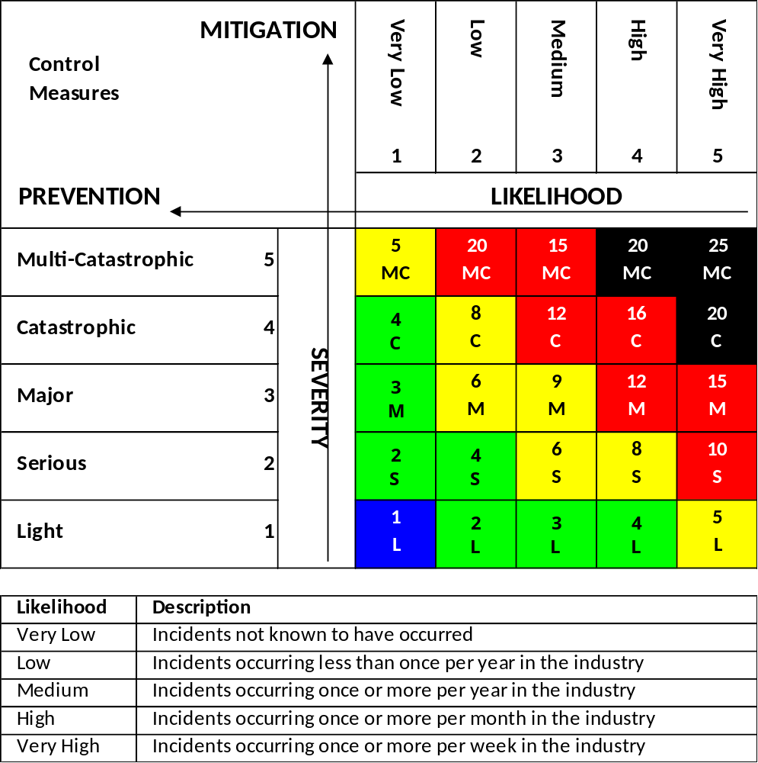

Appendix B – Residual Risk Approval
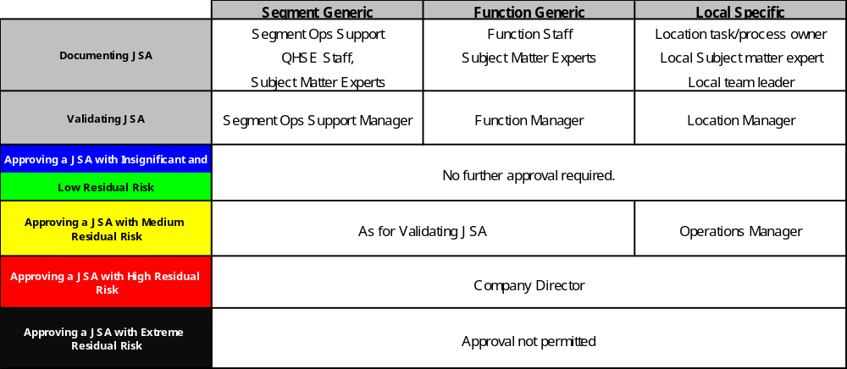

Appendix C – HSE CLassification
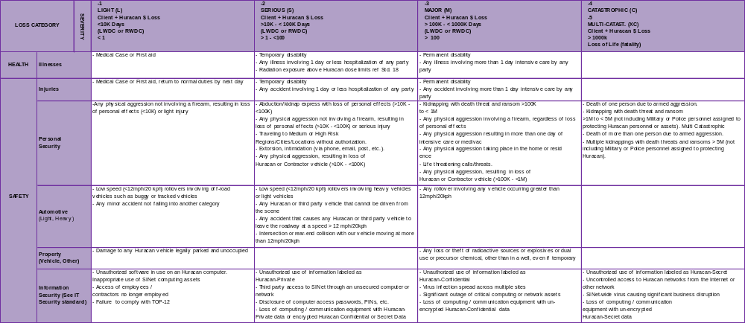

Appendix D – Witness Statement
