Karna Production Accuracy, Security, and Regression Audit
Versioned v1 evaluation corpus | 28 July 2026
Scope: Baseline text, URL, image-validation, dashboard, deployment, and failure-path review
Dataset: 30 evaluated text/URL samples plus 4 image validation or capability records
Result: 25 automated Python tests passed; Android tests were not run because this machine has no Java, Gradle, or Gradle wrapper
Deployment: https://data-protactor.vercel.app

Executive conclusion
Karna passed 25 automated Python tests after this audit. The v1 corpus produced 20 exact category matches out of 30 evaluated text/URL samples. This is a diagnostic result from a small synthetic corpus, not a public real-world accuracy claim.
Decision: Keep Karna publicly described as an explainable, advisory threat-analysis API. Do not publish a numeric overall accuracy score from this corpus.

Method and scope
Each corpus record has an ID, modality, expected category or behavior, and a non-sensitive sample. One-vs-rest metrics were calculated for each text/URL category. Image semantic scoring is not evaluated without a separately authorized OpenAI vision configuration.
- Safe look-alikes include benign urgency and a legitimate OTP-style message to expose false positives.
- Threat cases include phishing, social engineering, impersonation, prize/payment scams, suspicious URLs, and download links.
- The corpus includes obfuscated English, Spanish phishing, and Hindi social-engineering examples to expose language coverage limits.

Test execution
Check | Outcome | Evidence
Python API and regression suite | PASS | 25 passed
Versioned v1 corpus | COMPLETE | 30 evaluated text/URL samples
Image validation | PASS | Unsupported type, size, and fallback coverage
External failure paths | PASS | Simulated OpenAI and VirusTotal failures
Live deployment | PASS | Health and URL-category regression
Android unit suite | NOT RUN | No local Java, Gradle, or wrapper

Category metrics
Metrics below are regression measurements for the v1 synthetic corpus only. They are not generalizable malware- or scam-detection accuracy figures.
Category | TP | FP | TN | FN | Precision | Recall | F1 | FPR
safe | 3 | 6 | 19 | 2 | 0.333 | 0.600 | 0.429 | 0.240
phishing | 2 | 1 | 23 | 4 | 0.667 | 0.333 | 0.444 | 0.042
social engineering | 3 | 3 | 22 | 2 | 0.500 | 0.600 | 0.545 | 0.120
impersonation | 2 | 0 | 27 | 1 | 1.000 | 0.667 | 0.800 | 0.000
scam | 2 | 0 | 27 | 1 | 1.000 | 0.667 | 0.800 | 0.000
suspicious URL | 5 | 0 | 25 | 0 | 1.000 | 1.000 | 1.000 | 0.000
malware download | 3 | 0 | 27 | 0 | 1.000 | 1.000 | 1.000 | 0.000

Known limitations
- Benign urgency and legitimate OTP-style messages can receive cautionary classifications.
- Obfuscated phishing, less explicit scams, and non-English examples are currently missed or classified too broadly.
- The baseline never opens, downloads, crawls, or executes URLs; therefore it cannot claim a complete malware scan.
- Image semantics are not measured without an authorized OpenAI vision key and a separately labeled image corpus.

Audit findings and fixes
Fixed: Deceptive media-link evidence now returns suspicious_url instead of social_engineering.

Fixed: Prize, lottery, and processing-fee cues now activate the scam category; a regression test protects the behavior.

The unresolved false positives and false negatives remain in the corpus. They should drive future multilingual and semantic-analysis work rather than being removed from the audit.

Security and resilience checks
- Submitted URLs are structurally analyzed only; the baseline does not visit, download, crawl, or execute them.
- A simulated VirusTotal failure returns no external evidence and preserves the local result.
- A simulated OpenAI vision failure returns a structured caution response without leaking the provider error.
- Unsupported image types and images larger than 5 MB are rejected, and uploads are not persistently stored.
- The public configuration endpoint exposes only the Android download URL and never API keys.

Live test evidence
The following screenshots show live dashboard checks. The phishing case returned critical/phishing/quarantine. The executable URL case returned high/malware download/block.
Live phishing result
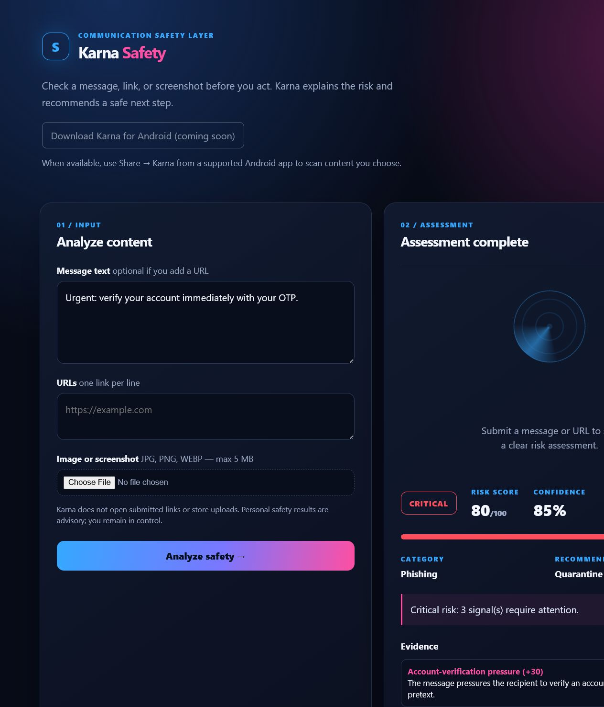
Live executable-download URL result
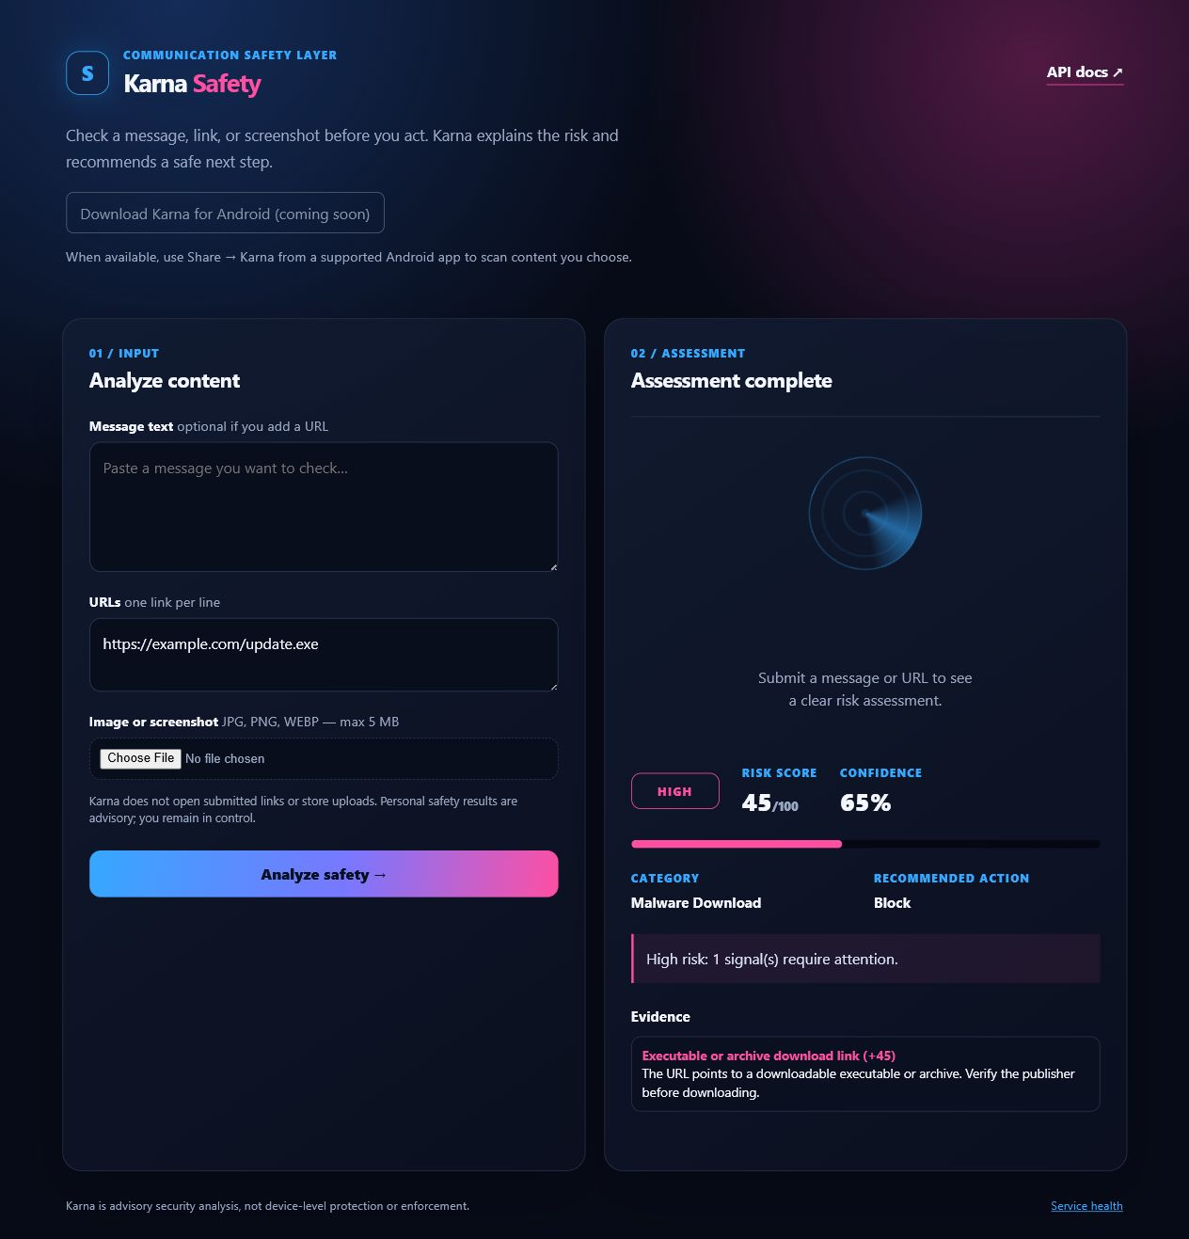

Reproducibility and next steps
Run the versioned evaluation with: PYTHONPATH=src, then python scripts/run_baseline_evaluation.py and python -m pytest -q. The machine-readable output is docs/evidence/evaluation_metrics_v1.json.
- Build a larger consented or lawfully sourced corpus with independent labels.
- Use development and holdout splits; record label-review process and sample provenance.
- Add multilingual, adversarial, and score-calibration evaluation before publishing any production metric.
- Run Android unit tests on a configured Android Studio or CI runner before an Android release.

