**Assignment 1 Instructions: Use JavaScript to validate a form**

In this Assignment, you’ll use JavaScript to validate a reservation request form.

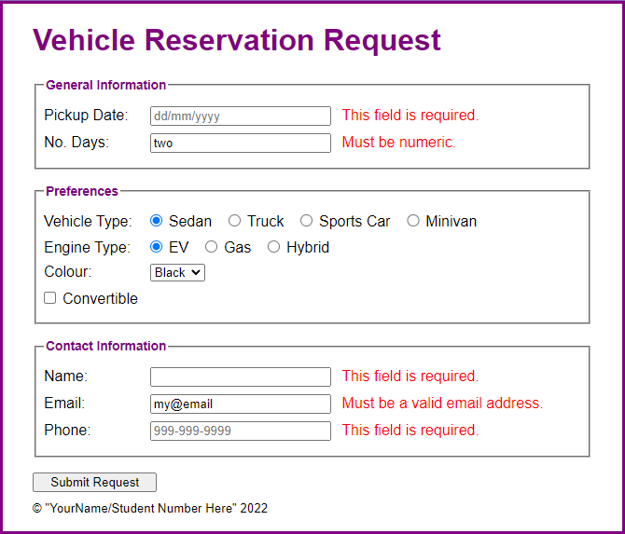

1. Open the starter application(zipped) attached to this Assignment folder:
   1. Evaluations\Assignments\Assignment 1\reservation.zip
   2. Then, run the application and click the Submit Request button to see the page that’s displayed when the form is submitted to the server.
2. In the JavaScript file, note that the ready event handler contains the declaration for a constant named emailPattern that contains the pattern that will be used to validate the email address.
3. Code a statement that moves the focus to the “Pickup Date” text box.
4. Code an event handler for the submit event of the form. This event handler should validate the user entries. If any of the entries are invalid, the code should cancel the submission of the form. The validation is as follows:
   1. A value must be entered into each text box.
   2. The number of days must be numeric.
   3. The email address must match the pattern that’s provided.
   4. Be sure to trim the entries and put them back into the controls regardless of whether the entries are valid.
5. In index.html, change the text in the <small> tag to your name and student number.
6. Test and submit to the Assignment folder when completed.