Cascade: A foreign key with cascade delete means that if a record in the parent table is deleted, then the corresponding records in the child table will automatically be deleted. This is called a cascade delete in SQL Server.

A foreign key with cascade delete can be created using either a CREATE TABLE statement or an ALTER TABLE statement.

Figure No.1 :

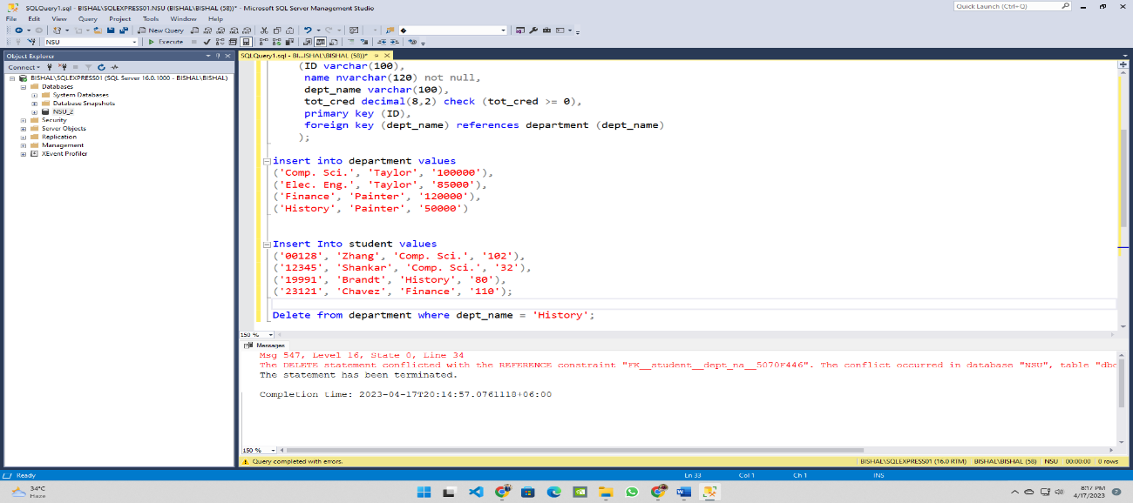

The following table shows that we cannot delete or modify any data due to foreign key constraint. Because depart name in Student table is the foreign key references of Department table. If we want to delete any data from Department table then the Data of student table must be affected. Hence, we cannot delete or update any data from Department table.

Figure No.2 :

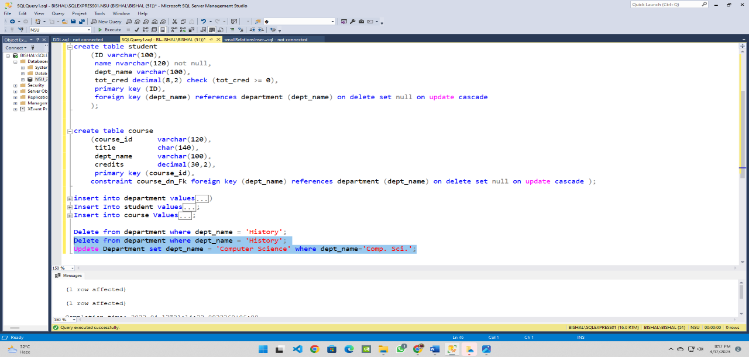

Figure No: 3

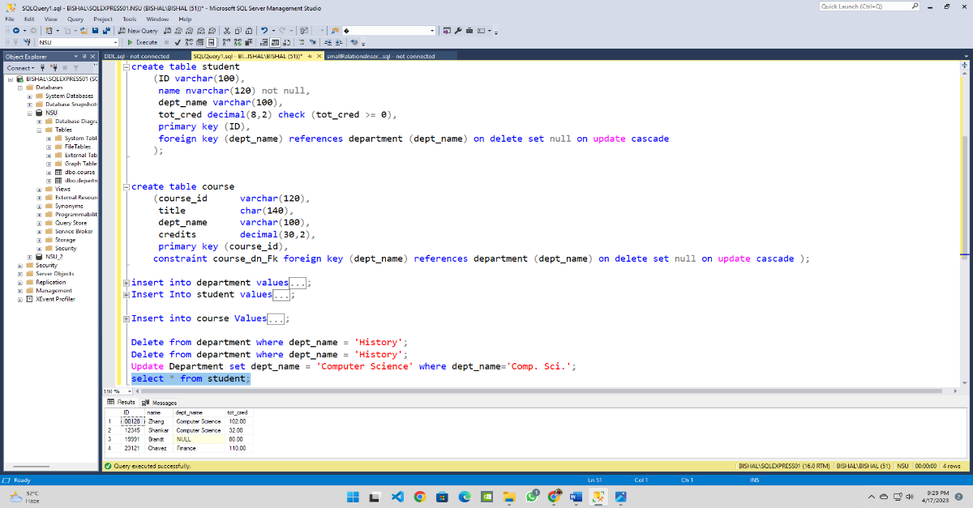

In the following pictures we don’t get any foreign key constraint after using cascade. We can delete and update any data by adding cascade in our query. And we can see that after updating the data of Department table the data of student table has also been updated. Hence, we can conclude that by using cascade We can delete and update any data of our foreign key constraint.